Jingwei Chen

1. Falling Glass
2. In the worst case, to guarantee getting the right result we have to try all the floors from lowest floor because if we try from the highest floor with one glass and it breaks we will no longer have glass to try the other floors which the result is not guaranteed, and for every floor the glass will either break or don’t break, if we just have 1 egg we will just try from the lowest to highest which the result will have to include all the floors, for 0 floor there is no trial, for 1 floor there just 1 trial, assume we have n floor, m glasses, if glass break at n floor, we lost 1 glass and have to check the floor below, this sub solution will be (n - 1, m - 1) trials left to check, if the glass does not break at n floor, the amount of glass does not change, but we can check further floor, this sub solution will be (n, highest floor - m) trials left to check because highest floor - m will get me the number of floor left to reach the highest floor. For every floor of these two possibility we choose the all the highest trial because we want the guaranteed result, and then since the question asking for minimum trial we choose the minimum trial from these floors.
3. Recurrence tree

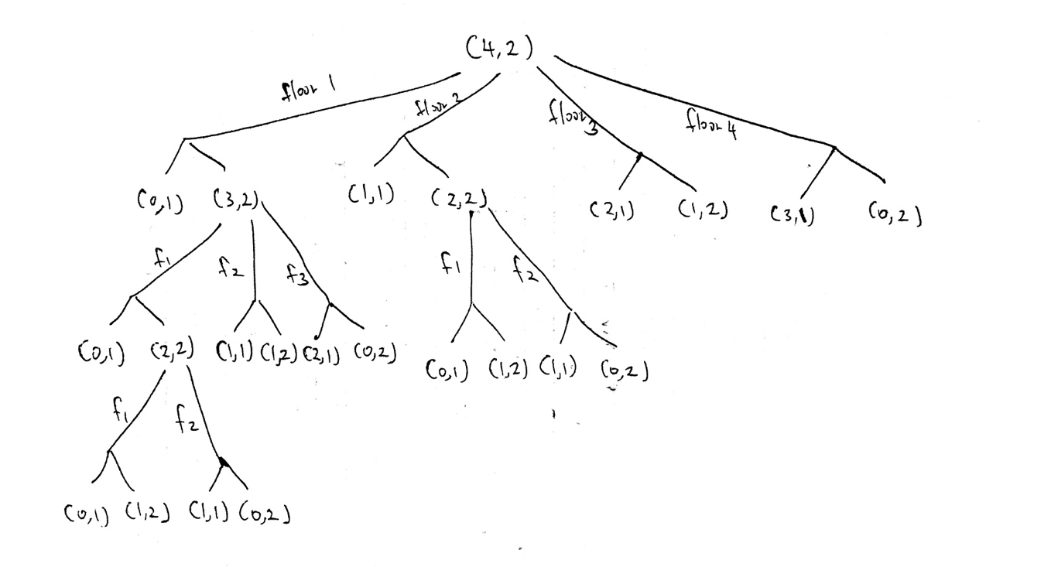

1. GlassFalling.java
2. 8 distinct subproblems
3. N\*M distinct subproblems
4. Describe how to memoize Recursion
5. GlassFalling.java

2. Rod Cutting

(a)

(b)

(c)

(d)