**Project Report**

**On**

**EK FOODMAPS**

**By**

**Team03nov16**

**Team Members**

* Kritpal Bhatti
* Erik Zhao

1. **Introduction**

It is challenging and difficult at times to adapt to the lifestyle to a foreign land and people often face the cultural shock or have difficulty in finding the food of their choice or cook the food of their choice as they are not very well versed with the local market. Therefore we have conceived the idea to develop a website where people will learn the simple yet good recipes.

(Please note: They will not be able to shop or order anything from the website, as the aim of the website is to provide cuisine information.)

1. **Project Title and its Objective**

The title of the website is EK FoodMaps and objective of the website is to develop a user friendly website which has a rich data of different cuisines like Thai, Continental, Chinese, Indian and other multicultural cuisines.

As mentioned above, this idea has been selected in order to make the life and experience of people a little easy as far as the cooking is concerned. As we understand that how difficult or challenging it can be to cook or try different a new cuisine. Hence, we want to make the cooking experience easy for people with no or limited cooking skills.

1. **Target users**

The target users are

* Students (local and overseas)
* Professionals
* Tourists/ bag packers
* Food enthusiasts

1. **Characteristics of Target users:**

The main characteristics of target users are –

* Have no or limited time for cooking (For example, Working professional)
* Lack of cooking skills ( for example students)
* Not aware of local market, restaurants ( for example, Tourists or bag packers)
* Food enthusiasts ( For example, people who want to try new recipes)

1. **Feature of website:**

* Registration and Login/Logout option - New member can register and others can have login logout options.
* Multi – national recipes database.
* Responsive and user friendly website that can be run on all standard devices

1. **Enhance User Experience:**

* The users can tryout and learn new cuisines
* Our website can effectively assist customers find out the item which they are looking for
* Responsive website, giving user the comfort to browse it in different devices ( mobile, tablet or desktop)

1. **Data Requirements:**

The following data is required –

* The multinational recipe database
* Information regarding potential customer (number of customers)

**9. Website Pages Screenshots**

Here are the screen shots of few of the pages of the website**.**

**Home Page**

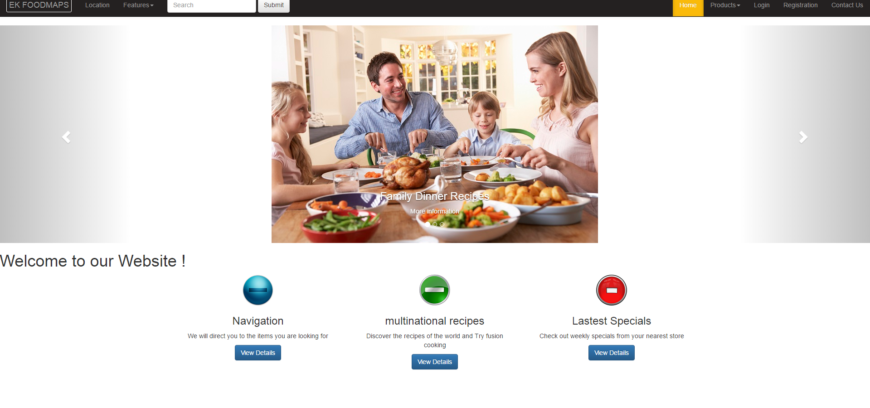

**Login Page**

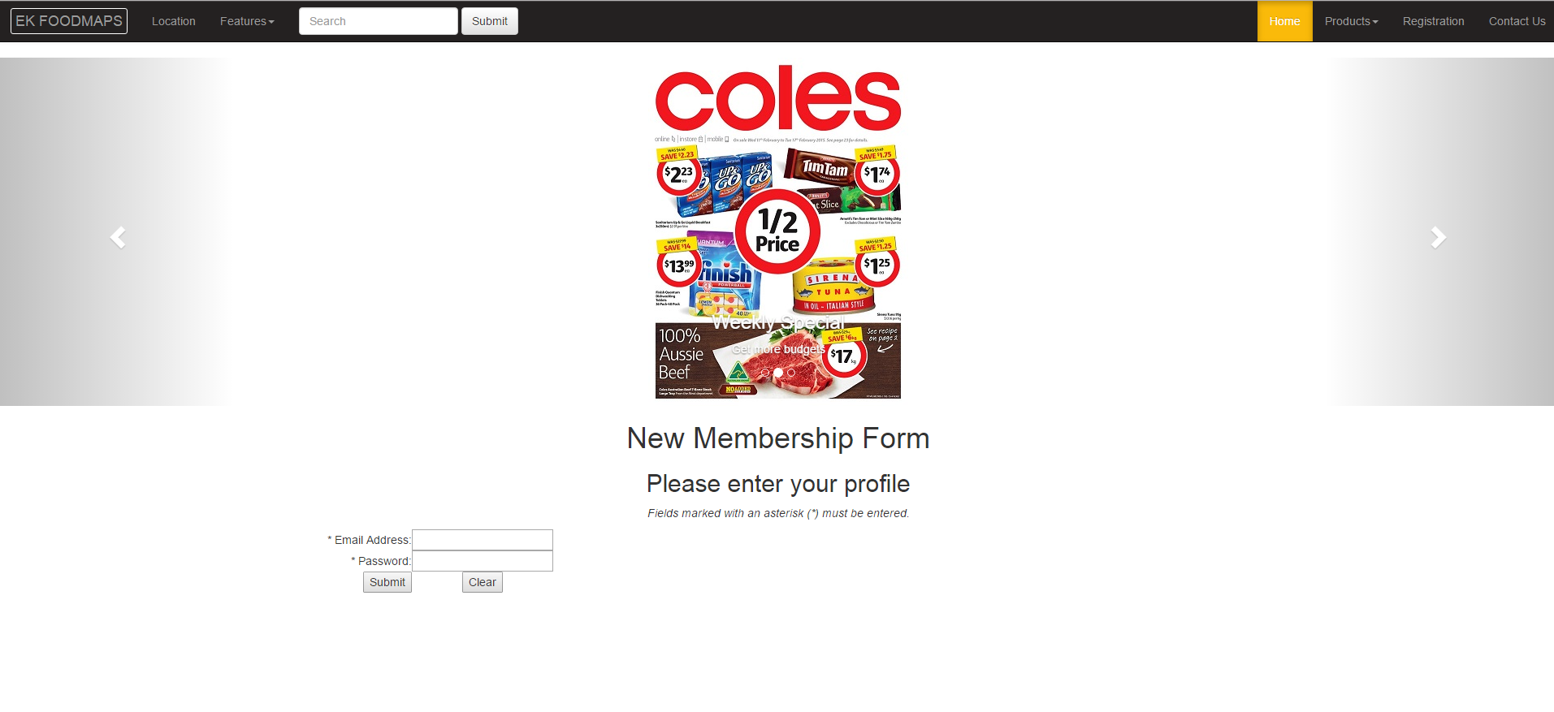

**Registration Page**

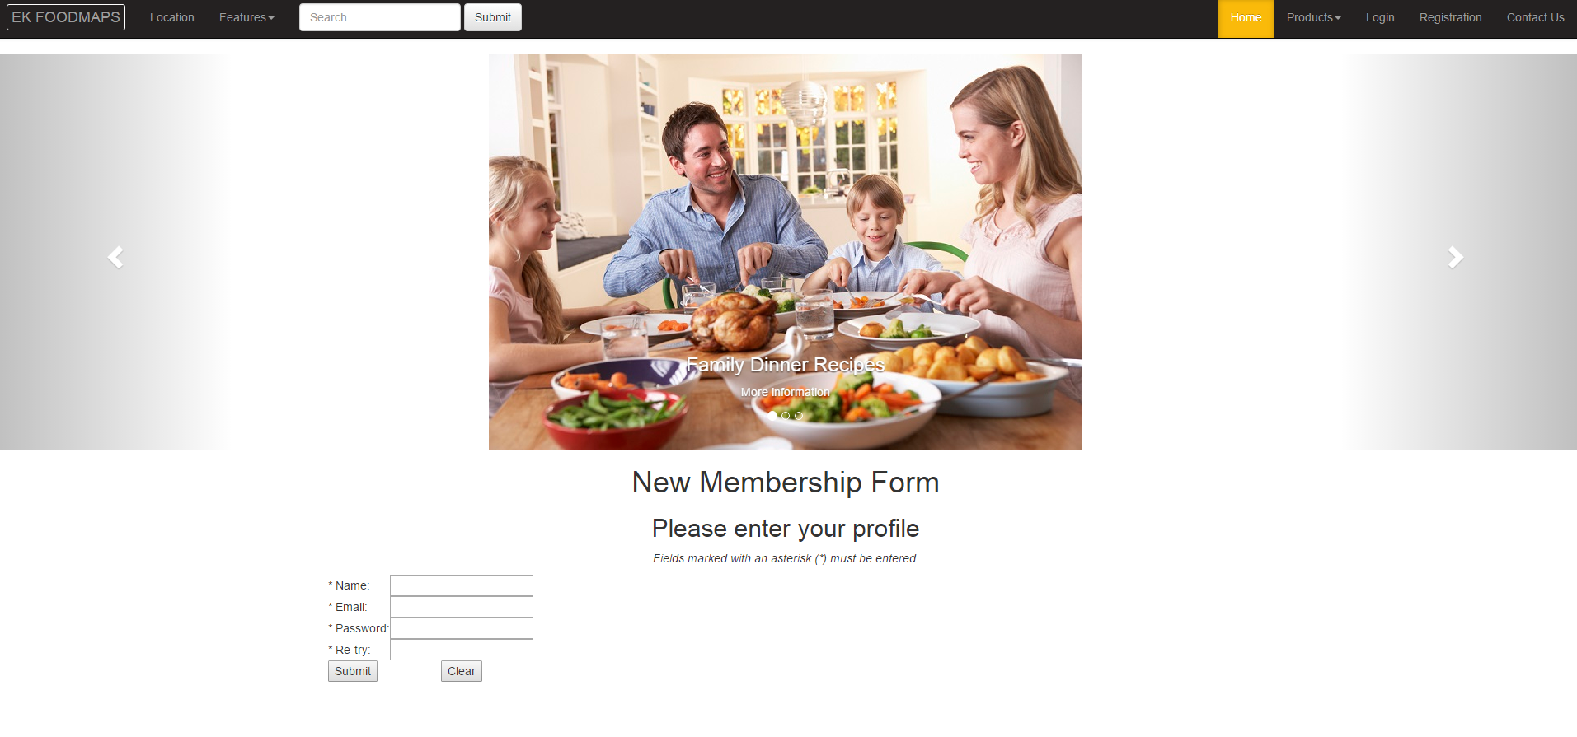

1. **Technologies:**

* Front end languages- HTML and CSS, JavaScript, Bootstrap
* Back end language- PHP, PL-SQL, JQuery

1. **Responsibilities:**

* Location, Registration and Contact Us – Kritpal
* Search, Home and Login page – Erik
* Data collection – Kritpal and Erik
* Selection of Idea - Erik
* Determination of Objective - Kritpal
* Data research – Kritpal and Erik

1. **Schedule:**

* Week 5 – Final submission of the proposal and draft along with home page
* Week 6 and 7 – Work on the individual pages
* Location, Feature and About Us – Kritpal
* Search, Contact Us and Product/recipe – Erik
* Week 8 and 9 testing and fixing the Website
* Week 10 – Final Submission

1. **Strength and Weakness:**

**Kritpal:**

* **Strength –** Organizational and planning skills.
* **Weakness –** Coding of the website pages as do not have any programming and IT background**.**
* **Approach adopted to check weakness –** Learning from www.w3schools.com as well as repeating the tutorials.

**Erik:**

* **Strength** - Good coding skills
* **Weakness** – Managing balance between work and studies
* **Approach adopted to overcome the weakness** – Applying the skill of time management

1. **Features Planned but not implemented:**

* Database of stores where a person can find the ingredient of the recipes mentioned in our website.
* Platform where stores owners can advertise on our website.

1. **Potential Improvement:**

There is always a scope for improvement and adding new features. If there is now scope of improvement that means we are not trying new things and our growth has ceased. We have identified few things that can be implemented in the website to make it more user friendly and useful. For example, the data regarding where a person can get a particular ingredient (which is used in the recipe mentioned in the website), providing a platform to the potential stores who want to advertise their products on our website.

1. **Special Notes :**

The login page has been fixed as per advise and inputs shared by our lecturer **Mr. Cue Nguyen**. Also the common element of the website has been implemented and now there is a same picture in the login and registration pages.

**Github Link:**

<https://github.com/jc432439/team03nov16.git>