

RENTAL PROPERTY RESPONSIVE WEBSITE

GROUP ASSIGNMENT

**GROUP MEMBERS(Team02jul17):**

Xiting Jia

Yu liu

Dinithi Vithanage

Shemal Jayawardena

Table of Contents

1.0 Project Title 3

1.1 The Team 3

2.0 Project Objectives 4

2.1 Target Users 4

3.0 Project Features and Features Implemented 5

3.1 Basic Features implemented 5

3.2 Features Planned but not implemented 6

3.3 Potential Improvements 6

4.0 Frameworks and Technologies Adapted 8

4.1 Main functions or tasks or pages 12

5.0 Site Diagram 13

6.0 Data Requirements 14

7.0 Team Review on individual contributions of each member and responsibilities 15

8.0 Actual Implementation Schedule 17

9.0 Project Access Links 18

# Project Title

**Rental Property listings website**

The following project would focus on designing a website for rental property listings to enable students and any other property seekers to be able to find houses, flats and apartments for lease.

## 1.1 The Team

**Team Name :**Team02jul17

**Team Members:**

* Xiting Jia
* Yu liu
* Dinithi Vithanage
* Shemal Jayawardena

# Project Objectives

The main goals of the following website would be to:

* To develop a responsive website providing a user-friendly mechanism for displaying and finding rental accommodation for students in Australia with focused budget friendly accommodation options.
* The website also allows users to seek partners/housemates for their properties and to view and contact sellers who display second hand items for sale on the website.
* The website also allows for the users to enter their details and sign up on our site for us to send further marketing information to them via emails through our database.

## Target Users

**Primary users**

* Students -Individuals or Families (above 16 )

**Secondary users**

* Agent (Accommodation providers)
* Second Hand items/appliance Resellers
* Individuals seeking roommates/partners for accommodation

**User characteristics**

* Age and gender: above 16 male and female
* Education: Secondary school or higher
* Income- 4 week’s rental bank balance

# Project Features and Features Implemented

## Basic Features implemented

1. Make rental website accessible online on any device (responsive)
2. Display range of rental options including homestay
   * Enlarge pictures of the selected address
   * Read more functionality of each property
3. Communication Bar for user communication or forums
4. Q and A section – For Frequently Asked Questions
   * Enable Students to seek for house mate or second-hand items available for resale.
   * Provide accommodation by different accommodation type
5. Proper navigation assistance for users
6. Simple and easy to use page layout
7. Clear contact details
8. Sign Up form for users
9. Downloadable contract agreement
10. Links to partner websites.

**Images and Colour Palette**

Images used for:

1. Rental properties
   * 1. Villa
     2. Apartment
     3. Sharehouse
     4. Townhouse
2. Home Stay
3. Second Hand Items Appliance resales
4. Logos etc.
5. Partners

**Information architecture and navigation systems**

* + - Breadcrumbs
    - Page Titles
    - Highlighted Tabs
    - Global/Local Navigation Bars
    - Help/Contact Us/ FAQ’s/ Communication Bar or Forums

## Features Planned but not implemented

|  |  |
| --- | --- |
| **Rental Page** | **Search Feature**- ability to search based on type of bedroom required and suburb etc.  In place of this we have added a Jump to feature and this would be considered as a future development |

Overall all the other features that were discussed initially were up to date and functioning

## Potential Improvements

Future improvements would include all the features that were planned but could not be implemented as mentioned above as well as the below:

|  |  |  |
| --- | --- | --- |
| **Page** | **Feature** | **Description of feature** |
| **Rental Page** | -Advanced Search Feature with filter options | Filtering user needs based on number of bedrooms, bathrooms, suburb etc. Making it a more personalized website |
| **Rental Page** | -Filter images based on price | Price filtering function would be future developments |
| **Home** | -User Profile | Allowing the user to have a personalized page that tracks his saved searches etc. |
| **Overall** | -Gather user search history based on login information | Ability to retrieve all the users saved searches once he/she logs in |

# 4.0 Frameworks and Technologies Adapted

**Front end requirements:**

**Tools:** HTML, CSS and JavaScript

**Back end requirements:**

**Tools:** PHP, SQL Server

The above frameworks and technologies were used in the following way in the below pages, HTML has been a basic framework used throughout the pages across the entire site:

|  |  |
| --- | --- |
| **Overall Site** | **CSS-** Used for overall formatting and responsive page design |
| **Rent Pages**  **(Refer Figure 2 and 3)** | **JavaScript-** Used for Expansion and Collapsing of text  **CSS-** Used for image pop ups |
| **Home stay and Communication Bar**  **(Refer Figure 4)** | **PHP**- For sign up features and user details retrieval purposes  SQL Server-  **JavaScript**- For collapsing of text  **CSS-** Used for image pop ups |
| **About us pages**  **(Refer Figure 6)** | **CSS** used for overall formatting |
| **Support Pages and Home pages**  **(Refer Figure 5 )** | **CSS-** Used for image pop ups  **JavaScript-** Used for Expansion and Collapsing of text |

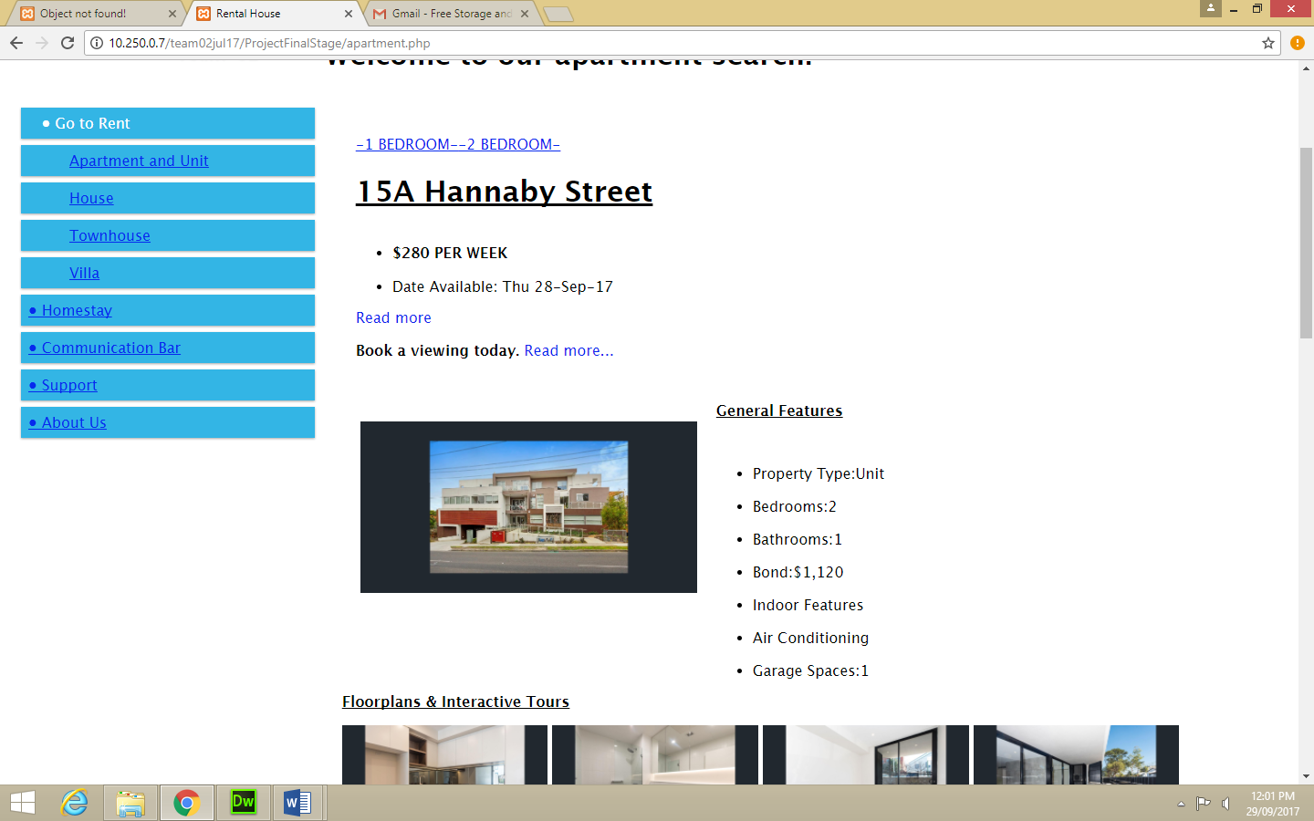

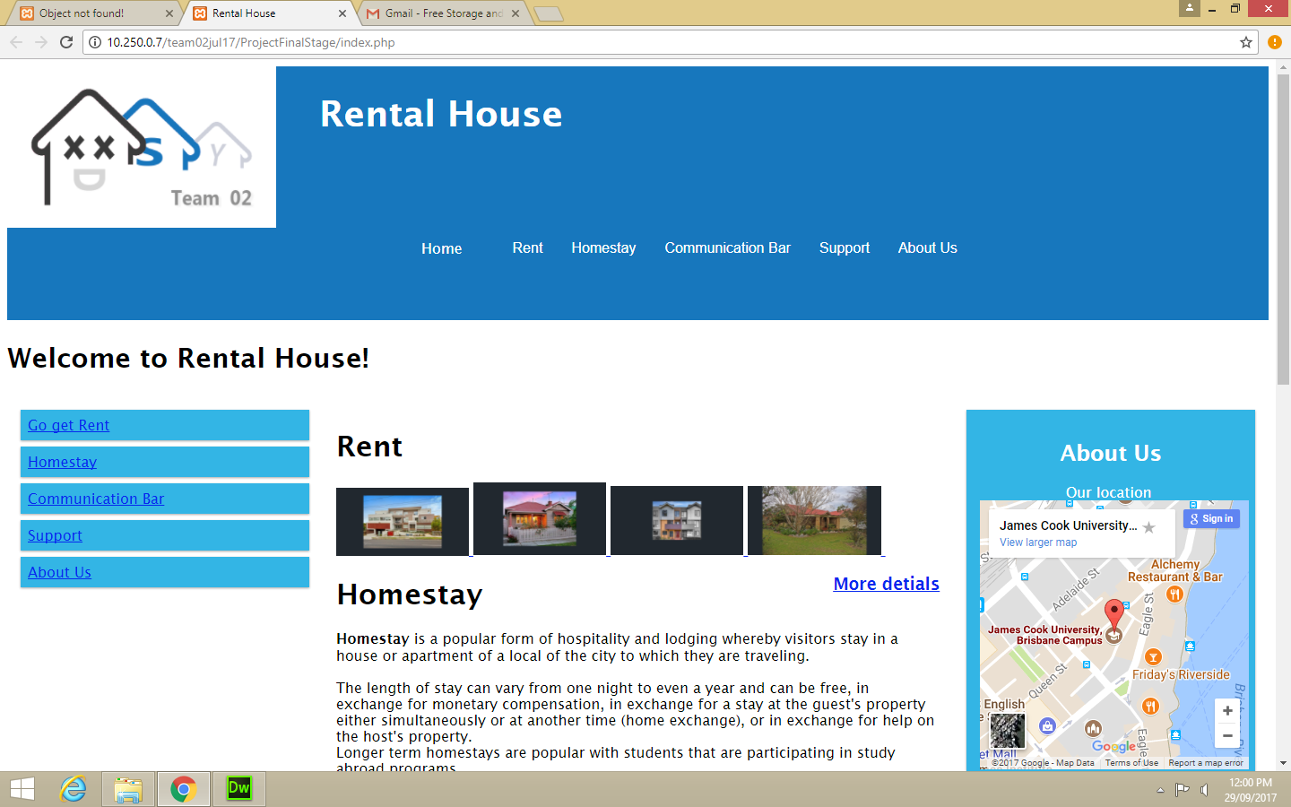

Figure 2 Rent Page

Figure 1 Home Page

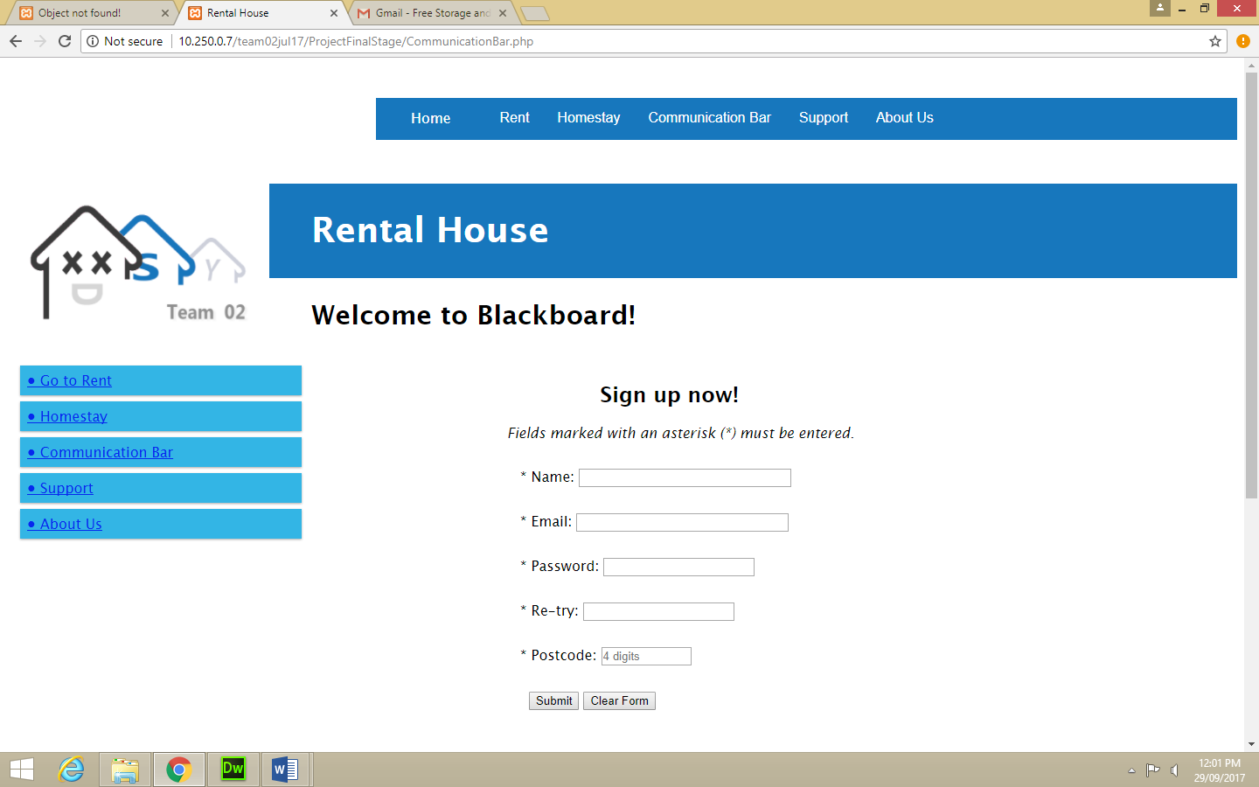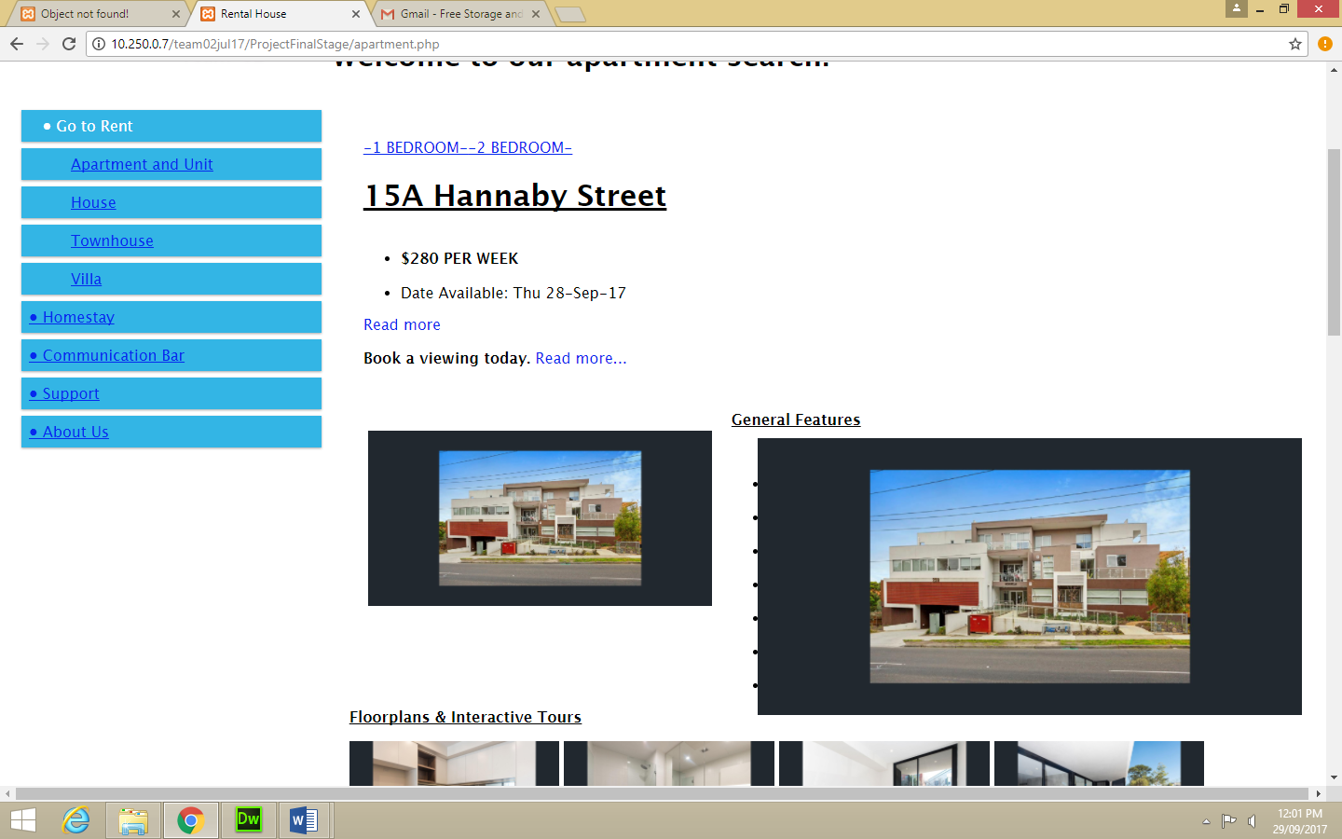

Figure 3 Rent Pages

Figure 4 Sign Up Form

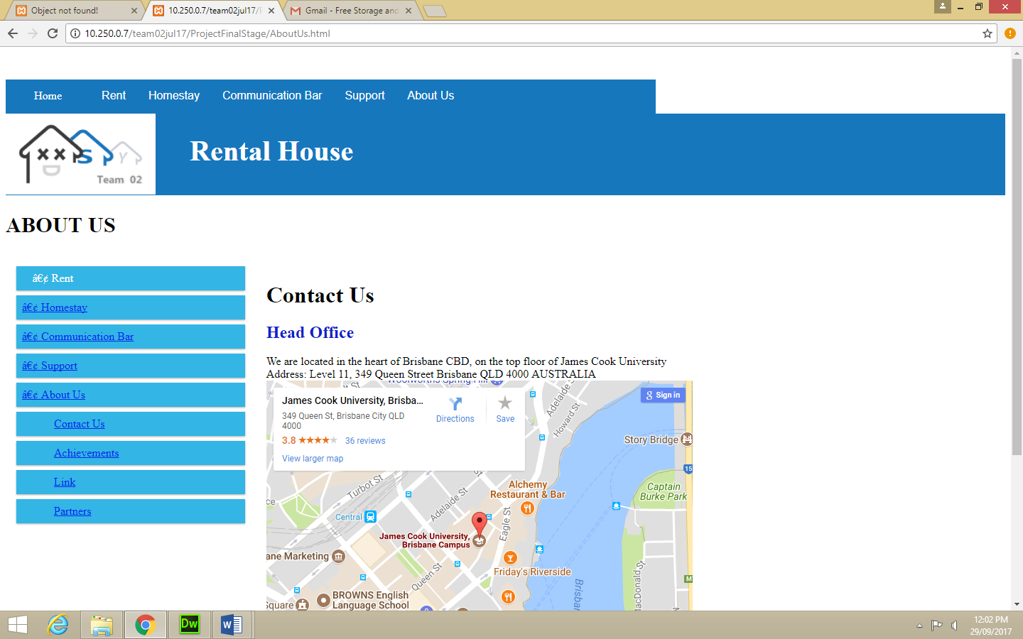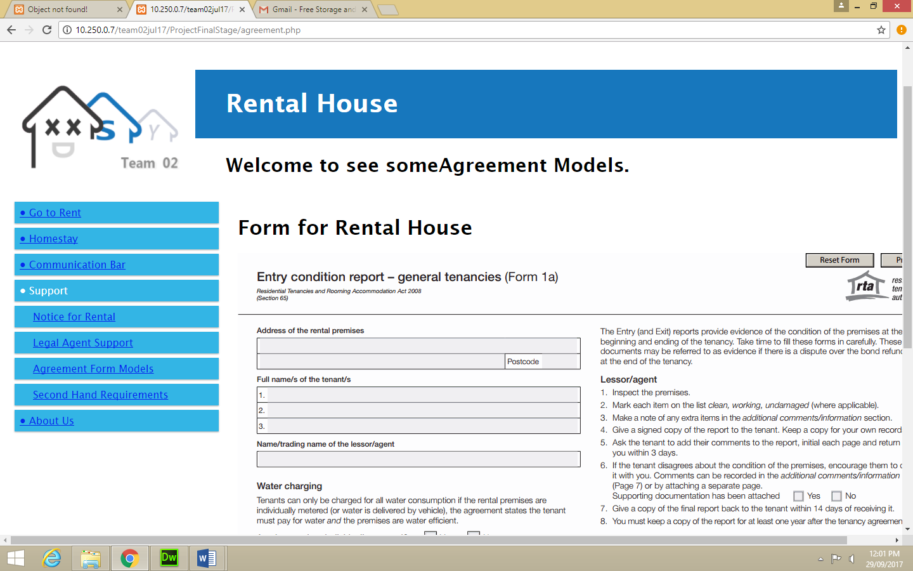

Figure 5 Rental Agreement

Figure 6 Rental Agreement

## 4.1 Main functions or tasks or pages

The main functions for this page would be to direct the user to choose a suitable accommodation for their needs as a student, comparing prices and conveniences. The options for each choice will be depicted in description. A search button and other links would assist the user to get to where result as well.

**Main Page functions are as follows:**

|  |  |
| --- | --- |
| **Rent Pages** | Provide links to various types of rental applications with details describing the apartment, images and contact details of agents |
| **Homestay** | Allows for students to check homestay options or homestay parents to view which students are looking for a homestay family |
| **Communication Bar** | FAQ’s and Questions from users can be posted here |
| **Support** | Any support required in terms of rent, legal agents, agreement model of even second-hand items/appliances can be viewed. |
| **About us** | About the company with contact information and other company details |

# Site Diagram

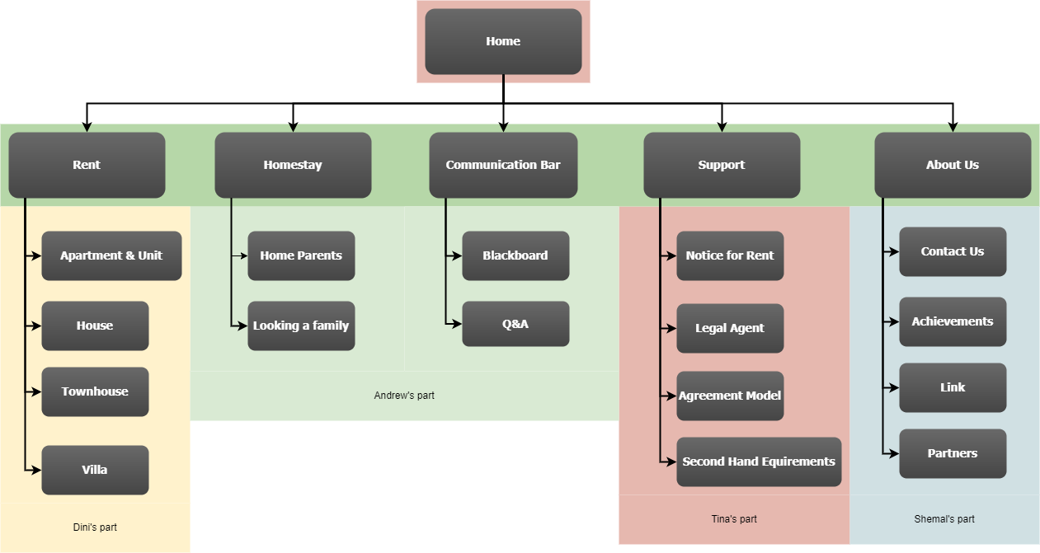

# 6.0 Data Requirements

* Rental Property Information
  + - Address of Property
    - Agent Name
    - Type pf property
    - Prices- Bond and weekly rent
    - Number of bedroom/bathrooms/car spaces etc.
    - Details- Amenities included and not included
      * Available Dates
* Homestay Information
  + - Address of Property
    - Home stay family details
    - Type of property
    - Prices- Deposit and weekly rent
    - Number of bedroom/bathrooms/car spaces etc
    - Details- Amenities included and not included
    - Available Dates
* Second-hand items
  + - Seller name and contact details
    - Product information- usage history and condition
    - Address to picked up from
    - Prices

# Team Review on individual contributions of each member and responsibilities

**Strengths**

* **Tina -** Well versed about software tools for web development, focused and motivated.
* **Dinithi** - Punctual and meets deadlines, previous experience in web designing. Organized and structured
* **Andrew** - Experienced in creating a website himself with a similar structure. Creative in nature.
* **Shemal-** Creative and has previous experience in web designing, motivated and a great team player.

**Responsibilities/division of tasks**

* **Tina**
  + Home Page
  + Support Pages
    - Notice for Rent
    - Legal Agent
    - Agreement Model
    - Second Hand Requirements
* **Dinithi** 
  + Rent Pages
    - Apartment and Unit
    - House
    - Townhouse
    - Villa
* **Andrew**
  + Homestay
    - Home Parents
    - Looking for a Family
  + Communication bar
    - Blackboard
    - Q & A
* **Shemal**
  + About Us
    - Contact Us
    - Achievements
    - Link
    - Partners

**Review**

Overall everyone contributed to the parts mentioned above and were focused on making sure the assigned pages ran smoothly while also helping out the other member of the team when needed when it came to implementation as well as documentation.

# Actual Implementation Schedule

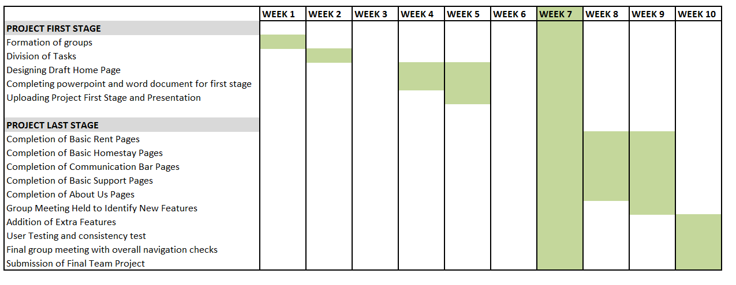

# Project Access Links

**Project URL**

<http://10.250.0.7/team02jul17>

**Project GitHub repository**

<https://github.com/jc444921/ProjectFirstStage>

**Project Team Communication**

<https://team02jul17.slack.com/open>