PROJECT REPORT

MAKE A FUTURE

TEAM02NOV12

TEAM MEMBERS:

* NEHA BISHT
* BALJINDER KAUR
* TANVEER KAUR
* HARPAL SINGH
* **Project Concept & Objectives**

We want to create a user friendly charitable and donation website for Make A Future foundation.

Make A Future primarily works towards creating a bright future for the children who come from down-trodden parts of the society and are underprivileged.

* **Use of Front End And Back End Technologies**

We will be using the mentioned languages to design the front-end of our website: HTML,CSS,XML,JAVASCRIPT.

We will be using the mentioned languages to design the back-end of our website: JAVASCRIPT,JQUERY,PL/SQL.

**The website encompasses through a some of the below mentioned pages:**

* 1. Home page: Gives an overall glimpse of the website and what we have to offer.
  2. About us: What we do and how we help in spreading our mission.
  3. Contact us: General contact details
  4. Support us: Consists of a direct link that lands up to the donation page.
  5. Donate: Enables users to donate money
* **Targeted Users**
  + Primary users: Donors
  + Secondary users:Guests, Database Administrator,Volunteers
* **Conceptual Features** **Of the Website**

1. Enables people to adopt a child and give donation to the homeless children.
2. There is a online form for the donors.
3. Enables people to help homeless and helpless children to making their future bright by giving them donation online.

* **Technical Features Of the Website For User friendliness**

Consider any of the followings:

* + - 1. Home, menu bar, icons, logo design for MAF
      2. Image colours, font(Times New Roman),poor kids images
      3. Usage of media: image, logo
      4. Client/User(Donor) Information architecture and database.
* **Strengths Of the Team**

HTML Designing, Communication and Presentation skills, Adaptability to new coding concepts.

* **Weaknesses Of the Team**

Coding.

**Websites Look-and-Feel**

**1) Website Blueprint**

**2) Website Web Pages**

* **Home Page**

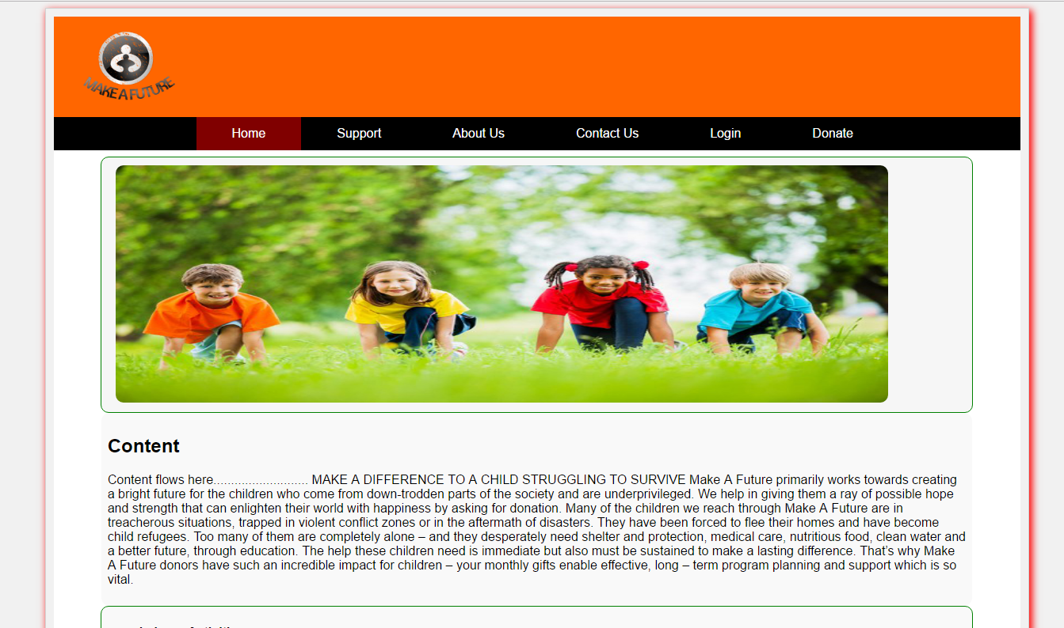

* **Sign Up Page**

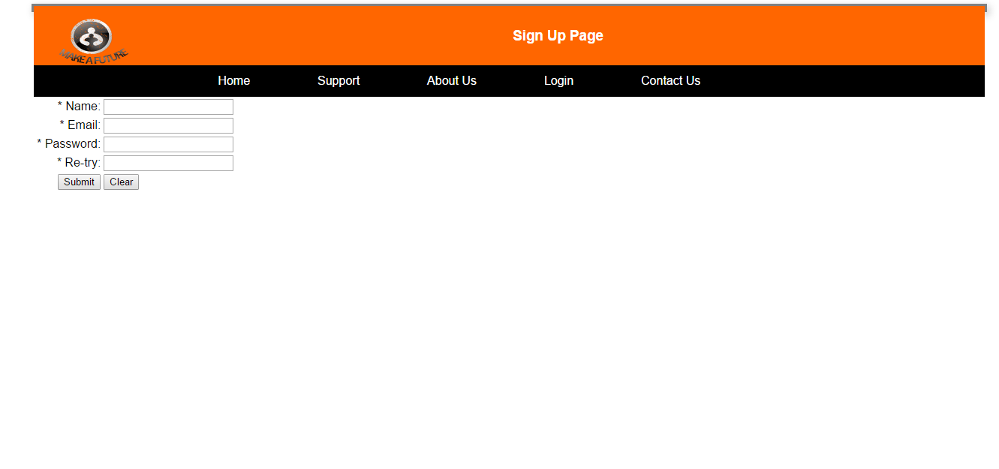

* **Contact Us Page**

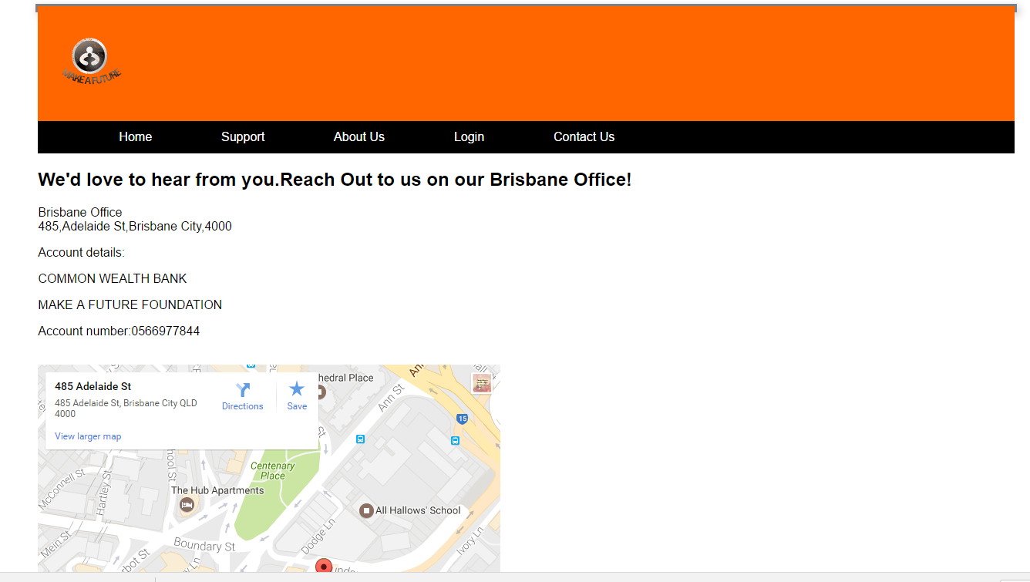

* **About Us Page**

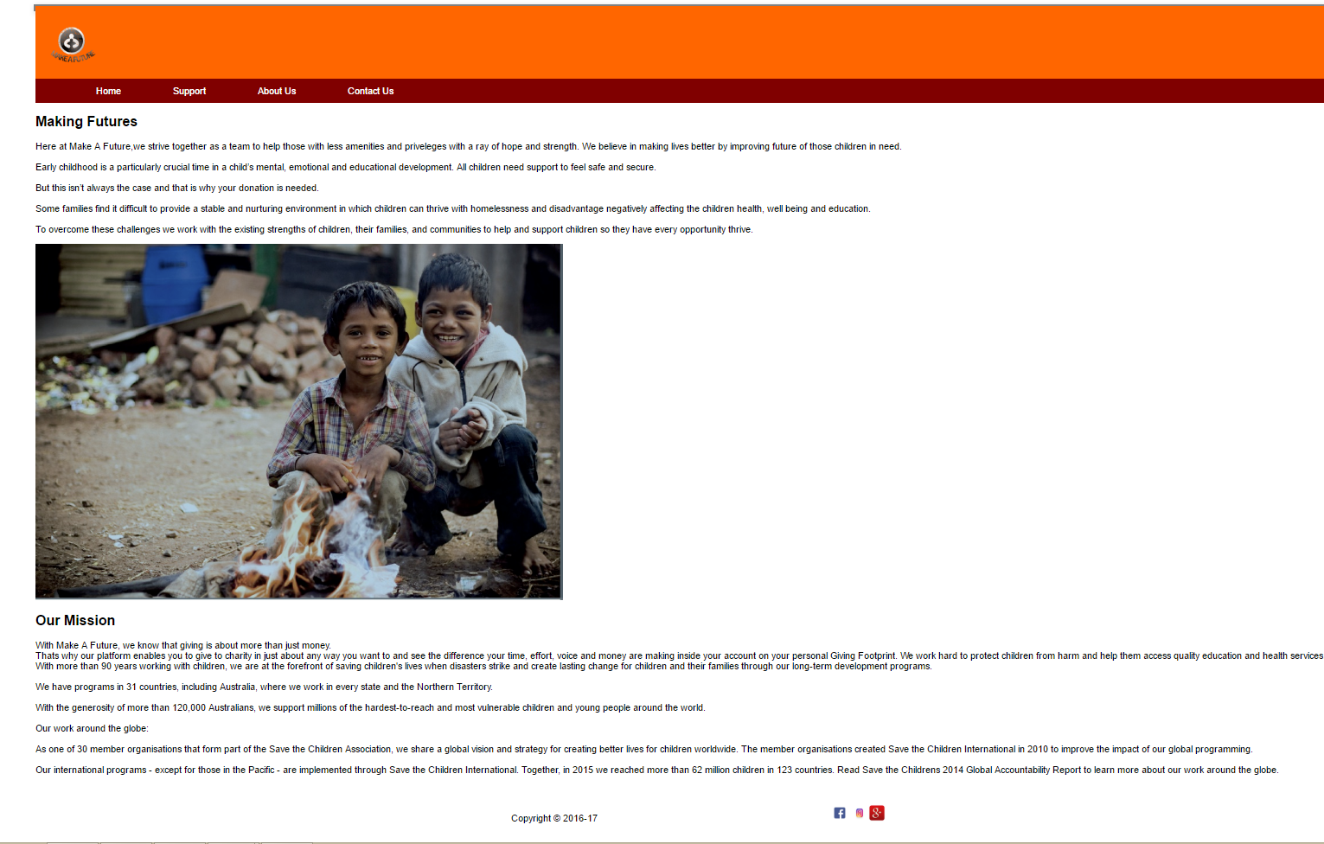

* **Log-In Page**

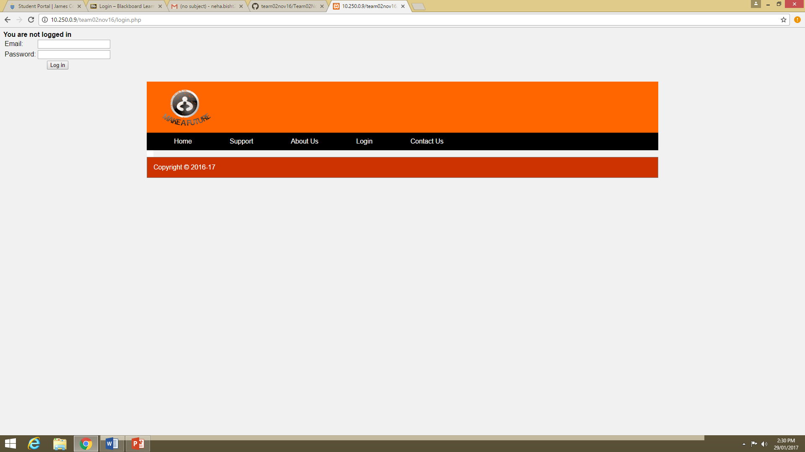

1. **Web Site Access: http://10.250.0.9/team02nov16/login.php**

**Responsibilities Of each Team Member:**

**Neha:**

Documentation

Data Collection and designing Of Contact Us Page

Data Collection For Home Page.

Data Collection For About Us Page.

Responsive and Style CSS File creation.

**Tanveer:**

Home Page: Header, Article

Database Creation (Client:Donors) and designing For Login Page

Database Creation For Signup Page

Data Collection for Home page

Responsive and Style CSS File creation.

**Bajinder :**

Data Collection For About Us Page.

Designing For About Us Page.

Header and Footer Designing

Linking Of All the pages

**Harpal :**

Home Page: NewsLetter, ,Footer

Designing Of Home Page

Designing Of Signup Page

Designing Of The MAF logo

Link Creation For Paypal for money transfer

* **Schedule & Milestones For the Designing Of the Website**
* **Week 6**:

Blue print ,discussions about the concept of the project & Website Visual Design layout.

* **Week 7**: Designing of all the following pages and assembling their database :

Home page

About us

Contact us

Support us

Donate

Adopt.

* **Week 8:**

Linking the Home, about us,contact us,support us,donate and adopt to the subsequent web pages:

Linking donation page to payment gateway.

* **Week 9:**

Launching all the Pages for a visual and running blueprint of the website over the server.

* **Week 10:**

Final Website Completion.