E-Business Technologies (CP310)

**Team Members (Team 07)**

**Manish Shakya (JC461242)**

**Jagdeep Kaur Tiwana**

**Akshay Sahnan**

**Bhoomi Raval**

Lecturer: Cue Nguyen

Table of Contents

Project Title 2

Goals or Objectives 2

Our Mission 2

Importance of project: 2

Features 2

Target Users 3

Who are eligible for blood donates? 3

Blood group’s requirements 3

Technologies 3

Front end requirement 3

Back end requirements 3

Functions 4

Data Requirements 4

Usability/Requirements 4

Site load time is reasonable: 4

Font Size and Spacing: 4

Styles & Colors Are Consistent: 4

Links are Consistent & Easy to Identify: 4

Logo is linked to Home-page: 5

User friendly 5

Responsibilities 5

Who in charge of what? 6

Schedule 7

Layouts 8

Navigational Diagram 9

Gantt chart 10

# Project Title

“Donate Blood” it is basically a website which create a platform to get information about upcoming blood donation programs, and provides awareness as well as encourage the people to donate blood.

# Goals or Objectives

## Our Mission

* Our main motive is, providing a right destination to all people who have deep emotions for the humanity and want to help needy ones by donating their blood. People, who are keen to help others, can go through our website.
* Moreover, we want to help those, who cannot afford these essential expenses. We will play a role of bridge between those who want to donate blood and who need blood.
* “Donate Blood” makes a promise with you to supply the quality blood.
* Provide information about upcoming blood donation programs.

## Importance of project:

* By designing this website we encourage people to donate blood for their and others wellness.
* Anybody who will in great need can directly contact us. They do not have any need to go anywhere else for example hospitals.

# Features

* Give information about upcoming blood donation camps.
* Enable user to know about the upcoming seminars.
* Provide the basic information about blood types.
* Enable user to go through main hospitals.
* Our website would be very easy to surf.  Any user who is beginner to internet can easily use this.
* Enable user to contact with us for any query.
* Provide the details of staff members and administration.

# Target Users

## Who are eligible for blood donates?

* Minimum age 16 or 17
* Maximum age is depend on the kind of donation and if someone already given blood before.
* If new donor:-start donating blood any time up until the age 71, and continue donating until age 81.

## Blood group’s requirements

* **AB** - It is the rarest blood type. So, it’s always in high demand.
* **A** - It is always needed.
* **B** - B is use for people with severe burns, or patients with blood disease.
* **O Negative -** it is the universal blood type, and can be given to any patient
* **O Positive** - it is the most common blood type, all donations are valuable.

Blood is the most important gift that anyone can give to another person- “The gift of life”. So our main targeting users for blood donation are, everyone who are healthy and fit above age 18.

# Technologies

## Front end requirement

* Tools-: Dreamweaver
* Languages-: HTML5, CSS, Java script (Client side)

## Back end requirements

* Tools-: Dreamweaver
* Languages-: PHP(Server side)
* Database-: oracle or MySQL

## Functions

* The blood bank is one of the major components of a hospital, with activities like blood donor registration.
* Our Blood Bank will provide the information regarding blood and donor.
* Information of upcoming events
* Request processing/cancellation

## Data Requirements

* Eligibility to donate blood( weight, blood group, medical condition, age )
* Any medication
* Weight
* Donor’s data (name, age, address, contact, blood group)

# Usability/Requirements

## Site load time is reasonable:

The main problem with most of the website is that it takes lots of time to load; as a result people will just leave.

## Font Size and Spacing:

Poor readability increases frustration, and frustration leads to site abandonment. So, the new proposed system shall make sure the line spacing and font size used is adequate.

## Styles & Colors Are Consistent:

Layout, headings, and styles should be consistent site-wide, and colors should usually have the same meaning.

## Links are Consistent & Easy to Identify:

The user should able to navigate links easily which can be maintained by making links either color (blue) or underlined

## Logo is linked to Home-page:

The logo should be linked to home-page so that whenever the user get confuse about what to do next, they can simple go back to home-page.

## **User friendly**

The system should be user friendly show that user feels easy to use the proposed system.

# Responsibilities

|  |  |  |
| --- | --- | --- |
| Team Member | Strengths | Weaknesses |
| Manish Shakya | * Font Size and Spacing * Coding and designing * Identifying features * Planning project | * Testing code |
| Akshay Sahnan | * Color combination * Layout designing * Analyzing requirements | * Identifying Goal * Analysis features |
| Bhoomi Raval | * Gathering information * Selecting images and picture * Project contents | * Analyzing Format |
| Jagdeep kaur Tiwana | * Project Idea * Identifying Goal * Analysis features * Developing Contents | * less sound in color combination * Font and styling |

## Who in charge of what?

|  |  |
| --- | --- |
| Responsibilities of Each Team Member and Team | |
| **TASKS** | **MEMBER ALLOCATED** |
| Analysis Project Title | Team |
| Finalized Project Tile | Team |
| Project Objectives | Jagdeep Kaur Tiwana |
| Identify the basic features | Team |
| Target users | Bhoomi Raval |
| Front-end and back-end requirements | Akshay Sahnan |
| Identify the Functional and Usability | Manish Shakya |
| Identify the data requirements | Akshay Sahnan |
| Features to enhance users experience | Manish Shakya |
| Project Side Plan(Blue Print) | Akshay Sahnan |
| **Layouts** | |
| Home page, Login, Events page Layout design, volunteers view, staff view, donors view, event view | Manish Shakya |
| About Us and Staff page Layout design | Jagdeep Kaur Tiwana |
| Contact and Volunteers page layout design | Bhoomi Raval |
| Donors Page layout design | Akshay Sahnan |
| **Coding and Design** | |
| Home page (index.php),Login page(login.php),Events page(events.php) | Manish Shakya |
| About Us page (about.php),Nurse staff page(nursestaff.php) | Jagdeep Kaur Tiwana |
| Contact Us page (contact.php),volanteers page(voluntary.php) | Bhoomi Raval |
| Donors page (donors.php) | Askhay Sahnan |
| Review Design and Coding | Team |
| Gantt Chart | Manish Shakya |
| **Executable system** | Team |

# Schedule

|  |  |  |  |  |
| --- | --- | --- | --- | --- |
| S.N | Millstone | Time duration | Start Date | Finish Date |
| 1 | Analysis Project Title | 1 day | 28-03-2017 | 29-03-2017 |
| 2 | Finalized Project Tile | 1 day | 29-03-2017 | 30-03-2017 |
| 3 | Project Objectives | 2 days | 31-03-2017 | 02-04-2017 |
| 4 | Identify features | 1 day | 02-04-2017 | 03-04-2017 |
| 5 | Target users | 1 day | 03-04-2017 | 04-04-2017 |
| 6 | Front-end and back-end requirements | 1 day | 04-04-2017 | 05-04-2017 |
| 7 | Identify the Functional and Usability | 1 day | 05-04-2017 | 06-04-2017 |
| 8 | Identify the strengths and weaknesses | 1 day | 06-04-2017 | 07-04-2017 |
| 9 | Responsibilities of each team member | 1 day | 07-04-2017 | 08-04-2017 |
| 10 | Features to enhance users experience | 1 day | 08-04-2017 | 09-04-2017 |
| 11 | Project Side Plan(Blue Print) | 1 day | 09-04-2017 | 10-04-2017 |
| 12 | Home page layout design | 1 day | 10-04-2017 | 11-04-2017 |
| 13 | Contact Us page Layout design | 1 day | 11-04-2017 | 12-04-2017 |
| 14 | Eligibility Page | 2 days | 12-04-2017 | 14-04-2017 |

# Layouts

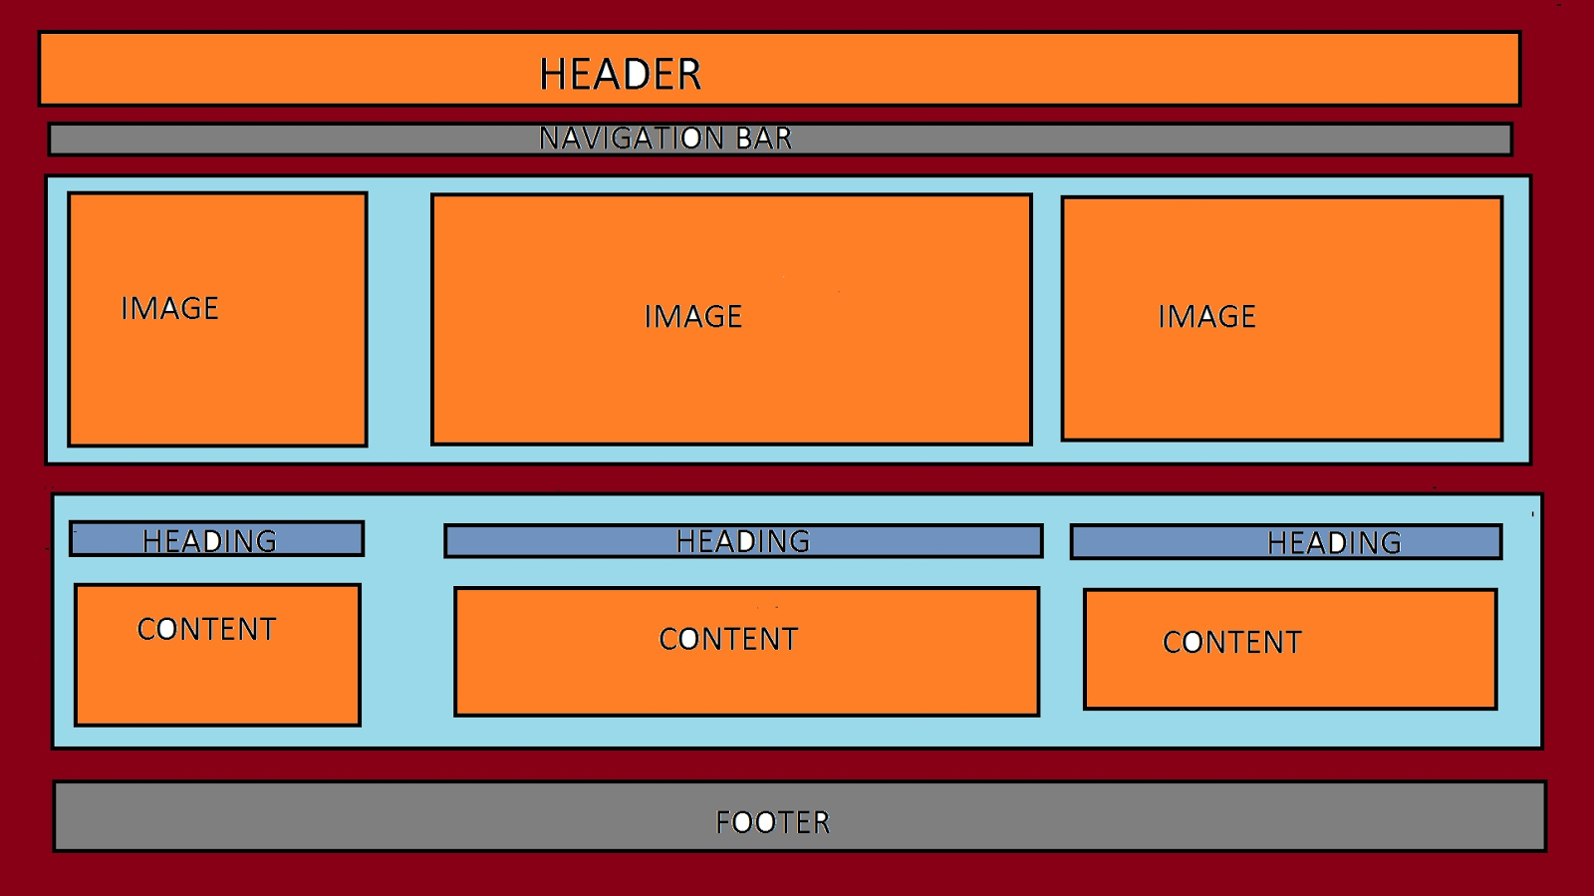

Figure 1 Home Page Layout

# Navigational Diagram

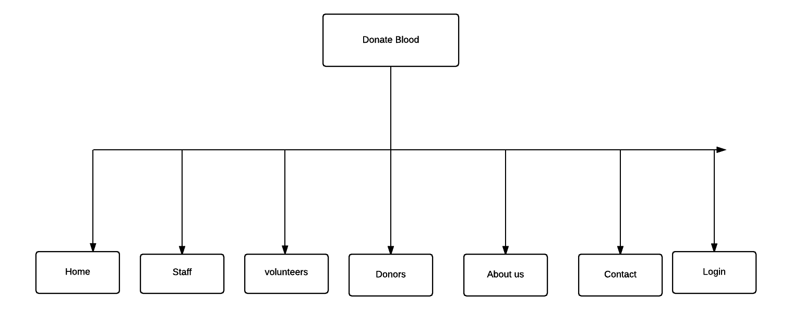

Figure 2: Navigational Diagram

# Gantt chart

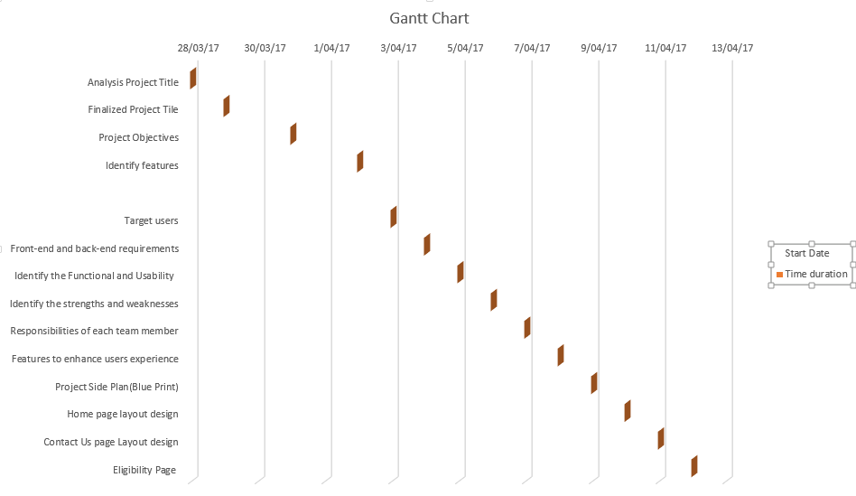

Figure 3: Gantt chart