ACKNOWLEDGEMENT

In performing our assignment, we had to take the help and guideline of some respected persons, who deserve our greatest gratitude. The completion of this assignment gives us much pleasure.

We would like to show our gratitude Laura Antochi, Lecturer, James Cook University Brisbane for giving us a good guideline for assignment throughout numerous consultations. Without her encouragement and guidancece, this project would not get materialized. We would also like to expand our deepest gratitude to all those who have directly and indirectly guided us in writing this assignment and making our project successful for the Alpha-Release. This project consumed huge amount of work, research and dedication.

I also would like to thank to our client, Michael Senescall, who took keen interest on our project work and guided us all along, till the completion of our project work by providing all the necessary information for developing a good system and also for not getting irritated when we had asked him a lot of questions.

Also, I would like to extend our sincere esteems to all staff in library for their timely support.

Project Description and Goals

The purpose of this website is to provide a platform (comprising a website and associated database) to outside users and internal company employees/contractors where users can inquire about IT solutions related to different IT problems and contractors would be able to submit invoice online for the performed work as well as enabling the client to keep track of different jobs assigned to different team members. It is a time of Information technology boom with ever changing business IT needs and requirements which requires prompt and creative ideas and solutions for IT problems.

The project is going to deliver a new website which will be hosted by a common hosting service and will be connected to a hosted database which also supports common database types. The use of the hosting provider will be decided with the client. Moreover, selection and provision of appropriate domain name, domain hosting, and SSL certificate for the project will be the responsibility of the client. Project will proceed in three main phases: the alpha, beta and the final stage release. All the client requirements will be assessed and determined before the alpha release and feedback on the project will be obtained between alpha and beta release and then between beta and final releases.

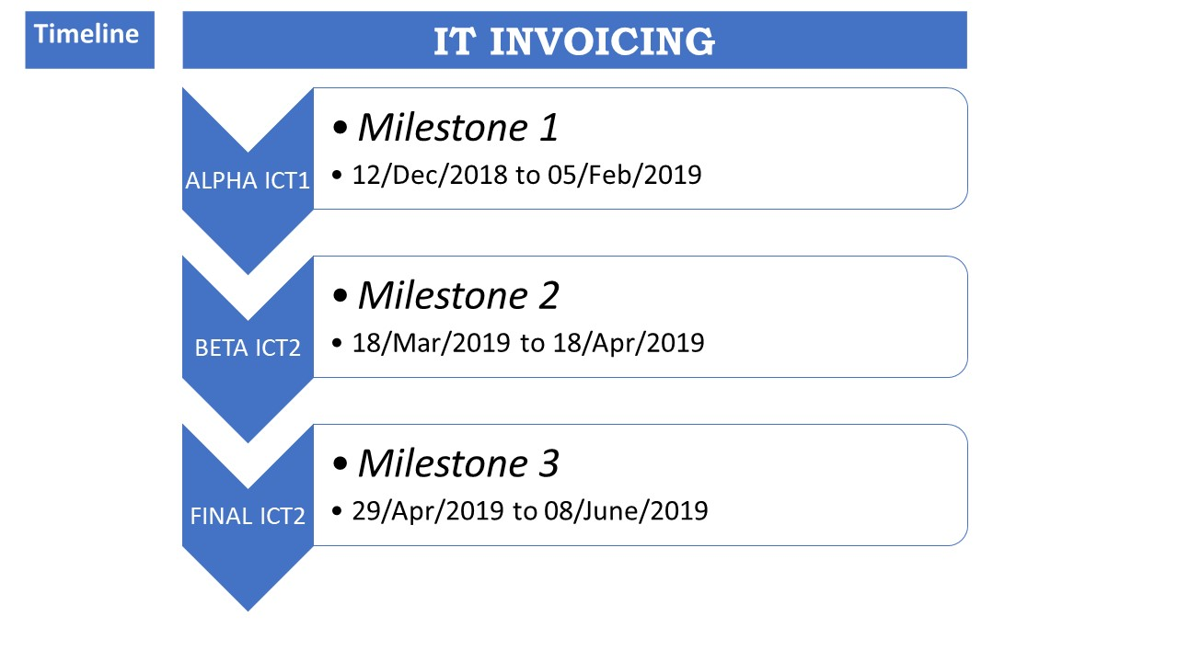

Figure: Project Milestone

**Our Team**

Successful projects are normally the aftereffect of careful arranging and the ability and coordinated effort of a project’s team members. Projects can’t move forward without each of its key team members. Team members have a variety of roles to contribute towards achieving the projects aims and goals. Our team is comprised of three team members. Here are the roles each team members have performed in each of the tasks.

**Team Members**

Rajendra Manandhar (JC476763)

Ranjita Kunwar (JC478496)

Usman Munir (JC500100)

After the formation of the team, we luckily came up to meet with our client Michael Senescall, who had to develop a website for IT solutions. So, we ended up deciding to develop a website called IT Invoicing with our team. With the approval from the lecturer, we started to divide the work and responsibilities.

**Individual Contribution for the Website**

After the finalization of the project to be developed, we divided our works and responsibilities as per the user stories of the Alpha Release as agreed by the client. The works have been divided equally to all of the three members to make us all learn and put equal effort on the project.

1. **Home Page**

This is the first user story and we decided to break it down in the navigation bar and work accordingly. The main home page and the navigation bar is created by ……. and some of the pages like why us, contact, products and services etc are created by …..

The total estimated time for this was 2 days.

1. **Registration/Log In**

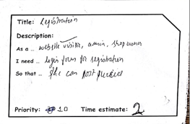

This page had the highest priority as per the client and Rajendra/Usman was working on this page and the total estimated days was 3 days. The task was to create form for user registration where they can add information regarding their first name, email, last name, password, retype password to make their account. The log in page is created for the users who are already a member for the website, IT Invoicing where users can only put their email and password and can get logged in and do their stuffs.

1. **Invoice**

This page aims where users can inquire about IT solutions related to different IT problems and contractors and would be able to submit invoice online for the performed work as well as enabling the client to keep track of different jobs assigned to different team members. This user story was assigned to …. and was estimated for 7 days.

1. **User Roles**

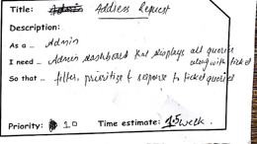

This is the page of the website where three roles are played by admin, contractors and clients. After the problem is enquired by the client, the admin assigns the tasks to the contractors and the client can keep a track of the assigned job to the contractor from their page. It had been estimated 4 days and was assigned to ….

1. **Query Portal**

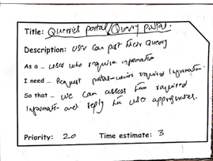

The task of Query Portal user story was assigned to …….. The main feature is that a user makes a single query request which is distributed to the database or search engine or we can access the information and reply accordingly.

**Individual Roles for Audit**

Talking about other individual contribution, for the audit, we have divided the work as follows:

Usman Munir :

* Deviation form alpha-release
* Screenshots of running alpha-release
* Participate and communicate with client to gather Client’s requirement

Ranjita Kunwar :

* Interact with client
* Burn down and velocity charts
* Planning for beta and final releases as per burn down and velocity charts
* Participate and communicate with client to gather Client’s requirement

Rajendra Manandhar :

* Project development and release ICT Infrastructure, configuration management, project tools and testing
* Develop Prototype
* Participate and communicate with client to gather Client’s requirement
* Prepare and finalize documentation and report for the project

**Alpha Release and Client**

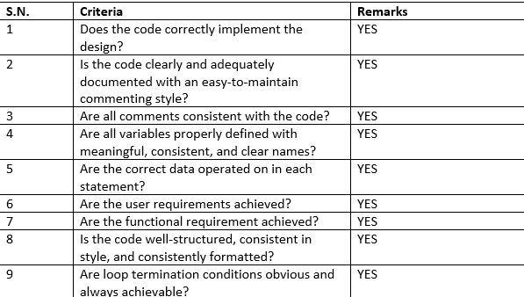

**Burn-Down Charts**

A burn down chart is a graphical representation of work left to do versus time. It is used in agile software development methodology. Below is the table representation of the status of the iterations:

|  |  |  |  |  |
| --- | --- | --- | --- | --- |
| **Iteration** | **Task Description** | **Developer** | **Estimated Days** | **Status** |
| 1 | Home Page |  | 2 | Completed |
| 2 | Registration/Log In |  | 3 | Completed |
| 3 | Invoice |  | 7 | Completed |
| 4 | User Roles |  | 4 | Completed |
| 5 | Query Portals |  | 5 | Completed |

Velocity Charts

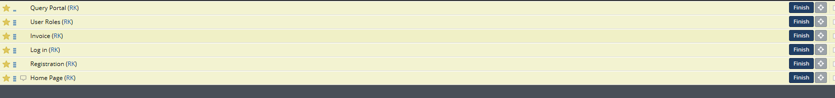

**Planning for Beta and Final Release**

The next step for the beta and final release is to create payment page, and also adding inventory to our website which also brings in one another function called cart which helps the users to easily go to the cart form to see their selected products and also can minimize and maximize the products they want to buy further or not. The feedback form also helps the users to provide valuable feedback. This is the page of our website that gives the chance to be better and help customers update their experience with the website and the products. A feedback form helps to connect the service provider and service receiver. If the service user are not satisfied with the service then they can tell their thoughts through this page so that it will be easier for the business to address the situation and act swiftly in their service.

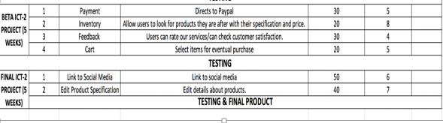

Github Repository

