Jiwon Cha

jc4va

**In-lab report**

**Topic**

Optimized code: Compare code generated normally to optimized code. To create optimized code, you will need to use the -O2 compiler flag. Can you make any guesses as to why the optimized code looks as it does? What is being optimized? Be sure to show your original sample code as well as the optimized version. Try loops and function calls to see what "optimizing" does. Be aware that if instructions are "not necessary" to the final output of the program then they may be optimized away completely! This does not lead to very interesting comparisons. Describe at least four (non-trivial) differences you see between 'normal' code and optimized code.

**Code 1**

**C++ code:**

* int foo(int a){return a+3};
* int main(){foo(3)};

**Assembly code – without –O2 flag:**

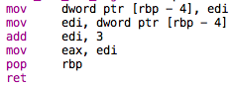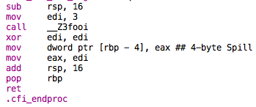

**Assembly code – with –O2 flag:**

/Users/Mac/Desktop/스크린샷 2017-11-15 오후 5.47.51.png/Users/Mac/Desktop/스크린샷 2017-11-15 오후 5.48.04.png

Foo function:

First of all, it is readily apparent that the optimized version is much shorter than the original assembly code. The optimized version ignores several unnecessary steps such as moving the element in edi to a spot on the stack and then moving the element in that spot into edi again. This step is not necessary within the context of this code, so the assembly takes it out. It also uses lea instruction instead of mov, which makes sense because lea can add and load at the same time while mov requires separate instruction for load and add. For example, if you want to add several constants to the register, lea is much shorter and faster. The code above shows how several steps can be shortened to one instruction; setting up edi, add edi, 3; mov eax, edi 🡪 lea eax, [rdi+3]

Main method:

Main method is also very short compared to the version without –O2 flag. First of all, the original main method manually adds 3 to the first parameter and then moves that value to eax. It also performs additional operations such as moving rsp to the original spot. However, the optimized version does not need to perform this step because 3 was already added to the first parameter inside of foo function. Therefore, in the main method, it simply returns what is in rax by calling ret.

**Code 2**

Assembly code for this program only includes the function part (foo) as the main function is the same as code 1.

**C++ code:**

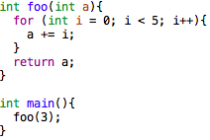

**Assembly code – without –O2 flag:**

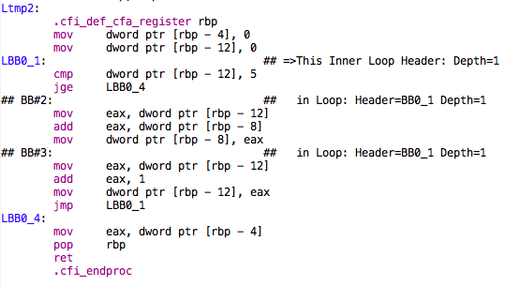

**Assembly code – with –O2 flag:**

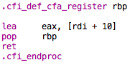

The original version of assembly carries out each step of the loop. We see that arguments of the for loop (such as int i) are stored on the stack as local variables. int i starts from 0 and increments until it reaches 5, therefore it first moves 0 to a spot on the stack and then compares the value stored in that spot to 5. If it is equal to 5, it jumps to the last part of loop and returns the value in eax. Otherwise, it keeps adding the value of i to eax and then incrementing the value in spot [rbp-12].

However, the optimized version skips most of the steps described above. The function simply adds 10 to the parameter and moves that value to eax, which means it has already calculated the result of 0+1+2+3+4. This is very convenient because the method is simply adding 0, 1, 2, 3, and 4 to the parameter.

To conclude, the optimized version seems to skip many steps unlike the original versions, and sometimes take parameters passed in the main function directly in the callee (foo function); it carries out operations that are usually performed in the main method, inside of the callee. The optimized version also produces significantly shorter code (less instructions) and less time consuming operations.

**Topic**

Dynamic dispatch: Describe how dynamic dispatch is implemented. Note that dynamic dispatch is NOT the same thing as dynamic memory! Show this using a simple class hierarchy that includes virtual functions. Use more than one virtual function per class.

**C++ code and dynamic dispatch**

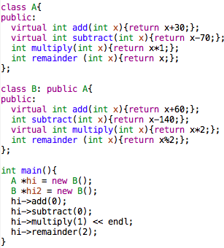

Output:

60 (B)

-140 (B)

1 (A)

2 (A)

***Dynamic dispatch:*** *the process of selecting which implementation of a*[*polymorphic*](https://en.wikipedia.org/wiki/Subtyping)*operation (*[*method*](https://en.wikipedia.org/wiki/Method_(computer_programming))*or function) to call at*[*run time*](https://en.wikipedia.org/wiki/Run_time_(program_lifecycle_phase))*.[1]*

In C++, dynamic dispatch is performed using the ‘virtual’ keyword. ‘‘virtual’ allows programmers to obtain ‘late binding’ where which implementation of the method is used is decided at compile time based on the type of the pointer that he calls through.’[2]

From the code and output above, we see that the program uses the function of superclass when the methods are declared without ‘virtual’; hi->remainder(2) yields 2, which means it uses the remainder function of ‘A’ class. However, we see that the program uses add and subtract method of B classes when we put virtual keyword in front of method names in ‘A’ class.

**Assembly code and implementation**

Add & subtract multiply

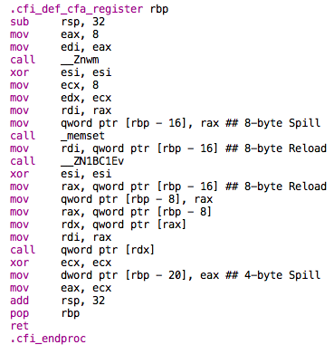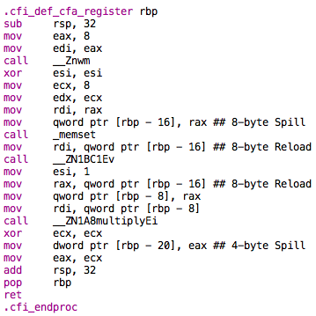

*Note that add and subtract use the member functions of class B (virtual dispatch) and multiply uses the member function of class A (static dispatch).

The general syntax for the methods for add(subtract) and multiply are very similar. Both function uses ‘hidden parameter register’ such as ecx and edx as it calls the functions.[3] They also both use call _memset, which sets the first number of bytes of the block of memory pointed by ptr to a specific spot.[4]

The main difference that we see is that ‘multiply’ function calls the function directly via the instruction call _ZN1A8multiplyEi, which indeed calls the multiply function of ‘A’. However, virtual dispatch ‘loads the address of the vtable from the object, then loads the function address from the vtable, then finally calls the function indirectly’.[5] Indeed, we see that the assembler loads the address at [rbp-8] to rax, then moves that address to rdx, then finally calls the pointer to [rdx]. This process facilitates dynamic binding.

Even though the syntax is rather similar, dynamic dispatch is different from dynamic memory. Dynamic dispatch involves selecting which member function or method to call (polymorphic implementation). They are similar in that dynamic memory allocation and dynamic dispatch both involve run-time operation.

**References:**

<https://groups.google.com/forum/#!topic/comp.lang.asm.x86/HhOsbmwyU_I>

<https://stackoverflow.com/questions/20147054/how-does-dynamic-dispatch-happen-in-assembly>

<https://stackoverflow.com/questions/9995922/how-to-tell-if-a-program-uses-dynamic-dispatch-by-looking-at-the-assembly>

<http://loci-lang.org/DynamicDispatch.html>

<https://stackoverflow.com/questions/2391679/why-do-we-need-virtual-functions-in-c>

1. https://en.wikipedia.org/wiki/Dynamic_dispatch
2. https://stackoverflow.com/questions/2391679/why-do-we-need-virtual-functions-in-c
3. http://loci-lang.org/DynamicDispatch.html
4. www.cplusplus.com/reference/cstring/memset/
5. https://stackoverflow.com/questions/20147054/how-does-dynamic-dispatch-happen-in-assembly