

CP2406 Programming 3 Assignment 1

Nguyen Le Hoang

[Company Name]

# **User Stories**

User Story 1

As for the user, I want to configure the simulator so that I can change the vehicle, the road and the duration of the simulator. Priority is high and the day is expected to be 3 days. Create a new city map for research, add a street map, and run the simulation.

User Story 2

As for the user, I want to keep my built city used again later so that I make sure that all the improvements to my personalized city do not vanish. Priority is Medium and Approximate time is 2 days. For the testing, after changing the city, press the save button to save the name of the city.

User Story 3

As for the user, I want to reload the previous established city to load the simulation so that I can replay the simulation with different scenarios, such as vehicles and prices.

Priority is Low and the approximate time is 1 day. Testing is achieved by pressing the open button to reach the saved city from the database.

User Story 4

As for the user, change the vehicle rate while I run a simulation so that I can monitor how many vehicles should be on the road. Priority is Medium and Approximate time is 2 days.

To test, press the Update Vehicle Rate button to render vehicles faster or slower.

User Story 5

As for the user, I want the stop button to stop the simulator while moving vehicles on the road so that I can stop the simulation process. Priority is high, and the approximate period is 2 days. For testing, click the stop button and watch the end of the car.

User Story 6

As for the user, I want to prevent collisions with other vehicles based on the distance from the vehicles ahead so that I can run the simulator without any problems.

The priority is high and the estimation time is three days. For testing, watch vehicles closely while running a simulation program.

## **Developer User Stories**

Developer User story 1

As a developer, I can add to adjust the light and traffic for the user. There ‘re bus and motorbike for this simulator. Priority is high, and the approximate time is three days. For the testing, abstract the class of vehicles and ask for certain methods to drive the cars.

Developer User Story 2

Developers can also stop the cars traffic to avoid collision with in front of car, there will be no error at all. Priority is Low and Estimate time is 2 days. As for the testing: get the gab distance from the front of vehicles and call some methods from vehicles.

Developer User story 3

Developer would set up a program to preserve all data that can't be created by missing data to customers. Priority is high, and the approximate time is three days. For testing, save all the data as a file to the main method and load the data to display the map again.

Developer User story 4

As for the developer, I want to load some of the data that the user has generated so that all data can be loaded and run again after the program has begun. Priority is medium and approximate time is 1 day. For research, read the data file from the particular path and load the data into the main process.

# **UML Diagram**

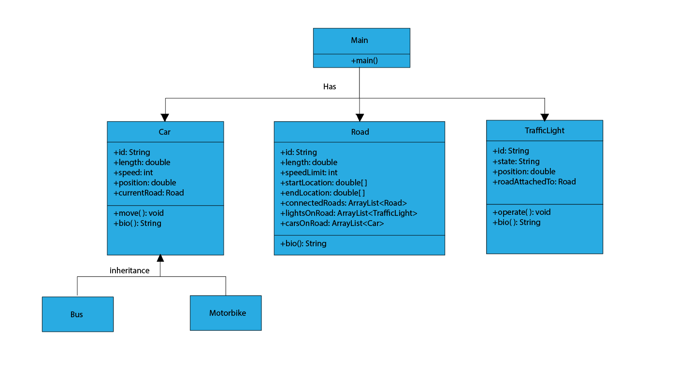

# **GitHub**

<https://github.com/jc578271/cp2406-assignment-1>

