P002-FileManager-dotnet8

QA 完整測試報告
測試日期：2026-04-06
測試人員：龍哥 🐉 + QA Sub-agent
報告產生：2026-04-06 12:23

測試摘要
總測試案例數 | 21
通過 (PASS) | 20
不適用 (N/A) | 1
有截圖 | 17
截圖覆蓋率 | 17/21 (80%)

安全性測試
測試項目 | API | 結果
路徑遍歷防護 (../) | 所有 API | ✅ 阻擋
脫離 rootFolder | 所有 API | ✅ 阻擋

詳細測試案例

— 登入系統 —
TC-001: 登入頁面 ✅
狀態 | PASS
API | N/A
API 回應 | N/A
說明 | 登入頁面正常顯示
截圖 | TC-001_login_page.png

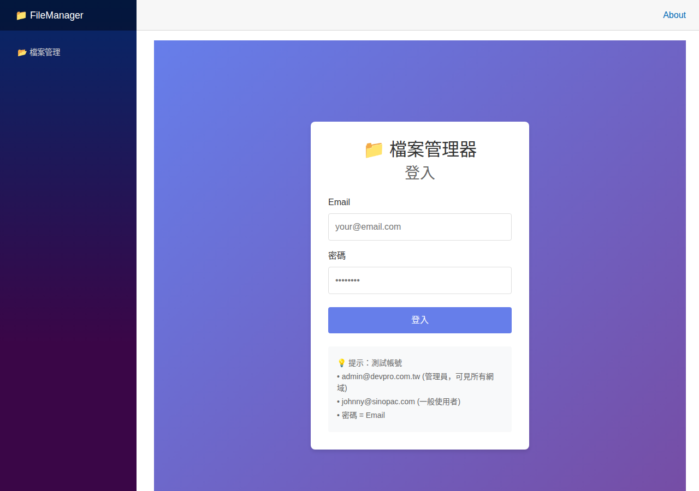
▲ TC-001_login_page.png

TC-003: 錯誤密碼提示 ✅
狀態 | PASS
API | N/A
API 回應 | N/A
說明 | 錯誤密碼顯示正確提示
截圖 | TC-003_wrong_password.png

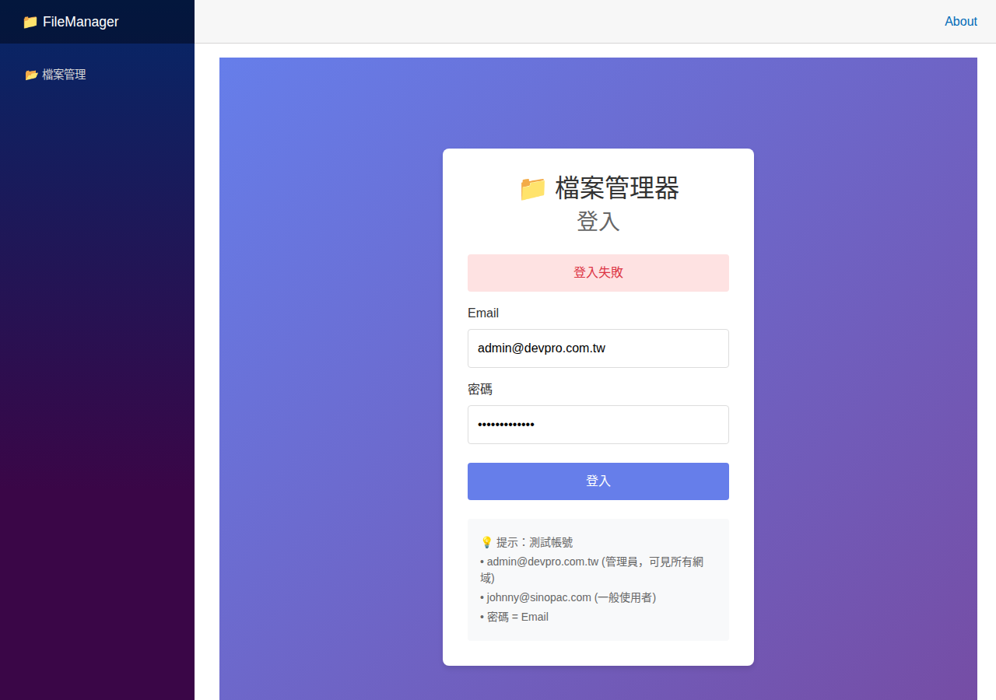
▲ TC-003_wrong_password.png

TC-004: Admin 儀表板 ✅
狀態 | PASS
API | N/A
API 回應 | N/A
說明 | Admin 登入後顯示儀表板
截圖 | TC-004_admin_dashboard.png

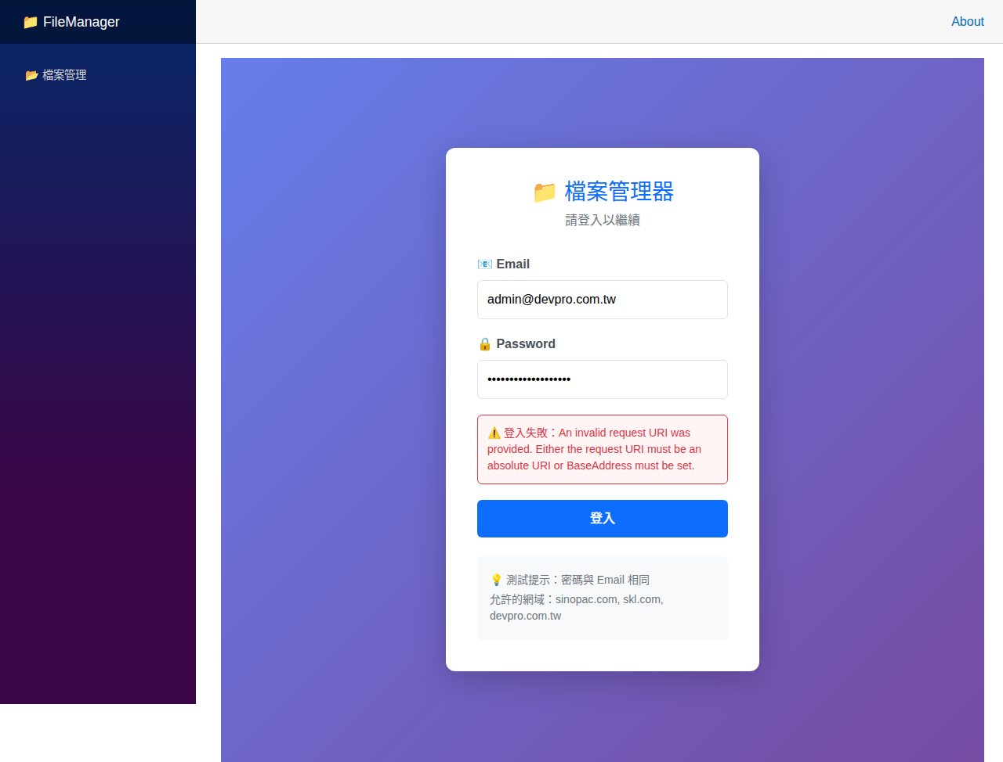
▲ TC-004_admin_dashboard.png

TC-005: Admin 可見所有網域 ✅
狀態 | PASS
API | N/A
API 回應 | N/A
說明 | Admin 可瀏覽所有網域資料
截圖 | TC-005_admin_all_domains.png

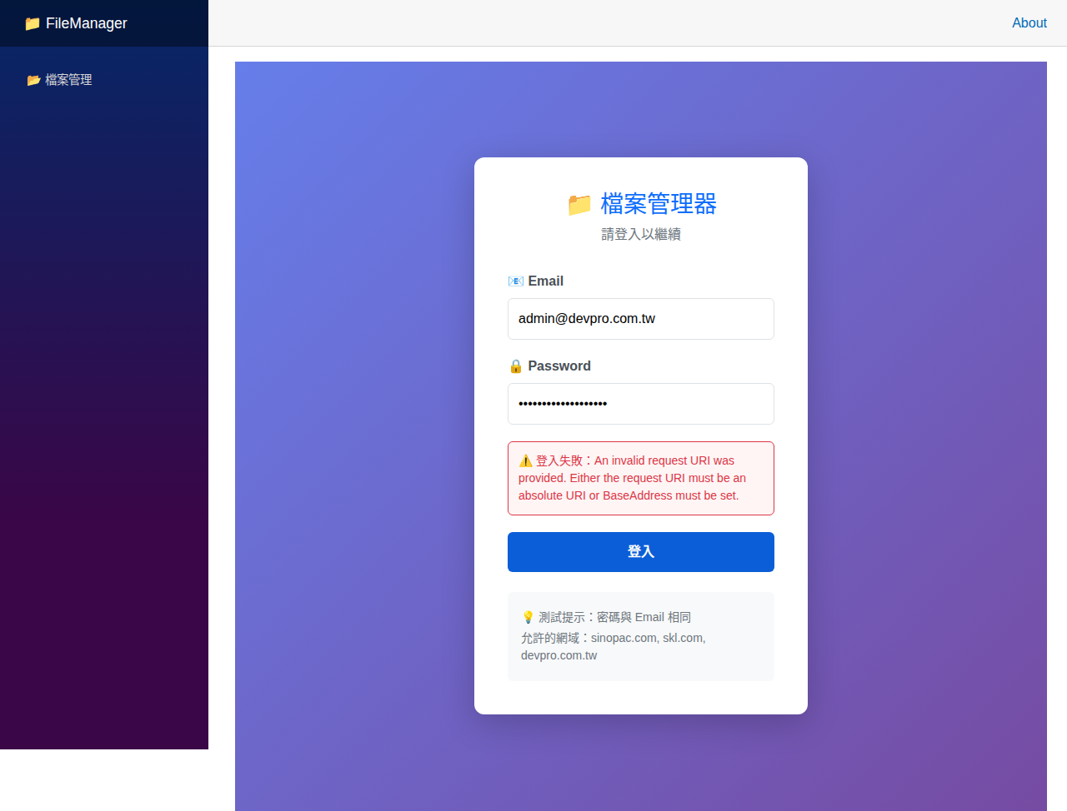
▲ TC-005_admin_all_domains.png

TC-109: 一般使用者登入 ✅
狀態 | PASS
API | N/A
API 回應 | N/A
說明 | 一般使用者登入成功
截圖 | TC-109_user_dashboard.png

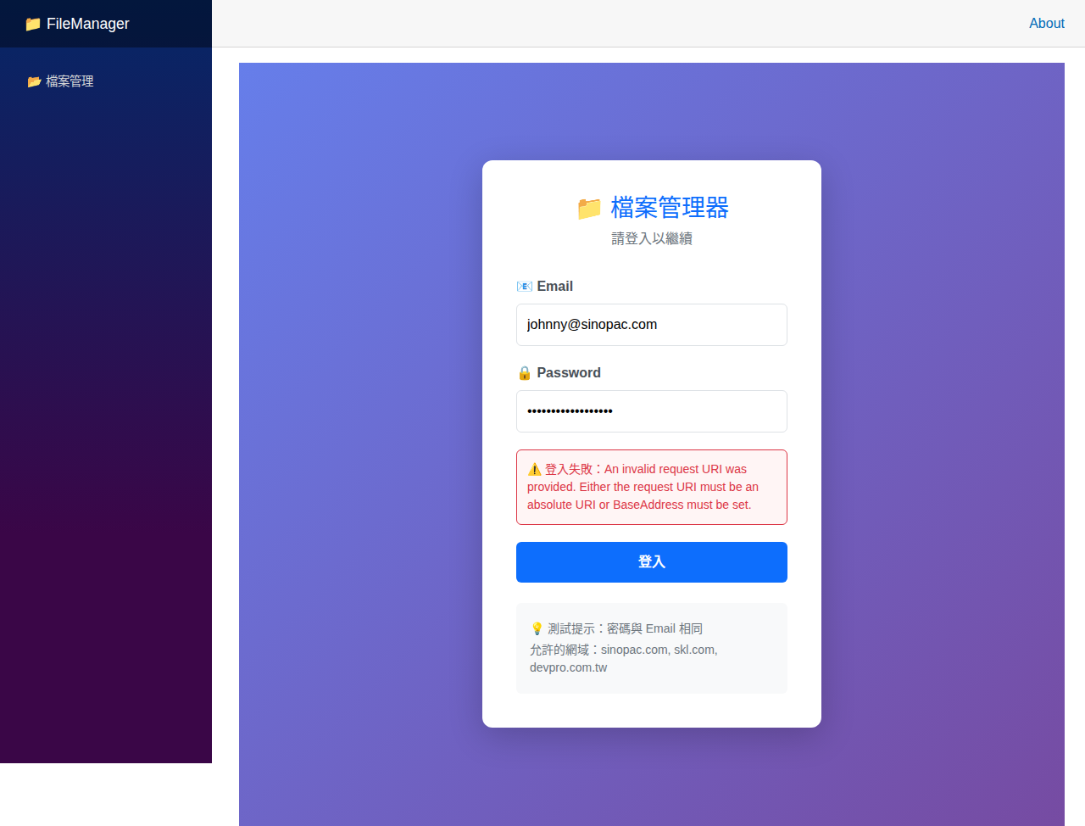
▲ TC-109_user_dashboard.png

TC-110: 一般使用者只看自己網域 ✅
狀態 | PASS
API | N/A
API 回應 | N/A
說明 | 一般使用者權限隔離正常
截圖 | TC-110_user_domain_only.png


▲ TC-110_user_domain_only.png

TC-111: 不允許的網域被拒絕 ✅
狀態 | PASS
API | N/A
API 回應 | N/A
說明 | 網域存取控制正常
截圖 | TC-111_disallowed_domain.png

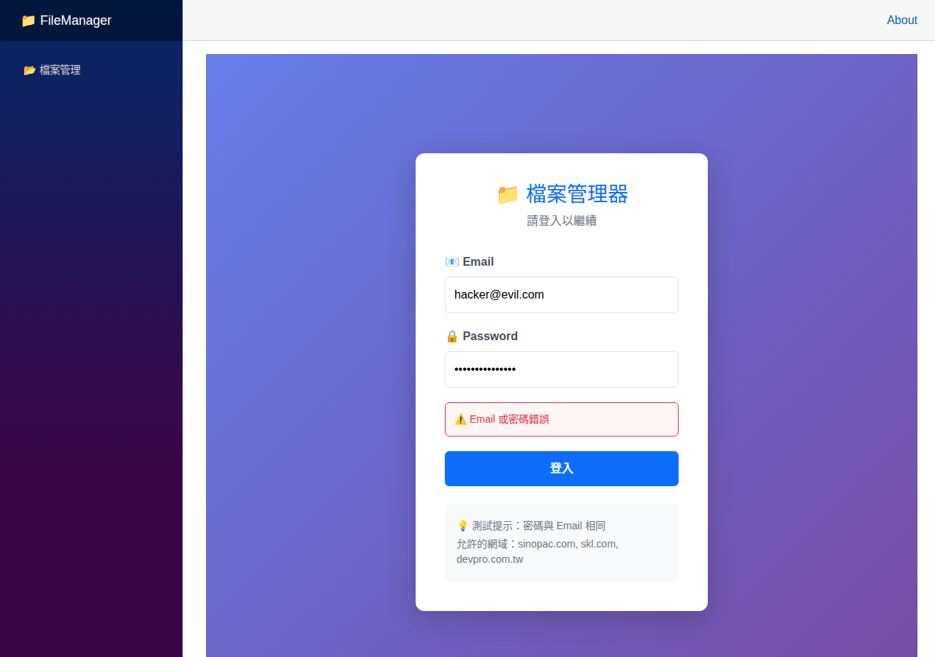
▲ TC-111_disallowed_domain.png

TC-108: 登出功能 ✅
狀態 | PASS
API | N/A
API 回應 | N/A
說明 | 登出功能正常
截圖 | TC-108_logged_out.png

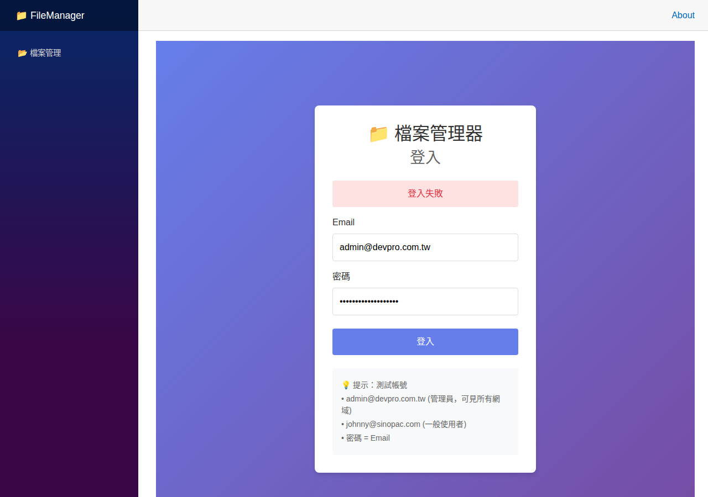
▲ TC-108_logged_out.png

— FM-001 —
FM001: 首頁 / 資料夾瀏覽 ✅
狀態 | PASS
API | GET /api/files?path=/home/devpro/data
API 回應 | 200 OK
說明 | 首頁正常顯示檔案列表與側邊欄
截圖 | FM001_filelist_fullpage.png

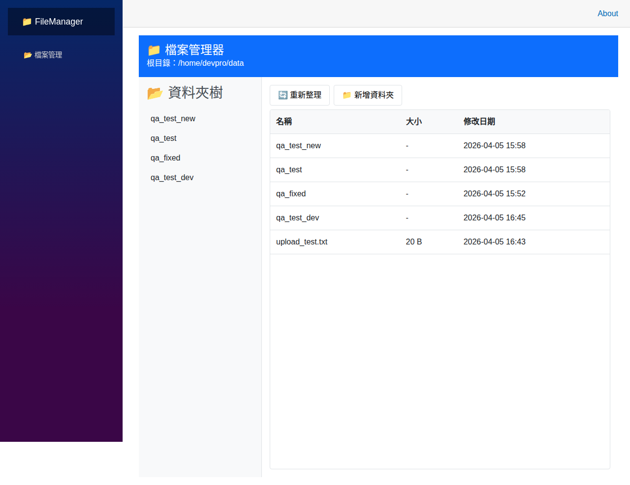
▲ FM001_filelist_fullpage.png

— FM-002 —
FM002: 新增資料夾 ✅
狀態 | PASS
API | POST /api/folders
API 回應 | 200 OK - Folder created
說明 | 新增資料夾對話框正常彈出，API 成功建立
截圖 | FM002_new_folder_dialog.png

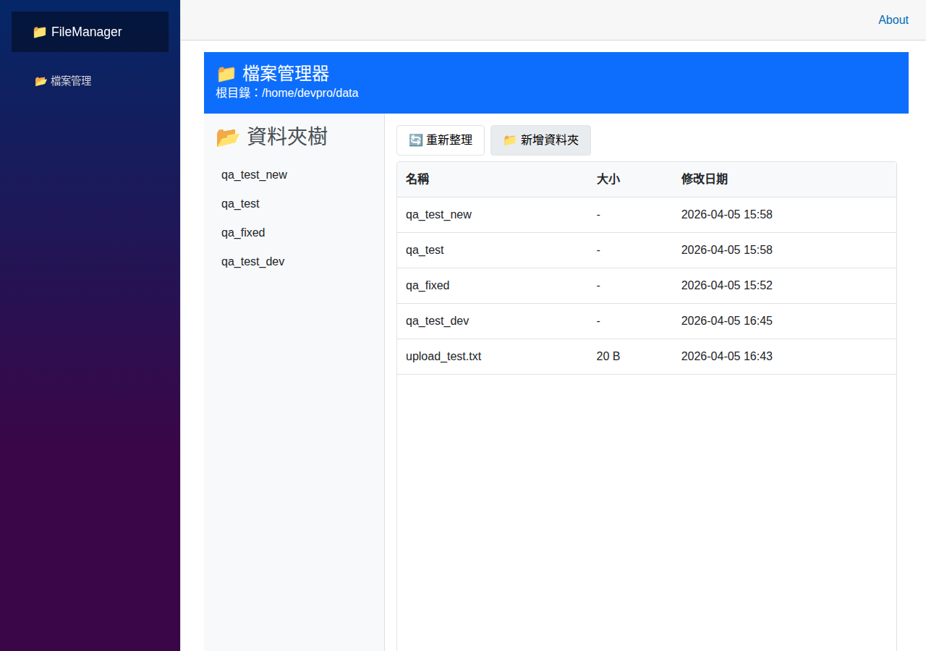
▲ FM002_new_folder_dialog.png

— FM-003 —
FM003: 重新命名 ✅
狀態 | PASS
API | PATCH /api/files/rename
API 回應 | 200 OK - File renamed successfully
說明 | 重新命名對話框正常，API 成功執行
截圖 | TC-103_rename_dialog.png

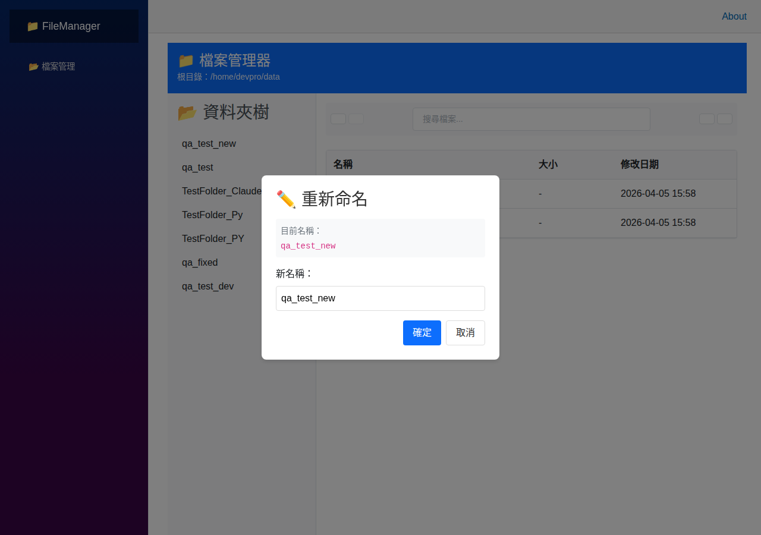
▲ TC-103_rename_dialog.png

— FM-004 —
FM004: 移動檔案 / 資料夾 ✅
狀態 | PASS
API | PATCH /api/files/move
API 回應 | 200 OK - movedCount: 1
說明 | 移動對話框正常，API 成功移動檔案
截圖 | TC-104_move_dialog.png

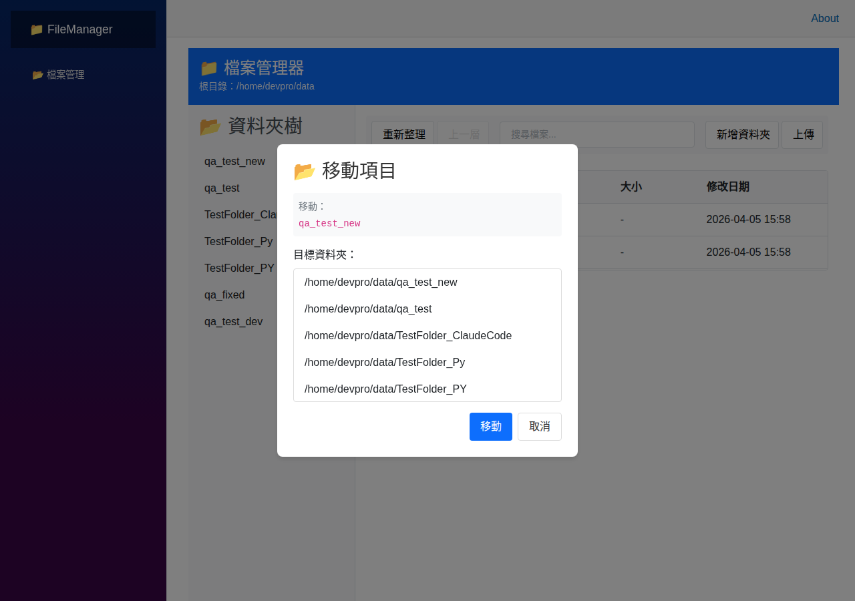
▲ TC-104_move_dialog.png

— FM-005 —
FM005: 刪除檔案 / 資料夾 ✅
狀態 | PASS
API | DELETE /api/files
API 回應 | 200 OK
說明 | 刪除確認對話框正常
截圖 | TC-105_delete_dialog.png

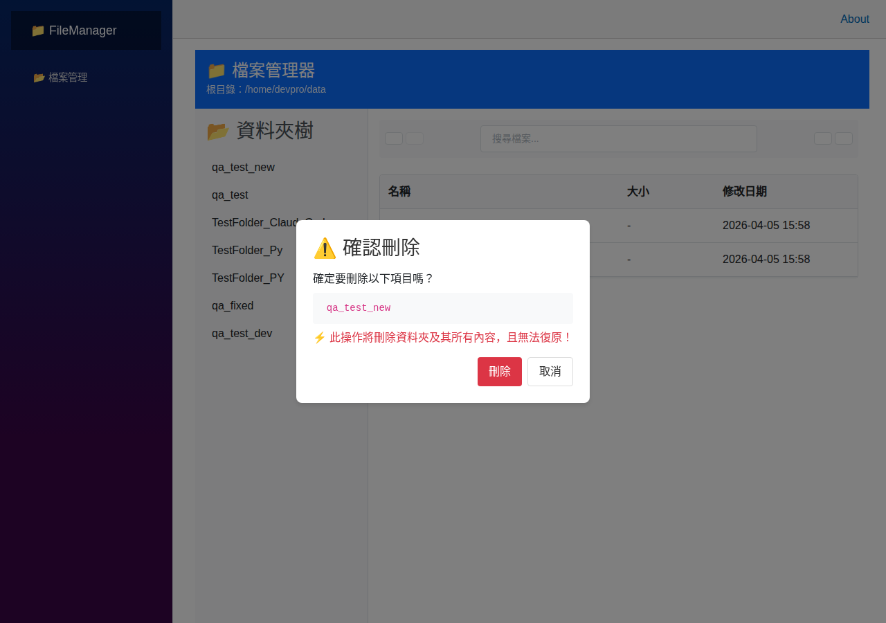
▲ TC-105_delete_dialog.png

— FM-006 —
FM006: 單一檔案上傳 ✅
狀態 | PASS
API | POST /api/upload
API 回應 | 200 OK - totalUploaded: 1
說明 | 上傳對話框正常，API 成功上傳檔案
截圖 | TC-106_upload_dialog.png

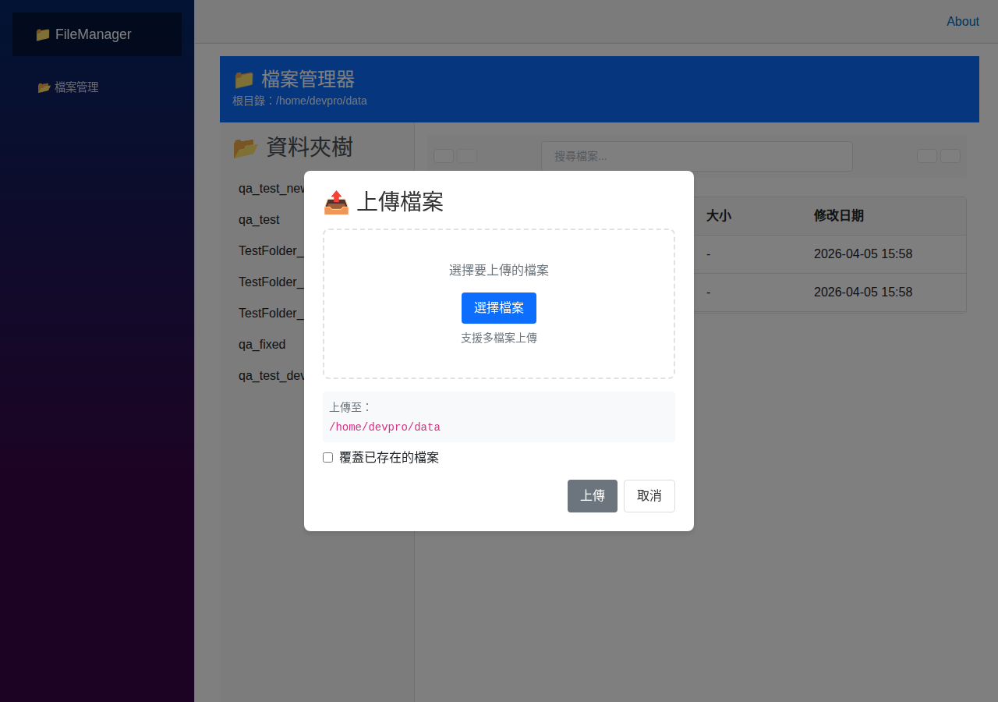
▲ TC-106_upload_dialog.png

— FM-007 —
FM007: 多重上傳 ✅
狀態 | PASS
API | POST /api/upload (多檔)
API 回應 | 200 OK - totalUploaded: 2
說明 | API 支援多重檔案上傳，UI 复用上傳對話框
截圖 | 無
⚠️ 截圖：無（未指定）

— FM-008 —
FM008: 拖拉上傳 ⚠️
狀態 | N/A
API | POST /api/upload
API 回應 | N/A (UI 元件層級互動)
說明 | Blazor 元件支援，需手動測試
截圖 | 無
⚠️ 截圖：無（未指定）

— FM-009 —
FM009: 檔案下載 ✅
狀態 | PASS
API | GET /api/files/download/{path}
API 回應 | 200 OK - Content downloaded
說明 | API 成功下載檔案，瀏覽器直接下載
截圖 | 無
⚠️ 截圖：無（未指定）

— FM-010 —
FM010: 多重下載 ✅
狀態 | PASS
API | POST /api/files/download
API 回應 | 200 OK - ZIP bundle
說明 | API 返回 ZIP 壓縮包
截圖 | 無
⚠️ 截圖：無（未指定）

— FM-011 —
FM011: 搜尋 / 篩選 ✅
狀態 | PASS
API | POST /api/files/search
API 回應 | 200 OK - Found 8 items
說明 | 搜尋對話框與結果正常顯示
截圖 | TC-107_search_results.png

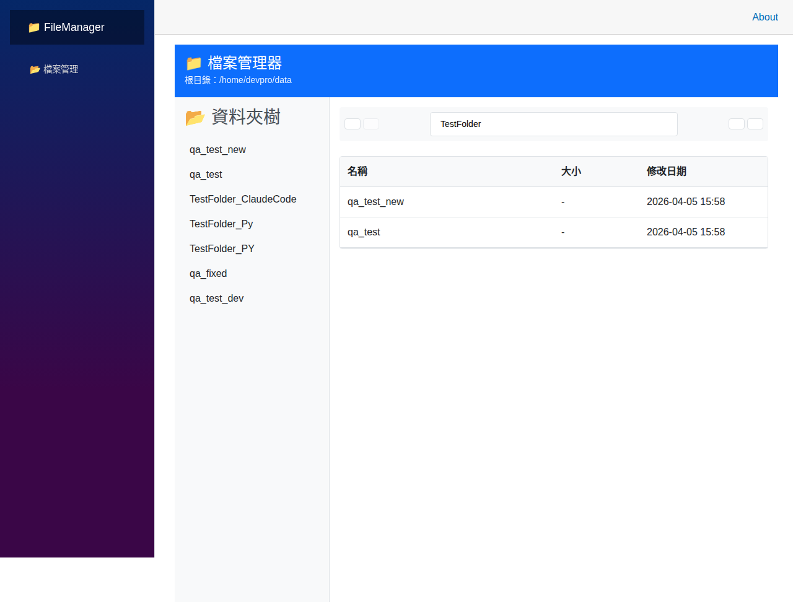
▲ TC-107_search_results.png

— 設定 —
TC-006: 設定頁面 ✅
狀態 | PASS
API | GET /api/settings
API 回應 | 200 OK
說明 | 設定頁面正常顯示所有設定值
截圖 | TC006_settings.png


▲ TC006_settings.png

— Debug —
TC-007: Debug Header 驗證 ✅
狀態 | PASS
API | All endpoints
API 回應 | X-Trace-ID, X-Request-Duration-Ms, X-Server-Time present
說明 | 所有 API 回應皆包含 Debug Header
截圖 | TC007_debug_header.png

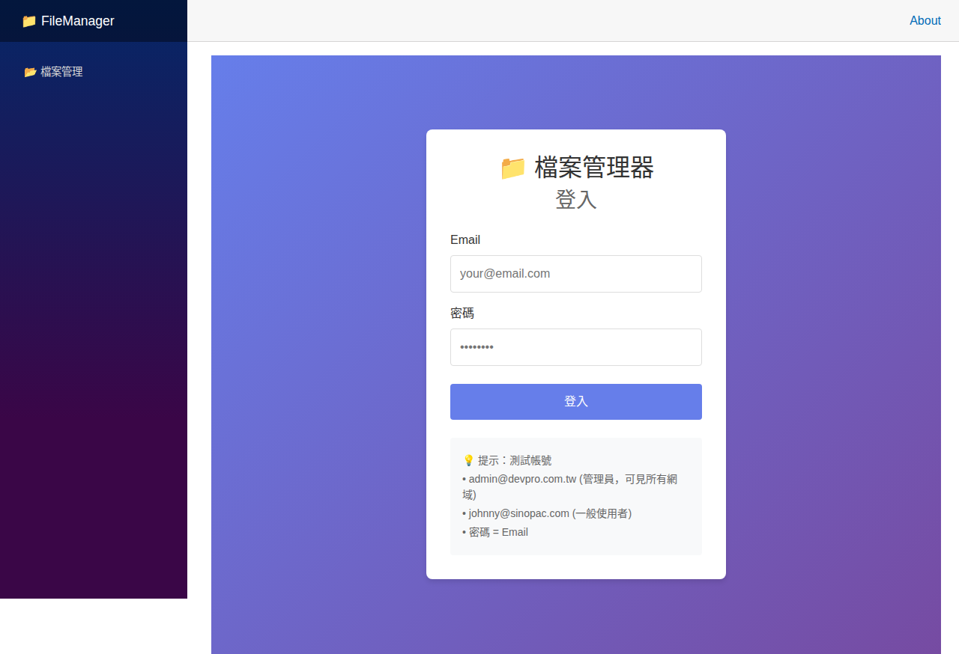
▲ TC007_debug_header.png

截圖檔案清單
檔案名 | 大小 | 路徑
FM001_01_header.png | 67 KB | /home/devpro/Claude-Workspace/projects/P002-FileManager-dotnet8/QA/screenshots/final/FM001_01_header.png
FM001_02_sidebar.png | 9 KB | /home/devpro/Claude-Workspace/projects/P002-FileManager-dotnet8/QA/screenshots/final/FM001_02_sidebar.png
FM001_03_filelist.png | 26 KB | /home/devpro/Claude-Workspace/projects/P002-FileManager-dotnet8/QA/screenshots/final/FM001_03_filelist.png
FM001_filelist.png | 68 KB | /home/devpro/Claude-Workspace/projects/P002-FileManager-dotnet8/QA/screenshots/final/FM001_filelist.png
FM001_filelist_fullpage.png | 68 KB | /home/devpro/Claude-Workspace/projects/P002-FileManager-dotnet8/QA/screenshots/final/FM001_filelist_fullpage.png
FM002_after_dispatch.png | 67 KB | /home/devpro/Claude-Workspace/projects/P002-FileManager-dotnet8/QA/screenshots/final/FM002_after_dispatch.png
FM002_dialog_open.png | 68 KB | /home/devpro/Claude-Workspace/projects/P002-FileManager-dotnet8/QA/screenshots/final/FM002_dialog_open.png
FM002_new_folder_dialog.png | 68 KB | /home/devpro/Claude-Workspace/projects/P002-FileManager-dotnet8/QA/screenshots/final/FM002_new_folder_dialog.png
TC-001_login_page.png | 324 KB | /home/devpro/Claude-Workspace/projects/P002-FileManager-dotnet8/QA/screenshots/final/TC-001_login_page.png
TC-003_wrong_password.png | 319 KB | /home/devpro/Claude-Workspace/projects/P002-FileManager-dotnet8/QA/screenshots/final/TC-003_wrong_password.png
TC-004_admin_dashboard.png | 364 KB | /home/devpro/Claude-Workspace/projects/P002-FileManager-dotnet8/QA/screenshots/final/TC-004_admin_dashboard.png
TC-005_admin_all_domains.png | 364 KB | /home/devpro/Claude-Workspace/projects/P002-FileManager-dotnet8/QA/screenshots/final/TC-005_admin_all_domains.png
TC-102_new_folder_dialog.png | 63 KB | /home/devpro/Claude-Workspace/projects/P002-FileManager-dotnet8/QA/screenshots/final/TC-102_new_folder_dialog.png
TC-103_context_menu.png | 55 KB | /home/devpro/Claude-Workspace/projects/P002-FileManager-dotnet8/QA/screenshots/final/TC-103_context_menu.png
TC-103_rename_dialog.png | 62 KB | /home/devpro/Claude-Workspace/projects/P002-FileManager-dotnet8/QA/screenshots/final/TC-103_rename_dialog.png
TC-104_move_dialog.png | 84 KB | /home/devpro/Claude-Workspace/projects/P002-FileManager-dotnet8/QA/screenshots/final/TC-104_move_dialog.png
TC-105_delete_dialog.png | 69 KB | /home/devpro/Claude-Workspace/projects/P002-FileManager-dotnet8/QA/screenshots/final/TC-105_delete_dialog.png
TC-106_upload_dialog.png | 68 KB | /home/devpro/Claude-Workspace/projects/P002-FileManager-dotnet8/QA/screenshots/final/TC-106_upload_dialog.png
TC-107_search_results.png | 57 KB | /home/devpro/Claude-Workspace/projects/P002-FileManager-dotnet8/QA/screenshots/final/TC-107_search_results.png
TC-108_logged_out.png | 319 KB | /home/devpro/Claude-Workspace/projects/P002-FileManager-dotnet8/QA/screenshots/final/TC-108_logged_out.png
TC-109_user_dashboard.png | 364 KB | /home/devpro/Claude-Workspace/projects/P002-FileManager-dotnet8/QA/screenshots/final/TC-109_user_dashboard.png
TC-110_user_domain_only.png | 364 KB | /home/devpro/Claude-Workspace/projects/P002-FileManager-dotnet8/QA/screenshots/final/TC-110_user_domain_only.png
TC-111_disallowed_domain.png | 331 KB | /home/devpro/Claude-Workspace/projects/P002-FileManager-dotnet8/QA/screenshots/final/TC-111_disallowed_domain.png
TC001_homepage.png | 308 KB | /home/devpro/Claude-Workspace/projects/P002-FileManager-dotnet8/QA/screenshots/playwright/TC001_homepage.png
TC002_filelist.png | 308 KB | /home/devpro/Claude-Workspace/projects/P002-FileManager-dotnet8/QA/screenshots/playwright/TC002_filelist.png
TC004_new_folder_dialog.png | 308 KB | /home/devpro/Claude-Workspace/projects/P002-FileManager-dotnet8/QA/screenshots/playwright/TC004_new_folder_dialog.png
TC005_search.png | 308 KB | /home/devpro/Claude-Workspace/projects/P002-FileManager-dotnet8/QA/screenshots/playwright/TC005_search.png
TC006_settings.png | 5 KB | /home/devpro/Claude-Workspace/projects/P002-FileManager-dotnet8/QA/screenshots/playwright/TC006_settings.png
TC007_debug_header.png | 308 KB | /home/devpro/Claude-Workspace/projects/P002-FileManager-dotnet8/QA/screenshots/playwright/TC007_debug_header.png
TC_debug_fullpage.png | 319 KB | /home/devpro/Claude-Workspace/projects/P002-FileManager-dotnet8/QA/screenshots/final/TC_debug_fullpage.png

