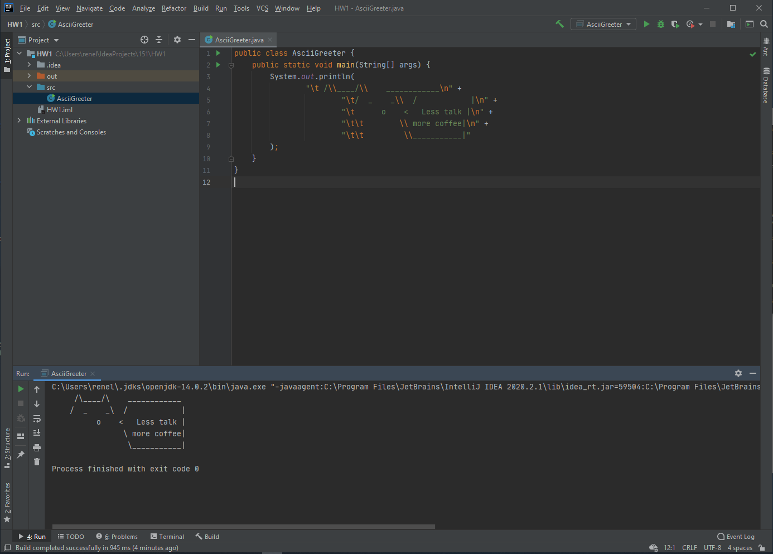

Repository link: https://github.com/jcal329/CS151-HW1