1. Install SQL Server Express

2. <https://www.microsoft.com/en-us/sql-server/sql-server-downloads>

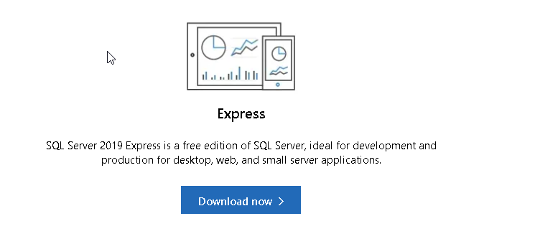

3. Make database , use SQL Server Management Studio : - <https://docs.microsoft.com/en-us/sql/ssms/download-sql-server-management-studio-ssms?view=sql-server-ver15>

4. C# Project