Reporting with R Markdown

John Camacho

2020-09-27

# Markdown Basics

## Favorite Foods

1.Steak 2.Pizza 3.Burrito

## Images

image: 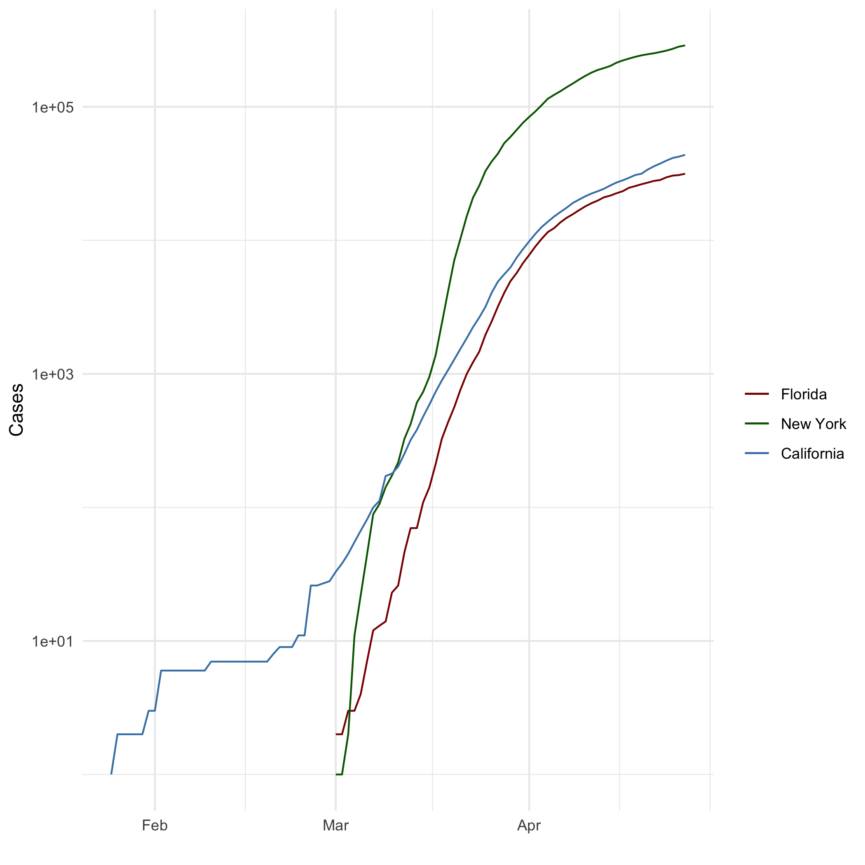

## Add a

“Whether you think you can, or you think you can’t – you’re right - Henry Ford

## Add an Equation

$$\sqrt{b^{2}−4ac}$$

## Add a Footnote

[^1:] Great Code

## Add Citations

“R Markdown has quickly become the preferred means of communicating results from R” [see ‘R for Everyone’, pp.427] “Many of the statistical procedure described in this book are parametric tests based on normal distributions” [see ‘Discovering Statistics Using R’, pp. 167]

# Inline Code

## NY Times COVID-19 Data

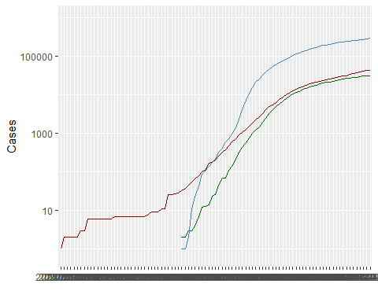

## R4DS Height vs Earnings

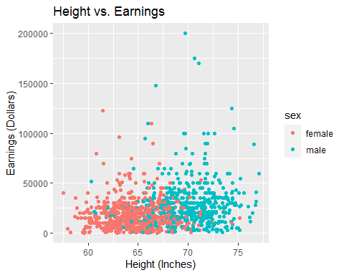 # Tables

## Knitr Table with Kable

One Ring to Rule Them All

|  |  |  |  |  |
| --- | --- | --- | --- | --- |
| name | race | in_fellowship | ring_bearer | age |
| Aragon | Men | TRUE | FALSE | 88 |
| Bilbo | Hobbit | FALSE | TRUE | 129 |
| Frodo | Hobbit | TRUE | TRUE | 51 |
| Galadriel | Elf | FALSE | FALSE | 7000 |
| Sam | Hobbit | TRUE | TRUE | 36 |
| Gandalf | Maia | TRUE | TRUE | 2019 |

## Pandoc Table

Name

Race

In Fellowship?

Is Ring Bearer?

Age

Argon

Bilbo

Frodo

Sam

Sauron

Men

Hobbit

Hobbit

Hobbit

Maia

Yes

No

Yes

Yes

No

No

Yes

Yes

Yes

Yes

88

129

51

36

7052

# References