Document ID: |  | Owner: | Document Type: | Language: | Version:
00000006 |  | OWNER | Procedure | EN | 0.1
Title: | RISK TREATMENT PROCEDURE

Status: | Name: | Function: | Date: | Signature:
Created | Aron Lange | The GRC Lab | 2024-04-08 | AL
Reviewed
Approved

REVISION HISTORY

Version | Date | Created by | Description of changes
0.1 | 2024-04-08 | Aron Lange | Initial draft

Table of Contents
1 PURPOSE 2
2 SCOPE 2
3 TERMS AND DEFINITIONS 2
4 RELATED DOCUMENTS 2
5 PROCEDURE 3
5.1 Select risk treatment options 4
5.2 Determine controls to implement risk treatment options 4
5.3 Compare selected controls with Annex A 4
5.4 Produce Statement of Applicability (SoA) 4
5.5 Formulate risk treatment plan 4
5.6 Communicate risk treatment plan 4
5.7 Implement risk treatment plan 4
5.8 Communicate results of risk treatment 5
5.9 Determine residual risk levels 5
5.10 Obtain acceptance for residual risks 5
5.11 Update risk register 5

PURPOSE

The purpose of this document is to define and describe the standardized processes of risk treatment within [Organization Name].

SCOPE

This procedure applies to all personnel within [Organization Name], who are involved in the management of risks.

TERMS AND DEFINITIONS

ISMS information security management system

RELATED DOCUMENTS

- ISO/IEC 27001:2022 – clause 6.1, 8.3
- Scope of the ISMS
- Project Plan – Step 7, 9
- Risk Assessment Process
- Risk Treatment Process
- Control Implementation Process

PROCEDURE
This procedure describes the activities of the Risk Treatment Process.

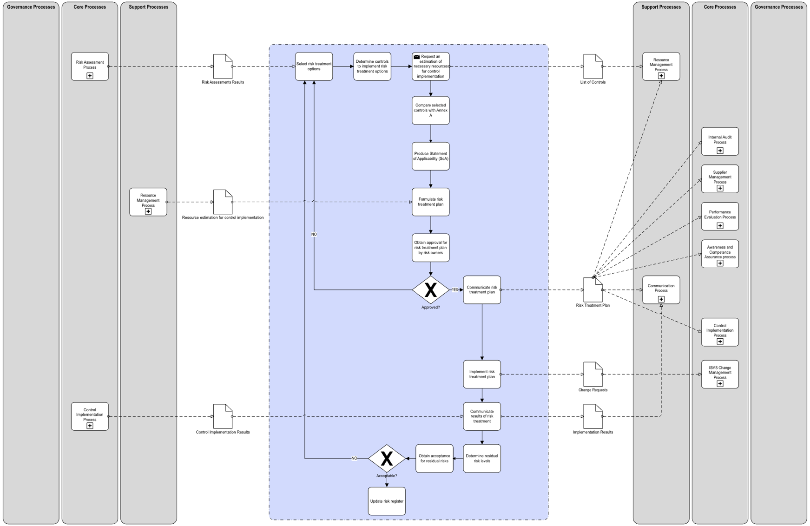

Select risk treatment options

The first step in risk treatment is to determine the possible options for treating each risk. There are typically four options:

- Risk Avoidance: Completely avoid the activities giving rise to the risk.
- Risk Reduction: Implement controls to reduce the likelihood or impact of the risk.
- Risk Transfer: Shift the risk to another party, such as through insurance.
- Risk Acceptance: Accept the risk and monitor it continuously.

For each risk, consider all these options and determine the most appropriate one based on the organization's risk tolerance and business objectives.

Determine controls to implement risk treatment options

For risks that are to be reduced, specific controls should be determined. These controls could be technical, organizational, legal, or a combination thereof. The objective of these controls is to reduce the risk to an acceptable level

Compare selected controls with Annex A

The controls identified should be compared with the controls listed in Annex A of ISO 27001. This ensures that all relevant controls are considered and nothing is overlooked. If any controls from Annex A are not applied, justification for their exclusion should be documented.

Produce Statement of Applicability (SoA)

The Statement of Applicability (SoA) is a key document that lists all the controls from Annex A and describes whether they are applicable and implemented or not. For each control, provide a justification for inclusion or exclusion and describe how the control is implemented.

Use the provided template to document the results of this activity.

Formulate risk treatment plan

The Risk Treatment Plan (RTP) outlines how the identified risks are to be treated. It includes information about the risk, the chosen treatment option, the controls to be implemented (if any), the expected outcomes, the resources required, and the timeline for implementation.

Communicate risk treatment plan

Upon implementation of the risk treatment plan, communicate the outcomes to all stakeholders. This includes detailing the effectiveness of the controls, any deviations from the plan, and lessons learned during the implementation phase.

Implement risk treatment plan

This stage involves the actual application of the risk treatment plan, including the deployment of specific controls and strategies to manage identified risks according to the outlined timelines and resource allocations.

Communicate results of risk treatment

Upon implementation of the risk treatment plan, communicate the outcomes to all stakeholders. This includes detailing the effectiveness of the controls, any deviations from the plan, and lessons learned during the implementation phase.

Determine residual risk levels

After the risk treatment measures have been applied, assess the remaining (residual) risk levels. This assessment should consider the efficacy of the controls and whether the residual risks are within the organization's risk acceptance criteria. Use the methodology described in the risk assessment procedure to determine the residual risk levels.

Obtain acceptance for residual risks
Present the residual risks to the risk owners for acceptance. This step involves making an informed decision on whether the remaining risk levels are acceptable or if further treatment is necessary.

Update risk register

Finally, update the risk register to reflect the current status of all risks following the treatment process. This includes documentation of the residual risks, any changes in risk levels, and the acceptance of residual risks by management. Regular updates ensure the risk register remains a relevant tool for ongoing risk management and decision-making.

