Original Trigger Box Code
  - Code review summary of the original M-Duino sketch, including intended behavior, missing documentation, and implementation risks.
Code file | M-Duino/ArduinoCode/M-Duino_Original/M-Duino_Original.ino
Document date | 2026-05-02
Focus | Explain what the original code appears to do and identify the main technical risks.
Important note | This document describes the original sketch, not the cleaned state-machine rewrite.

1. Why This Document Exists
The original trigger-box sketch is short, but that brevity hides several important assumptions. The file contains almost no comments, several variable names do not show their units, and at least two lines treat a boolean flag as if it were a hardware output pin. This document explains the original code in words so that colleagues can understand what it seems intended to do and why it is risky to use without review.

2. What the Original Code Appears to Do
The original sketch has two modes. When Mode is HIGH, it runs ConstSpark(), which repeatedly produces a spark pulse whenever Arm is active. When Mode is LOW, it runs HydrogenTest(), which appears intended to enforce an arming sequence, activate the hot-wire relays, fire the spark, issue a DAQ pulse, and then latch the system as fired until the operator resets it.
Although this intended sequence is visible by reading the code carefully, it is not written down anywhere in the original file. The next figure summarizes the expected behavior the code seems to be aiming for.

3. Expected Sequence from the Original Logic
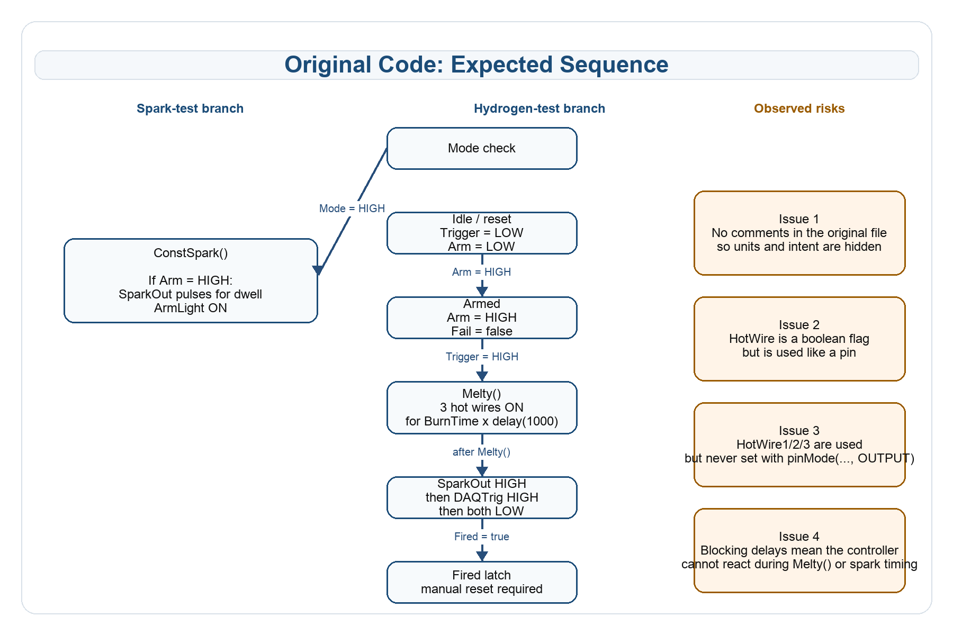
Figure 1. Expected sequence and major risks in the original sketch.

4. Missing Comments and Hidden Assumptions
- There are no top-level comments explaining the operating modes, safety assumptions, or intended firing sequence.
- Variables such as BurnTime, dwell, and Delay do not carry units in their names, so the reader must infer the units from delay() and delayMicroseconds().
- The code does not explain whether the inputs and outputs are active HIGH or active LOW.
- The code does not explain that the hot-wire outputs are assumed to drive relays or another external switching stage rather than the hot wire directly.
Because of these missing comments, different readers can misunderstand the same code in different ways. That is the main reason the cleaned rewrite adds comments, unit suffixes, and explicit state names.

5. Hidden Time Units in the Original Code
The original code works with mixed time scales, but the units are hidden. The M-Duino does not know the time unit from the number alone. It knows the time unit from the function the number is passed into.
Original variable | Current value | Effective unit | How the unit is inferred
BurnTime | 10 | seconds in practice | Used as the repeat count for delay(1000), so 10 x 1000 ms = 10 s.
dwell | 5000 | microseconds | Used in delayMicroseconds(dwell).
Delay | 600 | microseconds | Used in delayMicroseconds(Delay).
count | loop counter | no physical unit | Used only to count the BurnTime loop.

6. Main Technical Issues in the Original Sketch
Issue | Where it appears | Why it matters
Boolean used as pin | pinMode(HotWire, OUTPUT) and digitalWrite(HotWire, LOW) | HotWire is declared as a boolean flag, so this code is not controlling HotWire1/2/3 as intended.
Hot-wire outputs not configured | Melty() uses HotWire1/2/3 but setup() never calls pinMode() for them | Relay behavior may be unreliable because the outputs are not explicitly configured.
Blocking delays | Melty(), ConstSpark(), and the spark/DAQ timing block | The controller cannot check Arm or any abort condition while it is stuck inside these delays.
No explicit state machine | HydrogenTest() mixes Fail, Fired, Armed, and flag | It is hard to tell what the controller should do after unusual operator actions.
Repeated raw digitalRead calls | HydrogenTest() and loop() | The logic is harder to follow and there is no debounce handling.
Very limited serial output | loop() only prints raw input/state bits | The operator cannot directly see state transitions such as arming, melting, firing, or fail conditions.

7. Original Hydrogen-Test Logic in Words
- If both Trigger and Arm are LOW, the code clears Fired and Fail.
- If Trigger is HIGH while Arm is LOW, the code sets Fail = true.
- If Fail is false, Arm is HIGH, and Fired is false, the code sets Armed = true and turns on the ArmLight.
- If Trigger is then HIGH while Armed is true and Fired is false, the code enters the firing block.
- Inside the firing block, if HotWire is true, the code calls Melty(), which turns on the three hot-wire outputs for BurnTime cycles of delay(1000).
- After Melty(), the code turns SparkOut on, waits dwell - Delay microseconds, turns DAQTrig on, waits Delay microseconds, then turns both outputs off.
- The code sets Fired = true and then uses flag as an additional latch.
- After firing, the operator must release both Arm and Trigger to clear the Fired and Fail conditions.

8. Why the Original File Is Hard to Debug
The original file does not have named states such as IDLE, ARMED, MELTING, or FIRED. Instead, the operator has to infer the current situation from several booleans that interact with each other. This makes it hard to answer questions like: Did the sequence fail before arming? Is it currently in the hot-wire phase? Has it already fired once? Is it waiting for reset?
In addition, the serial output in the original sketch prints compact numeric values without describing transitions in words. That means the code may be running, but the operator still cannot easily see the sequence in real time.

9. Safety Concerns Specific to the Original Code
- There is no hardwired safety logic in software; the file assumes external protection exists.
- Because Melty() blocks for the full hot-wire duration, the code cannot react to Arm being released during that period.
- The original file contains no clear documentation of safe reset conditions or mode-change behavior.
- The hot-wire relay control is mixed up with a boolean flag, which is especially dangerous in a hardware-control file because it can create false confidence about what output is being driven.

10. Practical Reading of the Original File
The original sketch should be read as a first working prototype rather than a finished control program. It captures the intended test sequence in a compact form, but it leaves too much hidden in the implementation. For collaboration, safety review, and commissioning, the code benefits from explicit comments, visible units, deliberate debug output, and a clearer state structure.

11. Short Summary
The original code appears intended to run a valid trigger-box sequence, but it contains missing comments, hidden units, blocking timing, and at least one major pin/boolean mix-up. The code can therefore be understood as a prototype of the desired sequence, but not as a well-documented or low-risk final implementation.

