A first review over a 9-year period, 2009-2017, for launched Kickstarter campaigns, we can see that Kickstarter campaigns have an overall 53% successful rating. This leaves a 46% canceled or failed, and 1% live, or in progress, rating. What might be some ways to ensure your campaign is in the 53% instead of the 46%?



One might ponder, the more launched Kickstarter campaigns a category or sub-category might have could lead to a higher success rating. We can see in the data that sub-category plays make up 26% of the overall sub-categories. Further breaking down plays, they have a 65% successful rating, 33% failed rating, and 2% of their campaigns are still in progress. Interesting enough, when we look at sub-category’s hardware, metal, nonfiction, or ratio & podcast, they all have a 100% successful rating and combined, make up a total of 6% of the overall sub-categories. We can conclude, from the data, that launching more Kickstarter campaigns, per sub-category, does not necessary give you a higher successful rating.

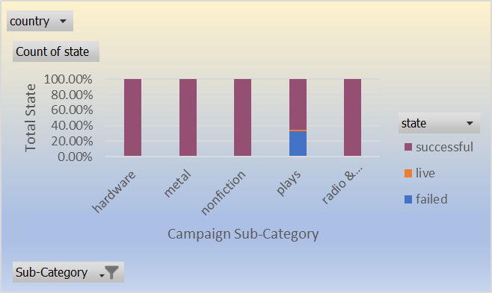

Now let’s consider when, during the year, you may want to launch your Kickstarter campaign, and if that could help improve your successful rating. When we review the data over the 9 years, we are going to consider the total successful rating and the lowest failure rating per month. Because these two outcomes are so closely correlated, it is good to look at the overall percentage of the two, to really understand if you have a higher chance of being successful in achieving the monetary goal. It appears that May has the highest successful per launched campaign rating totaling 61%, and has a 33% failure rating. The lowest overall failure rating totaling 30% is February. February also has a 57% successful rating. This data is telling us during both months you have an equal chance of having the best successful outcome and the least failure outcome.



Some things to consider are some holes in the data we are reviewing. Some unanswered questions are: What did these campaigns use for pledged incentives, if any? What is the amount of involvement each campaign staff had in total of each campaign? How much social media presence did they have? Did they hit the correct target market? All things that can set apart one campaign from another campaign.

We focused more on the state of the campaign, launched date, categories, and sub-categories. We could have also used a pie chart and looked at the correlation on the state of the campaign per staff pick, to see if that had any effect on successful rating or failure rating. Also, we could have further studied the time between the launched date and the deadline, using a scatter chart, and seen if that played any effect on the successful rating or failure rating.

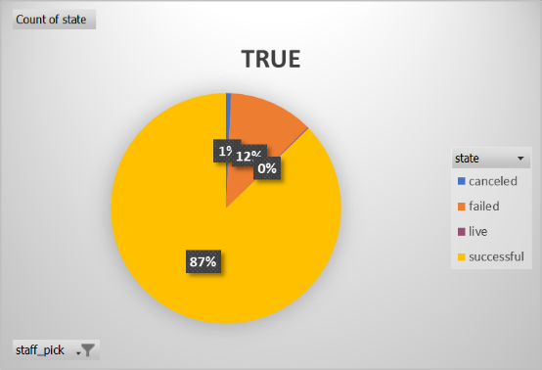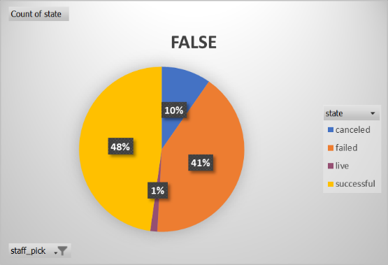

Just remember, this data is only one tool to help drive to the most successful campaign you can have. We can look at the data in many different ways to gather the different outcomes. But in reality, it is on you to have the best outcome overall. I wish you the best of luck on your Kickstarter campaign journey.