**Setup and Compilation**

1. Download and unzip the submission from eLearning on a Linux box in the multi-platform lab.
2. The submission includes:
   * Index.html
   * Img.jpg
   * testPresence.html
   * makefile
   * httpserver.hpp
   * httpserver.cpp
   * actionhandler.hpp
   * actionhandler.cpp
   * main.cpp
   * README.pdf
3. Environment: The program has been tested in Linux Virtual Machine, UWF SSH server (puTTY)
4. Compiling: Program include a Makefile for all the dependencies to run the program. In the command line in Linux, type “make main” to create executable files, including main.

Running the program: The submission comes with index.html, testPresence.html, img.jpg. Type “./main.” Firefox web browser in the Linux Virtual Machine was utilized to run client side.

UserInput: Type in “localhost:60012” before pressing enter to open index.html page. There will be two available links that the user can click. One will redirect to testPresence.html, and another to fake.html which is the 404 error page.

Output: Output for the program will resemble the following screen shots.

Compiling and running program: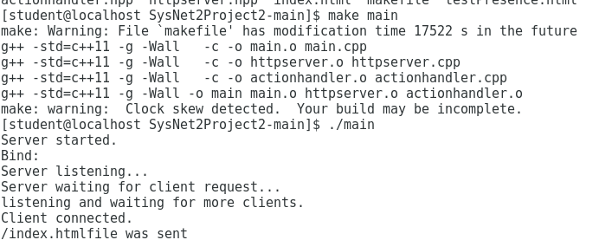

Index.html:

testPresence.html:



fake.html:



Test client after server shutdown:

