Software Requirements Specification

## for

UML Editor

## Version 1.0

## Prepared by Miller, Smirga, Card, Helms, Tinder, MISSING NO

# **Team++**

## 2/11/2014

# **Revision History**

|  |  |  |  |
| --- | --- | --- | --- |
| **Name** | **Date** | **Reason For Changes** | **Version** |
| TEAM++ | 11-Feb-2014 | Initial Writeup | 1.0 |
|  |  |  |  |
|  |  |  |  |
|  |  |  |  |

# **1. Introduction**

## 1.1 Purpose

To design and implement a program that can create UML diagrams.

## 1.2 References

Team git repository - <https://github.com/nateener/teamPlusPlus>

# **2. Overall Description**

## 2.1 Product Functions

User will be able to create and edit UML diagrams through a drag and drop interface. They will be able to create blocks that contain content (nodes) and links that describe their relation to other nodes (associations).

## 2.2 User Classes and Characteristics

We will consider only one general user.

## 2.3 Operating Environment

The program will operate on current versions of Linux and Windows.

## 2.4 Design and Implementation Constraints

Use curly braces even on 1 line statements:

if(this)

{

do(that);

}

**NOT**

if(this)

do(that);

Use pre-increment instead of post-increment:

++i

## 2.5 User Documentation

## 2.6 Assumptions and Dependencies

# **3. External Interface Requirements**

## 3.1 User Interfaces

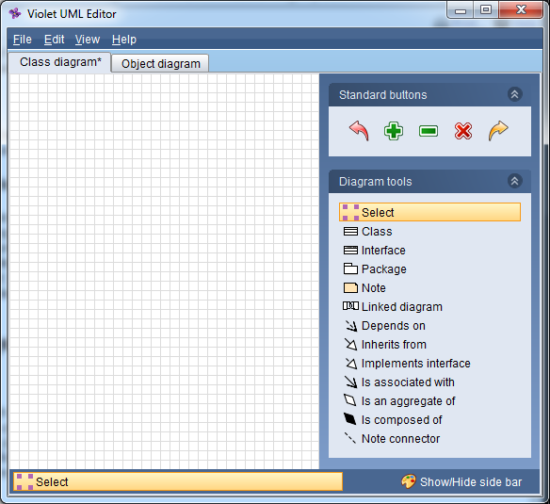

## 3.2 Software Interfaces

# **4. System Features**

## 4.1 Create New Diagram

As a user I want to create a new UML diagram.

## 4.2 Open an Existing Diagram from File

As a user I want to open a UML diagram from a file.

Save a Diagram required.

## 4.3 Save a Diagram

As a user I want to save a diagram to a file.

## 4.4 Close Program

As a user I want to close the program.

Opening the program required.

## 

## 4.5 Add a Node

As a user I want to add a node to the diagram

Node is being defined as any object on the graph that contains information or data inputted by the user.

## 4.6 Add an Association

As a user I want add an association between nodes.

Association is being defined as any object that is connecting one node to another node, or showing a recursive relationship on itself.

## 4.7 Delete an Object

As a user I want to delete a node or association.

## 4.8 Select an Object

As a user I want to select an object for further action (delete, move, etc.).

## 4.9 Move a Selected Object

As a user I want to move an object I’ve selected on the graph.

Selecting an object is required.

## 4.10 Edit Object Properties

As a user I want to edit the properties of an object, including labels and data.

# **5. Other Nonfunctional Requirements**

## 5.1 Software Quality Attributes

## 5.2 Deserving of an A