4D2A Information Management.
A Database of Superheroes and Supervillians.
Jack Cassidy 14320816.

Description
I have chosen to model the comic book world of superheroes and supervillians for my database project, encompassing the Marvel and DC universes. With the constant sci-fi related chaos going on in New York City, this database would benefit the NYPD as they could document all of the information they know about superheroes and supervillians so they can better understand what is going on.

The database has nine tables in total, after normalization.
- SuperPerson – Details concerning superheroes/villians
  - SuperID, Alias, True First Name, True Surname, Universe, Disposition (Good or Evil), HideoutID and NemesisID
- Sidekick – Details concerning and of the superhero/villians sidekicks
  - SidekickID, Sidekick Real Name and MentorID
- Powers (N) – A normalised table mapping superheros/villians to their powers
  - SuperID, Power
- OriginStory – The story of how each superhero/villian became super
  - StoryID, StoryDescription and SuperID
- Hideout – Details of the lairs each superhero/villian hides out in
  - HideoutID, HideoutName and AddressCity
- Equipment – Details of the various equipment used by each superhero/villian
  - SerialNumber, EquipmentName, Cost, OwnerID
- Disaster – Documented events that involve superheroes/villians
  - EventID, DamageCost, NumberCivilianCasualties, EventDate
- HeroDisaster (N) – A normalised table of Disasters prevented by superheroes
  - EventID, HeroID
- VillianDisaster (N) – A normalised table of Disasters caused by supervillians
  - EventID, VillianID

Entity Relationship Diagram
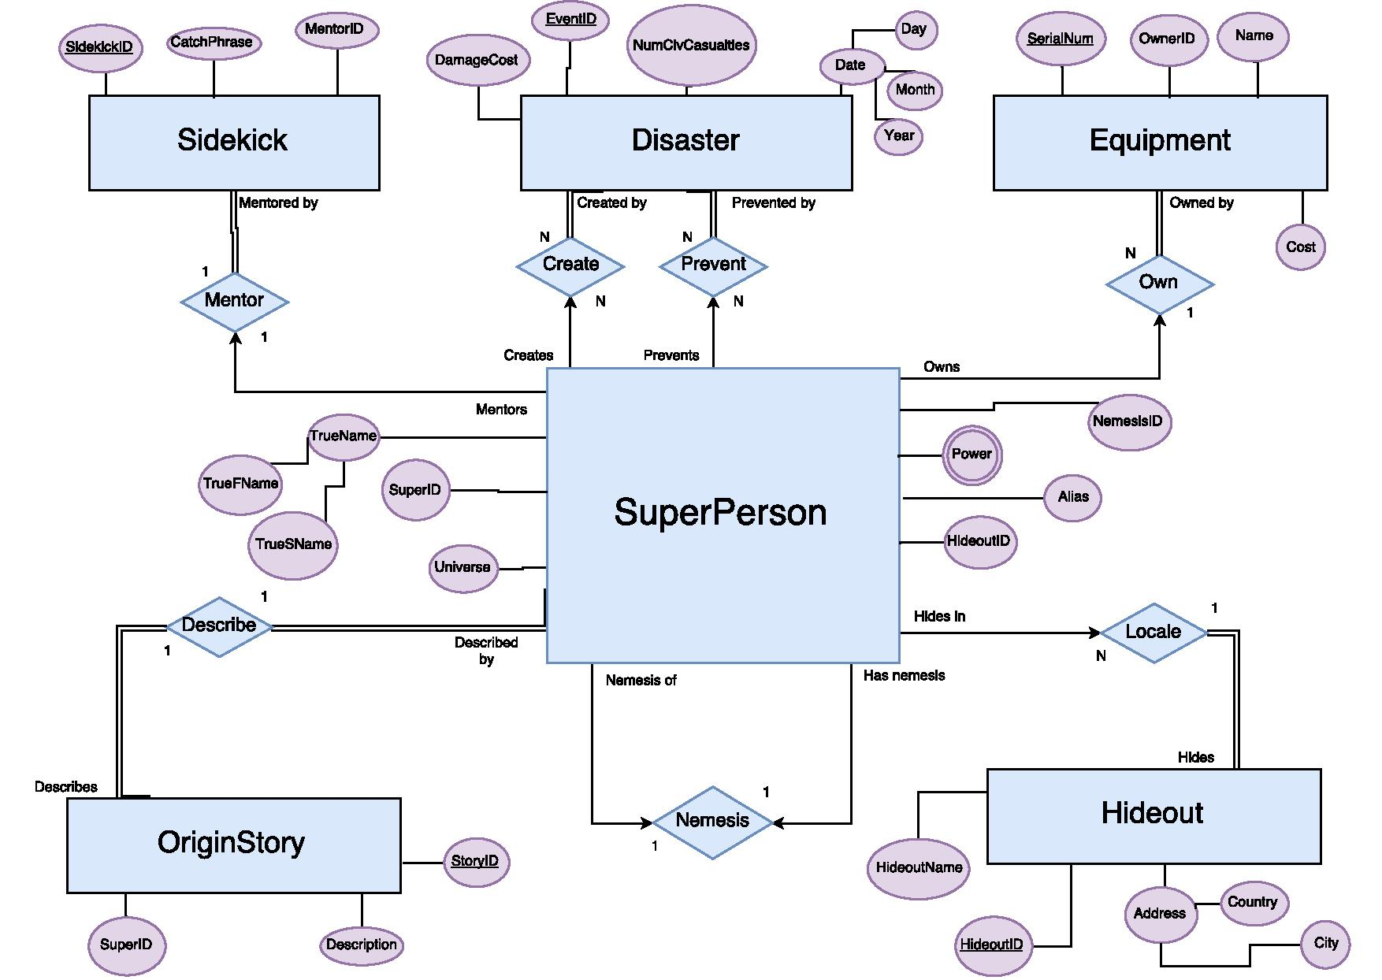

Relational Schema
Primary Keys underlined, Foreign Keys in italics
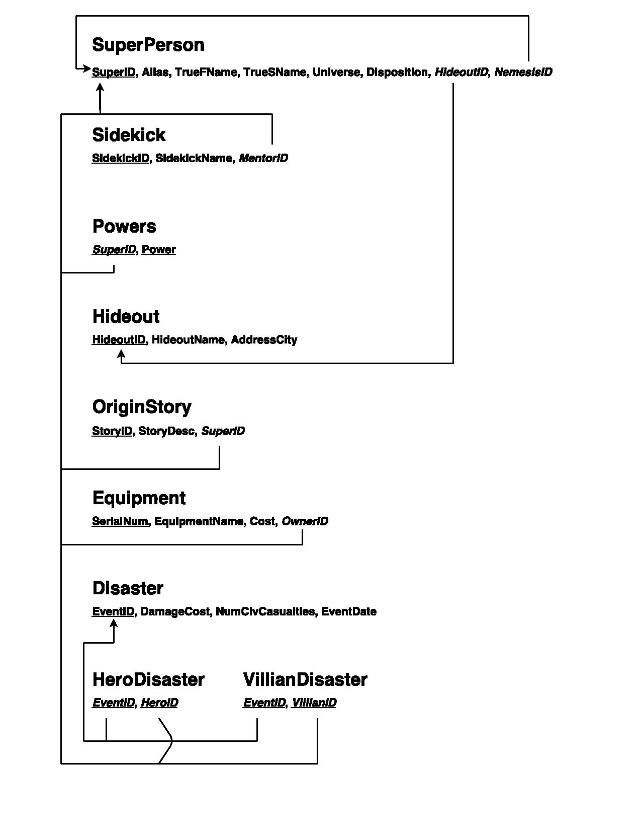

Functional Dependencies
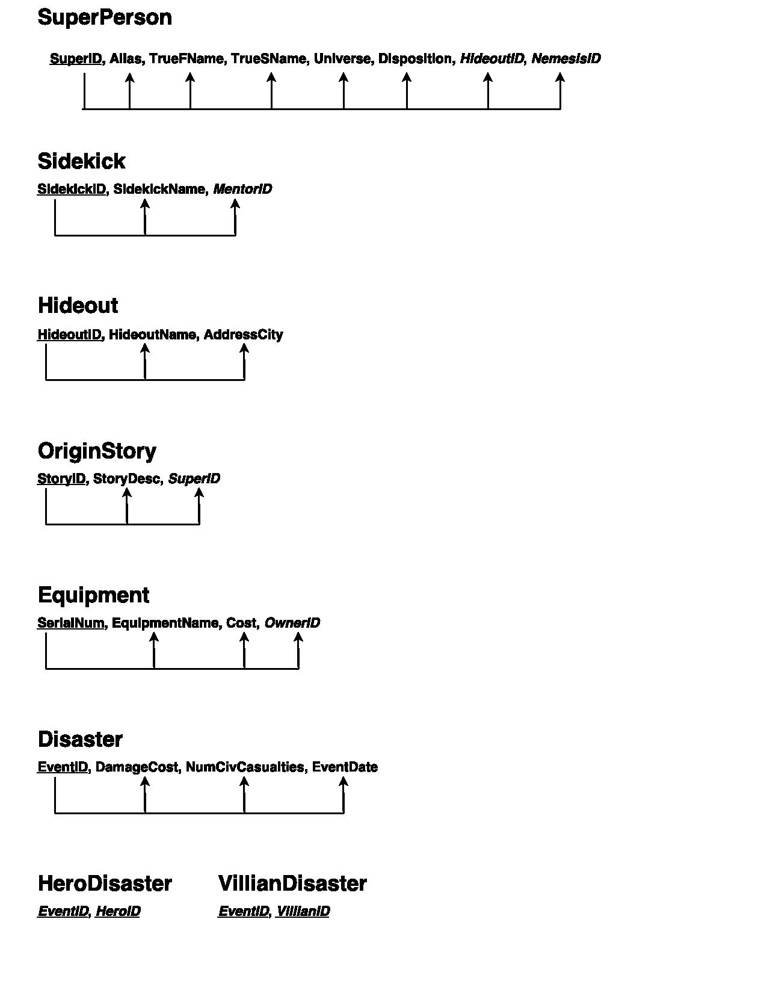

Constraints
Every Primary Key in the database is constrained to not null, in accordance with the definition of a primary key. In cases where there was total participation between two entities in a specific relationship, the foreign key associated with that relationship was also constrained to not null. Conversely, where there was not total participation in a relationship, the foreign key was not constrained to not null. Two examples of these scenarios, respectively:
Sidekick(MentorID) references SuperPerson(SuperID) and it has been defined that a Sidekick requires a Mentor. SuperPerson(HideoutID) references Hideout(HideoutID), but a SuperPerson has been defined to not require a Hideout.
There are two semantic constraint on the SuperPerson tables. SuperPerson(Universe) must be either ‘Marvel’ or ‘DC’ and SuperPerson(Disposition) must be ‘GOOD’ or ‘EVIL.’

Database Security
There are many aspects of this database where security and privacy are important. Depending on who is accessing the database, the True Names and Hideout Locations of each SuperPerson should remain hidden. Hence, a group called PoliceForce has been created as they are a likely group that might be accessing this database. They have been restricted to selecting on a specific view of the SuperPeople table, called SuperPrivacy. SuperPrivacy restricts the PoliceForce to seeing the SuperID, Alias, Universe, Disposition and NemesisID columns. In addition, the police should be able to document Disasters, hence they are granted select, insert and update priveledges on Disaster, HeroDisaster and VillianDisaster.
Some SuperHeroes have allies that handle their Equipment for them, such as Lucius Fox for Batman. Hence LuciusFox has been given his own group and can insert and update on Equipment.

View Creation and Joins
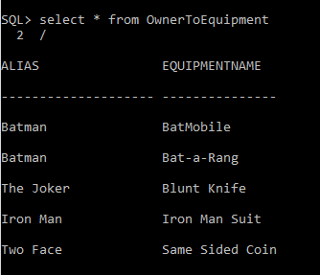
As mentioned above, a view was created to restrict access to sensitive data on the SuperPerson table, called SuperPrivacy. This is a very simple view that does span multiple tables. An OwnerToEquipment view was created to provide an easier lookup of which SuperPerson owns what Equipment, as it can be tiresome translating ID’s to Names across multiple tables. This makes use of a join across the SuperPerson and Equipment tables.
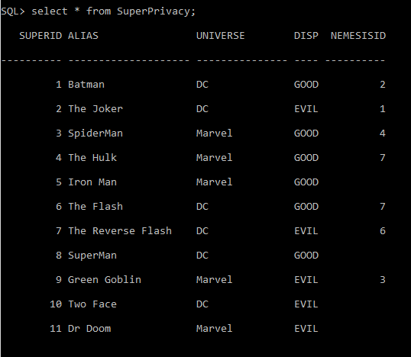

Triggers and Updates
When a user, such as police officer records a disaster in either the HeroDisaster or VillianDisaster tables, they may erronously enter a VillianID into HeroDisaster and vice-versa, hence two triggers were created on an insert into HeroDisaster or VillianDisaster. The trigger ensures that the SuperID being inserted corresponds to the correct ‘GOOD’ or ‘EVIL’ Disposition in the SuperPerson tables. This could not be implemented in a check constraint as checks do not allow referencing information in tables outside of the one to which the check is being inserted. This trigger makes use of PLSQL variables.
On each foreign key constraint, the ‘On Delete Cascade’ or ‘On Delete Set Null’ options were specified, which act as a pseudo trigger. If a row with a primary key that is referenced by a foreign key is deleted, On Cascade will delete the row with the referencing foreign key, and Set Null will set the foreign key attribute to null.
I wrote a script to provide a novel example of using the Update command. ‘The Avengers’ are an alliance of several Marvel superheroes. They reside in Avengers Tower in Manhattan. The update-hideout script updates the HideoutID attribute of every Marvel Superhero in the SuperPerson table to reference the HideoutID of Avengers Tower in the Hideout Table.

Appendix
I wrote several sql scripts to automate the building and rebuilding of the database. They are detailed below.

create-tables.sql
drop table SuperPerson;
create table SuperPerson (
SuperID number(9) not null,
Alias varchar2(20) not null,
TrueFName varchar2(15),
TrueSName varchar2(15),
Universe varchar2(15) constraint CK_Universe check(Universe in ('DC', 'Marvel')),
Disposition varchar2(4) constraint CK_Disposition check(Disposition in ('GOOD', 'EVIL', null)),
HideoutID number(9),
NemesisID number(9),
constraint PK_SuperPerson primary key(SuperID)
);

drop table Sidekick;
create table Sidekick(
SidekickID number(9) not null,
SidekickName varchar(15) not null,
MentorID number(9) not null,
constraint PK_Sidekick primary key(SidekickID)
);

drop table Powers;
create table Powers(
SuperID number(9) not null,
Power varchar2(15) not null,
constraint PK_Powers primary key(SuperID, Power)
);

drop table OriginStory;
create table OriginStory(
StoryID number(9) not null,
StoryDesc varchar2(500),
SuperID number(9) not null,
constraint PK_OriginStory primary key(StoryID)
);

drop table Hideout;
create table Hideout(
HideoutID number(9) not null,
HideoutName varchar(20),
AddressCity varchar(15),
constraint PK_Hideout primary key(HideoutID)
);

drop table Equipment;
create table Equipment(
SerialNum number(9) not null,
EquipmentName varchar2(15) not null,
Cost number(9),
OwnerID number(9) not NULL,
constraint PK_Equipment primary key(SerialNum)
);
drop table Disaster;
create table Disaster(
EventID number(9) not null,
DamageCost number(9),
NumCivCasualties number(9),
EventDate date,
constraint PK_Disaster primary key(EventID)
);

drop table HeroDisaster;
create table HeroDisaster(
EventID number(9) not null,
HeroID number(9) not null,
constraint PK_HeroDisaster primary key(EventID, HeroID)
);

drop table VillianDisaster;
create table VillianDisaster(
EventID number(9) not null,
VillianID number(9) not null,
constraint PK_VillianDisaster primary key(EventID, VillianID)
);

create-views.sql
------ View that hides the Super's real names and their hideouts -----
create view SuperPrivacy as
select SuperPerson.SuperID, SuperPerson.Alias, SuperPerson.Universe,
SuperPerson.Disposition, SuperPerson.NemesisID
from SuperPerson
/
------ View that shows who owns what -----
create view OwnerToEquipment as
select SuperPerson.Alias, Equipment.EquipmentName
from SuperPerson
inner join Equipment
on SuperPerson.SuperID = Equipment.OwnerID
/

create-constraints.sql
-- Add Foreign Key Constraints to all Tables

-------- Super Person --------
alter table SuperPerson
add constraint FK_HideoutID foreign key(HideoutID)
references Hideout(HideoutID)
on delete set null;

alter table SuperPerson
add constraint FK_NemesisID foreign key(NemesisID)
references SuperPerson(SuperID)
on delete set null;

-------- Sidekick --------
alter table Sidekick
add constraint FK_MentorID foreign key(MentorID)
references SuperPerson(SuperID)
on delete cascade;

-------- Power --------
alter table Powers
add constraint FK_PowersSuperID foreign key(SuperID)
references SuperPerson(SuperID)
on delete cascade;

-------- Origin Story --------
alter table OriginStory
add constraint FK_OriginStorySuperID foreign key(SuperID)
references SuperPerson(SuperID)
on delete cascade;

-------- Equipment --------
alter table Equipment
add constraint FK_OwnerID foreign key(OwnerID)
references SuperPerson(SuperID)
on delete cascade;

-------- Disasters --------
alter table HeroDisaster
add constraint FK_HeroID foreign key(HeroID)
references SuperPerson(SuperID)
on delete cascade;

alter table HeroDisaster
add constraint FK_HeroEventID foreign key(EventID)
references Disaster(EventID)
on delete cascade;

alter table VillianDisaster
add constraint FK_VillianID foreign key(VillianID)
references SuperPerson(SuperID)
on delete cascade;

alter table VillianDisaster
add constraint FK_VillianEventID foreign key(EventID)
references Disaster(EventID)
on delete cascade;

remove-constraints.sql
alter table SuperPerson
drop constraint FK_HideoutID;

alter table SuperPerson
drop constraint FK_NemesisID;

alter table Sidekick
drop constraint FK_MentorID;

alter table Powers
drop constraint FK_PowersSuperID;

alter table HeroDisaster
drop constraint FK_HeroID;

alter table HeroDisaster
drop constraint FK_HeroEventID;

alter table VillianDisaster
drop constraint FK_VillianID;

alter table VillianDisaster
drop constraint FK_VillianEventID;

alter table Equipment
drop constraint FK_OwnerID;

alter table OriginStory
drop constraint FK_OriginStorySuperID;

populate-tables.sql
----- SuperPerson -----
insert into SuperPerson values(1, 'Batman', 'Bruce', 'Wayne', 'DC', 'GOOD', 1, 2);
insert into SuperPerson values(2, 'The Joker', null, null, 'DC', 'EVIL', null, 1);
insert into SuperPerson values(3, 'SpiderMan', 'Peter', 'Parker', 'Marvel', 'GOOD', 2, 4);
insert into SuperPerson values(4, 'The Hulk', 'Bruce', 'Banner', 'Marvel', 'GOOD', null, 7);
insert into SuperPerson values(5, 'Iron Man', 'Tony', 'Stark', 'Marvel', 'GOOD', 3, null);
insert into SuperPerson values(6, 'The Flash', 'Barry', 'Allen', 'DC', 'GOOD', 6, 7);
insert into SuperPerson values(7, 'The Reverse Flash', 'Eobard', 'Thawne', 'DC', 'EVIL', null, 6);
insert into SuperPerson values(8, 'SuperMan', 'Clark', 'Kent', 'DC', 'GOOD', 5, null);
insert into SuperPerson values(9, 'Green Goblin', 'Harry', 'Osbourne', 'Marvel', 'EVIL', 3, 3);
insert into SuperPerson values(10, 'Two Face', 'Harvey', 'Dent', 'DC', 'EVIL', 1, null);
insert into SuperPerson values(11, 'Dr Doom', 'Victor', 'Von Doom', 'Marvel', 'EVIL', null, null);

----- Sidekick -----
insert into Sidekick values(1, 'Robyn', 1);
insert into Sidekick values(2, 'Rick Jones', 4);
insert into Sidekick values(3, 'Harley Quinn', 2);
insert into Sidekick values(4, 'War Machine', 5);
insert into Sidekick values(5, 'Krypto', 7);

----- Powers ------
insert into Powers values(1, 'Wealth');
insert into Powers values(1, 'Genius');
insert into Powers values(3, 'Strength');
insert into Powers values(3 ,'Wall Climbing');
insert into Powers values(4 , 'Strength');
insert into Powers values(4, 'Genius');
insert into Powers values(5, 'Wealth');
insert into Powers values(5, 'Genius');
insert into Powers values(6, 'Speed');

------ Origin Story -----
insert into OriginStory values(
1,
'As a young boy, Bruce Wayne was horrified and traumatized when
he watched his parents, the physician Dr. Thomas Wayne and his wife Martha, murdered with a gun
by a mugger named Joe Chill.',
1
);
insert into OriginStory values(
2,
'Though a number of backstories have been given, a definitive one has not yet been established
for the Joker. An unreliable narrator, the character is uncertain of who he was before and how
he became the Joker',
2
);
insert into OriginStory values(
3,
'One evening Parker attended a public exhibition demonstrating the safe handling of nuclear
laboratory waste materials sponcored by the General Techtronics Corporation.
During the demonstration, a small Common House Spider happened to be in the path of a particle
accelerators beam and was massively irradiated. The stricken spider fell on to Parkers hand,
broke his skin with its fangs, and died.',
3
);
insert into OriginStory values(
4,
'Supervising the trial of an experimental gamma bomb that he designed for the U.S. Defense
Department at a nuclear research facility in New Mexico, Bruce selflessly rushed to the rescue
of an Rick Jones who had wandered onto the testing field as the countdown ticked
inexorably toward zero. Bruce was struck full-force by the bomb blast. He survived, but was
irradiated by the deadly gamma energy.',
4
);
insert into OriginStory values(
5,
'Superman is born Kal-El on the alien planet Krypton. His parents, Jor-El and Lara become
aware of Kryptons impending destruction and Jor-El constructs a spacecraft to carry
Kal-El to Earth. During Kryptons last moments, Jor-El places Kal-El in the spacecraft.
Jor-El and Lara die as the spacecraft barely escapes Kryptons fate.',
7
);

----- Hideout -----
insert into Hideout values(1, 'The Bat Cave', 'Gotham');
insert into Hideout values(2, 'Aunt Mays House', 'New York City');
insert into Hideout values(3, 'Osbourne Manor', 'New York City');
insert into Hideout values(4, 'Stark Mansion', 'Malibu');
insert into Hideout values(5, 'Xaviers School', 'Westchester');
insert into Hideout values(6, 'Flashs Apartment', 'Central City');
insert into Hideout values(7, 'Hulkbuster Base', 'New Mexico');
insert into Hideout values(8, 'Fortress of Solidtude', null)

----- Equipment -----
insert into Equipment values(123456789, 'Bat-a-Rang', 500, 1);
insert into Equipment values(234567891, 'Same Sided Coin', 1, 10);
insert into Equipment values(345678912, 'Blunt Knife', 2.50, 2);
insert into Equipment values(456789123, 'Iron Man Suit', 7000000, 5);
insert into Equipment values(567891234, 'BatMobile', 9000000, 1);

----- Disaster -----
insert into Disaster values(1, 10000, 10, '08-JUN-1995');
insert into Disaster values(2, 500000, 0, '23-DEC-1992');
insert into Disaster values(3, 32452, 3, '12-DEC-1990');
insert into Disaster values(4, 78324, 21, '30-APR-1999');
insert into Disaster values(5, 7821634, 0,'06-FEB-1997');

----- Hero Disaster -----
insert into HeroDisaster values(1, 1);
insert into HeroDisaster values(2, 5);
insert into HeroDisaster values(3, 6);
insert into HeroDisaster values(4, 3);
insert into HeroDisaster values(5, 1);

----- Villian Disaster -----
insert into VillianDisaster values(1, 2);
insert into VillianDisaster values(2, 11);
insert into VillianDisaster values(3, 7);
insert into VillianDisaster values(4, 9);
insert into VillianDisaster values(5, 10);

view-tables.sql
select * from SuperPerson;
select * from Sidekick;
select * from Powers;
select * from OriginStory;
select * from Hideout;
select * from Equipment;
select * from Disaster;
select * from HeroDisaster;
select * from VillianDisaster;

security-rules.sql
grant select on SuperPrivacy to PoliceForce;
grant select, insert, update on Disaster to PoliceForce;
grant select, insert, update on HeroDisaster to PoliceForce;
grant select, insert, update on VillianDisaster to PoliceForce;
grant insert, update on Equipment to LuciusFox;

update-marvel-hideout.sql
----- Move all Marvel heroes to Avenger's Tower -----
update SuperPerson
set HideoutID = 8
where Universe = 'Marvel' and Disposition = 'GOOD';

create-triggers.sql
----- Prevent association of a Heroic Deed with a Villian -----
create or replace trigger Check_HeroDisposition
before insert on HeroDisaster
for each row
declare
V_Disposition varchar2(15);
begin
select Disposition
into V_Disposition
from SuperPerson
where SuperPerson.SuperID = :new.HeroID;

if V_Disposition != 'GOOD' then
raise_application_error(-20001, 'Tried to put a villian in the HeroDisaster table');
end if;
end;
/

----- Prevent association of a Villianous Deed with a Hero -----
create or replace trigger Check_VillianDisposition
before insert on VillianDisaster
for each row
declare
V_Disposition varchar2(15);
begin
select Disposition
into V_Disposition
from SuperPerson
where SuperPerson.SuperID = :new.VillianID;

if V_Disposition != 'EVIL' then
raise_application_error(-20001, 'Tried to put a hero in the VillianDisaster table');
end if;
end;
/

