**Dictionary.java**

Implements the Trie data structure explained below in the way it is explained below

**SpellChecker.java**

Reads in the user input (a text file to spell check or a string) and parses out the words from it. Each word is checked in the dictionary and if the word is not found, it is printed out as being misspelled.

After the input has been parsed, the program prints out the total number of misspellings.

**large.txt**

This file is the dictionary with one word per line that Dictionary.java reads to use when checking if words are spelled correctly

“DICTIONARIES.” *Gwicks.net*. <http://www.gwicks.net/dictionaries.htm> Accessed Dec 6, 2016

**Major Data Structure**: Trie (a type of tree)

Each node is an array of length 27 (to represent a-z and apostrophe)

Each element has a Boolean data value that indicates if a word following the path to get to that node/element is in the dictionary or not

Each element has a pointer to another node

Suppose the trie contained the word “cart” and “coral”, it would look like this

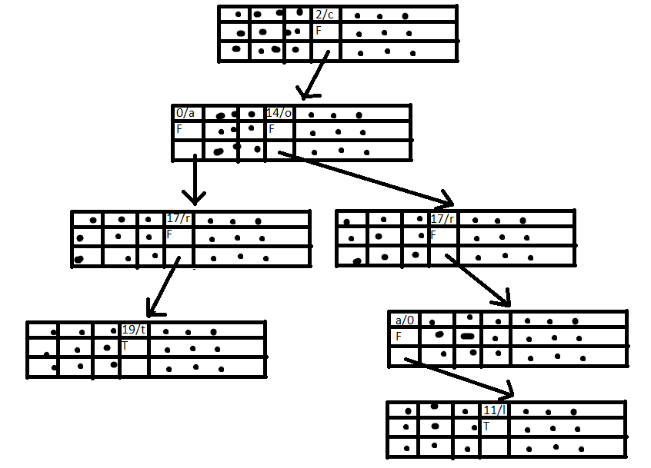

If the program checked if coral was in the dictionary, it would go to index 2 of the first node, find that there is another character in the keyword and a next pointer at index 2 and move to that. Then the program would go to index 14 of the newly selected node and move to that element’s next node repeating until it reaches the last character in the keyword (‘l’) where instead of looking for the next node, it would look at the Boolean data value and find that it was true, showing that the word is in the dictionary. Suppose the keyword checked was “cora”. The program would follow the path to the 0 index of the node 4th node in the path (4th row of nodes in the picture on the right) and find that the Boolean data value was true showing that the word is not in the dictionary.

**Sample Output**

Below is the sample output when the following is inputted through a text file: Tacos are tasty. Refrigerator. Computor Computor Computor. I liek chocolate milk.

Would you like to input a File or a String?

file

Enter file path:

src/resources/input2.txt

Mispelled words:

Computor

Computor

Computor

liek

Number of mispelled words: 4