

Make - Canon
Model - Canon PowerShot A80
Orientation - Top left
XResolution - 180
YResolution - 180
ResolutionUnit - Inch
DateTime - 2007:10:04 14:23:15
YCbCrPositioning - Centered
ExifOffset - 196
ExposureTime - 1/60 seconds
FNumber - 2.80
ExifVersion - 0220
DateTimeOriginal - 2007:10:04 14:23:15
DateTimeDigitized - 2007:10:04 14:23:15
ComponentsConfiguration - YCbCr
CompressedBitsPerPixel - 5 (bits/pixel)
ShutterSpeedValue - 1/60 seconds
ApertureValue - F 2.80
ExposureBiasValue - 0.00
MaxApertureValue - F 2.80

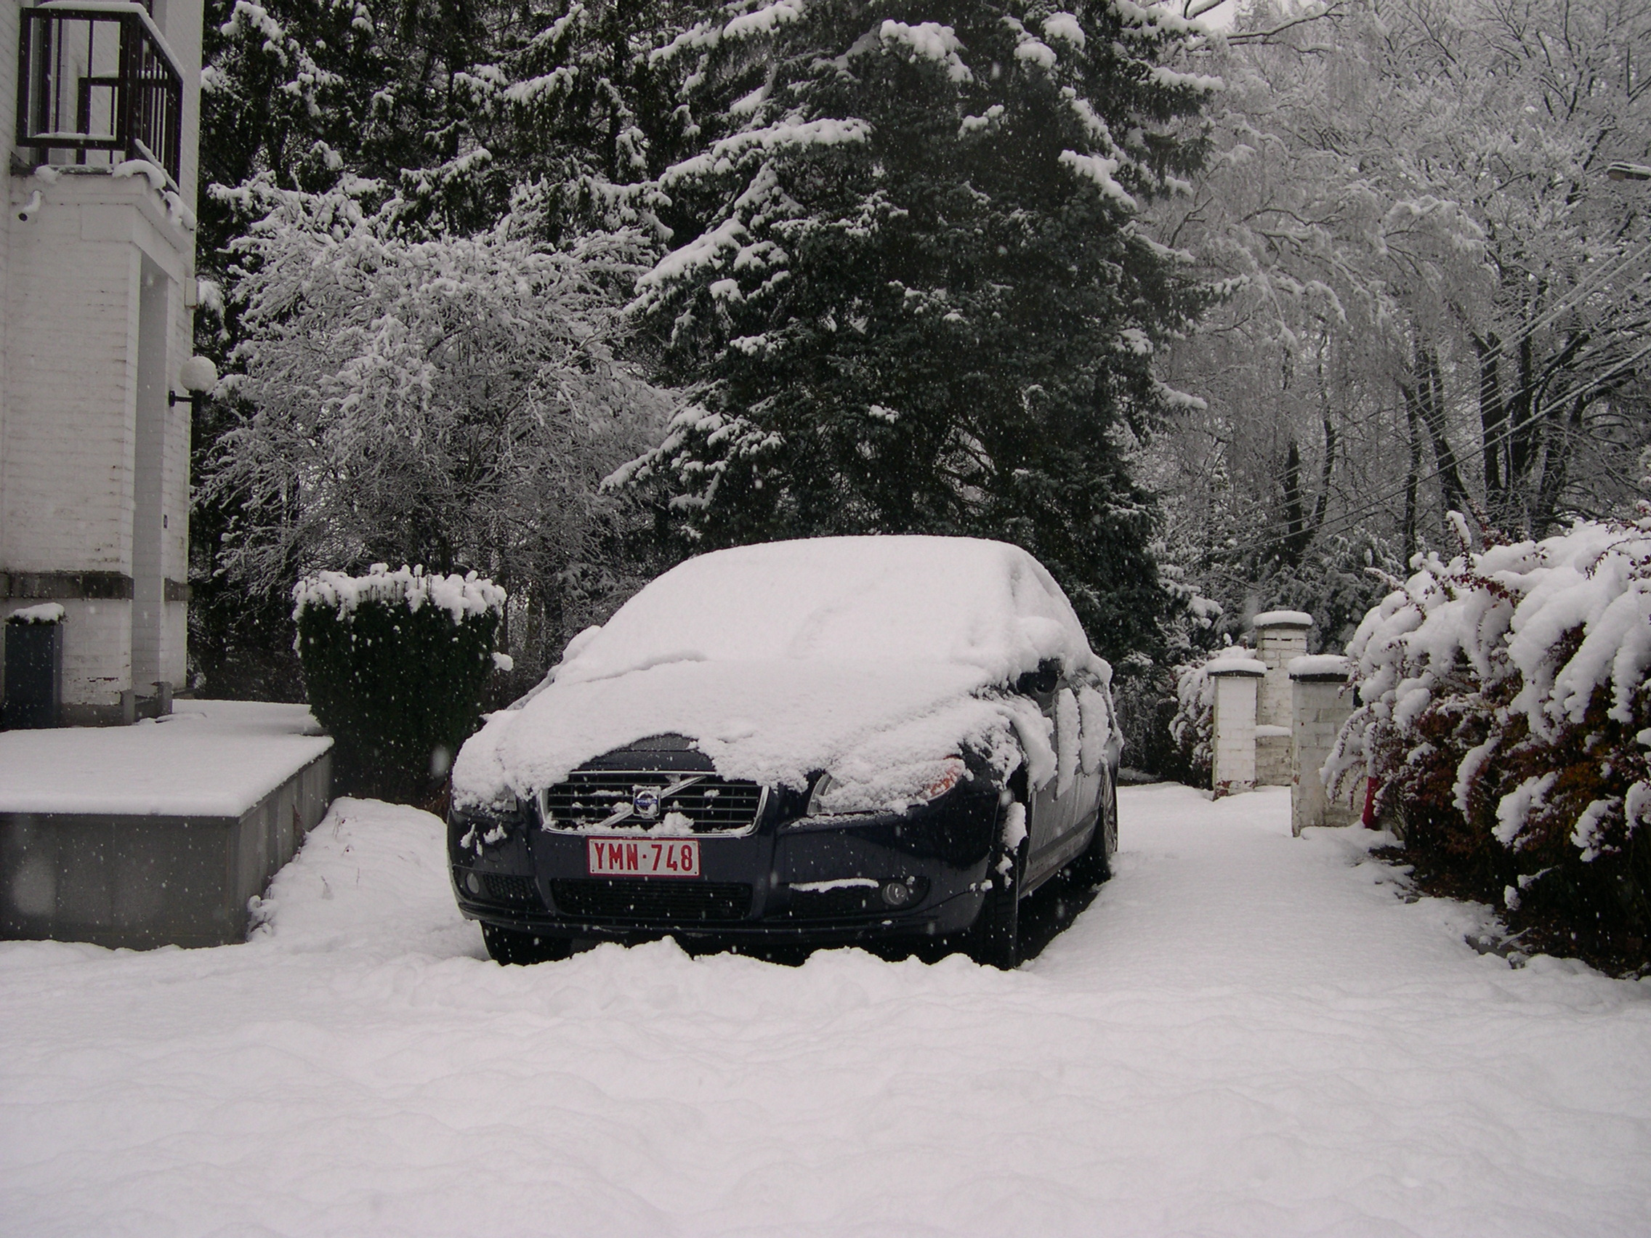

ImageDescription -
Make - NIKON
Model - E4300
Orientation - Top left
XResolution - 300
YResolution - 300
ResolutionUnit - Inch
Software - E4300v1.5
DateTime - 2008:12:03 12:26:00
YCbCrPositioning - Co-Sited
ExifOffset - 284
ExposureTime - 1/294.9 seconds
FNumber - 2.80
ExposureProgram - Normal program
ISOSpeedRatings - 100
ExifVersion - 0220
DateTimeOriginal - 2008:12:03 12:26:00
DateTimeDigitized - 2008:12:03 12:26:00
ComponentsConfiguration - YCbCr
CompressedBitsPerPixel - 3 (bits/pixel)
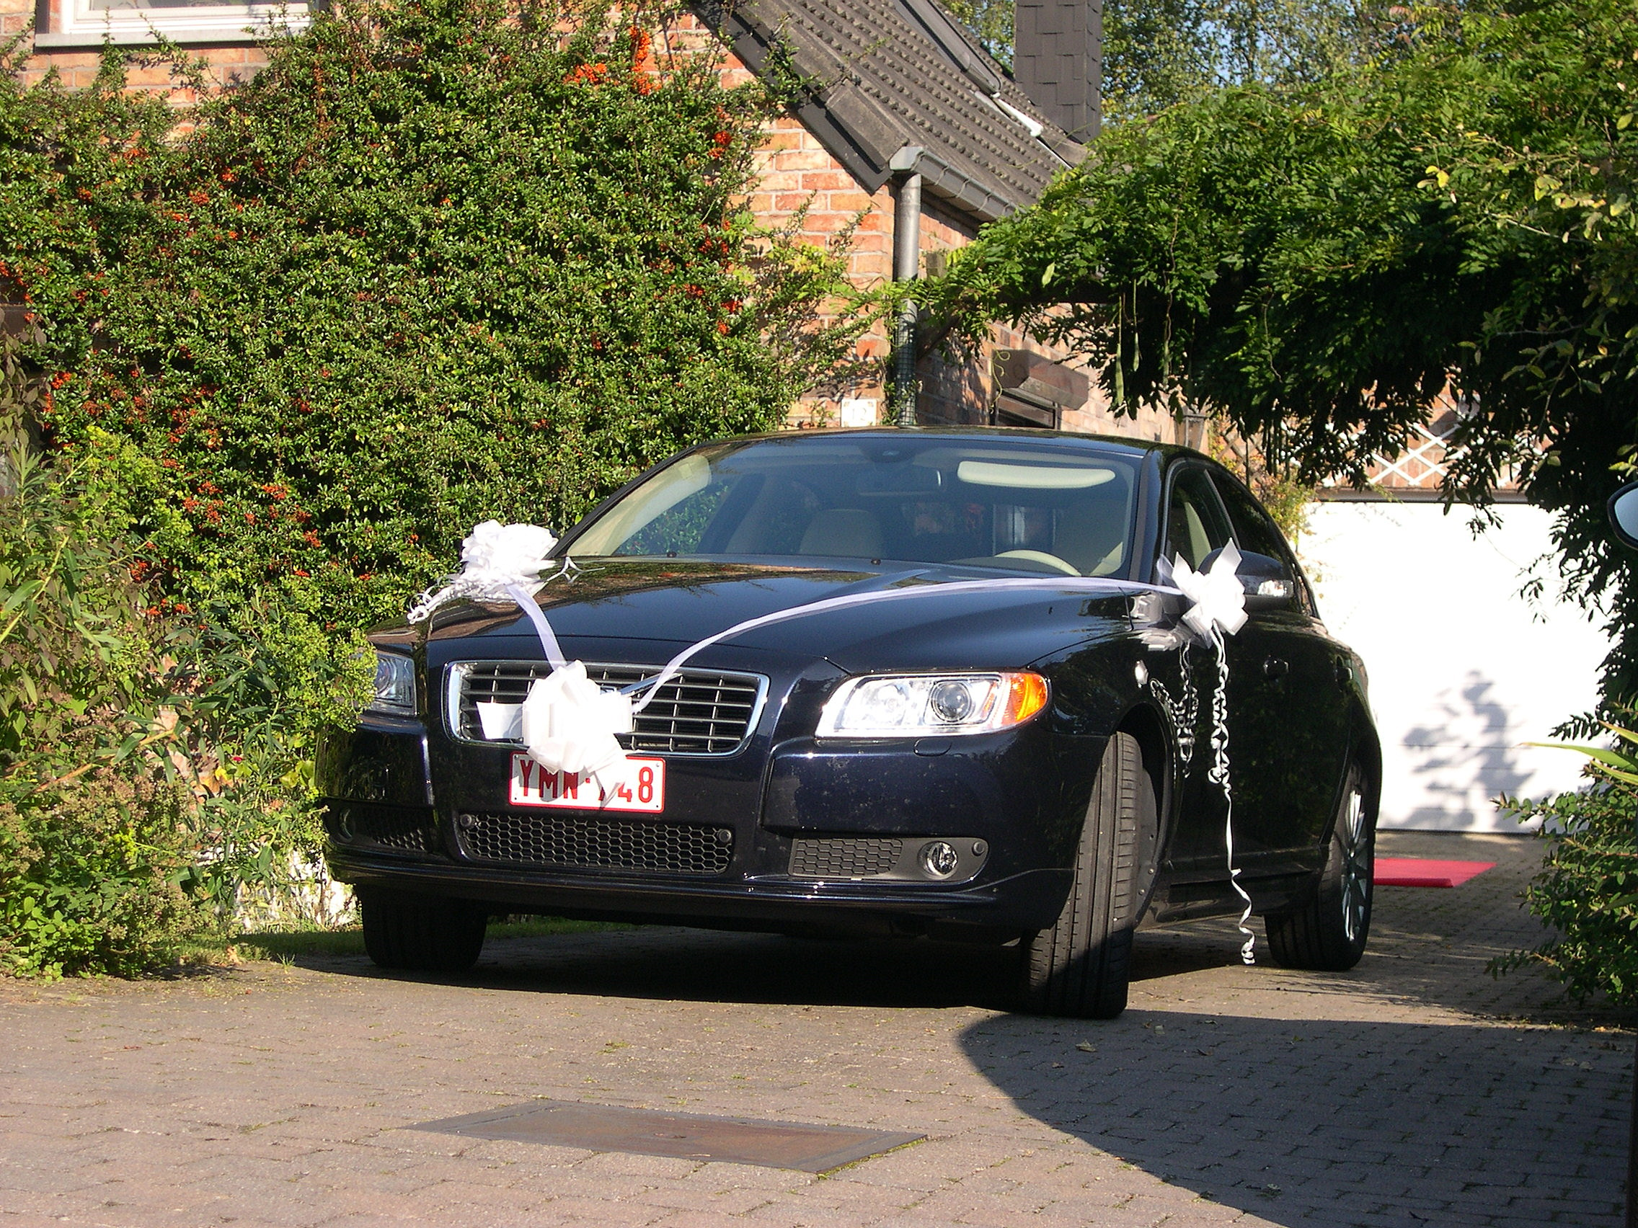

ImageDescription -
Make - NIKON
Model - E4300
Orientation -
XResolution - 300
YResolution - 300
ResolutionUnit - Inch
Software - Picasa 3.0
DateTime - 2008:09:20 10:53:30
YCbCrPositioning - Co-Sited
ExifOffset - 218
ExposureTime - 1/400.3 seconds
FNumber - 3.80
ExposureProgram - Normal program
ISOSpeedRatings - 100
ExifVersion - 0220
DateTimeOriginal - 2008:09:20 10:53:30
DateTimeDigitized - 2008:09:20 10:53:30
ComponentsConfiguration - YCbCr
CompressedBitsPerPixel - 3 (bits/pixel)
ExposureBiasValue - 0.00
teCount - 7804

