# Overview

On August 6th and 7th 2021, we sampled benthic and pelagic characteristics at a roughly 1 km grid around Lake Mývatn. Points occasionally had to be adjusted to avoid shallow areas or areas that could not be cored in due to rocks. This yielded 30 locations (Fig. 1). Most sites were around 1 km from each other, but the two northernmost were only 610 m away from each other. The furthest Euclidian distance was 8.6 km between the site in Álftavogur and the northernmost site in the north basin.

# General Characteristics

## Depth

We measured depth at each site. Our shallowest site was 1.8 m and our deepest was 3.97 (in the mined area of the north basin). The median depth was 2.92 m. Generally, the sites in the center of the main basin are deeper than those around the edges.

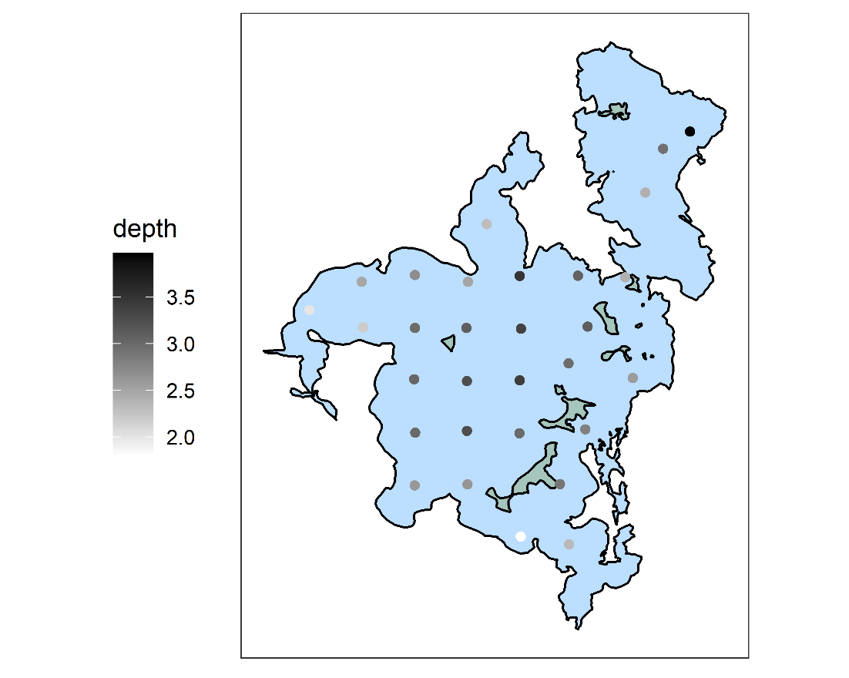

## Sediment Type

At each site we took to Kajak cores. We first visually characterized the surface of the benthos as either soft sediment, macrophyte, Cladophora mat, or midge tubes. No site fell into this last category.

## Temperature

Temperature was high for both days. Our measured water temperature was likely more driven by when within a day we sampled the location than meaningful differences in water temperature.

# Biological Information

## Measurements of Phytoplankton

### Secchi Depth

We estimated phytoplankton biomass using several metrics. The simplest metric we used was the secchi depth. This roughly describes the amount of material in the water column. There was minimal wind leading up to this sampling event, so the material in the water is most likely attributed to the phytoplankton biomass (rather than suspended sediment). A low secchi depth indicates lots of phytoplankton. The lowest secchi depth was in Álftavogur (0.8) and the secchi disk could be seen at the bottom of the lake near the cold springs south of the Kálfaströnd peninsula.

The median secchi depth was 1.83 m (after removing the site by the cold springs). I was surprised visibility was so low in the eastern side of the lake.

### Turner Handheld probes

At each location, we took two samples of water from each meter between the surface and benthos using the modified Schindler trap. We first took three measurements of chlorophyll and phycocyanin using the turner fluorosense probes. These are in “Turner units” and are not comparable between the pigment types. However, we do have a conversion to convert the phycocyanin to units that would have been read by Árni’s algae torch.

The chlorophyll readings are not related to the phycocyanin readings at the same location (adjusted r2=0.079, p = 0.073). Interestingly, the patterns are similar, but not identical to the secchi depth.

## BenthoTorch readings on Whatman filters

We filtered 300 mL of water from each site through GF/f Whatman filters. These were frozen and will be measured on a spectrometer by Phil’s group to pair with the AVARIS flight. Before freezing them, we took a benthotorch reading on the surface of the filters. This gave us approximate composition of the pelagic community in units of chlorophyll a per cm2. The probe separates greens, cyanobacteria, and diatoms. The resulting communities can be seen in these scatterplots. The size of the pies is the total units of chlorophyll added across the three taxa.

The cyanobacteria were generally the most abundant taxon, while diatoms were uncommon. Diatoms appeared more common in the north basin. This may be associated with methane (?) bubbles suspending sediment. We saw several places that had bubbles and lake balls.

There was no evidence that cyanobacteria and greens were related (p = 0.136).

## Vertical Changes in Dissolved Oxygen

At each of the sites, we did temperature and DO profiles. In general, temperature decreased with depth. There were some sites where dissolved oxygen increased with depth and others where it decreased. There were also some sites where the two had a nonlinear relationship.

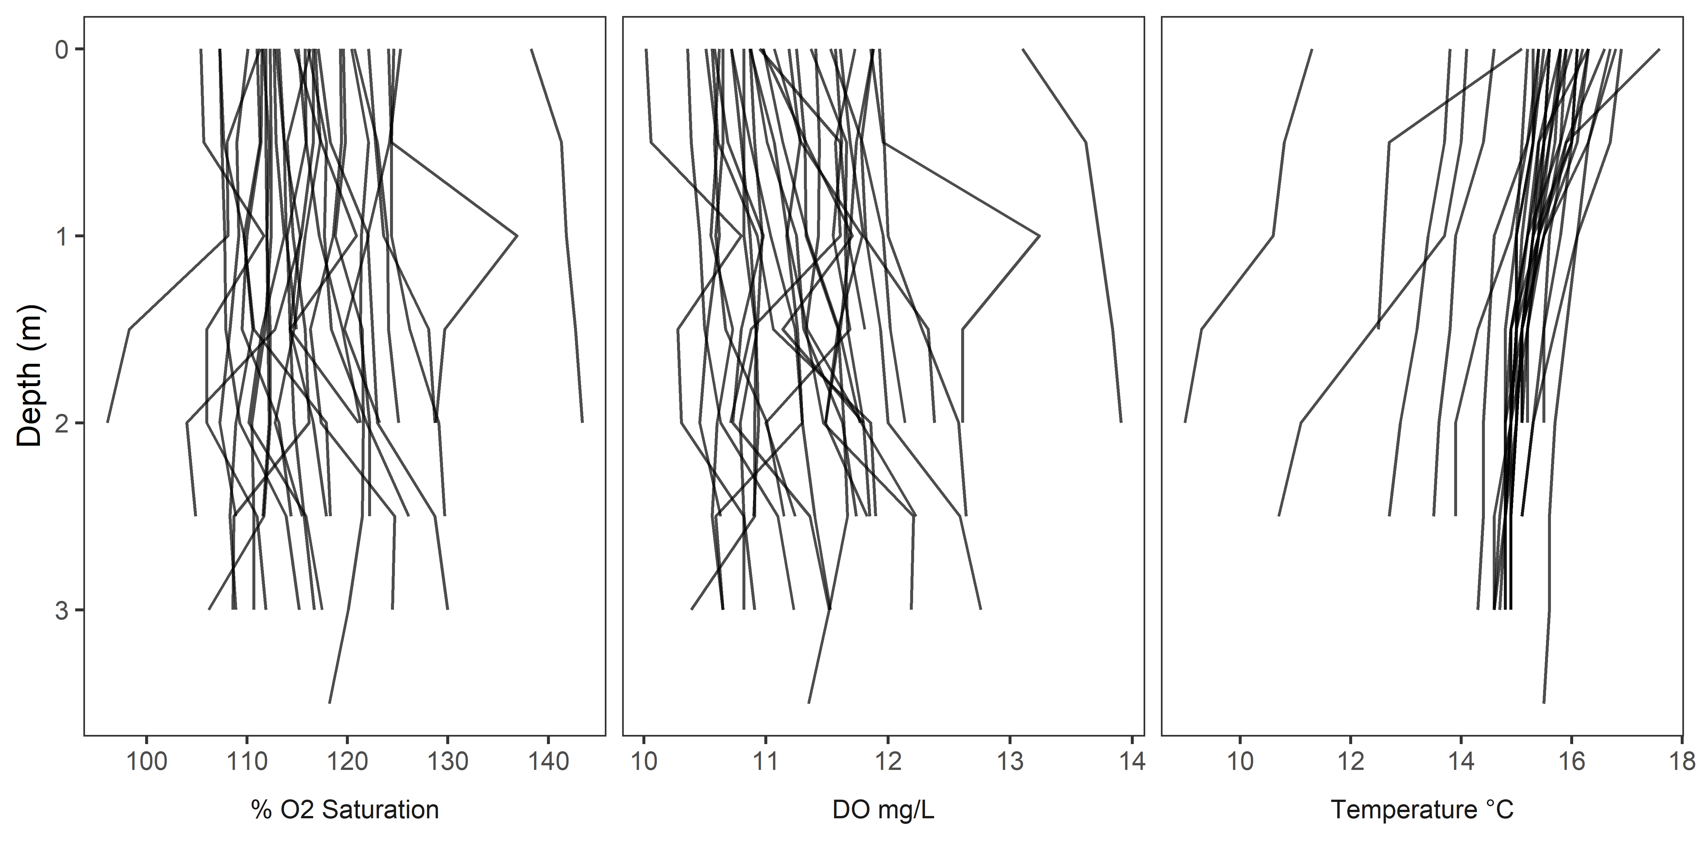

The highest DO readings were from the mouth separating the north and south basin. DO was lowest in the center of the main basin. For the below plot the left panel is the surface (depth = 0) and the benthic is the lowest reading.

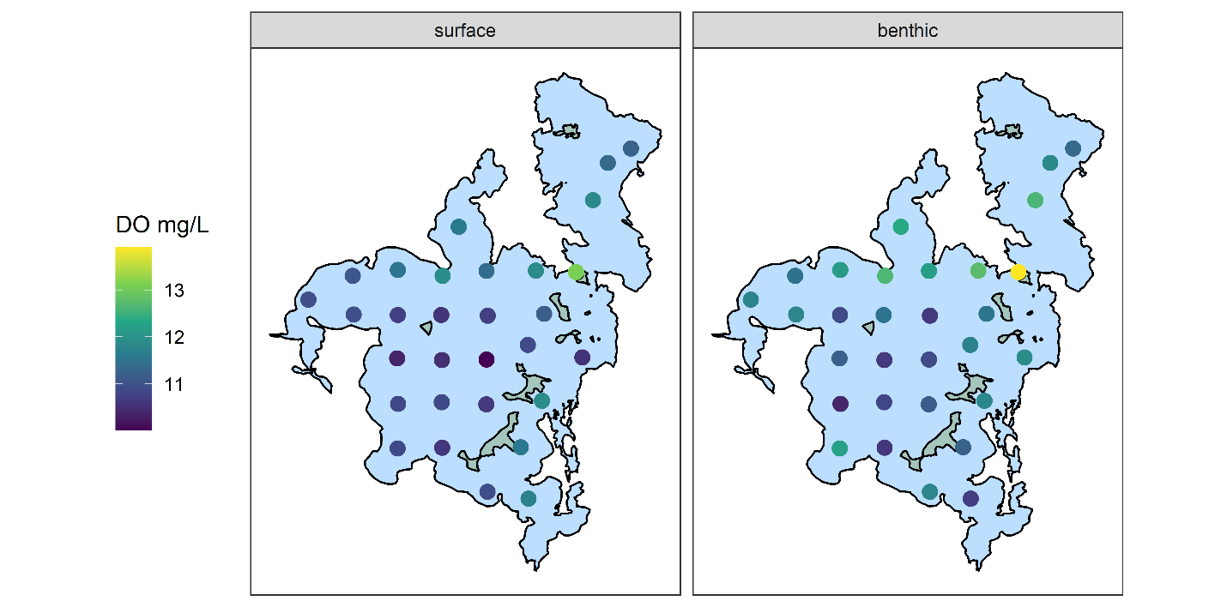

These DO profiles give a very rough sense of autotrophic structure. If DO increases with depth, it suggests that benthic production may exceed primary production. If DO decreases with depth, it suggests that the pelagic zone is a source of oxygen. This interpretation is flawed and should be treated with caution. To visualize this, I divided the difference in surface and benthic do by the average of the two values. Because temperature had a generally consistent negative trend with increasing depth, I did this both with concentration and % saturation. Higher values indicate a that surface DO exceeds benthic DO. Values near 0 are roughly in balance. Surprisingly, most spots had higher benthic DO than surface DO regardless of the metric. As expected, given the temperature trends, using concentration has more benthic dominated sites. Interestingly, the location by the cold springs had much higher surface than benthic dissolved oxygen, despite less phytoplankton and the Álftavogur site had higher benthic, despite the most phytoplankton. Álftavogur could be explained by the Cladophora mat.

For the moderate values (removing secchi of 0.8 and where it could be seen on the bottom), there perhaps a very weak negative trend in the autotrophic structure (as defined above) and secchi depth (p = 0.039). Why the two outliers show the opposite pattern is unclear to me. It all might be noise. The below plots are the same; The top plots show all data (with the secchi at the bottom, scored as 4); the bottom plots remove these two sites.

## Midges

One of my interests in this sampling event was to determine 1) are there any *Tanytarsus*? And 2) where are they? The timing may be suboptimal to clearly address this question. Early August sometimes corresponds to the *Tanytarsus* emergence, and we did observe a small, localized *T. gracilentus* swarm on 10 August at Kálfaströnd. However, we usually see second and third instar *Tanytarsus* at this time in our routine data, the summer emergence appears to be less discrete than the spring generation in our emergence traps, and the unusual warm and sunny weather we observed this summer may alter the emergence timing in unpredictable ways. Regardless, this should be treated with some caution.

We took a single core at each of the 30 locations and processed them in the standard way for midges. We sieved the top 1.5 cm through 63-μm mesh. We sieved the remainder of the core 125-μm mesh. We transferred all midges into ethanol. Once in ethanol, we identified them to subfamily (Orthocladiinae and Tanypodinae) and tribe for the Chironominae (Tanytarsini and Chironomini). We also counted *Tubifex sp*. (which are not midges but are moderately common detritivores in the benthos). We measured the head capsule width to determine the instar of the midges.

The lake had few midges in comparison with what we have seen in the past 7+ years. We found 5 Tanytarsini, primarily in the bay by Vindbelgjarfjall, although we did find one individual in the bay by Kálfaströnd. Of course, these need to be mounted and identified to species to determine if they are indeed *T. gracilentus* and not other Tanytarsini. Chironomini were the most abundant taxon. We found 52 individuals total and they were found in the highest abundance in the center of the main basin. Despite being the most numerous, these densities were still quite low for Mývatn. Orthoclades were found in low abundances in a handful of locations. These locations included a Cladophora mat, two areas dominated by macrophytes, and one bare sediment (although this location is very near lots of macrophytes). Tanypodines also appeared most common along the lake edge.

These species-specific patterns resulted in the midge communities in the center of the lake being dominated by the Chironomini and the edges were more diverse. There were 3 locations where no midges were found – off the southern edge of Miklay, in the dredged area by Reykjahlid, and along the southwestern edge of the lake, just north of Álftavogur.

Using our long-term data, we could determine the instar of the Tanytarsini and Chironomini. Most of the Tanytarsini we found were second instar. One individual was a third instar. At this stage they are predicted to be less mobile than the first instar, so perhaps this is where they have settled. Presumably they are the spring 2022 generation and not the summer 2021 generation (if this delineation is at all meaningful for last summer). The Chironomini included individuals in the second, third, and fourth instars. There may be meaningful patterns in Chironomini stage structure.

## Benthic Algal communities

In addition to the midge core, we took a core which we measured using a benthotorch. This estimated the composition of the algal community on the surface layer. In general, the benthos was characterized by diatoms. We did not observe any green algae on the benthic surface using the benthotorch. For Cladophora mats, these may be covered in *Epithemia*, which would be read by the benthotorch. Total algal abundances were highest in the east basin and near the outlet.

## Benthic-Pelagic Algal interactions

Because we have paired water column and sediment benthotorch readings, I just wanted to take a brief look at the correlation between benthic and pelagic algal taxa. I used the spearman rank correlation. There appears to be a negative association between the rank order of pelagic cyanobacteria and diatoms. Interesting. There is also a moderately strong correlation between sediment diatoms and cyanobacteria. Perhaps unsurprisingly, there are no obvious correlations in benthic and pelagic algal taxa.

## Zooplankton

At each of the locations, we filtered 2 L of water through 20-μm mesh. This retained phytoplankton and zooplankton. We have identified the zooplankton from the first 11 sample locations. Rotifers are the most numerous group of zooplankton. *Filinia* was the most common rotifer, followed by *Keratella*. One location by the outlet had over 300 *Daphnia*, but that was not true of its neighbors. Nauplii generally were the most common non-rotifer. *Cyclops* were also found at moderately high abundance at the north side of the outlet. *Chydorus sphaericus* were found to represent more than a third of non-rotifers at the Álftavogur site.

A very simple look at the communities shows no relationship between distance and community similarity.

# Unanalyzed samples

There are several sources of data that we have not yet analyzed.

## Nutrients

At each location, we took nutrient samples of the interstitial water and of the water column. Both were filtered through 0.45μm syringe filters prior to freezing. Árni has these samples and plans to send them to Sweden to be analyzed with the other monitoring data. The interstitial nutrients come from the same cores that we took benthotorch readings on.

## Midges

Midges have been identified roughly to subfamily/tribe. However, mounting larvae of some taxa (Tanytarsini) is essential and identifying all groups to species could be interesting. This may be more work than it is worth.

## Spectra

The timing of this sampling event was within 3 days of the NASA AVARIS flight (9 August 2021), which pointed a hyperspectral camera at the lake. As described in Phytoplankton: Benthotorch readings on Whatman filters, we filtered 300 mL of water on Whatman filters and froze them. These fit perfectly with Phils spectrometer, and he thought it may be interesting to measure spectra on these. We have samples from station 33 which we can use to calibrate the spectra for chlorophyll and zooplankton but counting zooplankton or identifying phytoplankton might be worthwhile.

## Phytoplankton

As described in Zooplankton, we sieved 2L of water from each location through 20 micron mesh (the same samples as the zooplankton). These contain both zooplankton and phytoplankton. The algal communities could be identified either qualitatively or quantitatively.

## Zooplankton

We have not analyzed all of the zooplankton and plan to evaluate how useful this will be based on the first 11 samples.