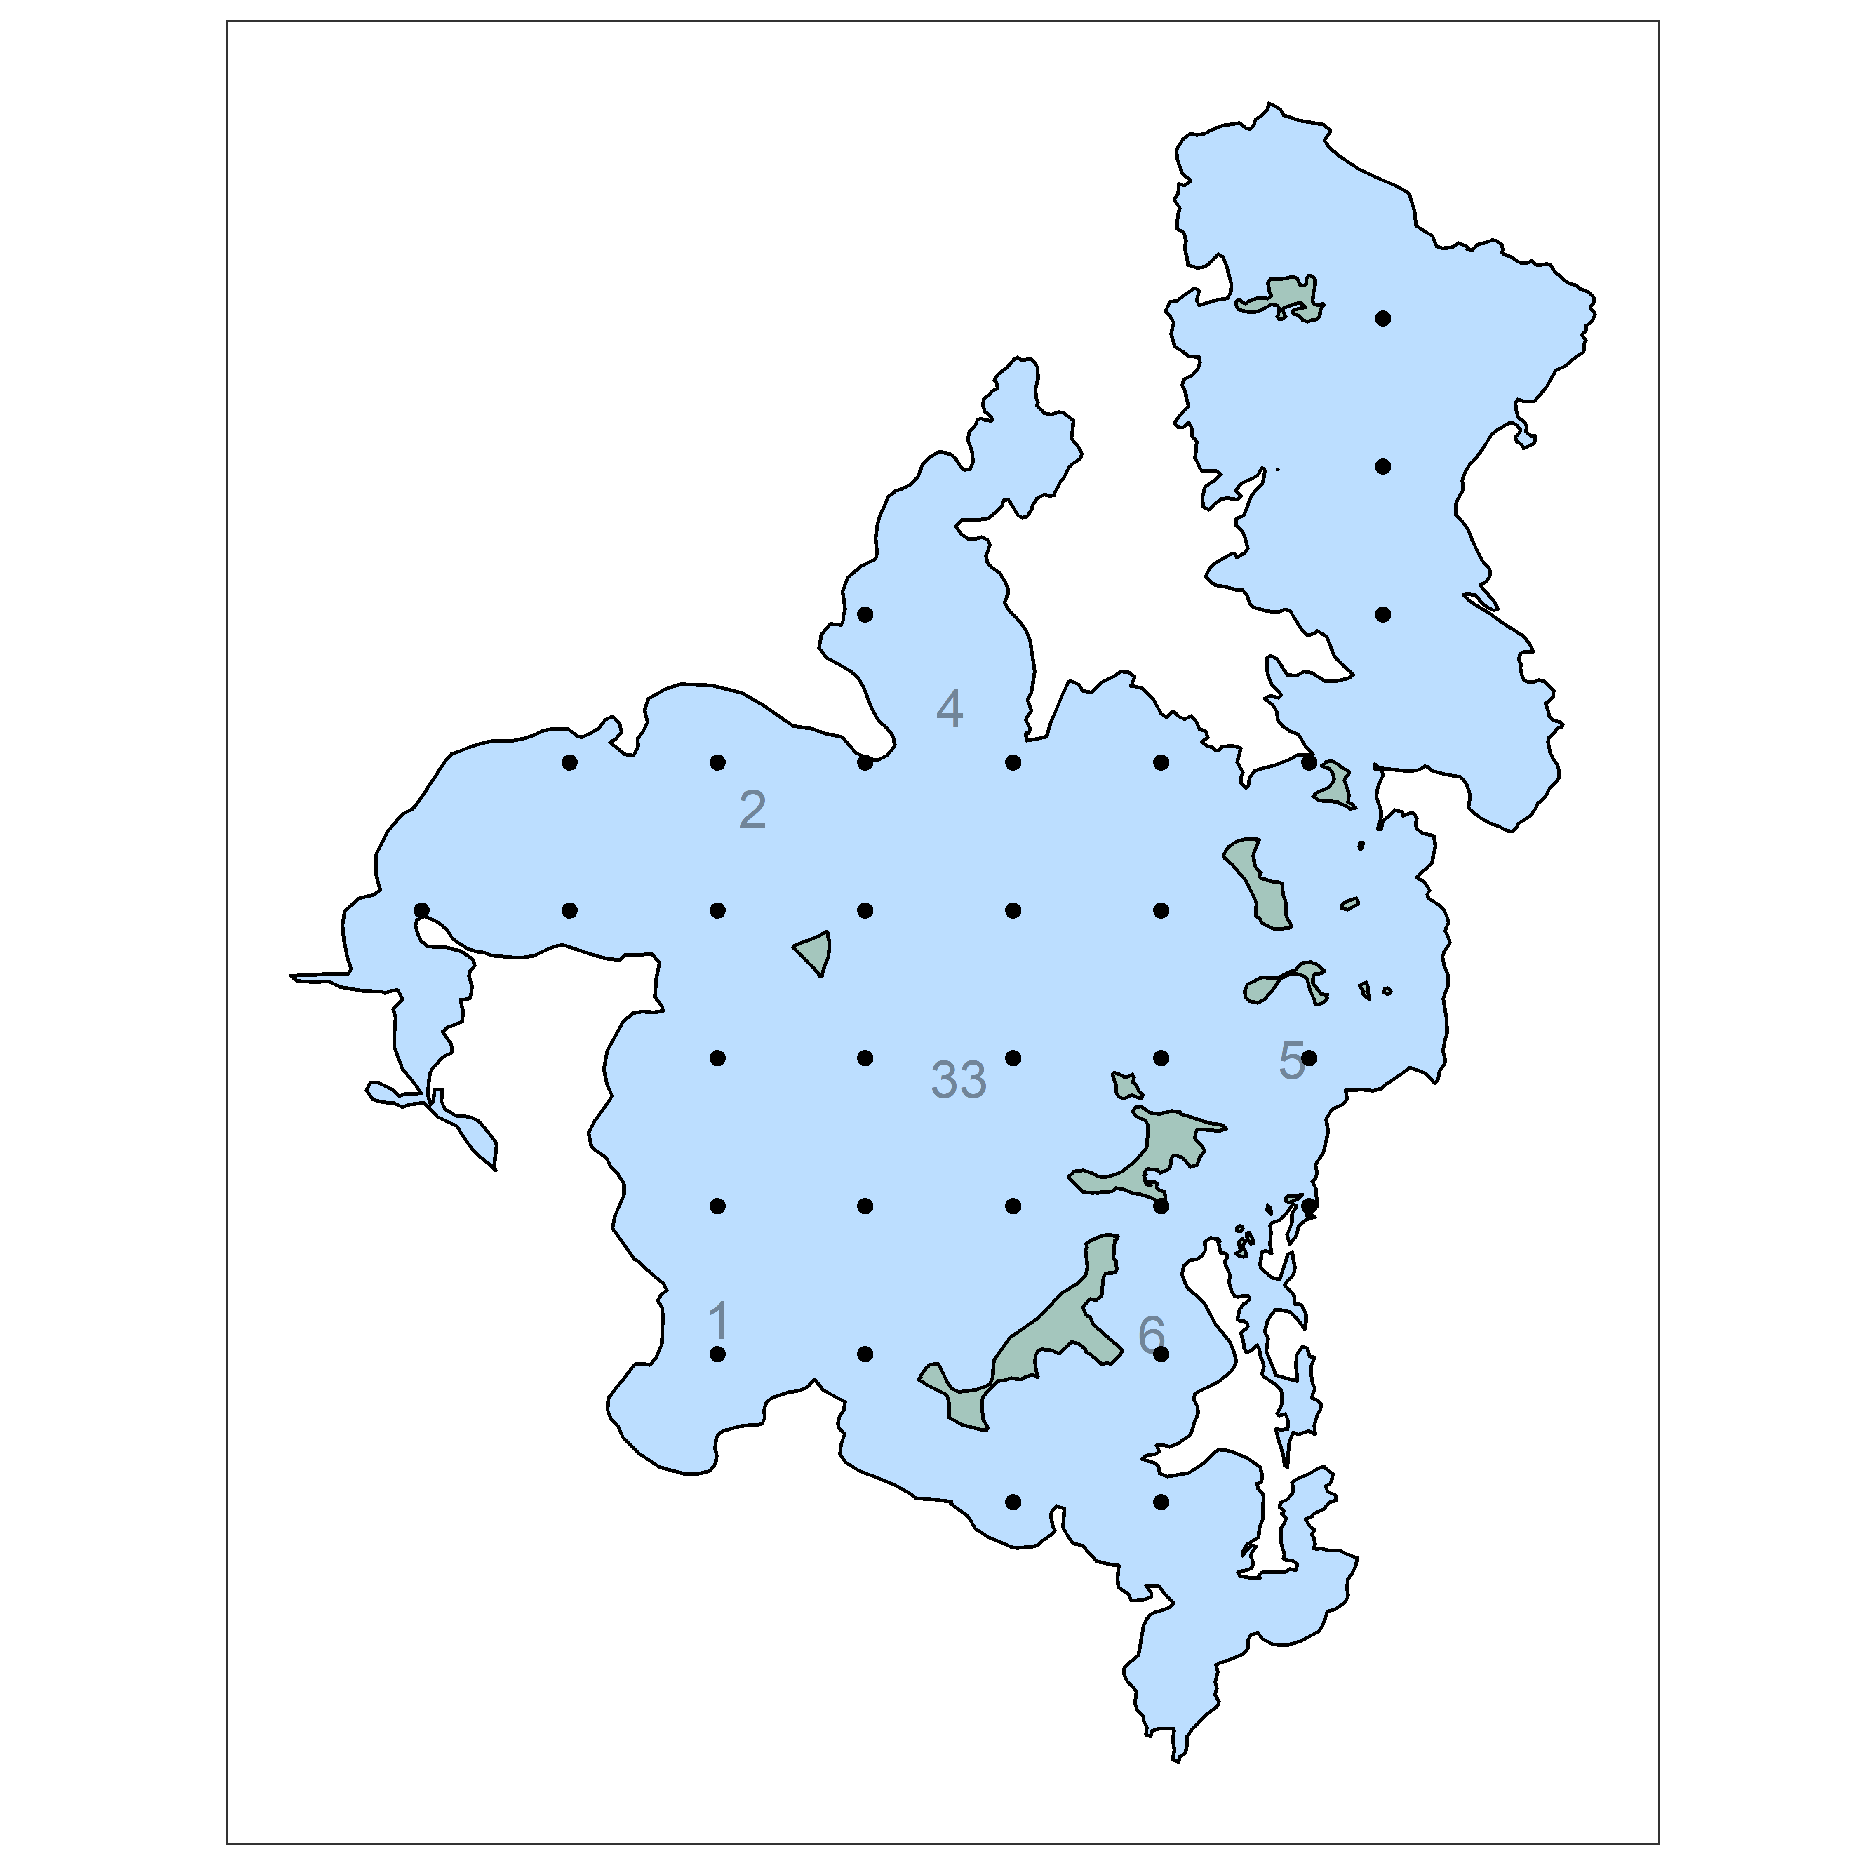

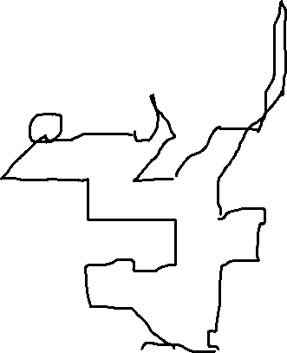

**IN BOAT**

☐Boating Equipment:

Life jackets

Dry box containing cell phone

Gas tank (Petrol NOT diesel)

Oil (20 mL oil per liter gas) – ONLY FOR MERCURY TANK, NOT SUZUKI TANK

Credit card with a PIN if need to fill up gas; something to record purchase (e.g., camera)

**GPS x2**

**Extra Batteries**

Sharpies

Scissors

Gorilla tape (keep in plastic bag)

Lab tape

Towel (e.g., to clean 30L water buckets)

Food

Head nets (if black flies are out)

Gloves (if needed)

☐Grapple (metal hook)

☐ Data Sheets

☐Backup paper and pencil (that should be kept in the box with the probes)

☐Water Column:

Secchi disk

DO optical probe (YSI model proODO: Harry or Hermione)

Chlorophyll and Phycocyanin probes

Árni trap (clear cylindrical zooplankton trap)

Clean 30L Bucket

32+3 scint vials for pelagic nutrients

1+1 60 mL syringe

1L DI water

DI Water squirt bottle (full)

Cooler with ice packs

Pitcher x2

☐Zooplankton and Phytoplankton:

32+3 1 L clean bottles

32+3 Zoop bottles

20 micron sieve

Squirt bottle

☐Sediment Collection

2 Corers (and weights for windy days)

4 clear coring tubes

Stoppers (10+5 blue, and 20+5 grey)

PVC Extruder x 2

Short buckets x2 to collect water during extruding

☐Sediment Characteristics

Benthotorch, Charged

32+3 scint vials

1+3 needles

Metal syringe arm

1+3 syringe

☐Midges

125 micron sieve

Stage and scraper

Labels 64 + 5 delis with labels

Squirt bottle

|  |  |  |
| --- | --- | --- |
| Stop | Easting | Northing |
| 1 | 407000 | 7274250 |
| 2 | 406000 | 7274250 |
| 3 | 406000 | 7275250 |
| 4 | 407000 | 7275250 |
| 5 | 408000 | 7275250 |
| 6 | 408000 | 7276250 |
| 7 | 407000 | 7276250 |
| 8 | 406000 | 7276250 |
| 9 | 406000 | 7277250 |
| 10 | 405000 | 7277250 |
| 11 | 404000 | 7277250 |
| 12 | 405000 | 7278250 |
| 13 | 406000 | 7278250 |
| 14 | 407000 | 7278250 |
| 15 | 407000 | 7279250 |
| 16 | 408000 | 7278250 |
| 17 | 407000 | 7277250 |
| 18 | 408000 | 7277250 |
| 20 | 409000 | 7278250 |
| 21 | 410000 | 7278250 |
| 22 | 410500 | 7279250 |
| 23 | 410500 | 7280250 |
| 24 | 410500 | 7281250 |
| 25 | 409000 | 7277250 |
| 26 | 409000 | 7276250 |
| 27 | 410000 | 7276250 |
| 28 | 410000 | 7275250 |
| 29 | 409000 | 7275250 |
| 30 | 409000 | 7274250 |
| 31 | 409000 | 7273250 |
| 32 | 408000 | 7273250 |