**GAME DESIGN DOCUMENT**

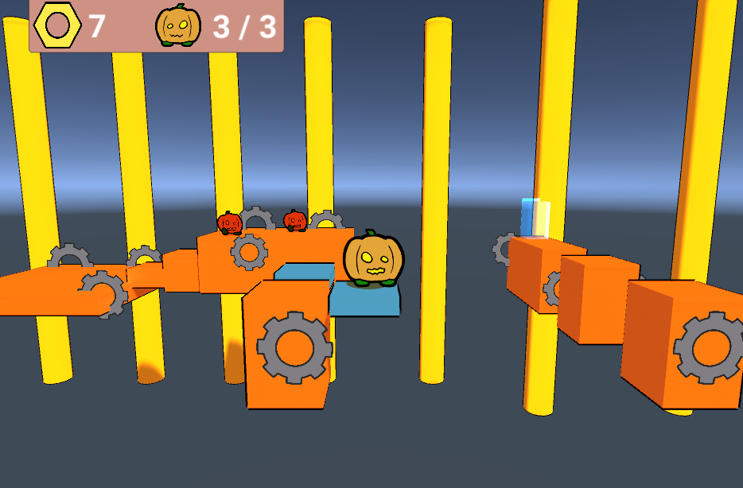

Jumping Repairman

**Last Updated:**

8/26/2021

**Prepared By:**

Aidan Cha

**TABLE OF CONTENTS**

Game Analysis 3

Mission Statement 3

Genre 3

Platforms 3

Target Audience 3

Storyline & Characters 4

Gameplay 5

Overview of Gameplay 5

Player Experience 5

Gameplay Guidelines 5

Game Objectives & Rewards 5

Gameplay Mechanics 5

Level Design 6

Control Scheme 7

Game Aesthetics & User Interface 7

Schedule & Tasks 8

# Game Analysis

Jumping Repairman is a platforming game where you play as Rodney, the best factory repairman. Rodney has to reset the “robo receivers” in each part of the factory before time runs out. The purpose of the game is to be easy and fun for new gamers. The player will have to dodge obstacles and jump a lot. They player will also have to avoid getting hit by crazy robots. They can’t harm any of the robots because they’ll lose their job.

# Mission Statement

Jumping Repairman is a platformer for PC where you have to dodge robots and jump on a lot of platforms.

# Genre

The game’s genre is a platformer.

# Platforms

The game will be made for PC.

# Target Audience

This game is targeted towards children 7+. The intended audience should have an interest in robots and should enjoy light and easy gameplay. This game is intended for everyone interested in platformers, especially new gamers.

# Storyline & Characters

Rodney, once the worst rookie factory repairman any factory has seen, two years later has become the worlds best repairman. After receiving a dangerous job request from a newer factory run by robots, Rodney will have to put his reputation as “best factory repairman” on the line. Rodney always carries his big wrench with him, but he can only use it for repairing, not for hitting robots or anything. Throughout the game Rodney will find out that being the world’s best repairman isn’t the easiest job and title to hold.

|  |  |  |  |
| --- | --- | --- | --- |
| Character | Description | Characteristics | Misc. Info |
| Rodney Ramairo | The main and only character of the story. World’s best factory repairman. Just does his job, and often replies with “si”. | Rodney jumps higher than most normal humans, working for so long has really helped him get in shape. He’s able to repair things almost instantly with his giant wrench he carries around. He’s from Mexico, but works all over the world. | Rodney usually makes one or two word replies that usually consist of “si” or “no”. |

# Gameplay

## Overview of Gameplay

The game is just like other platformers, where you run and jump. The game will be on PC only. There will only be a single player mode. The selling features of this game is easy gameplay for new gamers, time races on each level, and enemy avoidance. Touching a robot will cause your health to go down by 1 out of 3 total health points.

## Player Experience

You will start at the beginning of the factory, and see tons of gears and pipes in the factory. There will be a fast conveyer belt in one level you have to run backwards on, in order to dodge crushing machines. Lots of robots will be scattered around throughout the levels, and you’ll have to either wait for them to pass you or jump over them.

## Gameplay Guidelines

No excess violence or offensive language is allowed. The game is expected to be cartoonish and easy to enjoy. Writing should be simple, something 1st graders could read.

## Game Objectives & Rewards

|  |  |  |
| --- | --- | --- |
| Rewards | Penalties | Difficulty Levels |
| - Grabbing a golden gear gives you points. - Reaching the end of a level lets you proceed to the next and eventually reach a “repair minigame” | Being crushed by machinery or attacked by wild robots results in having to restart the game. | There’s only one normal difficulty, but it should be fairly easy for new gamers. |

## Gameplay Mechanics

|  |  |
| --- | --- |
| **Character Attributes** |  |
| **Character** | **Movement Abilities / Actions Available** |
| Rodney Ramairo | Move – WASD Jump – Space Click – Interact (minigames) |
|  |  |
| **Game Modes** |  |
| Normal Mode | Enemies throughout each level  Pit falls  Fast moving platforms  Time limits |
| **Scoring System** |  |
| **Points/Coins/Stars/Grades/Etc.** | **How it’s Awarded & Benefits** |
| List the scoring attribute | Describe how the player obtains this and the benefits. For instance, does getting more points unlock a special level. |

## 

## Level Design

|  |  |
| --- | --- |
| **Levels** |  |
| Level name and/or pic of it | There should always be pipes in the background of each level. The levels will all be orange-yellowish and factory themed. There are a few hazards like enemies, pitfalls, and fast platforms in each level. Most of the time there will be spinning cogwheels as well. |

# Control Scheme

|  |  |
| --- | --- |
| **Button/ Touch Input** | **Action it Performs** |
| W / UP | Up movement |
| A / LEFT | Left movement |
| S / DOWN | Down movement |
| D / RIGHT | Right movement |
| Space | Jump |
| Click | Interact |

# Game Aesthetics & User Interface

Everything should look very cartoony and have somewhat thick outlines. There shouldn’t be highly detailed effort put into the sprites, however the map and background can be very low detail and bare minimum. We are hoping for this game to have very minimal emotional impact on players, other than a fun experience at the end. The players should feel a smooth experience when playing this game.

UI Buttons will all have a background box/slice behind them (if possible). Important stats should be laid out on the top left. There will currently be no menu system, the player will drop right into the game.

# Schedule & Tasks

|  |  |  |  |  |
| --- | --- | --- | --- | --- |
| **Tasks to Complete & Schedule** | | | | |
| **Tasks** | **Task Lead** | **Start** | **End** | **% Complete** |
| **Development Phase** | | | | |
| Design |  |  |  |  |
| Storyline | John Doe | 9/4/15 | 9/8/15 | 0 % |
| Level Mechanics |  |  |  |  |
| Art |  |  |  |  |
| Level 1 |  |  |  |  |
| Special FX |  |  |  |  |
| UI |  |  |  |  |
| Engineering |  |  |  |  |
| Production Pipeline |  |  |  |  |
| Prototypes |  |  |  |  |
| Audio |  |  |  |  |
| Sound Design |  |  |  |  |
| Milestone: GamePlay Features & Music |  |  |  |  |
| **Testing Phase** | | | | |
| Test Plan |  |  |  |  |
| Beta Testing |  |  |  |  |
| Milestone: QA Testing |  |  |  |  |
| **Deploying Phase** |  |  |  |  |
| "Go Live" Plans |  |  |  |  |
| Milestone: Ready for Usage |  |  |  |  |