TRUSTPAY ESCROW
A Stablecoin Smart-Contract Escrow for Cross-Border Freelance Work — Short White Paper
A. de Hollanda Vieira Guerner · E. Gwoszdz De Lazari · J. P. Schmidt Cordeiro · M. A. Sabadin Presotto | INE5458, UFSC | v1.0
The Problem
Freelance work is global, but its payment layer is not. Two strangers in different countries and legal systems must agree to pay each other, and someone always has to go first. If the client pays in advance, the work may never arrive; if the freelancer delivers first, payment may never come — or be reversed later as a chargeback. Cross-border transfers are slow and costly. Centralized freelance platforms hold the money, but this only relocates trust: users must trust a private company as the sole, opaque keeper of their funds and judge of their disputes. They cannot verify the money is there, and fees and withdrawals are set unilaterally.
The Solution
TrustPay Escrow is a web platform that locks payment in a smart-contract escrow until work is delivered. The client deposits the funds up front, but they are locked: the freelancer can verify on-chain that the money exists before starting, and release happens only on milestone approval — so neither side goes first, and no private party secretly controls the funds. Payments settle in stablecoins (USDC/USDT, pegged 1:1 to the US dollar), giving fast, transparent, programmable payments with no exposure to crypto volatility. The platform hides blockchain complexity behind guided wallet setup and plain-language statuses, and runs on existing low-cost networks — no new blockchain is needed.
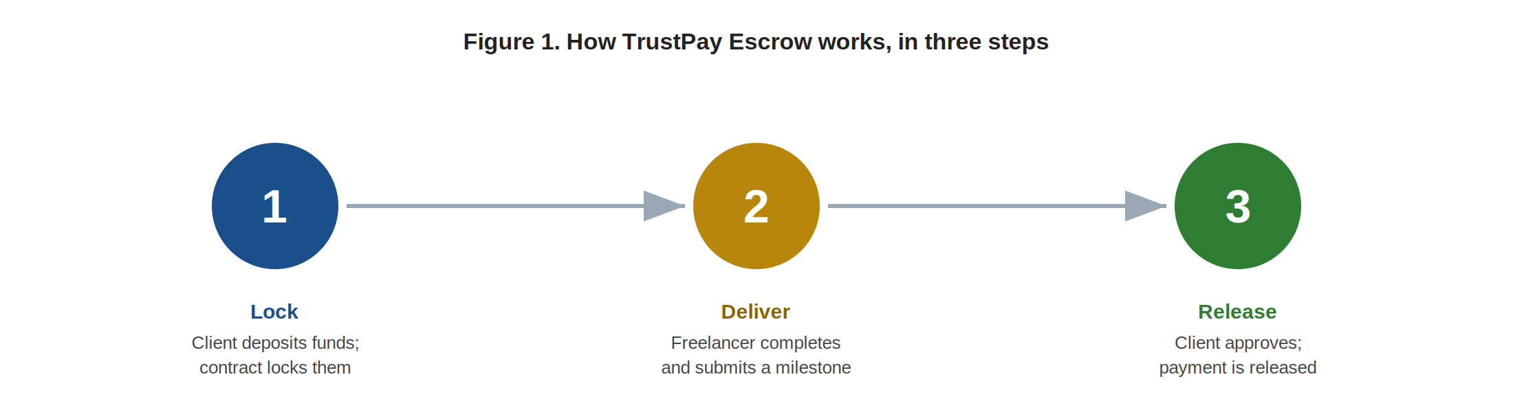
Figure 1. Lock funds → deliver milestone → release payment.
Key differences: the locked money is publicly verifiable by both parties; release rules are fixed before work starts and executed automatically; long projects are split into independently funded milestones; and once a payment is released on-chain it cannot be silently reversed.
Why Blockchain — and Only Here
An ordinary database could record milestones, but it cannot remove the need to trust the company controlling it. A smart contract changes the trust model: once funds are deposited, the release rules are public and network-enforced, and the platform cannot take or redirect locked money. We are honest about the limits — blockchain does not verify real identities, enforce court judgments, or judge whether work is good; those stay with KYC, terms of service, and human dispute review. Blockchain is used precisely where it adds value, and nowhere else.
Can it do this? | Bank / card | Centralized platform | TrustPay Escrow
Funds held conditionally | No | Yes | Yes
Both parties verify the money | No | No | Yes
Trust in a private custodian | Bank | Platform | None for custody
Table 1. The protocol is justified by verifiable, conditional custody — not by novelty.
Disputes
Because a contract cannot judge work quality, disputes use a hybrid model: the contract keeps the disputed funds locked while a human or decentralized arbitrator decides. Either side can open a dispute with a small fee and evidence; the arbitrator rules to pay, refund, or split the funds, and the contract executes the verdict. The fee deters frivolous claims, and outcomes feed a reputation signal.
Business Model
- Transaction fee — ~0.5–1.5% per completed escrow, collected automatically in stablecoin at release.
- Business subscription — a paid tier with team accounts, reporting, and priority support.
- Dispute resolution fees — premium arbitration fees shared with arbitrators.
Customers are international freelancers, startups and small businesses hiring globally, and small agencies. The model is sound because the fee is a few lines inside a contract that already exists for custody — no extra billing infrastructure. Security audits and compliance are treated as non-negotiable costs.
Roadmap
Each phase depends on the proven success of the previous one: (1) proof of concept on a testnet; (2) a pilot on a low-cost network with stablecoins and managed disputes; (3) business accounts and fiat on/off-ramps; (4) decentralized arbitration; (5) multi-chain scale. TrustPay Escrow locks money transparently, releases it on delivery, and lets no private party stand between the two sides — buildable today with proven infrastructure. A full technical white paper is available as a companion document.

