TRUSTPAY ESCROW
A Stablecoin Smart-Contract Escrow Protocol for Cross-Border Freelance Work
Long Technical White Paper
Version 1.0 — A living document

Augusto de Hollanda Vieira Guerner
Eduardo Gwoszdz De Lazari
João Pedro Schmidt Cordeiro
Micael Angelo Sabadin Presotto
INE5458 — Blockchain and Cryptocurrencies Technologies
Universidade Federal de Santa Catarina
Partial Delivery 2 — Technical White Paper

Abstract
International freelance work is now a global market, but the payment infrastructure that supports it has not kept pace. Clients are reluctant to pay before receiving work; freelancers are reluctant to deliver work before payment is guaranteed. Centralized freelance platforms reduce this friction, but only by becoming the custodian of the funds — the parties simply move their trust from each other to a private company.
This white paper proposes TrustPay Escrow, a payment protocol in which funds are locked in an EVM-compatible smart contract before work begins and released through milestone approval, predefined contract rules, or hybrid dispute resolution. The contract is settled in regulated, fiat-pegged stablecoins (USDC, USDT), so neither party is exposed to cryptocurrency volatility while still benefiting from programmable, transparent custody. The technical novelty is not the acceptance of crypto payments: it is the combination of stablecoin settlement, milestone-based escrow logic, a publicly auditable contract state, and a dispute workflow designed specifically for small cross-border service contracts.
The protocol does not require its own blockchain. It is deployable today on existing Layer 2 networks using audited token standards, mature wallet tooling, and event-indexing infrastructure. The document that follows justifies why a blockchain is necessary for this use case rather than a traditional database, specifies the smart-contract architecture and state machine, defines the on-chain / off-chain data boundary, and analyzes the security, scalability, and regulatory limitations honestly. The goal is to convince a technical reader that the system is feasible with present-day infrastructure and that blockchain is used precisely where it adds trust, transparency, and programmable custody — and nowhere else.
A note on this document
Following the example of the Ethereum white paper, this is intended as a living document. It states the protocol’s intent and design rather than a frozen specification, and it is expected to be revised as the design is validated against testnet deployment, audit feedback, and pilot users. Section numbering and the roadmap are versioned accordingly.

Contents

1. Introduction4
2. Problem Definition and Motivation6
3. Proposed Solution Overview8
4. Stakeholders, Entities, and Use Cases9
5. Why Blockchain Is Necessary11
6. Technical Architecture13
7. Smart Contract Design15
8. Data Model and Processing18
9. Security Model and Risk Controls20
10. Dispute Resolution Mechanism22
11. Scalability, Infrastructure, and Performance24
12. Innovation and Differentiation26
13. Business Model and Go-to-Market Connection27
14. Roadmap, Limitations, and Conclusion28
Appendix A — Index of Diagrams30
Appendix B — Terminology30
Appendix C — References and Inspiration31

1. Introduction

1.1 The problem in one paragraph
International freelance work has become genuinely global: a designer in Brazil can be hired by a startup in Germany, a developer in Vietnam by an agency in Canada. Yet the two parties usually do not know each other, may never have spoken before the contract, are subject to different legal systems, and carry asymmetric risk. A client who pays in advance can lose the money if the work is never delivered. A freelancer who delivers first can lose weeks of labor if the client refuses to pay. Traditional cross-border payment rails — international bank transfers, card payments, money-transfer services — are slow, charge layered fees, and are difficult to reconcile across borders. The result is a market that runs on uneasy trust.

1.2 Why existing solutions are incomplete
Centralized freelance marketplaces solve part of this by holding the client’s payment and releasing it on completion. This works, but it relocates rather than removes the trust problem: users must now trust the platform as the sole custodian of their funds and the sole, opaque judge of their disputes. The platform’s internal ledger is private; a user cannot independently verify that the deposited funds still exist, are not commingled, or are not frozen for reasons unrelated to the contract. Fees are set unilaterally, and withdrawal can be delayed or blocked by policy changes the user did not agree to. The escrow is real, but it is invisible and discretionary.

1.3 The TrustPay Escrow thesis
Our core thesis is narrow and testable: a stablecoin smart-contract escrow can reduce the trust and settlement problems of cross-border freelance work by locking funds transparently and releasing them through programmable milestone rules. Once a client deposits stablecoins into the escrow contract, the release conditions are publicly defined and executed by the network, not by a private company. The platform still provides usability, support, and dispute facilitation, but it does not secretly control the financial state of the escrow. We deliberately do not claim that blockchain eliminates legal, identity, or quality-evaluation risk; Section 5 and Section 14 are explicit about what stays off-chain and what stays unsolved.

1.4 Target users
The protocol is designed for, in order of priority: independent international freelancers and remote contractors; small businesses and startups that hire talent globally; and small agencies that coordinate several contractors. The common denominator is a recurring need to pay or be paid across borders for milestone-based service work — software development, design, marketing, consulting, translation, and remote operational support — in amounts large enough to matter but too small to justify lawyers and letters of credit.

1.5 Document structure
The remainder of this paper follows a backward-then-technical structure. Section 2 defines the problem in detail. Section 3 presents the solution as a complete product. Section 4 maps stakeholders and use cases. Section 5 — the pivotal justification — argues why a blockchain is necessary rather than a database. Sections 6 through 8 specify the architecture, the smart-contract design, and the data model. Sections 9 and 10 cover the security model and dispute resolution. Section 11 addresses scalability and infrastructure. Sections 12 and 13 cover innovation and the business model, and Section 14 closes with the roadmap, honest limitations, and conclusion.

2. Problem Definition and Motivation
Before describing any technology, this section explains why the payment problem is worth solving. The problem is not purely technical; it is also economic and behavioral, and it decomposes into four linked issues.

2.1 The four dimensions of the problem
- Trust. Client and freelancer typically have zero prior relationship and no shared legal forum. Each must extend credit — of money or of labor — to a stranger.
- Settlement. Cross-border bank transfers and card payments are slow (days to clear), expensive (FX spreads plus fixed and percentage fees), and prone to reversal or chargeback long after the work is done.
- Transparency. On a centralized platform, neither party can independently verify that funds are held, untouched, and available. The custody ledger is private.
- Dispute handling. When the parties disagree about whether work was completed, resolution is opaque, slow, and final at the discretion of an intermediary with its own incentives.

2.2 The problem is behavioral, not only technical
It is important to state that this is fundamentally a coordination problem under uncertainty. Each party would rationally prefer the other to commit first. In game-theoretic terms, advance payment and delivery-before-payment are both unstable equilibria for the disadvantaged side. The function of an escrow is to remove the ordering problem: both commitments become simultaneous and conditional. Blockchain becomes relevant precisely because it can make that conditional commitment verifiable by both parties without a trusted third party holding the money.

2.3 Problem map
The table below summarizes each actor’s fear, the current workaround, and the limitation that remains — the gap TrustPay Escrow targets.

Actor | Core fear | Current workaround | Remaining limitation
Client | Pays in advance; work is never delivered. | Use a centralized platform that holds funds. | Must trust the platform as opaque custodian and judge.
Freelancer | Delivers work; payment never arrives or is reversed. | Ask for partial up-front payment; rely on reviews. | Up-front payment shifts risk to client; chargebacks still possible.
Both | Slow, costly, hard-to-track settlement. | International transfer or card payment. | FX spreads, fees, multi-day delays, reconciliation effort.
Both | Disagreement over completion. | Platform support ticket / informal negotiation. | Opaque decision; no neutral, verifiable record of approvals.
Table 1. Problem map of cross-border freelance payment.

3. Proposed Solution Overview
TrustPay Escrow is a complete web platform connected to an EVM-compatible smart-contract escrow system — not merely a smart contract. The product is described here from the user’s point of view first; the contract logic and architecture follow in Sections 6–8.

3.1 The user-facing flow
- A client creates an escrow agreement, selecting the counterparty, the stablecoin, and a list of milestones with amounts and deadlines.
- The client deposits the total amount; the smart contract locks the funds. The freelancer can independently verify on-chain that the funds exist and are locked before doing any work.
- The freelancer completes a milestone and submits it, attaching deliverables off-chain with a content hash recorded on-chain.
- The client reviews and either approves the milestone — triggering an automatic release of that milestone’s amount — or requests changes / opens a dispute.
- If a dispute is opened, the disputed portion stays locked while the dispute workflow (Section 10) determines whether to pay the freelancer, refund the client, or split the funds.
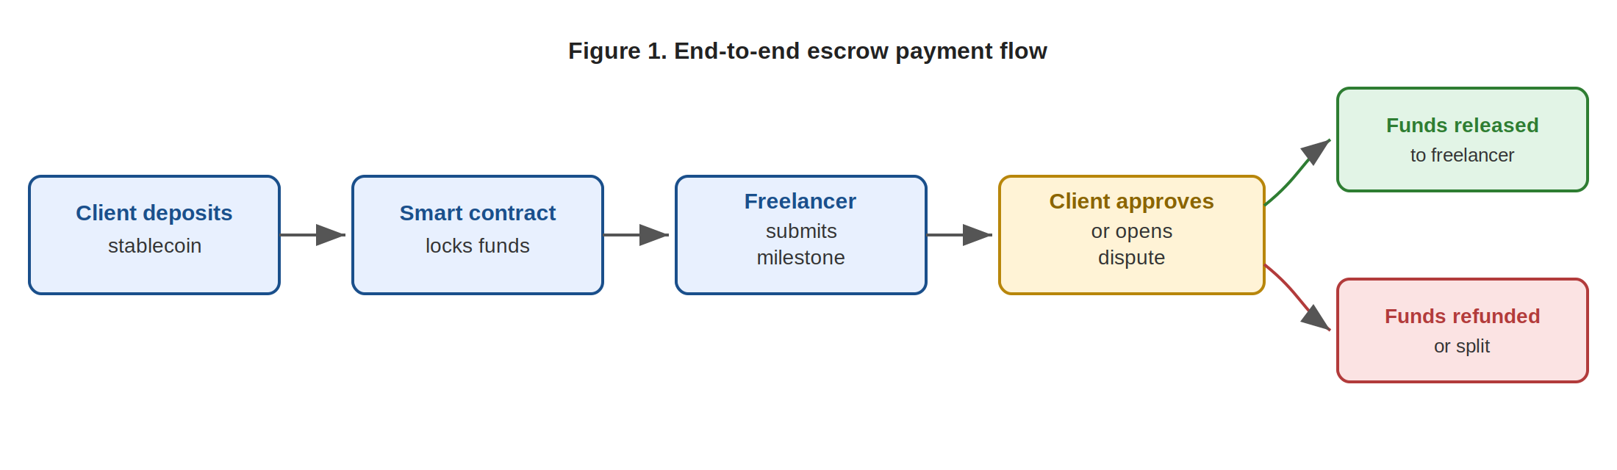
Figure 1. The end-to-end escrow payment flow, from deposit to release or refund.

3.2 What the platform abstracts away
Blockchain user experience is a real adoption barrier, so the platform deliberately hides complexity. Wallet connection is guided; contract states are translated into plain-language statuses (“Funds locked”, “Awaiting your approval”, “In dispute”); gas costs are estimated and explained before any signature; and business users get dashboards with invoices and reporting rather than raw transaction hashes. Crucially, the platform does not need to operate its own blockchain — it deploys on an existing chain or Layer 2 (Section 11).

3.3 High-level component view
At the highest level the system has five blocks: the web application; the backend / API and off-chain database; the wallet and stablecoin layer; the escrow smart contracts; and the indexer / off-chain storage. Section 6 expands each of these and explains why each exists.

4. Stakeholders, Entities, and Use Cases
This section transforms the entities identified in the project’s Blockchain Canvas into a stakeholder analysis. The protocol involves six core entities, each with a distinct incentive and responsibility.

Entity | Incentive | Responsibility / on-chain role
Client (payer) | Protection against non-delivery; funds released only after milestone approval. | Signs the deposit and the approval transactions. One per base contract.
Freelancer (payee) | Verifiable proof that funds exist before work starts; no chargeback risk. | Signs milestone-submission transactions. One per base contract.
Escrow smart contract | None — it is an autonomous agent executing fixed rules. | Holds locked funds, enforces state transitions and access control.
Arbitrator | Earns a share of dispute fees for ruling fairly and promptly. | Signs the dispute-resolution transaction. Platform moderator or decentralized panel.
Stablecoin issuer | Maintains the fiat peg and the value of its token. | Operates the ERC-20 token (e.g. Circle/USDC, Tether/USDT). External party.
Network validators | Block rewards / fees of the underlying chain. | Validate and finalize all escrow transactions. The platform runs no chain of its own.
Table 2. Core stakeholders, their incentives, and on-chain roles.

4.1 Who signs transactions, who does not
A useful distinction is between entities that sign on-chain transactions and entities that only consume off-chain services. The client, freelancer, and arbitrator hold wallets and sign transactions; the stablecoin issuer and validators participate in the chain independently of the platform. The platform itself is mostly off-chain: it operates the web application, indexer, and database, and it may hold a limited administrative key (Section 9) — but it cannot unilaterally move escrowed funds.

4.2 Representative use cases

Use case A — Normal milestone delivery
A startup hires a developer for a three-milestone project. Funds for all three milestones are deposited at creation. The developer submits milestone one; the client approves; the contract releases milestone one’s amount automatically. The cycle repeats. No dispute is ever opened. This is the expected majority path.

Use case B — Late delivery and refund
A freelancer misses a milestone deadline and stops responding. After the deadline passes, the client triggers the deadline-refund path for the unfunded or unsubmitted milestone, recovering the locked amount. Already-approved milestones remain paid.

Use case C — Disputed delivery
A freelancer submits a milestone and marks it complete; the client rejects it as not matching the agreed scope. The client opens a dispute, paying a dispute fee and submitting evidence. The disputed amount stays locked. An arbitrator reviews evidence from both sides and rules — pay, refund, or split. The contract executes the verdict (Section 10).

5. Why Blockchain Is Necessary
This is the pivotal section. The lecture material is explicit: if the question “why blockchain?” cannot be answered convincingly by comparing concrete alternatives, the project probably does not need a blockchain. We take that test seriously and answer it directly.

5.1 The alternatives, and why each falls short
A traditional database. A centralized SQL database can absolutely record escrow status, milestones, and approvals. What it cannot do is remove the need to trust the company that controls the database. The records can be edited, the schema can be changed, and the funds — which still sit in an ordinary bank account — can be frozen or moved by the operator. A database gives a record; it does not give custody guarantees that both adversarial parties can verify.
A traditional payment provider. Bank transfers and card processors move money well, but they cannot provide transparent, programmable escrow between strangers in different jurisdictions without themselves acting as the central custodian and arbiter. Card payments additionally carry chargeback risk that can reverse a settled payment months later — catastrophic for a freelancer who has already delivered.
A centralized freelance platform. This is the closest existing solution, and it works — but as Section 1 argued, it only relocates trust. The custody ledger stays private and discretionary.

5.2 What a smart contract changes
A smart contract changes the trust model, not merely the technology. Once funds are deposited, the release rules are publicly defined in deployed bytecode and executed by the network. The platform can provide usability and support, but it cannot secretly alter the financial state of the escrow. Specifically, the protocol relies on five properties that the lecture identifies as the genuine value of blockchain:
- Immutability — the deployed escrow rules and the history of deposits, approvals, and releases cannot be silently rewritten.
- Decentralization — no single private party holds custody of the funds or can unilaterally decide their release.
- Digital signatures — only the client can approve, only the freelancer can submit, only the arbitrator can resolve — enforced cryptographically, not by policy.
- Programmable token transfer — stablecoin movement is bound to milestone logic; payment is a consequence of an on-chain condition, not a manual instruction.
- Transparent state — both parties, and only those parties when appropriate, can independently verify the escrow’s exact state at any time.

5.3 Honest scope: what blockchain does not solve
Intellectual honesty is required here. Blockchain does not verify the real-world identity of the parties, does not enforce a legal judgment in any national court, and does not evaluate whether delivered work is actually good. Those problems are handled off-chain — by optional KYC, by terms of service, and by the human arbitration layer respectively. The contract executes a verdict; it never forms one about subjective quality.

5.4 Feature comparison
Table 3 compares the four approaches across the dimensions that matter for this use case.

Property | Bank transfer | Card / PayPal | Centralized escrow | Blockchain escrow
Funds held conditionally | No | No | Yes | Yes
Custody verifiable by both parties | No | No | No (private ledger) | Yes (public state)
Release rules programmable | No | No | Partial / opaque | Yes
Chargeback / reversal risk | Low | High | Medium | None on-chain
Cross-border by design | Slow / costly | Partial | Yes | Yes
Trust placed in a private custodian | Bank | Processor | Platform | None for custody
Table 3. Comparison of escrow approaches. Blockchain escrow is justified by verifiable custody and programmable release, not by novelty.

6. Technical Architecture
The system uses a hybrid architecture. Financial commitments and state transitions that must be auditable live on-chain; everything else — large files, profiles, messages, identity data — lives off-chain for cost, privacy, and scalability reasons (the boundary is defined precisely in Section 8). Figure 2 shows the four layers and how they interact.
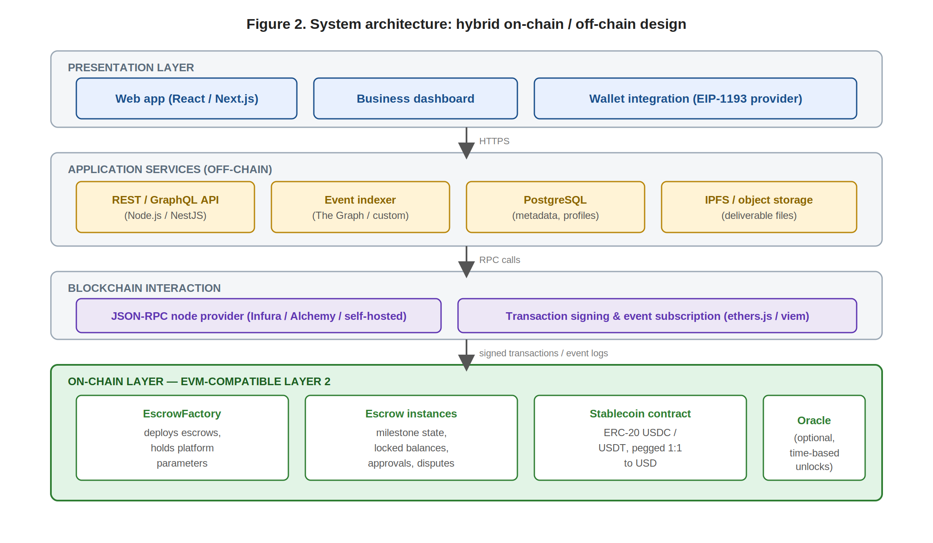
Figure 2. Hybrid architecture: presentation, application services, blockchain interaction, and the on-chain layer.

6.1 The on-chain layer
The on-chain layer stores only what must be auditable: escrow creation, deposits, milestone amounts, approvals, releases, refund decisions, and dispute verdicts. It consists of the escrow smart contracts (Section 7), the external stablecoin ERC-20 contract, and an optional oracle for time-based unlock conditions. It is deployed on an EVM-compatible Layer 2; the protocol never operates its own blockchain.

6.2 The off-chain layer
The off-chain layer stores user profiles, business metadata, in-app messages, KYC data where required, and deliverable files. It exists because putting any of this on-chain would be prohibitively expensive, would permanently expose private data, and would not benefit from on-chain immutability. When a deliverable must be verifiable, the file stays off-chain and only its cryptographic hash or IPFS content identifier is anchored on-chain.

6.3 The application and presentation layers
The web application connects users to the escrow contracts through wallet integrations and renders contract events as a readable interface. The backend exposes a REST/GraphQL API, manages off-chain records, and — critically — runs an event indexer that transforms raw on-chain logs into fast queries for dashboards and notifications. Without an indexer, every dashboard screen would require slow, repeated direct calls to the blockchain.

6.4 Suggested technology stack
Each component below is chosen for maturity and ecosystem support; the rationale, not just the name, is given.

Layer | Suggested technology | Why this choice
Smart contracts | Solidity on an EVM-compatible Layer 2 | Largest auditor pool, mature tooling, and audited token standards reduce security risk.
Frontend | React / Next.js | Server-side rendering for fast load; rich wallet-connector libraries available.
Backend / API | Node.js / NestJS | Shares the JavaScript/TypeScript toolchain with the frontend and Ethereum libraries.
Off-chain database | PostgreSQL | Reliable relational store for profiles, metadata, and indexed event projections.
File storage | IPFS or object storage | Content-addressed storage; the on-chain hash proves a file was not altered.
Event indexing | The Graph or a custom indexer | Converts contract logs into queryable data so the UI never polls the chain directly.
Chain access | ethers.js / viem + RPC provider | Standard libraries for signing transactions and subscribing to events.
Table 4. Suggested technology stack with rationale per component.

6.5 Data flow
The canonical data flow is: create contract → deposit → submit deliverable → approve or reject → release or refund. Each step is a transaction that emits an event; the indexer consumes the event, updates the off-chain projection, and the backend sends notifications. The user interface therefore stays responsive while reflecting authoritative on-chain state.

7. Smart Contract Design
The smart-contract layer is organized around two contract types: a single EscrowFactory and many individual Escrow instances. This section specifies the contracts in enough detail to convince a technical reader that the logic is implementable and conservative.

7.1 EscrowFactory
The factory deploys new escrow instances and holds platform-wide parameters: the fee receiver address, the platform fee rate, the set of supported stablecoin addresses, and the address(es) authorized to act as arbitrators. Centralizing these parameters in the factory means a new escrow is created with correct, consistent settings and that the supported-token allowlist (a security control, see Section 9) is enforced at creation time.

7.2 Escrow instance state
Each Escrow contract stores: the client address, the freelancer address, the stablecoin token address, an ordered list of milestones, the current status, the deposited balance, per-milestone deadlines, and the dispute status. Each milestone holds its own amount, deadline, state, and — once submitted — the content hash of the deliverable.

7.3 Core functions and access control
The contract exposes the following functions. Access control is strict: each function checks msg.sender against the role allowed to call it, and against the current state.

Function | Who may call it | Effect
createEscrow(...) | Client (via factory) | Deploys an escrow with the parties, token, and milestone list.
deposit() | Client | Transfers stablecoin into the contract; locks funds; moves milestones to Funded.
submitMilestone(id, hash) | Freelancer | Marks a funded milestone as Submitted and records the deliverable hash.
approveMilestone(id) | Client | Approves a submitted milestone, enabling release.
requestChanges(id) | Client | Returns a submitted milestone to the freelancer for rework.
releasePayment(id) | Client or freelancer | Transfers an approved milestone’s amount (minus fee) to the freelancer.
openDispute(id) | Client or freelancer | Locks the disputed milestone pending arbitration; records a dispute fee/stake.
resolveDispute(id, verdict) | Arbitrator only | Executes the verdict: pay, refund, or split the disputed amount.
refund(id) | Client (after deadline) | Returns a funded-but-undelivered milestone’s amount after its deadline.
cancelBeforeFunding() | Client | Cancels an escrow that has been created but not yet funded.
Table 5. Core escrow functions, their authorized callers, and effects.

7.4 The milestone state machine
Each milestone is a small, well-defined state machine. A milestone can be Created, Funded, Submitted, Approved, Released, Disputed, Resolved, or Refunded. Only legal transitions are permitted; for example, funds can only be released from a milestone that is Approved or whose dispute has been Resolved in the freelancer’s favor. Figure 3 shows the complete machine.
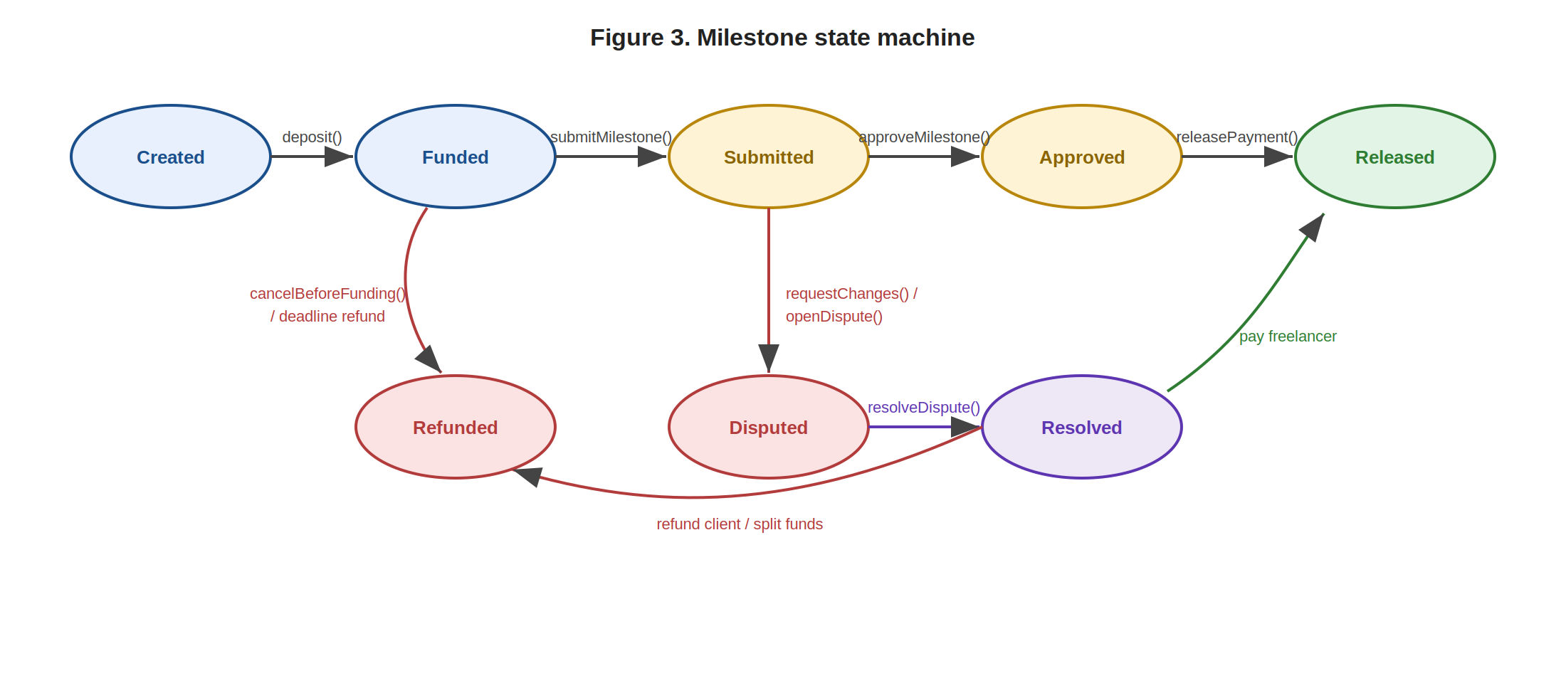
Figure 3. Milestone state machine. Only legal transitions are permitted; disputed funds cannot leave the contract without a verdict.

7.5 Emitted events
Every meaningful action emits an event so the off-chain indexer can reconstruct state without trusting any intermediary. The events are: EscrowCreated, FundDeposited, MilestoneSubmitted, MilestoneApproved, PaymentReleased, DisputeOpened, DisputeResolved, and RefundIssued. Dashboards, notifications, and reporting are all built from this event stream.

7.6 Conservative design principles
The first implementation deliberately favors simplicity over feature richness. It uses a small number of audited stablecoin interfaces, applies the checks-effects-interactions pattern and a reentrancy guard around every token transfer, and avoids speculative on-chain features. Security rather than cleverness is the design priority — the contracts custody real money.

8. Data Model and Processing
The guiding principle is to store only the minimum necessary data on-chain. Data that affects fund custody and must be auditable goes on-chain; everything else stays off-chain. Putting the wrong data on-chain is expensive, permanently public, and irreversible.

8.1 On-chain vs off-chain classification

Data | Location | Why
Contract state, milestone status | On-chain | Determines fund custody; must be tamper-proof and auditable.
Locked amounts, approvals, dispute verdicts | On-chain | Directly control who receives money; cannot be discretionary.
Deliverable file hash / IPFS CID | On-chain (hash only) | Proves the file was not altered without storing the file itself.
Deliverable files, descriptions | Off-chain | Too large and costly for on-chain storage.
Chat messages, support tickets | Off-chain | Operational data; no custody impact; immutability not desired.
User profiles, KYC / identity data | Off-chain | Private personal data must never be public or permanent.
Table 6. On-chain / off-chain data classification.

8.2 Inputs and outputs
On-chain inputs: client and freelancer addresses, the token address, milestone amounts and identifiers, approval or rejection signals, and the dispute verdict. On-chain outputs: emitted events, state changes, and stablecoin transfers.
Off-chain inputs: deliverable files, milestone descriptions, in-app messages, identity data, and support tickets. Off-chain outputs: dashboard projections, notifications, invoices, and reports.

8.3 Processing model
Processing is split cleanly. The smart contract executes the escrow rules — milestone checks, access control, and fund routing — as distributed, deterministic computation verified by the network’s consensus. The backend never computes custody decisions; it listens to emitted events, updates dashboards, sends notifications, and manages off-chain records. An optional oracle (e.g. Chainlink) can supply real-world data such as a time-based unlock if a milestone needs an automatic deadline action. This separation means a bug in the off-chain code can never misdirect escrowed funds.

9. Security Model and Risk Controls
Because the platform controls financial flows, the contracts must be designed conservatively and the risks must be acknowledged in full. Risks fall into three groups: smart-contract risks, user risks, and business/legal risks.

9.1 Smart-contract risks
The principal contract-level risks are logic bugs, reentrancy during token transfers, incorrect access control, funds becoming permanently stuck, and incorrect assumptions about a token’s behavior (for instance, fee-on-transfer or non-standard ERC-20 implementations). Mitigations are: keeping the first version small and simple; using the checks-effects-interactions pattern with an explicit reentrancy guard; restricting supported tokens to a short, audited allowlist; and writing exhaustive unit and integration tests before any mainnet deployment.

9.2 User risks
Users can lose funds in ways the contract cannot prevent: sending to a wrong wallet address, falling for phishing sites, misunderstanding gas fees, or losing their private keys. The product mitigates these with guided onboarding, explicit confirmation screens before every signature, prominently displayed and verifiable contract addresses, and plain-language warnings — but it states clearly that self-custody carries irreducible user responsibility.

9.3 Business and legal risks
Beyond code, the protocol faces stablecoin-availability risk in some jurisdictions, evolving compliance obligations, the legitimacy of disputes, and chargeback exposure on the fiat on-ramp side (before value becomes stablecoin). These are addressed through staged geographic rollout, conservative compliance posture, and clear terms of service — and they are listed honestly among the limitations in Section 14.

9.4 Risk matrix

Risk | Impact | Likelihood | Mitigation
Smart-contract bug | High | Medium | Independent audits, testnet pilot, bug bounty, minimal logic.
Reentrancy on transfer | High | Low | Checks-effects-interactions pattern plus reentrancy guard.
Wrong / non-standard token | Medium | Low | Short audited allowlist enforced by the factory.
User key loss / phishing | High | Medium | Guided onboarding, signature confirmations, verified addresses.
Stablecoin de-peg / freeze | High | Low | Support multiple issuers; monitor peg; clear user disclosure.
Regulatory / compliance change | High | Medium | Staged rollout by jurisdiction; conservative compliance posture.
Admin-key compromise | High | Low | Multisig admin control; tightly scoped, transparent admin powers.
Table 7. Risk matrix with impact, likelihood, and mitigation.

9.5 Administrative powers and upgradeability
Administrative capabilities exist for genuine operational needs — pausing new escrow creation in an emergency, updating the supported-token allowlist as new audited stablecoins emerge, adjusting the platform fee within its hard-coded maximum, and rotating the fee receiver address. These powers are held by a 3-of-5 multisig wallet, never a single key. The five signers are drawn from independent roles (e.g. founding team, legal counsel, an external advisor, a security partner, and a dedicated operations key held in cold storage) so that no single individual or organizational faction can act unilaterally. Two further controls bound this power:
- Scope limitation. The admin role can never seize, redirect, freeze, or modify the balance of any individual escrow. Funds already locked in an existing Escrow instance are governed exclusively by that instance's deployed code and the cryptographic signatures of its client, freelancer, and assigned arbitrator. There is no admin function that takes an escrow address as a parameter.
- Timelock. All non-emergency admin actions — fee changes, allowlist additions, fee-receiver updates — are subject to a 48-hour on-chain timelock between proposal and execution. This window gives users time to observe pending changes (the proposed action is publicly visible) and, if they object, to settle and withdraw from any active escrow before the change takes effect. The emergency pause is exempt from the timelock but can only stop new escrow creation; it cannot affect existing escrows.
Upgrade policy is conservative: individual Escrow instances are non-upgradeable proxies-less contracts so that users' locked funds are governed by exactly the bytecode they agreed to. The EscrowFactory itself is upgradeable through the same multisig + timelock process, but factory upgrades affect only escrows created after the upgrade — never retroactively. This design treats the admin role as a careful operator of shared infrastructure, not as a custodian of user funds, and it should be acknowledged in Section 5.3 as one of the residual trust assumptions the protocol does not fully eliminate.

10. Dispute Resolution Mechanism
Not every freelance deliverable can be judged by code — a contract cannot decide whether a logo is “good”. The protocol therefore uses a hybrid dispute model: the smart contract enforces that disputed funds stay locked, while the decision itself comes from a human or decentralized arbitration layer. Figure 4 shows the flow, with locked funds as the central, stable state.
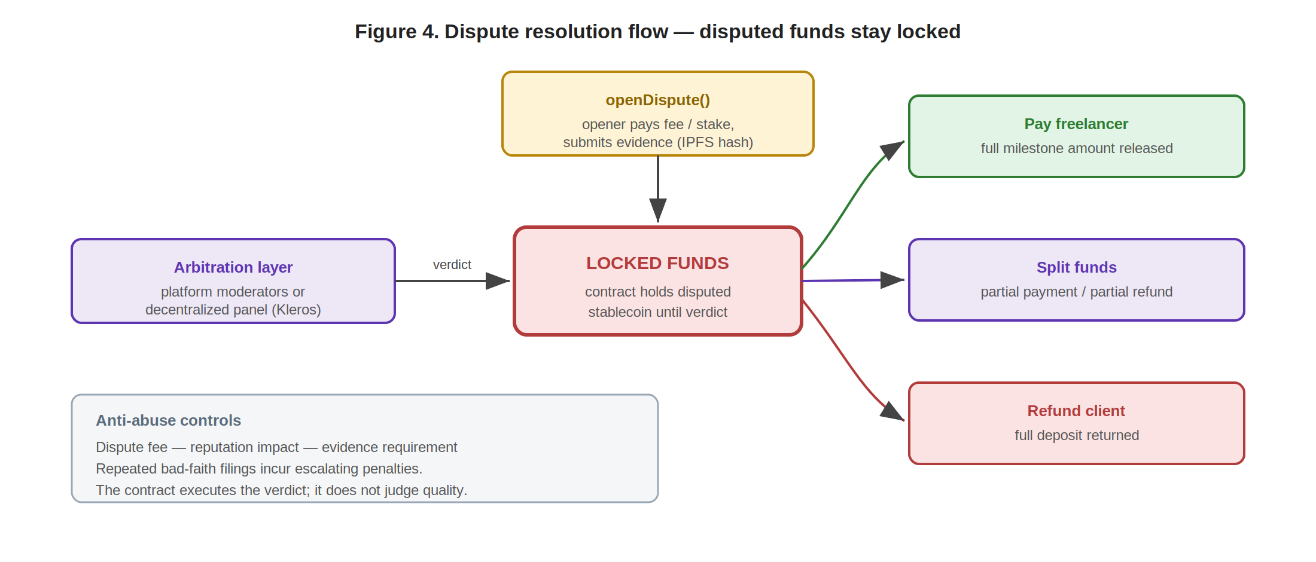
Figure 4. Dispute resolution flow. The contract holds the funds; the arbitration layer decides; the contract executes the verdict.

10.1 Opening a dispute
Either party may open a dispute on a submitted milestone before an approval deadline expires. Opening a dispute requires paying a dispute fee or posting a stake, and submitting evidence — typically off-chain files referenced by an on-chain hash. The fee/stake exists to discourage frivolous disputes; it is partially refundable to the party the arbitrator rules in favor of.

10.2 Resolution outcomes
An arbitrator can return one of three verdicts, which the contract then executes: pay the freelancer the full milestone amount; refund the client the full amount; or split the funds in a stated proportion. Where the product supports it, a fourth path — request rework — can return the milestone to the freelancer instead of a final verdict.

10.3 Anti-abuse controls
- Dispute fee / stake — a real cost to opening a dispute deters bad-faith filings.
- Reputation impact — dispute outcomes feed an off-chain reputation signal visible to future counterparties.
- Evidence requirement — a dispute with no submitted evidence can be summarily resolved against the opener.
- Escalating penalties — repeated bad-faith disputes from the same account incur progressively larger fees or stakes.

10.4 Evolution: from managed to decentralized arbitration
The first version uses platform-managed arbitration — trained moderators — for simplicity and speed. Later versions can integrate a decentralized arbitration protocol such as Kleros, where a randomly selected, economically incentivized juror panel rules, improving neutrality and scalability. The protocol is honest that the early system is moderated by the platform; it does not claim total decentralization it has not yet earned. In every version, the contract executes the verdict but never judges work quality itself.

11. Scalability, Infrastructure, and Performance
The platform does not require its own blockchain. It deploys on an EVM-compatible Layer 2 with low transaction costs and stablecoin support. This choice reduces development complexity while preserving the security and transparency of smart contracts.

11.1 Why a Layer 2
A Layer 2 network is preferable for three concrete reasons: transaction fees are low enough that paying a fee per milestone does not erode small contracts; confirmation is fast enough for a responsive user experience; and wallet tooling, stablecoin deployments, and indexers already exist on major L2s, so no custom infrastructure is needed. Building a dedicated chain would add enormous cost and security burden for no proportionate benefit.

11.2 Where the real scalability challenge lies
Each escrow produces only a small, bounded number of transactions — a deposit, a few submissions and approvals, perhaps a dispute. The system is therefore not computation-heavy. The actual scaling challenge is a high number of concurrent escrows generating events, plus the indexing, notification, and dashboard-query load that comes with many simultaneous users. That load is an off-chain engineering problem, solved with standard techniques.

11.3 Blockchain latency vs application latency
The two must not be confused. Blockchain confirmation has inherent latency; the web application does not have to inherit it. The UI shows explicit pending-transaction states (“Deposit confirming…”) and updates optimistically once a transaction is broadcast, then confirms when the event is indexed. The perceived experience stays smooth even when on-chain finality takes seconds.

11.4 Indexing and caching
Users never query the blockchain directly for routine screens. The event indexer maintains an off-chain projection of all escrow state; dashboards and notifications read from that cached projection. Direct chain reads are reserved for the moments a user explicitly wants to verify state independently. Off-chain file storage further reduces cost and protects privacy, since deliverables never touch the chain.

11.5 Performance assumptions

Operation | On-chain tx count | Expected bottleneck
Create + fund an escrow | 2 (+1 token approval) | L2 confirmation time; mitigated by pending-state UI.
Submit + approve a milestone | 2 | None significant at expected volumes.
Release a payment | 1 | Token transfer cost; negligible on an L2.
Open + resolve a dispute | 2 | Human arbitration time, not on-chain throughput.
Render dashboards (many users) | 0 (indexed reads) | Indexer throughput and database query load.
Table 8. Performance assumptions per operation. The dominant cost is off-chain indexing, not on-chain computation.

12. Innovation and Differentiation
The innovation here is not simply accepting cryptocurrency payments. It is the combination of four elements into escrow-as-programmable-infrastructure: stablecoin settlement, milestone-based escrow, a verifiable contract state, and a dispute workflow built specifically for small cross-border service contracts. Users can verify that funds are locked, milestones can be paid independently, and the release logic is fixed before work starts.

12.1 Versus ordinary crypto transfers
A direct wallet-to-wallet stablecoin transfer is fast and cheap but protects neither party: it is exactly as risky as a bank transfer with no recourse. TrustPay Escrow adds the conditional, milestone-bound custody that a raw transfer lacks.

12.2 Versus centralized freelance platforms
A centralized platform’s interface helps users, and so does ours — but on a centralized platform the fund state is enforced by a private, opaque ledger. Here it is enforced transparently by smart contracts the parties can audit. The platform is a facilitator, not a custodian.

12.3 Versus banks and payment processors
Banks and processors are not programmable and are not cross-border by design; escrow, where it exists, is a manual, jurisdiction-bound service. TrustPay Escrow’s escrow logic is programmable and cross-border by default, and fees are collected transparently in stablecoin at the moment of release.

12.4 Positioning
On a two-axis map of platform control (low to high) against custody transparency (low to high), banks and centralized platforms sit in the high-control, low-transparency quadrant; raw crypto transfers sit in the low-control, low-protection quadrant. TrustPay Escrow targets the high-transparency quadrant with only the minimum necessary platform control — and is candid that, until decentralized arbitration is integrated, dispute resolution keeps the protocol from claiming the extreme low-control corner.

13. Business Model and Go-to-Market Connection
Although this is a technical paper, the technical design must support a viable business. This section maps the project’s Business Model Canvas onto the architecture and shows that the two are consistent.

13.1 Revenue streams
- Transaction fee — a fee of roughly 0.5–1.5% on each completed escrow, collected transparently in stablecoin at release.
- Business subscription — a paid tier for businesses with advanced features, priority support, and an SLA.
- Dispute resolution fees — fees for premium arbitration, shared with arbitrators to incentivize fair, timely rulings.

13.2 Why the technical design supports the business
The architecture and the revenue model are aligned by construction. Because the escrow contract already mediates every release, the platform fee can be deducted at exactly that point — collected automatically, transparently, and in stablecoin, with no separate billing system and no intermediary. Business accounts are simply richer off-chain dashboards over the same on-chain escrows. The fee logic is a few lines in a contract that already exists for custody reasons.

13.3 Cost structure
Key costs are: engineering salaries and cloud/node infrastructure; smart-contract development and recurring security audits; node and API providers; marketing and growth; user support; and compliance. Audits and compliance are treated as non-negotiable line items, not optional extras, because the protocol custodies user funds.

13.4 Channels and customer acquisition
The primary channels are the web platform itself, crypto wallet integrations, and partnerships with fiat on/off-ramp providers that let users enter and exit without deep crypto knowledge. Customer acquisition focuses on communities of international freelancers, startup and small-business communities, agencies, remote-work platforms, and educational content explaining stablecoin payments to a non-crypto audience.

14. Roadmap, Limitations, and Conclusion

14.1 Roadmap
Development is staged so that each phase depends on the verified success of the previous one — a deliberately dependency-driven plan, shown in Figure 5.
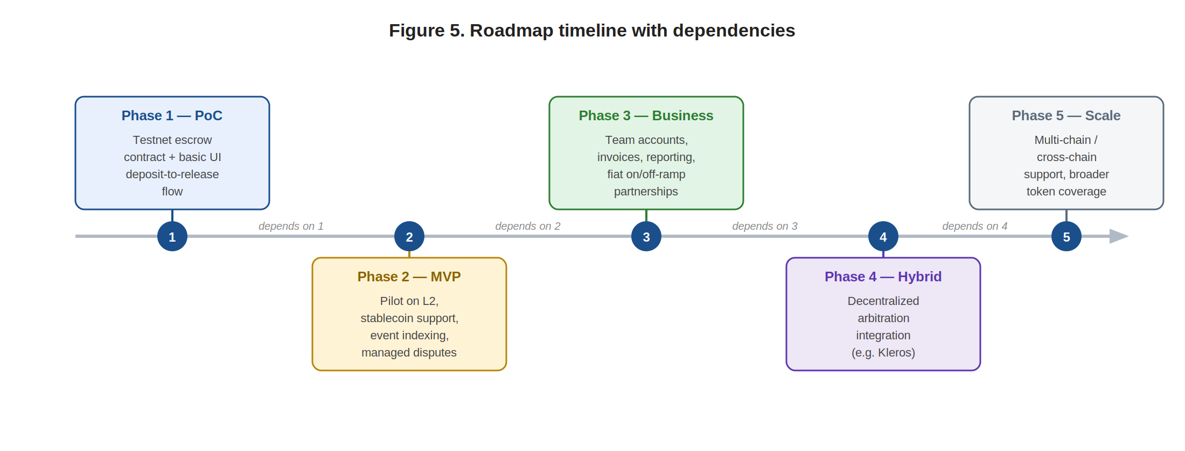
Figure 5. Roadmap timeline with explicit dependencies between phases.
- Phase 1 — Proof of concept. A testnet escrow contract, a basic web interface, and a complete flow from deposit to milestone release.
- Phase 2 — MVP / pilot. Deployment on a low-cost L2 with real stablecoin support, an event indexer, and platform-managed dispute resolution.
- Phase 3 — Business tier. Team accounts, invoices, reporting, and fiat on/off-ramp partnerships.
- Phase 4 — Hybrid arbitration. Integration of a decentralized arbitration protocol alongside platform moderation.
- Phase 5 — Scale. Multi-chain or cross-chain support and broader stablecoin coverage.

14.2 Honest limitations
Credibility requires stating what remains unsolved. The protocol depends on legal and regulatory conditions that vary by country and are still evolving. It carries stablecoin risk — a de-peg or issuer freeze would affect locked value. It cannot evaluate subjective work quality; that always requires a human arbitrator. Smart-contract bugs remain possible despite audits. And onboarding non-crypto users to wallets and gas is a genuine friction that good product design can reduce but not eliminate. None of these is hidden; each is mapped to a mitigation in Sections 9, 10, and this roadmap.

14.3 Conclusion
TrustPay Escrow applies blockchain exactly where it adds value and nowhere else. Blockchain provides what the use case genuinely needs — verifiable custody, transparent state, and programmable release between parties with zero prior trust — while off-chain systems handle usability, private data, and file storage, which they do better. The protocol is feasible with present-day infrastructure: audited token standards, EVM-compatible Layer 2 networks, mature wallet tooling, and established indexing services. It requires no new blockchain and no speculative technology.
The central thesis stands: a stablecoin smart-contract escrow can meaningfully reduce the trust and settlement friction of international freelance work by locking funds transparently and releasing them through programmable milestone rules. It does not eliminate every legal or operational risk — and this paper has been careful never to claim that it does. What it offers is a payment layer for cross-border service work in which neither side has to trust a private intermediary blindly. That is a concrete, buildable improvement, and it is the project we propose to build.

Appendix A — Index of Diagrams
The following diagrams appear in this document and may be reused in the short white paper and the pitch presentation:
- Figure 1 — End-to-end escrow payment flow (Section 3).
- Figure 2 — System architecture, on-chain and off-chain components (Section 6).
- Figure 3 — Milestone state machine (Section 7).
- Figure 4 — Dispute resolution flow with locked funds as the central state (Section 10).
- Figure 5 — Roadmap timeline with dependencies (Section 14).
- Tables 1–8 — problem map, stakeholders, escrow comparison, technology stack, escrow functions, data classification, risk matrix, and performance assumptions.

Appendix B — Terminology
The following terms are used consistently throughout this white paper:

Term | Definition
Client | The payer; the party that funds the escrow and approves milestones.
Freelancer | The payee; the party that performs the work and submits milestones.
Escrow | The smart contract that holds locked funds and enforces release rules.
Milestone | A defined unit of work with its own amount, deadline, and state.
Locked funds | Stablecoin held by the contract and not releasable until conditions are met.
Approval / Release | Client confirmation of a milestone, and the resulting transfer to the freelancer.
Refund | Return of locked funds to the client after a deadline or dispute verdict.
Dispute / Arbitrator | A contested milestone, and the human or decentralized party that rules on it.
Stablecoin | A fiat-pegged ERC-20 token (e.g. USDC, USDT) used for settlement.
On-chain / Off-chain | Data stored on the blockchain versus data stored in conventional systems.
Event indexer | A service that turns on-chain event logs into fast, queryable off-chain data.
Wallet integration | The connection between a user’s self-custody wallet and the platform.
Table B1. Consistent terminology for the white paper.

Appendix C — References and Inspiration
This document follows the audience-targeted white-paper strategy taught in INE5458 and adopts the living-document format of the Ethereum white paper. Two canonical references informed its structure and tone:
- S. Nakamoto, “Bitcoin: A Peer-to-Peer Electronic Cash System” — https://bitcoin.org/bitcoin.pdf
- V. Buterin et al., “Ethereum White Paper” (living document) — https://ethereum.org/en/whitepaper/

