Julio Cesar Correa
DBA Oracle
How-to
Aplicação do Patch 10.2.0.5 no Grid Control Server 10.2.0.1.1
O software(mídia) para instalação do patch 10.2.0.5 pode ser encontrado em :
http://www.oracle.com/technology/software/products/oem/htdocs/linuxsoft.html
O procedimento de aplicações deste patch está em :
http://www.oracle.com/technology/software/products/oem/htdocs/gridR5_10205_readme.html
Aplicando o patch
Obs .Certifique-se de que os serviços do OMS,Agent e banco de dados não estejam ativos.
[oracle@suecia patch10205]$ ps -ef|grep ora
root 3190 3165 0 08:13 ? 00:00:04 hald-addon-storage: polling /dev/hdc
oracle 14473 1 0 09:54 ? 00:00:00 /usr/libexec/bonobo-activation-server --ac-activate --ior-output-fd=16
root 14633 1816 0 09:55 ? 00:00:00 sshd: oracle [priv]
oracle 14635 14633 0 09:55 ? 00:00:00 sshd: oracle@notty
oracle 14636 14635 0 09:55 ? 00:00:00 /usr/bin/xterm -ls -display localhost:10.0
oracle 14655 14636 0 09:55 pts/1 00:00:00 -bash
root 15846 1816 0 10:03 ? 00:00:00 sshd: oracle [priv]
oracle 15848 15846 0 10:03 ? 00:00:00 sshd: oracle@pts/2
oracle 15849 15848 0 10:03 pts/2 00:00:00 -bash
oracle 15910 15849 0 10:14 pts/2 00:00:00 ps -ef
oracle 15911 15849 0 10:14 pts/2 00:00:00 grep ora
Descompactação dos arquivos
Execute o unzip nos dois arquivos :
[oracle@suecia ~]$ cd /u01/sw/grid_control/
[oracle@suecia grid_control]$ ls -l
total 4016004
drwxr-xr-x 3 oracle oinstall 4096 Jan 6 12:24 10.2_base
-rw-r--r-- 1 oracle oinstall 1138311452 Feb 23 2009 V15627-01_1of2.zip
-rw-r--r-- 1 oracle oinstall 1137845265 Feb 23 2009 V15627-01_2of2.zip
-rw-r--r-- 1 oracle oinstall 1832188952 May 9 2009 V16617-01.zip
[oracle@suecia grid_control]$ mkdir patch10205
[oracle@suecia grid_control]$ cp V15627-01_1of2.zip V15627-01_2of2.zip patch10205
[oracle@suecia grid_control]$ cd patch10205/
[oracle@suecia patch10205]$ ls -l
total 2225000
-rw-r--r-- 1 oracle oinstall 1138311452 Jan 7 10:05 V15627-01_1of2.zip
-rw-r--r-- 1 oracle oinstall 1137845265 Jan 7 10:06 V15627-01_2of2.zip
[oracle@suecia patch10205]$ mkdir part1 part2
[oracle@suecia patch10205]$ unzip V15627-01_1of2.zip -d part1
Archive: V15627-01_1of2.zip
extracting: part1/3731596.zip
extracting: part1/3822442.zip
inflating: part1/README.txt
creating: part1/doc/
inflating: part1/doc/BugList_EMGC_10.2.0.5.pdf
inflating: part1/doc/ReleaseNotes_EMGC_10.2.0.5.html
inflating: part1/doc/ReleaseNotes_EMGC_10.2.0.5.pdf
inflating: part1/doc/BugList_EMGC_10.2.0.5.html
[oracle@suecia patch10205]$
[oracle@suecia patch10205]$ unzip V15627-01_2of2.zip -d part2
Archive: V15627-01_2of2.zip
extracting: part2/p3731593_10205_LINUX.zip
[oracle@suecia patch10205]$
Baixamos do site da Oracle 2 arquivos identificados como xxx.1of2.zip e xxx2of2.zip.
Os arquivos da mídia 1 são usados para outro propósito como descrito no README :
- 3731596.zip is for patching Management Agent by staging the patch set. To understand how you can apply the Management Agent 10.2.0.5 patch set, refer to method 2 described in section 4.3.3 "Upgrading Management Agent - Multiple Hosts at a Time" of the Release Notes. The Release Notes can be found in the "doc" directory.
- 3822442.zip is for patching Management Agent by distributing the full patch set. To understand how to apply the Management Agent 10.2.0.5 patch set, refer to method 1 described in section 4.3.3 "Upgrading Management Agent - Multiple Hosts at a Time" of the Release Notes. The Release Notes can be found in the "doc" directory.
Fiz a descompactação do arquivo V15627-01_2of2.zip que gerará o arquivo p3731593_10205_LINUX.zip.Este é o arquivo que iremos utilizar para o upgrade !
É necessário fazer mais uma descompactação do arquivo gerado da mídia numero 2.
[oracle@suecia part2]$ unzip p3731593_10205_LINUX.zip
O resultado deve ser este aqui :
[oracle@suecia part2]$ ls
3731593 p3731593_10205_LINUX.zip
[oracle@suecia part2]$
Dentro do README do patch está uma informação muito IMPORTANTE :

Note: Make sure that you first upgrade the Oracle Management Service (OMS), and then the Management Agent before upgrading the
database that contains the Management repository (sysman schema)
Aplicando o patch no OMS e SYSMAN schema no repositório(database)
Setando a ORACLE_HOME do OMS
[oracle@suecia part2]$ export ORACLE_HOME=/u01/app/oms10g
[oracle@suecia ~]$ cd /u01/sw/grid_control/patch10205/part2/
[oracle@suecia part2]$ ls
3731593 p3731593_10205_LINUX.zip
[oracle@suecia part2]$ cd 3731593/
[oracle@suecia 3731593]$ ls
Disk1 preinstall.pl readme.html
[oracle@suecia 3731593]$ cd Disk1/
[oracle@suecia Disk1]$ ls
doc install oui response runInstaller stage
[oracle@suecia Disk1]$
Execute o runInstaller :
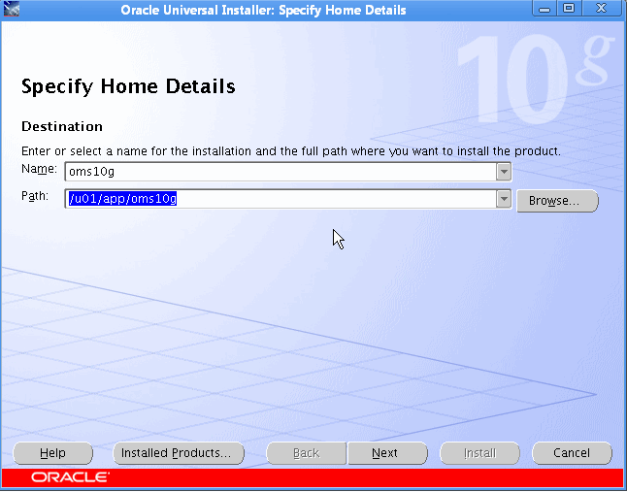
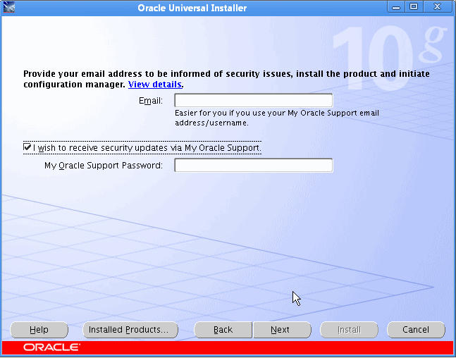
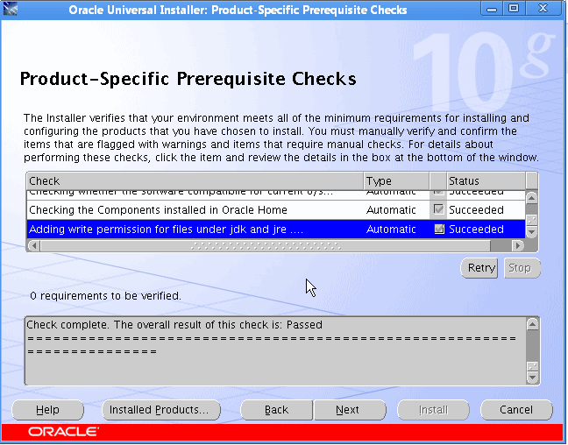
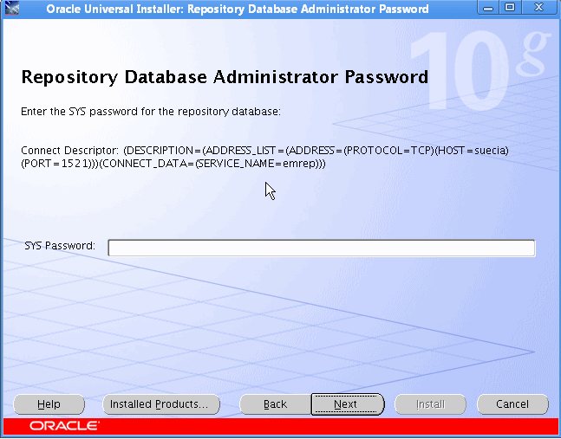
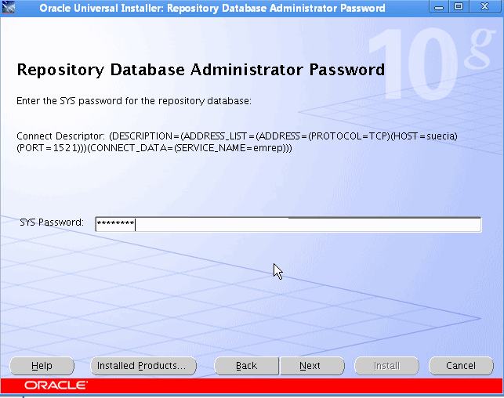
Obs. O banco dados do repositório(emrep) e o listener devem estar ativos e disponíveis.
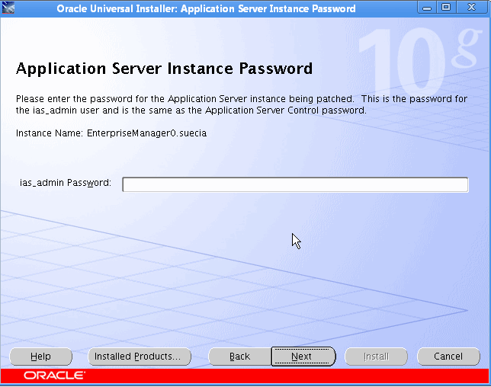
Obs. A senha usada foi definida para o usuário sysman no post anterior .
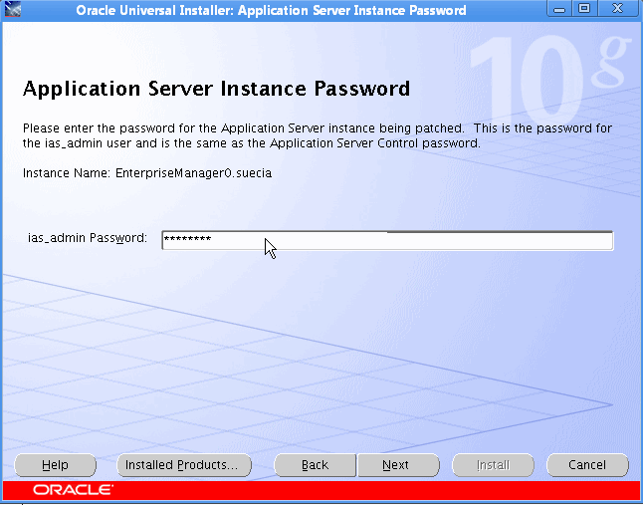
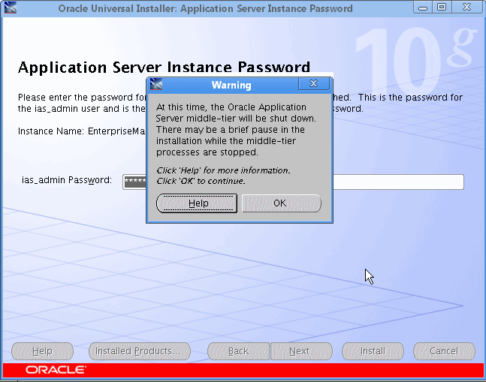
Depois de alguns instantes :
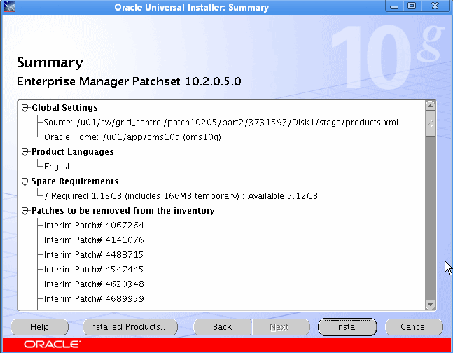
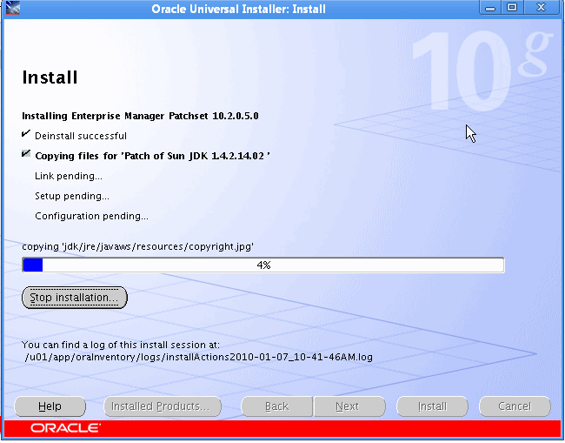
Depois de mais algum tempo :
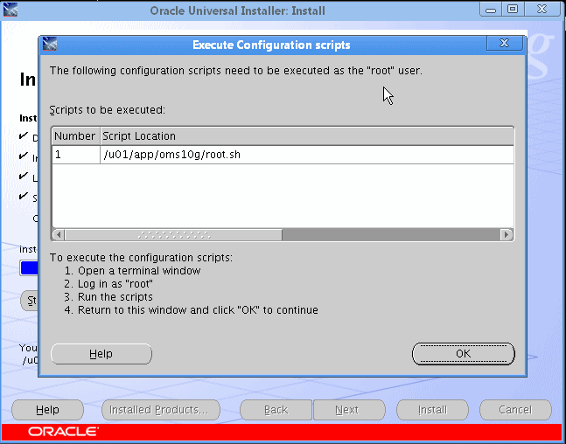
No prompt como root executar o root.sh:
[root@suecia /]# /u01/app/oms10g/root.sh
[root@suecia /]#
No OUI depois do Configuration Assistants :

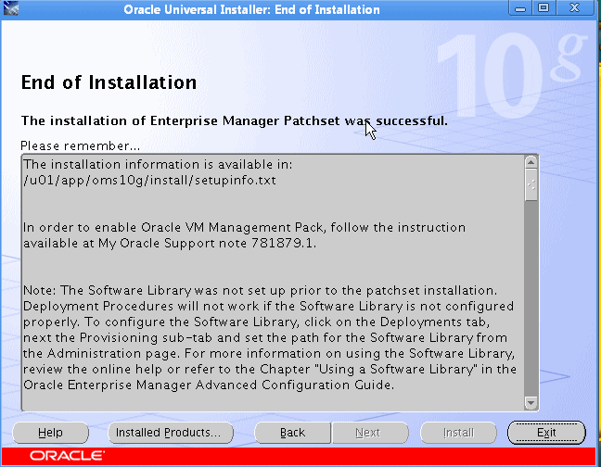
Aplicando o patch no Agent (Grid Server)
Setando o ORACLE_HOME do Agent0g
[oracle@suecia Disk1]$ export ORACLE_HOME=/u01/app/agent10g/
[oracle@suecia Disk1]$ echo $ORACLE_HOME
/u01/app/agent10g/
Executando o runInstaller :
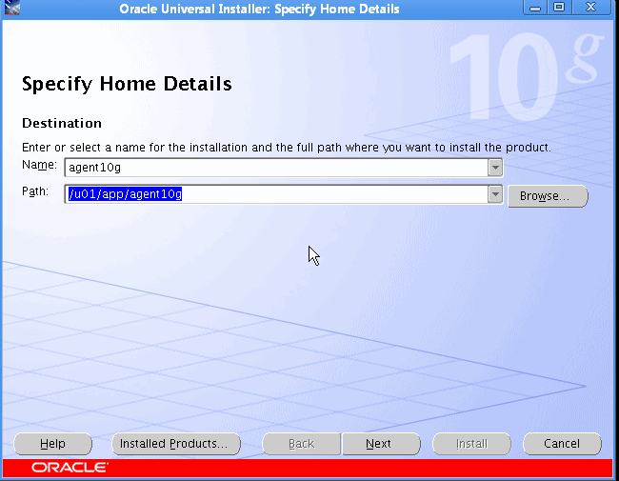
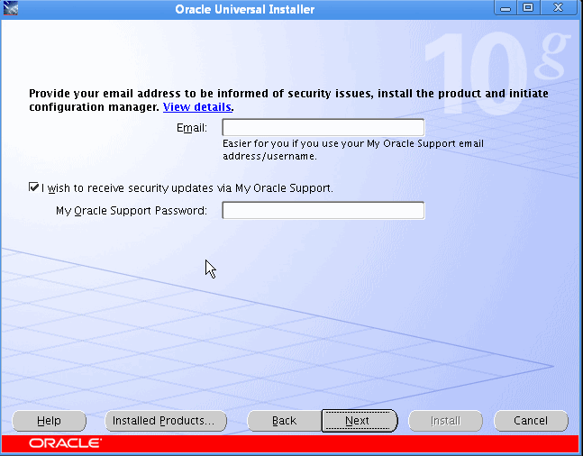
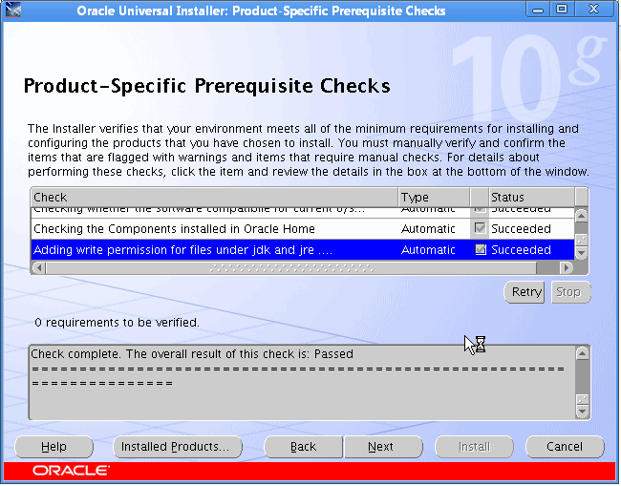
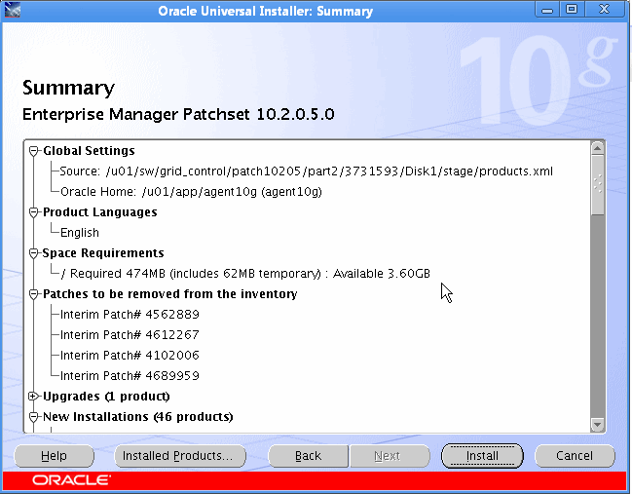
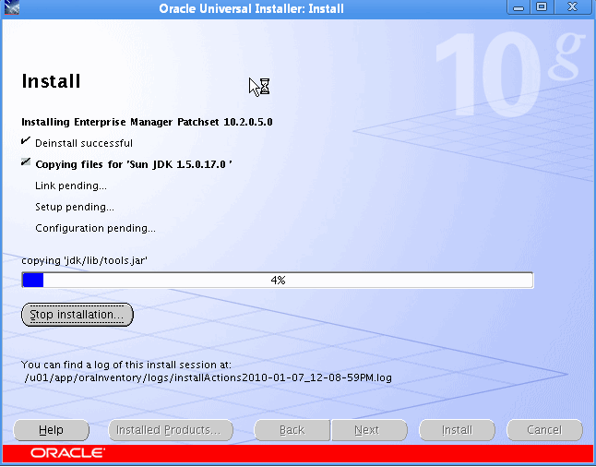
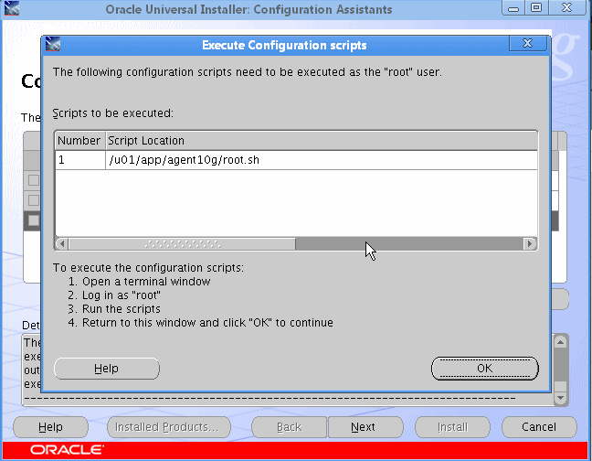
Executar o root.sh com o usuário root :
[root@suecia /]# /u01/app/agent10g/root.sh
Finished product-specific root actions.
[root@suecia /]#
[root@suecia /]#
Novamente no OUI :
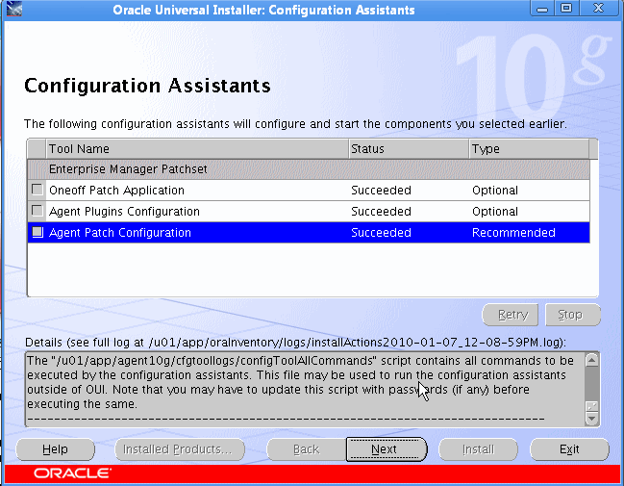
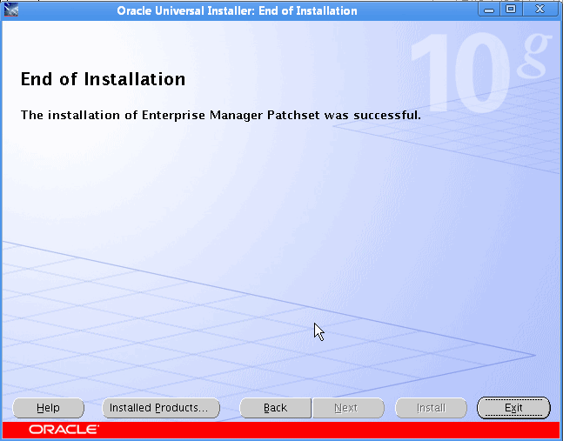
Patch instalado,vamos verificar os serviços e o banco de dados rodando
Banco de dados :
[oracle@suecia bin]$ ps -ef|grep pmon
oracle 3437 15849 0 12:24 pts/2 00:00:00 grep pmon
oracle 16555 1 0 10:48 ? 00:00:00 ora_pmon_emrep
Listener :
[oracle@suecia bin]$ ps -ef|grep tns
oracle 3443 15849 0 12:24 pts/2 00:00:00 grep tns
oracle 16478 1 0 10:47 ? 00:00:01 /u01/app/db10g/bin/tnslsnr LISTENER -inherit
OMS :
[oracle@suecia bin]$ ./opmnctl status
Processes in Instance: EnterpriseManager0.suecia
-------------------+--------------------+---------+---------
ias-component | process-type | pid | status
-------------------+--------------------+---------+---------
HTTP_Server | HTTP_Server | 23412 | Alive
LogLoader | logloaderd | N/A | Down
dcm-daemon | dcm-daemon | 24303 | Alive
OC4J | home | 23413 | Alive
OC4J | OC4J_EMPROV | 23414 | Alive
OC4J | OC4J_EM | 23415 | Alive
OC4J | OCMRepeater | 30423 | Alive
WebCache | WebCache | 23461 | Alive
WebCache | WebCacheAdmin | 23417 | Alive
DSA | DSA | N/A | Down
Agent :
[oracle@suecia bin]$ agenthome
[oracle@suecia agent10g]$ cd bin/
[oracle@suecia bin]$ ./emctl status agent
Oracle Enterprise Manager 10g Release 5 Grid Control 10.2.0.5.0.
Copyright (c) 1996, 2009 Oracle Corporation. All rights reserved.
---------------------------------------------------------------
Agent Version : 10.2.0.5.0
OMS Version : 10.2.0.5.0
Protocol Version : 10.2.0.5.0
Agent Home : /u01/app/agent10g
Agent binaries : /u01/app/agent10g
Agent Process ID : 1797
Parent Process ID : 1779
Agent URL : https://suecia:3872/emd/main/
Repository URL : https://suecia:1159/em/upload
Started at : 2010-01-07 12:15:14
Started by user : oracle
Last Reload : 2010-01-07 12:16:10
Last successful upload : 2010-01-07 12:23:58
Total Megabytes of XML files uploaded so far : 11.37
Number of XML files pending upload : 253
Size of XML files pending upload(MB) : 5.41
Available disk space on upload filesystem : 14.98%
Last successful heartbeat to OMS : 2010-01-07 12:24:52
---------------------------------------------------------------
Agent is Running and Ready
[oracle@suecia bin]$
Vamos acessar a pagina do EM Grid Control :
