Introduction

My wordsearch function begins by pre-processing the test data. The get_characters function I’ve written takes in a square array and outputs an array that can be inputted into the classify function. For test1 or test2, it takes a 450 by 450 array and turns it into a 225 array of 30 by 30 square arrays, ordered row by row. Each 30 by 30 subarray can then be turned into a 900 element feature vector. This is always the first step.

If the reduced argument is set to True, then training_dat variable to be inputted into the classifier as the training data will be the train_dat argument reduced to 10 features.

The classify function is called with training_dat as the training data and the testing data as preprocessed or preprocessed reduced to 10 features.

Testing

# Trial 1

Without dimensionality reduction, the classifier only classified 1 letter incorrectly. The wordsearch function, being able to find the best matches for words that aren’t exact matches, manages to draw every line on the image correctly.

**Input:**

wordsearch(test1, words, train_data, train_labels)

**Output:**

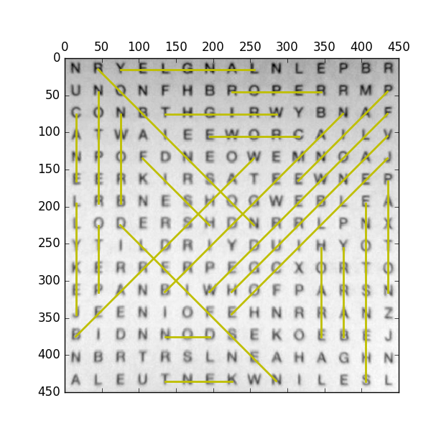224 letters were correctly labelled which is about 99% of the letters.

Searching for barry

Line from index 192 to index 132

Searching for beardshaw

Line from index 180 to index 68

Searching for bridgeman

Line from index 154 to index 42

Searching for brown

Line from index 92 to index 32

Searching for cane

Line from index 30 to index 75

Searching for crowe

Line from index 55 to index 51

Searching for don

Line from index 186 to index 184

Searching for fish

Line from index 63 to index 111

Searching for flowerdew

Line from index 44 to index 156

Searching for hoare

Line from index 131 to index 191

Searching for jekyll

Line from index 165 to index 90

Searching for jellicoe

Line from index 74 to index 172

Searching for kent

Line from index 217 to index 214

Searching for langley

Line from index 8 to index 2

Searching for nesfield

Line from index 219 to index 107

Searching for paine

Line from index 29 to index 85

Searching for paxton

Line from index 89 to index 164

Searching for peto

Line from index 151 to index 106

Searching for repton

Line from index 91 to index 16

Searching for robinson

Line from index 1 to index 113

Searching for roper

Line from index 22 to index 26

Searching for shenstone

Line from index 223 to index 103

Searching for vanbrugh

Line from index 59 to index 157

Searching for wright

Line from index 39 to index 34

Solved

24 out of 24 found correctly.

# Trial 2

With dimensionality reduction, the classifier classified 8 letters incorrectly. The wordsearch function draws the line for “cane” in the wrong place, every other line was drawn in the right place.

**Input**:

wordsearch(test1, words, train_data, train_labels, True)

**Output:**

Solving test1 With Reduction

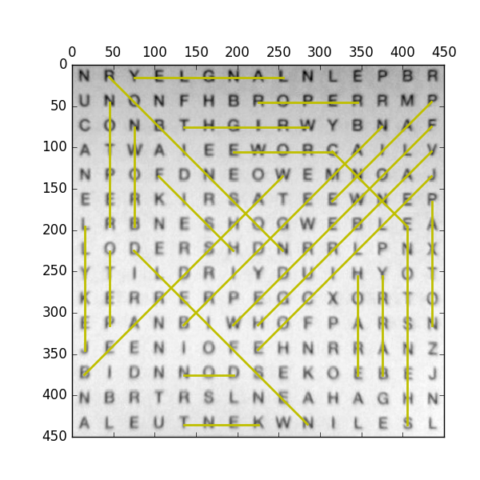217 letters were correctly labelled which is about 96% of the letters.

Searching for barry

Line from index 192 to index 132

Searching for beardshaw

Line from index 180 to index 68

Searching for bridgeman

Line from index 154 to index 42

Searching for brown

Line from index 92 to index 32

Searching for cane

Line from index 55 to index 103

Searching for crowe

Line from index 55 to index 51

Searching for don

Line from index 186 to index 184

Searching for fish

Line from index 63 to index 111

Searching for flowerdew

Line from index 44 to index 156

Searching for hoare

Line from index 131 to index 191

Searching for jekyll

Line from index 165 to index 90

Searching for jellicoe

Line from index 74 to index 172

Searching for kent

Line from index 217 to index 214

Searching for langley

Line from index 8 to index 2

Searching for nesfield

Line from index 219 to index 107

Searching for paine

Line from index 29 to index 85

Searching for paxton

Line from index 89 to index 164

Searching for peto

Line from index 151 to index 106

Searching for repton

Line from index 91 to index 16

Searching for robinson

Line from index 1 to index 113

Searching for roper

Line from index 22 to index 26

Searching for shenstone

Line from index 223 to index 103

Searching for vanbrugh

Line from index 59 to index 157

Searching for wright

Line from index 39 to index 34

Solved

23 out of 24 found correctly.

# Trial 3

Without dimensionality reduction, the classifier classified 129 letters incorrectly. The wordsearch function, being able to find the best matches for words that aren’t exact matches, manages to draw half of the lines in the correct place.

**Input:**

wordsearch(test2, words, train_data, train_labels)

**Output:**

Solving test2

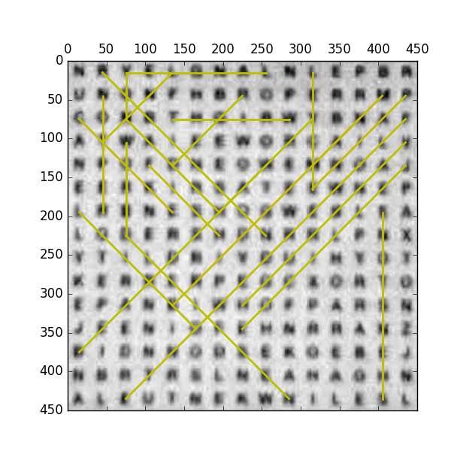96 letters were correctly labelled which is about 42% of the letters.

Searching for barry

Line from index 96 to index 40

Searching for beardshaw

Line from index 180 to index 68

Searching for bridgeman

Line from index 154 to index 42

Searching for brown

Line from index 96 to index 32

Searching for cane

Line from index 70 to index 28

Searching for crowe

Line from index 30 to index 94

Searching for don

Line from index 2 to index 32

Searching for fish

Line from index 63 to index 111

Searching for flowerdew

Line from index 44 to index 156

Searching for hoare

Line from index 156 to index 212

Searching for jekyll

Line from index 85 to index 10

Searching for jellicoe

Line from index 74 to index 172

Searching for kent

Line from index 4 to index 46

Searching for langley

Line from index 8 to index 2

Searching for nesfield

Line from index 219 to index 107

Searching for paine

Line from index 29 to index 85

Searching for paxton

Line from index 91 to index 16

Searching for peto

Line from index 22 to index 64

Searching for repton

Line from index 170 to index 90

Searching for robinson

Line from index 1 to index 113

Searching for roper

Line from index 47 to index 107

Searching for shenstone

Line from index 223 to index 103

Searching for vanbrugh

Line from index 59 to index 157

Searching for wright

Line from index 39 to index 34

Solved

12 out of 24 found correctly.