Introduction

Why a Framework?
A framework provides an easy pre-tested path to getting your application up and running sooner. As with all frameworks, some compromises must be made to facilitate both ease of use and broad flexibility. Too flexible and it become difficult to configure and use. Not flexible enough and it will not have a broad application base.
This framework is loosely based on the Wiring/Processing library, but does not use and C++ at all. C++ introduces large penalties in storage and time and is generally not used in this type of application (“bare metal” hard realtime).
It is designed and tested with Freescales Eclipse based Code Warrior, which as of this writing is at version 10.1.
It is assumed in this document that reader has used the “C” programming language and no attempt is made in this document to explain the “C” language.
The framework is provided as “C” and “H” files, that are to be included in the Eclipse project, but not copied into the workspace. If you decide to modify the frameworks, be aware that this may cause a problem with future updates and merging. There follows a more detailed explanation of how this all works.

Project Structure
This section explains the directory structure and components required to create a framework project from scratch. If you are using a provided sample project, you need not do any of this.
The projects relies on the files being in certain places and use relative paths so that the Framework directories are above workspaces. This makes it easy for several workspaces to use them.
As this framework is similar to the Wiring/Processing language, so the functions loop() and setup() are used. Setup() is called at the beginning, and each time loop() returns it is called again. You are certainly not obliged to use this set up, but the examples are geared to this. I have found it is really quite convenient to use this structure.

There is also a third function I have added which must be defined, RTCTickCallback(), which is called at 1 millisecond intervals. This is quite handy for performing periodic tasks, but it must be remembered that it is called in the context of an interrupt and there are do's and don'ts that should be followed. First, it must be remembered that since it is called at 1 millisecond intervals, if the function took 1 millisecond to execute it would consume 100% of the cpu's time, and lock out other interrupts.

As will be mentioned later, it is important to remember that there are two basic way a file can be added to a project. They can be added using copy or as links. Some files should be added as links, like the framework proper files, as this way when you update the framework all you projects will see the new files. Other files, such as config.h, should be copied as if you modify it for the project, would not what to change the default one. Also if you are starting a project from a sample file, you would copy it as again you would be modifying it.

Another important thing to know that that if links file are deleted from a project, only the link is deleted not the file. If a file that is in a project directory is deleted, the file is actually deleted. Files that are copied into a project directory are automatically added to the project.

After adding or removing a file from a project, the project must be cleaned and rebuilt, or you will get errors about the make file. When you clean the project, the makefiles are re-created.

Always Clean and Rebuild the project after adding or removing files or include paths!

Directory Structure
The framework uses a certain directory structure:
--Project Directory ( e.g C:\CWProjects )
|--- Framework (the framework files C:\CWProjects\Framework)
|---Framework/Headers (C:/CWProjects/Framework/Headers)
|---Framework/Sources (C:/CWProjects/Framework/Sources)
|---Framework/Samples (C:/CWProjects/Framework/Samples)
|---WORKSPACE
|---ECLIPSE PROJECT DIRECTORY
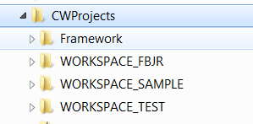Illustration 1.1: Directory Structure

Creating the Framework folder in the Porject.
First,with the project selected, create a new Source Folder Called Framework.

Adding Framework files to an Eclipse Project
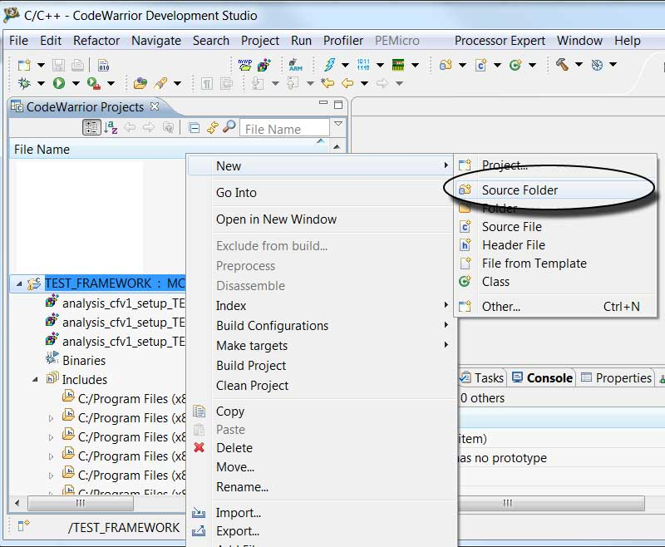Illustration 1.2:
To add files to a project, with the Folder Selected and Highlighted select Add Files from the right click context menu:
Now, Browse to ../../Framework/Sources and add ALL_SOURCES.c, exceptions_frmwrk.c and main_loop.c. You will then get the “File and Folder Import Dialog which is explained below.
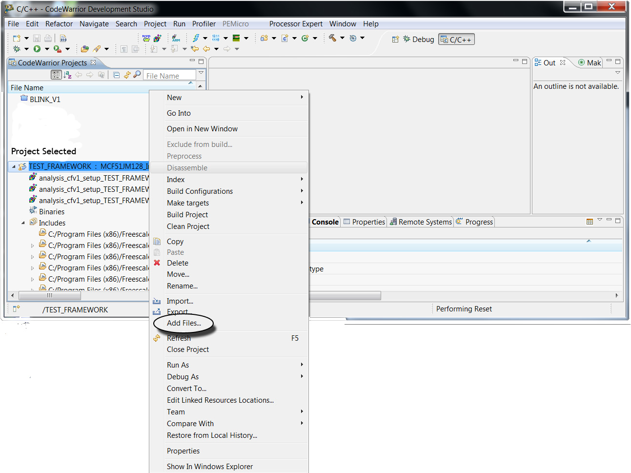Illustration 1.3: Adding files to a Project.
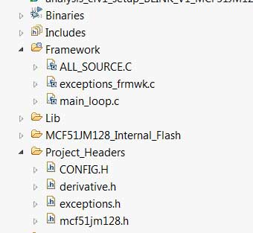Illustration 1.4: Framework and CONFIG.H added to project.

There are two basic ways to add files to an Eclipse project: copied and linked. You will get this dialog when using the “Add Files” operation after you have selected files.
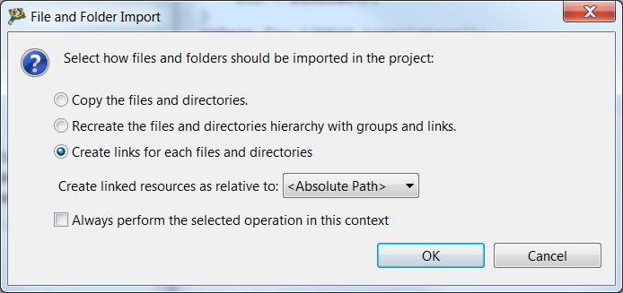Illustration 1.5: File and Folder Import Dialog

The options used are “Copy the files and directories” and “Create links for each files and directories”. So “copy the file” refers to option 1 and “link the files” refers to option 3.
The framework proper should be linked. The file CONFIG.H must be copied. Sample files should be copied if you plan on changing them.

Adding CONFIG.H to the project
Add the file CONFIG.H from Framework\Config to the Project_Headers folder. (See previous illustration).

Adding a sample file.
First, delete the files main.c and excpetions.c from the Sources folder if this is a newly created project.
Then add one of the sample files from Framework\Samples as a copied file to the Sources folder.
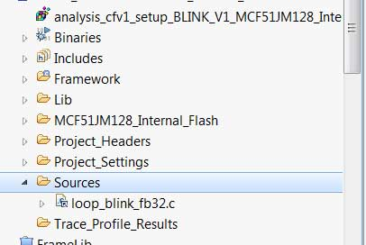Illustration 1.6: Added sample file.

Adding an Include Path to the Project
Select Properties with the project highlighted:
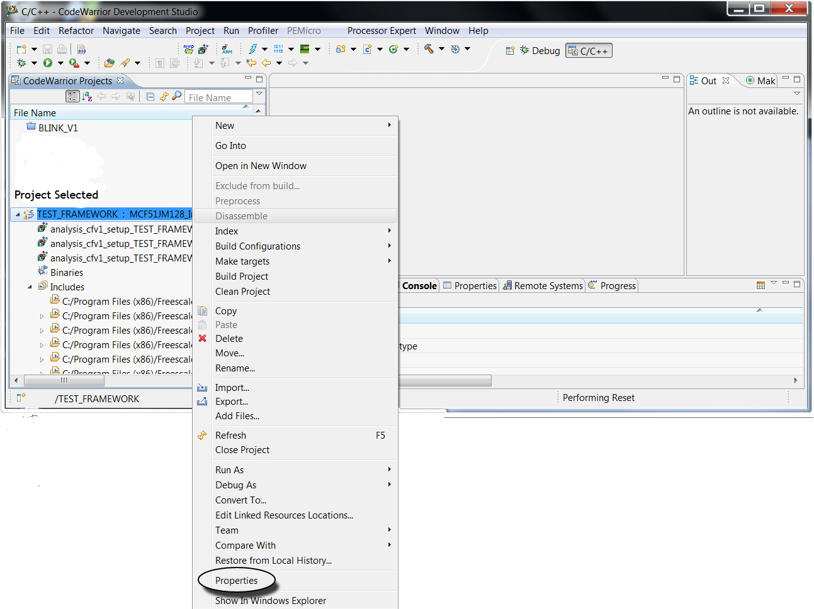Illustration 1.7: Selecting Properties for the Project
Next, select “C C++ General”/”Paths and Symbols”/”Includes” Tab/C Source File Item
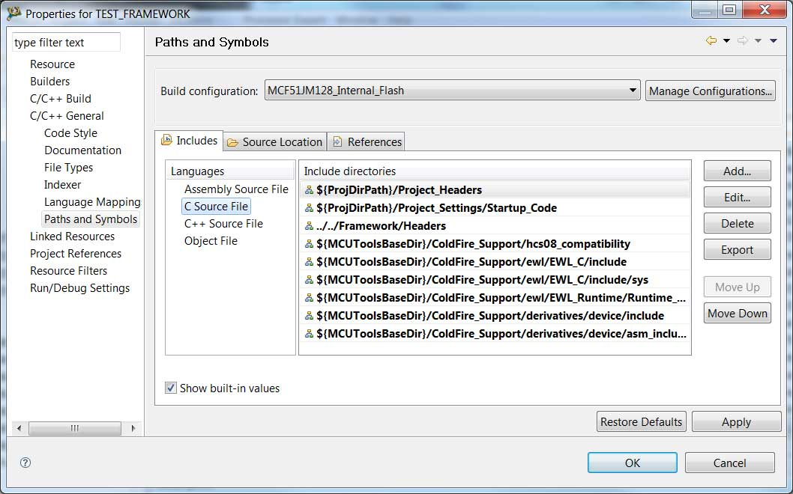Illustration 1.8: Add the Framework include path to the Includes Tab.
Then use the Add... button to add ../../Framework/Headers
The project should now build.
Always Clean and Rebuild the project after adding or removing files or include paths!

CONFIG.H
The file CONFIG.H must be in the projects Project_Headers folder, and should be added as a copied file. There are standard ones provided or it can be customized. Please see comments in the file as new features will be added.

ALL.H
This is an include file that includes all the other framework include files. It should be included in all source files that use the frameworks.

I/O Channels
The Framework uses I/O channels for digital I/O, analog I/O and interrupts. The digital channels are configurable both internally and by the user. Analog and interrupt channels are predefined, and assigned to to the MCU pins that support there function. Since almost all MCU pins can also be digital I/O there is a flexible method of assignments of logical channel to digital MCU pins.
The assignments for digital I/O to physical MCU pins is accomplished using PIO (port i/o) tables.

BEGIN_PIO_TABLE(mytable)
PIO_ENTRY(D_PORTE,BIT2)
PIO_ENTRY(D_PORTE,BIT2) // PTE1 TX
PIO_ENTRY(D_PORTE,BIT0) // PTE0 RX
PIO_ENTRY(D_PORTG,BIT3) // PTG3
PIO_ENTRY(D_PORTE,BIT2) // PTE2 TPM1CH0
END_PIO_TABLE(mytable)

Then, to cause the framework to use this table:

useTable(PIO_TABLE(mytable));

It is important to use these macro as it will insulate the code from future implementation changesin in the internal pio table structure.
See Also Table PWM Channels and Table Interrupt Channels for a listing of these per-set channels.

