**Home Page**

WELCOME to the Department of Petroleum & Energy (DPE) of Papua New Guinea (PNG). This site provides information on the Petroleum & Energy in PNG. The Department is comprised of two main Divisions, Petroleum, Energy and Corporate Services Division.

Petroleum Division is responsible for administering and regulating all petroleum related projects within Papua New Guinea. The aim of the Petroleum Division is to support the Government’s efforts to develop the Nation’s discovered and potentially discoverable petroleum resources by promoting, monitoring and regulating all activities directly related to the exploration of petroleum in Papua New Guinea.

The Department’s Energy Division is responsible for non-renewable energy policy formulation, research, and planning and data collection.

**Petroleum Projects**

ExxonMobil PNG LNG Project *ExxonMobil PNG LNG Plan*

• 1997; ExxonMobil came on the scene, proposed LNG project. Formally endorsed late 2007, Gas Agreement signed 2009; FID reached 1st quarter 2010, construction start June 2010.

•Only ~ 8 tcf (2P) gas reserves from only 1 basin have been committed for the ExxonMobil PNG LNG Project.

•Plan for the project is to extract natural gas from the current gas (red) fields plus oil (green) fields, send the gas by pipeline down to the coast for processing and export as LNG.

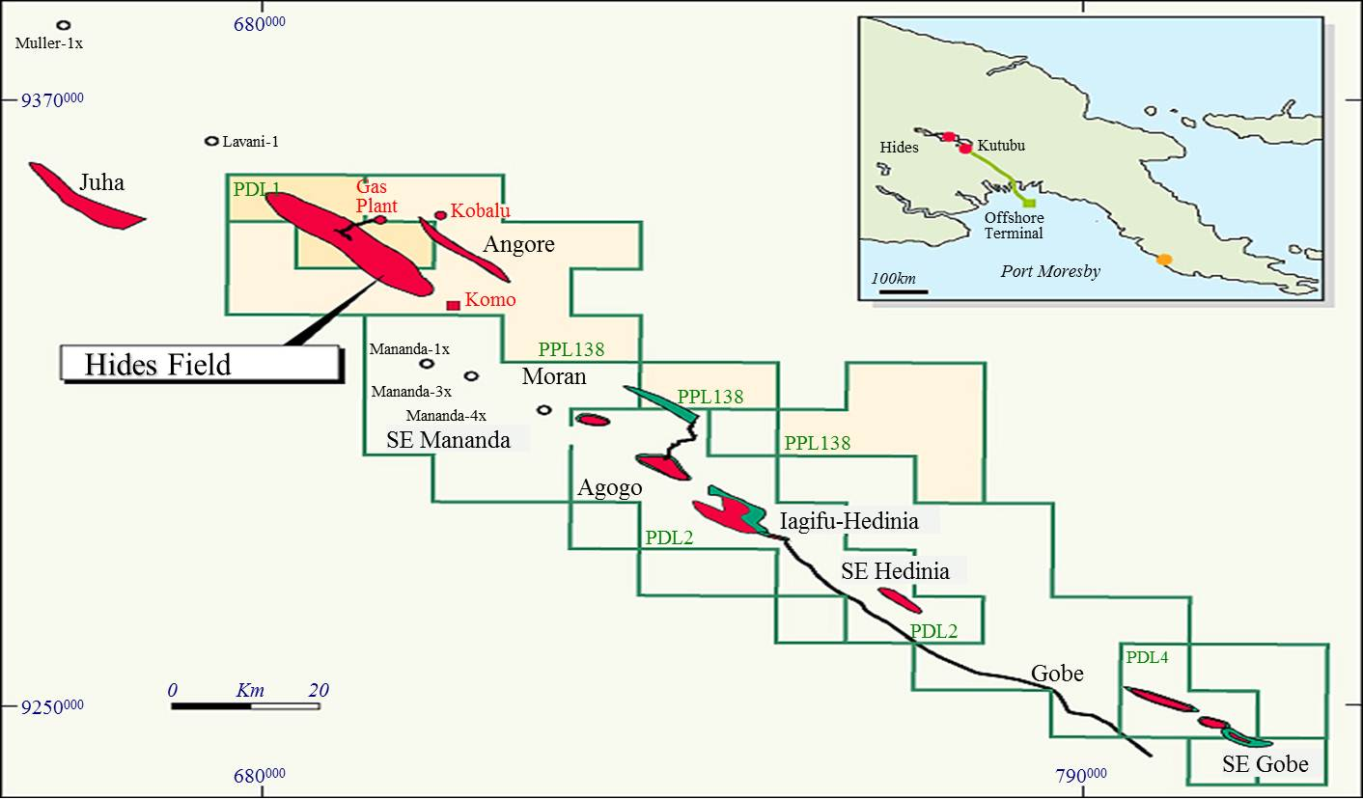PNG LNG Project Fields

PNG LNG Project Description

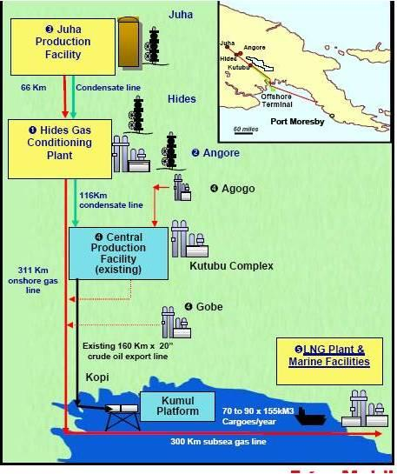

**News / Events**

Gearing up for the Mining & Petroleum Conference

Progress

* Project currently at peak construction in the chain. HGCP (Hides Gas Conditioning Plant), Pipeline and LNG processing plant under full construction.
* All major construction work outsourced.
* Korean company, DAEWOO, is the major contractor that is constructing the LNG processing plant at portion 578 outside of Port Moresby.
* Project on schedule for first gas export, 1st quarter of 2014.

**LNGL/Interoil LNG Project**

LNGL/Interoil LNG project plan

* 2006; Interoil makes gas discovery in the Elk fields.
* 2008; Interoil makes natural gas discoveries in the Antelope fields.
* 2009 LNGL/Interoil sign Project Agreement with the State to develop a non-integrated LNG project based on the Elk/Antelope natural gas discoveries.
* Plan for the project is to extract natural gas from the current Elk/Antelope fields, send the gas by pipeline down to the coast for processing and export as LNG.
* Condensate will be extracted and processed upstream and transported via barges to InterOil’s Napanapa refinery at Port Moresby.

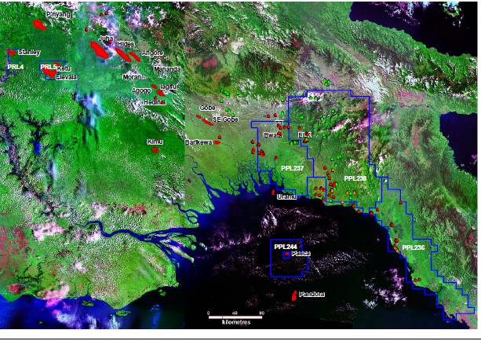LNGL/ Interoil Project fields

Progress to date

* Gas reserves confirmed by GCA (Gaffney, Cline & Associates), 6.5 tcf (2P).
* As required by the State and in accordance with the Project Agreement, project currently looking for a reputable Operator to operate the project.
* Three world renowned Banks currently searching for the Operator on behalf of the project.
* Due to many delays, State has given ultimatum for project to finalise Operator issue by November 2012.
* Project obligated to make FID (Final Investment Decision), July 2013.
* First gas export, scheduled for 1st quarter 2016.

**Horizon Oil Ltd Gas/Condensate Project**

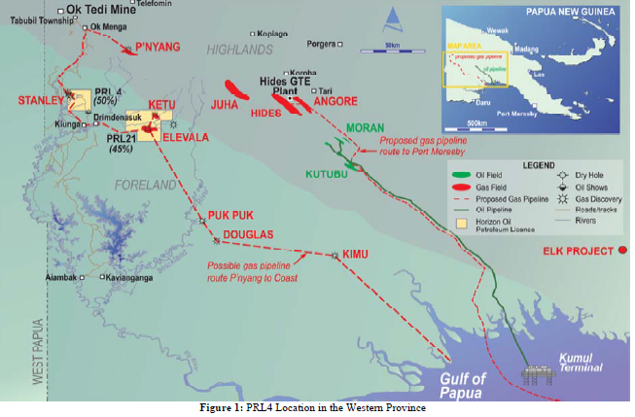

Horizon Oil Ltd gas project plan

* 1989/1990; Horizon Oil Ltd makes gas/condensate discovery in the Stanley 1 well
* 2012 Horizon oil Ltd currently negotiating Gas Agreement with the State to develop a gas/condensate project based on the Stanley natural gas discoveries.
* Plan for the project is to extract natural gas from the current Stanley gas fields, process the gas and generate electricity for a nearby gold/copper mine.
* Condensate will be extracted, transported via a pipeline downstream and transported via barges to the Napanapa oil refinery at Port Moresby.

Progress to Date

* Gas reserves confirmed, 355 bcf(2P), but only 68 bcf required for this project. Condensates, 11mmbbls.
* 2012; Horizon oil Ltd currently negotiating Gas Agreement with the State to develop a gas/condensate project based on the Stanley natural gas discoveries.
* 2012; A PDL application to be lodged soon after the Gas Agreement negotiations are completed.
* Major workforce will be outsourced but Horizon Oil Ltd is confident there are many skilled personnel in the project area due to OK Tedi Gold/Copper mine. Major construction work will be outsourced.
* Project expected to commence production, 1st quarter 2014

**Contact Us**

**Minister’s Office**

Post Office National Parliament

Independence Drv. Waigani

3rd Flr. First Heritage Bldg. Waigani Drv. Hohola

Enquiries: (675) 323 8884/ 323 7531/ 323 4281

**Office of the Secretary**

Eleanese St. New Town, Port Moresby

P.O Box 1993 Port Moresby

Executive Secretary: (675) 322 4240

Enquires: (675) 321 1936

**Petroleum Division**

Eleanese St. New Town, Port Moresby

P.O Box 1993 Port Moresby

Enquires: (675) 321 1936

**Energy Division**

Gabaka St. Gordons

P.O Box 494, Waigani

Enquires: (675) 325 3233

**Corporate Service Division**

For general enquiries email us at [enquiries@petroleum.gov.pg](mailto:enquiries@petroleum.gov.pg)