**Working Title:**

The Black Women: Doing Both, Giving Both, Making Both

**Abstract:**

This interactive, screen-based environment is an archive of the intermingled identities of worker, laborer, property, and individual due to the subjectivity of the enslaved Black African Woman. By addressing labor and work through the critique of Carl Marx by Hannah Arendt, I hope to identify the woman as a double laborer by nature, and then expound upon the generality of these identifications for bodies that have the ability to produce into thought on bodies that have been commoditized so that their natural ability has now become part of this profitable system of extraction. In doing this, the goal is to help the viewer recognize that when this type of body has been tied within the system of capitalism, the object of identity has been lost (or taken) through the transformation of an object into a subject. Because the Black slave woman does not belong to herself, neither do her children, and because the product of Black intimacy is of value, this work is set out to uncover how we might we define the agency of the Black body as a laborer vs. a worker. In addition to Arendt from the natural laboring perspective, Cedric Robinson in his “Racial Capitalism: The Nonobjective Character of Capitalist Development” in Black Marxism: The Making of the Black Radical Tradition, gives agency in filtering through a Marxist understanding the relationship between bodies and labor from the specific context of the Black body and the identity of what has now been described as Blackness by result of this conflation of things.

In conjunction with primary texts describing the work and experience of the laborer, I intend to use the illustrations documented in, *A Woman Rice Planter* by Elizabeth W. Allston Pringle and Alice R. Huger Smith (1913) to appropriate a work of subjectivity and attempt to reapply personhood, and acknowledgement to the number of roles that these women took outside of their production of rice crops. In doing this, I will reference primary, ethnographic, biographic, and autobiographic texts such as Todd Lee Savitt’s *Medicine and Slavery : The Diseases and Health Care of Blacks in Antebellum Virginia*, Kimberly Cleveland’s *Black Women Slaves Who Nourished a Nation: Artistic Renderings of Black Wet Nurses of Brazil*, and Eddie Donoghue’s *Black Women/white Men: The Sexual Exploitation of Female Slaves In the Danish West Indies* in order to work through the layered identity of these enslaved women as subject, worker, laborer, and self. Through this thought framework, harnessed within the limits of these pre-emancipation texts and recollections, will be an uncovering and discovering some of the various methods of which the Black Woman’s body has become the central sustainer of American infrastructure, and how the documentation of the labor/work production of black children in slavery has fed this system that keeps the Black Woman’s body in a state of subjectivity.

**Working Bibliography:**

* Hannah Arendt, “The Human Condition,” “Labor,” and “Work” in The Human Condition. University of Chicago Press. 1958.
* Cedric Robinson, “Racial Capitalism: The Nonobjective Character of Capitalist Development” in Black Marxism: The Making of the Black Radical Tradition. University of North Carolina Press. [1983] 2000.
* Joe Trotter, “Genesis of the Black Working Class” in Workers on Arrival: Black Labor in the Making of America. University of California Press. 2019.
* Todd Lee Savit, MEDICINE AND SLAVERY: THE DISEASES AND HEALTH CARE OF BLACKS IN ANTEBELLUM VIRGINIA
* *Elizabeth W. Allston Pringle, (Author) and Alice R. Huger Smith (Illustrator), A Woman Rice Planter. Schomburg Center for Research in Black Culture, Jean Blackwell Hutson Research and Reference Division. 1913.*
* [Author unknown], Emily Runs Away. Schomburg Center for Research in Black Culture, Photographs and Prints Division. 1857-1997
* [Author unknown], Sale in New York. Auction and Sales. Schomburg Center for Research in Black Culture, Photographs and Prints Division. 1789-03-30.
* “Childbirth and Midwifery. “Gale Library of Daily Life: Slavery in America. Encyclopedia.com. (February 22, 2023).
* Kimberly Cleveland, Black Women Slaves Who Nourished a Nation: Artistic Renderings of Black Wet Nurses of Brazil.
* Nadir Lahiji, Can Architecture Be an Emancipatory Project?: Dialogues on the Left. UK: Zero Books. 2016.
* Six Women's Slave Narratives. New York: Oxford University Press.1988.
* 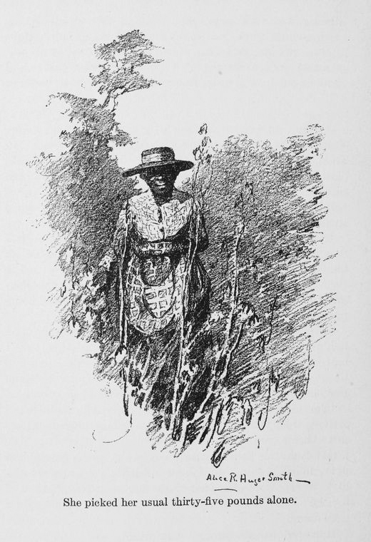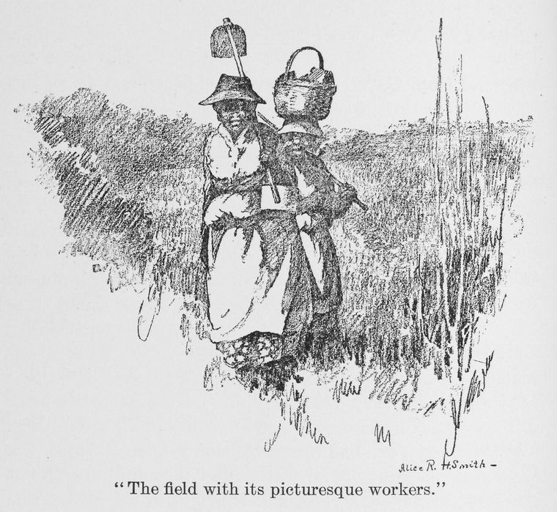Eddie Donoghue, Black Women/white Men: The Sexual Exploitation of Female Slaves in the Danish West Indies. Trenton, NJ: Africa World Press. 2002.

