**Project 1**

**<Restaurant>**

**CIS-18A 25664**

**Name: Cervantes, Jose**

**Date: 07/25/2019**

**Introduction**

Title: Table availability

I included all of the concepts except for interface I could not think of a way to include it.

**Summary**

This program is intended to hold 25 tables in a restaurant or more tables depending on the size of the restaurant and display “OPEN” or “OCCUPIED” depending if the table is available. The point of this program is intended to help servers be able to see which tables are available with out the server leaving to see which tables are open and save time. This is also a program for the customers to see how many tables are available to see how long the wait might be.

**Screen Shot (To Show it works)** 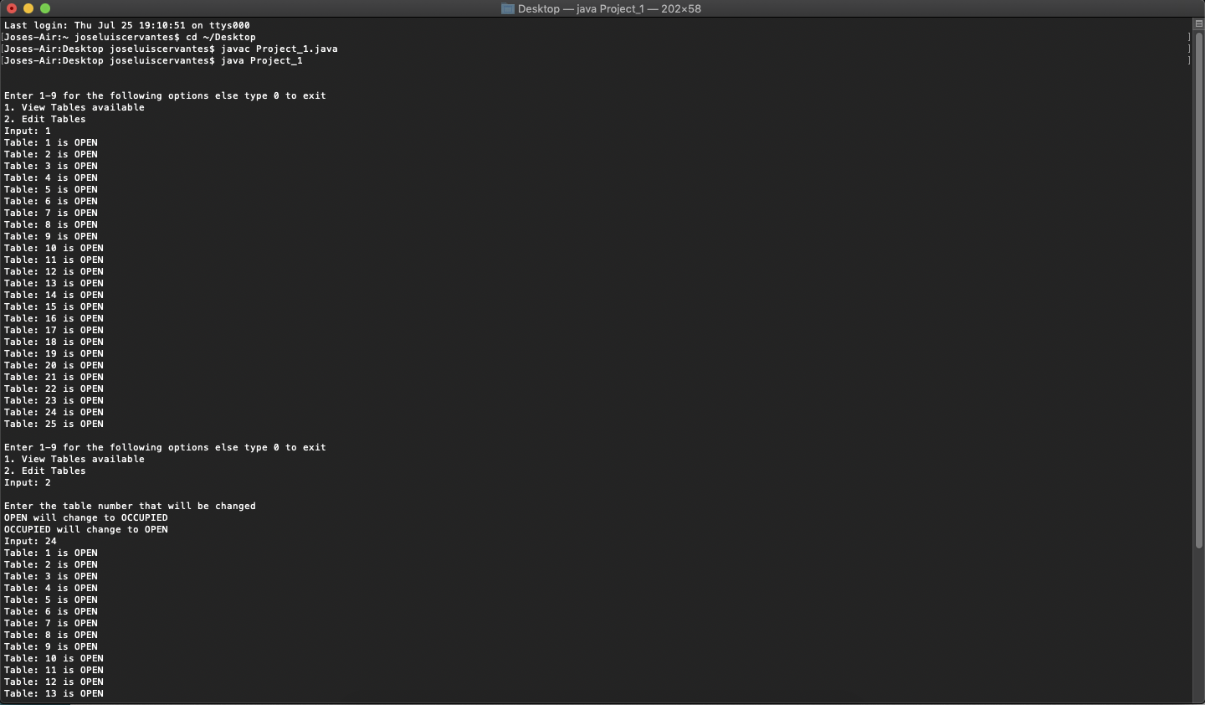

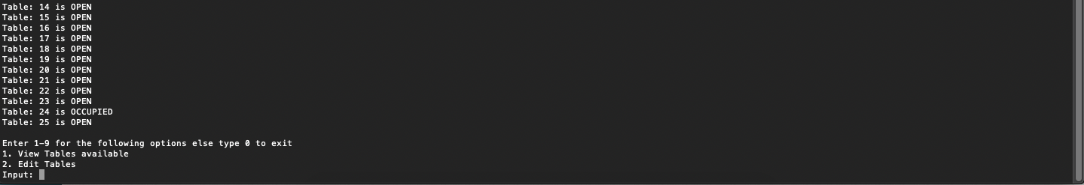

**Flow Chart**

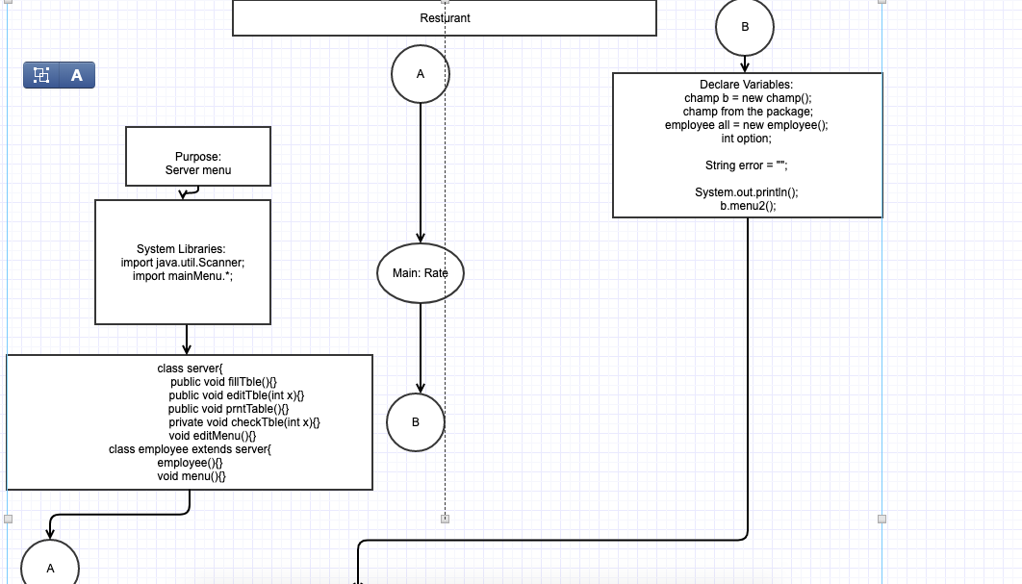

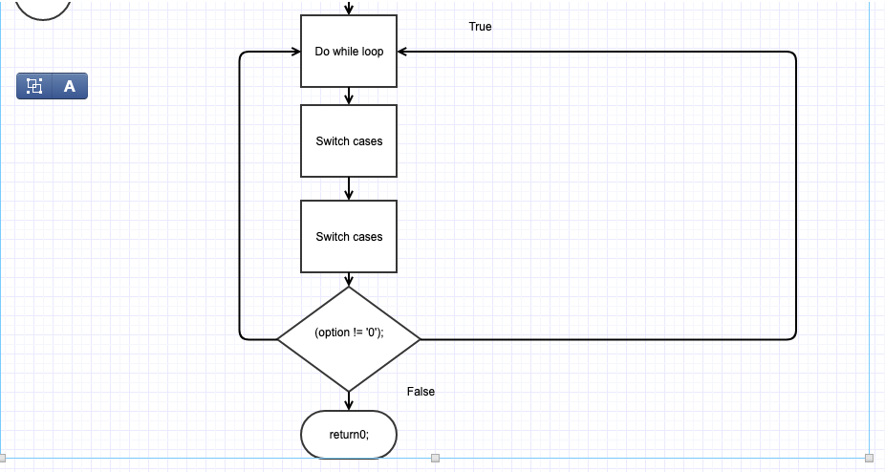

**Pseudocode**

import java.util.Scanner;

import mainMenu.*;

class server{

private String table [][]= new String[1][25];

//fillTble is used to auto fill all the tables with open

public void fillTble(){

for(int i=0; i<1; i++){

for(int j=0; j<25; j++){

table[i][j] = "OPEN";

}

}

}

//editTable is used to edit the table that the server entered

public void editTble(int x){

checkTble(x);

prntTable();

}

//prntTable prints the table of its current version

public void prntTable(){

for(int i=0; i<1; i++){

for(int j=0; j<25; j++){

System.out.println("Table: " + (j+1) + " is " + table[i][j]);

}

}

}

//checkTble checks to see if the input is within the range of the two dimensional array

private void checkTble(int x){

if((x <=25) && (x>=1)){

if(table[0][x-1]=="OPEN"){

table[0][x-1] = "OCCUPIED";

}else{

table[0][x-1] = "OPEN";

}

}else{

System.out.println("Table not within range");

}

}

//Displays the menu for instructions on editing a table

void editMenu(){

System.out.println();

System.out.println("Enter the table number that will be changed");

System.out.println("OPEN will change to OCCUPIED");

System.out.println("OCCUPIED will change to OPEN");

System.out.print("Input: ");

}

}

class employee extends server{

//constructor that auto fills the constructor

employee(){

fillTble();

}

//main menu for the program

void menu(){

System.out.println();

System.out.println("Enter 1-9 for the following options else type 0 to exit");

System.out.println("1. View Tables available");

System.out.println("2. Edit Tables");

System.out.print("Input: ");

}

}

class Project_1 {

//A Java Program begins with a call to main()

public static void main(String args[])

throws java.io.IOException { //Handles any errors

champ b = new champ(); //Creates an object champ from the package

employee all = new employee(); //Creates an employee object

int option; //Creates an int option for the switch

String error = ""; //String that holds the error

System.out.println();

b.menu2(); //Displays the menu

do{ //Loop that keeps on looping until the user decides to quit

option = (char) System.in.read(); //Reads in the user input

switch (option) {

case 49:

all.prntTable();

all.menu();

break;

case 50:

all.editMenu();

Scanner answer = new Scanner(System.in);

int a = answer.nextInt();

all.editTble(a);

all.menu();

break;

case 51:

all.menu();

break;

case 52:

all.menu();

break;

case 53:

all.menu();

break;

case 54:

all.menu();

break;

case 55:

all.menu();

break;

default:

error = "Goodbye";

System.out.println(error);

break;

}

}while(option != '0');

}

}