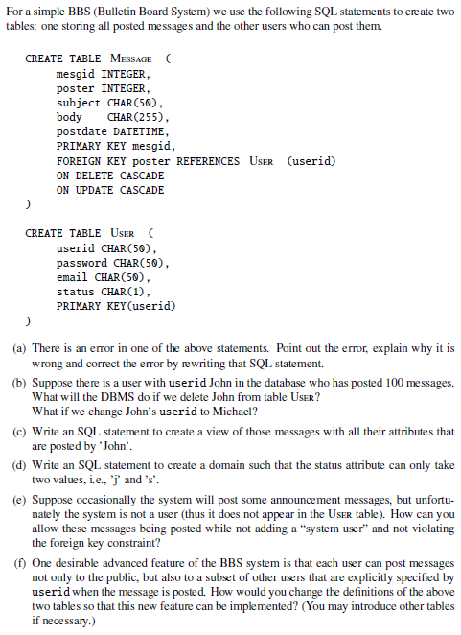

1. The error is in the line **FOREIGN KEY poster REFERNECES User (userid).** poster and user are of two different types, poster is of type int and user id is of type char. This can be resolved by declaring poster under the table Message of type char: poster CHAR(50).
2. In CREATE TABLE Message, there is a SQL statement **ON DELETE CASCADE.** If John is deleted from the table user, any messages or data with the value of poster = ‘John” will also be deleted. The Message table also includes the statement **ON UPDATE CASCADE.** If John’s userid is changed to Michael all posts with the value John as the userid will be changed to Michael because of the **ON UPDATE CASCADE** statement.
3. **CREATE VIEW MessagesJohn AS**

**SELECT * FROM MESSAGE WHERE poster = ‘John’;**

This selects from all message where the poster has the value of John and adds them to the view.

1. **CREATE DOMAIN StatusAttr**

**CHECK (VALUE IN (‘j’ ,’s’));**

This creates a domain called StatusAttr that will check for two values within posts: s and j

1. Since the system is not a user, it will be a null character in the user table. Foreign keys are allowed to have null values and the system will should still be able to broadcast messages.
2. To post to specific users, we can create a table like so:

CREATE TABLE SpecificPostings (

mesgid INTEGER,

recipient CHAR(50),

poster CHAR(50),

FOREIGN KEY poster REFERENCES USER (userid),

FOREIGN KEY recipient REFERENCES USER (userid))