**CSC 4710 Fall 2018 Assignment 2**

**Due Date: November 7, 2018**

**1. Problem for Chapter 4: Conceptual Modeling of Databased with ER**

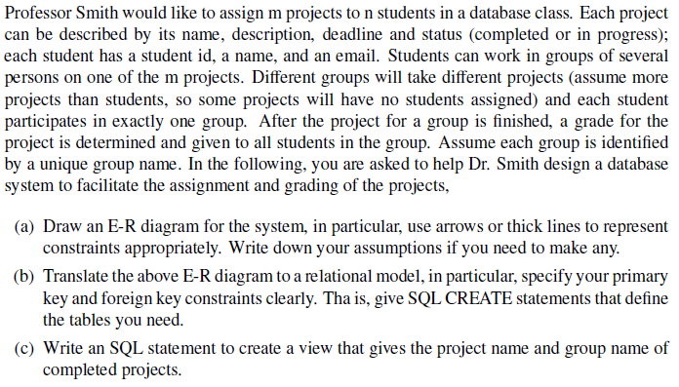

a) Underlined attributes are unique.

Group

Project

WorksOn

IsIn

Student

b)

Student

|  |  |  |  |
| --- | --- | --- | --- |
| stid | stname | stemail | gname |
| 123 | Joe Morgan | [jm@gmail.com](mailto:jm@gmail.com) | Data Group |

Project

|  |  |  |  |
| --- | --- | --- | --- |
| pname | pdescription | deadline | status |
| MyProject | This is the final project. | 2018-12-09 | Complete |

GroupP

|  |  |  |
| --- | --- | --- |
| gname | grade | pname |
| MyProject | 90 | MyProject |

use GroupProject;

CREATE TABLE Student(

stid INTEGER,

stname CHAR(50),

stemail CHAR(50),

gname CHAR(50),

PRIMARY KEY (stid),

FOREIGN KEY (gname) REFERENCES GroupP (gname))

use GroupProject;

CREATE TABLE Project(

pname CHAR(100),

pdescription CHAR(500),

deadline DATE,

status CHAR(30),

PRIMARY KEY (pname))

use GroupProject;

CREATE TABLE GroupP(

gname CHAR(50),

grade INTEGER,

pname CHAR(100),

PRIMARY KEY (gname),

FOREIGN KEY (pname) REFERENCES Project (pname)

)

c)

CREATE VIEW ProjectComplete AS

SELECT P.pname, G.gname

FROM GroupP G, Project P

WHERE G.pname=P.pname

AND P.status='Complete'

SELECT *FROM ProjectComplete

**2. Question for Chapter 5: Relational Algebra and SQL**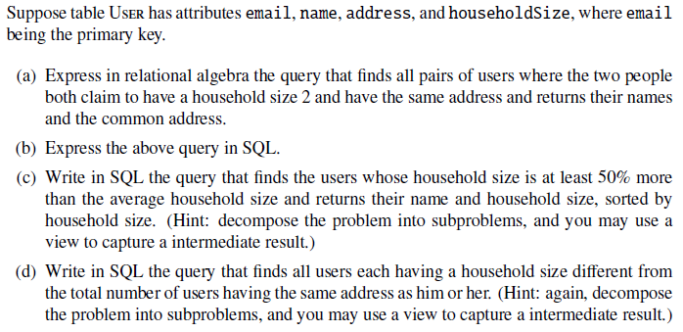

a) πname,address(USER address=address2 AND *σ*householdSize=2 (USER))

b)

SELECT U1.name, U2.name, U.address

FROM USER U, USER U2

WHERE U.name <> U2.name AND U.household=2 AND U2.household=2

AND U.address=U2.address

c)

CREATE VIEW AverageSize (averageSize) AS

select AVG (U.household)

FROM USER U

SELECT U.name, U. household

FROM USER U, AverageSize A

WHERE U.household >=0.5*A.averageSize

ORDERED BY household

d)

CREATE VIEW DiffHouseholdSize (address,size) AS

SELECT U.address, COUNT(*)

FROM USER U

Group by U.address

SELECT U.uname

FROM USER U, DiffHouseholdSize D

WHERE U.address=A.address AND U.householdSize <>D.size