How to use DeoVR\HereSphere in XTP remotely

- Enable remote control in DeoVR or HereSphere
For Deo VR:
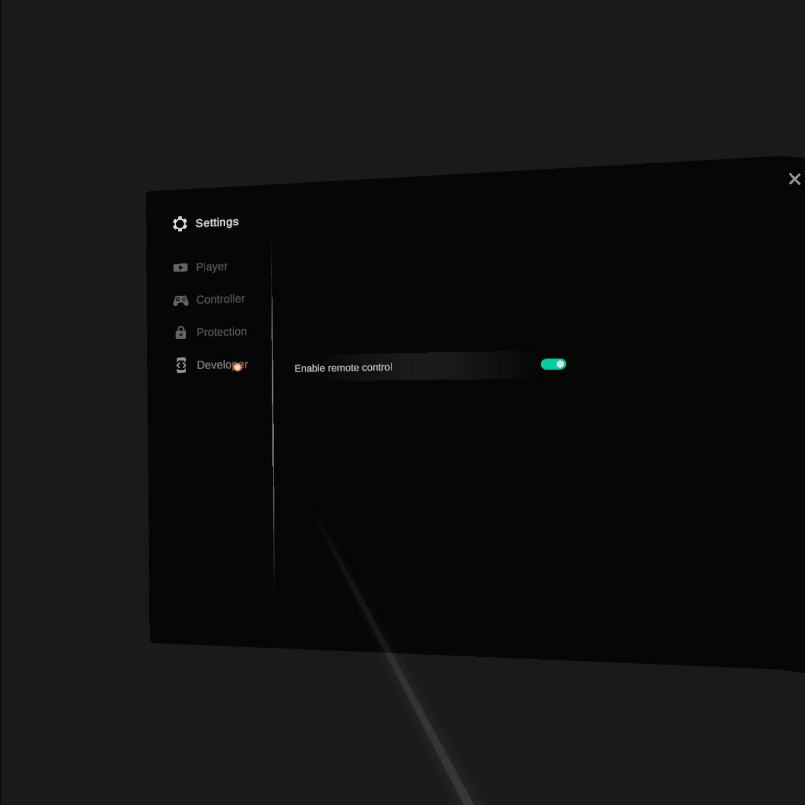

For HereSphere:
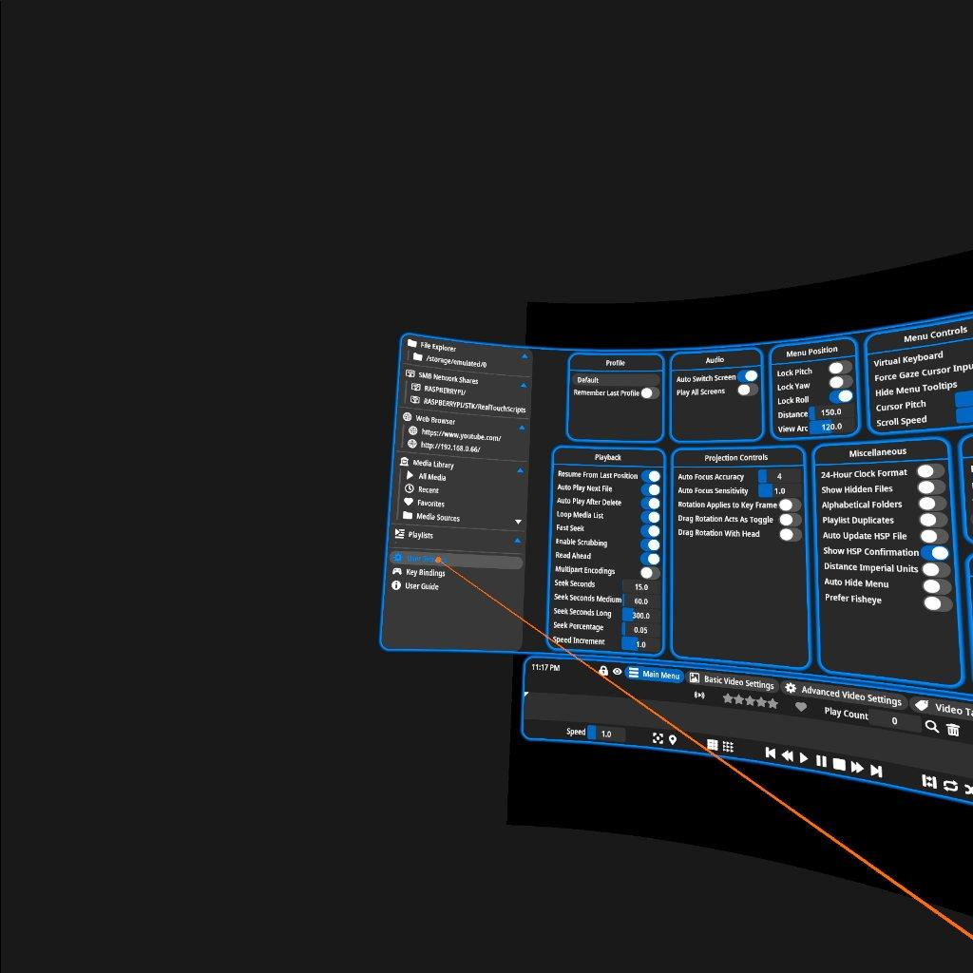
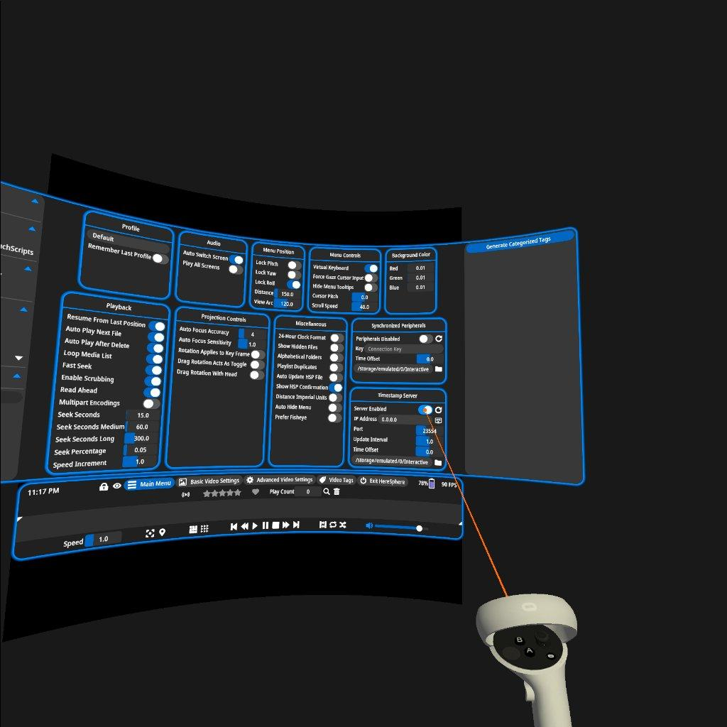

- Find the IP address of the device DeoVR/HereSphere is installed on to. (Your router web interface is usually the easiest way) This is harder to describe because every router interface is different.
Refer to your router documentation.

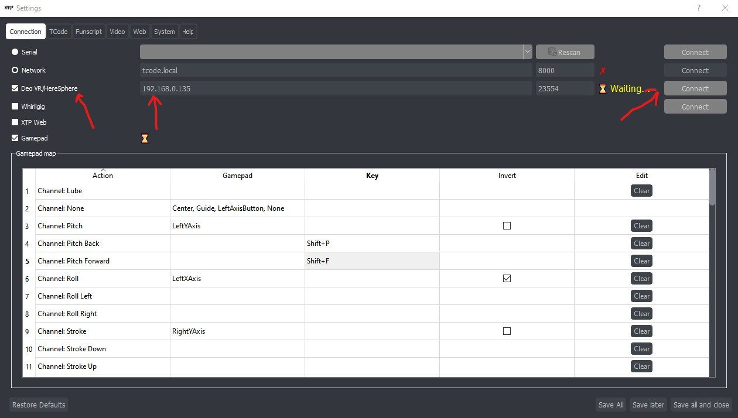

- Enable DeoVR/HereSphere in the XTP settings by checking the checkbox that says
Deo VR/HereSphere
- Enter the IP address you found in step 2 in to XTP settings
- Click connect
- Launch Deo VR/HereSphere

At this point XTP should connect to DeoVR/HereSphere.

UPDATE: 12/31/2021. As of XTP version 0.27b XTP Web has been added to greatly simplify the steps below. You can still use this method but XTP Web is highly recommended.
Follow the same steps above then
Enable XTP Web on the “Web” tab in XTP settings LEAVE THE REST AT DEFAULT UNLESS YOU KNOW WHAT IT MEANS.
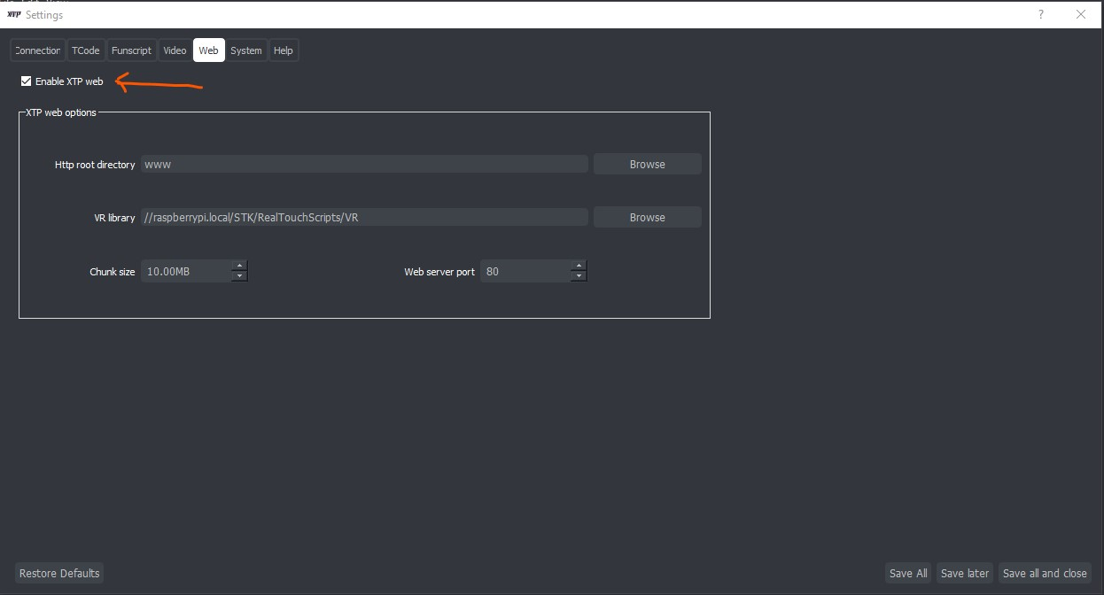
Input http://<IP Address of XTP machine> into the DeoVR or HereSphere web browser. (only http is supported at the time of this writing)
Wait for your media to load verify your devices are connected then click n go.
XTP will find the script if its along side the video with the same name at the same URL (Folder).
Side note, as of XTP v0.28 you can place your own thumb nail file in the same directory named “videoname.jpg” (valid extensions ".jpg" << ".jpeg" << ".png" << ".jfif" << ".webp" )
To avoid the awkward in video VR thumbnails XTP will generate.
Side sidenote: You can either keep your VR media separate from the 2D media and select it in the Web settings.
Or you can name your VR media in accordance with DeoVR naming scheme outlined in section 9. on this site. https://deovr.com/app/doc

If you choose not to use XTP Web keep reading.

When you start a video in DeoVR if a file with same name as the video thet DeoVR sends (Depending on where the video is, DeoVR sometimes sends an internally generated filename) is not found in the same directory or root of the library folder you have currently selected in XTP, you will get a pop up on the computer XTP is on asking you to select the funscript you want to sync to the video.

XTP will will save this funscript location in your XTP settings for next use.
If for some reason you want to change this stored location.
While the video is playing in DeoVR, navigate to Edit > Change current deo script...

and select a new funscript.

You can also view and edit all your stored scripts with the new “Manage VR Funscripts” interface.
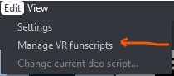
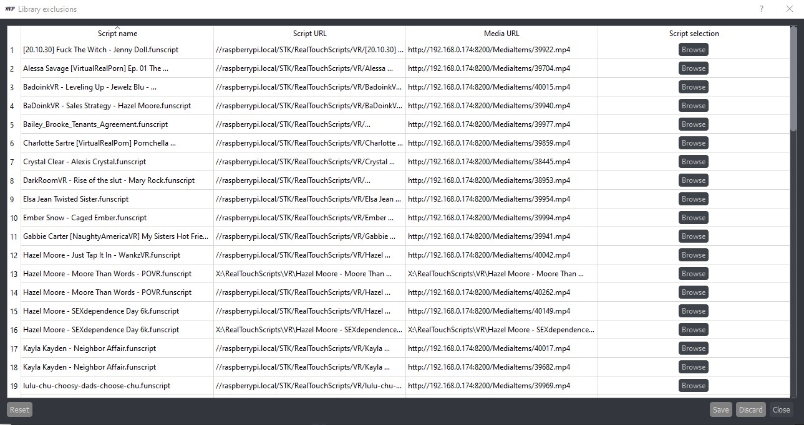

For HereSphere DLNA will be similar as above but HereSphere offers SMB/Windows FileShare streaming making the process for XTP to find scripts easier. The scripts just need to be inside the chosen XTP Library folder somewhere. XTP will search every file until it finds one that matches the video name.

