**Creative Brief**

James Fawcett

11/9/2016

**Project Title: Muhammad Ali Website**

**1. Project overview**The goal of my website is to be generally informational, but to present Muhammad Ali’s life and past in a way that illustrates his struggles, not just in the boxing ring, but his struggles for equality for himself and all people.

**2. Resources**Copy is available at <https://en.wikipedia.org/wiki/Muhammad_Ali>, as well as some photography. There are a lot of other photographs available on Google Images as well.

**4. Audience**

This is a strictly informational site, and won’t be promoted commercially in any way. This will be a part of my portfolio though, so it’s likely that my instructors will see and review it. It’s also likely that prospective employers will see it. Demographic information could be all across the board, but the audience won’t likely include children, or people of higher than retirement age.

**5. Message**I’d like to focus on the legacy that Muhammad Ali left behind. He was not only a great fighter, but an influential social activist and pop icon in a time of segregation and injustice for black people in this country.

**6. Tone**The tone here I think should be historic and moving. Maybe “gravitas” is the right word. I’m not looking to highlight his playful side or his relationship with Howard Cosell. I want to convey the struggles Ali had and overcame.

**8. Visual Style**

My instinct is to go one of two ways – 1. black and white, maybe even a newsprint sort of feel, or 2. Use an old fight poster feel, with yellowed, worn parchment and styling. I think I’m leaning toward more of a newspaper style, as I think the important things about his career and life were the things that happened outside the ring.

Here are a couple of jpgs of inspiration or ideas. Maybe something in the same vein as these, but not so literal perhaps.

<http://www.rootsoffight.com/> - Some of the visual styles on Roots of Fight could work pretty well.

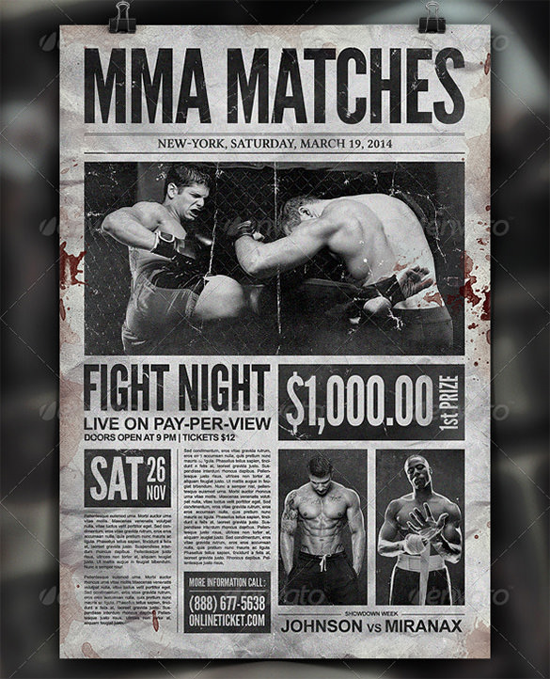

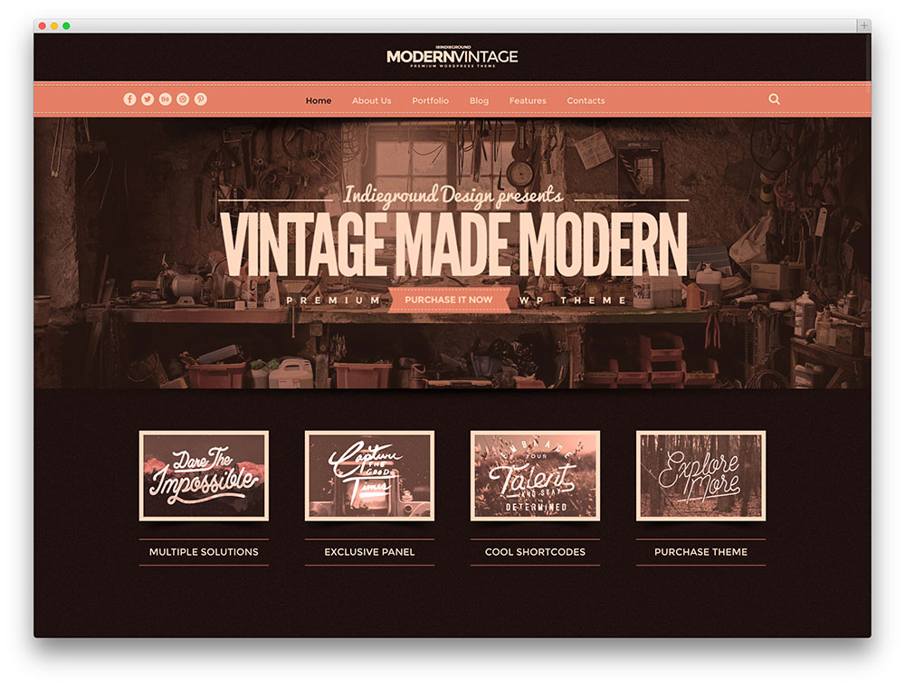

(but not so pink)

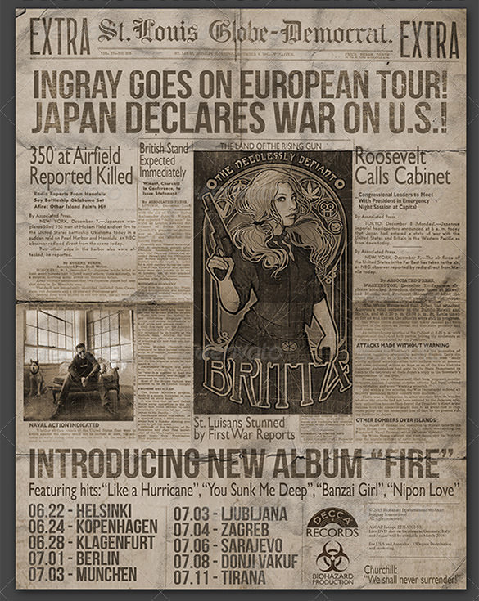

(but not so grungy and worn out)