Pattern Classification and Machine Learning Project

Introduction
The goal of this project is to implement some algorithms described during the lectures in order to do classification on a given database. This report shows the key results we obtained. We had to take into account three different approaches (Backpropagation, EM/GMM with K-Means Initialization and SVM). We present for each of them their quality by showing some graphs (MSE graph); we also make some other comments about specificities of each method and we finally compare the different approaches.

Database
We only consider a specific database in this research: the “Wisconsin Diagnostic Breast Cancer data base” (WDBC).
This data base contains 569 instances. Each of them has 32 attributes: the ID number, the diagnostic of an expert (either malignant (M) or benign (B)) and 30 real-valued input features. Each input corresponds to information of the cell nucleus of the sample and each of these parameters has a direct influence on the final diagnostic. These parameters are:

- radius (mean of distances from center to points on the perimeter)
- texture (standard deviation of gray-scale values)
- perimeter
- area
- smoothness (local variation in radius lengths)
- compactness (perimeter² / area - 1.0)
- concavity (severity of concave portions of the contour)
- concave points (number of concave portions of the contour)
- symmetry
- fractal dimension ("coastline approximation" - 1)

We have separated this database into three random parts (training, validation and test). These parts are used during the entire project.

BackProp

Structure and Parameters
This chapter explains how we have implemented the backProp algorithm both in term of architecture of the used neural network and the main parameters of the algorithm.

For beginning, the architecture of the used Artificial Neural Network (ANN) has some characteristics: its number of hidden layers (NL), its number of hidden neurons (NN) (same number for each layer) and for each layer the transfer function of the corresponding neuron (either sigmoid or linear). Then a main parameter is the learning rate (LR). This value weight the influence of new arrival input during the learning step of the algorithm. To finish we need some criterion for stopping the algorithm. For stopping the main loop, we have determined an MSECriterion coupled with a limit on the number of iteration and with an end accuracy test.

Parameters Influence
It is quite hard to play with all the parameters at the same time and get relevant results. Indeed, we have first chosen a given configuration (1 layer with 25 hidden neurons – a good configuration to see an overfitting effect) and then play with the learning rate. We observed that it had a strong effect on the overfitting effet: bigger the learning rate, bigger the overfitting. We however noticed that the error rate for the validation set stayed the same from a certain value of the learning rate (~0.006). We also observed that the learning rate had an effect on the convergence speed: bigger the learning rate, faster the convergence. Concerning the effect on the error rate, it was quite harder to consider. However, we observed that bigger the learning rate, smaller the error rate for the learning sample.
Then, we changed the configuration of the network (reasonable configurations), but we noticed that it didn’t have a strong influence on the convergence, the error rate and the overfitting effect. However, we still noticed that the more complicated the network, the higher the overfitting.
To conclude, we noticed that the learning rate was the most influent parameter, between learning rate and the configuration of the network. It is also important to say that, we have chosen a simple configuration to obtain our best results (without weight decay term to reduce the flexibility of the network)(1 layer with less than 10 hidden neurons) with a learning rate of 0.0005. The best configuration with a weight decay term will be presented in section 6.

With these results, we have launched a simulation (see Figure 1) with parameters which are good to see an overfitting effect. It will be corrected in the next chapter by adding a weight decay term.

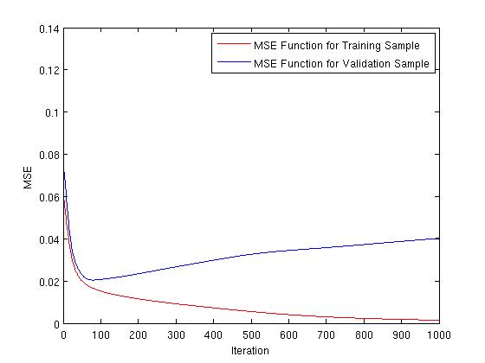
   | Success | Fail | MSE
  Training Sample | 253 | 0 | 0.0020
  Validation Sample | 118 | 8 | 0.0400
  Test Sample | 184 | 6 | 0.0373
Figure 1 First simulation
(a) MSE function with: LR = 0.005, NHN = 25, NL = 1
(b) Table containing the results of the samples applied on the MLP

One Variant of BackProp
In this section, we implement a method (weight decay) to control the flexibility of the network. We first find the optimal value for the λ (Figure 2a) by generating the MSE function according to λ. The optimal λ is visible in the minima of the Validation Sample MSE Function. Then, we present (Figure 2b) the MSE on the training and validation set as a function of optimal λ.

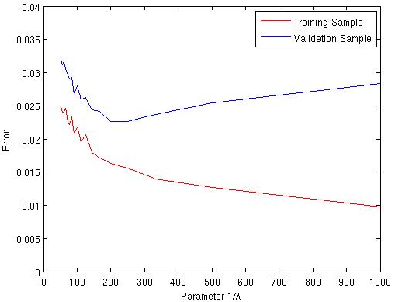 | 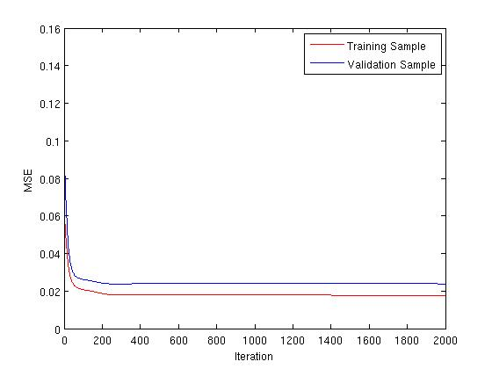
Figure 2
(a) Regularization graph – minimum weight decay at about 0.005
(b) Simulation with: LR = 0.005, NHN = 25, NL = 1 and WD = 0.005

SVM
This algorithm is a combination between an optimal perceptron and a kernel which linearize the input space. Two parameters are relevant and need to be specified:

- σ: Parameter of the Gaussian Kernel (“Thickness of the curve”)
- C: Regularization parameter: Compromise between a small number of incorrect classified vectors and a big margin.

The graph in Figure 3 shows the regularization graph. We have found the parameter σ empirically and we plot the training and validation error as a function of C in Figure 3 (a). In Figure 3 (b) we plot the error as a function of 1/σ². The optimal value of σ is about 13. In this both graphs, we can see that the value change by steps. It’s due to the lack of data of our data base.

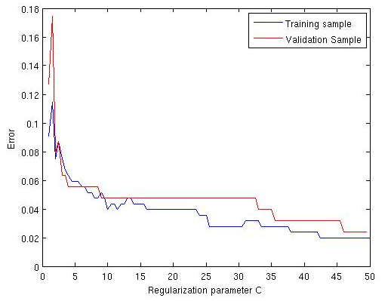 | 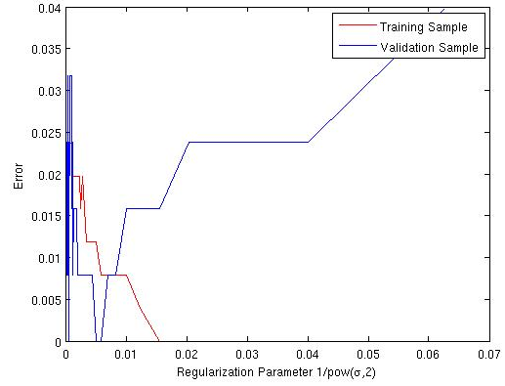
Figure 3
(a) Regularization graph of C parameter for SVM – Gaussian σ = 65
(b) Regularization graph of σ parameter for SVM – C = 50

EM/GMM with K-Means Initialization
The aim of this method is to represent the distribution of the points, describing the data, by a certain number of Gaussian functions. The algorithm is then based on an EM algorithm to find the solutions.

We plot two different graphs for this method. In Figure 4, we plot the regularization graph as a function of the number of Gaussians. We can notice in Figure 4 (a) that if the number of Gaussians approaches the number of input samples, the generated error increase drastically. The error is also very high if the number of Gaussian is too small (less than 8). In Figure 5, we plot the overfitting graph, which represent the MSE of the training and validation set as a function of the EM iterations. This figure represents a bad example; the convergence occurs after about ten iterations. It normally appears after only two to five iterations.

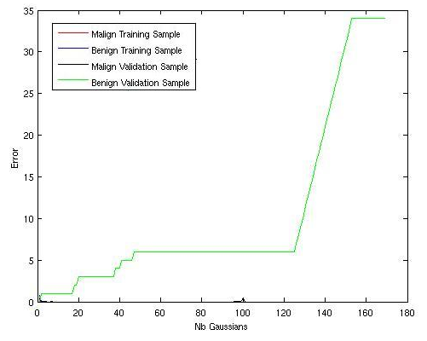 | 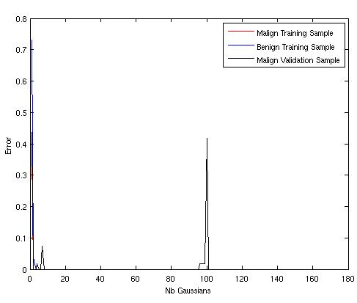
Figure 4
(a) Error in function of the number of the Gaussians
(b) Idem without the Benign Validation Sample

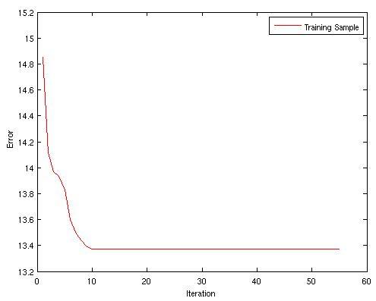 | 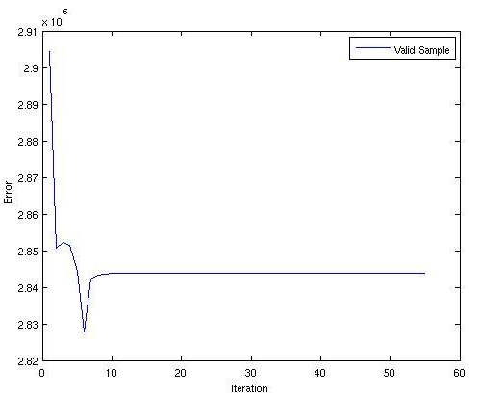
Figure 5 Error (arbitrary units) according to the number of iterations
(a) for the Training Sample
(b) for the Validation Sample

Conclusion
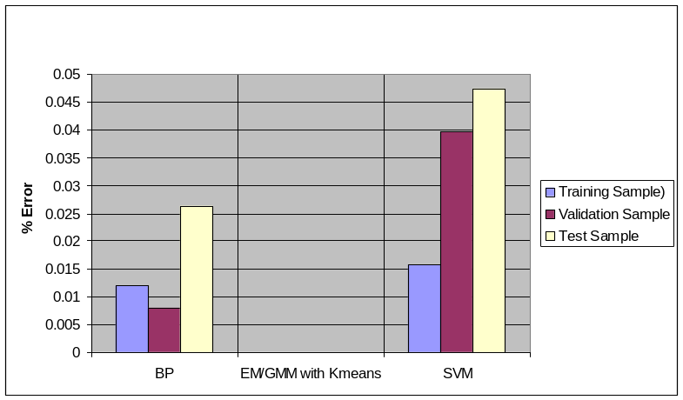
Figure 6 Comparison Graph with parameters:
(a) BP: NL = 1, NHN = 1, LR = 0.005 and WD = 0.005
(b) EM/GMM: Number of Gaussians = 10
(c) SVM: C = 50, σ=13

In Figure 6, the diagram compares the different used algorithms. All the simulations are done with best parameters (show the caption). We can easily remark which is the algorithm rank for our data base.

http://www.ics.uci.edu/%7Emlearn/databases/breast-cancer-wisconsin/

