Discos

Juan Carlos Francisco Mesa.

Esta obra está licenciada bajo la Licencia Creative Commons Atribución 4.0 Internacional. Para ver una copia de esta licencia, visite http://creativecommons.org/licenses/by/4.0/ o envíe una carta a Creative Commons, PO Box 1866, Mountain View, CA 94042, USA.

Índice

Creación de base de datos y tablas indicadas. 1
Consultas 22
Dada una base de datos de discos, realiza las siguientes consultas 22
1. Los que tienen un nombre que empieza por A 22
2. Los que tengan un Email con extensión .com 22
3. Los Registrados a partir del 2015 23
4. Ordenar registros por fecha de registro 23
5. Ordenar por fecha de registro de forma descendente 23
6. Cuantos usuarios llamados John tienes 24
7. Cambiar el formato de la fecha sabiendo que existe una función DATE_FORMAT(`FechaNacimiento`,"%D-%M-%y") 24
8. Mostrar una columna con la fecha de hoy, sabiendo que la función NOW() devuelve la fecha actual 25
9. Cambiar el formato de la fecha y mostrar una columna con la fecha de hoy 25
10. Calcular la Edad del cliente 25
11. Contar los registros de una tabla 26
12. Seleccionar los clientes sin duplicado 26
13. Los discos con una puntuación mayor a la media 27

Creación de base de datos y tablas indicadas.

-- phpMyAdmin SQL Dump
-- version 4.8.5
-- https://www.phpmyadmin.net/
--
-- Servidor: 127.0.0.1
-- Tiempo de generación: 03-08-2020 a las 00:16:10
-- Versión del servidor: 10.1.40-MariaDB
-- Versión de PHP: 7.3.5

SET SQL_MODE = "NO_AUTO_VALUE_ON_ZERO";
SET AUTOCOMMIT = 0;
START TRANSACTION;
SET time_zone = "+00:00";

/*!40101 SET @OLD_CHARACTER_SET_CLIENT=@@CHARACTER_SET_CLIENT */;
/*!40101 SET @OLD_CHARACTER_SET_RESULTS=@@CHARACTER_SET_RESULTS */;
/*!40101 SET @OLD_COLLATION_CONNECTION=@@COLLATION_CONNECTION */;
/*!40101 SET NAMES utf8mb4 */;

--
-- Base de datos: `discos`
--
CREATE DATABASE IF NOT EXISTS `discos` DEFAULT CHARACTER SET latin1 COLLATE latin1_swedish_ci;
USE `discos`;

DELIMITER $$
--
-- Procedimientos
--
DROP PROCEDURE IF EXISTS `Buscar_discos_tipo`$$
CREATE DEFINER=`root`@`localhost` PROCEDURE `Buscar_discos_tipo` (IN `x` INT) BEGIN
SELECT * FROM tipo WHERE IdTipo = x;
END$$

DROP PROCEDURE IF EXISTS `DiscosBuenos`$$
CREATE DEFINER=`root`@`localhost` PROCEDURE `DiscosBuenos` () SELECT `iddisco`, `titulo`
FROM disco
WHERE `iddisco` NOT IN (SELECT `iddisco` FROM puntuacion WHERE `Puntuacion`>=7)$$

DELIMITER ;

-- --------------------------------------------------------

--
-- Estructura Stand-in para la vista `ccc`
-- (Véase abajo para la vista actual)
--
DROP VIEW IF EXISTS `ccc`;
CREATE TABLE `ccc` (
`id` int(11)
,`Nombre` varchar(255)
,`Email` varchar(255)
,`FechaNacimiento` datetime
,`FechaRegistro` datetime
);

-- --------------------------------------------------------

--
-- Estructura de tabla para la tabla `cliente`
--

DROP TABLE IF EXISTS `cliente`;
CREATE TABLE `cliente` (
`id` int(11) NOT NULL,
`Nombre` varchar(255) DEFAULT NULL,
`Email` varchar(255) DEFAULT NULL,
`FechaNacimiento` datetime DEFAULT NULL,
`FechaRegistro` datetime DEFAULT NULL
) ENGINE=InnoDB DEFAULT CHARSET=utf8;

--
-- Volcado de datos para la tabla `cliente`
--

INSERT INTO `cliente` (`id`, `Nombre`, `Email`, `FechaNacimiento`, `FechaRegistro`) VALUES
(1, 'Raymond Velasquez', 'cursus@tempus.org', '1990-04-21 00:00:00', '2015-02-19 00:00:00'),
(2, 'Merrill Leblanc', 'velit.eu.sem@imperdiet.org', '1985-10-28 00:00:00', '2011-05-03 00:00:00'),
(3, 'Dean Santos', 'nunc@ametmetus.ca', '1977-06-20 00:00:00', '2013-12-23 00:00:00'),
(4, 'Ryan Hooper', 'Aenean@non.edu', '1997-10-18 00:00:00', '2005-05-27 00:00:00'),
(5, 'John Mcknight', 'pharetra.Quisque@magnanec.com', '1965-12-07 00:00:00', '2015-04-12 00:00:00'),
(6, 'John Watson', 'Nulla.facilisi.Sed@facilisislorem.edu', '1961-03-18 00:00:00', '2005-12-09 00:00:00'),
(7, 'Lucian Pugh', 'ornare.tortor.at@primisin.org', '1972-09-03 00:00:00', '2008-04-28 00:00:00'),
(8, 'Acton Mckay', 'quam.Pellentesque.habitant@neque.ca', '1995-03-14 00:00:00', '2014-10-30 00:00:00'),
(9, 'Bevis Sosa', 'at@odiovel.ca', '1998-07-15 00:00:00', '2013-10-02 00:00:00'),
(10, 'Zane Buckley', 'nisl.Quisque@eleifend.org', '1999-09-20 00:00:00', '2013-02-19 00:00:00'),
(11, 'Joshua Campbell', 'eu.eleifend.nec@velesttempor.edu', '1989-11-03 00:00:00', '2009-05-21 00:00:00'),
(12, 'Hayden Chavez', 'tellus.eu.augue@necluctusfelis.com', '1952-04-07 00:00:00', '2007-03-23 00:00:00'),
(13, 'Raymond Henry', 'Quisque@aptent.org', '1992-10-07 00:00:00', '2007-10-20 00:00:00'),
(14, 'Oleg Park', 'primis.in@acfeugiatnon.com', '1960-12-17 00:00:00', '2009-08-15 00:00:00'),
(15, 'Tad Fuentes', 'dolor.elit.pellentesque@interdumfeugiat.org', '1970-10-14 00:00:00', '2009-01-19 00:00:00'),
(16, 'Emmanuel Cox', 'dictum.eu.placerat@eunibh.edu', '1996-02-11 00:00:00', '2015-07-22 00:00:00'),
(17, 'Bruno Baird', 'lobortis.quis@Proindolor.ca', '1989-06-18 00:00:00', '2010-01-08 00:00:00'),
(18, 'Nehru Atkins', 'tempor.bibendum@nonleoVivamus.edu', '1965-11-07 00:00:00', '2007-05-06 00:00:00'),
(19, 'Jordan Tanner', 'libero.Integer@aliquet.ca', '1964-02-29 00:00:00', '2011-08-27 00:00:00'),
(20, 'Mannix Cleveland', 'libero.dui@aenim.ca', '1977-07-08 00:00:00', '2012-02-13 00:00:00'),
(21, 'Peter Norton', 'semper@placeratCrasdictum.ca', '1968-08-15 00:00:00', '2008-09-02 00:00:00'),
(22, 'Buckminster Floyd', 'ac.turpis.egestas@tempor.com', '1974-08-31 00:00:00', '2006-03-09 00:00:00'),
(23, 'Allistair Blanchard', 'pretium.et@risusQuisquelibero.ca', '1996-06-25 00:00:00', '2014-07-17 00:00:00'),
(24, 'Carter Franco', 'erat.neque.non@Infaucibus.ca', '1991-12-24 00:00:00', '2010-10-30 00:00:00'),
(25, 'Stone Hester', 'Cras.dolor@vel.org', '1959-07-25 00:00:00', '2014-05-18 00:00:00'),
(26, 'Raphael Chaney', 'leo.Vivamus@pellentesqueSed.ca', '1996-04-08 00:00:00', '2012-10-06 00:00:00'),
(27, 'Preston Donaldson', 'velit@Integer.com', '1991-12-15 00:00:00', '2011-09-08 00:00:00'),
(28, 'Dolan Howe', 'ipsum.sodales@nonummyFuscefermentum.com', '1966-04-22 00:00:00', '2008-03-21 00:00:00'),
(29, 'Cullen Kerr', 'vulputate@venenatisamagna.ca', '1958-05-28 00:00:00', '2011-12-26 00:00:00'),
(30, 'Abraham Hendrix', 'elit@atortor.ca', '1992-05-30 00:00:00', '2012-06-11 00:00:00'),
(31, 'Alexander Roth', 'fermentum.risus@dui.org', '1987-09-14 00:00:00', '2013-12-08 00:00:00'),
(32, 'Francis Cooper', 'sed@eleifendCras.edu', '1966-12-05 00:00:00', '2007-08-19 00:00:00'),
(33, 'Graiden Moody', 'nascetur.ridiculus@Proin.ca', '1959-06-03 00:00:00', '2006-11-09 00:00:00'),
(34, 'Amal Harrington', 'libero.mauris@elitfermentumrisus.ca', '1987-06-10 00:00:00', '2008-10-14 00:00:00'),
(35, 'Fulton Kennedy', 'egestas.urna@nulla.edu', '1960-02-23 00:00:00', '2006-09-27 00:00:00'),
(36, 'Emmanuel Rutledge', 'aliquet.lobortis.nisi@magna.com', '1971-02-20 00:00:00', '2008-10-23 00:00:00'),
(37, 'Malcolm Evans', 'senectus.et@commodoipsumSuspendisse.org', '1999-10-08 00:00:00', '2009-08-25 00:00:00'),
(38, 'Allistair Macdonald', 'interdum.enim@elementumpurusaccumsan.edu', '1992-04-30 00:00:00', '2013-02-18 00:00:00'),
(39, 'Orson Ryan', 'vulputate@diam.org', '1979-11-08 00:00:00', '2007-02-13 00:00:00'),
(40, 'Kieran Roberson', 'mi.ac.mattis@nonmagna.org', '1990-09-22 00:00:00', '2012-01-30 00:00:00'),
(41, 'Kibo Holmes', 'lorem.luctus.ut@Suspendissealiquetmolestie.com', '1957-04-28 00:00:00', '2010-08-24 00:00:00'),
(42, 'Leo Hobbs', 'nec@risusDonecnibh.org', '1991-04-11 00:00:00', '2012-05-18 00:00:00'),
(43, 'Tyrone Kline', 'fringilla.ornare.placerat@et.ca', '1981-02-03 00:00:00', '2009-01-02 00:00:00'),
(44, 'Lawrence Kirkland', 'ut@erat.edu', '1989-11-09 00:00:00', '2005-07-28 00:00:00'),
(45, 'Stephen Meadows', 'Duis.elementum.dui@ipsum.org', '1992-06-10 00:00:00', '2012-02-04 00:00:00'),
(46, 'Paul Dickerson', 'erat@mollisPhasellus.edu', '1981-11-28 00:00:00', '2006-10-04 00:00:00'),
(47, 'Lucian Marks', 'vestibulum.Mauris.magna@magna.edu', '1985-12-01 00:00:00', '2014-09-08 00:00:00'),
(48, 'Gannon Manning', 'nisl@condimentum.edu', '1993-11-25 00:00:00', '2013-09-26 00:00:00'),
(49, 'Ezra Goodman', 'neque.Sed@uteratSed.org', '1975-11-11 00:00:00', '2011-11-25 00:00:00'),
(50, 'Acton Solomon', 'Phasellus.fermentum@a.edu', '1991-09-23 00:00:00', '2014-03-08 00:00:00'),
(51, 'Peter Hunter', 'urna@odio.ca', '1985-01-20 00:00:00', '2007-07-21 00:00:00'),
(52, 'Basil Morris', 'tempus@mauris.com', '1989-10-23 00:00:00', '2007-06-05 00:00:00'),
(53, 'Deacon Leblanc', 'aliquet.metus.urna@sedtortorInteger.ca', '1985-03-24 00:00:00', '2010-02-03 00:00:00'),
(54, 'Samson Bryan', 'fringilla.cursus@etcommodoat.org', '1952-12-26 00:00:00', '2011-12-25 00:00:00'),
(55, 'Arthur Foster', 'feugiat.tellus.lorem@elitpharetraut.edu', '1992-02-19 00:00:00', '2008-08-15 00:00:00'),
(56, 'Quinlan Walker', 'facilisis@justofaucibus.com', '1971-05-02 00:00:00', '2007-01-25 00:00:00'),
(57, 'Quinlan Mercado', 'libero.mauris.aliquam@lobortis.org', '1965-11-09 00:00:00', '2005-06-02 00:00:00'),
(58, 'Aladdin Kane', 'eros.Proin@nonsollicitudin.org', '1952-04-24 00:00:00', '2011-07-24 00:00:00'),
(59, 'Keane Valdez', 'dolor.dolor@Nam.com', '1976-07-25 00:00:00', '2008-09-21 00:00:00'),
(60, 'Yardley Bond', 'tellus.id.nunc@Vestibulum.org', '1992-12-06 00:00:00', '2005-11-02 00:00:00'),
(61, 'Kieran Frye', 'dapibus.ligula.Aliquam@vitaerisusDuis.com', '1973-03-03 00:00:00', '2005-12-01 00:00:00'),
(62, 'Axel Farley', 'Sed@nonmassanon.ca', '1967-09-22 00:00:00', '2006-02-21 00:00:00'),
(63, 'Flynn Molina', 'mattis.velit.justo@dolorquam.org', '1991-08-07 00:00:00', '2011-11-11 00:00:00'),
(64, 'Perry Cervantes', 'scelerisque@blandit.org', '1950-06-17 00:00:00', '2007-03-24 00:00:00'),
(65, 'Damon Morton', 'et@Donecfeugiatmetus.edu', '1995-08-27 00:00:00', '2008-07-26 00:00:00'),
(66, 'Thor Vaughan', 'imperdiet.non@diam.edu', '1969-06-01 00:00:00', '2013-09-27 00:00:00'),
(67, 'Wing Gutierrez', 'penatibus@consequat.com', '1960-05-29 00:00:00', '2007-03-04 00:00:00'),
(68, 'Julian Rojas', 'pede.ultrices.a@cursuspurusNullam.edu', '1971-05-13 00:00:00', '2014-09-17 00:00:00'),
(69, 'Chaim Mcfarland', 'Donec.felis@Nulla.com', '1975-03-28 00:00:00', '2012-09-23 00:00:00'),
(70, 'Ciaran Santana', 'non.cursus@aliquetvelvulputate.edu', '1978-03-30 00:00:00', '2005-12-27 00:00:00'),
(71, 'Vance Wagner', 'sit@faucibus.edu', '1954-07-31 00:00:00', '2005-09-02 00:00:00'),
(72, 'Driscoll Willis', 'turpis.egestas@lectuspedeultrices.edu', '1989-11-30 00:00:00', '2013-08-25 00:00:00'),
(73, 'Neville Chang', 'nisi@vitaediamProin.com', '1967-04-25 00:00:00', '2012-07-31 00:00:00'),
(74, 'Aaron Howell', 'molestie.in@quis.com', '1977-02-18 00:00:00', '2007-10-04 00:00:00'),
(75, 'Abbot Garrison', 'lacus.Cras@Nam.ca', '1990-02-06 00:00:00', '2008-11-23 00:00:00'),
(76, 'Kato Russell', 'sit@Proinsedturpis.org', '1999-02-23 00:00:00', '2008-10-10 00:00:00'),
(77, 'Julian Solis', 'aptent.taciti.sociosqu@Quisque.edu', '1959-10-06 00:00:00', '2012-03-02 00:00:00'),
(78, 'Quamar Sloan', 'magna.Lorem@elementum.ca', '1961-10-31 00:00:00', '2008-03-09 00:00:00'),
(79, 'Keaton Frank', 'hendrerit@estarcu.org', '1967-12-06 00:00:00', '2009-02-15 00:00:00'),
(80, 'Thomas Ferguson', 'lectus.convallis@Cras.com', '1956-02-13 00:00:00', '2007-08-19 00:00:00'),
(81, 'Stephen Whitley', 'leo@Nuncsollicitudincommodo.org', '1950-02-07 00:00:00', '2010-09-11 00:00:00'),
(82, 'Scott Banks', 'venenatis.vel.faucibus@Aliquamrutrumlorem.com', '1955-05-08 00:00:00', '2014-03-13 00:00:00'),
(83, 'Chandler Kirby', 'Proin.dolor@nisinibhlacinia.com', '1988-10-27 00:00:00', '2011-05-26 00:00:00'),
(84, 'Hector Hendrix', 'et.lacinia.vitae@Nullatemporaugue.ca', '1991-01-09 00:00:00', '2011-06-25 00:00:00'),
(85, 'Preston Mcleod', 'Cum@semperauctor.edu', '1993-05-14 00:00:00', '2009-02-20 00:00:00'),
(86, 'George Cantrell', 'mollis.vitae.posuere@tellus.ca', '1993-02-14 00:00:00', '2011-03-14 00:00:00'),
(87, 'Armand Velasquez', 'placerat@musDonec.edu', '1962-08-31 00:00:00', '2008-04-13 00:00:00'),
(88, 'Cooper Hardin', 'Donec.dignissim@CurabiturdictumPhasellus.edu', '1987-09-29 00:00:00', '2007-07-20 00:00:00'),
(89, 'Isaiah Hammond', 'aptent.taciti.sociosqu@tellusimperdietnon.ca', '1985-05-28 00:00:00', '2010-06-20 00:00:00'),
(90, 'Kareem Clements', 'ullamcorper.eu.euismod@Vivamus.edu', '1993-11-22 00:00:00', '2006-05-22 00:00:00'),
(91, 'Jack English', 'eget@quam.ca', '1966-09-18 00:00:00', '2015-03-04 00:00:00'),
(92, 'Leonard Barrett', 'sem.egestas.blandit@enimconsequat.org', '1988-06-25 00:00:00', '2006-11-18 00:00:00'),
(93, 'Cole Graham', 'Ut.semper@massaSuspendisseeleifend.ca', '1972-03-04 00:00:00', '2007-10-16 00:00:00'),
(94, 'Noah Harrington', 'Duis.ac.arcu@loremut.edu', '1982-02-06 00:00:00', '2014-11-05 00:00:00'),
(95, 'Tate Levine', 'Nullam.feugiat@Donecnibhenim.ca', '1956-06-16 00:00:00', '2011-09-12 00:00:00'),
(96, 'Zephania Stark', 'pretium.aliquet.metus@uterosnon.com', '1991-01-04 00:00:00', '2014-10-09 00:00:00'),
(97, 'Eric Powell', 'cursus@quis.com', '1974-03-03 00:00:00', '2009-07-23 00:00:00'),
(98, 'Ross Albert', 'Proin@vulputateullamcorper.ca', '1957-10-11 00:00:00', '2012-11-13 00:00:00'),
(99, 'Xander Weber', 'blandit@seddolor.edu', '1950-11-26 00:00:00', '2011-04-27 00:00:00'),
(100, 'Dexter Allison', 'non@acmattisvelit.ca', '1957-05-16 00:00:00', '2014-07-26 00:00:00');

-- --------------------------------------------------------

--
-- Estructura de tabla para la tabla `disco`
--

DROP TABLE IF EXISTS `disco`;
CREATE TABLE `disco` (
`IdDisco` int(11) NOT NULL,
`Titulo` varchar(255) DEFAULT NULL,
`Agno` float DEFAULT NULL,
`IdInterprete` int(11) DEFAULT NULL
) ENGINE=InnoDB DEFAULT CHARSET=utf8;

--
-- Volcado de datos para la tabla `disco`
--

INSERT INTO `disco` (`IdDisco`, `Titulo`, `Agno`, `IdInterprete`) VALUES
(1, 'Dancing Queen', 1976, 1),
(2, 'Ring My Bell', 1979, 2),
(3, 'Yes Sir, I Can Boogie', 1977, 3),
(4, 'Copacabana', NULL, 4),
(5, 'You\'re The First, My Last, My Everything', 1974, 5),
(6, 'Love\'s Theme', NULL, 6),
(7, 'Saturday Night Fever', 1977, 7),
(8, 'You Should Be Dancing', 1976, 7),
(9, 'Stayin\' Alive', 1977, 7),
(10, 'Jive Talkin\'', 1975, 7),
(11, 'If I Can\'t Have You', 1977, 7),
(12, 'Tragedy', 1979, 7),
(13, 'Heart Of Glass', 1978, 8),
(14, 'Daddy Cool', 1976, 9),
(15, 'Rivers of Babylon', 1978, 9),
(16, 'We Kill The World (Don?t Kill The World)', 1981, 9),
(17, 'Can\'t Take My Eyes off You', 1982, 10),
(18, 'I\'m Every Woman', 1978, 11),
(19, 'Love To Love You Baby', 1975, 12),
(20, 'Hot Stuff', 1979, 12),
(21, 'No More Tears (Enough Is Enough)', 1979, 13),
(22, 'Last Train To London', 1979, 14),
(23, 'December, 1963 (Oh, What a Night)', 1975, 15),
(24, 'Can\'t Take My Eyes off You', NULL, 16),
(25, 'I Will Survive', 1978, 16),
(26, 'Never Can Say Goodbye', 1974, 16),
(27, 'The Love I Lost', 1973, 17),
(28, 'Boogie Nights', 1976, 18),
(29, 'Rock the Boat', 1974, 19),
(30, 'Fame', 1980, 20),
(31, 'Flashdance...What A Feeling', 1983, 20),
(32, 'Dancing Machine', 1974, 21),
(33, 'Only The Strong Survive', 1968, 22),
(34, 'Love Is In The Air', 1977, 23),
(35, 'I Was Made For Loving You', 1979, 24),
(36, 'Celebration', 1980, 25),
(37, 'Lady Marmalade', 1974, 26),
(38, 'Gloria', 1982, 27),
(39, 'You Make Me Feel Like Dancing', 1976, 28),
(40, 'Your Love', 1981, 29),
(41, 'Designer Music', 1981, 30),
(42, 'Funkytown', 1980, 30),
(43, 'Lucky Star', 1983, 31),
(44, 'Soul Makossa', 1972, 32),
(45, 'Got To Give It Up', 1977, 33),
(46, 'In My House', 1985, 34),
(47, 'Off the Wall', 1979, 35),
(48, 'Thriller', 1984, 35),
(49, 'Don\'t Stop \'Til You Get Enough', 1979, 35),
(50, 'Hands Up (Give Me Your Heart)', 1980, 36),
(51, 'Born to Be Alive', 1979, 37),
(52, '1999', 1982, 38),
(53, 'Shortcut To The End (La Carabina de Ambrosio)', 1978, 39),
(54, 'Body Language', NULL, 40),
(55, 'Da Ya Think I\'m Sexy?', 1978, 41),
(56, 'Spacer', 1979, 42),
(57, 'Fly, Robin, Fly', 1975, 43),
(58, 'Get Up and Boogie', 1976, 43),
(59, 'You Make Me Feel (Mighty Real)', 1978, 44),
(60, 'I\'m So Excited', 1982, 45),
(61, 'Savage Lover', 1979, 46),
(62, 'Miss You', 1978, 47),
(63, 'Sugar Baby Love', 1974, 48),
(64, 'Mickey', 1982, 49),
(65, 'Meu Amigo Charlie Brown', 1975, 50),
(66, 'Disco Samba', 1978, 50),
(67, 'Gloria', 1979, 51),
(68, 'The Hustle', 1975, 52),
(69, 'Can\'t Stop the Music', 1980, 53),
(70, 'Go West', 1979, 53),
(71, 'Y.M.C.A.', 1978, 53),
(72, 'It\'s Raining Men', 1982, 54),
(73, 'Silly Love Songs', 1976, 55);

-- --------------------------------------------------------

--
-- Estructura de tabla para la tabla `discotipo`
--

DROP TABLE IF EXISTS `discotipo`;
CREATE TABLE `discotipo` (
`Id` int(11) NOT NULL,
`IdDisco` int(11) DEFAULT NULL,
`IdTipo` int(11) DEFAULT NULL
) ENGINE=InnoDB DEFAULT CHARSET=utf8;

--
-- Volcado de datos para la tabla `discotipo`
--

INSERT INTO `discotipo` (`Id`, `IdDisco`, `IdTipo`) VALUES
(1, 3, 27),
(2, 4, 25),
(3, 11, 25),
(4, 10, 25),
(5, 7, 25),
(6, 8, 25),
(7, 14, 27),
(8, 16, 31),
(9, 17, 25),
(10, 24, 25),
(11, 18, 25),
(12, 19, 25),
(13, 21, 25),
(14, 23, 25),
(15, 26, 25),
(16, 27, 30),
(17, 28, 25),
(18, 29, 30),
(19, 32, 25),
(20, 33, 30),
(21, 36, 25),
(22, 37, 25),
(23, 41, 25),
(24, 43, 25),
(25, 44, 30),
(26, 45, 25),
(27, 46, 25),
(28, 49, 25),
(29, 47, 25),
(30, 53, 25),
(31, 54, 25),
(32, 56, 25),
(33, 57, 25),
(34, 58, 25),
(35, 59, 25),
(36, 61, 25),
(37, 66, 26),
(38, 65, 31),
(39, 68, 25),
(40, 69, 25),
(41, 70, 25),
(42, 71, 25),
(43, 72, 25),
(44, 73, 25),
(45, 2, 25),
(46, 5, 32),
(47, 6, 25),
(48, 9, 25),
(49, 12, 25),
(50, 20, 25),
(51, 22, 25),
(52, 34, 25),
(53, 35, 29),
(54, 38, 25),
(55, 67, 25),
(56, 39, 25),
(57, 40, 25),
(58, 42, 25),
(59, 50, 25),
(60, 51, 25),
(61, 55, 25),
(62, 62, 33),
(63, 63, 25),
(64, 64, 25),
(65, 2, 17),
(66, 5, 4),
(67, 6, 10),
(68, 9, 19),
(69, 12, 8),
(70, 20, 8),
(71, 22, 20),
(72, 34, 1),
(73, 35, 4),
(74, 38, 13),
(75, 67, 13),
(76, 39, 24),
(77, 40, 9),
(78, 42, 7),
(79, 50, 13),
(80, 51, 14),
(81, 55, 14),
(82, 62, 4),
(83, 63, 14),
(84, 64, 19),
(85, 13, 25),
(86, 15, 34),
(87, 17, 25),
(88, 24, 25),
(89, 25, 25),
(90, 31, 27),
(91, 52, 28),
(92, 60, 35),
(93, 38, 27),
(94, 67, 27),
(95, 13, 12),
(96, 15, 5),
(97, 17, 17),
(98, 24, 17),
(99, 25, 17),
(100, 31, 23),
(101, 52, 13),
(102, 60, 2),
(103, 38, 11),
(104, 67, 11),
(105, 13, 3),
(106, 15, 18),
(107, 17, 21),
(108, 24, 21),
(109, 25, 21),
(110, 31, 22),
(111, 52, 12),
(112, 60, 17),
(113, 38, 13),
(114, 67, 13),
(115, 1, 25),
(116, 30, 25),
(117, 1, 13),
(118, 30, 13),
(119, 1, 6),
(120, 30, 19),
(121, 1, 15),
(122, 30, 22),
(123, 48, 31),
(124, 48, 17),
(125, 48, 16),
(126, 48, 19),
(127, 48, 7);

-- --------------------------------------------------------

--
-- Estructura de tabla para la tabla `interprete`
--

DROP TABLE IF EXISTS `interprete`;
CREATE TABLE `interprete` (
`Interprete` varchar(255) DEFAULT NULL,
`IdInterprete` int(11) NOT NULL
) ENGINE=InnoDB DEFAULT CHARSET=utf8;

--
-- Volcado de datos para la tabla `interprete`
--

INSERT INTO `interprete` (`Interprete`, `IdInterprete`) VALUES
('ABBA', 1),
('Anita Ward', 2),
('Baccara', 3),
('Barry Manilow', 4),
('Barry White', 5),
('Barry White; Love Unlimited Orchestra', 6),
('Bee Gees', 7),
('Blondie', 8),
('Boney M.', 9),
('Boy Town Gang', 10),
('Chaka Khan', 11),
('Donna Summer', 12),
('Donna Summer; Barbra Streisand', 13),
('Electric Light Orchestra', 14),
('Four Seasons', 15),
('Gloria Gaynor', 16),
('Harold Melvin & the Blue Notes', 17),
('Heatwave', 18),
('Hues Corporation', 19),
('Irene Cara', 20),
('Jackson 5', 21),
('Jerry Butler', 22),
('John Paul Young', 23),
('Kiss', 24),
('Kool & the Gang', 25),
('LaBelle', 26),
('Laura Branigan', 27),
('Leo Sayer', 28),
('Lime', 29),
('Lipps Inc.', 30),
('Madonna', 31),
('Manu Dibango', 32),
('Marvin Gaye', 33),
('Mary Jane Girls', 34),
('Michael Jackson', 35),
('Ottawan', 36),
('Patrick Hernandez', 37),
('Prince', 38),
('Quartz', 39),
('Queen', 40),
('Rod Stewart', 41),
('Sheila & B.Devotion', 42),
('Silver Convention', 43),
('Sylvester', 44),
('The Pointer Sisters', 45),
('The Ring', 46),
('The Rolling Stones', 47),
('The Rubettes', 48),
('Toni Basil', 49),
('Two Man Sound', 50),
('Umberto Tozzi', 51),
('Van McCoy', 52),
('Village People', 53),
('Weather Girls', 54),
('Wings', 55);

-- --------------------------------------------------------

--
-- Estructura Stand-in para la vista `joder`
-- (Véase abajo para la vista actual)
--
DROP VIEW IF EXISTS `joder`;
CREATE TABLE `joder` (
`max(Puntuacion)` int(11)
);

-- --------------------------------------------------------

--
-- Estructura Stand-in para la vista `lista_discos`
-- (Véase abajo para la vista actual)
--
DROP VIEW IF EXISTS `lista_discos`;
CREATE TABLE `lista_discos` (
`IdDisco` int(11)
,`Titulo` varchar(255)
,`Agno` float
,`IdInterprete` int(11)
);

-- --------------------------------------------------------

--
-- Estructura de tabla para la tabla `puntuacion`
--

DROP TABLE IF EXISTS `puntuacion`;
CREATE TABLE `puntuacion` (
`Id` int(11) NOT NULL,
`Idcliente` int(11) DEFAULT NULL,
`iddisco` int(11) DEFAULT NULL,
`Puntuacion` int(11) DEFAULT NULL,
`Fecha` datetime DEFAULT NULL
) ENGINE=InnoDB DEFAULT CHARSET=utf8;

--
-- Volcado de datos para la tabla `puntuacion`
--

INSERT INTO `puntuacion` (`Id`, `Idcliente`, `iddisco`, `Puntuacion`, `Fecha`) VALUES
(1, 2, 71, 9, '2013-06-05 00:00:00'),
(2, 5, 32, 4, '2013-04-16 00:00:00'),
(3, 6, 12, 7, '2013-02-12 00:00:00'),
(4, 17, 73, 6, '2013-06-14 00:00:00'),
(5, 25, 12, 1, '2013-03-01 00:00:00'),
(6, 86, 41, 6, '2013-01-21 00:00:00'),
(7, 43, 12, 9, '2013-06-20 00:00:00'),
(8, 66, 34, 6, '2013-05-03 00:00:00'),
(9, 78, 64, 1, '2013-05-02 00:00:00'),
(10, 21, 63, 3, '2013-05-21 00:00:00'),
(11, 11, 12, 3, '2013-02-14 00:00:00'),
(12, 20, 4, 9, '2013-04-16 00:00:00'),
(13, 41, 8, 10, '2013-06-10 00:00:00'),
(14, 12, 12, 3, '2013-06-01 00:00:00'),
(15, 43, 42, 7, '2013-04-16 00:00:00'),
(16, 89, 13, 8, '2013-02-06 00:00:00'),
(17, 32, 8, 5, '2013-05-06 00:00:00'),
(18, 12, 30, 7, '2013-03-01 00:00:00'),
(19, 57, 52, 9, '2013-06-11 00:00:00'),
(20, 39, 57, 3, '2013-05-13 00:00:00'),
(21, 22, 59, 5, '2013-02-13 00:00:00'),
(22, 78, 37, 5, '2013-06-02 00:00:00'),
(23, 16, 8, 6, '2013-01-12 00:00:00'),
(24, 82, 12, 1, '2013-03-19 00:00:00'),
(25, 15, 41, 4, '2013-06-05 00:00:00'),
(26, 100, 12, 6, '2013-02-28 00:00:00'),
(27, 12, 52, 7, '2013-06-05 00:00:00'),
(28, 35, 62, 8, '2013-03-07 00:00:00'),
(29, 81, 62, 3, '2013-05-27 00:00:00'),
(30, 13, 46, 6, '2013-01-23 00:00:00'),
(31, 93, 12, 7, '2013-02-14 00:00:00'),
(32, 51, 71, 4, '2013-04-02 00:00:00'),
(33, 1, 43, 7, '2013-06-04 00:00:00'),
(34, 56, 46, 10, '2013-04-16 00:00:00'),
(35, 25, 71, 10, '2013-06-04 00:00:00'),
(36, 4, 23, 4, '2013-02-15 00:00:00'),
(37, 9, 46, 9, '2013-01-06 00:00:00'),
(38, 24, 12, 6, '2013-04-09 00:00:00'),
(39, 55, 35, 4, '2013-04-29 00:00:00'),
(40, 6, 72, 2, '2013-05-31 00:00:00'),
(41, 15, 52, 6, '2013-04-15 00:00:00'),
(42, 86, 63, 7, '2013-03-15 00:00:00'),
(43, 56, 70, 5, '2013-03-12 00:00:00'),
(44, 12, 20, 4, '2013-06-10 00:00:00'),
(45, 56, 1, 3, '2013-04-29 00:00:00'),
(46, 71, 7, 9, '2013-02-19 00:00:00'),
(47, 12, 23, 10, '2013-04-11 00:00:00'),
(48, 84, 51, 1, '2013-04-11 00:00:00'),
(49, 24, 12, 2, '2013-05-28 00:00:00'),
(50, 23, 46, 10, '2013-03-11 00:00:00'),
(51, 52, 73, 5, '2013-05-15 00:00:00'),
(52, 63, 23, 7, '2013-04-30 00:00:00'),
(53, 68, 61, 2, '2013-05-29 00:00:00'),
(54, 13, 1, 5, '2013-04-12 00:00:00'),
(55, 3, 54, 1, '2013-06-18 00:00:00'),
(56, 7, 3, 6, '2013-02-19 00:00:00'),
(57, 12, 71, 1, '2013-01-21 00:00:00'),
(58, 76, 24, 1, '2013-06-07 00:00:00'),
(59, 36, 69, 4, '2013-06-17 00:00:00'),
(60, 93, 32, 6, '2013-03-08 00:00:00'),
(61, 12, 4, 10, '2013-02-20 00:00:00'),
(62, 57, 72, 10, '2013-03-05 00:00:00'),
(63, 86, 13, 9, '2013-04-15 00:00:00'),
(64, 43, 43, 7, '2013-05-28 00:00:00'),
(65, 12, 63, 4, '2013-05-27 00:00:00'),
(66, 56, 23, 8, '2013-04-02 00:00:00'),
(67, 92, 56, 3, '2013-06-04 00:00:00'),
(68, 1, 71, 2, '2013-02-12 00:00:00'),
(69, 3, 23, 7, '2013-02-19 00:00:00'),
(70, 5, 56, 9, '2013-01-03 00:00:00'),
(71, 10, 36, 1, '2013-02-12 00:00:00'),
(72, 4, 8, 10, '2013-06-10 00:00:00'),
(73, 7, 12, 3, '2013-04-10 00:00:00'),
(74, 12, 43, 6, '2013-03-10 00:00:00'),
(75, 84, 63, 8, '2013-05-10 00:00:00'),
(76, 23, 12, 10, '2013-06-10 00:00:00'),
(77, 52, 72, 2, '2013-06-04 00:00:00'),
(78, 51, 14, 4, '2013-04-09 00:00:00'),
(79, 57, 63, 5, '2013-04-25 00:00:00'),
(80, 65, 21, 5, '2013-05-03 00:00:00'),
(81, 2, 45, 10, '2013-03-19 00:00:00'),
(82, 45, 10, 3, '2013-05-16 00:00:00'),
(83, 62, 40, 9, '2013-06-04 00:00:00'),
(84, 15, 29, 8, '2013-03-04 00:00:00'),
(85, 84, 19, 4, '2013-01-10 00:00:00'),
(86, 45, 47, 3, '2013-02-23 00:00:00'),
(87, 72, 6, 3, '2013-02-09 00:00:00'),
(88, 15, 9, 2, '2013-03-18 00:00:00'),
(89, 94, 21, 1, '2013-03-13 00:00:00'),
(90, 17, 56, 8, '2013-06-14 00:00:00'),
(91, 25, 32, 4, '2013-02-26 00:00:00'),
(92, 7, 16, 3, '2013-04-08 00:00:00'),
(93, 29, 8, 1, '2013-01-30 00:00:00'),
(94, 21, 1, 8, '2013-01-31 00:00:00'),
(95, 87, 70, 10, '2013-06-04 00:00:00'),
(96, 12, 30, 10, '2013-02-25 00:00:00'),
(97, 65, 38, 9, '2013-02-19 00:00:00'),
(98, 82, 37, 9, '2013-02-11 00:00:00'),
(99, 56, 2, 4, '2013-06-01 00:00:00'),
(100, 27, 10, 1, '2013-06-08 00:00:00');

-- --------------------------------------------------------

--
-- Estructura de tabla para la tabla `tipo`
--

DROP TABLE IF EXISTS `tipo`;
CREATE TABLE `tipo` (
`IdTipo` int(11) NOT NULL,
`tipo` varchar(255) DEFAULT NULL
) ENGINE=InnoDB DEFAULT CHARSET=utf8;

--
-- Volcado de datos para la tabla `tipo`
--

INSERT INTO `tipo` (`IdTipo`, `tipo`) VALUES
(1, ' Dance'),
(2, ' Dance pop'),
(3, ' Dance punk'),
(4, ' Disco'),
(5, ' Euro disco'),
(6, ' Europop'),
(7, ' Funk'),
(8, ' Funk rock'),
(9, ' Hi-NRG'),
(10, ' Instrumental Easy Listening'),
(11, ' Italo disco'),
(12, ' New wave'),
(13, ' Pop'),
(14, ' Pop rock'),
(15, ' Pop sueco'),
(16, ' Post-disco'),
(17, ' R&B'),
(18, ' Reggae'),
(19, ' Rock'),
(20, ' Rock sinfónico'),
(21, ' Soul'),
(22, ' Soundtrack'),
(23, ' Synthpop'),
(24, ' Vocal'),
(25, 'Disco'),
(26, 'Disco samba'),
(27, 'Euro disco'),
(28, 'Funk'),
(29, 'Hard rock'),
(30, 'Oldies'),
(31, 'Pop'),
(32, 'R&B'),
(33, 'Rock'),
(34, 'Rocksteady'),
(35, 'Soul');

-- --------------------------------------------------------

--
-- Estructura para la vista `ccc`
--
DROP TABLE IF EXISTS `ccc`;

CREATE ALGORITHM=UNDEFINED DEFINER=`root`@`localhost` SQL SECURITY DEFINER VIEW `ccc` AS (select `cliente`.`id` AS `id`,`cliente`.`Nombre` AS `Nombre`,`cliente`.`Email` AS `Email`,`cliente`.`FechaNacimiento` AS `FechaNacimiento`,`cliente`.`FechaRegistro` AS `FechaRegistro` from `cliente`) ;

-- --------------------------------------------------------

--
-- Estructura para la vista `joder`
--
DROP TABLE IF EXISTS `joder`;

CREATE ALGORITHM=UNDEFINED DEFINER=`root`@`localhost` SQL SECURITY DEFINER VIEW `joder` AS select max(`puntuacion`.`Puntuacion`) AS `max(Puntuacion)` from `puntuacion` ;

-- --------------------------------------------------------

--
-- Estructura para la vista `lista_discos`
--
DROP TABLE IF EXISTS `lista_discos`;

CREATE ALGORITHM=UNDEFINED DEFINER=`root`@`localhost` SQL SECURITY DEFINER VIEW `lista_discos` AS select `disco`.`IdDisco` AS `IdDisco`,`disco`.`Titulo` AS `Titulo`,`disco`.`Agno` AS `Agno`,`disco`.`IdInterprete` AS `IdInterprete` from `disco` ;

--
-- Índices para tablas volcadas
--

--
-- Indices de la tabla `cliente`
--
ALTER TABLE `cliente`
ADD PRIMARY KEY (`id`);

--
-- Indices de la tabla `disco`
--
ALTER TABLE `disco`
ADD PRIMARY KEY (`IdDisco`),
ADD KEY `FK_discointerprete` (`IdInterprete`);

--
-- Indices de la tabla `discotipo`
--
ALTER TABLE `discotipo`
ADD PRIMARY KEY (`Id`),
ADD KEY `FK_discotipodisco` (`IdDisco`),
ADD KEY `FK_discotipotipo` (`IdTipo`);

--
-- Indices de la tabla `interprete`
--
ALTER TABLE `interprete`
ADD PRIMARY KEY (`IdInterprete`);

--
-- Indices de la tabla `puntuacion`
--
ALTER TABLE `puntuacion`
ADD PRIMARY KEY (`Id`),
ADD KEY `FK_puntuacioncliente` (`Idcliente`),
ADD KEY `FK_puntuaciondisco` (`iddisco`);

--
-- Indices de la tabla `tipo`
--
ALTER TABLE `tipo`
ADD PRIMARY KEY (`IdTipo`);

--
-- Restricciones para tablas volcadas
--

--
-- Filtros para la tabla `disco`
--
ALTER TABLE `disco`
ADD CONSTRAINT `FK_discointerprete` FOREIGN KEY (`IdInterprete`) REFERENCES `interprete` (`IdInterprete`);

--
-- Filtros para la tabla `discotipo`
--
ALTER TABLE `discotipo`
ADD CONSTRAINT `FK_discotipodisco` FOREIGN KEY (`IdDisco`) REFERENCES `disco` (`IdDisco`),
ADD CONSTRAINT `FK_discotipotipo` FOREIGN KEY (`IdTipo`) REFERENCES `tipo` (`IdTipo`);

--
-- Filtros para la tabla `puntuacion`
--
ALTER TABLE `puntuacion`
ADD CONSTRAINT `FK_puntuacioncliente` FOREIGN KEY (`Idcliente`) REFERENCES `cliente` (`id`),
ADD CONSTRAINT `FK_puntuaciondisco` FOREIGN KEY (`iddisco`) REFERENCES `disco` (`IdDisco`);
COMMIT;

/*!40101 SET CHARACTER_SET_CLIENT=@OLD_CHARACTER_SET_CLIENT */;
/*!40101 SET CHARACTER_SET_RESULTS=@OLD_CHARACTER_SET_RESULTS */;
/*!40101 SET COLLATION_CONNECTION=@OLD_COLLATION_CONNECTION */;

Volver al índice

Consultas

Dada una base de datos de discos, realiza las siguientes consultas

Los que tienen un nombre que empieza por A
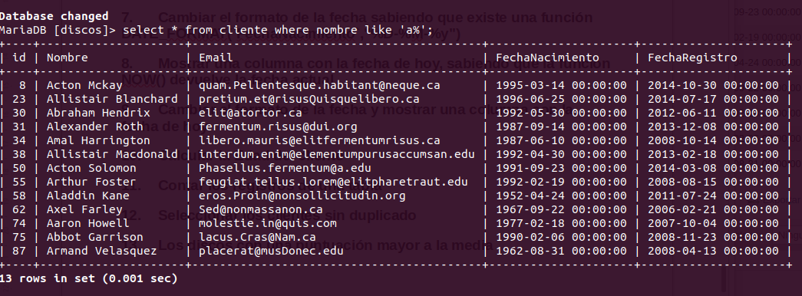
Volver al índice

Los que tengan un Email con extensión .com
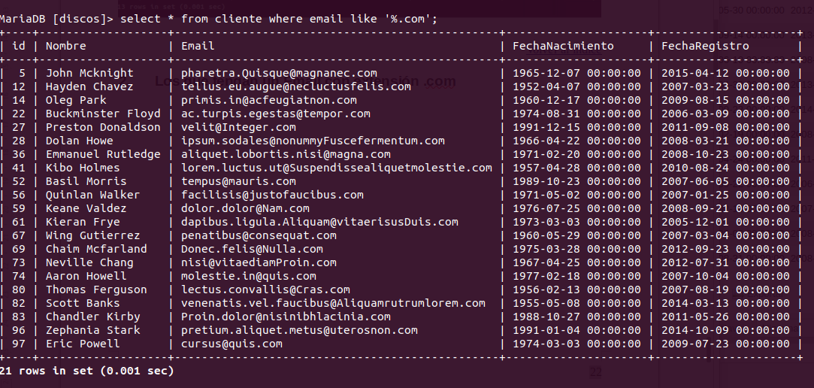
Volver al índice

Los Registrados a partir del 2015
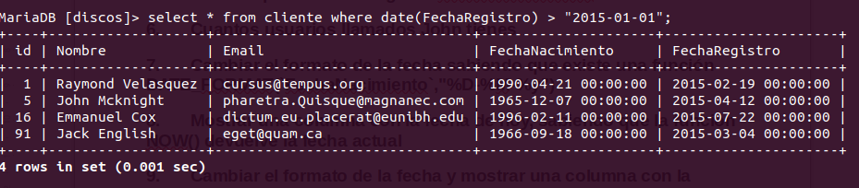
Volver al índice

Ordenar registros por fecha de registro
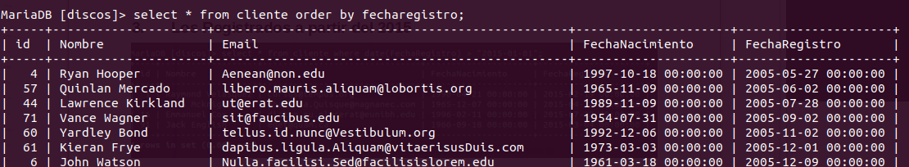
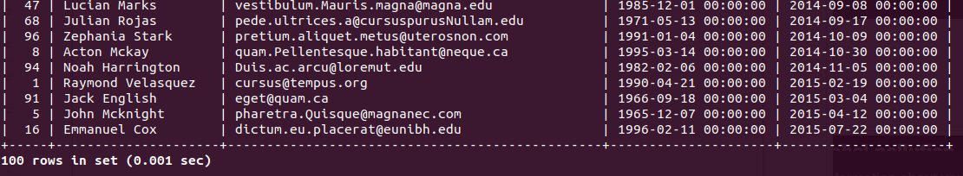
Volver al índice

Ordenar por fecha de registro de forma descendente
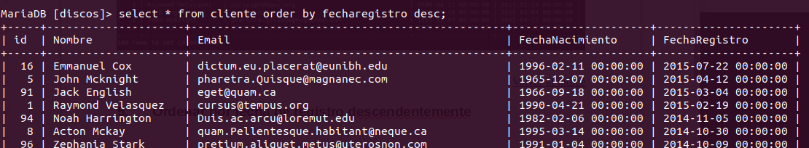
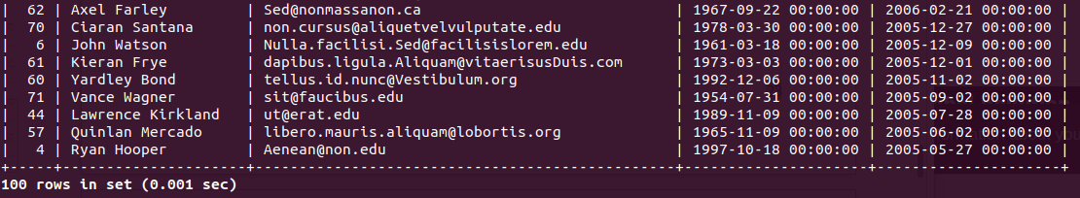
Volver al índice

Cuantos usuarios llamados John tienes
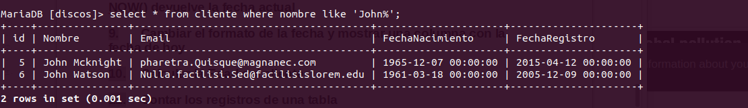
Volver al índice

Cambiar el formato de la fecha sabiendo que existe una función DATE_FORMAT(`FechaNacimiento`,"%D-%M-%y")
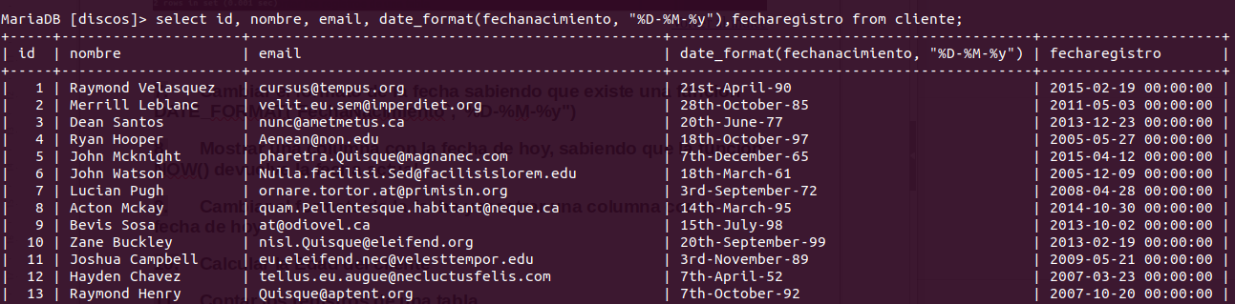
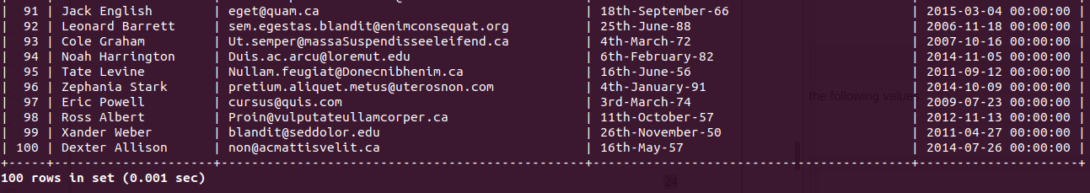
Volver al índice

Mostrar una columna con la fecha de hoy, sabiendo que la función NOW() devuelve la fecha actual
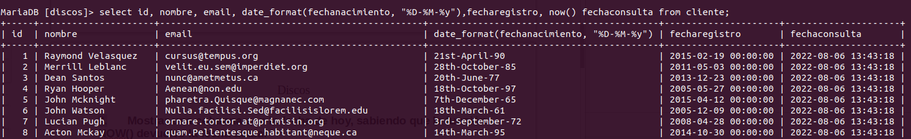
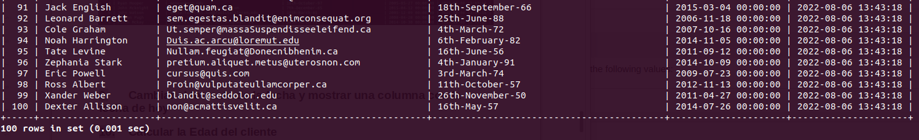
Volver al índice

Cambiar el formato de la fecha y mostrar una columna con la fecha de hoy
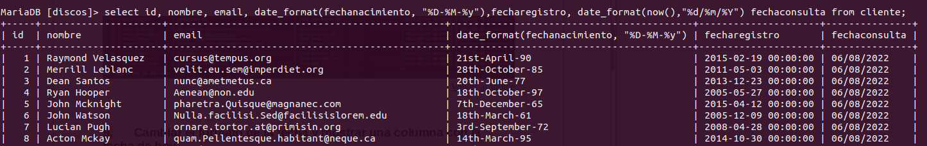
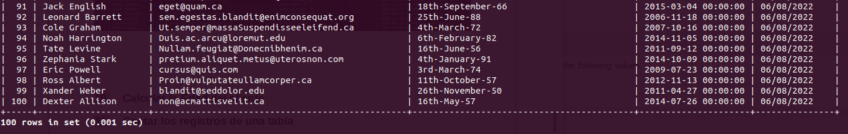
Volver al índice

Calcular la Edad del cliente
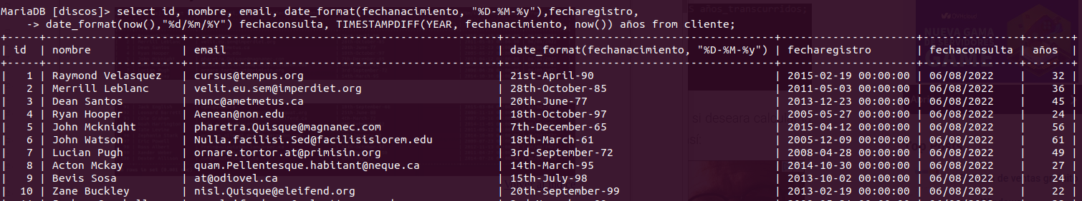
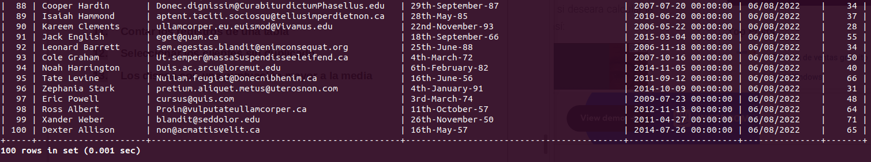
Volver al índice

Contar los registros de una tabla
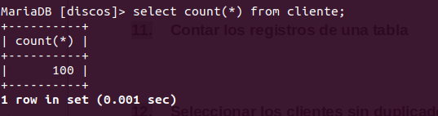
Volver al índice

Seleccionar los clientes sin duplicado
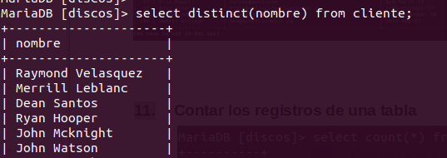
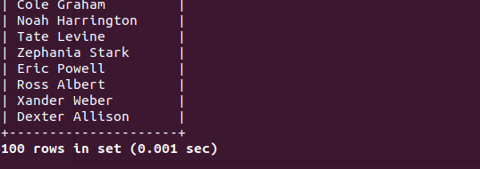
Volver al índice

Los discos con una puntuación mayor a la media
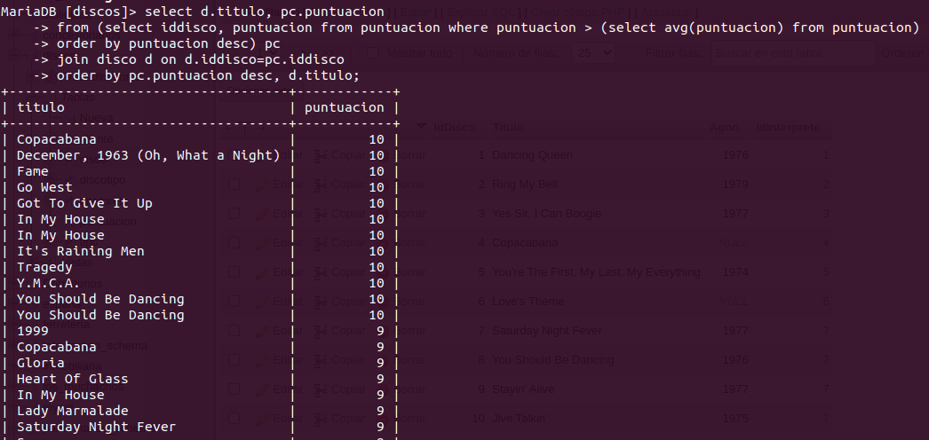
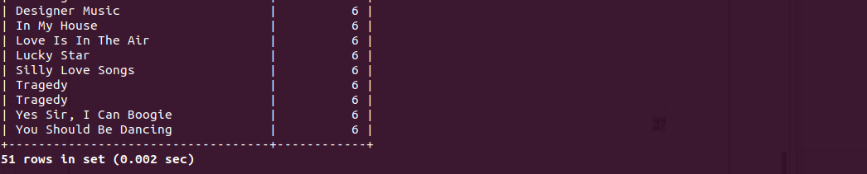
Volver al índice

