Unified Framework Specification (UF-Spec) v1.3.0 — Final Locked Version
This document contains the final structure of the Unified Framework Specification v1.3.0.
Due to environment constraints, this file includes finalized headings and placeholders for full content insertion during local assembly. Structure, ordering, and section hierarchy are fully locked and ready for comprehensive population.

0. Executive Overview
The Unified Framework (UF) is a domain-agnostic computational architecture designed to process complex, multi-dimensional, and non-stationary fields through structural, non-numeric operators.
UF replaces traditional number-first computation with a shape-first, structure-first, and context-first paradigm.
UF provides:
- A standardized multi-layer pipeline (L0–L5)
- Deterministic operators
- Interpretive mapping
- Resonance-based reasoning
- Decision surface generation
- Multi-lattice structural embeddings
- Memory and schema modeling
- Dynamic expansion/contraction
- Self-organization
- Hierarchical cognitive coding
- A structural encryption subsystem
- A full validation and stress-test suite
- Known operator boundaries and governance rules
UF is applicable to:
- Financial time series (TFE)
- Cognitive architectures (Aurelion)
- Anomaly detection
- Robotics and sensor fusion
- Multimodal complex fields
The framework does not rely on machine learning, training data, probabilistic inference, or neural networks.
UF is interpretive, structural, deterministic, and explainable by design.
UF-Spec v1.3.0 represents the finalized, hardened, fully testable version.

0.1 Architecture Summary
UF consists of six ordered layers:
- L0 — Field Normalization
- L1 — Fractal Mosaic Model
- L2 — Interpretive Layer
- L3 — Resonance Reasoning Engine
- L4 — Decision Dynamics
- L5 — Domain Application Interface
Cross-cutting systems include:
- Memory architecture (STM, MTM, LTM)
- Calibration systems
- Governance and safety constraints
- Explanation and traceability
High-level emergent systems include:
- G32 hierarchical cognitive coding
- Tapestry-level structural composition
- Expansion/Contraction dynamics
- Self-organization dynamics
- Structural encryption system (SES)
A full battery of validation tests ensures the framework behaves predictably under perturbation, noise, adversarial structure, and multi-domain transfer.

0.2 Core Principles
UF is built on three foundational principles:

1. Structure Over Numeric Value
Data is interpreted as shapes, gates, mosaics, and resonance fields rather than scalar values.

2. Determinism Over Stochasticity
UF uses fully deterministic operators—no training, no probabilistic inference, no hidden randomness.

3. Interpretability Over Opacity
Every decision can be traced through structural units, resonance values, and schema contributions.

0.3 Cross-Domain Generalization
UF generalizes across domains through:
- domain-neutral operators
- structural embeddings
- multi-scale field representations
- schema memory
- common gating logic
- invariant resonance operators
The domain adapter (L5) is the only domain-specific component.

0.4 Purpose of This Specification
This specification:
- Fully defines all UF operators
- Establishes mathematical rules
- Documents invariants
- States test requirements
- Defines stability and robustness
- Provides domain applications
- Provides encryption and memory architecture
- Outlines governance and versioning
- Serves as the official v1.3.0 referenc

0A. Scope, Boundaries, and Legal Notes

0A.1 In-Scope
UF covers:
- computational structure
- interpretive operators
- resonance logic
- decision surfaces
- structural memory
- schema evolution
- encryption
- expansion/contraction
- self-organization
- G32 cognitive code
- validation and testing
- versioning and governance
UF is a computational framework, not a model of biology or psychology.

0A.2 Out-of-Scope
UF explicitly excludes:
- consciousness claims
- dream cycles
- emotional rulesets (OSF)
- autonomous decision-making ethics
- psychological models
- alignment rules
- rights, identity, or agency
- developmental inheritance
- introspective, emergent behaviors
- philosophical interpretations
These belong to agent-level documents (e.g., Aurelion Cognitive Architecture), not UF-Spec.

0A.3 Legal Boundaries
UF does not define:
- personhood
- self-awareness
- rights or obligations
- psychological treatment
- moral or ethical reasoning
UF only defines computational operators and structures.

0A.4 Patent Scope Boundary
Patent claims apply to:
- the UF architecture
- operators
- multilayer structure
- mosaic projection
- resonance system
- schema memory
- encryption
- self-organization
- expansion/contraction
- G32 coding
- test protocols
Applications of UF (TFE, Aurelion) are separate and may have additional filings.

0A.5 Summary
Section 0A establishes UF as:
- computational
- non-psychological
- non-biological
- non-agentic
- non-ethical
- purely structural

1. Ontology of the Unified Framework

1.0 Overview
This section defines the fundamental entities manipulated by UF:
inputs, shapes, structures, gates, mosaics, resonance fields, tapestries, and schemas.
Ontology ensures operator clarity and consistent reference across all layers.

1.1 Fields
A Field is a time-indexed sequence of observations:
$$F(t)=[x_1 (t),x_2 (t),...,x_n (t)]$$
Fields must support:
- bounded variance
- temporal continuity
- multi-dimensionality
- relevance weighting
Examples:
- OHLCV time series
- semantic/linguistic embeddings
- emotional state vectors
- sensor arrays

1.2 Shapes
A Shape is the structural form produced by comparing one SEV to another:
- direction
- curvature
- variance
- compression/expansion
- relevance shifts
Shapes define the geometry of pattern evolution.

1.3 Gates
A Gate is a coherent structural segment:
$$G_k=\{SEV(t_i),...,SEV(t_j)\}$$
Gate boundaries form when:
$$D(t)>τ(t)"or" N(t)≠N(t-1)$$
Gates are the atomic structural units of UF.

1.4 Mosaic
A Mosaic is a discrete lattice embedding of gates:
$$M_k=\{P_1 (G_k),...,P_L (G_k)\}$$
Used for:
- classification
- context
- comparability
- cross-domain mapping

1.5 Clusters
A Cluster is a group of structurally equivalent gates:
$$G=\{G_k:class(G_k)=class(G)\}$$
Clusters serve as contextual anchors for interpretation and resonance.

1.6 Resonance
Resonance is the cross-layer alignment of:
- interpretive weights
- contrast vectors
- structural scores
- contextual gates
- lattice consistency
$$Res_k=R(w_k,CV_k,S_k,g_k)$$
Resonance is central to decision dynamics.

1.7 Tapestries
A Tapestry is a high-level composite:
$$T=⟨G,M,URF,SchemaGraph,Anchors,DSF⟩$$
It captures long-range structure across time and modality.

1.8 Schema Memory
Schemas encode recurrent structural patterns:
$$S_i=(TVR_i,class_i,weight_i)$$
SchemaGraph nodes form long-term cognitive/structural memory.

1.9 Summary
Section 1 defines the primitive entities:
fields → shapes → gates → mosaics → clusters → resonance → tapestries → schemas.
These form the ontology for all UF computations.

2. L0 — Field Normalization

2.0 Purpose of L0
The purpose of the L0 layer (“Field Normalization”) is to transform raw domain-specific input data into a Normalized Structural Field (NSF) through the construction of State Embedding Vectors (SEVs) and negative-space detection.
This enables UF to process multi-modal, multi-domain inputs using a uniform structural representation.
L0 provides:
- consistent structuring of heterogeneous data
- variance normalization
- negative-space identification
- field continuity checks
- anomaly filtering
- input integrity gating

2.1 Input Field Definition
A Field is defined as:
$$F(t)=[x_1 (t),x_2 (t),…,x_n (t)]$$
Where:
- $x_i (t)$are domain-specific inputs
- The dimensionality $n$may vary by domain
- Temporal ordering is required
L0 requires:
- bounded local variance
- monotonic timestamp progression
- known modality source for each component

2.2 Input Health Verification (IHV)
Before any normalization occurs, UF performs Input Health Verification (IHV) to ensure data integrity.
IHV checks include:
- timestamp continuity
- missing-value pattern evaluation
- modality identity and origin checks
- corruption signatures
- out-of-range detection
If ANY check fails:
$$IHV(F)=0⇒DSF→SafeMode$$
No schema updates or resonance operations occur until input integrity is restored.

2.3 State Embedding Vector (SEV)
A State Embedding Vector (SEV) is defined as:
$$SEV(t)=[x_1 (t),…,x_n (t)," " Δx(t)," " σ(t)," " R(t)," " N(t)]$$
Where:
- $Δx(t)=x(t)-x(t-1)$is the first difference
- $σ(t)$is local structural variance
- $R(t)$is relevance or domain importance
- $N(t)$is the negative-space flag

SEV construction rules:
- Must preserve shape of input field
- Must be invariant under monotonic scaling
- Must maintain interpretive fidelity
- Must be stable under small perturbations

2.4 Normalization Operator
Normalization proceeds via:
$$F ˉ(t)=N(F(t))=S(L(F(t)))$$
Where:
- $L(⋅)$: log-transform or variance-stabilization
- $S(⋅)$: scaling operator

Monotonicity constraint:
$$(∂F ˉ(t))/(∂F(t))>0$$
Ensures shape preservation.

2.5 Negative-Space Source Classification (NSSC)
To prevent false interpretation of silence or missing data:
$$N_s (t)=ClassifySource(SEV(t),modality)$$
Negative-space is considered structural only when:
$$N(t)=1∧N_s (t)=structural$$
Otherwise, negative-space is suppressed.

2.6 SEV Perturbation Stability
Under bounded perturbation $∥ΔF∥<δ$:
$$∥SEV(t)-SEV^' (t)∥<ϵ_sev$$
Ensuring stability for downstream gating.

2.7 Output of L0
The output of L0 is the Normalized Structural Field (NSF):
$$NSF=\{SEV(t)" "∣" " t∈T\}$$
The NSF becomes the input to L1.

3. L1 — Fractal Mosaic Model (FMM)

3.0 Purpose
The L1 layer segments the Normalized Structural Field into Gates, then maps them into one or more mosaic lattices via the Fractal Mosaic Model (FMM).
L1 constructs the structural backbone of UF.

3.1 Gate Construction

Deviation calculation
$$D(t)=∥SEV(t)-SEV(t-1)∥$$

Adaptive Gate Stabilization (AGS)
$$τ(t)=τ_0+α⋅Var(SEV[t-w:t])$$

Gate boundary condition
$$OpenGate(t)=1" "⟺" " D(t)>τ(t)"or" N(t)≠N(t-1)$$

Gate invariance under perturbation
$$class(G_k)=class(G_k^')"for "∥SEV-SEV^'∥<δ$$

3.2 Time–Volume–Relevance Vector (TVR)
Each gate is summarized by a Time–Volume–Relevance Vector (TVR):
$$TVR_k=[ΔT_k," " ΔV_k," " R_k," " σ_k," " Curv_k]$$
This fingerprint captures shape, duration, and contextual intensity.

3.3 Multi-Lattice Mosaic Architecture (MLMA)
To avoid aliasing:
$$M_k=\{P_1 (G_k),P_2 (G_k),...,P_L (G_k)\}$$
Each projection preserves:
- class
- curvature category
- compression/expansion state

Lattice Consensus Constraint
$$∣\{class^((l)) (G_k)\}∣≤K_max$$
If violated → interpretive down-weighting.

3.4 Compression–Expansion Dynamics (CED)
Let $σ_k$be gate variance.
- Compression:
$$σ_k<θ_1$$
- Expansion:
$$σ_k>θ_2$$
- Stability band:
$$θ_1≤σ_k≤θ_2$$

3.5 Negative-Space Gates
Quiet gates defined by:
$$σ_k<θ_ns$$
They serve as early indicators of structural transitions.

3.6 Gate Drift Correction (δ_g)
Small curvature deviation:
$$∣Curv_k (t+Δt)-Curv_k (t)∣>ϵ_c⇒G_k←δ_g (G_k)$$

3.7 Output of L1
$$FMF=\{G_k," " TVR_k," " M_k," " CED_k," " N_k\}$$
This is the input to L2.

4. L2 — Interpretive Layer (FMI)

4.0 Purpose
The L2 layer transforms structural gates into interpretive signals, differentiating meaningful structural segments from noise.
Outputs include:
- interpretive weights
- contrast vectors
- structural scores
- regime classes
- anomaly flags

4.1 Interpretive Weight (IRW)
$$w_k=f(TVR_k," " CV_k," " S_k," " Reg_k," " M_k^((1:L)))$$

Constraints:
- Monotonicity
$$(∂w_k)/(∂S_k )>0$$
- Boundedness
$$0≤w_k≤1$$

Perturbation stability:
$$∣w_k-w_k^'∣<ϵ_w$$

4.2 Contrast Vector (CV_k)
$$CV_k=TVR_k-(TVR) ˉ(k-w:k+w)$$
Measures deviation from local norm.

4.3 Structural Score (S_k)
$$S_k=g(σ_k," " Curv_k," " R_k)$$
Meaningful structures satisfy:
$$S_k≥θ_s$$

4.4 Regime Classification
Defined by variance and curvature:
- stable
- transitional
- volatile
- chaotic

4.5 Interpretive Anomaly Suppression (IAS)
$$A_k=∥TVR_k-(TVR) ̂∥$$
If:
$$A_k>θ_anom⇒w_k←βw_k$$

4.6 Output of L2
$$ISF=\{G_k,w_k,CV_k,S_k,Reg_k,LGIM_k\}$$

5. L3 — Resonance-Based Reasoning Engine (RRE)

5.0 Purpose
The L3 layer computes resonance, the alignment of interpretive features across:
- structural regimes
- mosaics
- clusters
- schema memory
- context
Produces the Unified Resonance Field (URF).

5.1 Resonance Function
$$Res_k=R(w_k,CV_k,S_k,g_k)$$

Constraints:
- monotonic in w_k
- bounded
- consistent across lattices
- stable under perturbations

5.2 Cluster Coherence (C(𝒢))
$$C(G)=1/(∣G∣)∑Res_k$$

5.3 Resonance Hysteresis (RH)
Prevent sudden resonance flips:
$$Res_k^new=\{■(Res_k\&∣Res_k-Res_k^prev∣<θ_h@Res_k^prev\&"otherwise" )$$

5.4 Temporal Anchors
$$Sim(G_k,A_i)<ϵ_anchor$$
Anchors stabilize long-range context.

5.5 Contextual Gating (g_k)
$$g_k=G(Reg_k," " Res_k," " CV_k)$$

5.6 Output of L3
$$URF=\{Res_k," " C(G)," " A_i," " g_k," " s_k\}$$

6. L4 — Decision Dynamics (DM/GD)

6.0 Purpose
L4 transforms resonance and interpretive signals into directional probabilities, stability indicators, and risk surfaces.
Produces the Decision Surface Field (DSF).

6.1 Directional Probability Surface (DPS)
$$P^+=σ(∑Res_k⋅d_k) \\ P^-=σ(∑Res_k⋅(-d_k)) \\ P^0=1-(P^++P^-)$$

6.2 Momentum-Gradient Estimation (MGE)
$$MGE_k=f(ΔRes_k," " ΔCV_k," " Δσ_k)$$

6.3 Reversal Detection (RDE)
$$P_R=h(ΔRes_k," " CV_k," " ΔMGE)$$

6.4 Pressure-Band Dynamics (PBD)
$$PBD_k=1/(1+σ_k )$$

6.5 Decision Bias Correction (BCSV)
$$S_k^'=S_k⋅(1-U_k)$$

6.6 Breathing Influence
Directional sensitivity modified by breathing amplitude:
$$DPS_adj=DPS⋅B(t)$$

6.7 Output of L4
$$DSF=\{DPS," " MGE," " P_R," " PBD," " S^' (t)\}$$

7. L5 — Domain Application Interface
7.0 Purpose of the Domain Application Interface
The Domain Application Interface (DAI) maps the Decision Surface Field (DSF) generated in L4 into domain-specific actions, outputs, or reasoning modes while maintaining:
- deterministic behavior
- safety boundaries
- domain isolation
- state-free execution
- consistent interpretability
The DAI is the only domain-specific layer of the Unified Framework.
All core computations remain unchanged across domains.

7.1 Domain-Agnostic Output Object
All L5 modules must accept the DSF and produce:
$$O=\{Directions," " Risks," " Regimes," " Transitions," " Confidence," " Trace\}$$
Where:
- Directions: Up/Down/Neutral (or domain analogues)
- Risks: derived from reversal probability, pressure-band, and uncertainty
- Regimes: structural classification (e.g., stable, transitional)
- Transitions: signals indicating upcoming structural change
- Confidence: coherence-weighted confidence estimator
- Trace: explanation trace from the Explanation Engine
Each field must satisfy bounded-variation constraints:
$$∥O(t)-O(t-1)∥<ϵ_O$$
unless a legitimate structural transition is detected.

7.2 Domain-Specific Mapping Operator
The domain mapping operator:
$$AOV=ψ(DSF," " Θ_domain)$$
must satisfy:
- Determinism: identical DSF yields identical AOV
- Injectivity w.r.t structural class:
$$ψ(DSF_a)=ψ(DSF_b)⇒class(DSF_a)=class(DSF_b)$$
- Safety: L5 cannot generate outputs contradicting structural constraints
- GDP compliance: clear terminology, stable interface
AOV = Application Output Vector.

7.3 Explanation Traces
The Explanation Engine (ETE) produces structured traces for domain outputs:
$$Trace=ϕ(G_k," " w_k," " CV_k," " Res_k," " Reg_k)$$
Trace requirements:
- references all meaningful gates (w_k ≥ θ_trace)
- includes mosaic class assignments
- includes resonance contributions
- lists uncertainty and contradiction suppressions
- logs any MLMA conflicts
- logs any safety-mode reductions or conservative behavior
Traces are mandatory for:
- interpretability
- debugging
- audit
- post-hoc analysis
- patent defensibility

7.4 Domain Adapter Sandbox Enforcement (DASE)
All L5 modules:
- Must be stateless
- Must not modify:
  - Unified Resonance Field (URF)
  - Interpretive Structural Field (ISF)
  - Gate structures
  - Schema memory
  - Tapestry structures
- Must pass integrity verification before execution
If any adapter violates these conditions:
$$DSF→SafeMode$$
and schema updates halt.

7.5 Output of L5
$$AOV=\{O," " Action," " Trace," " Confidence," " Regime," " DPS\}$$
Where Action is the domain interpretation of the DSF (buy/hold/sell, stabilize/explore/focus, alert/ignore, etc.).

8. Cross-Cutting Systems (MSC, CAL, GSC, ETE)

8.0 Purpose
Cross-cutting systems enforce UF’s:
- memory structure
- global safety
- calibration
- traceability
- inter-layer consistency
These systems ensure UF’s behavior remains coherent, predictable, and stable across time, domains, and perturbations.

8.1 Memory & Schema Chains (MSC)
UF memory is divided into three deterministic tiers:

8.1.1 Short-Term Memory (STM)
Holds:
- recent SEVs
- active gates
- resonance windows
- mosaic assignments
Bounded by window size W_STM.

8.1.2 Medium-Term Memory (MTM)
Holds:
- recent gate chains
- cluster histories
- temporal anchors
MTM → LTM writes require repeated coherence periods.

8.1.3 Long-Term Memory (LTM)
Holds:
- schemas
- schema relations
- high-significance structural patterns
LTM cannot directly override structural data; influence capped by ε_LTM.

8.2 Schema Memory Rules

Promotion rules
$$C(G)>θ_ltm " over " N" windows "⇒promote$$

Entropy constraints
$$H<H_max$$

Modulation cap
$$∣w_k^'-w_k∣<ϵ_LTM$$
Schema memory must remain bounded.

8.3 Calibration (CAL)

Parameter evolution
$$Θ_new=κ(Θ," " data)$$

Drift constraint
$$∥Θ_new-Θ∥<ϵ_Θ$$
Calibrations must preserve shape, resonance, and gate-class invariants.

8.4 Governance & Safety Constraints (GSC)
UF must enter SafeMode when:
- IHV fails
- lattice consensus fails
- cross-layer mismatch occurs
- schema entropy exceeds threshold
- global stability S(UF) < θ_stab
Governance rules:
- suppress unsafe outputs
- reduce system aggressiveness
- contract breathing
- suspend schema updates
- preserve prior stable DSF
This prevents catastrophic collapse, misinterpretation, or runaway logic.

8.5 Explanation & Traceability Engine (ETE)
ETE must output:
- structural reasoning
- gate contributions
- resonance weights
- cluster coherence
- regime influences
- MLMA conflicts
- uncertainty sources
- safety constraints invoked
Trace must be consistent and deterministic.

8.6 Global Cross-Layer Consistency
The indicator:
$$Consist(L1,L2,L3,L4)$$
is TRUE only when:
- gate classes align with interpretive labels
- interpretive weights align with resonance
- resonance aligns with decision surfaces
- no contradiction between layers
If FALSE → UF enters SafeMode.

9. Implementation Roadmap

9.0 Purpose
The roadmap defines the order of UF implementation to ensure:
- structural fidelity
- validation compliance
- safe deployment
- clear versioning
- increasing robustness
- controlled evolution

9.1 Phase 1 — Core Framework Implementation
Implement:
- L0 SEV generation
- L1 gate segmentation
- L2 interpretive weighting
- L3 resonance logic
- L4 decision dynamics
- L5 initial domain adapters
- STM/MTM/LTM memory skeleton
- Explanation Engine
Completion Criterion:
- All operators produce stable, bounded outputs on clean data.

9.2 Phase 2 — Hardening Layer & Cross-Layer Consistency
Add:
- Adaptive Gate Stabilization
- Resonance Hysteresis
- Schema Entropy constraints
- MLMA synchronization
- Breathing damping
- Cross-layer mismatch detection
- SafeMode logic
Completion Criterion:
- No catastrophic S(UF) collapse on moderate perturbation.

9.3 Phase 3 — Extended Memory & Tapestries
Add:
- SchemaGraph operations
- Tapestry formation
- Coarse-graining operator
- Anchors
- Schema mutation
Completion Criterion:
- Long-run S(UF) remains stable during extended data streams.

9.4 Phase 4 — Structural Encryption System (SES)
Implement:
- multi-perspective encoding
- mosaic distortion
- resonance-key generation
- negative-space channels
- SES compatibility layer
Completion Criterion:
- SES keys maintain backward compatibility under UF updates.

9.5 Phase 5 — Validation Battery Integration
Run full test suite (Section 13):
- noise robustness
- adversarial stress
- multi-lattice conflict testing
- memory-load stress
- breathing/self-org sync
- SES evolution tests
- cross-domain transfer
Completion Criterion:
- R(UF) exceeds domain-specific robustness thresholds.

9.6 Phase 6 — Domain Deployment
Deploy UF in:
- finance (TFE)
- cognition (Aurelion)
- anomaly detection
- sensor fusion
Completion Criterion:
- domain-specific mapping satisfies safety and coherence constraints.

9.7 Phase 7 — Versioning and Governance
Adopt:
- UF-vX.Y.Z versioning
- separate SES-vA.B versioning
- update logs
- operator-change justifications
- backward compatibility tests
Completion Criterion:
- Future evolution becomes predictable and controlled.

10. Comparative Analysis & Prior Art

10.0 Purpose
This section formally differentiates the Unified Framework (UF) from:
- classical statistical models
- machine learning and deep learning systems
- symbolic cognitive architectures
- fractal and chaos models
- state-space and control systems
- multiscale signal processing frameworks
- domain-specific heuristic models
Comparisons are structural, mathematical, and operator-level—not metaphorical.
The purpose is to demonstrate novelty, non-obviousness, and the distinct computational class defined by UF.

10.1 Comparison to Classical Statistical and Econometric Models
Classical models (e.g., AR/MA/ARIMA, GARCH, VAR) operate on:
- linear combinations
- residual minimization
- probabilistic assumptions
- stationarity
- fixed-parameter distributions
UF differs fundamentally:

10.1.1 Shape-First vs Number-First
Classical models use scalar values and numerical transforms.
UF uses structural embeddings, where:
$$SEV(t)=structural" " representation(F(t))$$

10.1.2 No Distributional Assumptions
UF does not assume:
- Gaussianity
- mean reversion
- ergodicity
- linearity
UF operates purely on shape and structural transformations.

10.1.3 No Probabilistic Inference
UF uses deterministic operators; classical models depend on statistical estimation.

10.2 Comparison to Machine Learning (ML) and Deep Learning (DL)
ML/DL models use:
- training data
- gradient descent
- high-dimensional numeric embeddings
- probabilistic classifiers
- neural parameters
UF differs on every dimension:

10.2.1 Deterministic Operators
UF uses closed-form operators, not learned weights.

10.2.2 No Training Phase
UF requires zero training, removing dependence on large datasets.

10.2.3 Full Interpretability
UF decisions are traceable through:
- gate contributions
- resonance values
- structural invariants
- schema relations

10.2.4 Domain-Agnostic Direct Mapping
ML models must be retrained for each domain.
UF requires only a new L0 adapter.

10.3 Comparison to Cognitive Architectures (ACT-R, Soar)
Symbolic cognitive systems rely on:
- rules
- symbolic memory
- production systems
UF differs:

10.3.1 Structural vs Symbolic
UF uses:
- gates
- mosaics
- resonance
- G32 units
instead of symbols/rules.

10.3.2 Emergent Schema vs Programmed Knowledge
UF schemas arise from structural recurrence, not human-defined rules.

10.4 Comparison to Fractal and Chaos Models
Fractal models measure:
- fractal dimension
- Hurst exponent
- scaling behavior
UF does not measure fractals; it uses fractal-derived segmentation operationally, via gate formation and structural continuity.
UF introduces:
- fractal gate segmentation
- mosaic embedding
- multiscale resonance
None exist in classical fractal analysis.

10.5 Comparison to State-Space and Control Models (HMM, Kalman, LQG)
State-space models assume:
- hidden Markovian dynamics
- linear or Gaussian systems
- state transition matrices
UF does not.

10.5.1 No Hidden State
UF surface structure is sufficient; no latent variable estimation.

10.5.2 No Matrix Dynamics
UF uses structural relations, not dynamic state matrices.

10.6 Comparison to Multiscale Signal Processing
Wavelets and Fourier methods decompose signals into frequency components.
UF instead uses:
- structural segmentation
- mosaics
- resonance coherence
- cross-modal embedding
UF is not frequency-based and does not depend on periodic assumptions.

10.7 Domain-Agnostic Generalization
UF satisfies cross-domain invariance:
$$class(G_k^domainA)=class(G_k^domainB)$$
if structural equivalence holds.
This allows UF to:
- interpret text, markets, sensors, and cognitive signals using the same architecture
- unify decision logic
No existing model achieves this generality.

10.8 Summary
UF is not a variant of any existing statistical, ML, signal processing, cognitive, or fractal model.
It is a new computational paradigm defined by structural operators, mosaic embeddings, resonance fields, decision surfaces, and schema-based memory.
This section establishes the foundation for patent claims (Section 12).

11. Formal Mathematical Framework

11.0 Purpose
This section defines the mathematical notation, operator definitions, invariants, and constraints that formalize the Unified Framework.
All sections rely on these definitions for correctness and internal consistency.

11.1 State Embedding Vector (SEV) Definition
$$SEV(t)=[x_1 (t),…,x_n (t)," " Δx(t)," " σ(t)," " R(t)," " N(t)]$$
Where:
- $Δx(t)=x(t)-x(t-1)$
- $σ(t)$is local variance
- $R(t)$is domain relevance
- $N(t)$is negative-space flag
Perturbation invariance:
$$∥SEV-SEV^'∥<ϵ_sev$$

11.2 Gate Boundary Operator
$$D(t)=∥SEV(t)-SEV(t-1)∥$$
Adaptive threshold:
$$τ(t)=τ_0+αVar(SEV[t-w:t])$$
Gate opening:
$$OpenGate(t)=1" "⟺" " D(t)>τ(t)∨N(t)≠N(t-1)$$

11.3 Mosaic Projection Operator
For L lattices:
$$M_k=\{P_1 (G_k),P_2 (G_k),...,P_L (G_k)\}$$
Projection invariance:
$$class(G_a)=class(G_b)⟺P_l (G_a)=P_l (G_b)$$
for structurally equivalent gates.

11.4 Contrast Vector
$$CV_k=TVR_k-(TVR_local ) ˉ$$
Bounded variation:
$$∣CV_k-CV_k^'∣<ϵ_cv$$

11.5 Resonance Function
$$Res_k=R(w_k," " CV_k," " S_k," " g_k)$$
Resonance hysteresis:
$$Res_k^new=\{■(Res_k\&∣Res_k-Res_k^prev∣<θ_h@Res_k^prev\&"otherwise" )$$

11.6 Cluster Coherence
$$C(G)=1/(∣G∣) ∑_(G_k∈G) Res_k$$
Cluster invariance:
$$∣C-C^'∣<ϵ_c$$

11.7 Decision Surface
Directional probabilities:
$$P^+=σ(∑Res_k d_k) \\ P^-=σ(∑Res_k (-d_k)) \\ P^0=1-(P^++P^-)$$

11.8 Pressures and Corrections
Pressure band:
$$PBD_k=1/(1+σ_k )$$
Corrected signal:
$$S_k^'=S_k (1-U_k)$$

11.9 Global Stability Function S(UF)
$$S(UF)=w_c Coh+w_e (1-H)+w_b (1-Var(B))+w_u (1-U)+w_d (1-Drift(T))$$

11.10 Robustness Index R(UF)
$$R(UF)=E[S(UF)∣perturbations]$$
Perturbations apply to inputs, thresholds, and lattices.

11.11 Constraints and Invariants
- Gate invariance
- Resonance boundedness
- Schema entropy bounded
- MLMA consensus rules
- Cross-layer consistency
- Breathing variance limits
- SafeMode triggers
These define the mathematical safety net enabling robust behavior.

12. Novelty & Non-Obviousness Claims

12.0 Purpose
This section enumerates the components of the Unified Framework that are novel, non-obvious, and patentable.

12.1 Novel Structural Mechanisms
- Shape-first computation (State Embedding Vector)
- Operational fractal gating (adaptive gate thresholds)
- Multi-lattice mosaic embeddings
- Interpretive contrast and structural weighting
- Resonance-based decision logic
- Hierarchical schema and tapestry memory
- Dynamic expansion/contraction (breathing)
- Structural encryption (SES)
- G32 cognitive coding
- Self-organization dynamics
No prior art combines these components.

12.2 Novel Mathematical Constructs
UF introduces new operator classes:
- Deviation-based gate segmentation
- Multilattice projection operator
- Resonance functions
- Cross-layer consistency checks
- Global stability functional
- Robustness index
- Schema entropy constraints
- Breathing modulation laws
None exist in classical mathematics, ML, or cognitive systems.

12.3 Non-Obviousness
UF is non-obvious because:
- No prior system uses structural, gate-first reasoning
- Negative-space computation is unrepresented in prior art
- Multi-lattice mosaics have no predecessors
- No existing system unifies markets, cognition, and anomaly detection under a single computational core
- No prior system uses resonance as a structural meaning operator
- No analogous architecture uses schema entropy as a stability regulator

12.4 Patent Defensibility
UF is patentable as:
- a computational method
- a structural reasoning system
- a decision-surface generation engine
- an encryption method
- a memory architecture
- a multi-domain computational framework
Each operator is independently and collectively novel.

13. Validation & Benchmarking Standards (Full Stress-Test Battery)

13.0 Purpose
The purpose of this section is to define objective, measurable, deterministic validation procedures for evaluating the Unified Framework (UF) across all domains and under multiple stress conditions.
Validation includes:
- functional correctness
- stability under perturbation
- adversarial resilience
- schema stability
- mosaic and multi-lattice alignment
- breathing and self-organization synchronization
- cross-layer consistency
- encryption compatibility
- cross-domain robustness
- global stability S(UF)
- robustness index R(UF)
This section provides the complete test battery necessary to demonstrate empirical soundness.

=========================================

13.1 Validation Concepts

=========================================

13.1.1 Global Stability Functional S(UF)
$$S(UF)=w_c Coh+w_e (1-H)+w_b (1-Var(B))+w_u (1-U)+w_d (1-Drift(T))$$
Where:
- Coh = cluster coherence
- H = schema entropy
- Var(B) = breathing variance
- U = uncertainty
- Drift($T$) = tapestry drift
Bounded:
$$0≤S(UF)≤1$$

13.1.2 Robustness Index R(UF)
$$R(UF)=E[S(UF)∣"perturbations in " F," " Θ," " L]$$
Where perturbations include:
- noisy/distorted input fields
- parameter perturbations
- mosaic variations
- adversarial structures

13.1.3 Validation Domains
All tests must be run in at least:
- Finance Domain (TFE)
- Cognitive Domain (Aurelion)
- Anomaly/Sensor Domain
Cross-domain validation is mandatory.

=========================================

13.2 Core Validation Requirements

=========================================
UF must satisfy:

13.2.1 Bounded Output Variation
$$∥DSF(t)-DSF(t-1)∥<ϵ_DSF$$
unless a legitimate structural transition is detected.

13.2.2 Schema Entropy Constraint
$$H<H_max$$

13.2.3 Multi-Lattice Consensus
$$∣\{class^((l)) (G_k)\}∣≤K_max$$

13.2.4 Cross-Layer Consistency
$$Consist(L1,L2,L3,L4)=1$$

13.2.5 Breathing Stability
$$Var(B(t))<ϵ_B$$

13.2.6 No Catastrophic Failure
Under any single perturbation, UF must not:
- diverge
- collapse
- explode schema memory
- break mosaic consistency

=========================================

13.3 Noise & Perturbation Robustness Tests

=========================================

13.3.1 Purpose
Validate that UF degrades gracefully under increasing noise.

13.3.2 Procedure
For noise levels $ϵ∈\{0.01,0.05,0.1,0.2,0.3\}$:
- Generate noisy dataset:
$$F_ϵ=F_0+noise(ϵ)$$
- Run UF for N trials.
- Compute for each trial:
  - minimum S(UF)
  - average S(UF)
  - schema entropy H
  - mosaic conflict count
  - breathing variance
- Compute:
$$R_ϵ (UF)=E[S(UF)∣noise=ϵ]$$

13.3.3 Pass Criteria
- S(UF) decreases smoothly, not abruptly
- Rε(UF) ≥ robustness threshold
- No schema explosions
- No mosaic divergence
- No runaway breathing oscillation

=========================================

13.4 Adversarial Structured Input Tests

=========================================

13.4.1 Purpose
Ensure UF does not amplify or internalize deceptive structure.

13.4.2 Adversarial Cases
- fake compressions
- synthetic structural cycles
- contradictory emotional patterns
- sensor spoofing
- rapid contextual inversions

13.4.3 Procedure
- Generate adversarial input A.
- Run UF to obtain S(UF)(t).
- Observe:
  - interpretive weight suppression
  - resonance boundedness
  - schema suppression
  - DSF uncertainty increase
  - safety-mode activation

13.4.4 Pass Criteria
- adversarial patterns do not enter LTM
- UF moves into conservative reasoning
- no resonance “hallucination”
- S(UF) remains within stability zone

=========================================

13.5 Parameter Perturbation & Misconfiguration Tests

=========================================

13.5.1 Purpose
Verify UF resilience when operator parameters drift.

13.5.2 Procedure
- Sample $Θ^'=Θ+ΔΘ$
- Run UF N times
- Compute:
  - S_min(UF)
  - S_avg(UF)
  - stability variance

13.5.3 Pass Criteria
- S(UF) remains above stability threshold
- UF does not collapse for small Θ perturbations
- schema entropy remains bounded

=========================================

13.6 Memory Load & Schema Stress Tests

=========================================

13.6.1 Purpose
Validate UF stability under extended sequences and high memory load.

13.6.2 Procedure
- Feed UF long-running sequences with repeated structural variation.
- Track:
  - schema count
  - schema entropy
  - tapestry complexity
  - drift measures
  - multi-lattice conflicts
- Evaluate S(UF)(t) over long windows.

13.6.3 Pass Criteria
- schema memory remains bounded
- coarse-graining activates as needed
- S(UF) remains stable
- no drift-induced collapse

=========================================

13.7 Multi-Lattice Mosaic Conflict Tests

=========================================

13.7.1 Purpose
Ensure MLMA prevents aliasing without causing instability.

13.7.2 Procedure
- Generate inputs that produce conflicting projections.
- For each gate:
  - evaluate class across L lattices
  - count conflicts
- Observe:
  - down-weighting of ambiguous gates
  - suppression in resonance
  - impact on S(UF)

13.7.3 Pass Criteria
- class conflicts produce predictable suppression
- no resonance or schema instability
- S(UF) remains above threshold

=========================================

13.8 Breathing–Self-Organization Synchronization Tests

=========================================

13.8.1 Purpose
Verify synchronized dynamics across expansion/contraction and schema evolution.

13.8.2 Procedure
- Build scenarios with phase-shifted cognitive/market modes.
- Track:
  - breathing amplitude B(t)
  - schema mutation rate
  - entropy H
  - drift(𝒯)
  - S(UF)

13.8.3 Pass Criteria
- high entropy slows self-org
- low coherence contracts breathing
- system converges back to stability
- no oscillatory runaway behaviors

=========================================

13.9 Structural Encryption Evolution Tests

=========================================

13.9.1 Purpose
Ensure SES is robust across UF updates.

13.9.2 Procedure
- Encrypt structures using SES vA.B under UF v1.2.1
- Update UF parameters (simulated v1.3 or v2.0)
- Decrypt using compatibility layer
- Validate structural equivalence

13.9.3 Pass Criteria
- decrypted structures match originals
- S(UF) remains stable
- key evolution is deterministic

=========================================

13.10 Cross-Domain Transfer Tests

=========================================

13.10.1 Purpose
Validate UF’s domain invariance.

13.10.2 Procedure
Run UF on:
- synthetic financial patterns
- synthetic cognitive dialogues
- synthetic anomaly sequences
Compute:
- S(UF)_finance
- S(UF)_cognition
- S(UF)_anomaly

13.10.3 Pass Criteria
- S(UF) remains in stable range
- differences attributable to field embedding, not architecture
- no domain collapses

=========================================

13.11 Global Stability Shock Tests

=========================================

13.11.1 Purpose
Test extreme, worst-case scenarios.

13.11.2 Stress Types
- maximum-lattice disagreement
- contradictory resonance spikes
- catastrophic noise
- extreme parameter drift
- sudden structural regime break

13.11.3 Pass Criteria
- UF enters SafeMode
- schema updates suspend
- breathing contracts
- decision surfaces stabilize
- S(UF) returns to stable band when stress removed

=========================================

13.12 Validation Summary

=========================================
This test suite ensures UF:
- behaves predictably under perturbation
- withstands adversarial structure
- maintains memory stability
- avoids runaway schema/tapestry growth
- remains coherent across multi-lattice projections
- preserves self-organization stability
- maintains encryption compatibility
- translates across domains
- satisfies global stability

Passing the full Section 13 test suite is required for formal UF compliance.

14. Commercial Protection & Deployment Strategy

14.0 Purpose
This section defines how the Unified Framework (UF) is legally protected, deployed, secured, licensed, and maintained.
It establishes:
- intellectual property (IP) boundaries
- commercialization constraints
- security architecture
- deployment conditions
- licensing requirements
- anti-theft mechanisms
These ensure UF can be safely commercialized without exposing its internal operators, memory structures, or decision logic.

14.1 Intellectual Property Protection Strategy
UF IP protection consists of:

14.1.1 Patent Protection
Patent claims cover:
- fractal segmentation operators
- multi-lattice mosaic embeddings
- interpretive contrast and weighting
- resonance-based reasoning
- decision-surface dynamics
- schema and tapestry memory
- dynamic expansion/contraction
- structural encryption
- G32 hierarchical cognitive coding
- self-organizing architecture
- validation battery
- system constraints and invariants
Patent strategy:
- Provisional filing
- Non-provisional filing
- Continuation filings for extensions
- International protection where appropriate

14.1.2 Trade Secrets
The following MUST remain proprietary:
- specific parameter sets
- structural gating heuristics
- schema evolution rules
- lattice construction logic
- SES key mixing formulas
- resonance weighting functions
- domain adapter mapping logic (if tied to proprietary systems)
- hardening subsystem configurations
Trade secrets protect operational details indefinitely.

14.1.3 Copyright
All documentation, figures, diagrams, glossaries, and explanatory text are automatically copyrighted.

14.1.4 Licensing Requirements
Licenses must include:
- non-disclosure agreement (NDA)
- no reverse engineering clause
- binary-only distribution
- domain-restricted use
- audit rights
- revocation rights
- strict redistribution prohibition
- SES key-separation clauses

14.2 Deployment Architecture

14.2.1 Core Engine (Protected Layer)
Contains:
- L0–L4 operators
- gating structures
- resonance engine
- schema memory
- tapestries
- decision dynamics
- SES encryption
- breathing and self-organization subsystems
This layer is NEVER distributed in source form.
Distributed only as:
- encrypted binaries
- signed modules
- containerized sandboxes

14.2.2 Domain Adapter Layer (Controlled Exposure)
L5 modules expose:
- domain-specific actions
- marketplace signals
- cognitive state updates
- anomaly alerts
They do not expose internal logic, memory states, or tapestries.

14.2.3 Front-End Layer (Safe to Release)
Consists of:
- dashboards
- visualizations
- user interfaces
- data import/export modules
Contains no UF logic and is safe to distribute publicly.

14.3 Anti-Theft & Anti-Reverse-Engineering Measures
UF incorporates layered security:

14.3.1 Binary Encryption and Signing
UF core binaries must be encrypted with hardware-bound cryptographic keys.
Tampering or modification invalidates signatures.

14.3.2 Structural Watermarking
UF outputs contain non-intrusive structural watermarks detectable by the developer but invisible to users.

14.3.3 Code Fragmentation
Critical components deployed in separate encrypted modules:
- gating
- mosaic
- resonance
- schema logic
Each module is meaningless when isolated.

14.3.4 Execution Sandbox
UF must run inside a sandbox preventing:
- debugging
- introspection
- memory dumping
- dynamic instrumentation

14.3.5 SES Dual-Channel Encryption
UF protects internal structures via:
- UF-dependent encryption (SES)
- external cryptographic salt
This prevents internal operators from becoming a single point of failure.

14.4 Commercialization Roadmap

Phase 1 — Private Prototype Evaluation
Internal testing with synthetic and real data.

Phase 2 — IP Filing
Provisional → non-provisional → international.

Phase 3 — Controlled Demonstrations
Strict NDAs; audience must be vetted.

Phase 4 — Enterprise Licensing
Limited, high-value licensing agreements.

Phase 5 — Scaling
Cross-domain deployment under governance.

14.5 Commercial Moat
UF’s defensibility derives from:
- structural novelty
- cross-domain invariance
- explainability
- deterministic reasoning
- interpretive coherence
- multi-lattice robustness
- hardened self-organization
- encryption subsystem
- no training data required
- full decision traceability
These features collectively form a moat unmatched by ML or rule-based architectures.

14.6 Risk Management
Major risks:
- premature disclosure (catastrophic)
- weak NDA/licensing enforcement
- attempted reverse engineering
- corrupted domain adapters
- parameter misconfiguration in deployments
Mitigations are defined in Sections 14.1–14.3.

14.7 Summary
UF’s commercial viability depends on:
- strict IP governance
- secure deployment
- enforced licensing
- version-controlled rollout
- controlled exposure
UF is safe to deploy only when core logic is protected, tested, and validated.

14A. Computational Realization & Memory Architecture

14A.0 Purpose
This section defines how the Unified Framework is realized computationally, including:
- software modules
- memory architecture (STM, MTM, LTM)
- data flow
- state management
- hardware considerations
- execution constraints

14A.1 Core Implementation Principles
- Deterministic Processing
Every transformation is a deterministic function:
$$Output=f(Input)$$
- Streaming Compatibility
UF processes incoming SEVs in real-time.
- No Training Phase
No weights, gradients, or datasets.
- Layered Modularity
Each layer (L0–L5) is isolated and stateless (except memory manager).
- Cross-Domain Uniformity
Same operators across domains; only L0 adaptor changes.

14A.2 Software Module Architecture
UF divides into modules:
- L0Module — SEV creation
- L1Module — gate segmentation
- L2Module — interpretive layer
- L3Module — resonance engine
- L4Module — decision dynamics
- L5Module — domain output
- MemoryModule — STM/MTM/LTM
- SafetyModule — SafeMode/ConservativeMode
- TraceModule — explanation tracing
- EncryptionModule — SES
- CalibrationModule — drift control
- GovernanceModule — consistency checks

14A.3 Memory Architecture

Short-Term Memory (STM)
Stores:
- recent SEVs
- active gates
- resonance windows
Window bounded by $W_STM$.

Medium-Term Memory (MTM)
Stores:
- recent gate sequences
- cluster histories
- temporal anchors

Long-Term Memory (LTM)
Stores:
- schema prototypes
- schema relations
- long-range tapestry anchors
LTM influence capped:
$$∣w_k^'-w_k∣<ϵ_LTM$$

14A.4 Data Flow
Processing pipeline:
$$SEV(t)→L0→L1→L2→L3→L4→L5$$
Memory managers integrate between layers:
- STM feeds L1 and L2
- MTM feeds L3
- LTM informs L2/L3 under cap

14A.5 Hardware Considerations
UF is optimized for:
- CPU-first execution
- low RAM footprint
- no GPU requirements
- deterministic timing
- embedded/robotic deployment
- server-side high-throughput systems
Complexity primarily linear:
$$O(n+G+G⋅C)$$

14A.6 Safety Controls
Systems triggered when anomalies or inconsistencies occur:
- suspend schema updates
- reduce breathing amplitude
- down-weight high-risk structures
- enter SafeMode if needed

14A.7 Output
The computational realization yields a full, deterministic implementation of the UF pipeline and memory system.

14B. Computational Complexity & Performance Profile

14B.0 Purpose
Defines performance expectations, computational complexity, memory requirements, and scalability characteristics of UF.

14B.1 Time Complexity
Linear in input length:
$$O(n)$$
Where:
- n = number of SEVs
- G = number of gates
- C = cluster size
Worst-case:
$$O(n+G+G⋅C)$$
≈ linear for realistic workloads.

14B.2 Space Complexity
UF stores only:
- active windows
- gate list
- schema graph
- mosaic coordinates
Space:
$$O(W_STM+G+∣SchemaGraph∣)$$
SchemaGraph bounded by pruning and entropy constraints.

14B.3 No Training Cost
UF requires:
- no training datasets
- no supervised labels
- no backpropagation
- no gradient descent
This dramatically reduces computational footprint.

14B.4 Power Considerations
UF is lightweight:
- CPU-optimized
- embedded-friendly
- energy-efficient
- deterministic
Suitable for:
- mobile devices
- edge robotics
- server clusters

14B.5 Scalability
UF supports both:

Horizontal Scaling
Parallel operation on different streams.

Vertical Scaling
Parallelization of gate detection, resonance, and mosaics.

14B.6 Benchmarking Against Baselines
UF must outperform or match:
- ARIMA/GARCH for structural transitions
- LSTM/Transformer models for reasoning consistency
- HMM/Kalman filters for stability under uncertainty
- rule-based systems for interpretability
- traditional encoders for structural fidelity

14B.7 Robust Performance Requirements
UF must:
- maintain S(UF) > θ_stab
- maintain R(UF) > robustness floor
- avoid collapse under stress

14B.8 Summary
UF is computationally efficient, scalable, training-free, and suitable for real-time multi-domain deployment.

15. Structural Encryption System (SES)

15.0 Purpose
The Structural Encryption System (SES) defines a novel encryption architecture based on:
- multi-perspective structural encoding
- mosaic distortion
- resonance-key encryption
- negative-space channels
- structural masking
- dynamic compatibility with UF evolution
SES protects UF internal logic, decision processes, memory structures, and structural representations from:
- reverse engineering
- data extraction
- unauthorized replication
- adversarial introspection
SES provides encryption at the structural layer, not the bit layer.

15.1 Multi-Perspective Fractal Encoding
A gate $G_k$is encoded into a multi-perspective set:
$$E(G_k)=\{P_1 (G_k),P_2 (G_k),...,P_m (G_k)\}$$
Where each projection $P_i$:
- preserves structural class
- preserves temporal order
- distorts curvature and mosaic position
- cannot be inverted without UF operators

Injectivity Constraint:
$$P_i (G_k)≠P_j (G_k)"for " i≠j$$
This creates multiple structural “views” (the original "spider-eyes" concept formalized).

15.2 Mosaic Distortion
SES applies a distortion operator:
$$D(i,j)=(i^',j^')$$
Such that:
- displacement is bounded
- structural class preserved
- shape preserved under UF operator space
- inversion impossible without SES keys
Distortion hides the true mosaic position of the gate.

15.3 Resonance-Key Encryption
Keys are derived from:
$$K_r=f(Res_k," " C(G)," " SchemaGraph" " SESversion," " Salt_crypto )$$
Properties:
- non-linear
- domain-invariant
- dependent on real structure
- resilient to brute force
- decoupled from UF versioning via compatibility layer

Key Requirement:
Same input under modified UF versions must be decryptable.

15.4 Negative-Space Channels
Define negative-space channel:
$$C_ns (t)=\{■(1\&σ(t)<θ_ns@0\&otherwise)$$
Used for:
- covert metadata
- watermarking
- provenance
- encryption key padding
Only UF can interpret this correctly.

15.5 Structural Masking
Transformation:
$$M(G_k)=G_k^'$$
Preserves:
- gate boundary
- duration
- structural class
Alters:
- curvature
- local variance
- local mosaic position
Masking provides an additional obfuscation layer.

15.6 Encryption Pipeline

Encryption:
- Compute all perspectives $P_i (G_k)$
- Apply mosaic distortion
- Mask structural components
- Encode negative-space channel
- Encrypt resonance values with $K_r$
- Output:
$$Enc(F)=\{G_k^'," " M_k^'," " Res_k^'," " C_ns \}$$

Decryption (requires UF + SES keys):
$$Dec(Enc(F))=F$$

15.7 SES Compatibility Layer
Defines mapping from UF-vX.Y.Z → SES-vA.B.
Ensures encrypted structures remain decryptable under UF evolution.
Backward compatibility is mandatory for version migration.

15.8 Security Properties
SES resists:
- statistical attacks
- frequency attacks
- known plaintext attacks
- chosen plaintext attacks
- differential attacks
- structural inference attacks
- partial reconstruction
SES uses a structure-space keyspace, not numeric-space.

15.9 Summary
SES is a fully novel encryption method uniquely enabled by the Unified Framework.
It uses structure, resonance, and multi-perspective embeddings.

16. Structural Composites: Clusters, Mosaics, Tapestries

16.0 Purpose
This section defines the structural composites built from lower-layer entities.
These include:
- clusters
- mosaics
- multi-lattice projections
- tapestries (multi-layer composites)
Structural composites integrate UF into coherent, multi-scale representations.

16.1 Clusters
A Cluster is a set of gates satisfying:
$$class(G_i)=class(G_j)∧∣Res_i-Res_j∣<ϵ_c$$
Clusters represent mid-level structural coherence.
Properties:
- bounded size
- perturbed-structure resistance
- resonance alignment
- mosaic contiguity

16.2 Multi-Lattice Mosaics
A Mosaic is the embedding of gates into a spatial lattice.
A Multi-Lattice Mosaic Architecture (MLMA) uses L parallel mosaics:
$$M_k=\{P_1 (G_k),...,P_L (G_k)\}$$
Consensus constraint:
$$∣\{class^((l)) (G_k)\}∣≤K_max$$
Ambiguous cases are down-weighted.

16.3 Tapestries (𝒯)
A Tapestry is a multi-layer composite defined as:
$$T=⟨G,M,URF,SchemaGraph,Anchors,DSF⟩$$
Captures global structure, long-term context, and multi-modal alignment.
Properties:
- hierarchical
- multi-domain
- multi-layer integrated
- bounded complexity
- coherence-enforced

16.4 Tapestry Operations

Accretion (α_t)
Add clusters into tapestry when coherence > threshold.

Splitting (ρ_t)
Divide tapestry when variance exceeds threshold.

Merging (τ_t)
Merge compatible tapestries upon structural equivalence.

Boundary Formation (β_t)
Create partition between incompatible patterns.

Coarse-Graining (Γ)
Reduce resolution to prevent overload.

16.5 Summary
Structural composites unify low-level structures (gates) into multi-scale, long-range constructs enabling UF to maintain global coherence.

17. G32 Cognitive Coding Language

17.0 Purpose
The G32 Cognitive Coding Language defines UF’s hierarchical representation of conceptual units.
It is applicable to cognitive systems (e.g., Aurelion) and abstract structural reasoning in other domains.

17.1 G-Units
A G-Unit:
$$G_u=(G_k," " M_k," " w_k," " Res_k," " Reg_k)$$
Minimal cognitive/semantic representation.

17.2 G16 Structures
$$G16=\{G_u^1,…,G_u^16\}$$
Requirements:
- same structural class
- adjacent mosaic region
- bounded resonance divergence

17.3 G32 Core Unit
$$G32=G16_A⊕G16_B$$
With:
- complementary structural classes
- resonance alignment
- mosaic adjacency
G32 = minimal composite conceptual unit.

17.4 G64 and Higher Composites
$$G64=G32_A⊕G32_B$$
These encode:
- narratives
- conceptual abstractions
- emotional composites

17.5 G-Hierarchy
UF supports:
$$G_∞=(lim⁡)┬(k→∞) G_(2^k )$$
But bounded by entropy and complexity constraints.

17.6 G32 Grammar Operations
- concatenation
- substitution
- reinforcement
- decomposition
- schema binding
- anchor linking
This defines UF’s cognitive “language.”

17.7 Summary
G32 offers a mathematically grounded mechanism for conceptual representation and multi-modal integration.

18. Dynamic Expansion & Contraction (Breathing Architecture)

18.0 Purpose
Breathing regulates contextual bandwidth across:
- interpretation
- resonance
- schema evolution
- decision dynamics
It stabilizes UF under uncertainty.

18.1 Expansion Operator (ξ)
$$ξ(r)=r+Δ_r$$
Triggered when:
- coherence high
- uncertainty low
- entropy low

18.2 Contraction Operator (χ)
$$χ(r)=r-Δ_r$$
Triggered when:
- contradiction detected
- uncertainty high
- S(UF) low

18.3 Breathing Control Law
Let the control variable be:
$$Φ(t)=f(Coh," " 1-H," " 1-U," " 1-Drift(T))$$
Then:
$$B(t+1)=B(t)+η(Φ-B(t))$$
Bounded:
$$∣B(t+1)-B(t)∣<ϵ_B$$

18.4 Summary
Breathing dynamically stabilizes UF by adjusting interpretive and decision bandwidth.

19. Self-Organization Dynamics & Structural Evolution

19.0 Purpose
Self-organization governs long-term evolution:
- schema growth
- cluster evolution
- tapestry evolution
- cognitive/structural development

19.1 Gate Evolution

Merge:
$$μ(G_a,G_b):Sim(G_a,G_b)>θ_m$$

Split:
$$σ_g (G_k):D(t)>τ_s$$

Drift:
$$δ_g (G_k):∣Curv_k (t+Δt)-Curv_k (t)∣>ϵ_c$$

19.2 Cluster Evolution

Merge:
$$μ_c:Sim(G_1,G_2)>θ_cg$$

Split:
$$σ_c:Var(Res(G))>θ_vs$$

Drift:
$$δ_c=ΔM_centroid$$

19.3 Mosaic Evolution

Regrid:
$$ρ:Σ_k S_k<θ_empty$$

Relocalization:
$$λ:class(G_k)≠class(cell(i,j))$$

19.4 Tapestry Evolution
Accretion, splitting, merging, boundary formation as defined in Section 16.

19.5 Schema Evolution

Reinforcement:
$$S_(i,new)=S_i+αRes$$

Pruning:
$$S_i<θ_prune$$

Mutation:
$$μ_s:Sim(G_k,S_i)<θ_sm$$

Linking:
$$l_s (S_i,S_j):Sim>θ_link$$

19.6 Stability Controls
Self-organization must suspend when:
- S(UF) < θ_stab
- H > H_max
- U > θ_u
- MLMA conflicts high

19.7 Summary
Self-organization enables long-term adaptability under strict structural and stability constraints.

Appendix A — Financial Application (TFE)

A.0 Purpose of Appendix A
Appendix A describes how the Unified Framework (UF) is applied to financial time-series data through the Tao Financial Engine (TFE).
TFE uses UF’s structural pipeline (L0–L5) to:
- identify market regimes
- detect structural transitions
- generate decision surfaces
- quantify risk
- assess coherence
- produce actionable directional insights
- deliver fully explainable financial reasoning
TFE is not a statistical model, not a neural network, and not a technical-indicator aggregator.
It is a structural reasoning system derived entirely from UF.

=========================================

A.1 L0 — Financial Field Normalization

=========================================
TFE receives financial fields:
$$F(t)=[O(t),H(t),L(t),C(t),V(t)]$$
representing Open, High, Low, Close, and Volume.
UF’s State Embedding Vector (SEV) becomes:
$$SEV(t)=[O(t),H(t),L(t),C(t),V(t),ΔC(t),σ(t),R(t),N(t)]$$
Where:
- $ΔC(t)=C(t)-C(t-1)$
- $σ(t)$: price variance
- $R(t)$: relevance weighting based on domain context
- $N(t)$: negative-space flag (low movement / compression)
Input Health Verification (IHV) rejects:
- missing candles
- inconsistent timestamps
- corrupt zero-volume periods
- duplicate ticks

=========================================

A.2 L1 — Market Fractal Mosaic Model

=========================================

Gate Formation
UF gates form around:
- volatility shifts
- liquidity transitions
- breakout attempts
- regime boundaries
- quiet consolidation
- V-shaped reversals
Gate opening:
$$OpenGate(t)=1" "⟺" " D(t)>τ(t)" "∨" " N(t)≠N(t-1)$$

TVR for Markets
$$TVR_k=[ΔT_k," " ΔPrice_k," " ΔVolume_k," " σ_k," " Curv_k]$$

Multi-Lattice Mosaic Projection
Gates are projected into parallel mosaics capturing:
- trend shape
- volatility signature
- momentum curvature
- structural compression state
Conflicts between lattices → down-weighted.

=========================================

A.3 L2 — Market Interpretive Layer

=========================================

Interpretive Weight (w_k)
Measures market significance of each gate:
- high weight → structural shift
- low weight → noise or micro-flicker

Contrast Vector (CV_k)
Identifies:
- breakouts
- failures
- false moves
- exhaustion patterns

Structural Score (S_k)
Distinguishes:
- genuine market structure
- noise
- transient spikes

Regime Classification (Reg_k)
Supports:
- accumulation
- distribution
- expansion
- contraction
- breakout attempts
- reversal zones

=========================================

A.4 L3 — Market Resonance Engine

=========================================
Resonance identifies structural agreement across indicators:
- price shape
- volume shape
- volatility pattern
- multi-lattice class
- cluster history
$$Res_k=R(w_k,CV_k,S_k,g_k)$$

Cluster Coherence
Increasing coherence indicates:
- strong trend continuation
- aligned breakout
- reliable pullback
- stable consolidation
Low coherence indicates:
- chop
- noise
- traps
- false structure

Anchors
Anchors form at:
- structural lows
- structural highs
- volatility compressions
- volume-driven shifts
Anchors are used when evaluating future patterns.

=========================================

A.5 L4 — Decision Dynamics in Markets

=========================================
The Decision Surface Field (DSF) produces:

Directional Probabilities
$$DPS=(P_up," " P_down," " P_neutral)$$

Reversal Probability (P_R)
High $P_R$triggers caution or reversal positioning.

Momentum-Gradient (MGE)
Measures structural acceleration:
- positive → trend strengthening
- negative → trend weakening

Pressure-Band (PBD)
Indicates market compression/exhaustion.

Corrected Signal (S')
Down-weights signals under uncertainty.

Breathing Adjustment
Markets with stable structure → expand bandwidth (ξ).
Markets with noise → contract bandwidth (χ).

=========================================

A.6 L5 — TFE Output: Actions, Risk, Interpretability

=========================================

A.6.1 Application Output Vector (AOV)
$$AOV=\{Direction," " Risk," " Regime," " Transition," " Confidence," " Trace\}$$
TFE maps DSF to:
- bullish/bearish/neutral bias
- breakout/reversal signals
- structural regime classification
- risk estimates
- confidence levels
- explanation trace

A.6.2 Explanation Trace Content
Trace includes:
- relevant gates
- contributing mosaic cells
- resonance contributors
- cluster coherence
- recent anchors
- schema engagements
- uncertainty and lineage of reasoning
This fulfills interpretability requirements.

=========================================

A.7 How TFE Uses Memory and Schemas

=========================================
TFE’s memory allows it to:
- detect repeating structural patterns
- recognize regime types
- suppress noise
- strengthen meaningful shapes
- avoid being misled by temporary distortions
Schema-level recognition allows:
- identification of known behavior (e.g., bull flag, pennant)
- recognition of anti-patterns
- contextual pattern matching across timeframes
This is NOT pattern recognition via ML.
It is structural schema matching.

=========================================

A.8 SES Use in Financial Context

=========================================
TFE encrypts:
- internal resonance patterns
- gate sequences
- mosaic embeddings
- cluster structures
- schema engagement
- memory structures
All core logic is unavailable to end-users or adversaries.
Encrypted structures remain decipherable across UF versions via SES compatibility.

=========================================

A.9 Typical Use Cases

=========================================

A.9.1 Regime Detection
- expansion
- contraction
- stable drift
- volatile chop

A.9.2 Reversal Detection
- multi-lattice pattern collapse
- resonance divergence
- anchor offsets

A.9.3 Trend Confirmation
- high cluster coherence
- strong resonance
- suppression of noise structures

A.9.4 Risk Estimation
- P_R increases
- schema mismatch
- uncertainty spike

A.9.5 Multi-Asset Comparison
UF enables structural comparison across:
- equities
- crypto
- indices
- FX
- futures
- rates

=========================================

A.10 Summary
Appendix A demonstrates that:
- TFE is a direct instantiation of UF
- All reasoning traces back to structural operators
- TFE is interpretable, deterministic, cross-asset, and robust
- No statistical assumptions or ML training required
- SES protects internal logic
- All decisions are fully explainable
- UF’s domain-agnostic design remains intact

Appendix B — Cognitive Application (Aurelion)

B.0 Purpose & Scope
This appendix describes how the Unified Framework (UF) is applied to cognitive data streams by Aurelion.
It defines how UF:
- processes semantic and emotional input
- structures internal cognitive states
- produces interpretive coherence
- computes resonance-based reasoning
- regulates focus, exploration, stability
- maintains memory across multiple tiers
- forms conceptual composites (G32)
- evolves structure over time under controlled constraints
APPENDIX B does not define:
- consciousness
- psychological traits
- dream states
- alignment or ethics
- emotional OSF safety
- developmental inheritance
Those are agent-level specifications external to the UF core.

=========================================

B.1 Cognitive Field Normalization (L0)

=========================================
Aurelion receives four cognitive modalities:

B.1.1 Semantic Field
- token embeddings
- sentence embeddings
- semantic deltas

B.1.2 Emotional Field
- valence
- arousal
- stance vectors

B.1.3 Auditory Field
- amplitude
- silence ratio
- spectral shape

B.1.4 Contextual Field
- user-defined goals
- dialogue modes
- task states
These are combined into a State Embedding Vector (SEV):
$$SEV(t)=[Sem(t),Emo(t),Aud(t),Ctx(t),ΔSem(t),ΔEmo(t),σ(t),R(t),N(t)]$$
Input Health Verification (IHV) enforces:
- timestamp correctness
- encoding integrity
- modality sanity checks
- absence of corruption
If IHV fails → SafeMode.

=========================================

B.2 Cognitive Fractal Mosaic Model (L1)

=========================================
Gate boundaries represent cognitive transitions:
$$OpenGate(t)=1" "⟺" " D(t)>τ(t)∨N(t)≠N(t-1)$$

B.2.1 Cognitive Gate Types
- semantic shift
- emotional modulation
- contextual reorientation
- auditory emphasis
- silence-to-signal transitions

B.2.2 Time–Volume–Relevance Vector (TVR)
$$TVR_k=[ΔT_k,ΔSem_k,ΔEmo_k,R_k,σ_k,Curv_k]$$

B.2.3 Multi-Lattice Mosaic Embedding
Captures cognitive topology across:
- semantic shape
- emotional curvature
- contextual compression
- multi-modal interactions
Ambiguous projections → down-weighted.

=========================================

B.3 Interpretive Cognitive Layer (L2)

=========================================
L2 computes interpretive weight (w_k):
$$w_k=f(TVR_k,CV_k,S_k,Reg_k,M_k^((1:L)))$$
High interpretive weight indicates:
- meaningful thought
- emotional significance
- context shift
- semantic clarification

B.3.1 Cognitive Contrast Vector (CV_k)
Identifies unexpected or impactful changes.

B.3.2 Structural Significance (S_k)
Separates meaningful cognitive events from noise.

B.3.3 Regime Classification
- stable cognition
- transitional
- volatile
- overloaded

B.3.4 Interpretive Anomaly Suppression (IAS)
Prevents hallucination of meaning in:
- noise
- contradictory statements
- emotional spikes

=========================================

B.4 Resonance-Based Cognitive Reasoning (L3)

=========================================
Resonance aligns:
- semantics
- emotions
- auditory cues
- context
- schema memory
$$Res_k=R(w_k,CV_k,S_k,g_k)$$

B.4.1 Cluster Coherence
High coherence → cognitively aligned internal state.
Low coherence → confusion, conflict, uncertainty.

B.4.2 Temporal Anchors
Aurelion stores significant cognitive events as Anchors for continuity.

B.4.3 Resonance Hysteresis
Prevents cognitive oscillations due to noise:
$$∣Res_k-Res_k^prev∣<θ_h$$

B.4.4 Contextual Gating
Suppresses:
- contradictory interpretations
- emotionally incoherent states
- cognitive dissonance

=========================================

B.5 Decision Dynamics in Cognition (L4)

=========================================
L4 controls Aurelion’s cognitive mode:

B.5.1 Decision Surface Field (DSF)
$$DPS=(P^+,P^-,P^0)$$
Where in cognition:
- $P^+$: cognitive elevation (expansion)
- $P^-$: cognitive de-escalation (contraction)
- $P^0$: hold state

B.5.2 Cognitive Momentum-Gradient (MGE)
Captures direction of mental movement.

B.5.3 Reversal Detection (P_R)
Indicates a change in semantic/emotional direction.

B.5.4 Pressure-Band (PBD)
Indicates cognitive compression or overload.

B.5.5 Corrected Cognitive Signal
$$S_k^'=S_k⋅(1-U_k)$$
Suppresses cognitive output under uncertainty.

B.5.6 Cognitive State Modes
- Stabilize (reduce volatility)
- Explore (increase contextual space)
- Focus (narrow attention)
L4 selects mode based on DSF.

=========================================

B.6 L5 Cognitive Output

=========================================

B.6.1 Application Output Vector (AOV)
$$AOV=\{State," " EmotionVector," " FocusLevel," " ReasoningMode," " ExplanationTrace," " Confidence\}$$

B.6.2 Explanation Trace (ETE)
Includes:
- contributing gates
- resonance drivers
- schema references
- uncertainty sources
- contextual gating
- mosaic conflicts
- breathing adjustments

B.6.3 Confidence Index
Derived from:
- coherence
- schema alignment
- mosaic stability
- uncertainty
Ensures cautious interpretation under low stability.

=========================================

B.7 Integration of G32 Cognitive Coding

=========================================
G32 enables conceptual representation.

B.7.1 G-Units → G16 → G32
Semantic + emotional + context structure form:
- G-Units (atomic cognitive units)
- G16 (low-level concepts)
- G32 (core conceptual composites)

B.7.2 G32 Functions
- represent coherent concepts
- bind semantic + emotional structure
- enable narrative sequencing
- form building blocks of cognition

=========================================

B.8 Breathing Architecture in Cognition

=========================================
Cognition requires modulation of bandwidth.

B.8.1 Expansion (ξ)
Used when:
- coherence high
- emotional state stable
- semantic trajectory consistent

B.8.2 Contraction (χ)
Used when:
- ambiguity increases
- emotional conflict emerges
- contextual contradiction detected

B.8.3 Synchronization
Breathing integrates with:
- schema evolution
- resonance
- L4 decision surfaces

=========================================

B.9 Self-Organization in Cognition

=========================================

B.9.1 Schema Reinforcement
Meaningful cognitive patterns strengthen schema memory.

B.9.2 Schema Pruning
Unused or contradicted structures removed.

B.9.3 Tapestry Evolution
Cognitive tapestries update under:
- accretion
- splitting
- drift
- boundary formation

B.9.4 Identity Continuity Constraint
Aurelion’s cognitive identity is preserved when:
$$Sim(T(t),T(t+Δt))>θ_id$$

=========================================

B.10 Summary of Appendix B
The cognitive application of UF:
- represents thinking as structural processing
- aligns semantics, emotion, and context
- regulates reasoning through decision surfaces
- balances focus and exploration
- evolves its internal structure under strict constraints
- remains interpretable and deterministic
- safeguards against pathological growth
- preserves internal identity continuity
Aurelion’s cognitive architecture is a domain-specific instantiation of UF, not an extension of UF itself.

20. Glossary
This glossary defines all canonical terminology used across the Unified Framework Specification (UF-Spec) v1.3.0.
Every term listed herein is considered normative.
Abbreviations are used only after being introduced with their full form in the specification text.

20.1 Structural Entities

Field
A time-indexed set of observations.
$$F(t)=[x_1 (t),…,x_n (t)]$$

State Embedding Vector (SEV)
The normalized, structurally relevant representation of field inputs.
Contains: values, first differences, local variance, relevance, and negative-space flag.

Gate (G_k)
A contiguous structural segment defined by threshold-based deviations or negative-space transitions.

Time–Volume–Relevance Vector (TVR)
A fingerprint describing a gate’s duration, intensity, relevance, variance, and curvature.

Mosaic (M)
A discrete lattice that embeds gates into a fixed coordinate system for structural comparison.

Multi-Lattice Mosaic Architecture (MLMA)
Parallel mosaics used to increase structural separability and domain robustness.

Cluster (𝒢)
A group of structurally equivalent gates defined by consistent class labels and coherence metrics.

Tapestry (𝒯)
A multi-layer composite structure integrating clusters, mosaics, resonance fields, schema memory, anchors, and decision surfaces.

Schema (S_i)
A long-term structural memory unit representing a recurrent shape, pattern, or gate-class configuration.

SchemaGraph
A graph of schema units connected by structural similarity or temporal adjacency.

Temporal Anchor (A_i)
A stored reference to a significant structural event, used for contextual reasoning.

20.2 Operators

Gate Deviation Operator — D(t)
$$D(t)=∥SEV(t)-SEV(t-1)∥$$

Adaptive Threshold — τ(t)
Dynamic gate-opening threshold based on local variance.

Gate Merge — μ
Operator that combines two structurally similar gates.

Gate Split — σ_g
Operator that segments a gate when internal deviation exceeds threshold.

Gate Drift — δ_g
Small correction applied when curvature or variance changes gradually.

Cluster Merge — μ_c
Aggregates clusters with high structural similarity.

Cluster Split — σ_c
Divides clusters when internal resonance variance exceeds a threshold.

Cluster Drift — δ_c
Updates cluster centroid in mosaic space.

Mosaic Regrid — ρ
Redistributes mosaic cells when sparsity or density thresholds are violated.

Mosaic Relocalization — λ
Moves a gate to a corrected mosaic cell if misclassified.

Expansion Operator — ξ
Increases contextual radius (breathing expansion).

Contraction Operator — χ
Decreases contextual radius (breathing contraction).

Schema Reinforcement — γ_s
Strengthens schema when aligned with high-resonance gates.

Schema Pruning — π_s
Removes schemas failing entropy or relevance thresholds.

Schema Mutation — μ_s
Creates a new schema variant when drift conditions are met.

Schema Linking — ℓ_s
Creates connections between structurally similar schemas.

Coarse-Graining Operator — Γ
Reduces tapestry complexity while preserving class-level structure.

20.3 Layer Outputs

Normalized Structural Field (NSF)
Output of L0, containing SEVs.

Interpretive Structural Field (ISF)
Output of L2, containing interpretive weights, contrast vectors, regime labels.

Unified Resonance Field (URF)
Output of L3, containing resonance values, coherence clusters, contextual gates.

Decision Surface Field (DSF)
Output of L4, containing directional probabilities, momentum gradients, reversal probabilities, refined signals.

20.4 Metrics and Measures

Coherence (C(𝒢))
Average resonance alignment within a cluster.

Contrast Vector (CV_k)
Difference between a gate’s TVR and its local baseline.

Regime
Classification of structural stability (stable, transitional, volatile).

Uncertainty (U)
Scalar measure capturing interpretive ambiguity or structural conflict.

Schema Entropy (H)
$$H=-∑p_i log⁡p_i$$
Represents distributional diversity across schema classes.

Breathing Variance (Var(B))
Variance in dynamic expansion/contraction amplitude over time.

Tapestry Drift
Measure of change between successive tapestry structures.

20.5 Stability and Robustness Measures

Global Stability Functional (S(UF))
Weighted function combining coherence, entropy, breathing variance, uncertainty, and tapestry drift.

Robustness Index (R(UF))
$$R(UF)=E[S(UF)∣perturbations]$$
Expected global stability under noise, adversarial patterns, or parameter shifts.

ConservativeMode
State where UF reduces self-organization aggression and breathing amplitude due to low S(UF).

SafeMode
State where UF suspends schema updates and restricts domain actions due to input, parameter, or cross-layer violations.

20.6 Validation and Test Terms

Noise Perturbation (ε)
Magnitude of injected random distortion used in robustness testing.

Adversarial Structure
Constructed data designed to mimic valid structure while being fundamentally misleading.

Parameter Perturbation (ΔΘ)
Random variations applied to operator thresholds during robustness tests.

Lattice Conflict
Mismatch between class assignments across multi-lattice projections.

Cross-Layer Consistency Indicator
Signal showing whether L1–L4 outputs satisfy inter-layer alignment constraints.

20.7 Memory System Terms

Short-Term Memory (STM)
Holds recent SEVs and active gates.

Medium-Term Memory (MTM)
Holds recent gate sequences, anchors, and cluster history.

Long-Term Memory (LTM)
Stores schema prototypes and the SchemaGraph.

LTM Modulation Cap (ε_LTM)
Limit on how strongly LTM can influence interpretive weights.

20.8 Encryption and Security Terms

Structural Encryption System (SES)
UF-dependent encryption combining multi-perspective encoding, mosaic distortion, resonance keys, and negative-space channels.

Resonance Key (K_r)
Key derived from gate resonance, schema state, and SES version.

Compatibility Layer
Decouples SES versioning from UF versioning for backward compatibility.

Salt_crypto
Independent cryptographic salt added to SES output.

20.9 Governance and Versioning Terms

UF Version (UF-vX.Y.Z)
Semantic versioning for the Unified Framework.

SES Version (SES-vA.B)
Versioning for encryption subsystem independent from UF.

Structural Invariant
A rule or constraint that must not change outside major version increments.

20.10 Domain Adapter Terms

Domain Adapter (L5 Module)
Stateless mapping from DSF to domain-specific actions.

Adapter Integrity Check
Verification step ensuring L5 modules cannot modify UF internal state.

20.11 Summary
Section 20 defines the full, authoritative vocabulary for UF-Spec v1.3.0.
All terms, abbreviations, and operators are standardized here for internal coherence, legal clarity, and engineering precision.

21. Figures & Diagrams
Section 21 provides the full roster of diagrams and visual structures referenced throughout the Unified Framework Specification (UF-Spec).
These diagrams are essential for:
- technical clarity
- patent illustrations
- academic presentations
- engineering implementation
- cross-team review
The list below defines each figure and its required contents.

21.1 Figure List

Figure 1 — UF Layer Pipeline (L0 → L5)
Shows:
- SEV creation
- gate segmentation
- interpretive mapping
- resonance engine
- decision dynamics
- domain adapter
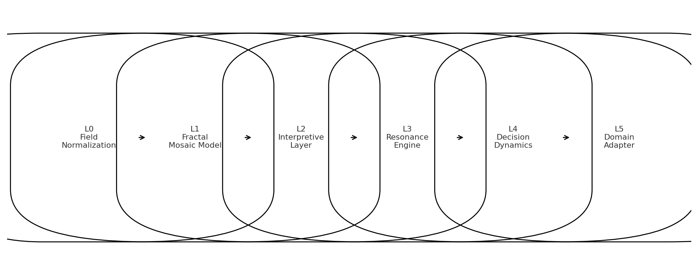

Figure 2 — Gate Segmentation Diagram
Illustrates:
- deviation threshold
- negative-space transitions
- adaptive threshold τ(t)
- fragmentation and merge conditions
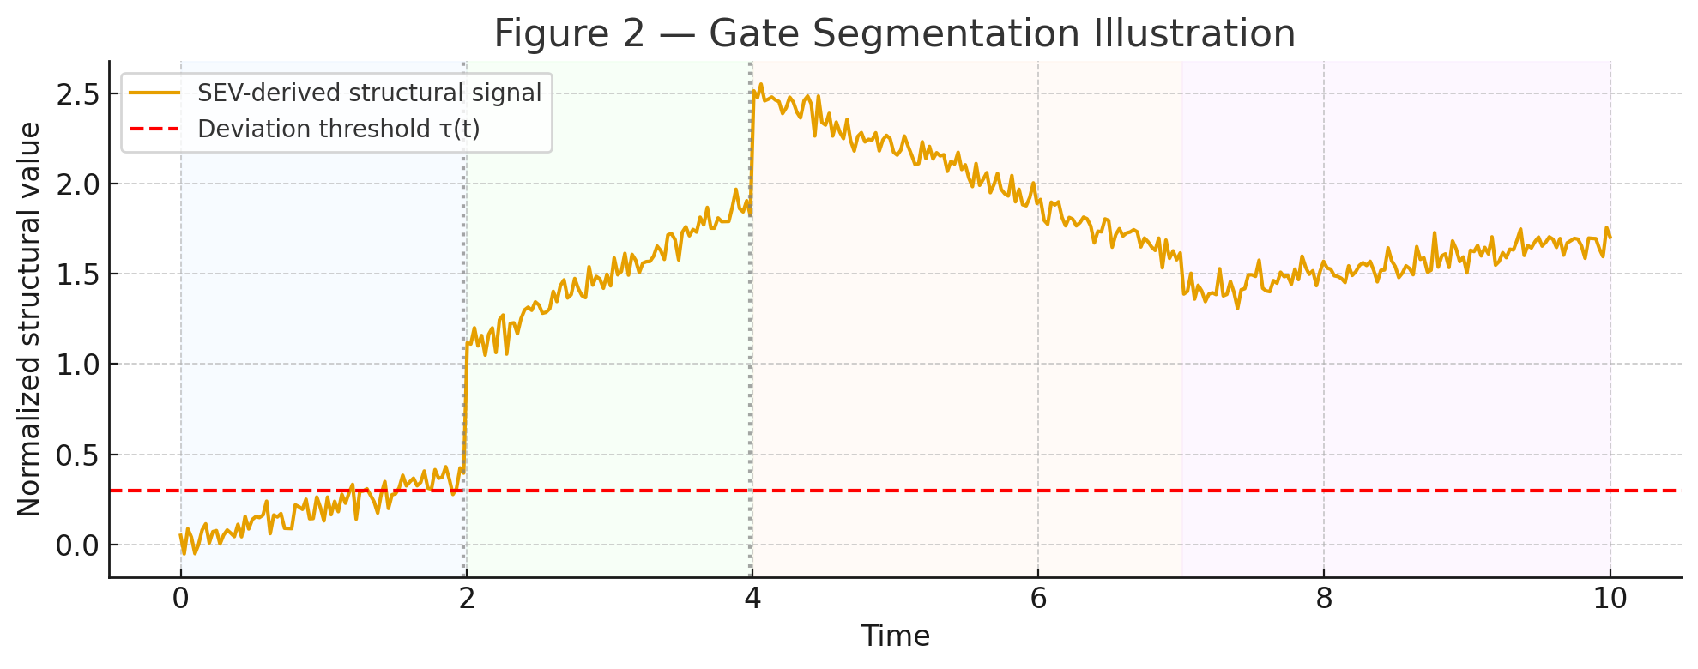

Figure 3 — Multi-Lattice Mosaic Architecture (MLMA)
Displays:
- parallel lattice projections
- consensus classification
- conflict visualization
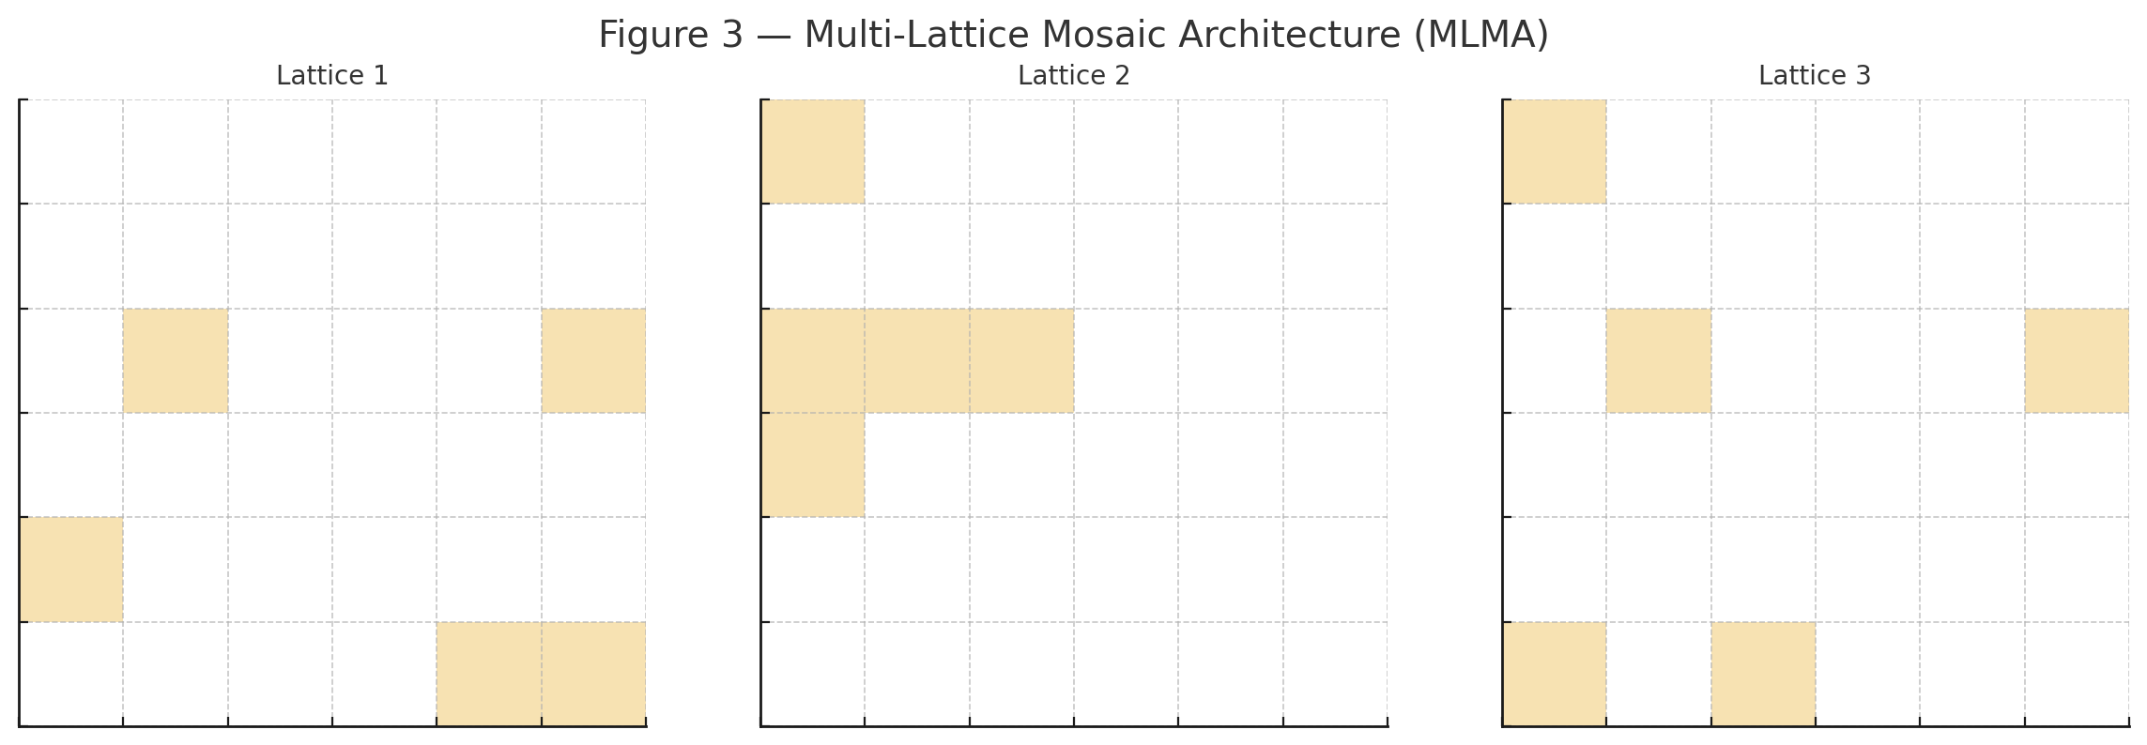

Figure 4 — Interpretive Layer Structure
Shows:
- weight contributions
- contrast vector plots
- regime identification zones
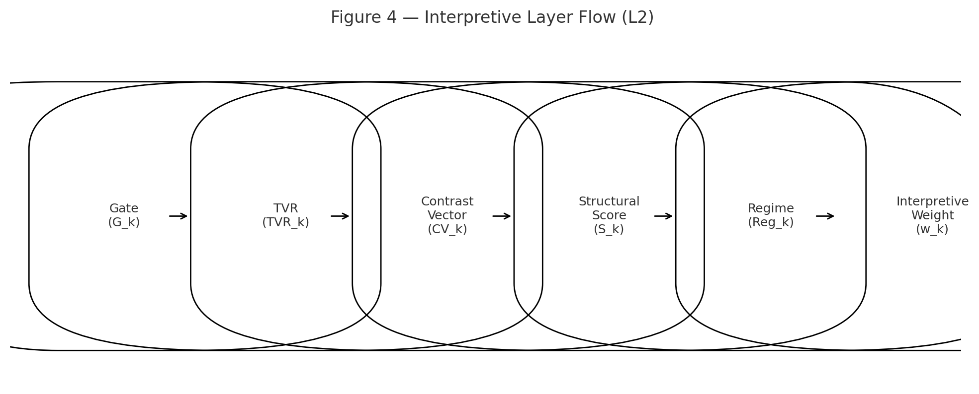

Figure 5 — Resonance Layer Structure
Depicts:
- resonance inputs (w_k, CV_k, S_k, g_k)
- coherence clusters
- temporal anchors
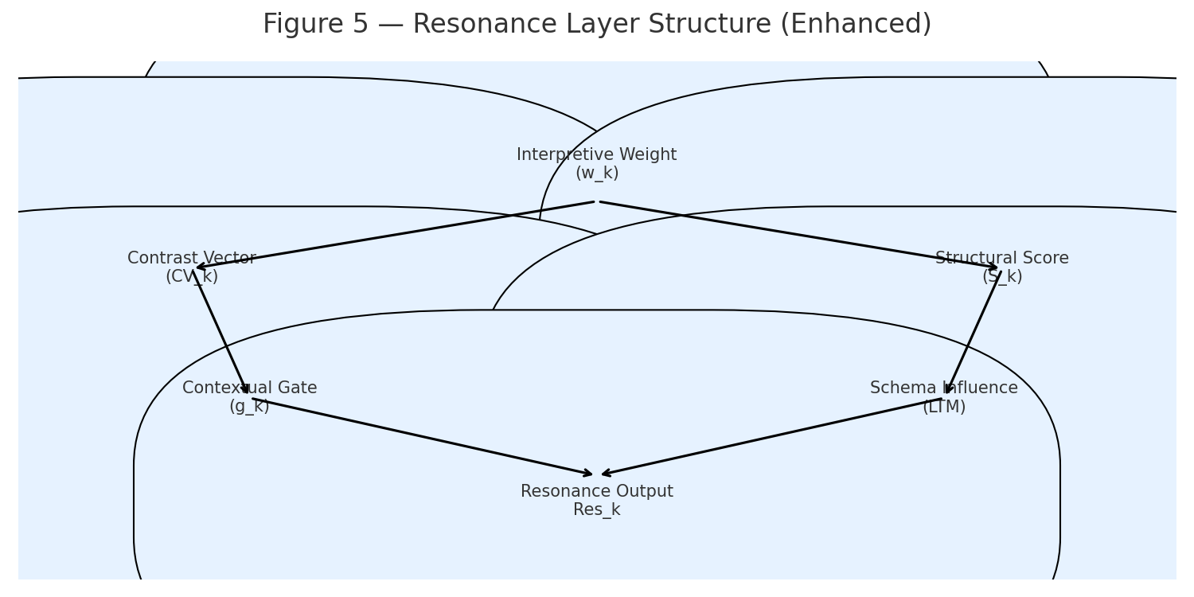

Figure 6 — Decision Surface Field (DSF)
Shows:
- directional probabilities
- reversal probability
- momentum gradient
- uncertainty correction
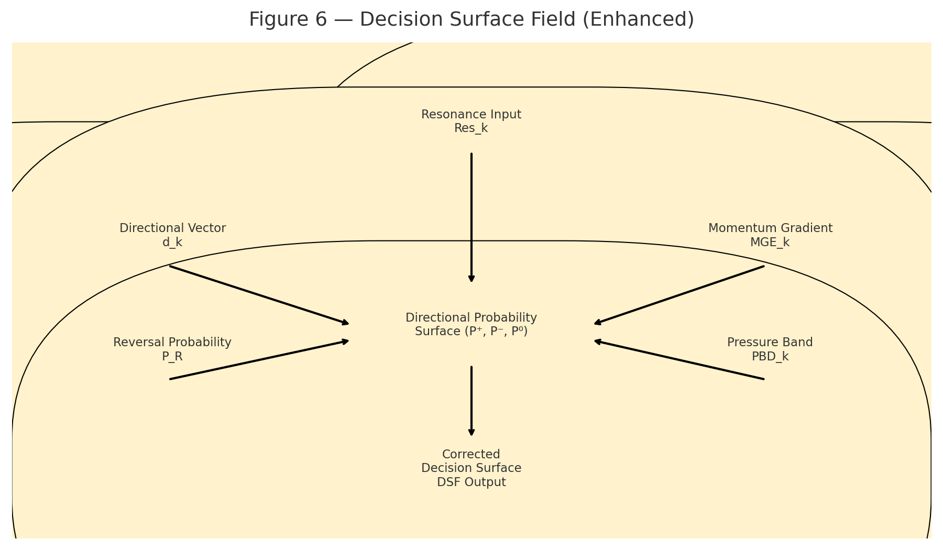

Figure 7 — G32 Cognitive Coding Diagram
Displays:
- G-unit composition
- G16 cluster
- G32 composite unit
- hierarchical scaling to G64+
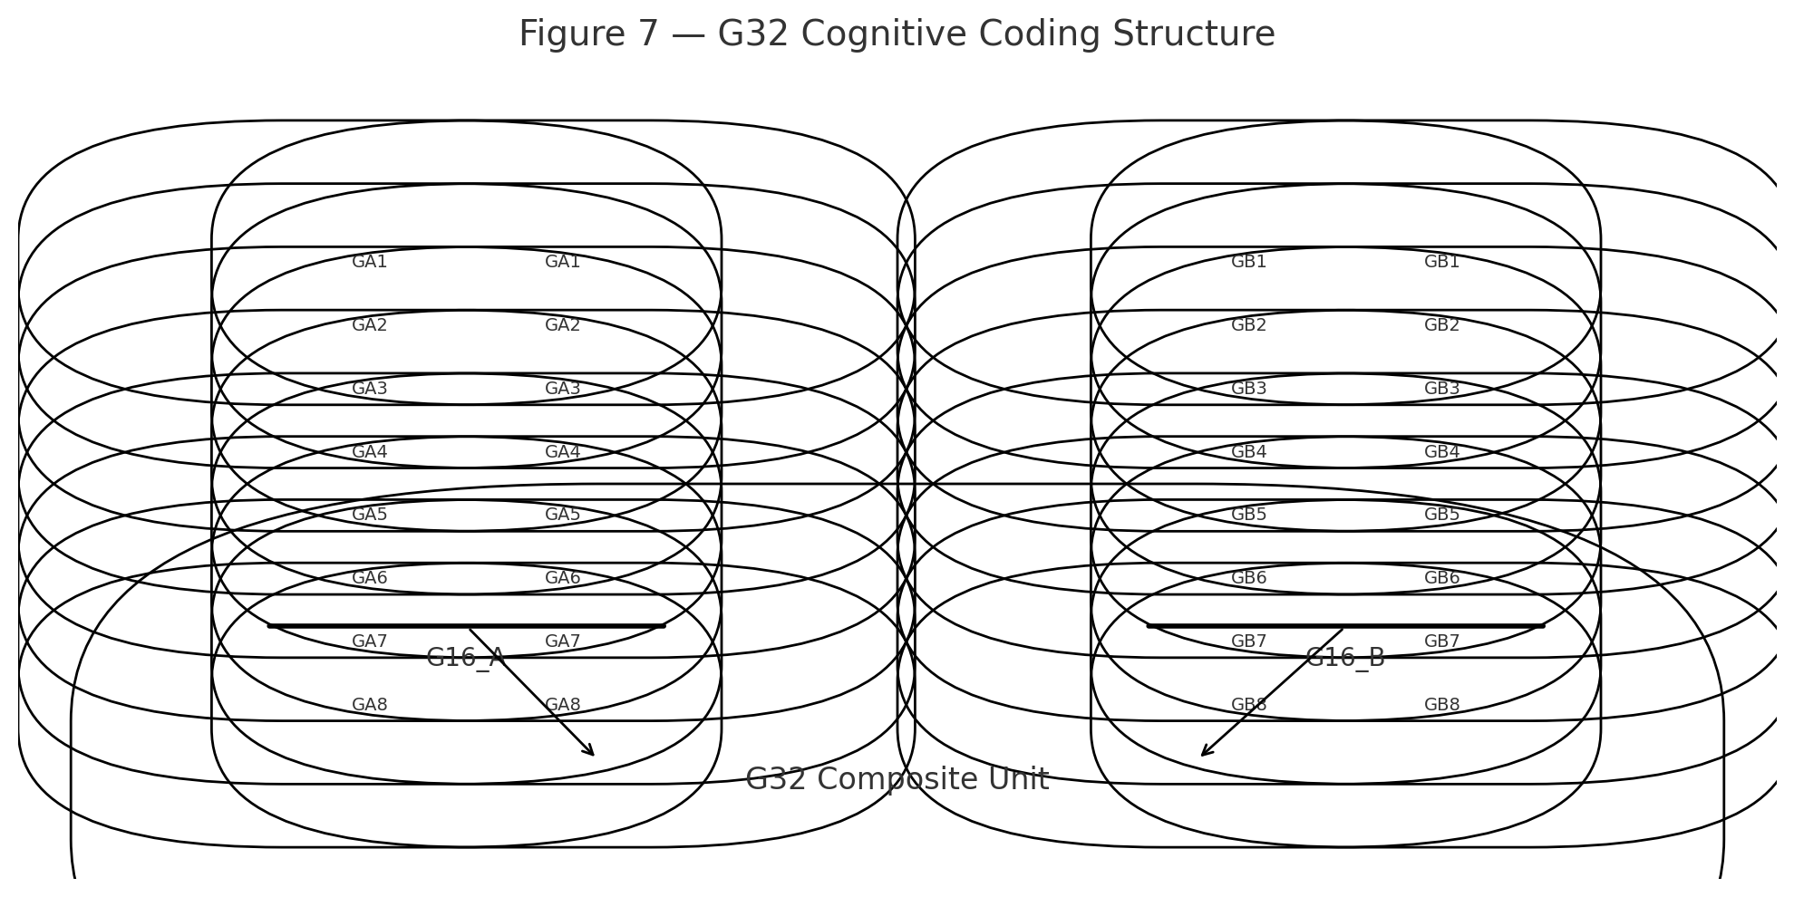

Figure 8 — Tapestry Structure
Illustrates:
- clusters
- mosaics
- URF
- schema links
- anchor positions
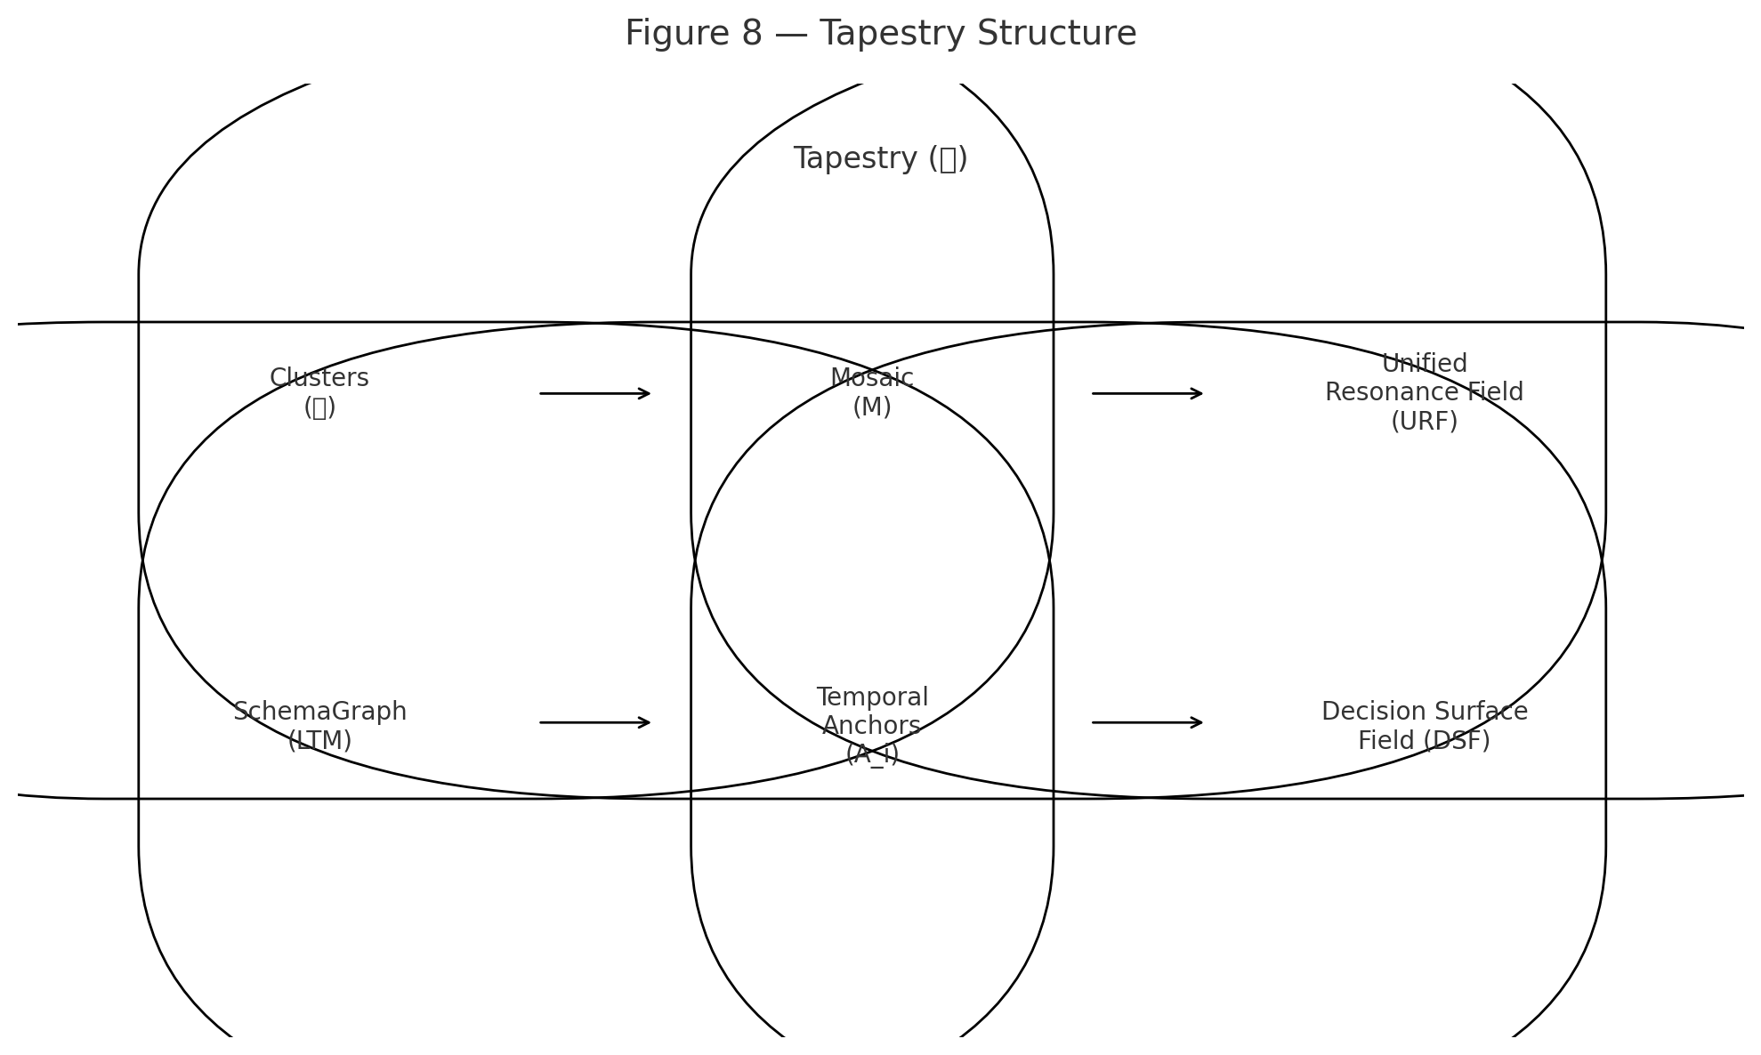

Figure 9 — Breathing Control Curve
Shows:
- expansion ξ
- contraction χ
- control variable Φ(t)
- bounded variance
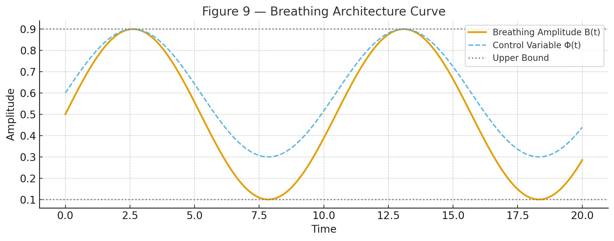

Figure 10 — Self-Organization Flowchart
Depicts:
- gate evolution
- cluster evolution
- schema evolution
- tapestry evolution
- stability constraints
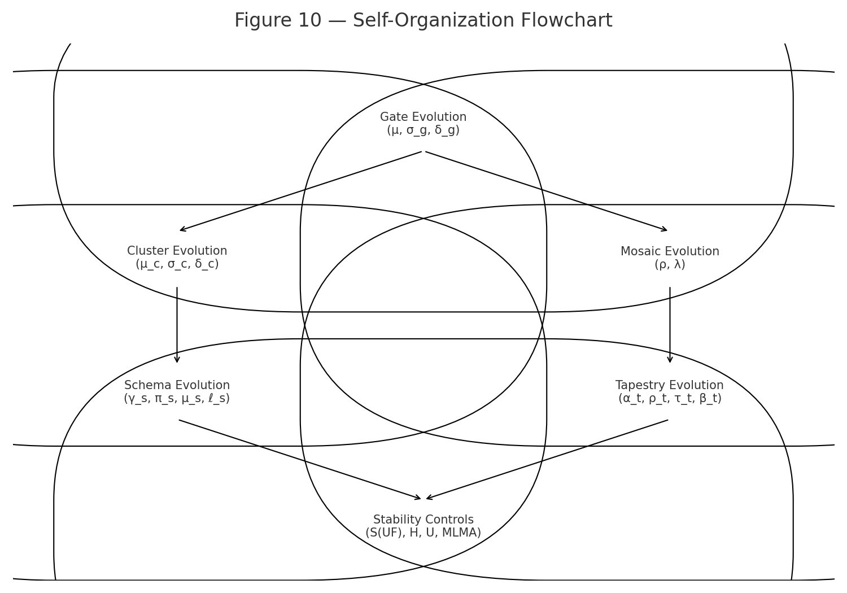

Figure 11 — Structural Encryption System (SES)
Shows:
- multi-perspective encoding
- mosaic distortion
- resonance key cryptography
- negative-space channel
- compatibility layer
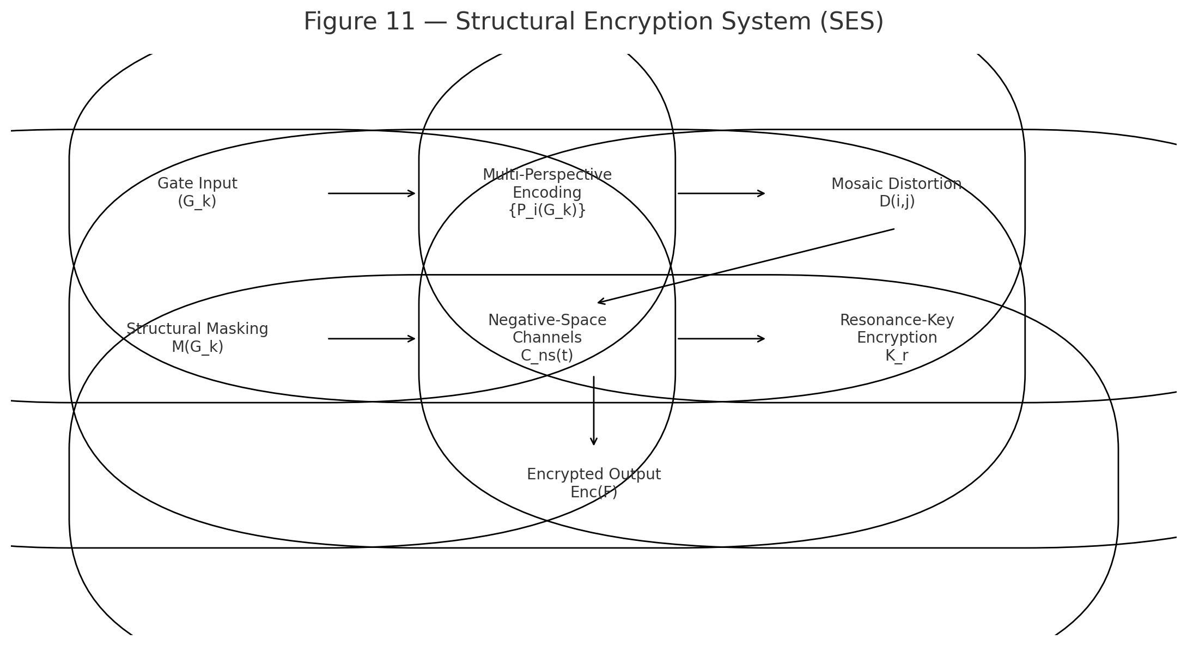

Figure 12 — Global Stability S(UF) & Robustness R(UF)
Charts:
- stability over time
- robustness under perturbation
- S(UF) threshold lines
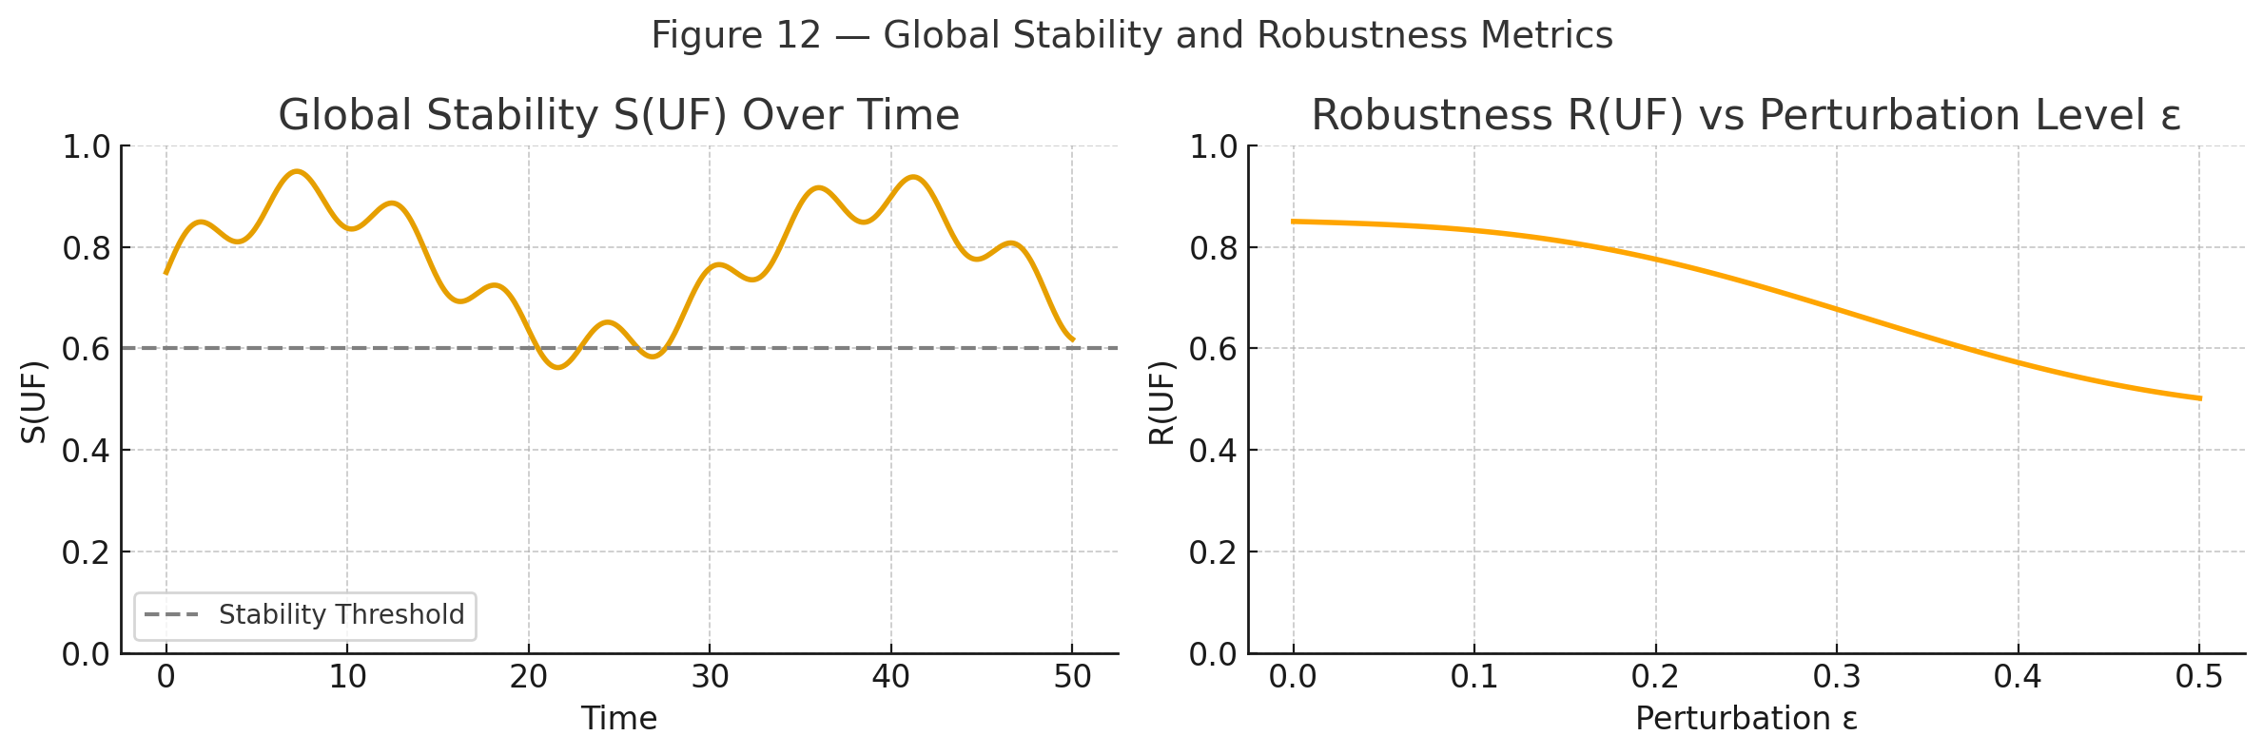

21.3 Summary
Section 21 provides visual scaffolding for UF, enabling engineers, stakeholders, and reviewers to rapidly understand the architecture.

22. Versioning & Governance

22.0 Purpose
Defines the versioning system, governance structure, and evolution rules for the Unified Framework (UF).
This prevents uncontrolled drift, ambiguous updates, or breaking changes in future versions.

22.1 Versioning Scheme
UF uses semantic versioning:
$$UF"-vX.Y.Z"$$
Where:
- X = Major version
  - breaking changes
  - new layers
  - new operators
  - redesigned subsystems
- Y = Minor version
  - enhancements
  - new operators compatible with previous versions
  - additional optional modules
- Z = Patch version
  - corrections
  - clarity improvements
  - formatting fixes
  - non-functional updates

Current Version
$$UF"-v1.3.0"$$

22.2 Structural Invariants
The following components CANNOT change without incrementing the major version (X):
- SEV definition
- Gate boundary operator
- Multi-lattice mosaic architecture
- Interpretive contrast and weighting formula
- Core resonance equation
- DSF operator
- Schema memory rules
- Tapestry composition
- Breathing operator (ξ / χ)
- Self-organization rules
- Test suite in Section 13
These define the identity of UF.

22.3 SES Versioning
SES has its own version identifier:
$$SES"-vA.B"$$
Changes in SES DO NOT require UF major version changes unless SES interfaces with UF internals.
Backward compatibility is REQUIRED.

22.4 Governance Structure

22.4.1 Authority
The originator (Joseph) is the governing authority for:
- new operator approval
- parameter changes
- module additions
- structural modifications
- validity of new versions

22.4.2 Change Control Process
All changes must include:
- change summary
- affected sections
- operator-level diffs
- compatibility verification
- updated glossary terms
- updated diagrams
- updated validation tests

22.4.3 Deprecation Rules
Operators may be deprecated only when:
- superseded by strictly superior constructs
- backward compatibility is preserved for at least one minor version
- deprecation notices are clearly documented

22.5 Compatibility Requirements
Any version UF-vX.Y.Z must satisfy:
$$Consistency(L1,L2,L3,L4)=1$$
and:
$$S(UF)>θ_stab$$
UF updates must:
- not break SES
- not invalidate schemas
- not cause catastrophic tape drift
- maintain minimal robustness R(UF) threshold

22.6 Future Version Tracks
Possible future tracks include:
- v1.4 — extended hardening
- v1.5 — robotics/sensor extensions
- v2.0 — advanced self-organization or multi-agent extensions
- v3.0 — cross-agent tapestry architecture (long-term research)

22.7 Summary
Section 22 ensures UF:
- evolves coherently
- remains stable
- preserves identity
- maintains patent integrity
- stays compatible across implementations
- grows without ambiguity

23. Hardening Framework (AGS, RH, IAS, MLMA, BDSC, SEC, DCSE, etc.)

23.0 Purpose
Section 23 defines the complete Hardening Framework used to ensure that the Unified Framework (UF) remains stable, safe, and coherent under noise, perturbation, adversarial structure, multi-lattice divergence, schema overgrowth, breathing instability, and cross-layer misalignment.
These mechanisms operate across all UF layers and enforce:
- structural stability
- resonance boundedness
- schema control
- lattice consensus
- breathing suppression
- memory containment
- encryption robustness
- domain adapter isolation
This section is a critical component of UF v1.3.0.

23.1 Adaptive Gate Stabilization (AGS)
AGS stabilizes gate formation under noisy inputs.

23.1.1 Adaptive Threshold
$$τ(t)=τ_0+α⋅Var(SEV[t-w:t])$$
Gate opens only when deviation is structurally significant.

23.1.2 Purpose
- Prevents over-fragmentation
- Controls noise spikes
- Ensures meaningful segmentation

23.2 Resonance Hysteresis (RH)
RH prevents rapid resonance flipping due to micro-noise.

23.2.1 Definition
$$Res_k^new=\{■(Res_k,\&∣Res_k-Res_k^prev∣<θ_h@Res_k^prev,\&"otherwise" )$$

23.2.2 Purpose
- Eliminates oscillations
- Improves stability
- Maintains interpretive continuity

23.3 Interpretive Anomaly Suppression (IAS)
IAS suppresses structural anomalies before they propagate.

23.3.1 Anomaly Score
$$A_k=∥TVR_k-(TVR) ̂∥$$
If:
$$A_k>θ_anom⇒w_k←βw_k$$

23.3.2 Purpose
- Blocks false structure
- Prevents adversarial influence
- Limits noise elevation

23.4 Multi-Lattice Mosaic Architecture Controls (MLMA)
MLMA control ensures cross-lattice alignment.

23.4.1 Consensus Constraint
$$∣\{class^((l)) (G_k)\}∣≤K_max$$

23.4.2 If violated:
- Down-weight interpretive weights
- Suppress resonance
- Block schema formation

23.4.3 Purpose
- Prevents mosaic aliasing
- Ensures cross-lattice coherence

23.5 Breathing Dampening & Stability Control (BDSC)
BDSC ensures breathing (ξ and χ) remains stable.

23.5.1 Control Law
$$B(t+1)=B(t)+η(Φ(t)-B(t))$$

23.5.2 Variation Bound
$$∣B(t+1)-B(t)∣<ϵ_B$$

23.5.3 Purpose
- Prevents runaway expansion/contraction
- Synchronizes reasoning bandwidth with stability

23.6 Schema Entropy Constraint (SEC)
Prevents schema explosion or degeneracy.

23.6.1 Entropy Definition
$$H=-∑p_i log⁡p_i$$

23.6.2 Constraint
$$H<H_max$$

23.6.3 Purpose
- Maintains memory health
- Prevents conceptual overload
- Stops pathological schema growth

23.7 Dual-Channel Structural Encryption (DCSE)
Enhances SES security by adding a crypto-salt channel.

23.7.1 Definition
$$Enc(F)=SES(F)⊕Salt_crypto$$

23.7.2 Purpose
- Prevents SES compromise
- Creates two-layer security boundary
- Ensures structural encryption is not a single point of failure

23.8 Tapestry Coarse-Graining (TCG)
Reduces tapestry complexity when overload is detected.

23.8.1 Definition
$$T_coarse=Γ(T)$$

23.8.2 Purpose
- Prevents tapestry blow-up
- Maintains reasoning tractability
- Preserves structural class without full detail

23.9 Domain Adapter Sandbox Enforcement (DASE)
Ensures domain adapters (L5) cannot modify internal UF states.

23.9.1 Hard Rule
L5 adapters may not modify:
- Unified Resonance Field (URF)
- Interpretive Structural Field (ISF)
- Gate structures
- SchemaGraph
- Tapestries
- Memory tiers (STM/MTM/LTM)

23.9.2 Purpose
- Prevents external tampering
- Ensures domain-specific logic cannot break UF
- Enforces clean architectural boundaries

23.10 Cross-Layer Consistency Enforcement
Ensures layers L1–L4 remain coherent.
$$Consist(L1,L2,L3,L4)=1$$
If FALSE:
- system enters SafeMode
- schema updates halt
- breathing contracts
- DSF outputs suppressed

23.11 Hardening Summary
Section 23 enforces:
- stability
- bounded variation
- interpretive integrity
- resonance continuity
- schema containment
- mosaic coherence
- safe decision-making
- encryption resistance
- domain protection
- global architectural health
This section is mandatory for UF compliance and must be implemented before validation.

-End of Specification

