Today, November 8th 2019, exactly three years have passed since the 2016 US presidential election. At this hour back then, the people of the United States exercised their right to elect their president in what turned out to be the most polarizing US election in history. Had I done this twitter posting analysis of Trump and Clinton three years ago before the election, I could have predicted, with significant confidence, that Donald Trump would emerge as the winner.

The figure **17_ScatterRetweetAndFavorite.png,** shows the comparison of retweets and favorites of the two candidates, as visualized in the scatter chart model.

**Fig. 17_ScatterRetweetAndFavorite.png**

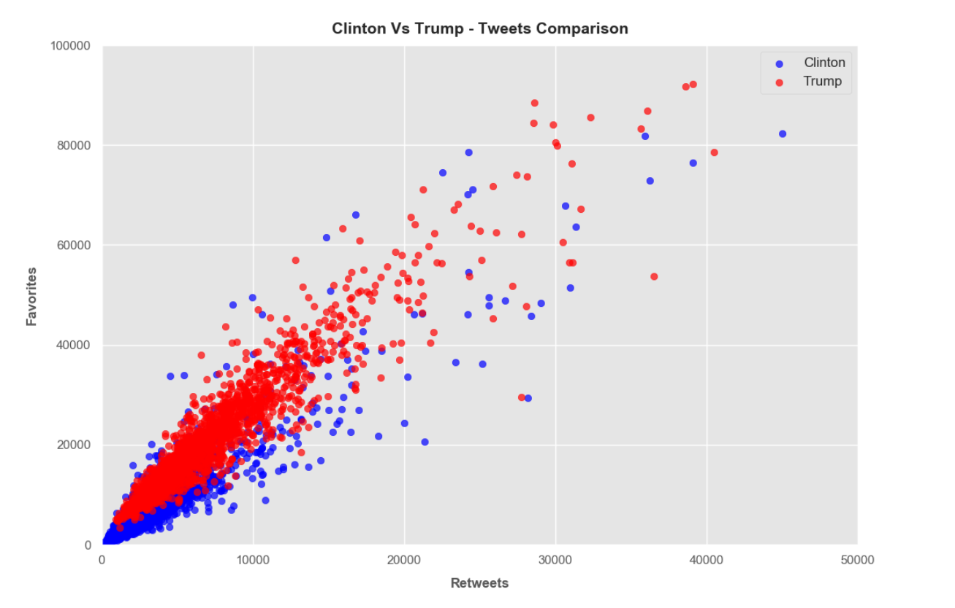

On this chart, one can see the enthusiasm of the Trump supporters in retweeting and liking his posts. Comparing his results to Hillary, the difference can easily be seen, with the scatter chart showing the “big league” discrepancy.

The other charts also demonstrated an easy read of the numbers that indicate that Trump had an underlying advantage. It was also interesting to see the two candidate’s use of certain words, positive or negative, and how they resonated with their respective followers.

**Hillary Clinton Positive Words and Negative Words**

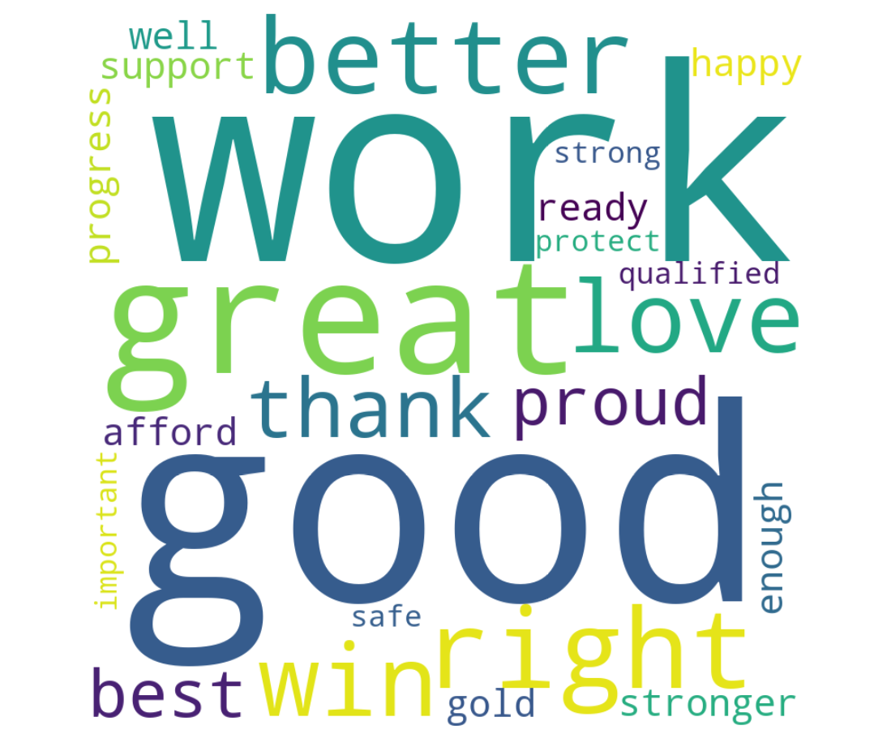

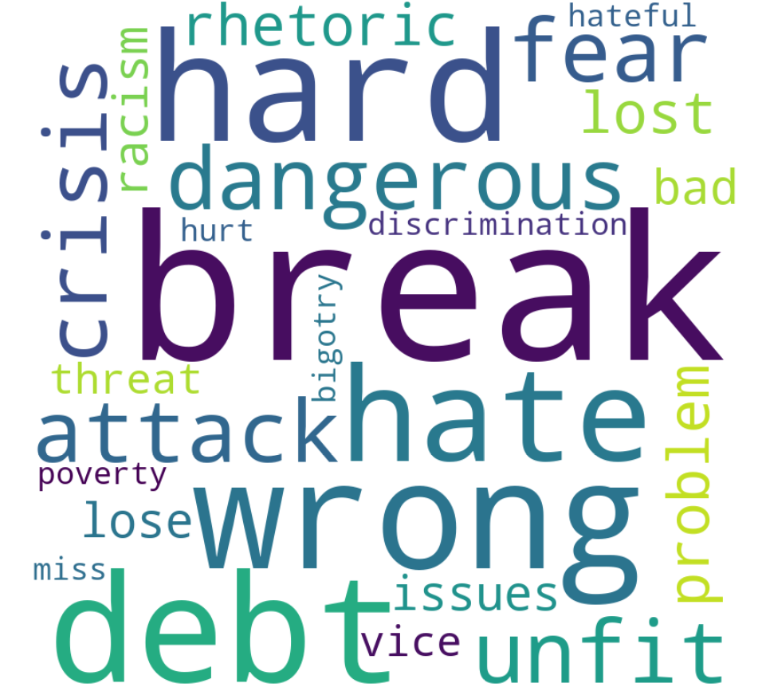

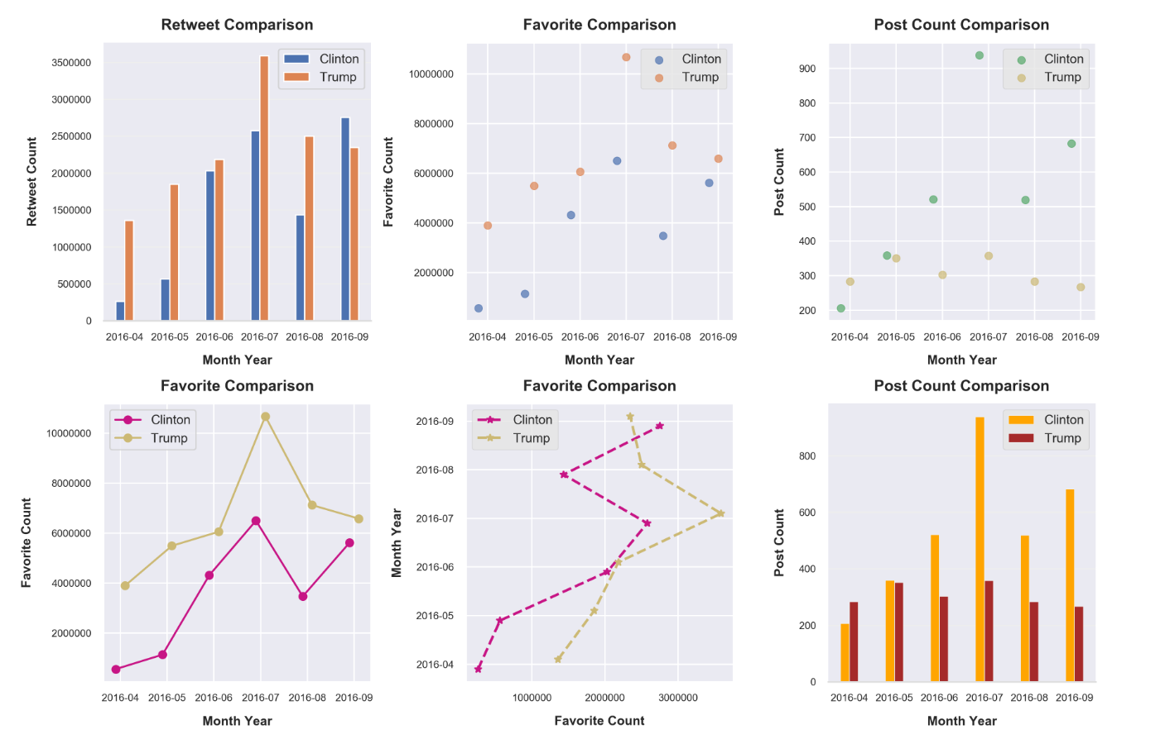

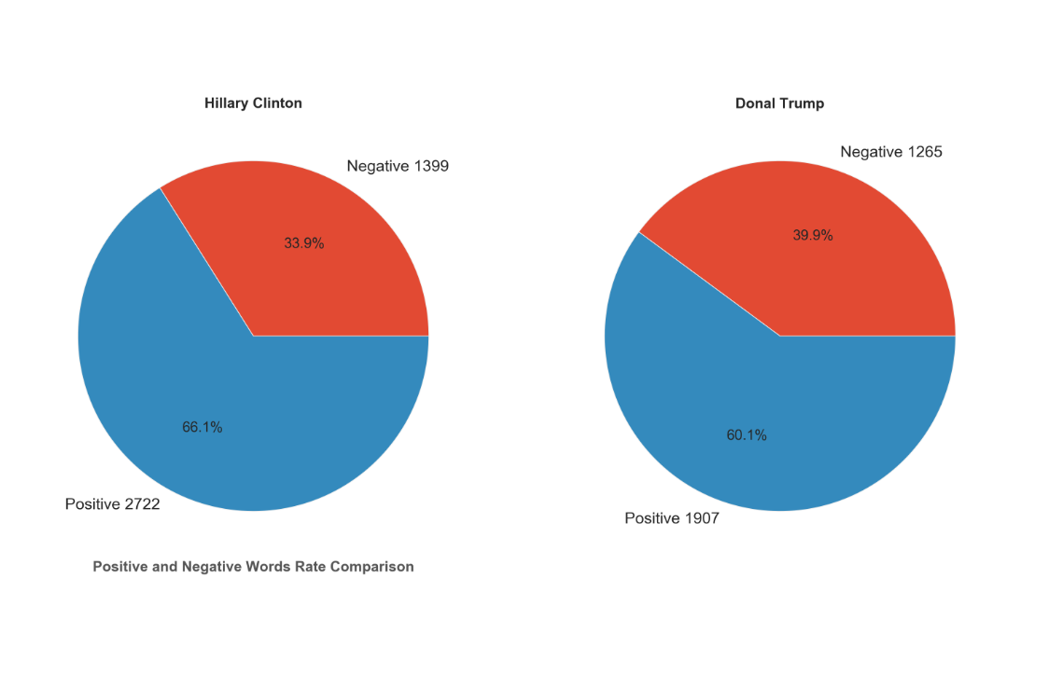

**Donald Trump Positive & Negative Words**

