ECE554 – Embedded System Design
Summer 2008

Installation and User Manual
Virtual reality program for Nashua Public Library

Proposed by Juan Garcia
June 5, 2008
Dr. Adnan Shaout
Virtual Reality Program for the Public Library of Nashua

1. Installation & Execution of the virtual program

this Virtual Reality Program was developed using the latest versions of the J2SE and Java3D, please install the latest version of these programs before you install and execute the virtual reality program. Please follow the steps below in order to installed the required software. If you have the required software already installed in you computer, proceed with step 3.

Step 1. Install the latest version of Java J2SE 6 (JDK)
In the link below you’ll find the different versions of JDK, click on the latest version to download and install it in your computer.
http://java.sun.com/javase/downloads/index.jsp
For any question see the installation instructions below
http://java.sun.com/javase/6/webnotes/install/index.html

Step 2. Install the Java 3D 1.5.1 API
Once the latest JDK version is installed in your computer, proceed to install the Java 3D 1.5.1 API on your PC. To get the latest version of this program click on the link below
http://java.sun.com/javase/technologies/desktop/java3d/index.jsp
Then select the option Java 3D 1.5.1 API. Click on the option download Java 3D 1.5.1. For question regarding installation click on “How to Install”.

Step 3. Install the virtual reality program on your PC
Unzip the package JuanCGarciaEce554.zip under any of the directories on you PC. Once the software is unzipped you are ready to run the application.

Step 4. Execution of the Virtual Reality Program
Once all the software has been installed proceed to double click on the file JuanCGarciaECE554.bat to run the application.

2. User Manual

The Virtual Reality Program offers the following functionality so the user can interact with the system

Daily and Weekly Notification Events
These events are set up so the user is notify on any events that are happening during the day and it will also notify the user of the events that are happening during that week. In order

If you want to set up notification events follow these steps:
Open file name library.properties under your installation folder and modify the following entries accordingly. See example below

#Events
....
DAILY_EVENTS_LIST=event1,event2,event3,weekly_events
..
event1= Open Storytime and Puppet Show \n\
Children's Room \n\
It will start @ 18:35 AM
event1_time=18:35

Once the event has been schedule it will be shown in the message window with the green color. See screen shot below for details.
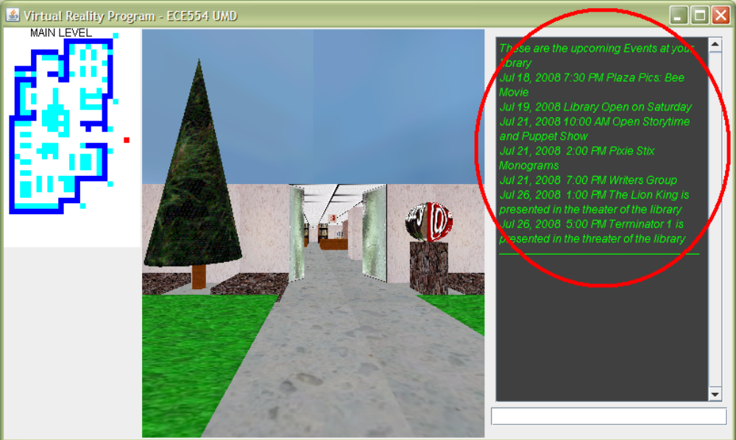
Key Board Navigation
Navigating through the virtual world is really easy. By hitting the navigation keys of the keyboard (arrow keys up, down, left right) you’ll be able to navigate through the virtual world. The program uses collision detection so you will not be able to navigate through walls or anything else unless specified by in library.properties.

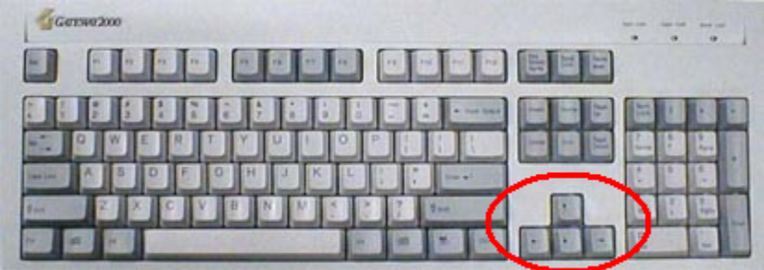
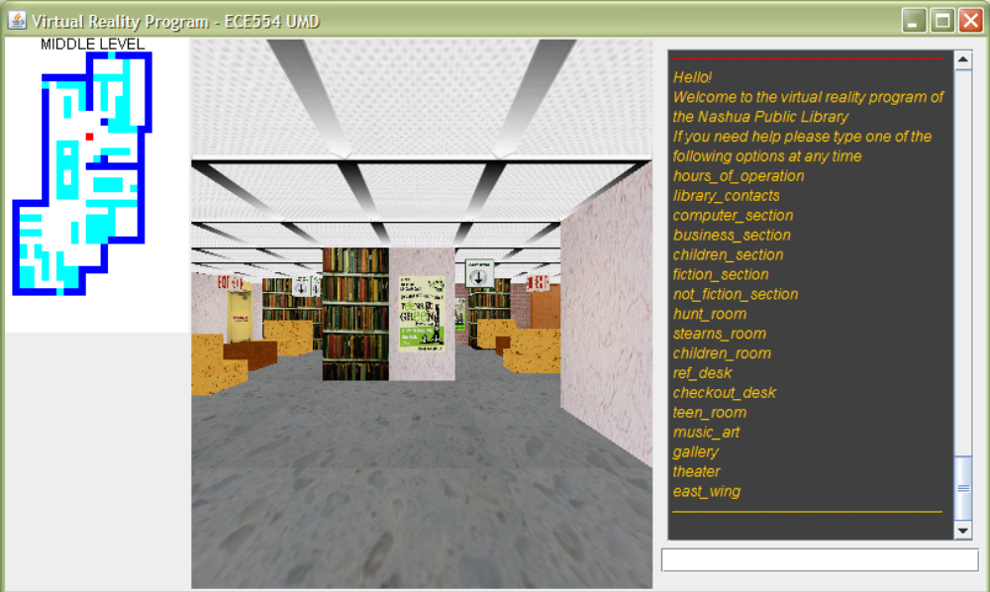
Useful Map locator
There is also a Map locator on the left of the screen that will show your current location on the virtual world, this is important if you are not familiar with the building. This map is changed dynamically if you move up and down from Main Level to the Middle Level and vice versa.
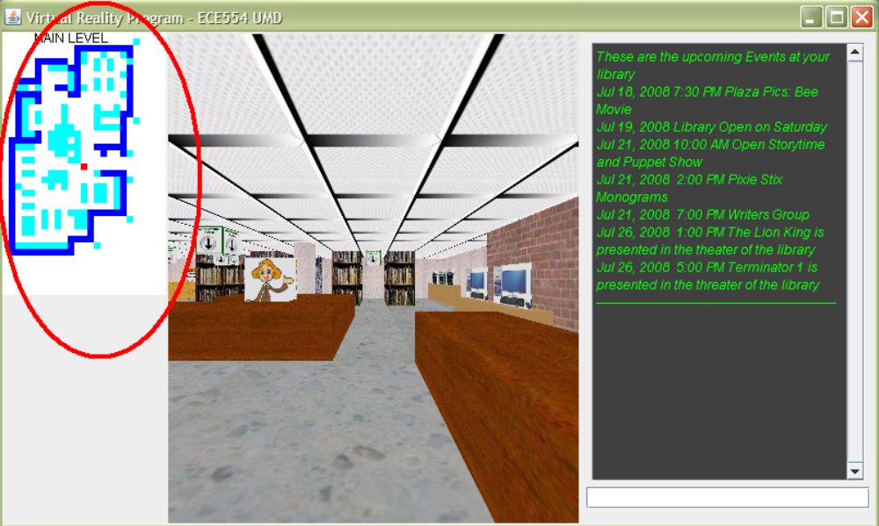

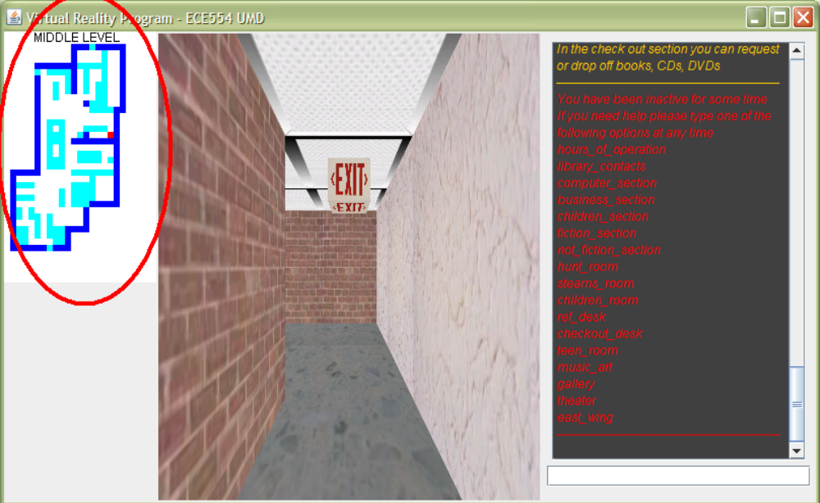
Mouse Interaction
You can also interact with the virtual world by using your mouse. In this case you can retrieve information of the different sections of the library by clicking on the icons of the virtual world. Usually the icons used to get information are similar to the one below, but you can also click on the people and other graphics within the virtual program. The message will be shown with the color cyan in the text message window

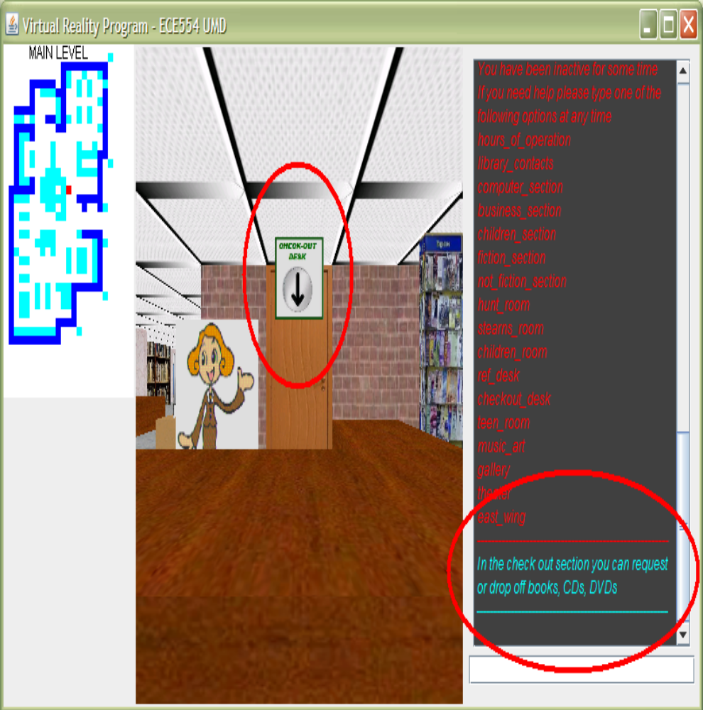
Text Message Interaction
You can also interact with the system via the text message window located on the right side. In order to get the options type help on the input box located on the bottom left. It will bring you the options you can use to get information about the library. These message will be shown with the dark yellow color in the text message window. The follow are the options you can type in the input box
- hours_of_operation
- library_contacts
- computer_section
- business_section
- children_section
- fiction_section
- not_fiction_section
- hunt_room
- stearns_room
- children_room
- ref_desk
- checkout_desk
- teen_room
- music_art
- gallery
- theater
- east_wing

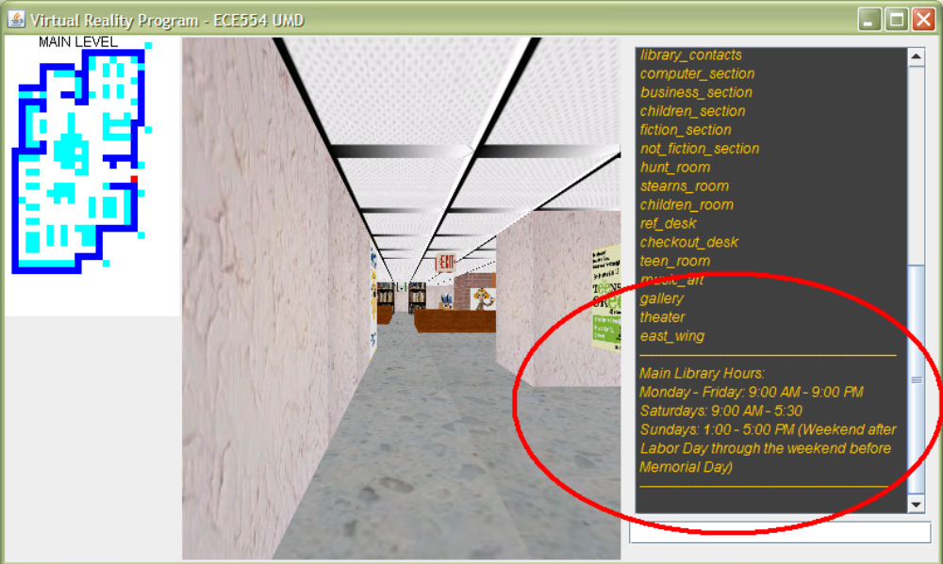

User Inactivity
If the user is inactive for sometime the application will show a red message showing the different options the user might want to use. This inactivity time is set up in library.properties where 1 can be replaced for the amount in minutes as shown below:
#Events
SCHEDULER_DELAY=100
EVENT_DELAY=5
USER_IDLE=1

The message for user inactivity is shown with red in the text message window

