Fuzzy System for Software Reliability Classification using Object Oriented Metrics
Juan Garcia
Directed Studies, College of Engineering and Computer Science, University of Michigan Dearborn, Dearborn, Michigan, USA
E-mail: † garciajc@umd.umich.edu
Abstract. Given the central role that software development plays in the delivery and application of information technology, managers have been focusing on process improvement in the software development area. This improvement has increased the demand for software measures, or metrics to manage the process. This metrics provide a quantitative basis for the development and validation of models during the software development process. In this paper I proposed to develop a fuzzy rule-based system to classify java applications using object oriented metrics [1].
Keyword Fuzzy Set, Fuzzy Rule, Fuzzy Based Rule model, Object Oriented Principles, Object Oriented Metrics, Java Patterns, Transitive Closure Relation, Hamming Distance, Defuzzification, Mean of Max.

- Introduction
Given the central role that software development plays in the delivery and application of information technology, managers have been focusing on process improvement in the software development area. This improvement has increased the demand for software measures, or metrics to manage the process. With the development of Object-Oriented (OO) paradigm since the early 1990 the development and use of metrics has been growing. These metrics focus in OO concepts like classes, objects, instance, method, message passing, inheritance, multiple inheritance, abstraction, encapsulation, polymorphism, decoupling, internal object structures that reflect the complexity of each individual entity external complexity that measures the interactions among entities, such as coupling and inheritance. They measure computational complexity that affects the efficiency of an algorithm and the use of machine resources, as well as psychological complexity factors that affect the ability of a programmer to create, comprehend, modify and maintain software. They provide a quantitative basis for the development and validation of models during the software development process, and are used to monitor the software and its areas that need corrective or management action to improve productivity, reliability, usability, testability and quality [11].
Several studies and research papers were dedicated to the study of OO metrics and research of tools using these metrics. In 1994 Chidamber and Kemerer developed and implemented a set of six metrics for OO design: response for a class (RFC), weighted methods per class (WMC), coupling between objects (CBO), lack of cohesion (LCOM), number of children (NOC), depth of inheritance tree (DIT). These metrics are described later in this paper. They were based in measurement theory and also reflected view points of experienced OO software developers. In their opinion these metrics help uncovering possible design flaws or violations of design philosophy and can help managers/designers to exercise some measures of architectural control over the evolution of an OO application [1]. Later in 1998, Linda H. Rosenberg applied and interpreted object oriented metrics. She selected three traditional metrics and six additional OO metrics and were applied to NASA projects to evaluate principle object oriented structures and concepts. She concluded that object oriented metrics help in the evaluation of development and testing efforts needed, and helped the understandability, maintainability and reusability of the code [2]. In 2004 Tsenga et al, proposed an approach that applied software reuse, OO metrics object-oriented, and genetic algorithm to manage and optimize the embedded system. With their research they open new avenues for evaluating integration of software in the embedded system environment using the quantitative approach [3]. Also in 2004 Thwin and Quah presented the application of Ward and General Regression neural networks in software quality estimation using object-oriented metrics. These metrics were useful in predicting software quality and they were closely related to the number of faults and the maintenance effort [4]. Later in 2006, due to the quick evolution of games, their demand for great flexibility, code reusability and low maintenance costs and their differentiation between versions, Ampatzoglou and Chatzigeorgiou evaluated object-oriented design patterns in game development. The projects were analyzed by reverse engineering techniques to calculate OO metrics like size, complexity, coupling and cohesion. They concluded that metrics and architectural patterns are beneficial with respect to maintainability, and tend to increase the cohesion of the software [5].
Currently many studies are using object oriented metrics. In 2008 Quah used defect tracking as a proxy method for software readiness prediction. The model use product metrics as independent variables for the predictions and they are selected depending on the nature of source code with regards to architecture layers, types of faults and contribution factors of the metrics. The results of the experiment showed that the proposed models outperform regression analysis models in term of prediction accuracy and the experiment model was able to predict all the three correlated variables to support software managers in evaluating software readiness [6]. In 2007 Karim O. Elish, Mahmoud O. Elish evaluated the capability of Support Vector Machine (SVM) to predict defect-prone software modules, and compares its prediction against eight statistical and machine learning models in the context of four NASA datasets. For the empirical evaluation they used 21 static metrics and their results suggest that the prediction model can be useful and practical addition to the framework of software quality prediction [7]. In 2008 Pizzi and Pedrycz presented a new methodology, which systematically addresses design classification issues to accomplish a successful discrimination between different classes using OO metrics. The experiments demonstrated that the aggregated classification results using fuzzy integration were superior to the predictions from the respective best single classifiers [8]. In 2008 Sarkar, Kak, and Rama presented several metrics for measuring the quality of modularization of large-scale object-oriented software, and these metrics measured the quality of the modularization of the software [9]. In 2009, Kitchenham identified the trends in influential software metrics papers and assess the possibility of using secondary studies to integrate research results. They concluded that metrics researchers need to understand the difference between statistical properties, and conceptual properties which are to a large degree independent of the specific coding paradigm, and paradigm specific properties such as the specific way in which attributes are measured [10]. Virtual Machinery since 1999 have maintained and developed JHawk, a commercial application that generates a number of software metrics relating to Java code. They include standard Object-oriented code metrics which can be viewed at System, Package, Class and Method level and provide complexity analysis and a guide to interpretation of object-oriented metrics [12].
The investigation does not stop here and there are many proposals to continue research on object oriented metrics in the near future. Ampatzoglou and Chatzigeorgiou propose the applicability of other object-oriented design patterns to be examined in game development, they also proposed investigations related prone changing classes in patterns and 3D rendering module for design pattern detection [5]. Quah proposes to extend his investigation for a wider range of applications to develop a new set of presentation logic tier metrics regarding various types of user interface objects, such as by separating pure display interface objects from the interface object which are able to perform both input/output functions, by separating control interface objects from interface objects which can be control objects that hold values, etc [4]. Karim and Mahmoud Elish propose to conduct additional empirical studies with other datasets to realize the full potential and possible limitation of SVM [7]. Sarkar, Kak, and Rama propose to improve the automatic discovery of APIs (both S-APIs and E-APIs), for example the EJB framework has notions such as the “Bean interface” that can be exploited to better identify the APIs [9]. Also they propose to customize API discovery procedures to specific frameworks that could potentially be a useful extension on their research. Another topic for future is to carry out a multivariate analysis of the metrics presented to see if the extension of the metrics is independent and consistent.
Despite of the number of investigations in several areas and the development of some tools to gather metrics, OO metrics haven’t been widely adopted by the software development community. This seems to be due to the following factors:
- As pointed by Ampatzoglou, Chatzigeorgiou [5], Sarkar, Kak, and Rama [9] some metrics are collected manually, or there is manual intervention during their collection or preprocessing of the metrics.
- Chidamber and. Kemerer[1], Rosenberg [2], Ampatzoglou, Chatzigeorgiou [5], Sarkar, Kak, and Rama [9] showed that the metrics seem to be independent from each other and managers/leaders/architects have to analyze metrics separately.
- In their research Pizzia, Pedrycz [8], Karim and Mahmoud Elish [7] showed there are usually complex methodologies that need to be applied after the metrics are extracted in order to get the analysis, results and prediction of the system.
- Thwin and Quah [4], Quah [6], Karim and Mahmoud Elish[7] and Pizzia and Pedrycz [8] demonstrated that the metrics computed with other factors help predict the reliability and quality of the system, but the metrics haven’t been used to produce the classification of the system.
- Additionally as presented by Virtual Machinery in their application JHawk[12], the results of the metrics give a complexity analysis and statistical information, but do not produce any classification nor suggestion of how to reduce the value of the metrics.
Due to these factors and because of Object Oriented metrics present concepts like loosely or tightly coupled, high or lack of cohesion, etc that provide unsharp boundaries and allow gradual transition which are closer to human interpretation I propose to develop a system to classify java applications based on OO metrics. The system will contain the following features:
- Automated method to extract the OO metrics from the source code
- Default/base set of rules that can be easily configured via XML file so companies, developers, team leaders, etc, can modify the set of rules according to their needs.
- Implementation of a framework so new metrics, fuzzy sets and fuzzy rules can be added or removed depending on the needs of the end user.
- General classification of the software application and fine grain classification of the java classes based on OO metrics.
- Two interfaces are provided for the system: GUI and command.
The paper is organized as follows: Section 2 shows the definition of the traditional and object oriented metrics utilized. Section 3 shows the software application design including use cases, sequence and class diagrams. Section 4 shows the design of the fuzzy system including block diagram and the definition of membership functions and fuzzy rules. Section 5 shows the data of the applications being evaluated. Section 6 shows the experiments and results of the fuzzy system compared to analysis of histograms of the metrics and manual analysis of source code of the software applications. Finally section 7 concludes and presents future work for this paper.
- Background
Many traditional and object oriented metrics extract information of the application regarding traditional principles like complexity and object oriented principles like inheritance, coupling, cohesion, polymorphism, etc. The following is the description of the metrics use in this paper.
Lines of Code – LOC: This is a traditional metrics and counts all lines within the class including blank lines, command lines and comments. Size of a class is used to evaluate the ease of understanding of code during development and maintenance [2]. The rationale of this class is that high number of lines of code increases complexity of the code, making it difficult to understand, maintain and test.
Weighted Methods Per Class – WMC: This is an object oriented metric developed by Chidamber and Kemerer and counts the number of methods implemented within a class or the sum of the complexities of the methods [1]. The rationale of this metric is that classes with many methods are likely to be more application specific, limiting the possibility of reuse [2].
Response for a Class – RFC: This metric object oriented metric counts the set of methods that can be invoked in response to a message to an object of the class or by some method in the class [1]. The rationale of this metric is that the larger the number of methods that can be invoked from a class through messages, the greater the complexity of the class. Therefore testing and debugging becomes complicated since it requires a greater level of understanding on the part of the tester [2].
Lack of Cohesion – LCOM2: This metric counts the percentage of methods that do not access a specific attribute averaged over all attributes in the class [1]. For this metric a low cohesion increases complexity, thereby increasing the likelihood of errors during the development process. Equation is shown in (1) below.
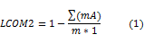
where mA is the number of methods that access a variable, m is the number of methods in class and a is number of variables (attributes) in class
Coupling Between Object Classes – CBO: This metric counts the number of other classes to which a class is coupled [1]. Excessive coupling is detrimental to modular design and prevents reuse. Therefore the larger the number of couples, the higher the sensitivity to changes in other parts of the design and maintenance is more difficult [2].
Number of Children - NOC: This metric count the number of immediate subclasses subordinate to a class in the hierarchy. NOC and DIT are closely related because NOC measures the breadth of a class hierarchy, where maximum DIT measures the depth [1]. The greater the number of children, the greater the likelihood of improper abstraction of the parent and may be a case of misuse of sub classing [2].
Depth of Inheritance Tree – DIT: This metric measures the maximum inheritance path from the class to the root class [1]. The deeper a class within the hierarchy the greater the number methods it is likely to inherit making the code more complex to predict its behavior. Deeper trees constitute greater design complexity, since more methods and classes are involved [2].
Method Hiding Factor – MHF: This metric measures how variables and methods are encapsulated in a class in relation to all the classes in the application. The invisibility of a method is the percentage of the total classes from which this method is not visible. The ideal value is between 8% and 24%. A low value indicates insufficiently abstracted implementation and a very high value indicates very little functionality. The larger the proportion of methods unprotected the higher the probability of errors [13]. Equation is shown in (2) below.
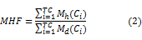

where TC is the total number of classes, M_{h} is the number of methods hidden and M_{h} is the number of methods defined in a class.
Attribute Hiding Factor – AHF: This metric measures how variables are encapsulated in a class in relation to all the classes in the application. The invisibility of an attribute is the percentage of the total classes from which this method is not visible. The ideal value for this metric is 100% because of encapsulation indicates that the attributes should have no visibility to other classes [13]. Equation is shown in (3) below.
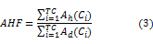
where A_{h} is the number of attributes hidden and A_{h} is the number of attributes defined in a class.
Method Inheritance Factor – MIF: This metric measures the inherited methods in a class in relation to all the classes in the application. For this metric a very high value indicates either superfluous inheritance or too wide member scopes, and a low value indicates lack of inheritance or heavy use of Overrides/Shadows. The ideal value for this metric should be between 20%-80% [13]. Equation is shown in (4) below.
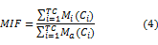
where M_{i} is the number of methods inherited and M_{a} is the number of methods defined in a class.
Attribute Inheritance Factor – AIF: This metric measure the number of attributes inherited in a class in relation to all the classes in the application. The ideal value for this metrics is between 0% and 48%. A very high a value indicates either superfluous inheritance or too wide member scopes, and a low value indicates lack of inheritance or heavy use of Overrides/Shadows [13]. Equation is shown in (5) below.
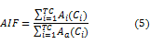
where A_{i} is the number of attributes inherited and A_{a} is the number of attributes defined in a class.
Coupling Factor – COF: Definition: this metric measure the actual couplings among classes in relation to the maximum number of possible couplings. Low value is ideal between 0% and 12%. A very high value should be avoided because coupling relations increase complexity, reduce encapsulation and potential reuse, and limit understandability and maintainability [13]. Equation is shown in (6) below.

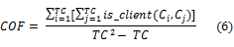
where is_client(C_{i,}C_{j})is 1 if C_{j} client of C_{i} otherwise is 0.

Polymorphism Factor – POF: This metric measures the degree of method overriding in the class inheritance tree. Polymorphism should be used to a reasonable extent to keep the code clear, but that excessively polymorphic code may be too complex to understand. The ideal value should be either less than 10% or greater than 10%. Equation is shown in (7) below.
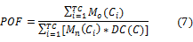
where M_{o} is the number of methods overridden and M_{n} is the number of new methods defined in a class.

- Software Application Design
Use case Diagram: For the application five main use case diagrams were designed: Run Diagnose, Load Configuration, Extract Metrics, Fuzzy Diagnose, and Generate Report. These use cases are shown in figure 1 below.
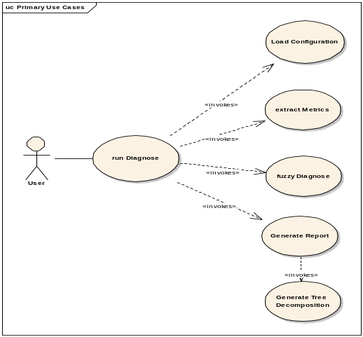
Figure 1. Use Case Diagram
Run Diagnose is the main use case diagram and orchestrates the execution of all the other use cases. Load Configuration loads the configuration of the fuzzy system from XML. This configuration is given by the fuzzy sets, fuzzy rules and definition of Object Oriented (OO) Metrics. Additionally this use case loads the information of the java application given by classes, class variables methods, variables methods, etc. This information utilized during the calculation of the OO metrics. Fuzzy Diagnose use case basically processes all the fuzzy rules. It calculates two results: a result for each of the classes within the application and a global result for the entire application. Finally Generate Report use case generates a report in including decomposition tree report in two formats (XML and screen). The decomposition tree shows the clustering of elements by their transitive distance from one to another. The following steps are followed to obtain a Decomposition tree [19]:
1. Obtain a relation by using one of the similarity methods (Hamming Distance, Cosine Amplitude, Min Max, etc)
2. Obtain the Min Max transitive Closure. In this case if the relation is reflexive and anti-symmetric then the complement of the relation is calculated before following the next step.
3. Obtain the alpha cuts and generate the transition graphs of distance for each of the alpha cuts.
4. Build the decomposition tree
Sequence Diagrams: This section describes the most processes of the system: Extract Metrics and Fuzzy Engine. Figure 2 shows the sequence diagram Extract Metrics. This process extracts the metrics from the source code. Each metric is calculated and its value is returned to the parent for processing. It is important to mention that the metrics are calculated at the class level and the total value is calculated at the application level.
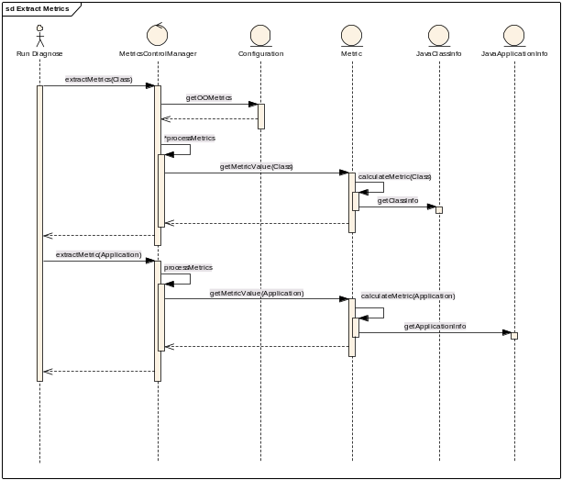
Figure 2. Sequence Diagram – Extract Metrics

Figure 3 shows the sequence diagram of the fuzzy engine use case. In this process the classification of the classes and the entire application take place. The code is reused in both cases however the fuzzy rules change depending on the type of classification being executed. In this process the basic flow for a based rule fuzzy engine takes place: Fuzzy Matching, inference, combination and defuzzification.

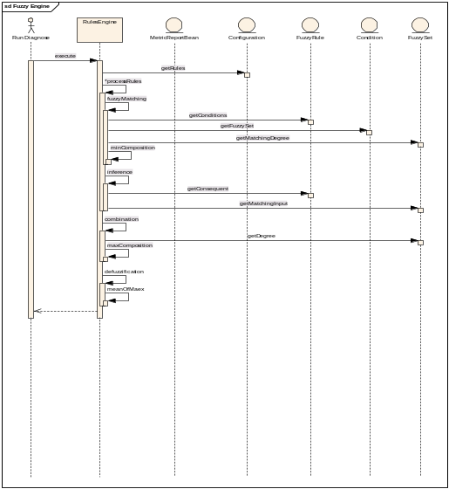
Figure 3. Sequence Diagram – Fuzzy Engine
Class Diagrams: Figure 4 shows the main class diagram of the application. The most important classes of this system are DiagnoseFacade and FuzzyEngineImpl . The first one orchestrates all the subsystems of the application and latter one manages the extraction of the metrics and the execution of the fuzzy engine rules.
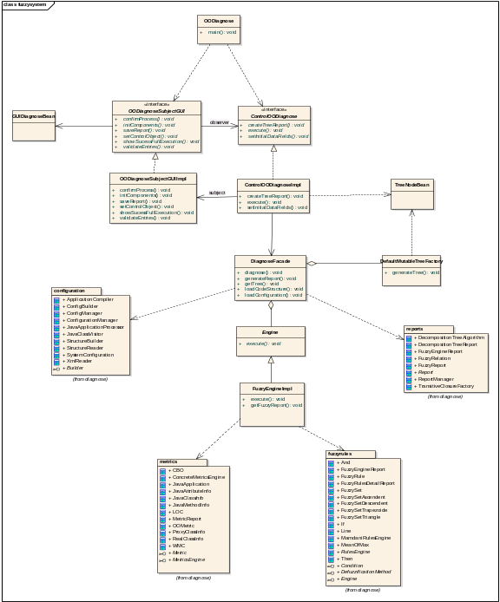
Figure 4. Class Diagram – Fuzzy System
The following subsections explain each of the subsystems within the application.
Fuzzy Rules Engine Subsystem: This subsystem shown in figure 5 is responsible for the execution of the fuzzy rules defined in the system. The most important classes of this subsystem are RulesEngine and FuzzyRuleBasedEngine. RulesEngine is the main class of the template pattern and contains all the steps of a Fuzzy Rules-based Inference Engine: matching degree, inference, combination and defuzzification [14]. The FuzzyRuleBasedEngine actually implements each of the steps using a Fuzzy Rule Based model. The defuzzification method used in the application is the Mean of Max [14].
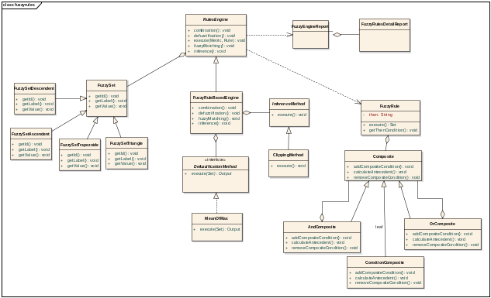
Figure 5. Class Diagram – Fuzzy Rules Engine Subsystem

Fuzzy Configuration Subsystem: This subsystem is responsible for reading the configuration file and extracting the metrics from the java classes (See figure 6 for details). The main classes are: XMLReader that is in charge of reading the XML configuration file (metrics, fuzzy sets, fuzzy rules, etc), and JavaClassVisitor that reads the class variables, methods and variables methods of the java classes and stores their respective values in java beans so they can be extracted in the calculation of each of the metrics. This application uses the utility API javax.tools.JavaCompiler to extract the information of the java classes.
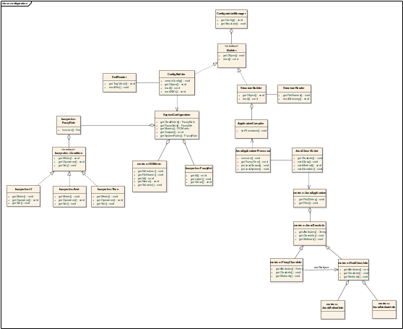
Figure 6. Class Diagram – Configuration Subsystem

Object Oriented Metrics Subsystem: This subsystem shown in figure 7 orchestrates the extraction of each of the metrics. The main class of this subsystem are ConcreteMetricsEngine that executes each of the metrics defined of the system. Additionally the metric interface defines the signature of the methods that needs to be implemented by each of the metrics.
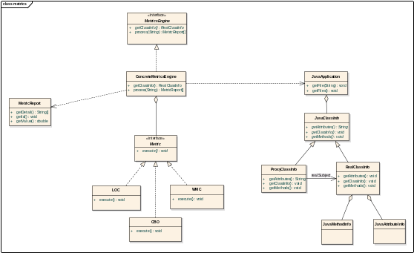
Figure 7. Class Diagram – OO Metrics Subsystem
Report Subsystem: This subsystem is in charge of the presentation of the results to the end user in two formats: XML and Screen. This subsystem is shown in figure 8 below.

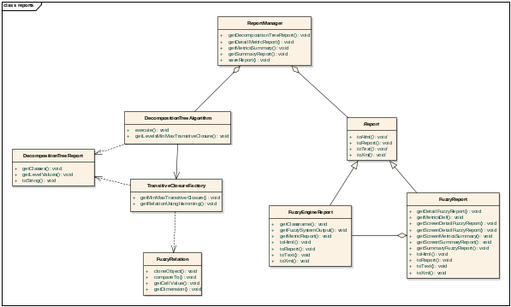
Figure 8. Class Diagram – Report Subsystem

- Fuzzy System Design
  - Design of the diagnose system
The objective of the system is to classify the reliability and potential flaws in the object oriented design of java applications based on OO Metrics. Figure 9 below shows the block diagram of the system.

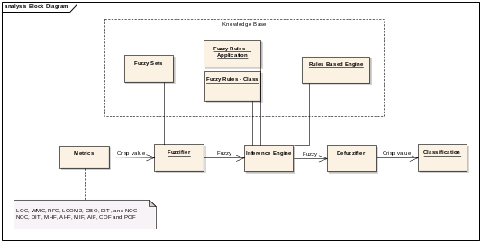
Figure 9. Block Diagram of the fuzzy system
In the diagram the input of the system is the OO metrics extracted from java application. The Fuzzifier process calculates the matching degree to which the metrics match the condition of the fuzzy rules. The Inference Engine calculates the rule’s conclusion based on its matching degree by using the clipping method and combines the conclusion inferred by all fuzzy rules into a final conclusion. Finally the Defuzzifier process coverts the fuzzy conclusion into a crisp value by using the mean of max method. There are two types of results given by the system: A fine grain classification for each of the classes and a general classification for the java application being evaluated [14]. For this reason two sets of rules are used during the classification: one set of rules to classify single classes and another one to evaluate the application. Moreover a decomposition tree is generated for the classes reported for the single class classification. This tool will help the developer to analyze and address classes within the same similarity group.
  - Input variables
The input variables of the system are the Object Oriented metrics shown below
LOC = Lines of code
WMC = Weighted Methods per Class
RFC = Response for a Class
LCOM2 = Lack of Cohesion
CBO= Coupling Between Object Classes
NOC= Number of Children
DIT = Depth of Inheritance Tree
MHF= Method Hiding Factor
AHF= Attribute Hiding Factor
MIF= Method Inheritance Factor
AIF= Attribute Inheritance Factor
COF= Coupling Factor
POF= Polymorphism Factor
  - Output variables
The output variable of the system is defined as:
OODC= Software classification.
  - Definitions
The definition of the values used in the fuzzy sets and fuzzy rules are:
C- Critical
H – High
M – Medium
N - Normal
L - Low
VL – Very Low
  - Membership function definition
The membership functions have been designed based on empirical results presented by Chidamber, Rosenberg and Briand. The design of the membership functions has followed the conditions proposed by Yen and Langary where “each function overlaps only with the closest neighboring membership function and for any possible input data, its membership values in all relevant fuzzy sets should sum to 1 or nearly so” [14]. The following is the definition for each of the metrics:
WMC: For this metric three membership functions were designed: normal (x:10,20), medium (x:10,20,30) and high(x:20,30). The normal value was chosen based on two observations: Rosenberg’s experiment showed a histogram with values between 0 and 20 for most of the classes; on the other hand Chidamber reported most of the cases with values between 0 and 10. As a result the values for the normal membership function are chosen between 0 and 20. Due to Yen and Langary’s conditions, the medium membership function is derived with values 10, 20, 30 overlapping with the normal set, and high fuzzy set is derived with values 20 and 30 overlapping with the medium fuzzy set. The membership functions are shown in the figure 10 below.

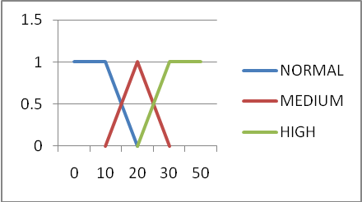
Figure 10. WMC membership functions

RFC: For this metric three membership functions were created: normal (x:30,40), medium (x:30,40,50) and high (x:40, 50). The empirical data from Rosenberg showed that the majority of classes only invoke between 0 and 40 methods; on the other hand Chidamber reported a median value between 6 and 29. Based on this information the normal membership function is defined with values between 0 and 40; and medium and high fuzzy sets are derived using Yen and Langary’s conditions. The membership functions are shown in figure 11 below.
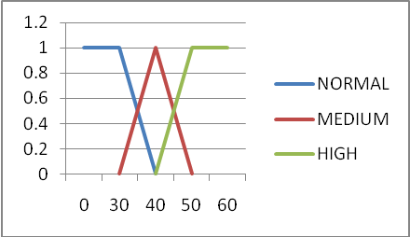
Figure 11. RFC membership functions
LCOM2: For this metric three membership functions were created: normal (x:60,70), medium (x:60,70,80) and high (x:70,80). Rosenberg did not present statistical data for this metric however she said that “smaller LCOM to its maximum value the better”. On the other hand Briand obtained a median value 64% and min value 18%. The normal value is derived based on the median and the other two values are derived from the conditions presented by Yen and Langary. The membership functions are shown in figure 12 below.
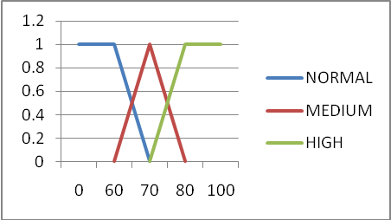
Figure 12. LCOM2 membership functions

CBO: For this metric three membership functions were defined: normal (x: 5, 10), medium(x: 5, 10, 15), high(x: 10, 15). Rosenberg reported than more than one-third of the classes reported values between 0 and 10 and fewer classes between 11 and 13. On the other hand Chidamber obtained a median value between 0 and 9. Based on this information the normal membership function is defined with values between 0 and 10; the other fuzzy sets are derived based on Yen and Langary’s conditions using overlapping of 5. The membership functions are shown in figure 13 below.
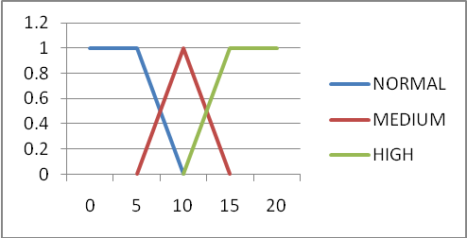
Figure 13. CBO membership functions

DIT: For this metric three membership functions were defined: normal (x:3,6), medium (x:3,6,9) and high (x:6,9). Rosenberg reported 60% classes with a DIT less than or equal to 1, 20% between 2 and 3; and only 5% greater than 5. Chidamber on the other hand reported a maximum DIT less than 10, and a median value between 1 and 3. Based on this information the normal membership function is chosen between 0 and 6 and the other membership functions are derived using Yen and Langary’s conditions. The membership functions are shown in figure 14 below.
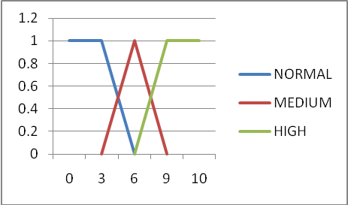
Figure 14. DIT membership functions

NOC: For this metric three membership functions were created: normal (x:10,20), medium (x:10,20,30) and high(20,30). In his research Rosenberg reported that most of the classes had between 0 and 10 children, and fewer classes between 10 and 20 children. On the other hand Chidamber reported that most of the classes did not have children, and that the maximum value obtained in this metric was between 42 and 50. Giving an overlap of 10 the normal membership function is chosen between 0 and 20; and the other fuzzy sets are derived based on Yen and Langary’s conditions. The membership functions are shown in figure 15 below.

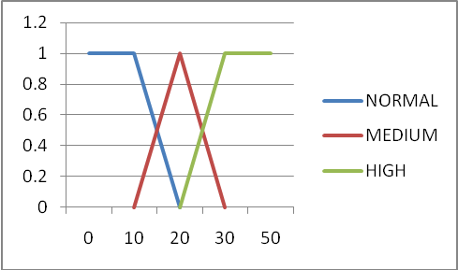
Figure 15. NOC membership functions

LOC: for this metric three membership functions were created: normal (x:750,1000), medium (x:750,1000,1250) and high (x:1000,1250). The fuzzy sets for this metric have been defined based on intuition rather than empirical of theoretical data. As per definition of this metric a class with a low number of lines will be less complex and easier to maintain and test. I consider a class with a normal value to be between 0 and 1000. The other sets are derived with an overlap of 250 and using Yen and Langary’s conditions. The membership functions are shown in figure 16 below
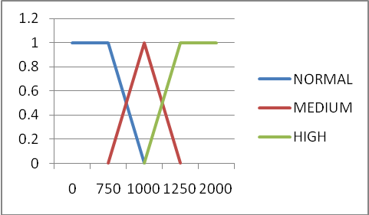
Figure 16. LOC membership functions

MHF: For this metric five membership functions were created: very low (x:5,10), low (x:5,10,15), normal (x:10,15,20,25), medium(20,25,30) and high (x:25,30). The normal membership function was defined based on Brito e Abreu’s statistical distribution reported in their paper. In this case most of the cases and contained values between 8-25%. Therefore a normal fuzzy set is defined using trapezoidal form with values 10,15,20,25. The other membership functions are derived based on Yen and Langary’s conditions using an overlap of 5. Since values between 0 and 10 needs to be included then “very low” and “low” membership are also defined. The membership functions are shown in figure 17 below.
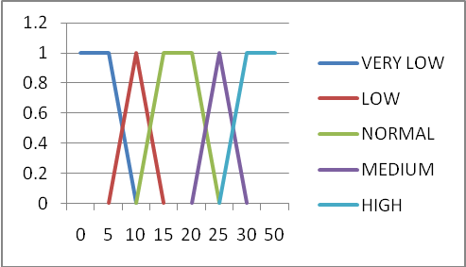
Figure 17. MHF membership functions

AHF: For this metric three membership functions were created: normal (x:80,90), medium (70,80,90) and high (70,80). In their paper Brito e Abreu said that a good encapsulation should not share any attributes between classes and that a good value for this metric should be 100%. However taking into account static variables shared across different classes then the normal membership function is defined with values between 80 and 100. The other membership functions are defined based on Yen and Langary’s condition using an overlap of 10. The membership functions are shown in figure 18 below.

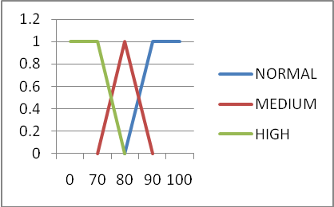
Figure 18. AHF membership functions

MIF: For this metric five membership functions were defined: very low(x:15,20), low(15,20,25), normal(x:20,25,75,80), medium (x:75,80,85) and high (80,85). The normal membership function is derived based on information reported by Brito e Abreu. In their paper they reported an average of 85% among 5 applications and suggested a metric value between 20% and 80%. Therefore the normal membership function is defined in a trapezoidal form with values 20, 25, 75 and 80. The other fuzzy sets are derived based on Yen and Langary’s proposed condition using an overlap of 5. The membership functions are shown in figure 19 below.

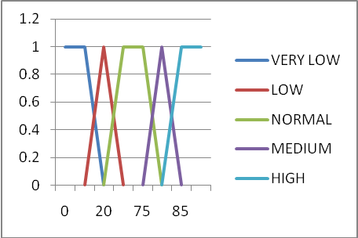
Figure 19.MIF membership functions

AIF: For this metric three membership functions were defined: normal(x:40,50), medium(x:40,50,55,65) and high (x:55,65). In their empirical data Brito e Abreu reported a statistical distribution with most classes between 50 and 65%, maximum value 80% and minimum value of 40%. They also suggested a metric value between 0 and 48%. For this reason a normal membership function is defined using a trapezoidal form with values 40, 50, 55, 65 and the other membership functions are derived using Yen and Langary’s condition with an overlap of 10. The membership functions are shown in figure 20 below.

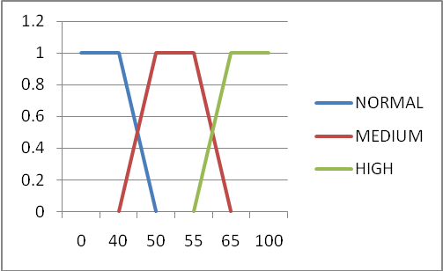
Figure 20. AIF membership functions

COF: For this metric three membership functions were created: normal (x:10,20), medium (x:10,20,30) and high (x:20,30). Normal membership function was derived based on empirical data reported by Brito e Abreu. They showed statistical distributions with most values between 5% and 15%, maximum value 30% and minimum value 3%. They also suggested an ideal value of less than 12%. Therefore a normal membership function is defined with values between 0 and 20 and the other membership functions are derived using Yen and Langary’s condition using an overlap of 10. The membership functions are shown in figure 21 below.

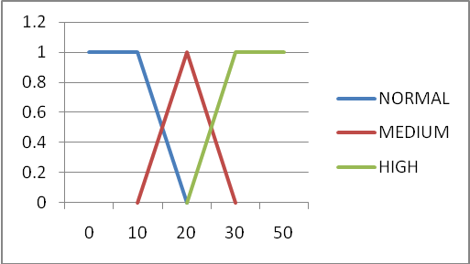
Figure 21. COF membership functions

POF: For this metric three membership functions were created: normal (x:0,10), medium (x:0,10,20) and high (x:10,20). The normal membership function is derived based on empirical data reported by Brito e Abreu. They reported two tendencies in this metric, one of them states that POF should be less than 10% due to polymorphism increases the flexibility of the application, and the other one states than POF should be no greater that 10% because complexity increases testability, maintainability and decreases understandability. In my opinion having very low polymorphism defeats one of the most important principles of object oriented programming; therefore a normal membership function is chosen with values between 10 and 100. The other membership functions are derived based on Yen and Langary’s condition and using 10 points of overlapping. The membership functions are shown in figure 22 below.

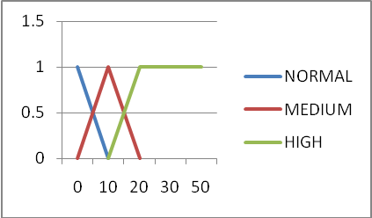
Figure 22. POF membership functions

OODC: Output membership function has been defined with three membership functions: critical (x:80,90,100), high (x:70,80,90) and medium (x:60,70,80). If the matching degree does not fall within these fuzzy sets then it is considered normal and not reported. The membership functions are shown in figure 23 below.
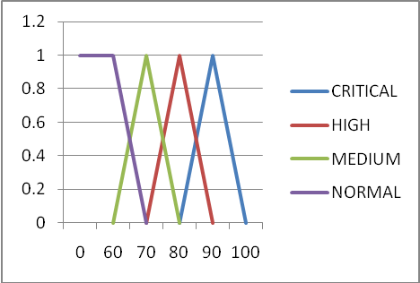
Figure 23. OODC – Output membership functions

  - Fuzzy Rules Definition
Due to some metrics gather single class information and others gather information of the entire application the fuzzy rules are separated in two groups: fuzzy rules to classify single java classes and fuzzy rules to classify the entire java application. The metrics to classify single java classes are: LOC, WMC, RFC, LCOM2, CBO, DIT, and NOC. These metrics gather information about complexity, cohesion, coupling and hierarchical tree of single classes. The metrics to classify the entire application are: NOC, DIT, MHF, AHF, MIF, AIF, COF and POF; and they gather information about encapsulation, inheritance, coupling and hierarchical tree structure of the entire application. Both groups of metrics are complementary and their results provide detail and general information about the application. It is worth to mention that despite of DIT and NOC do not gather information at application level, its maximum value is used in the classification of the application due to these metrics have a direct impact in the hierarchical structure of the application.
Analyzing each group of metrics to classify single classes and applications an additional clustering is performed based on the objectives of the metrics. Metrics that share the same objective are grouped together and metrics that do not share same objective are left alone. Table 1 below shows the results of this clustering.

Group # | Metrics | Objective
1 | LOC, WMC, RFC | Complexity
2 | DIT, NOC | Hierarchical tree.
3 | LCOM2 | Cohesion
4 | CBO, CFO | Coupling
5 | MIF, AIF | Inheritance
6 | MHF, AHF | Encapsulation
7 | POF | Polymorphism
Table 1. Metrics Objectives per Group
This grouping is used during the definition of the fuzzy rules and each cluster represents a single condition within the fuzzy rule. The evaluation of the metrics within the cluster is performed using the OR command (min fuzzy operation), and the evaluation of all the clusters within the condition is performed using the AND command (max fuzzy operation). For example:
R1 → IF (LOC IS HIGH OR WMC IS HIGH OR RFC IS HIGH) AND (DIT IS HIGH AND NOC IS HIGH)… THEN
This fuzzy rule is evaluated as shown in (8) below:
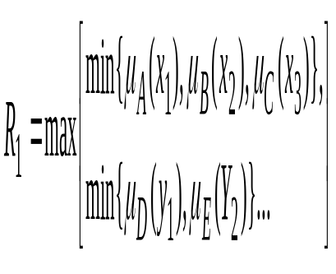 (8)
The next two sections explain the definition of the fuzzy rules for single java classes and for the entire application.
Fuzzy Rules for Classification of Single Java Classes: These rules use the membership functions LOC, WMC, RFC, LCOM2, CBO, DIT, and NOC; and classify the class as critical, high or medium. Table 2 below explains the conditions for each of the classifications.

Fuzzy Consequent | Fuzzy Conditions
Critical | At least three of the clusters being evaluated have high value;
High | At least two of the clusters being evaluated have high value;
Medium | At least one of the clusters being evaluated have high value;
Table 2. Conditions for class classification
As shown in the table a rule with critical consequent evaluates if at least three clusters in the fuzzy rule have a high value. A class under this classification has a very poor object oriented design and does not follow at least three OO metrics. This class can impact other classes within the application. A considerable amount of work is expected to address all of the metrics within the class. For this reason a critical classification should trigger immediate attention of the developer, leader or project manager for review and modification.
A rule with high classification evaluates if at least two clusters within the fuzzy rule have a high value. A class under this classification does not conform with at least two of the metrics being evaluated therefore testing and maintaining the class can become a challenge. A class under this classification will most probably move to critical instead of moving to medium or normal stage, therefore this classification should trigger the attention of the developer, architect, leader for review.
Finally a rule with medium fuzzy set consequent evaluates if at least one cluster has a high value. A class under this classification should be reviewed and verified to make sure that there are no potential issues in the design. Again classes with medium classification will most probably to move to high or critical instead of moving back to normal. This classification should trigger attention of the developer for review. The rules derived are shown in the table 3 below
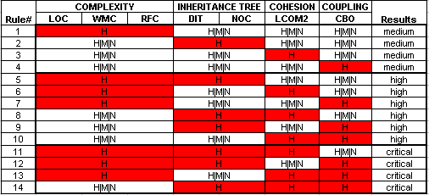
Table 3. Fuzzy rules for class classification

Fuzzy Rules for Classification of the Entire Application: Similar to the fuzzy rules at the class level, the application rules have critical, high or medium classification. These rules use the membership functions: NOC, DIT, MHF, AHF, MIF, AIF, COF and POF. Table 4 below shows the conditions needed in order to meet each of the classifications mentioned.

Fuzzy Consequent | Fuzzy Conditions
Critical | At least three clusters have a high value;
High | At least two clusters have a high value;
Medium | At least one cluster has a high value.
Table 4. Conditions for application classification
As shown in the table above a rule with critical fuzzy set consequent evaluates if at least three clusters in the fuzzy rule have high value. Most probably the application has a very poor object oriented design and a considerable amount is needed to redesign the application. This classification should trigger immediate attention of the designer, architect, leader or project manager.
A rule with high fuzzy set consequent evaluates that at least two clusters in the fuzzy rule have high value. If the result of the application falls under this classification then a review must be performed and high values addressed. Medium values on the other hand should be reviewed for impact and potential modifications. Usually an application under this classification will most probably move to critical stage instead of medium or normal. This classification should trigger the attention of the designer, architect, leader or project manager for review of the object oriented design and correction of the metrics.
Finally a rule with medium fuzzy set consequent evaluates if at least one of the clusters within the fuzzy rule has high value. An application under this classification should be reviewed for evaluation and verification. Without revision the application most probably will move to high or critical instead of moving back to normal. This classification should trigger the attention of the designer, leader or project manager for review. The rules derived are shown in the table 5 below:
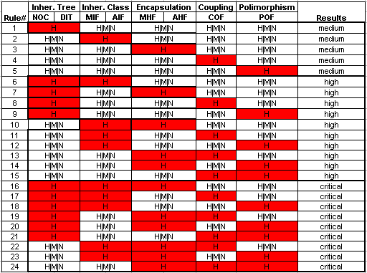
Table 5. Fuzzy rules for application classification

- Data Analysis and Data Preparation
Three applications were diagnose during the experiments. 2 of them were provided by CGI, one of the largest IT companies in Canada. The other application is the java application developed for this project. The experiments were executed using most of the java classes; however JUnit test classes and Exception classes were excluded from the experiments. Because of its nature these classes do not follow object oriented design principles therefore can affect the results of the metrics. Table 6 below shows information number of applications along with packages, classes and lines of code.

Application | # Packages | # Classes | Lines of Code
OODiagnose | 6 | 90 | 6088
BIE Portal | 43 | 842 | 77395
ETLF | 4 | 45 | 2497
Table 6. Java applications used during the experiment
The results of the fuzzy system were compare to those of a manual classification using histograms of the metrics class diagrams, java code and a brief documentation. These results were then compared to those of the fuzzy application. For the manual process concepts like rigidity, fragility, immobility and viscosity were used to classify the application. Rigidity states that a simple change causes a cascade change in the dependent modules. Fragility is defined as the tendency of a program to break in many places when a single change is made. Immobility is the unsuccessful software reuse of the same design. And viscosity is when usability and employability of the existing methods is very poor making viscosity of the design very high [17].

- Experiments and results

6.1 OO Diagnose application

Results Fuzzy Diagnosis
During the diagnosis of the application the fuzzy system classified the application as normal. Only MHF and NOC metrics were categorized as medium and the other metrics as normal. Table 7 below shows the details of the metrics reported for this classification. These results show a high polymorphism, low coupling, good encapsulation, normal inheritance class and normal inheritance tree which reinforce good object oriented principles of a good design.

Metric | Classification | Value
AHF | Normal | 96.80842
AIF | Normal | 35.80247
COF | Normal | 3.655041
DIT | Normal | 2
MHF | Medium | 24.18428
MIF | Normal | 69.55381
NOC | Medium | 15
POF | Normal | 90.625
Table 7. Classification of the Diagnose Application
Regarding the diagnosis of the classes the system reported 21 classes out of 90 classes being evaluated: 3 of the classes had high classification and 18 medium classification. Figure 24 below shows the Number of Classes vs. Classification per Metric. LCOM2 has the highest number of high classes with 20 out of 21; on the other hand DIT, LOC and NOC had the lowest classification with 21 classes with normal categorization. According to the results the classes do not have a high complexity (low LOC, low WMC and low RFC), the inheritance is keep under control (normal DIT and normal NOC), and coupling is low therefore changes in one class most probably will not cascade to other classes. The only concern is the lack of cohesion (LCOM2) which reports a number of classes with multiple responsibilities.
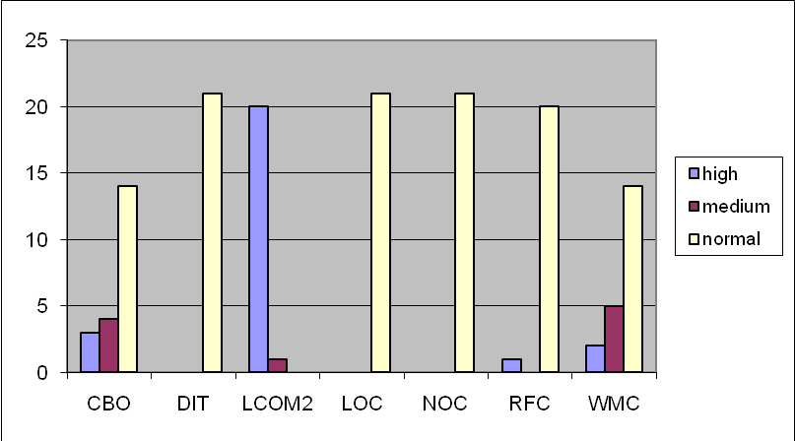
Figure 24. Classes Reported vs Classification per Metric
The system also generated the decomposition tree for the 21 classes reported by the system. As shown in figure 25 21 levels were generated in the tree and the classes were grouped depending on the similarity of the metrics. For example in the similarity group 2.76190476190476 the classes JavaClassInfo and FuzzyRulesEngine are grouped in the same cluster. They have normal CBO, DIT, LOC, RFC and WMC, the difference reported is with LCOM2 where one of the classes has medium and the other one has high classification. Another example is the similarity group 1.78061224489796 where the classes DecompositionTreeAlgorithm and RFC are grouped together. Their similarity is that all of them have high LCOM2 and normal DIT, LOC, RFC and WMC. The only difference between the classes is that one has medium CBO and the other one is normal.
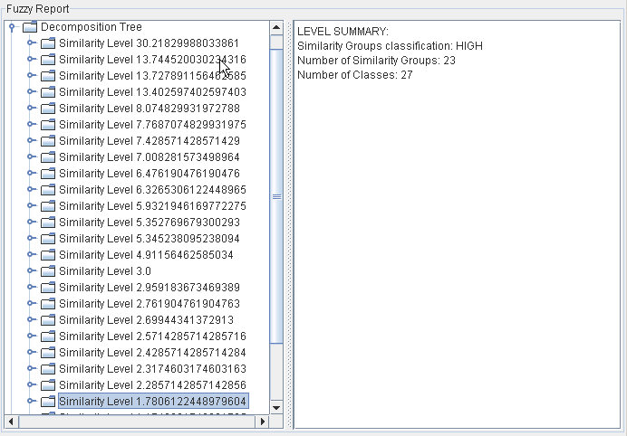
Figure 25. Similarity Groups- OO Design Application

Results of Manual Analysis
During the manual analysis the rigidity, fragility, immobility and viscosity of the application show low values based on the results of the metrics (See figure 26 for details) and validation of the java classes: Inheritance of the attributes (AIF) with 40% seems to be high because all the attributes should be encapsulated.
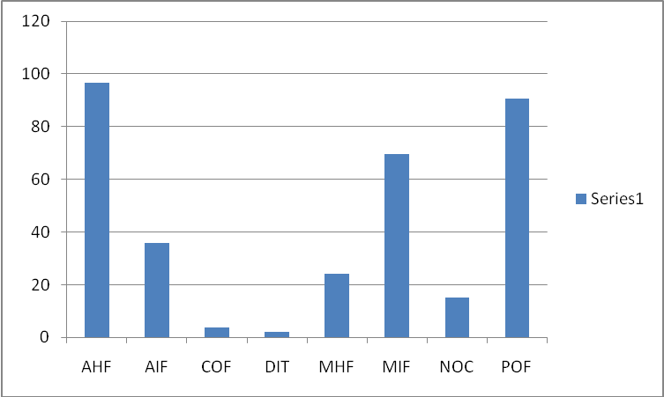
Figure 26. Metrics Results used during classification of the application.

The application seems to have “top heavy” architecture because DIT and NOC have lower values which keeps the inheritance under control. Application seems to be very flexible because POF and MIF have high values. Due to these values it is suggested that the application has high inheritance and high polymorphism. As per class diagram provided it is due to the usage of bridge and strategy pattern to keep the application flexible [18].

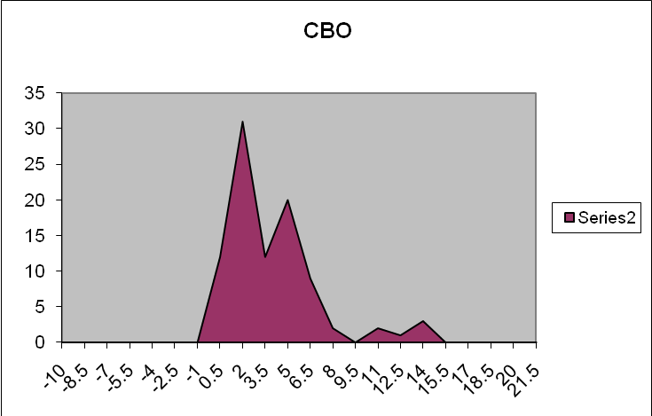
Figure 27. Histogram – CBO metric
Regarding the classification of the java classes the following observations draw the attention during the verification: In general the classes seem to be well written however coupling (CBO) seems to have a couple of outlier classes that need to be reviewed. This is shown in figure 27.
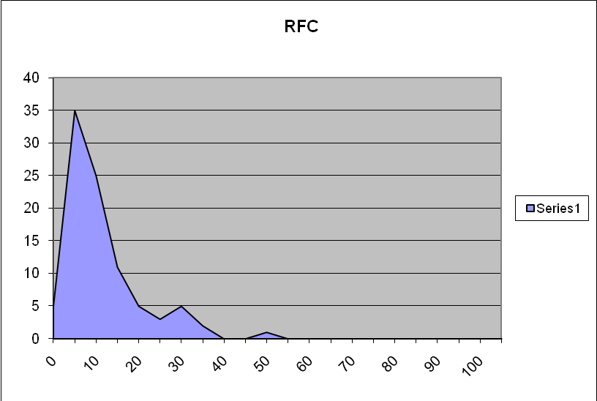
Figure 28. Histogram – RFC metric
There are also a couple of outlier classes for RFC and WMC shown in figure 28 and 29. The classes involved in this measure seem to be either main classes or classes that manage the GUI of the application.

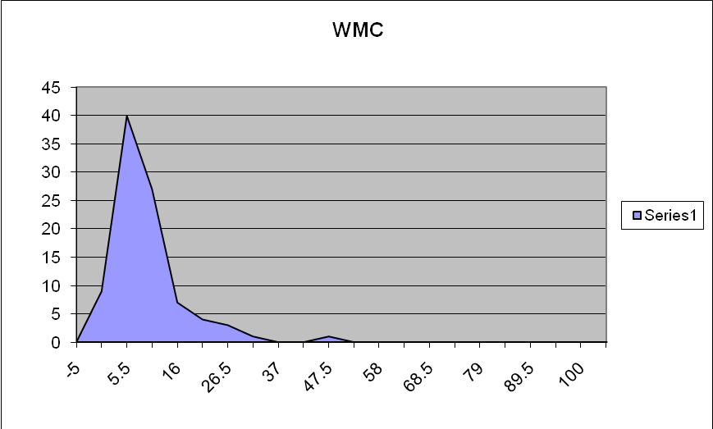
Figure 29. Histogram – WMC metric
There is also a high concern about the results presented by LCOM2 metric which are shown in figure 30. The metric seems to report many false positives because after reviewing the results there were many Java Bean objects reported with high lack of cohesion which is very unusual.

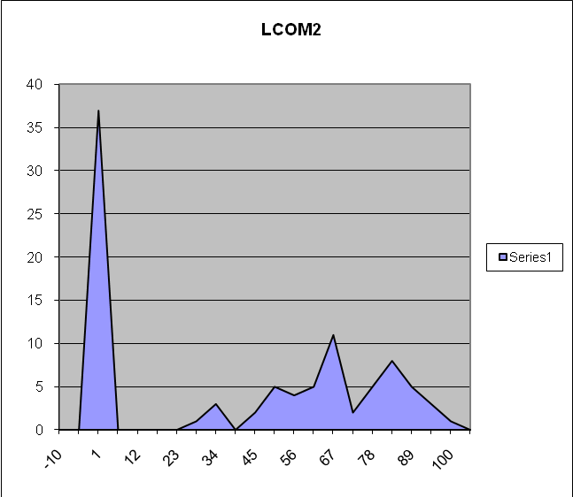
Figure 30. Histogram – LCOM2 metric

Comparison and Discussion
The results of the manual analysis and the fuzzy system are comparable. In general both results reported a relative good object oriented design. Regarding the fine grained details both results reported high lack of cohesion. There seems to be a problem with LCOM2 metrics because false-positives are being reported. During manual verification of the source code java bean objects are being reported with medium and high values despite of the fact that they do have single responsibility, low coupling and high encapsulation. Java Beans are reusable objects utilized in java to represent objects and follow conventions about method naming, construction and behavior therefore these classes should be valid objects with normal cohesion [15].
The only difference between the diagnosis procedures is that low values in deep of inheritance tree (DIT) and number of children (NOC) were detected during the manual analysis of the histograms. The fuzzy rules seem to be overseeing low values for these metrics; however this is subjective because as pointed by Rosenberg higher values indicate higher complexity which affects the maintainability and testability of the classes and therefore the application [2]. The metrics provide a trade-off and their values should be assigned depending on the experts, company and client policies, etc.

6.2 ETLF application
Results Fuzzy Diagnosis
During the diagnosis of the application the system classified the application as high. POF is classified as high, MIF is classified as very low, MHF is classified as medium and AHF, AIF, COF, DIT, NOC are classified normal. Table9 below shows the details of the metrics reported for this classification. These results show low inheritance at the class level (low MIF) and very low polymorphism (POF). Additionally the application has low encapsulation at the class level (low MHF) so it seems to be that the classes provide very little functionality [13]. From the results it is deducted that object oriented principles such as inheritance and polymorphism are not being used therefore the application is duplicating code instead of reusing it. High classification seems to be appropriate for this diagnosis.

Metric | Classification | Value
AHF | normal | 99.32432
AIF | normal | 0
COF | normal | 3.989899
DIT | normal | 0
MHF | Low | 8.171206
MIF | very-low | 0
NOC | normal | 0
POF | High | 0
Table 9. Classification of the ETLF Application
Regarding the diagnosis of the classes the system reported 15 classes reported out of 45 classes analyzed: One of the classes has high classification and 14 have medium classification. LCOM2 has the largest number of classes with 13 out of 15 cataloged with high classification and one with medium classification; Coupling is high for one class and medium for 2 classes and WMC is medium in 8 classes. Cohesion is a concerned for most of the classes reported and seems to be that most of the classes have more than one responsibility. Also complexity has medium classification for half of the classes reported and might be due to low cohesion. Figure 31 below shows the Classes Reported vs Classification per Metric.
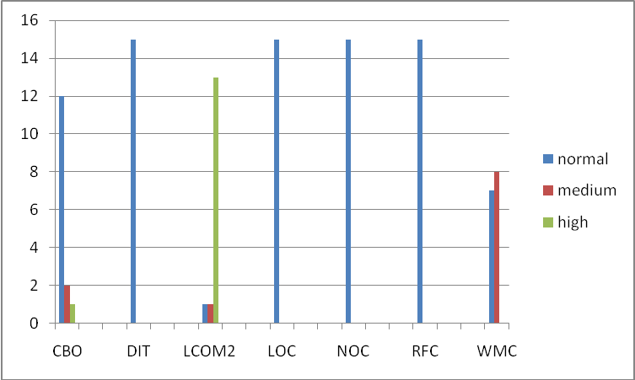
Figure 31. Classes Reported vs Classification per Metric
Additionally the system generated a decomposition tree with 15 similarity levels. The results are shown in figure 32. Sample results were analyzed for validity of the results: similarity level 6.52622469105985 with two classes (JobLogDAOHibernate and AbstractHibernateDAO) showed normal values for CBO, DIT, LOC, NOC, RFC and WMC. LCOM2 showed high value in one class and medium value in the other class. Another group analyzed with similarity level 3.95918367346939 reported four classes: ExecutionStatus, RecoverType, CommandType, NotificationType. All of the classes have normal CBO, DIT, LOC, NOC, and RFC, and high LCOM2. WMC reported 3 classes with medium classification and other one with normal classification. The sample results above mentioned show similarity within the groups and results are useful for developers, architects, etc to address similar issues within the groups.
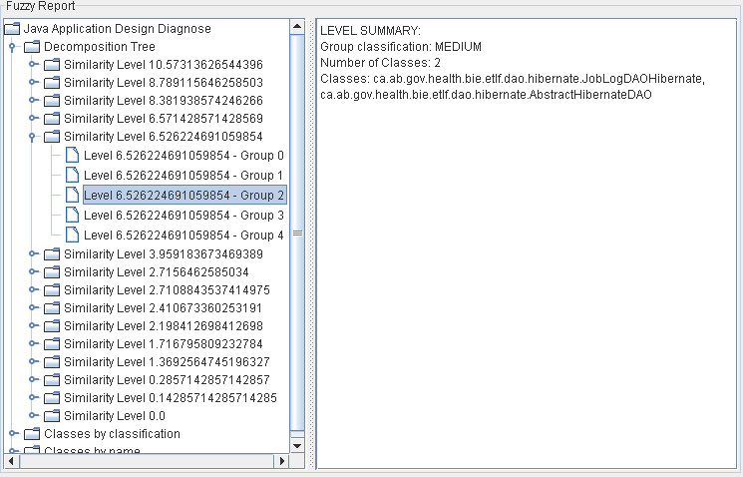
Figure 32. Similarity Groups – ETLF Application
Results of Manual Analysis
According to the results of the metrics shown in figure 33 the application does have high rigidity, fragility and immobility. The design has high Immobility due to lack of inheritance tree; this is demonstrated in the very low values of DIT, NOC and MIF. Additionally the design has a low viscosity due to lack of polymorphism.
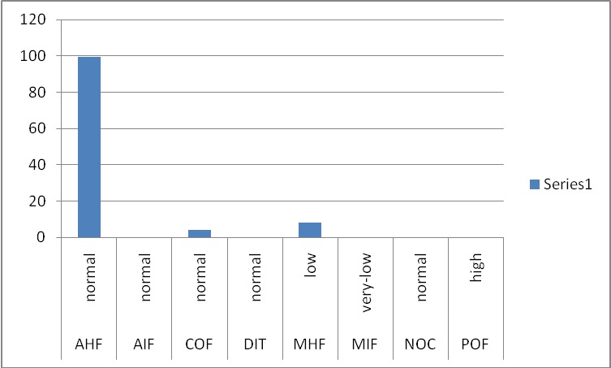
Figure 33. Metrics Results – Application Classification
The system has high rigidity so changes in the application cascade to other classes because of no polymorphism and low reusability. A closer look to the code shows no usage of patterns in the design of the application showing lack of flexibility. These results indicate a bad object oriented design and a thorough review should be carried out by the designer and architect of the application. In the verification of the java classes the following was observed: There are few classes with high coupling and most probably these are main classes that orchestrate the interaction between the different objects within the application. CBO is shown in figure 34 for details.

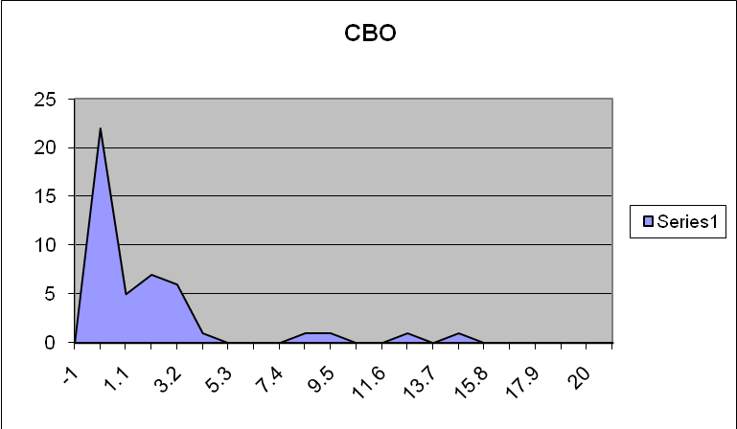
Figure 34. Histogram – CBO metric
As shown in figure 35 there are some outlier classes with high number of methods defined. These classes are very complex and most probably they are related to the outlier classes reported in CBO. This indicates that the core functionality of the application is kept in only few classes which indicate high rigidity and fragility and small changes will cascade to these classes.

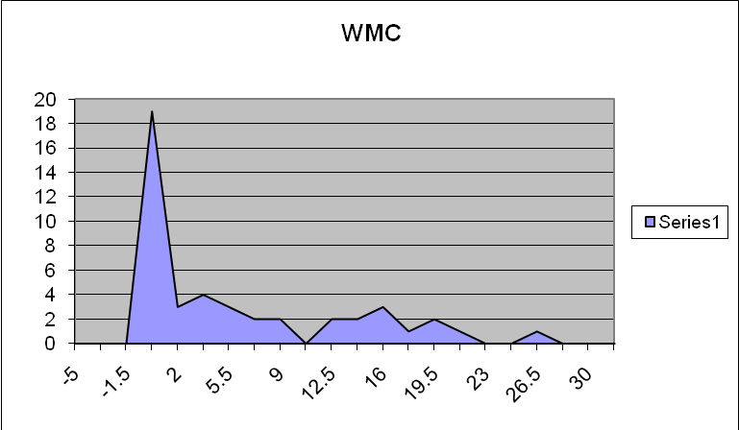
Figure 35. Histogram – WMC metric
Figure 36 below shows a number of outliers classes in the RFC metrics. The similarity of the CBO, WMC and RFC figures confirms that the outlier classes keep the core functionality of the application. Which confirm high rigidity and fragility.

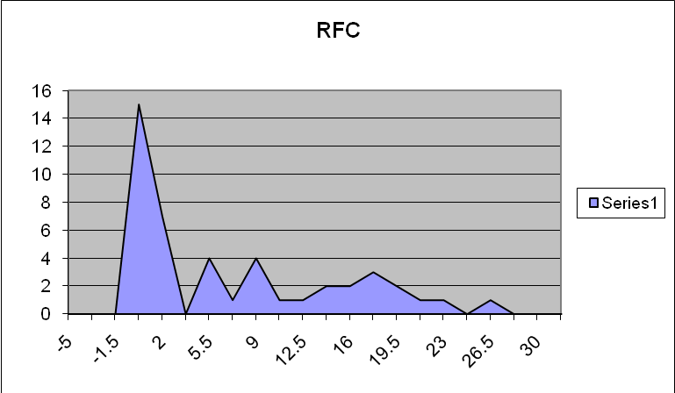
Figure 36. Histogram – RFC metric
LCOM2 is shown in figure 37 and shows low cohesion for some classes and this observations combined with the histograms for CBO, RFC and WMC confirms that the classes that contain the core functionality of have also multiple responsibilities. Additionally the histograms for DIT and NOC confirm a completely lack of inheritance therefore there is little or no reusability within the application.
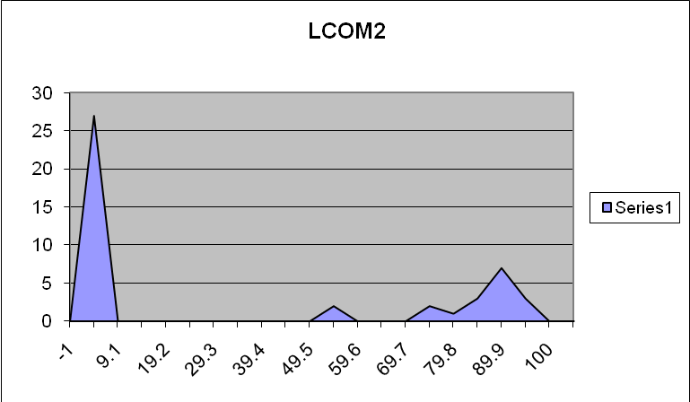
Figure 37. Histogram – LCOM2 metric

Comparison and discussion of the results
The fuzzy system and the manual analysis have comparable results; however the fuzzy system gave a lower classification. and low values in DIT and NOC were not reported. The fuzzy system reported the application high due to a lack of inheritance and polymorphism within the application. The same results were obtained with the manual verification which reported high rigidity, fragility and immobility due to lack of inheritance. Both results consider a review in the inheritance and polymorphism of the application. With low reusability, maintainability and testing of the system becomes very complex and most probably functionality is duplicated in some instances. Therefore revision of the system should be performed and reorganization of the java classes should be considered.

6.3 BIE Portal application
Results Fuzzy Diagnosis
The diagnosis of the fuzzy system classified the application as medium. NOC was reported high indicating that inheritance of methods and classes is very high and understandability and maintainability can be very complex. On the other hand reusability and flexibility of the application are good and therefore the possibility that changes within the application cascade to other classes is low. Additionally AIF, DIT and MIF metrics have medium values which confirm the flexibility and high use of inheritance within the application. These results are shown in table 11 below.

Metric | Classification | Value
AHF | normal | 99.77572
AIF | medium | 47.09656
COF | normal | 0.69762
DIT | medium | 6
MHF | normal | 18.81308
MIF | medium | 78.73542
NOC | high | 40
POF | normal | 18.32651
Table 11. Classification of the BIE Portal Application
In the diagnosis of the single classes the system reported 329 classes: 12 classes with critical, 94 with high and 329 with high warnings. Figure 38 shows 263 classes with high LCOM2, 82 classes with high coupling, 19 classes with high RFC, 67 with high WMC, 2 with high LOC and 2 with high NOC. Additionally a significant number of classes with medium values is reported for CBO, LCOM2, RFC and WMC. There seems to be very complex (WMC, LOC, and RFC), tightly coupled classes and most probably having multiple responsibilities. Unfortunately the fuzzy system does not generate decomposition tree if more than 200 classes are reported due to system limitations.
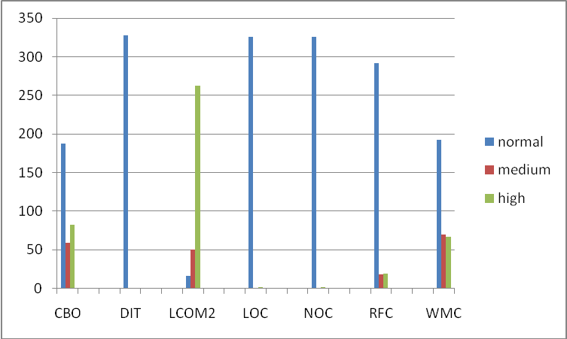
Figure 38. Classes vs Classification per Metric

Results of Manual Analysis
According to the results of the metrics shown in figure 39 the application does have low rigidity, fragility, immobility; therefore the application seems to have well defined object oriented principles of inheritance, encapsulation, low coupling, Polymorphism seems to be a little low therefore viscosity value is a little high and usability and signature of the methods is not well defined. The number of children seems to be a little high; however not too high when comparing this value to the size of the application.
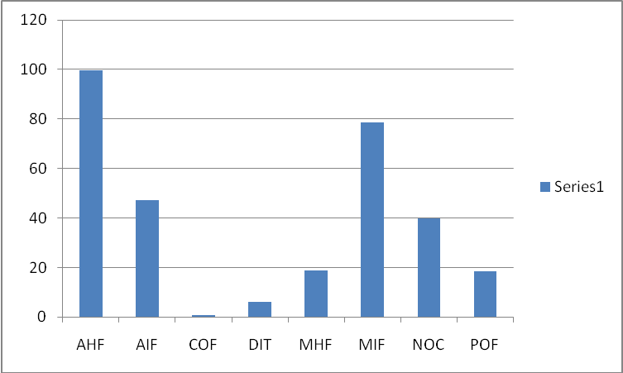
Figure 39. Metrics Results used during classification of the application.
While validating the histograms of the metrics for single java classes, there are a few of outliers for LOC and NOC. While taking a closer look at the source code of the classes with high number of lines of code, they are the main classes of the application responsible for managing the core functionality of the application. Outliers in RFC, WMC confirm that there are few classes that manage the core functionality of the application. These results are shown in figure 40 and 41.

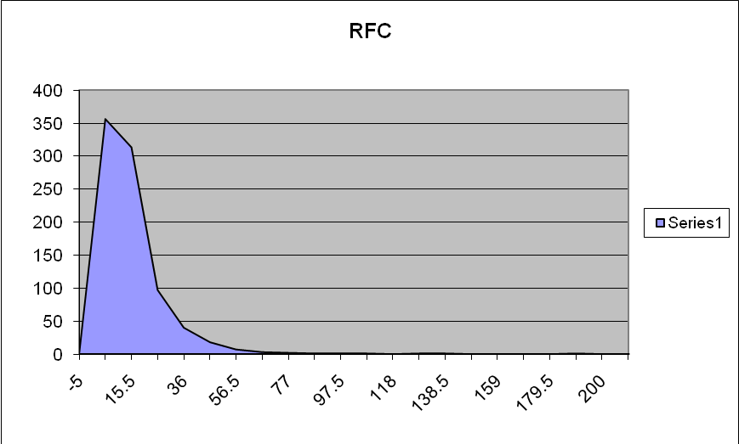
Figure 40. Histogram – RFC metric

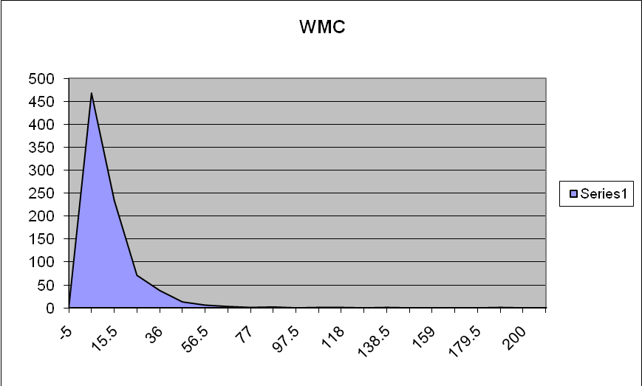
Figure 41. Histogram – WMC metric

There are a number of outlier classes tightly coupled, therefore these classes have high rigidity and fragility, changes to this class will most probably cascade to the classes to which this class is coupled. The histogram of this metric is shown in figure 42 below.
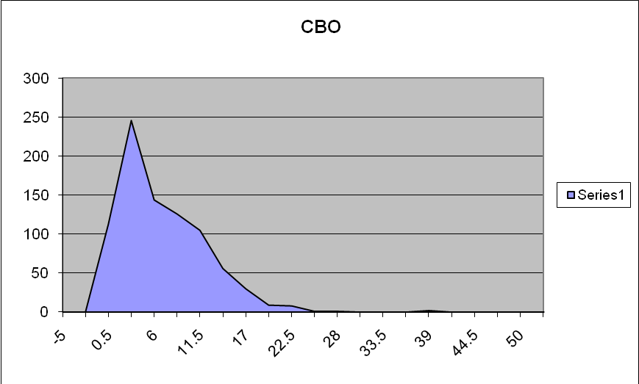
Figure 42. Histogram – CBO metric
According to the results of the DIT shown in figure 43, the application has “bottom heavy” architecture therefore it has high reusability impacting negatively the usability and testability of the application.
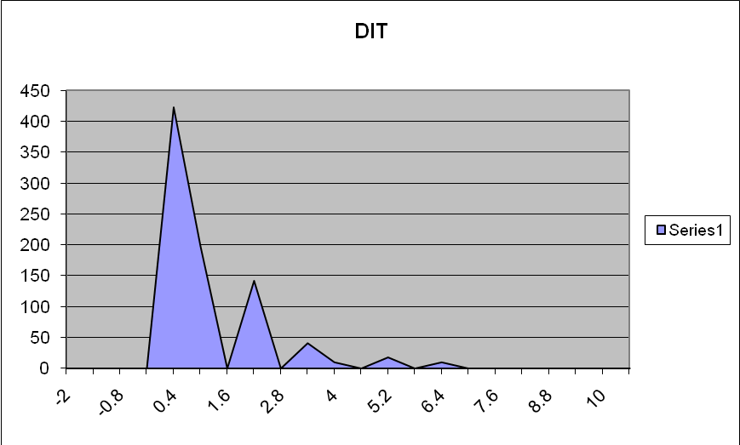
Figure 43. Histogram – DIT metric
As shown in figure 44, the results of LCOM2 are very suspicious because there are a number of classes with low cohesion. According to the results of the metric almost 25% of the classes have multiple responsibilities and therefore should be verified and restructure. While this should be true for the core classes other classes have been reviewed to corroborate the objective of the metric. As pointed in previous analysis the metric is reporting false-positives so therefore a manual work from the developer is needed to corroborate these results.
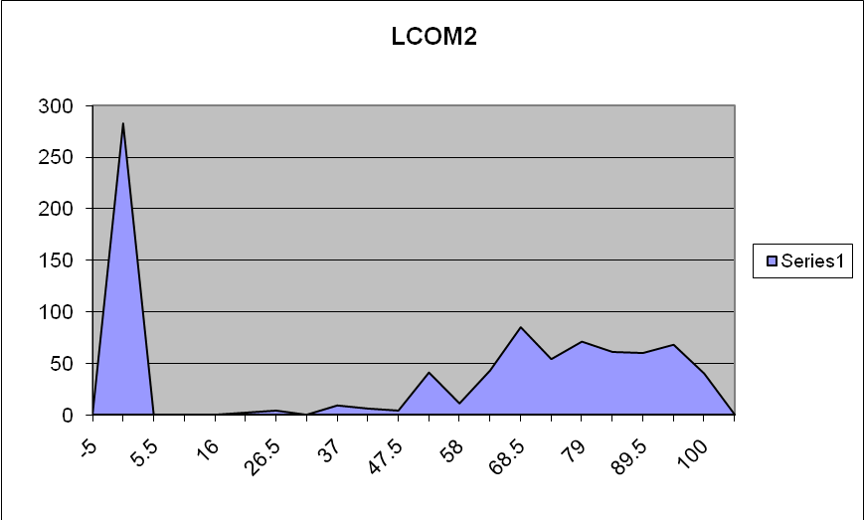
Figure 44. Histogram – LCOM2 metric

Comparison and discussion of the results
These indicate that overall the application utilizes object oriented principles; however review to the hierarchical tree structure of the application is needed to avoid an explosion of the number of children increasing the complexity of the application. In the future it can negatively impact the complexity, testability and maintainability of the application. This result is comparable to the fuzzy system diagnosis which rated the application with medium due to the high number of children. No immediate action is needed, however changes should be considered. As suggested by Gamma et Al in some cases the decorator pattern is useful in these cases[18].

- Conclusion and Future Work
In this paper I developed a software system to diagnose the reliability of java applications using object oriented metrics and a fuzzy rule-based system. The fuzzy membership functions and fuzzy rules have been defined from using statistical data from previous studies that have defined and/or analyzed the different object oriented metrics. Three applications for different business purposes and sizes have been analyzed, and results of the fuzzy system have been compared to those of a manual analysis of histograms and source code. The following can be inferred from the experiment:
- The fuzzy system has an appropriate default set of fuzzy sets and fuzzy rules to classify object oriented java applications.
- The fuzzy system provides reliable results and no additional analysis is needed.
- The decomposition tree is a very useful analysis tool for developers who need to address issues with classes with similar metric values.
- The results help the developers, designers and team leaders to enforce the use of object oriented principles in the design and development of java applications.
- Unfortunately the fuzzy system does not prevent metrics to report false-positives therefore manual analysis is needed in cases were abnormal results are suspected.
- Overall the current fuzzy sets and fuzzy rules provide accurate results however the system does not report low values in NOC and DIT at the application level, therefore modifications of these rules and fuzzy sets are expected if these values need to be considered by the user.
- The fuzzy rules did not entirely utilize medium and normal membership functions, but these fuzzy sets are provided so the user can modify the current fuzzy rules if a more accurate result is needed.
- The fuzzy system provides objective results because they contain information from statistical sources and several human experts in contrast to human analysis that is bias and can vary depending on the knowledge and experience of the expert.
In the future work the following suggestions are provided:
- Integration of the fuzzy system with the popular java compiler ant, to obtain instant results at compilation time.
- Include a neural network prediction system to forecast the reliability of the applications using statistical and historical information of the fuzzy reports.
- Integrate the fuzzy system with a continuous monitoring system (for example Hudson dashboard) so snapshot reports for the different tools (JUnits, FindBugs, OO Fuzzy Diagnose, etc.) are available for developers, project leaders, architects, managers and clients in order to increase productivity, reliability, usability, testability of the application.

References
[1] Chidamber, Shyam R. and. Kemerer, Chris K, A Metrics Suite for Object Oriented Design, 1994
[2] Dr. Rosenberg, Linda H., Applying and Interpreting Object Oriented Metrics, 1998
[3] Tsenga, Tzu-Laing et al, Applying Genetic Algorithm for the Development of the Components-Based Embedded System, Department of Mechanical and Industrial Engineering, The University of Texas at El Paso, United States, Department of Information Management, National Changhua University of Education, Taiwan, Department of Information Management, National Chi-Nan University, Taiwan, 2004
[4] Thwin, Mie Mie Thet, and Quah, Tong-Seng, Application of Neural Networks for Software Quality Prediction using Object-Oriented Metrics, School of Electrical and Electronic Engineering, Nanyang Technological University, Singapore, 2004
[5] Ampatzoglou, Apostolos, and Chatzigeorgiou, Alexander Evaluation of Object-Oriented Design Patterns in Game Development, Department of Applied Informatics, University of Macedonia, Thessaloniki, Greece, 2006
[6] Tong-Seng Quah, Estimating Software Readiness using Predictive Models, School of Electrical and Electronic Engineering, Nanyang Technological University, Singapore, 2008
[7] Elish, Karim O., and Elish, Mahmoud O. , Predicting Defect-Prone Software Modules using Support Vector Machines, Information and Computer Science Department, King Fahd University of Petroleum and Minerals, Saudi Arabia, 2007
[8] Pizzia, Nick J., and Pedrycz, Witold , Effective Classification using Feature Selection and Fuzzy Integration, National Research Council of Canada, Institute for Biodiagnostics, Winnipeg, Canada, Department of Computer Science, University of Manitoba, Winnipeg, Canada
[9] Sarkar, Santonu, and Kak, Avinash C., and Rama, Girish Maskeri , Metrics for Measuring the Quality of Modularization of Large-Scale Object-Oriented Software, 2008
[10] Kitchenham, Barbara, What’s up with Software Metrics? – A Preliminary Mapping Study, Dept. Computer Science and Mathematics, Keele University, UK, 2009
[11] Object Oriented Programming, Wikipedia, http://en.wikipediaorg/wiki/Object-oriented_programming
[12] Virtual Machinery – JHAWK, http://www.virtualmachinery.com/jhawkprod.htm, 1999
[13] Brito e Abreu, The design of Eiffel Programs: Quantitative Evaluation using the MOOD Metrics, 1996.
[14] Yen, John, and Langary, Reza, Fuzzy Logic: Intelligence, control, and information, Prentice Hall, 1999.
[15] Voss, Greg, Java Beans: Introducing Java Beans, Oracle, http://java.sun.com/developer/onlineTraining/Beans/Beans1, Nov. 1996.
[16] Briand Lionel C. et al, A Comprehensive Empirical Validation of Design Measures for Object-Oriented Systems, 1996.
[17] Sarker, Muktamyee, An overview of Object Oriented Design Metrics, Master Thesis, Department of Computer Science, University of Sweden, 2005.
[18] Gamma Eric, et al, Design Patterns – Elements of Reusable Object-Oriented Software. Addison Wesley, 1994.
[19] Shaout, Adnan Fuzzy Logic. University of Michigan, p 43-78.

