ECE591 / ECE695 – Master’s Project

Progress Report – Fuzzy System Definition & Experiments

Fuzzy System for Software Reliability Classification using Object Oriented Metrics

University of Michigan – Dearborn

Presented by Juan C. Garcia

November 19, 2010

Dr. Adnan Shaout

Progress Report

Phase | Description | % Completed
Design Phase – High Level | Software Application High Level Design (Use cases, Sequence diagrams) | 100%
Design Phase – Low Level | Software Application Low Level Design (Class Diagrams) | 100%
Development and Unit Testing Phase | Software Development and Unit testing (GUI and Command interfaces). | 100%
Integration Testing Phase | Integration of all the subsystems within the application | 100%
Fuzzy System Definition Phase | Fuzzy Sets and Fuzzy Rules Definition with respect to the OO Metrics | 100%
Experiments Execution Phase | Execution of the system using several java applications. | 100%
Analysis of Results and Documentation Phase | Analysis of the results, documentation (application, results, etc) | 85%

Fuzzy System to classify the reliability of the application using OO Metrics

1.1 Design of the diagnose system.
The objective of the system is to classify the reliability and potential flaws in the design of object oriented java applications based on OO Metrics. The following is the block diagram of the system.

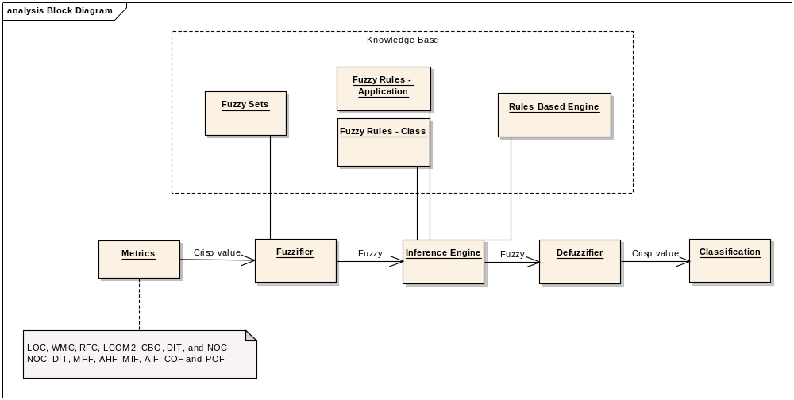

The input of the system is OO metrics extracted from java application, find the matching degree based on the matching fuzzy sets and depending on the evaluation performed (single class or application). The inference of each fuzzy rule is performed using the clipping method and its result is combined and later defuzzified using Mean of Max (MOM) method. The output of this method is result of the classification. There are two types of results given by the system: A fine grain classification for each of the classes and a general classification for the java application being evaluated. For this reason two sets of rules will be used during the classification: one set of rules to classify single classes and another one to evaluate the application. And additional decomposition tree generated provided for the classes reported during single class classification for the developer to analyze and address classes within the same similarity group.

1.2 Input variables
The input variables of the system are Object Oriented metrics extracted from java source code and are shown below, and additional information can be found in Appendix A:
LOC = Lines of code
WMC = Weighted Methods per Class
RFC = Response for a Class
LCOM2 = Lack of Cohesion
CBO= Coupling Between Object Classes
NOC= Number of Children
DIT = Depth of Inheritance Tree
MHF= Method Hiding Factor
AHF= Attribute Hiding Factor
MIF= Method Inheritance Factor
AIF= Attribute Inheritance Factor
COF= Coupling Factor
POF= Polymorphism Factor

The output variable of the system is defined as
OODC= Software classification.

1.3 Definitions
The definition of the values used in the fuzzy sets and fuzzy rules are:
C- Critical
H – High
M – Medium
N - Normal
L - Low
VL – Very Low

1.4 Membership function definition
The membership functions have been designed based on empirical results presented by Chidamber, Rosenberg and Briand; and the design of the membership functions has followed the conditions proposed by Yen and Langary where “each function overlaps only with the closest neighboring membership function and for any possible input data, its membership values in all relevant fuzzy sets should sum to 1 or nearly so” [4]. The following is the definition for each of the metrics:

WMC – For this metric three membership functions were designed: normal (x:10,20), medium (x:10,20,30) and high(x:20,30). The normal value was chosen based on two observations: Rosenberg’s experiment showed a histogram with most classes with values between 0 and 20; on the other hand Chidamber reported most of the cases with values between 0 and 10. As a result the values for the normal membership function were chosen between 0 and 10 with degree of one, and 20 with degree of zero. Due to Yen and Langary’s conditions, the medium membership function is derived with values 10, 20, 30 overlapping with the normal set, and high fuzzy set is derived with values 20,30 values. The membership functions are shown in the graphic below.

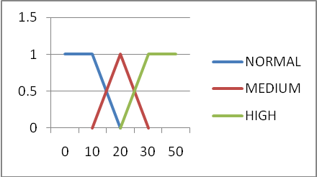

RFC – For this metric three membership functions were created: normal (x:30,40). Medium (x:30,40,50) and high (x:40, 50). The empirical data from Rosenberg showed that the majority of classes only invoke between 0 and 40 methods; on the other hand Chidamber reported a median value between 6 and 29. Based on this information the normal membership function is defined with values between 30 and 40; and medium and high fuzzy sets are derived using Yen and Langary’s conditions. The membership functions are shown in the graphic below.

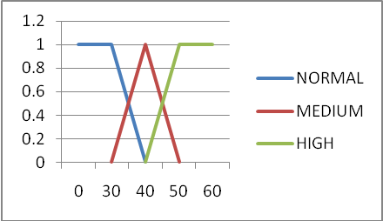

LCOM/LCOM2 – For this metric three membership functions were created: normal (x:60,70), medium (x:60,70,80) and high (x:70,80). Rosenberg did not present historical data for this metric however she said that smaller LCOM to its maximum value the better. On the other hand Briand obtained a median value 64% and min value 18%. The normal value is derived based on the medium value and it is set to (x:60,70). The other two values are derived from the conditions presented by Yen and Langary. The membership functions are shown in the graphic below.

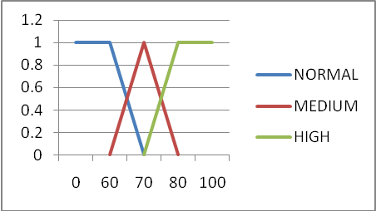

CBO – For this metric three membership functions were defined: normal (x: 5, 10), medium(x: 5, 10, 15), high(x: 10, 15). Rosenberg reported than more than one-third of the classes reported values between 0 and 10 and fewer classes between 11 and 13. On the other hand Chidamber obtained a median value between 0 and 9. Based on this information and the fact the less tightly coupled the class the better the normal membership function is defined with values between 0 and 5 with degree of one and 10 with degree of zero; the other fuzzy sets are derived based on Yen and Langary’s conditions. The membership functions are shown in the graphic below.

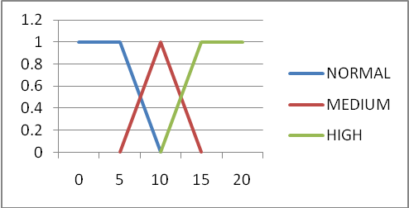

DIT – For this metric three membership functions were defined: normal (x:3,6), medium (x:3,6,9) and high (x:6,9). Rosenberg reported 60% classes with a DIT less than or equal to 1, 20% between 2 and 3; and only 5% greater than 5. Chidamber on the other hand reported a maximum DIT less than 10, and a median value between 1 and 3. Based on this information the normal membership function is chosen between 3 and 6 and the other membership functions are derived using Yen and Langary’s conditions. The membership functions are shown in the graphic below.

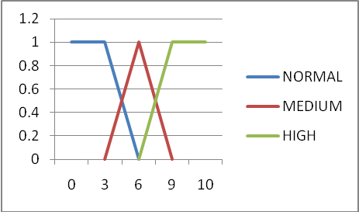

NOC – For this metric three membership functions were created: normal (x:10,20), medium (x:10,20,30) and high(20,30). In his research Rosenberg reported that most of the classes had between 0 and 10 children, and fewer classes between 10 and 20 children. On the other hand Chidamber reported that most of the classes did not have children, and that the maximum value obtained in this metric was between 42 and 50. Giving an overlap of 10 the normal membership function is chosen between 10 and 20; and the other fuzzy sets are derived based on Yen and Langary’s conditions. The membership functions are shown in the graphic below.

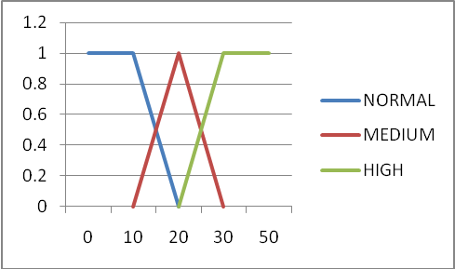
LOC – for this metric three membership functions were created: normal (x:750,1000), medium (x:750,1000,1250) and high (x:1000,1250). The fuzzy sets for this metric have been defined based on the intuition rather than empirical of theoretical information. As per definition of this metric a class with a low number of lines will be less complex and easier to maintain and test. I consider a class with a normal value to be between 750 and 1000. The other sets are derived with an overlap of 250 and using Yen and Langary’s conditions. The membership functions are shown in the graphic below .

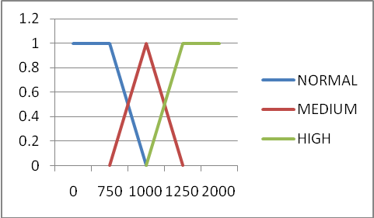

MHF – For this metric five membership functions were created: very low (x:5,10), low (x:5,10,15), normal (x:10,15,20,25), medium(20,25,30) and high (x:25,30). The normal membership function was defined based on Brito e Abreu’s statistical distribution reported in their paper. In this case most of the cases and contained values between 8-25%. Therefore a normal fuzzy set is defined using trapezoidal form with values 10,15,20,25. The other membership functions are derived based on Yen and Langary’s conditions using an overlap of 5. Since values between 0 and 10 needs to be included then very low and low membership are also defined. The membership functions are shown in the graphic below.

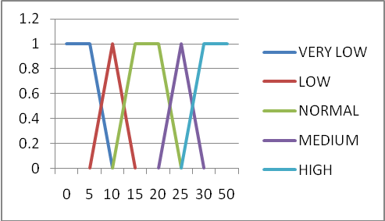

AHF – For this metric three membership functions were created: normal (x:80,90), medium (70,80,90) and high (70,80). In their paper Brito e Abreu said that a good encapsulation should not share any attributes between classes and that a good value for this metric should be 100%. However taking into account static variables shared across different classes then the normal membership function is defined with values between 80 and 90 with a max value of 100. The other membership functions are defined based on Yen and Langary’s condition using an overlap of 10. The membership functions are shown in the graphic below.

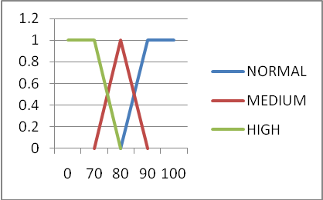

MIF – For this metric five membership functions were defined: very low(x:15,20), low(15,20,25), normal(x:20,25,75,80), medium (x:75,80,85) and high (80,85). The normal membership function was derived based on information reported by Brito e Abreu. In their paper they reported an average of 85% among 5 applications and suggested a metric value between 20% and 80%. Therefore the normal membership function is defined in a trapezoidal form with values 20, 25, 75 and 80. The other fuzzy sets are derived based on Yen and Langary’s proposed condition using an overlap of 5. The membership functions are shown in the graphic below.

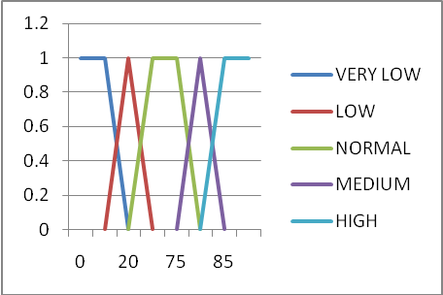
AIF– For this metric three membership functions were defined: normal(x:40,50), medium(x:40,50,55,65) and high (x:55,65). In their empirical data Brito e Abreu reported a statistical distribution with most classes between 50 and 65%, maximum value 80% and minimum value of 40%. They also suggested a metric value between 0 and 48%. For this reason a normal membership function is defined using a trapezoidal form with values 40, 50, 55, 65 and the other membership functions are derived using proposed Yen and Langary’s condition using an overlap of 10. The membership functions are shown in the graphic below.

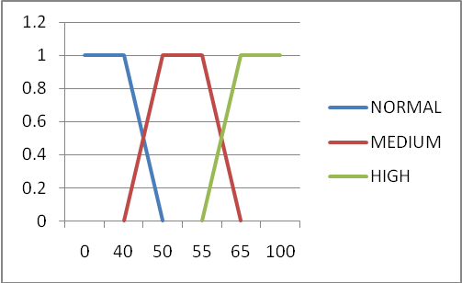

COF - For this metric three membership functions were created: normal (x:10,20), medium (x:10,20,30) and high (x:20,30). Normal membership function was derived based on empirical data reported by Brito e Abreu. They showed statistical distributions with most values between 5% and 15%, maximum value 30% and minimum value 3%. They also suggested an ideal value of less than 12%. Therefore a normal membership function is defined with values 10, 20 and the other membership functions are derived using the proposed Yen and Langary’s condition using an overlap of 10. The membership functions are shown in the graphic below.

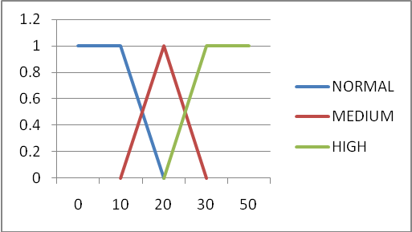

POF - For this metric three membership functions were created: normal (x:0,10), medium (x:0,10,20) and high (x:10,20). The normal membership function is derived based on empirical data reported by Brito e Abreu. They reported two tendencies in this metric, one of them states that POF should be greater than 10% due to polymorphism increases the flexibility of the application, and the other one states than POF should be no greater that 10% because complexity increases testability, maintainability and decreases understandability. In my opinion having very low polymorphism defeats one of the most important principles of object oriented programming; therefore a normal membership function is chosen with values 10, 20 with maximum of 100. The other membership functions are derived based on Yen and Langary’s condition and using 10 points of overlapping. The membership functions are shown in the graphic below.

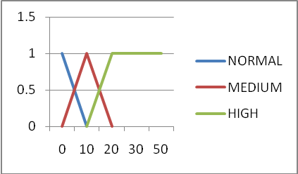

OODC - Output membership function has been defined with three membership functions: critical (x:80,90,100), high (x:70,80,90) and medium (x:60,70,80). If the matching degree does not fall within these fuzzy sets then it will be considered normal and not reported. The membership functions are shown in the graphic below.

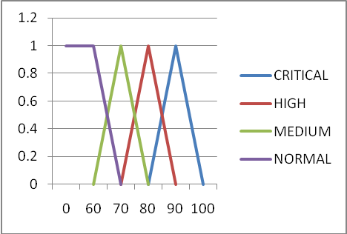

1.5 Fuzzy Rules
The metrics are separated in two groups: Fuzzy rules to classify single java classes and fuzzy rules to classify the entire java application. The metrics to classify single java classes are: LOC, WMC, RFC, LCOM2, CBO, DIT, and NOC. These metrics gather information about complexity, cohesion, coupling and hierarchical structure of single classes. The metrics to classify the entire application are: NOC, DIT, MHF, AHF, MIF, AIF, COF and POF; and they gather information about encapsulation, inheritance, coupling and hierarchical structure of the entire application. Both groups of metrics are complementary and their results provide detail and general information about the application. It is worth to mention that despite of DIT and NOC do not gather metrics at application level, its maximum value is used in the classification of the application due to these metrics have a direct impact in the hierarchical structure of the application.
Analyzing each group of metrics to classify single classes and applications an additional clustering is performed based on the objectives of the metrics. Metrics that share the same objective are grouped together and metrics that do not share same objective are left alone. Table below shows the results of the clustering.
Group # | Metrics | Objective
1 | LOC, WMC, RFC | Complexity
2 | DIT, NOC | Inheritance, structural information of hierarchical tree.
3 | LCOM2 | Cohesion
4 | CBO, CFO | Coupling
5 | MIF, AIF | Inheritance at the class level
6 | MHF, AHF | Encapsulation
7 | POF | Polymorphism

This grouping is used during the definition of the fuzzy rules and each cluster represents a single condition within the fuzzy rule. The evaluation of the metrics within the cluster is performed using the OR command (min fuzzy operation), and the evaluation of all the clusters is performed using the AND command (max fuzzy operation). For example:
R1 → IF (LOC IS HIGH OR WMC IS HIGH OR RFC IS HIGH) AND (DIT IS HIGH AND NOC IS HIGH)… THEN
is evaluated as
The next two sections explain the definition of the fuzzy rules for single java classes and for the entire application.

1.5.1 Fuzzy Rules for Single Java Class Classification

These rules use the membership functions LOC, WMC, RFC, LCOM2, CBO, DIT, and NOC; and classify the class as critical, high or medium. The table below explains the conditions for each of the classifications.
Fuzzy Consequent | Fuzzy Conditions
Critical | All the clusters have a high value;
High | At least one of the cluster have a high value, and the rest of the clusters have a medium value;
Medium | At least one of the cluster have a high value, and  the rest of the clusters have a high, medium, normal value; or  all the clusters have a medium value

As shown in the table a rule with critical consequent evaluates if the average of the clusters in the fuzzy rule have a high value. A class under this classification has a very poor object oriented design does not follow loosely coupling, and cohesion OO principles and the hierarchical structure is very complex. This class can impact other classes within the application. A considerable amount of work is expected to address all of the metrics within the class. For this reason a critical classification should trigger immediate attention of the developer, leader or project manager for review and modification.
A rule with high fuzzy set consequent evaluates if the average value of the clusters within the fuzzy rule is higher than medium. A class under this classification has a poor object oriented design, therefore testing and maintaining the class can become a challenge. A class under this classification will most probably move to critical instead of moving to medium or normal stage, therefore this classification should trigger the attention of the developer, architect, leader for review.
Finally a rule with medium fuzzy set consequent evaluates if the average value in the fuzzy rule is higher than normal. A class under this classification should be reviewed and verified to make sure that there are no potential issues in the design. Again classes with medium value will most probably to move to high or critical instead of moving back to normal. This classification should trigger attention of the developer for review.
The rules derived are shown in the table below:
RULES | COMPLEXITY |  |  | STRUCTURAL/INHERITANCE |  | COHESION | COUPLING | NOT IN RULE | RESULT
RULES | LOC | WMC | RFC | DIT | NOC | LCOM2 | CBO | NOT IN RULE | RESULT
1 | H |  |  | H |  | H | H |  | critical
2 | H |  |  | H|M |  | H|M | H|M | 1 | high
3 | H|M |  |  | H |  | H|M | H|M | 1 | high
4 | H|M |  |  | H|M |  | H | H|M | 1 | high
5 | H|M |  |  | H|M |  | H|M | H | 1 | high
6 | H |  |  | H|M|N |  | H|M|N | H|M|N | 2,3,4,5 | medium
7 | H|M|N |  |  | H |  | H|M|N | H|M|N | 2,3,4,5 | medium
8 | H|M|N |  |  | H|M|N |  | H | H|M|N | 2,3,4,5 | medium
9 | H|M|N |  |  | H|M|N |  | H|M|N | H | 2,3,4,5 | medium
10 | M |  |  | M |  | M | M |  | medium

1.5.2 Fuzzy Rules for Application Classification
Similar to the fuzzy rules at the class level, the application rules have critical, high or medium classification (See table below for details). These rules use the membership functions: NOC, DIT, MHF, AHF, MIF, AIF, COF and POF. The table below explains the conditions need in order to meet each of the classifications mentioned.
Fuzzy Consequent | Fuzzy Conditions
Critical | All the results of the clusters have a high value;
High | At least one of the cluster have a high value, and the rest of the clusters have a medium value;
Medium | At least one of the cluster have a high value, and  the rest of the clusters have a high, medium, normal value; or  all the clusters have a medium value

As shown in the table above a rule with critical fuzzy set consequent evaluates if the average of the clusters in the fuzzy rule have high value. Most probably the application has a very poor object oriented design and a considerable amount is needed to redesign the application. This classification should trigger immediate attention of the designer, architect, leader or project manager.
A rule with high fuzzy set consequent evaluates if the average value of the clusters in the fuzzy rule is higher than medium. If the result of the application falls under this classification then a review should definitely be considered and high values should be address. Medium values on the other hand should be reviewed for impact and potential modifications. Usually an application under this classification will most probably move to critical stage instead of medium or normal. This classification should trigger the attention of the designer, architect, leader or project manager for review of the object oriented design and correction of the metrics.
Finally a rule with medium fuzzy set consequent evaluates if the average value of the clusters within the fuzzy rule is higher than normal. An Application under this classification should be reviewed for evaluation and verification. And application most probably will move to high or critical instead of moving back to normal. This classification should trigger the attention of the designer, leader or project manager for review.
The rules derived are shown in the table below:
Rule | STRUCTURE |  | INHERITANCE |  | ENCAPSULATION |  | COUPLING | POLIMORPHISM | NOT IN RULES | RESULT
Rule | NOC | DIT | MIF | AIF | MHF | AIF | COF | POF | NOT IN RULES | RESULT
1 | H |  | H |  | H |  | H | H |  | critical
2 | H |  | H|M |  | H|M |  | H|M | H|M | 1 | high
3 | H|M |  | H |  | H|M |  | H|M | H|M | 1 | high
4 | H|M |  | H|M |  | H |  | H|M | H|M | 1 | high
5 | H|M |  | H|M |  | H|M |  | H | H|M | 1 | high
6 | H|M |  | H|M |  | H|M |  | H|M | H | 1 | high
7 | H |  | H|M|N |  | H|M|N |  | H|M|N | H|M|N | 2,3,4,5,6 | medium
8 | H|M|N |  | H |  | H|M|N |  | H|M|N | H|M|N | 2,3,4,5,6 | medium
9 | H|M|N |  | H|M|N |  | H |  | H|M|N | H|M|N | 2,3,4,5,6 | medium
10 | H|M|N |  | H|M|N |  | H|M|N |  | H | H|M|N | 2,3,4,5,6 | medium
11 | H|M|N |  | H|M|N |  | H|M|N |  | H|M|N | H | 2,3,4,5,6 | medium
12 | M |  | M |  | M |  | M | M |  | medium

Data Analysis
The applications utilized during the experiment were provided by CGI, one of the largest IT companies in Canada. 5 business applications some of them developed by CGI and others being maintained by CGI plus the current diagnose application develop for this project were utilized during the experiments. Exception classes and JUnit test classes were excluded from the experiment because these classes do not affect the metrics result and do not follow object oriented design principles. The table below shows information of the applications used during the experiment.
Application | Developed by | Packages | Classes | Lines of Code
OODiagnose | Juan Garcia | 6 | 90 | 6088
Sufa | CGI/AHW | 5 | 72 | 7084
BIE Portal | CGI/AHW | 43 | 842 | 77395
Macar | CGI/AHW | 55 | 680 | 60112
ETLF | CGI/AHW | 4 | 45 | 2497
AAIMS | CGI/AHW | 102 | 918 | 145163

Simulation and results

OO Diagnose application
This is a GUI and command based framework Java application with plug and play capabilities for fuzzy rules, fuzzy sets and object oriented metrics. The system evaluated 90 classes for this application and it was classified as normal; the metrics with medium classification were NOC and MHF. NOC is medium due to the all the OO metrics in the application need to extend from an abstract class and in order to be plugged in the application. MHF is also medium due to the private methods were set as protected in order to be tested by the JUnit test classes. Additional analysis shows that the application has a high polymorphism due to the usage of bridge and strategy pattern to keep the application flexible which reinforces the results of the POF metric with a value of 90%. Additionally the DIT equal to 2 shows that the application has a top heavy structure which keeps the inheritance of the application low but under control. The chart below shows the details of the metrics results for the classification of the application.
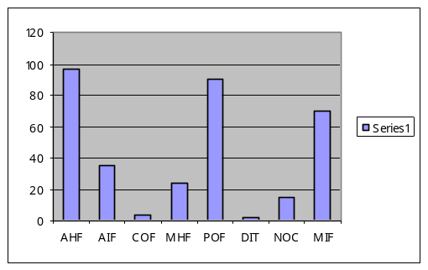
The classification of the single java classes showed that out of the 90 classes within the application there were 21 classes with medium classification. The result of the metrics for this classification is shown in the table below.

 | WMC | CBO | LOC | RFC | LCOM2 | DIT | NOC
high | 2 | 2 | 0 | 1 | 20 | 0 | 0
medium | 5 | 5 | 0 | 0 | 1 | 0 | 0
normal | 14 | 14 | 21 | 20 | 0 | 21 | 21

The table shows 20 classes with high lack of cohesion, 2 classes tightly coupled, 2 classes with high number of methods and 1 class with high number of RFC. While taking a closer look at LCOM2, it seems to have problems with false-positives because Java Bean objects are being reported with high/medium lack of cohesion which is very unusual. These objects are classes written in the Java programming language conforming to a well known standard convention; they represent objects in the real world and encapsulate their attributes through setter and getter methods. An example of this issue is that LCOM2 returns 66% for a java bean with 3 class variables and 2 accessor methods per variable; but in fact the class is well formed. This paper does not pretend to point disadvantages of the metrics so we will keep note of this metric so the results can be reviewed by the developer for accuracy. The decomposition tree reported 21 similarity groups and it will be helpful for the developer to analyze an address classes within the same similarity group. The overall classification of the classes seems to be in accordance with those of the classification of the application. The chart below shows the results of the metrics that influenced this classification.
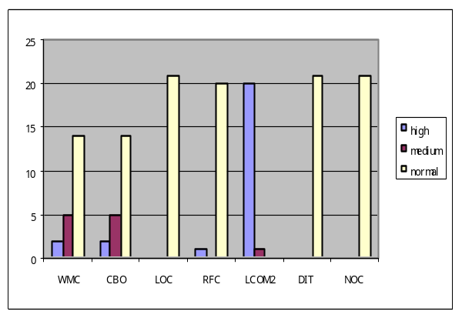
SUFA application
Command based Java application use to archive files within a secure UNIX structure. This application uses Spring framework for database execution, reports via email and executes UNIX commands to verify UNIX security. The system classified the application as medium and the single results show high AIF and low MHF. The results point an issue in attribute inheritance due to the parent classes share attribute values directly with descendant classes which affects the encapsulation of the classes. Attributes should be private and accessor methods should be used instead. The low MHF is explained by the fact that the JUnit test classes need public/protected method signature in order to execute white box testing for the methods. The chart below shows these results.
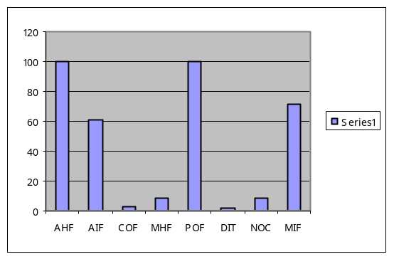
The classification at the class level shows that there are 19 classes with medium classification out of 72 classes within the application. The result of the metrics for this classification is shown in the table below.
 | WMC | CBO | LOC | RFC | LCOM2 | DIT | NOC
high | 7 | 0 | 0 | 5 | 17 | 0 | 0
medium | 1 | 5 | 1 | 1 | 1 | 0 | 0
normal | 11 | 14 | 18 | 13 | 1 | 19 | 19

Despite of the similarity of the results with OODiagnose, this application has higher number of classes in the high metrics results. The results show 17 classes with high LCOM2, 7 with high WMC and 5 with high RFC. There are more than 7 classes with high complexity which is confirmed by the higher number of lines of code for in this application. Complexity, cohesion and coupling are affected therefore a medium classification shows an accurate classification of the application. The chart below shows the results of the metrics that influenced this classification.
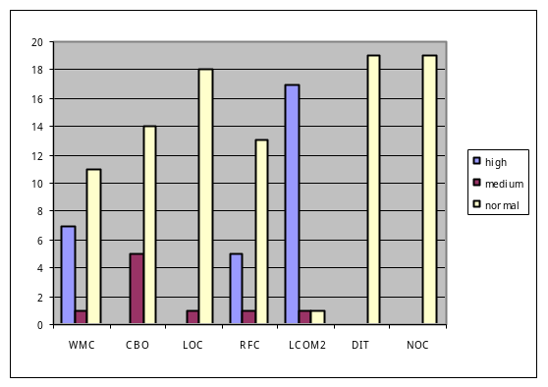
BIE Portal application
This is a web and command based application that uses Spring framework for database execution. The application is classified as medium by the diagnose system. The results of the system show that the encapsulation of the application is normal however there are problems in inheritance (medium AIF and medium MIF), and hierarchical structure (medium DIT and high NOC). Having a medium inheritance and complex structure makes the application more difficult for testing and maintainability. Additional enhancements to the application can produce poor reusability of the code and therefore decrease the reliability of the application and more time will be spent during testing. The result of these metrics is shown below.
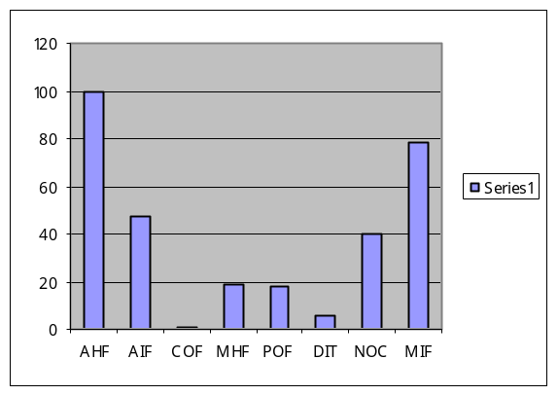

Taking a look at the classification of the classes the results show that out of 842 classes, there are 310 classes with medium classification and 1 class with critical classification. The results of the metrics affecting these 311 classes are shown in the table below.
 | WMC | CBO | LOC | RFC | LCOM2 | DIT | NOC
high | 67 | 81 | 2 | 19 | 262 | 0 | 2
medium | 70 | 59 | 1 | 18 | 50 | 1 | 1
normal | 191 | 188 | 325 | 291 | 16 | 327 | 325

One of the classes has a critical classification and it might be due to this is the class that orchestrates the core logic of the application. It should definitely be reviewed, potential architectural changes to delayer the application are needed; most probably a façade can be utilized for decoupling this class. On the other hand the table shows WMC, RFC and LOC to be highest metrics which indicates high complexity in these classes. There are also tightly coupled classes with low cohesion which indicates classes executing more than a single responsibility and a rigid design which poor extensibility to changes. As pointed previously high LCOM2 should be reviewed for accuracy. Additionally there are few classes affecting the hierarchical structure of the application which will definitely need to be reviewed. Small enhancements will not probably impact the application, but definitely medium or high enhancements can negatively impact it if they do not include a re-architectural review of the application. It is most likely for this application to move to a higher classification rather than remaining in medium classification due to the number of classes being reported. The result of the metrics to classify single classes is shown in the chart below. It is worth to mention that decomposition tree could not be generated for this application due to the large number of classes being reported. Due to performance issues only application with less than 200 classes will generate the decomposition tree.
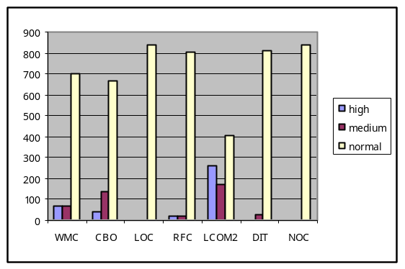
MACAR application
This is a web and command based application that uses Spring framework for database execution. The application’s objective is to validate files based on configurable rule and to submit valid files the client. The application is diagnose as medium by the system and the high values are due to a high NOC and MIF. Both of this metrics are related because they impact the hierarchical structure of the application and therefore its inheritance, which can be explained by the flexibility of the application. The application should be kept as simple as possible for an easier testing and maintainability. This application most likely will have problems when changing the resources (developer) that maintain the application. The chart with the results of the metrics is shown below.
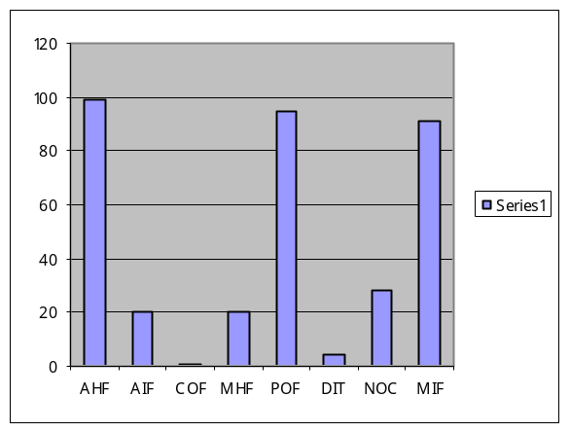

Taking a look at the classification of the classes the results show that there are 134 classes with medium classification. It is low compare with the results of the Portal application. So despite of the complexity of the logic this application seems to be in a better shape. The result of the metrics affecting these classes is shown in the table below.

 | WMC | CBO | LOC | RFC | LCOM2 | DIT | NOC
high | 18 | 32 | 1 | 5 | 118 | 0 | 1
medium | 34 | 10 | 3 | 4 | 16 | 0 | 0
normal | 88 | 98 | 136 | 131 | 6 | 140 | 139

The results indicate that a small number of classes are causing problems. LCOM2 should be reviewed for accuracy because it seems to be a little high compared to the other metrics. Higher numbers are due to WMC and CBO so complexity and coupling seem to be a factor to be reviewed. Changes affecting these classes might be difficult to include and increase the flexibility and decrease testing time and complexity. It would be worth to address the metrics with high value to simplify the complexity of the application. Class classification is ok and most probably this application will remain in medium instead of moving to a high class classification. The result of the metrics affecting single class classification is show in the chart below.
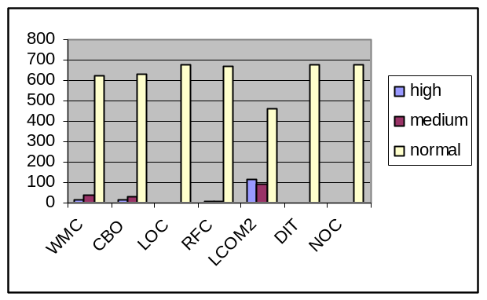
ETLF application
This is a command based application framework that uses Hibernate framework for database execution and its main objective is to execute schedule jobs dynamically. This application is classified as medium and the results show a low MHF, and very low POF and MIF. Despite of the classification a closer look at the metrics shows a max DIT of 0 and max NOC of 0. These results help conclude that the inheritance of this application is really low therefore the reusability of the application is in question. It also suggests a change in the fuzzy rules to classify the application in order to validate not only high values in NOC and DIT but also very low ones. The chart with the results of these metrics is shown below.
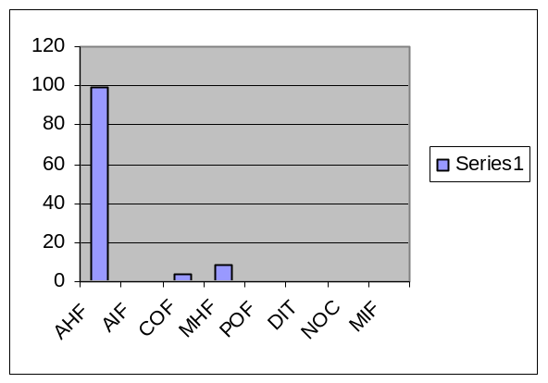
The classification at the class level shows that there are 14 classes with medium classification out of 45 classes within the application. The result of the metrics affecting this 14 classes is shown in the table below.
 | WMC | CBO | LOC | RFC | LCOM2 | DIT | NOC
high | 0 | 1 | 0 | 0 | 13 | 0 | 0
medium | 8 | 2 | 0 | 0 | 1 | 0 | 0
normal | 7 | 12 | 15 | 15 | 1 | 15 | 15

Taking a look at the results of the classification there are 13 classes with high LCOM2 (lack of cohesion) and 8 with medium WMC and 2 with medium CBO. This implies that due to the lack of inheritance there are a number of classes that have more than one objective and medium complexity. These classes should be reviewed and addresses to comply with the object oriented principle of single responsibility. And additional review of the architecture is suggested to review the lack of inheritance and see if there are functionalities within the application that can be factor and reuse. A medium classification is accurate however the application will most probably move to a high or critical classification if the issues are not addressed. The chart with these results is shown below.
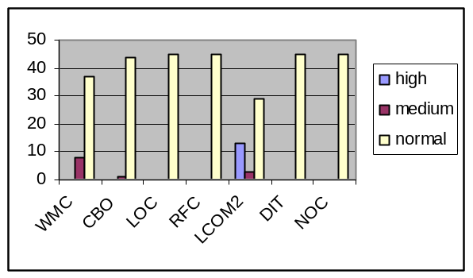
AAIMS application
This is a web based J2EE application that uses Hibernate framework for database execution. The business details of this application were not available at the moment of the experiment and the analysis of the application is performed with out them. This application as was classified as medium, with low MHF, medium MIF and high NOC. It seems to be that low MHF (method hiding factor) is due to JUnits need for protected and public methods. The high number of children and medium method inheritance metrics point to a high explosion of number of children with a superfluous inheritance or wide member scopes. Changes in the parent classes would have a direct impact in all of the children and the amount of code to be change and tested will have a high impacting in the implementation time. The chart below shows the results of the metrics at the application level.

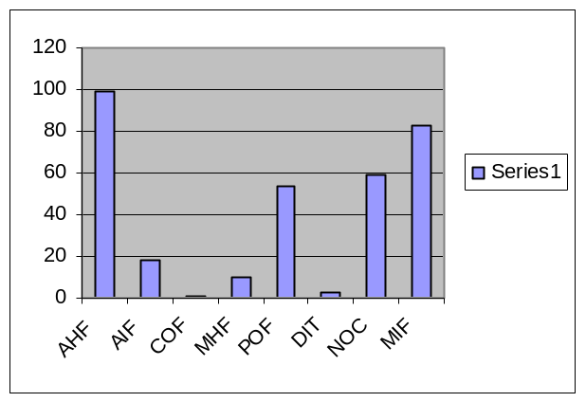
Taking a look at the classification of the classes the results show that out of 918 classes, there are 498 classes with medium classification and 1 class with critical classification. The results of the metrics affecting these 498 classes are shown in the table below.

 | WMC | CBO | LOC | RFC | LCOM2 | DIT | NOC
high | 137 | 148 | 13 | 56 | 366 | 0 | 6
medium | 147 | 73 | 8 | 39 | 72 | 0 | 3
normal | 634 | 697 | 897 | 823 | 480 | 918 | 909

The metrics at the class level show high LOC, WMC and RFC impacting the complexity of the class, besides there are a number of classes with high coupling and low cohesion. Still LCOM2 should be reviewed because of the high number of classes. Still there are a number of classes with a high number of methods and most probably these classes have a very low cohesion. They should be addressed first to enforce the single responsibility object oriented principle. Also coupling is an issue in this application therefore strategy and bridge patterns are suggested to decreased the coupling and increase flexibility. In general the results of the metrics at the application and class level are not very promising and this application will most likely move to a high classification. Due to the size of this application the amount of work needed to modify the classes is high, so this application will most probably need to be analyzed between the designer, architect and team leader. The chart with the results of the metrics is shown below.
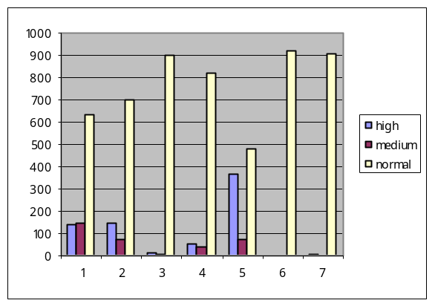

APPENDIX A. OO Metrics

Name | Author | Type | Objective | Description
Lines of Code - LOC |  | Traditional | Low | Definition: This metric count all lines within the class. Size of a class is used to evaluate the ease of understanding of code during development and maintenance.  Rationale: A high number of lines of code increases complexity of the code, making it difficult to understand, maintain and test.
Weighted Methods Per Class – WMC | Chidamber and Kemerer | OO Metric | Low | Definition: This metric counts number of methods implemented within a class or the sum of the complexities of the methods.  Rationale: classes with many methods are likely to be more application specific, limiting the possibility of reuse.
Response for a Class – RFC | Chidamber and Kemerer | OO Metric | Low | Definition: This metric counts the set of methods that can be invoked in response to a message to an object of the class or by some method in the class.  Rationale: The larger the number of methods that can be invoked from a class through messages, the greater the complexity of the class. Therefore testing and debugging becomes complicated since it requires a greater level of understanding on the part of the tester.
Lack of Cohesion – LCOM2 | Chidamber and Kemerer | OO Metric | Low | Definition: It counts the percentage of methods that do not access a specific attribute averaged over all attributes in the class.  Rationale: Low cohesion increases complexity, thereby increasing the likelihood of errors during the development process.
Coupling Between Object Classes - CBO | Chidamber and Kemerer | OO Metric | Low | Definition: This metric counts the number of other classes to which a class is coupled.  Rationale: Excessive coupling is detrimental to modular design and prevents reuse. Therefore the larger the number of couples, the higher the sensitivity to changes in other parts of the design and maintenance is more difficult.
Number of Children - NOC | Chidamber and Kemerer | OO Metric | Low (tread-off) | Definition: this metric count the number of immediate subclasses subordinate to a class in the hierarchy. NOC and DIT are closely related because NOC measures the breadth of a class hierarchy, where maximum DIT measures the depth.  Rationale: The greater the number of children, the greater the likelihood of improper abstraction of the parent and may be a case of misuse of sub classing.
Depth of Inheritance Tree - DIT | Chidamber and Kemerer | OO Metric | Low (tread-off) | Definition: This metric measures the maximum inheritance path from the class to the root class.  Rationale: The deeper a class is within the hierarchy, the greater the number methods it is likely to inherit making the code more complex to predict its behavior. Deeper trees constitute greater design complexity, since more methods and classes are involved.
Method Hiding Factor - MHF | Brito e Abreu | MOOD | Between 8%-25% | Definition: This metric measures how variables and methods are encapsulated in a class in relation to all the classes in the application. The invisibility of a method is the percentage of the total classes from which this method is not visible.  Rationale: Low value indicates insufficiently abstracted implementation and a very high value indicates very little functionality. The larger the proportion of methods unprotected the higher the probability of errors.
Attribute Hiding Factor - AHF | Brito e Abreu | MOOD | 100% | Definition: This metric measures how variables are encapsulated in a class in relation to all the classes in the application. The invisibility of an attribute is the percentage of the total classes from which this method is not visible.  Rationale: Encapsulation indicates that the attributes should have no visibility to other classes.
Method Inheritance Factor - MIF | Brito e Abreu | MOOD | Between 20%-80% | Definition: this metric measure the inherited methods in a class in relation to all the classes in the application.  Rationale: A very high value indicates either superfluous inheritance or too wide member scopes, and a low value indicates lack of inheritance or heavy use of Overrides/Shadows.
Attribute Inheritance Factor - AIF | Brito e Abreu | MOOD | Good between 0%-48% | Definition: this metric measure the number of attributes inherited in a class in relation to all the classes in the application.  Rationale: A very high a value indicates either superfluous inheritance or too wide member scopes, and a low value indicates lack of inheritance or heavy use of Overrides/Shadows.
Coupling Factor - COF | Brito e Abreu | MOOD | Low. No greater than 12% | Definition: this metric measure the actual couplings among classes in relation to the maximum number of possible couplings.  Rationale: Avery high value should be avoided because coupling relations increase complexity, reduce encapsulation and potential reuse, and limit understandability and maintainability.
Polymorphism Factor - POF | Brito e Abreu | MOOD | Less than 10%, or greater than 10% | Definition: This metric measures the degree of method overriding in the class inheritance tree.  Rationale: Polymorphism should be used to a reasonable extent to keep the code clear, but that excessively polymorphic code may be too complex to understand

BIBLIOGRAPHY

[1] Shyam R. Chidamber and Chris K. Kemerer, A Metrics Suite for Object Oriented Design, 1994
[2] Dr. Linda H. Rosenberg, Applying and Interpreting Object Oriented Metrics, 1998
[3] Brito e Abreu, The design of Eiffel Programs: Quantitative Evaluation using the MOOD Metrics, 1996.
[4]Yen and Langary, Fuzzy Logic: Intelligence, control, and information, 1999.
[5] Gamma et al, Design patterns, Elements of reusable object-oriented software, 1994.
[6] Lionel C. Briand et al, A Comprehensive Empirical Validation of Design Measures for Object-Oriented Systems, 1996.

