# Lab 1: MadLibs

Academic Honesty

* The work you turn in is to be your work, not copied from someone else, from the web, or generated by a program.
* Never allow anyone access to your files.
* Never give anyone your password.
* Never share your USB memory or email your files to anyone else.
* Never give anyone a printed copy of your file or an electronic copy.
* Never allow anyone to copy your work.

Purpose

This lab is an introduction to the Python programming language. This is a step by step tutorial to help you build your first application.

## Hello World

In Computer Science, the first program you always right is called Hello World.

1. Open IDLE
2. Type: print(“Hello World!”)
3. The program should display Hello World! Back to you.

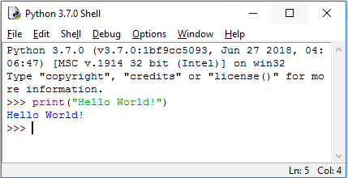

## Files

From now on our programs will be more than 1 line, so we will create files to hold them.

1. In IDLE’s dropdown menu select: File -> New File

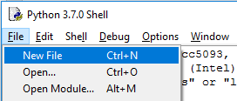

1. Save your file as Lab1XY, where XY are your initials. The file should have an extension of .py
2. In your file type: print(“Hello World!”)

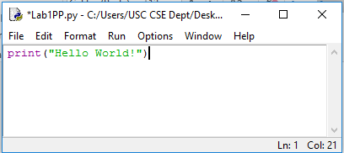

1. Save your file
2. Under the Run menu, Select Run Module. Or just press F5.

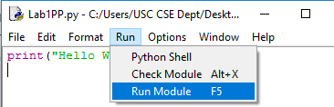

1. You should see Hello World appear in the Python Shell

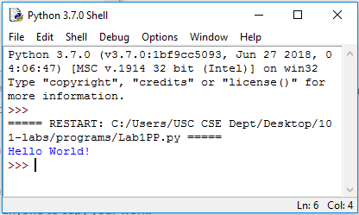

## Comments

You can delete the print line from your file, as we will be starting out fresh.

Comments are instructions to someone reading your code, Python will not run lines of code which are comments. We will now begin our programs with a comment to let everyone know the purpose of the program. Write the following lines of comments in your code.

#Lab 1 – MadLibs

#Author – First name last name

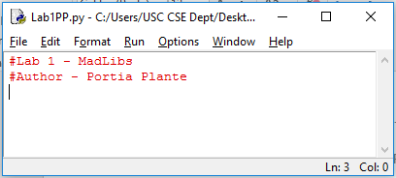

If you run this program it will not produce any results.

## User Input

* Let’s ask the user a question, get the result, and display it.
* We will ask the user a question using the input function.
* Enter the program as seen below:

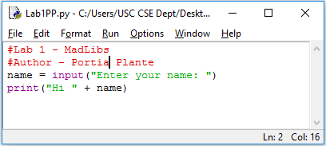

* Run the program.
* The program should ask you for your name, and then greet you:

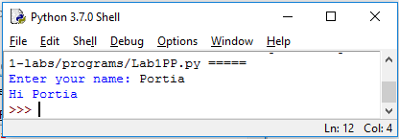

* The program asked you your name using the input command, stored your name in the variable name, and displayed it back to you using a print command.

## Creating the MadLibs Game

* We will be making an excuse generator for not coming to class.
* Here’s an example of how the program works:

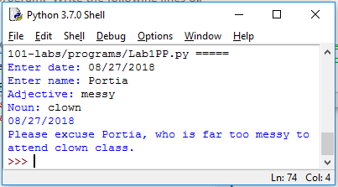

* Notice, the program asks you for the date, your name, an adjective, and a noun.
* Then it creates an excuse based on your inputs.

### Get user input

* Let’s start by asking the user for the following 4 things: date, name, adjective, noun.
* Your code will look like this:

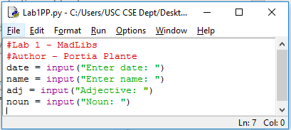

* Test your code and make sure it asks the user for the required information.

## Display Results

We want our excuse generator to display the following result.

___________________________________________________

*Date*

Please excuse *Name*, who is far too *Adj* to attend *Noun* class.

­­­­­­­­­­­­­­­­___________________________________________________

Enter the following code to achieve your result. The ‘+’ symbol puts to pieces of text next to each other.

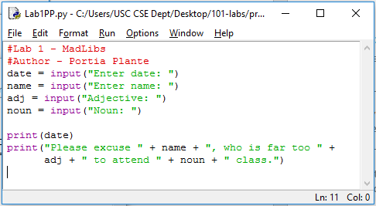

Now, test your program and make sure it works as expected.

## Submitting your files

* Copy your .py file and move it to your X:\101Labs directory for grading.
* Make sure your file is named Lab1XY.py where XY are your initials
* Print your code, and submit it to your lab instructor at the beginning of your next lab class.

## Grade Breakdown

|  |  |
| --- | --- |
| **Points** | **Expectation** |
| 20% | Comments, listing program and your name |
| 40% | Correctly get input from the user |
| 40% | Correctly display message. |