Lesion_GNB Toolbox for SPM12

User Guide

Please view the ReadMe file included in the lesion_gnb folder.

To utilize batch scripts to run the necessary functions for lesion classification, see the file “example_batch_script.m”.

To utilize the user interface for single patient jobs, make sure that the lesion_gnb toolbox is installed in the “toolbox” folder located within the SPM12 folder:

Once you have added the folder location to your path, simply type “lesion_gnb_ui” in the command window. A prompt will appear asking whether or not you wish to run the SPM12 tissue segmentation (New Segment) function. If you have not already segmented the T1-weighted scan, type “Y” into the text box, and click “OK”. This will
run the SPM12 tissue segmentation with default parameters.
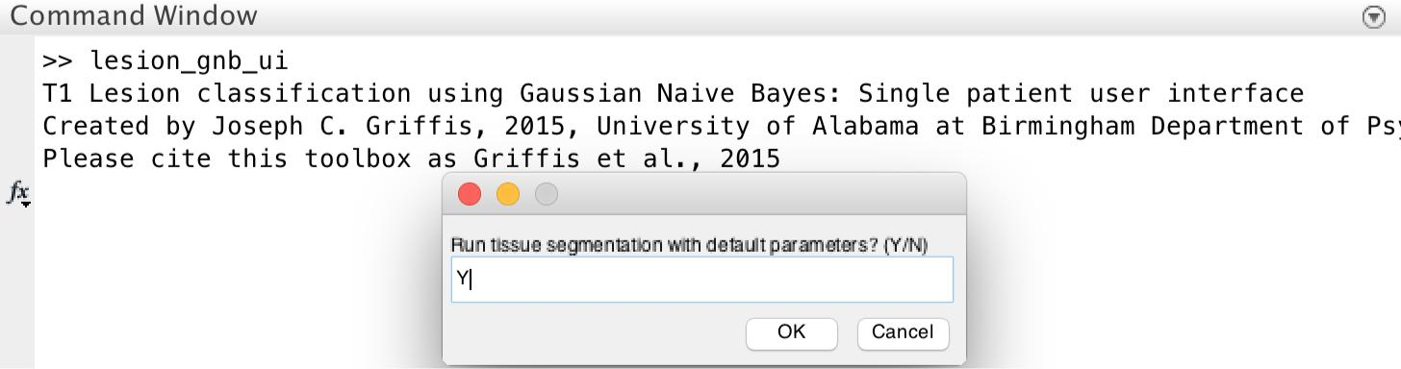

An interactive window will appear. If you indicated that you would like to run the SPM12 segmentation, select the folder containing the T1-weighted scan that you wish to segment, and click “Open”. If you indicated that you would not like to run the SPM12 segmentation, select the folder containing the tissue segmentations from the T1-weighted scan in .nii format (prefixed with wc), and click “Open”.
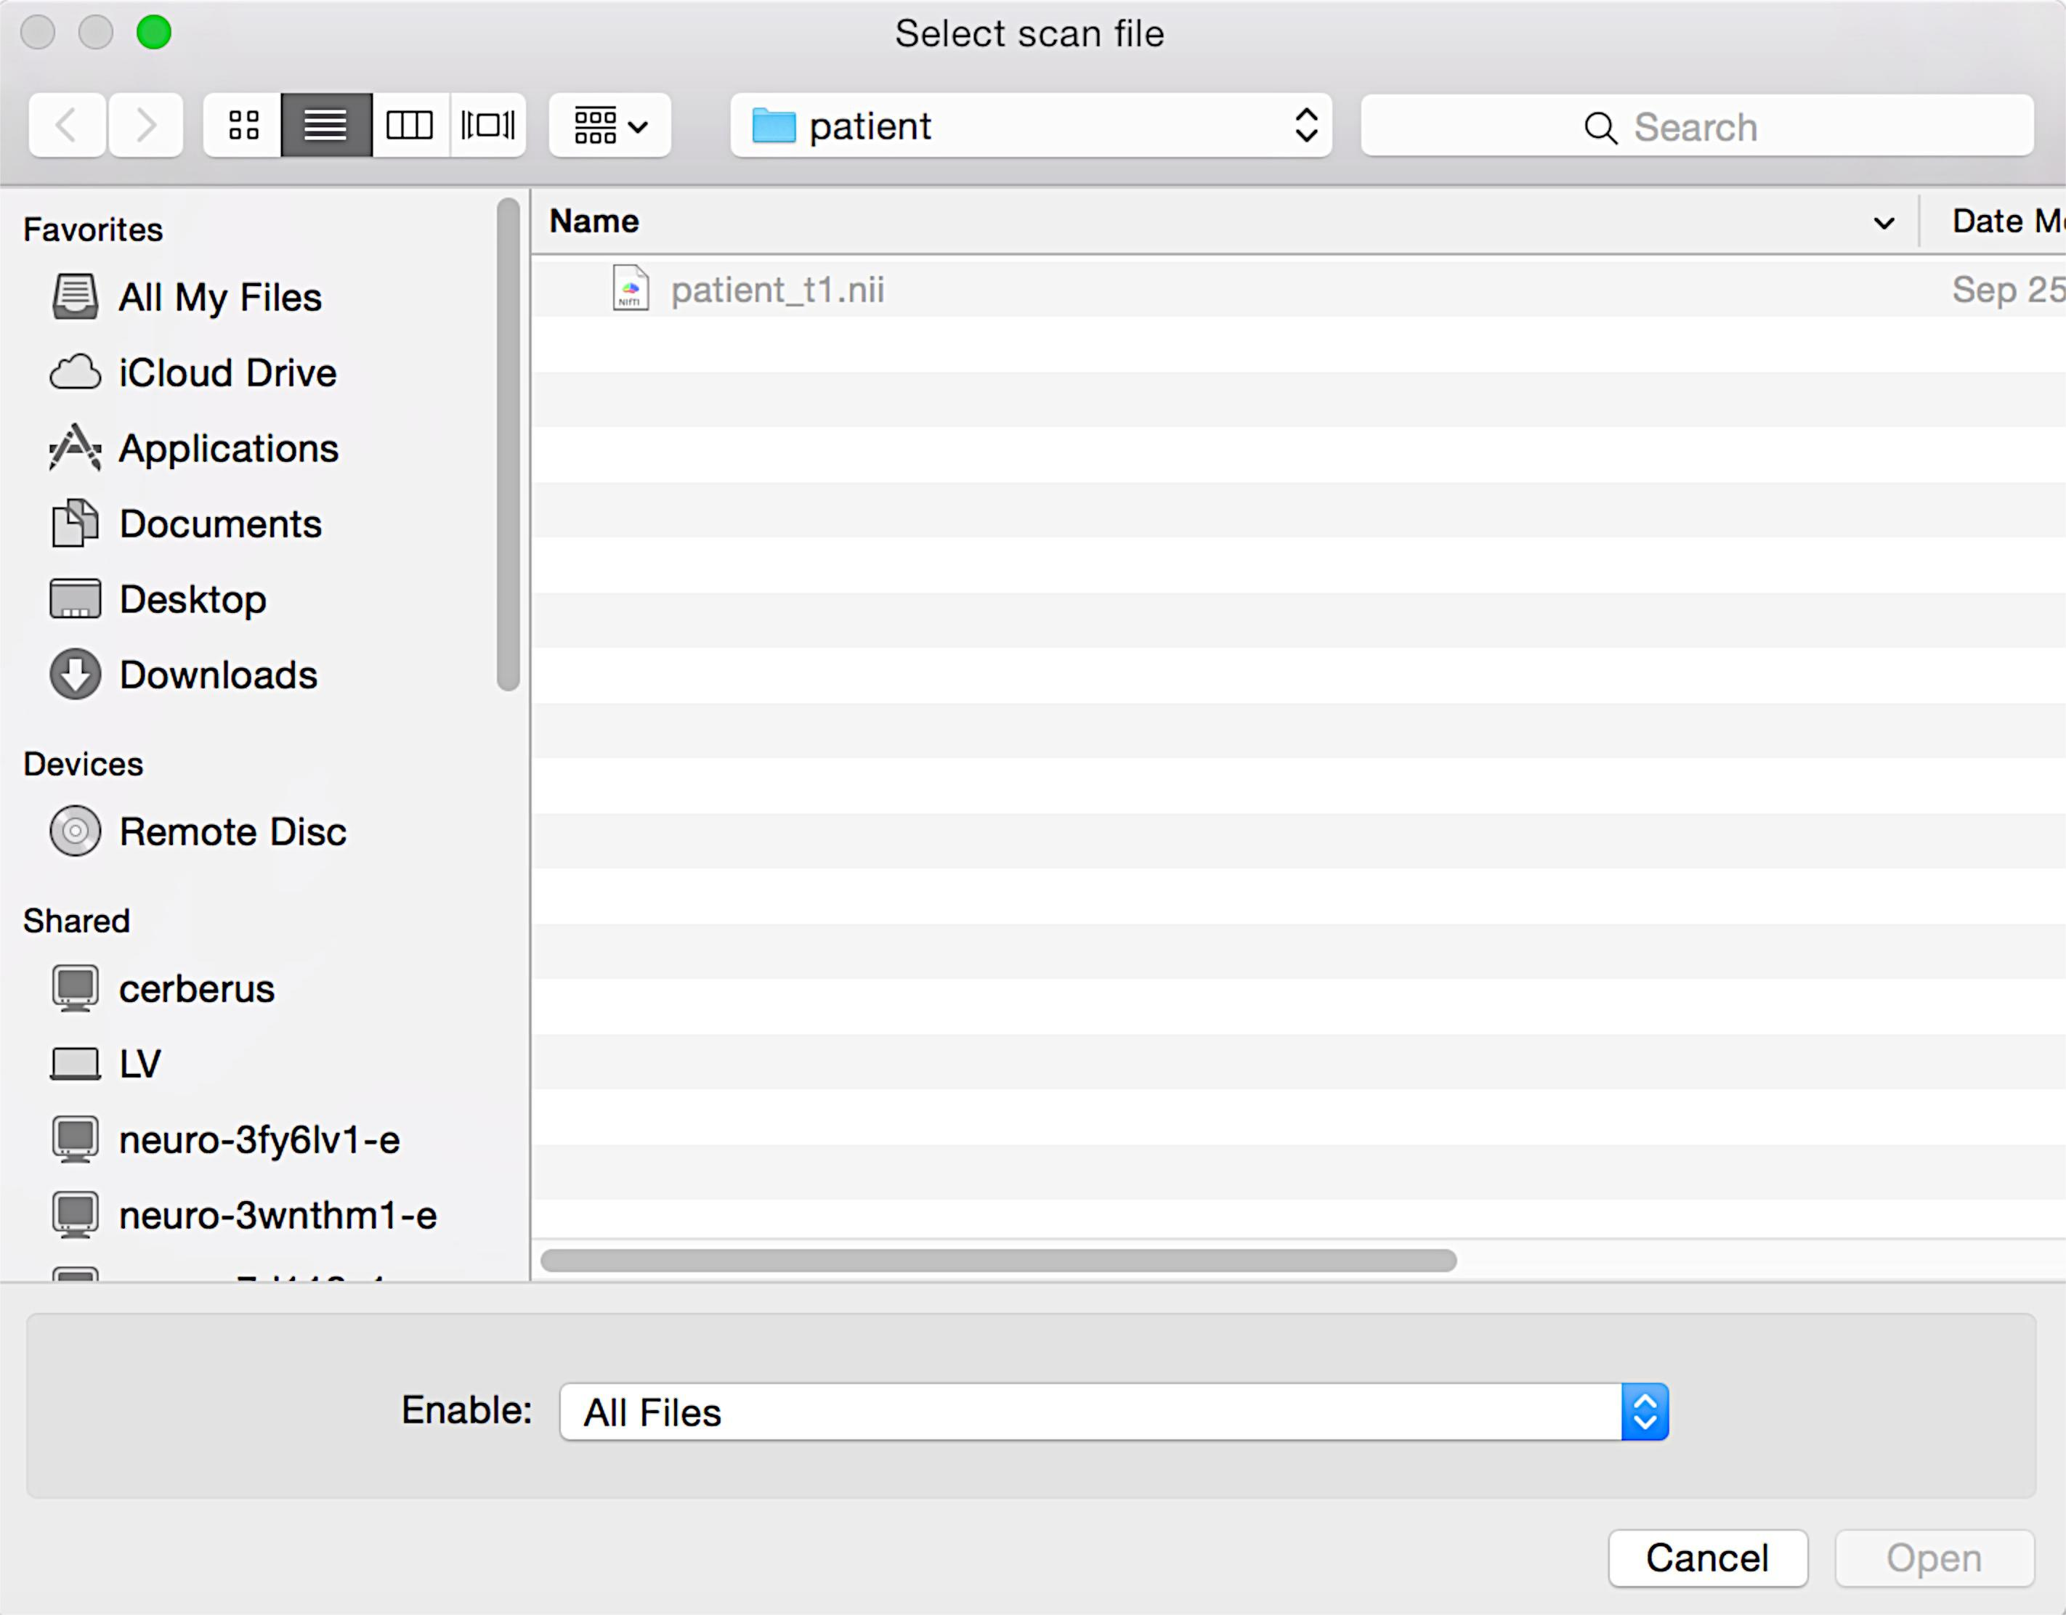

If you indicated that you would like to run the segmentation routine, a second window will appear asking you to select the scan that you wish to segment. Select the appropriate scan, and click “Open”.

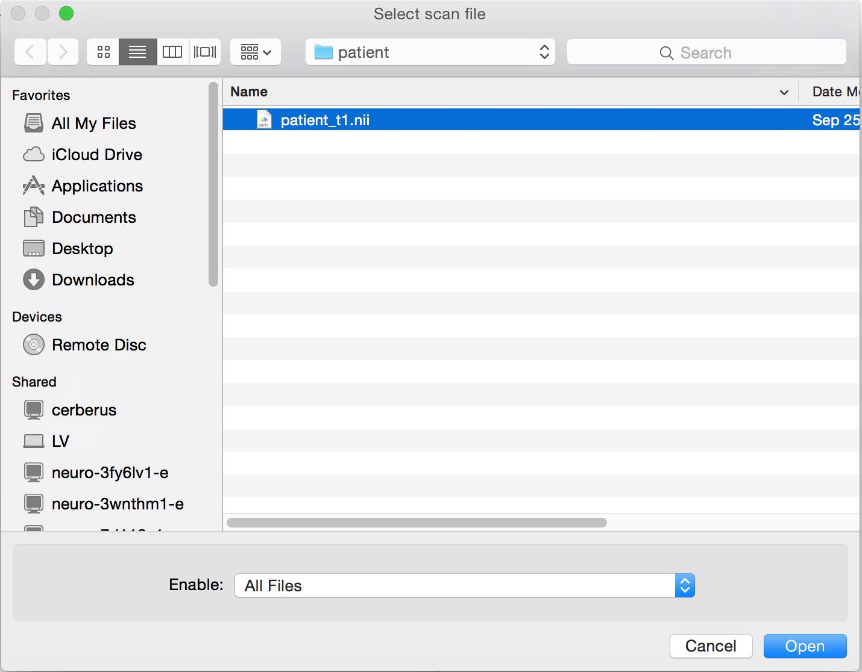

The segmentation will take several minutes (~5-30 min) to run depending on the computational resources of your machine.
Once segmentation is complete (or if you indicated that you did not wish to perform the tissue segmentation), a new dialogue box will appear.
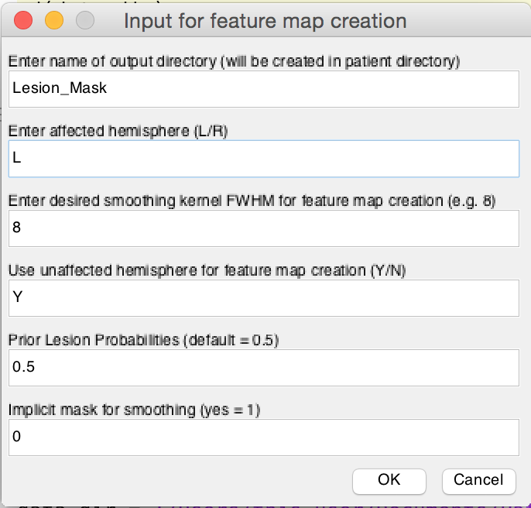
- Indicate the name of the directory that you wish to output the feature maps and lesion class label volume files in the first text box (Lesion_Mask is the default).

- Next, indicate whether the lesion classification will be applied to the left (L) or right (R) hemisphere. If you wish to create lesion masks for both hemispheres, you will have to run a separate feature map creation for each hemisphere (and should create separate output directories to avoid over-writing important files, e.g. Lesion_Mask_LH and Lesion_Mask_RH).

- Next, indicate the desired smoothing kernel FWHM to be used for feature map creation (8 mm FWHM is the default).

- Indicate whether the hemisphere not indicated in (2) should be considered “unaffected” and utilized in feature map creation (Yes is the default).

- Indicate prior lesion probabilities (0.5 is equal class probabilities, but this can be adjusted based on the expected extent of the lesion).

- Select whether or not you wish to apply implicit masking for the smoothing operation.

- Click “OK”.

Feature map creation and lesion classification should only take a minute or two depending on your machine’s resources.

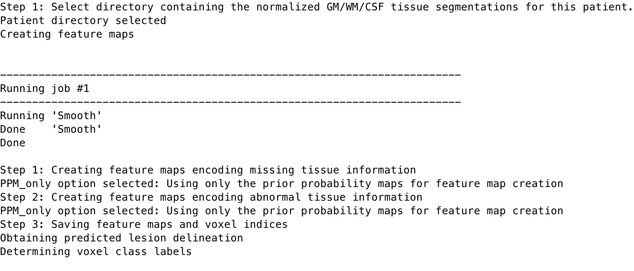
The command window output for each post-segmentation step is shown below
Once the lesion class label volumes have been created, a new dialogue box will appear asking whether or not you wish to perform additional post-processing (post-processing is recommended). Type either “Y” or “N” (without quotations) into the box and click “OK”.
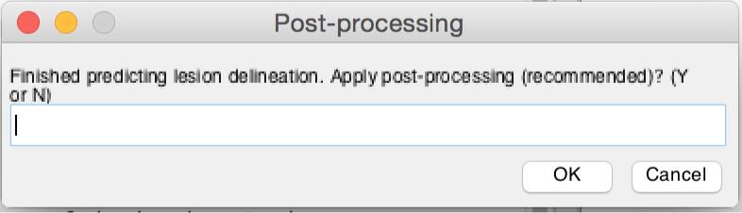

A new dialogue box will ask you to input the desired smoothing kernel width (FWHM in mm) to be applied to the lesion class label volumes (8 is the default), and a second dialogue box will ask if you wish to use implicit masking.
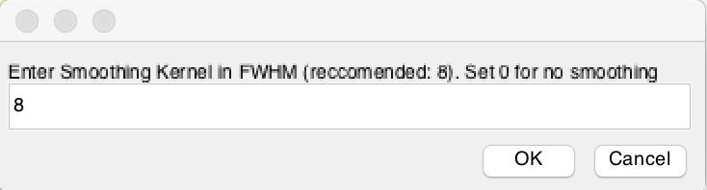

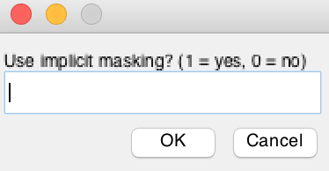

After selecting the smoothing kernel width, a second dialogue box will appear asking you to input the desired cluster-size threshold (in voxels per cluster) to apply to the smoothed lesion class label volumes (100 is the default).
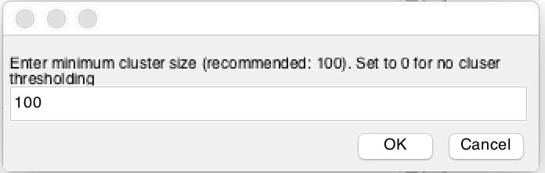

The final smoothed/cluster-thresholded lesion label volumes will then be saved to the output folder. An example of the final output folder contents is shown below:
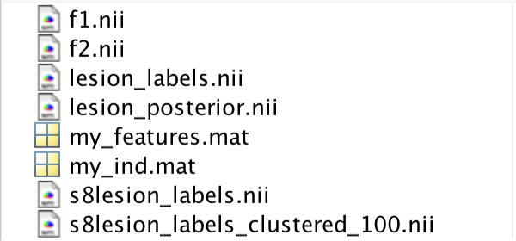

The files “f1.nii” and “f2.nii” correspond to the feature maps described in the publication. The files “my_features.mat” and “my_ind.mat” correspond to the predictor matrix and the in-brain voxel indices, respectively. The files “lesion_labels.nii” and “lesion_posterior.nii” correspond to the binary lesion class volume and the continuous posterior probability volume, respectively.

If post-processing was applied, the smoothed file contain the prefix ‘s’ and the selected smoothing kernel width (e.g. s8), and the cluster thresholded file will contain the suffix ‘_clustered_’ and the selected threshold value (e.g. 100). In this case, the final lesion mask is named “s8lesion_labels_clustered_100.nii”.

Finally, visually inspect the final lesion volume to ensure quality.

