ultrasonic transducer test report
The ultrasonic transducer board is used to detect the object, The sound wave speed is 340m/s,so the mcu can detect the time between the sending and receiving, the distance is: D = 340*T/2, you can calculate the time using the timer of MCU.
The board use NE555 to generate the 40 kHz wave, so you can enable the NE555 250us to generate 10 pulses, then enable the timer to calculate the time, you can send the data to the PC through UART.
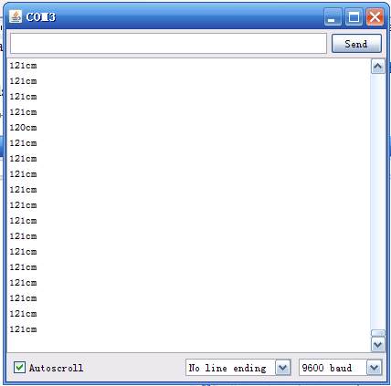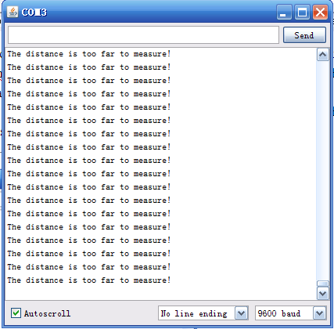
Note: the PC receives “The diatance is too far to measure!” when the distance is longer than 1.5m

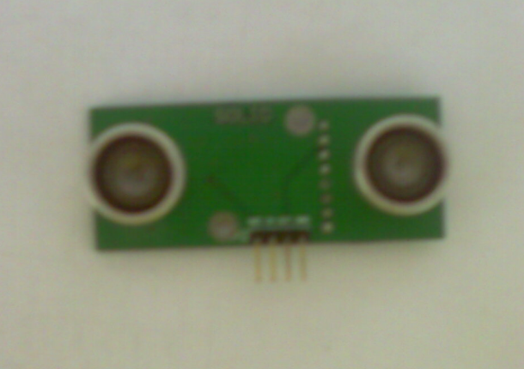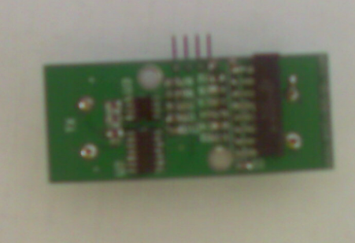

Test step:
1、Connect the board to the arduino, the board can work at 5V.
2、The arduino enable the NE555 for 250us,the board send 10 pulses to the poart TX.
3、Enable the timer to calculate the time, when the output is low, disable the timer.
4、Calculate the diatance and send the data to PC through UART.

