Haut du formulaire

Question 1: **Incorrect**

Your company is planning on using Azure Boards. They want to be able **to create and track user stories and bugs on a Kanban board**. Which of the following work item process would they choose when creating the project in their Azure DevOps organization?

* **Agile**

**(Correct)**

* 

**CMMI**

* 

**Scrum**

* 

**Basic**

**(Incorrect)**

**Explanation**

If they want to track user stories on a Kanban board, **they can choose Agile as the work item** process when creating the project.

For more information on choosing the right process for Azure Projects, one can visit the following URL

<https://docs.microsoft.com/en-us/azure/devops/boards/work-items/guidance/choose-process>

Bas du formulaire

Haut du formulaire

Question 2: **Incorrect**

Your company is planning on using Azure Boards. They want to be able **to create and track product backlog items** and bugs on a Kanban board. Which of the following work item process would they choose when creating the project in their Azure DevOps organization?

* 

**Agile**

**(Incorrect)**

* 

**CMMI**

* 

**Scrum**

**(Correct)**

* 

**Basic**

**Explanation**

If they want to track product backlog items on a Kanban board, they can choose **Scrum** as the work item process when creating the project.

For more information on choosing the right process for Azure Projects, one can visit the following URL

<https://docs.microsoft.com/en-us/azure/devops/boards/work-items/guidance/choose-process>

Bas du formulaire

Haut du formulaire

Question 3: **Correct**

Your company is planning on using Azure Boards. They want to be able **to create and track requirements, change requests, risks and reviews**. Which of the following work item process would they choose when creating the project in their Azure DevOps organization?

* 

**Agile**

* 

**CMMI**

**(Correct)**

* 

**Scrum**

* 

**Basic**

**Explanation**

They can create a project based on the **CMMI** work item process for this requirement.

For more information on choosing the right process for Azure Projects, one can visit the following URL

<https://docs.microsoft.com/en-us/azure/devops/boards/work-items/guidance/choose-process>

Bas du formulaire

Haut du formulaire

Question 4: **Incorrect**

Your company has created an Azure DevOps project within an organization. The project is based on the Agile work item process. They want to be able **to visualize the user stories created as part of the project**. Which of the following helps to accomplish this?

* **Work items**
* **Queries**

**(Incorrect)**

* **Repos**
* **Kanban boards**

**(Correct)**

**Explanation**

You can visualize the user stories via the use **of Kanban boards.**

Bas du formulaire

Haut du formulaire

Question 5: **Incorrect**

Your company is planning on using Azure Boards. They want to **add widgets** to the dashboard based on specific requirements. Which widget can be used for tracking the following requirement?

**“Track the time taken to close a work item after work on it has started”**

* **Cycle time**

**(Correct)**

* **Lead time**

**(Incorrect)**

* **Velocity**
* **Burndown chart**

**Explanation**

This can be accomplished by the Cycle time widget.

For more information on the various widgets, one can visit the following URL

<https://docs.microsoft.com/en-us/azure/devops/report/dashboards/widget-catalog?view=azure-devops>

Bas du formulaire

Haut du formulaire

Question 6: **Incorrect**

Your company is planning on using Azure Boards. They want to add widgets to the dashboard based on specific requirements. Which widget can be used for tracking the following requirement?

**“Track the time taken to close a work item after it was created”**

* 

**Cycle time**

**(Incorrect)**

* 

**Lead time**

**(Correct)**

* 

**Velocity**

* 

**Burndown chart**

**Explanation**

This can be accomplished by the Lead time widget.

For more information on the various widgets, one can visit the following URL

<https://docs.microsoft.com/en-us/azure/devops/report/dashboards/widget-catalog?view=azure-devops>

Bas du formulaire

Haut du formulaire

Question 7: **Correct**

Your team has a project in an Azure DevOps organization. The project administrator has created a shared query.

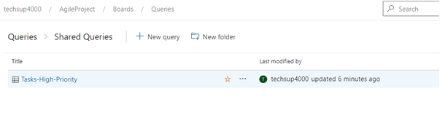

You must ensure that a **user named UserA has access to edit the shared query**. You must ensure the least permissions are given to the user for this requirement. Which permission on the shared query would you grant the user for this requirement?

* **Contribute**

**(Correct)**

* **Read**
* **Delete**
* **Manage permissions**

**Explanation**

The Contribute permission would allow the user to be able to edit the shared query.

The Read permission would not grant the required permission

The Delete and Manage permissions would give additional permissions that are not required.]

Bas du formulaire

Haut du formulaire

Question 8: **Correct**

Your Azure DevOps project currently has the following wiki

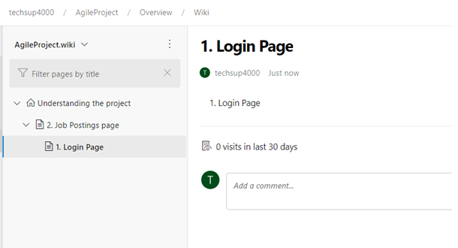

You need to move the “1.Login Page” to be directly under the Understanding the project home folder. How can you accomplish this?

* **Add another subs wiki under the main wiki page.**
* **Delete and recreate the page again.**
* **Just drag and drop the page accordingly.**

**(Correct)**

**Explanation**

You can just drag and drop the pages within the wiki.

**Bas du formulaire**

**Haut du formulaire**

**Question 9**: **Correct**

Your company has an Azure DevOps project under an Azure DevOps organization. You have to **create a published wiki from within the project**. Which of the following is required for the published wiki?

* **An Azure DevOps Kanban board**
* **An Azure DevOps Test Plan**
* **An Azure DevOps Repository**

**(Correct)**

* **An Azure DevOps Pipeline**

**Explanation**

An Azure **DevOps repository** is required for the published wiki.

**Bas du formulaire**

**Haut du formulaire**

**Question 10**: **Correct**

Your company has just setup an Azure DevOps organization and a project.

An Azure repo based on Git is in place. Developers use this for version control for an ASP.NET application.

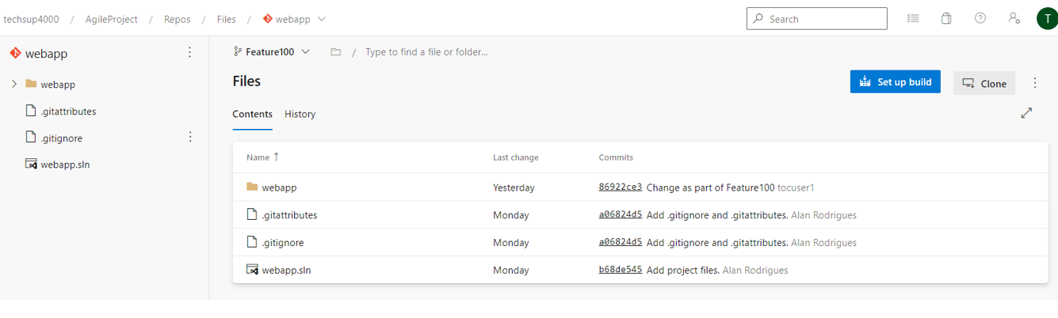

The developers need to work on many new features for the application from time to time. Which of the following should they consider when integrating the new features into the application code?

* **Commit changes to the code directly to the main branch**
* **Create feature branches and use pull requests to merge the branches into the main branch**

**(Correct)**

* **Create multiple main branches and make changes to each main branch**

**Explanation**

The ideal approach is to create feature branches based on the different features. And then later merge the feature branches into the main branch.

Bas du formulaire

Haut du formulaire

Question 11: **Correct**

Bas du formulaire

Haut du formulaire

A development team is working on application code that is hosted in a Git repository. They need to create multiple feature branches off the main branch. Which of the following is the right approach when creating feature branches?

* **Make sure the feature branches are long-lived branches**
* **Make sure the feature branches are short-lived branches**

**(Correct)**

* **Make sure the feature branches are primary branches**

**Explanation**

As a practice, you should always ensure that feature branches are short-lived branches.

Bas du formulaire

Haut du formulaire

Question 12: **Incorrect**

Your company has setup an Azure DevOps organization and a project team within the organization. They are setting up several repositories in Azure Repos. They want to setup the following set of permissions for several types of users.

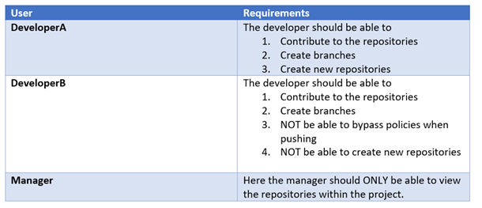

You have to assign the users to the correct Azure DevOps in-built groups. You need to ensure the least privilege is used when assigning the required group.

Which of the following group would you assign to **DeveloperA**?

* **Project Administrators**

**(Correct)**

* **Contributors**
* **Project Collection Service Administrators**

**(Incorrect)**

**Explanation**

When you look at the Project Administrators group, they do have the required permissions.

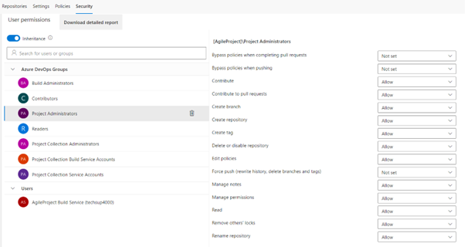

Bas du formulaire

Haut du formulaire

Question 13: **Correct**

Your company has setup an Azure DevOps organization and a project team within the organization. They are setting up several repositories in Azure Repos. They want to setup the following set of permissions for several types of users.



You have to assign the users to the correct Azure DevOps in-built groups. You need to ensure the least privilege is used when assigning the required group.

Which of the following group would you assign to **DeveloperB**?

* **Project Administrators**
* **Contributors**

**(Correct)**

* **Project Collection Service Administrators**

**Explanation**

The Contributors role should suffice for this requirement

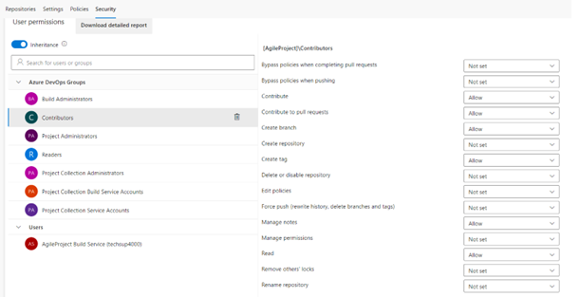

Bas du formulaire

Haut du formulaire

Question 14: **Incorrect**

Your company has setup an Azure DevOps organization and a project team within the organization. They are setting up several repositories in Azure Repos. They want to setup the following set of permissions for several types of users.



You have to assign the users to the correct Azure DevOps in-built groups. You need to ensure the least privilege is used when assigning the required group.

Which of the following group would you assign to the Manager?

* **Project Administrators**

**(Incorrect)**

* **Contributors**
* **Project Collection Build Service Account**

**(Correct)**

**Explanation**

The Project Collection Build Service Account role should suffice for this requirement

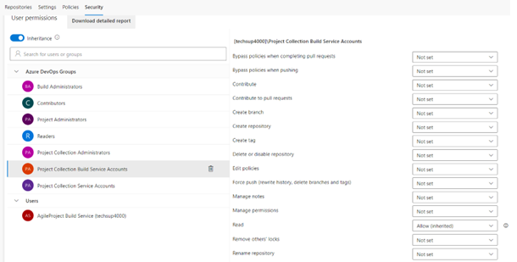

Bas du formulaire

Haut du formulaire

Question 15: **Correct**

Your company has setup an Azure DevOps organization and a project within the organization. Developers are currently working on application code within a particular repository.

https://dev.azure.com/techsup4000/AgileProject/_git/webapp

You need to ensure that notifications are sent to slack whenever pull requests are created.

Which of the following command would issue within Slack for this requirement?

* **/azrepos tag https://dev.azure.com/techsup4000/AgileProject/_git/webapp**
* **/azrepos assign https://dev.azure.com/techsup4000/AgileProject/_git/webapp**
* **/azrepos subscribe https://dev.azure.com/techsup4000/AgileProject/_git/webapp**

**(Correct)**

* **/azrepos signin https://dev.azure.com/techsup4000/AgileProject/_git/webapp**

**Explanation**

One of the specific commands you would need to execute within Slack to get notifications on Azure Repos is /azrepos subscribe and then give the repository URL.

For more information on the integration of Slack and Azure Repos, one can visit the below URL

<https://docs.microsoft.com/en-us/azure/devops/repos/integrations/repos-slack?view=azure-devops>

Bas du formulaire

Haut du formulaire

Question 16: **Incorrect**

Your team is currently working on application code within a Git repository. **You must reduce the data size of the repository.** You need to complete the below command for this requirement.

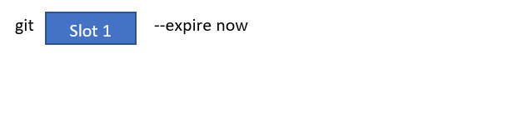

Which of the following would go into Slot 1?

* **commit**
* **push**

**(Incorrect)**

* **prune**

**(Correct)**

* **merge**

**Explanation**

For this requirement, you can use the git prune command.

For more information on Git maintenance and data recovery, one can visit the below URL

<https://git-scm.com/book/en/v2/Git-Internals-Maintenance-and-Data-Recovery>

Bas du formulaire

Haut du formulaire

Question 17: **Correct**

Your company has just setup a project team. The team is going to be working on developing application code. The code needs to be part of a source code versioning tool. The developers need to work offline on the application code and make the required changes. They also need the full project history when they work with the application code offline. Which of the following would the ideal tool to use for this requirement?

* **Team Foundation Version Control**
* **Subversion**
* **Git**

**(Correct)**

**Explanation**

Git is a distributed system. This is the ideal tool to use for developers when they want to work with changes offline.

Bas du formulaire

Haut du formulaire

Question 18: **Correct**

Your team has setup a Git repository within Azure Repos

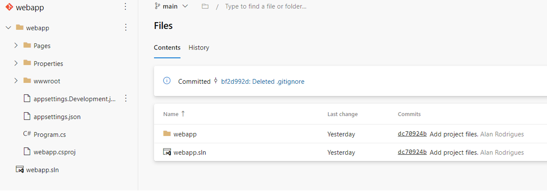

They want to ensure that certain binary files are not committed to the repository. Which of the following can be implemented for this requirement? Choose 4 answers from the options given below

* **Run the git add command**

**(Correct)**

* **Run the git commit command**

**(Correct)**

* **Add the names of the required binary files to the .gitignore file**

**(Correct)**

* **Run the git init command**
* **Create a .gitignore file**

**(Correct)**

**Explanation**

First, we have to create the .gitignore file

Add the required file names to the .gitignore file. These are the binary files that don’t need to be tracked in Git.

Then run the git add command to add the .gitignore file

Finally commit the .gitignore file to the repository.

Bas du formulaire

Haut du formulaire

Question 19: **Incorrect**

Your team is working on a Git repository hosted in Azure Repos. The team is creating multiple feature branches and different team members are working on each feature branch. You want to ensure that **when team members merge the features into the main branch via Pull requests, the history volume does not increase significantly on the main branch**. Which of the following merge strategy can be used for this requirement?

* **fast-forward-merge**

**(Incorrect)**

* **squash merge**

**(Correct)**

* **three-way merge**

**Explanation**

When you want to reduce the commit history on the main branch, you should consider using the **squash** merge technique.

Bas du formulaire

Haut du formulaire

Question 20: **Correct**

Your company has a build pipeline in place

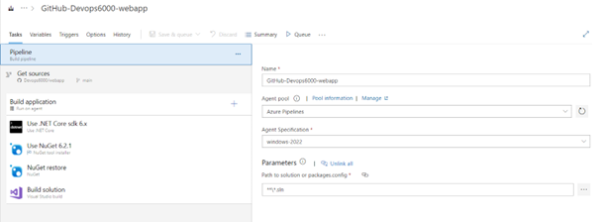

You have to ensure that when code is checked into the corresponding repository, a build runs automatically. Which of the following would you configure in the pipeline for this requirement?

* **Create a new pipeline variable**
* **Add a new task to the pipeline**
* **Enable Continuous Integration**

**(Correct)**

* **Enable batch changes**

**Explanation**

To ensure that the build triggers automatically, you need to enable Continuous integration in the triggers tab of the pipeline

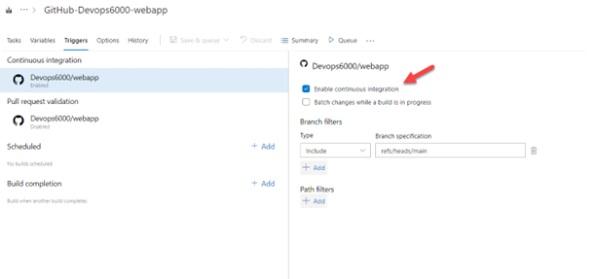

Bas du formulaire

Haut du formulaire

Question 21: **Correct**

Haut du formulaire

Your company is planning on implementing a security process within their DevOps pipelines. **They want to ensure the right testing strategy is conducted during the various phases in the DevOps pipeline**. Which of the following should ideally be done during the planning phase?

* **Load Testing**
* **Static Code Analysis**
* **Penetration Testing**
* **Threat modeling**

**(Correct)**

**Explanation**

**Threat Modeling** can be conducted during the planning phase to understand the various threats against an application.

Bas du formulaire

Haut du formulaire

Question 22: **Correct**

Your company currently has a project defined in a Jenkins instance.

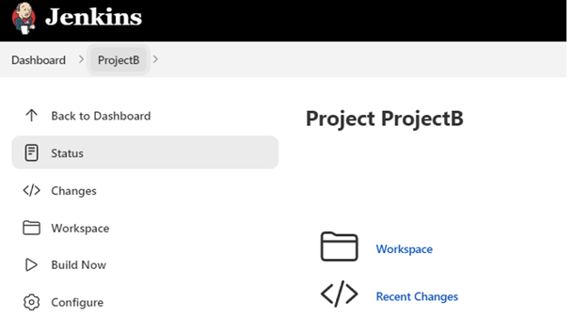

The project needs to pick up code from a repository defined in Azure repos. It has to be ensured that a build is triggered in Jenkins whenever a developer commits a change to the main branch in the repository in Azure repos. Which of the following needs to be implemented for this requirement?

* **Create a service connection in Project settings in the Azure DevOps project containing the repository.**
* **Create a service connection in Jenkins.**
* **Create a service hook in Project settings in the Azure DevOps project containing the repository.**

**(Correct)**

* **Create a service hook in Jenkins.**

**Explanation**

You have to create a service hook in the Azure DevOps project. The service hook would ensure that a code commit would trigger a build in the Jenkins pipeline.

For more information on the service hook, one can visit the below URL

<https://docs.microsoft.com/en-us/azure/devops/service-hooks/services/jenkins?view=azure-devops>

Bas du formulaire

Haut du formulaire

Question 23: **Correct**

Your company is planning on using the Azure DevOps set of tools. They currently use Jenkins when it comes to Continuous Integration. Which of the following tool within Azure DevOps could be used to replace the Jenkins tool?

* **Azure Boards**
* **Azure Build Pipelines**

**(Correct)**

* **Azure Artifacts**
* **Azure Repos**

**Explanation**

Azure Build Pipelines can be used to create the pipelines that would have been defined in the Jenkins instance.

Bas du formulaire

Haut du formulaire

Question 24: **Incorrect**

Your company currently has an Azure DevOps project in place. The project is being used for the DevOps lifecycle for a Java-based application. They are planning on using SonarQube when it comes to Static code analysis. Which of the following task should be defined in the build pipeline for usage of SonarQube for **measuring code quality for the Java application**?

* **Gradle**

**(Correct)**

* **Grunt**

**(Incorrect)**

* **MSBuild**
* **Docker**

**Explanation**

For more information on the Gradle task, one can visit the below URL

<https://docs.microsoft.com/en-us/azure/devops/pipelines/tasks/build/gradle?view=azure-devops>

Bas du formulaire

Haut du formulaire

Question 25: **Correct**

Your company currently has an Azure DevOps project in place. The project is being used for the DevOps lifecycle for a .NET-based application. They want **to identify any security vulnerabilities during the application build process when it comes to any open-source libraries used in the application**. Which of the following could be used for this requirement?

* **Grunt**
* **Gulp**
* **Black Duck**

**(Correct)**

* **Docker**

**Explanation**

Black Duck is an option that can be used for this requirement.

For more information on Black Duck, one can visit the below URL

<https://marketplace.visualstudio.com/items?itemName=black-duck-software.detect-for-tfs>

Bas du formulaire

Haut du formulaire

Question 26: **Incorrect**

Your company has just set an Azure DevOps account based on the **free tier**. They have setup a number of private projects. Each project has a build pipeline defined that used a self-hosted agent. They are experiencing delays when it comes to the build process, and this is because of the queueing of the builds. Which of the following can be done to rectify this issue?

* **Implement caching in the pipeline**
* **Use Microsoft-hosted agents instead.**

**(Incorrect)**

* **Configure a policy for the project**
* **Purchase parallel jobs**

**(Correct)**

**Explanation**

With the free-tier, you only get the option of one parallel job that can run at a time. If you need more jobs to run in parallel, then you need to purchase more jobs.

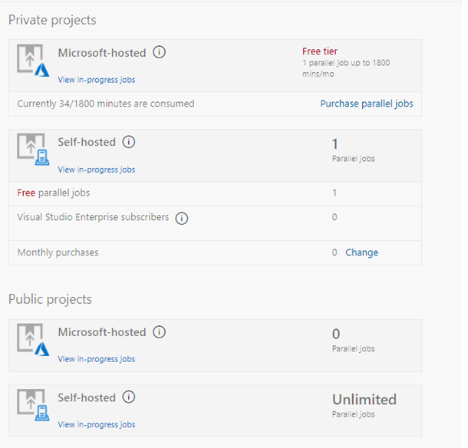

Bas du formulaire

Haut du formulaire

Question 27: **Correct**

Your company has a build pipeline in place

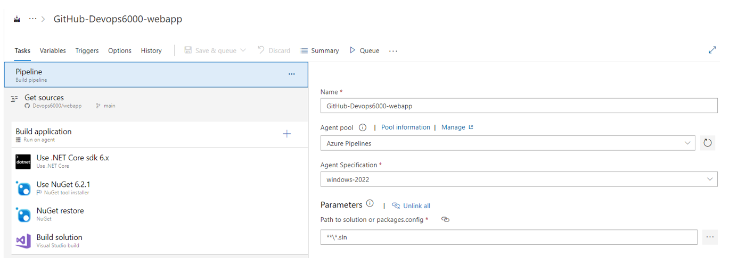

How many tasks have been defined in the pipeline?

* **1**
* **4**

**(Correct)**

* **5**
* **10**

**Explanation**

There are four tasks that are part of one job defined in the pipeline.

Bas du formulaire

Haut du formulaire

Question 28: **Correct**

Your company has the following Azure pipeline in place

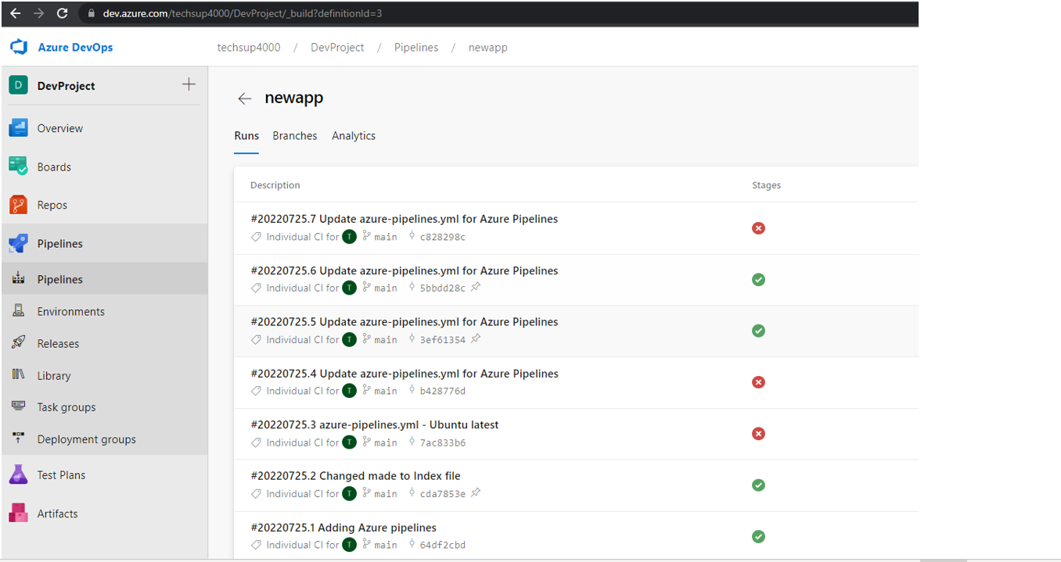

They want to ensure that a project teams defined in **Microsoft Teams** gets notified whenever there are failures in the pipeline.

Which of the following command can be used for this requirement?

* **@azure pipelines subscribe https://dev.azure.com/techsup4000/DevProject/_build?definitionId=3**

**(Correct)**

* **@azure pipelines subscriptions https://dev.azure.com/techsup4000/DevProject/_build?definitionId=3**
* **@azure pipelines subscribe https://dev.azure.com/techsup4000/DevProject/_package?definitionId=3**
* **@azure pipelines subscriptions https://dev.azure.com/techsup4000/DevProject/_package?definitionId=3**

**Explanation**

You need to use the @azure pipelines subscribe command. And then you can use the build definition to the command.

For more information on Integrating Azure Pipelines and Microsoft Teams, one can visit the below URL

<https://docs.microsoft.com/en-us/azure/devops/pipelines/integrations/microsoft-teams?view=azure-devops>

Bas du formulaire

Haut du formulaire

Question 29: **Incorrect**

Your company has an organization defined in **GitHub**. They also have a repository defined within the organization. They want to create an Azure Pipeline that would pick up code from the GitHub repository. You have to **ensure that Azure Pipelines runs under the Azure Pipelines identity when it comes to the integration with GitHub**. Which form of authentication would you use for this requirement?

* **OAuth**
* **Personal Access Token**

**(Incorrect)**

* **GitHub App**

**(Correct)**

**Explanation**

You need to use the GitHub App for this requirement

For more information on building GitHub repositories, one can visit the below URL

<https://docs.microsoft.com/en-us/azure/devops/pipelines/repos/github?view=azure-devops&tabs=yaml>

Bas du formulaire

Haut du formulaire

Question 30: **Correct**

You have to configure an availability test with the use of Application Insights. You will be setting a URL ping test against the site https://cloudportalhub.com.

You must ensure that tests are conducted from 5 locations at a duration of every 5 minutes. A successful test should mean that the main application page load along with the images on the page.

Which of the following would you configure in the test for the requirement

**“You must ensure that tests are conducted from 5 locations at a duration of every 5 minutes”**

* **Parse dependent requests**
* **Enable retries for availability test failures**
* **Test locations**

**(Correct)**

* 

**Content match**

**Explanation**

You can set this up from the test location setting in Application Insights

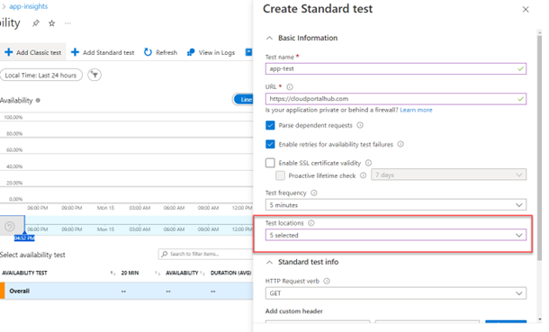

Bas du formulaire

Haut du formulaire

Question 31: **Correct**

Bas du formulaire

Haut du formulaire

You have to configure an availability test with the use of Application Insights. You will be setting a URL ping test against the site https://cloudportalhub.com.

You must ensure that tests are conducted from 5 locations at a duration of every 5 minutes. A successful test should mean that the main application page load along with the images on the page.

Which of the following would you configure in the test for the requirement

**“A successful test should mean that the main application page load along with the images on the page.”**

* **Parse dependent requests**

**(Correct)**

* **Enable retries for availability test failures**
* **Test locations**
* **Content match**

**Explanation**

You can configure the setting ,’ Enable retries for availability test failures’. This will ensure to parse all dependent requests which also includes images on the web page.

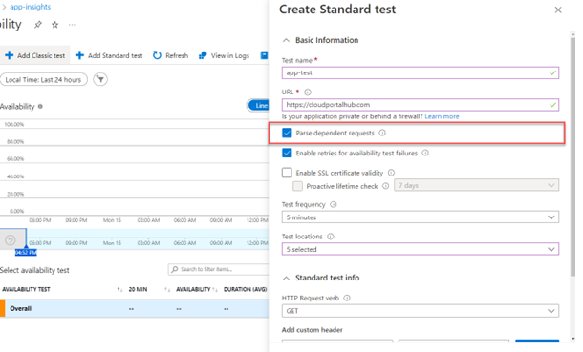

Bas du formulaire

Haut du formulaire

Question 32: **Incorrect**

Your team has the following virtual machine defined as part of their subscription

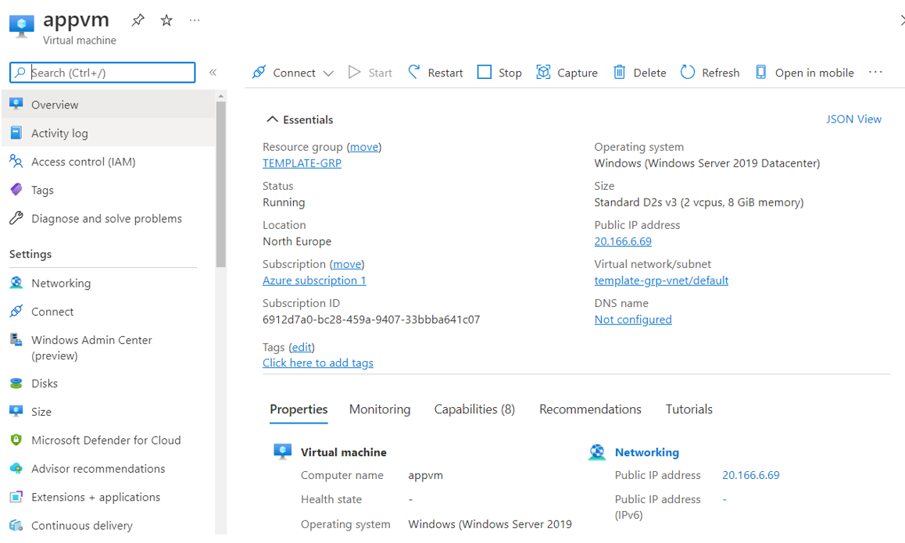

An Azure DevOps pipeline has been setup to release a web application onto the Azure virtual machine. You have to configure an Azure Monitor alert that would **generate an alert if the CPU utilization of the machine goes beyond 75% for 5 minutes. Azure Monitor should be configured to calculate the average CPU utilization every 15 minutes**.

Which of the following would you configure as the threshold type for the alert?

* **Static**

**(Correct)**

* **Dynamic**

**(Incorrect)**

**Explanation**

Since this is based on a threshold value , we need to define a static alert.

Bas du formulaire

Haut du formulaire

Question 33: **Correct**

Your team has the following virtual machine defined as part of their subscription

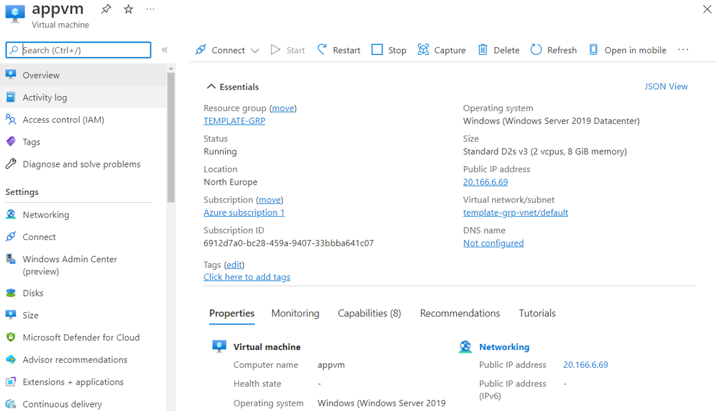

An Azure DevOps pipeline has been setup to release a web application onto the Azure virtual machine. You have to configure an Azure Monitor alert that would generate an alert if the CPU utilization of the machine goes beyond 75% for 5 minutes. **Azure Monitor should be configured to calculate the average CPU utilization every 15 minutes.**

Which of the following would you configure as the Aggregation granularity?

* **5 minutes**
* **10 minutes**
* **15 minutes**

**(Correct)**

**Explanation**

Here since the average needs to be calculated every 15 minutes , we have to define this as the Aggregation granularity.

Bas du formulaire

Haut du formulaire

Question 34: **Incorrect**

Your team has an Azure DevOps pipeline. The pipeline is used for building a Core Services application.

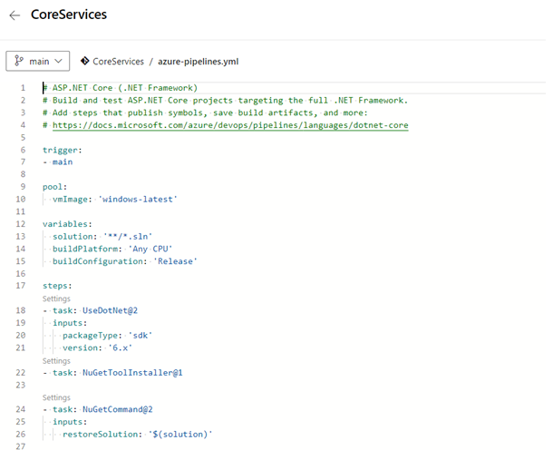

**The application needs to pick up a secret defined in an Azure Key vault**. The secret needs to be then used in the pipeline. Which of the following needs to be implemented for this requirement? Choose 3 answers from the options given below.

* **Create a service principal in Azure Active Directory**

**(Correct)**

* **Enable the managed identity for the Azure Key vault service**

**(Incorrect)**

* **Configure an access policy for the key vault**

**(Correct)**

* **Configure an access policy in Azure Active Directory**
* **Configure a service connection in the pipeline**

**(Correct)**

**Explanation**

**First, create a service principal in Azure Active Directory**

**Next configure an access policy in the key vault to give access to the service principal to the Key vault.**

**Then configure a service connection to the Azure subscription to use the Azure Key Vault**.

For more information on using Azure Key vault secrets in Azure pipelines, one can also visit the below URL

<https://docs.microsoft.com/en-us/azure/devops/pipelines/release/azure-key-vault?view=azure-devops&tabs=yaml>

Bas du formulaire

Haut du formulaire

Question 35: **Correct**

Your team currently has an Azure DevOps pipeline that deploys application-based containers to an Azure **Kubernetes** cluster. The **container images are stored in Azure container registry**. As part of the security process, you have to ensure that you detect for any application security vulnerabilities as early on in the lifecycle as possible. Which of the following can be carried out for this requirement?

* **A task which analyses the deployed container in the cluster for any security vulnerabilities**
* **A task which analyses the deployed container in an Azure container instance for any security vulnerabilities**
* **A task which analyses the image in Azure container registry for any security vulnerabilities**

**(Correct)**

**Explanation**

Since we need to check for any security vulnerabilities as early in the lifecycle as possible , we should scan the image in the Azure container registry.

Bas du formulaire

Haut du formulaire

Question 36: **Correct**

Which of the following in Azure pipelines allows you **to reference secrets defined in an Azure Key vault?**

* **Task groups**
* **Deployment groups**
* **Variable groups**

**(Correct)**

**Explanation**

You can reference secrets from an Azure Key vault with the use of Variable groups.

Bas du formulaire

Haut du formulaire

Question 37: **Incorrect**

Your team has an Azure Artifacts feed as shown below

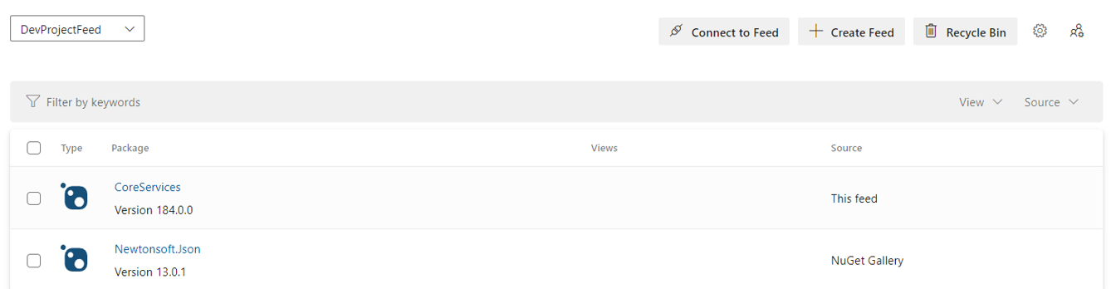

**The feed is part of a private DevOps project. You have to ensure that other developers can restore the NuGet packages in the feed automatically**. Which of the following can be used for this requirement?

* **Azure Artifacts Credential Provider**

**(Correct)**

* **Azure Active Directory Application**
* **Azure DevOps service connection**

**(Incorrect)**

* **Azure DevOps service hook**

**Explanation**

You can use the Azure Artifacts Credential Provider to authenticate to the Azure Artifacts feed and get the packages accordingly.

Bas du formulaire

Haut du formulaire

Question 38: **Incorrect**

Your team is creating a build pipeline for a **Java**-based application. They want to **use a tool that can calculate the percentage of code accessed by tests**. Which of the following can be used for this requirement?

* **WhiteSource Bolt**

**(Incorrect)**

* **Maven**
* **Cobertura**

**(Correct)**

**Explanation**

This tool can be used to calculate the percentage of code accessed by tests for Java-based applications

For more information on the Cobertura tool, one can visit the below URL

<https://cobertura.github.io/cobertura/>

Bas du formulaire

Haut du formulaire

Question 39: **Correct**

Your team needs to deploy a set of resources via the use of **Azure Resource Manager** templates. These templates need to **access secrets that would be stored in an Azure Key Vault** resource. Which of the following is one of the aspects that needs to be configured in the key vault for this requirement?

* **Azure Disk Encryption for volume encryption**
* **Soft-Delete for the key vault**
* **Azure Resource Manager for template deployment**

**(Correct)**

**Explanation**

When you need ARM templates to access secrets in the key vault, you also need to configure the below setting

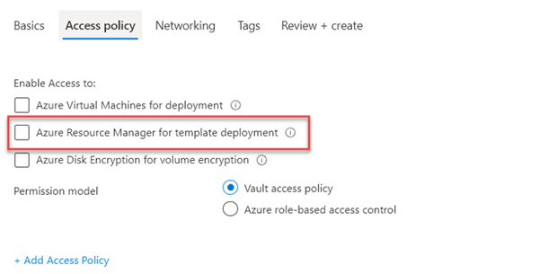

Bas du formulaire

Haut du formulaire

Question 40: **Correct**

Your team is currently working on source code for an application. A Git repository in Azure Repos is being used for version control. You have to ensure that the **types of merges are limited when pull requests are being made to the master branch**. Which of the following can be configured for this requirement?

* **Branch permissions**
* **Branch policies**

**(Correct)**

* **Service hooks**
* **Agent pools**

**Explanation**

You can configure a branch policy for this as shown below

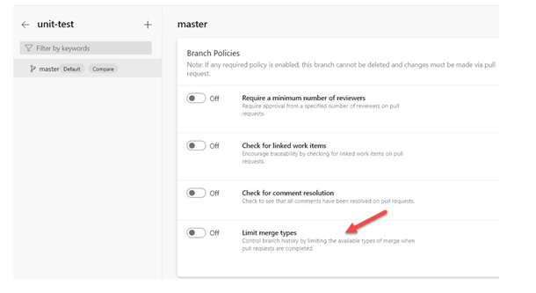

Bas du formulaire

Haut du formulaire

Question 41: **Incorrect**

Haut du formulaire

You have to configure an availability test with the use of Application Insights. You will be setting a URL ping test against the site https://cloudportalhub.com.

You must ensure that tests are conducted from 5 locations at a duration of every 5 minutes. A successful test should mean that the main application page load along with the images on the page.

Which of the following would you configure in the test for the requirement

**“A successful test should mean that the main application page load along with the images on the page.”**

* **Parse dependent requests**

**(Correct)**

* **Enable retries for availability test failures**
* **Test locations**
* **Content match**

**Explanation**

You can configure the setting ,’ Enable retries for availability test failures’. This will ensure to parse all dependent requests which also includes images on the web page.



Bas du formulaire

Haut du formulaire

Bas du formulaire

Haut du formulaire

Question 41: **Incorrect**

Haut du formulaire

Your team is currently working on different revisions of an application. The application **builds are being made available via packages via the Azure Artifact** service. **You have to ensure that packages that are currently under development are not visible to users**. Which of the following can be used for this requirement?

* **Upstream sources**

**(Incorrect)**

* **Feed views**

**(Correct)**

* **Package promotion**

**Explanation**

With the use of Feed views, you can ensure that only certain packages are made available to users. Those packages which are still under development won’t be visible to users.

For more information on Feed views , one can visit the below URL

<https://docs.microsoft.com/en-us/azure/devops/artifacts/concepts/views?view=azure-devops>

Bas du formulaire

Haut du formulaire

Question 42: **Correct**

Your team is planning on using Azure DevOps for the Continuous Integration and Deployment of an application. The application needs to be automatically deployed **via Azure Pipelines onto a set of Azure virtual machines**. Which of the following would you provision in Azure DevOps to manage the target servers?

* **Agent pools**
* **Target jobs**
* **Deployment Groups**

**(Correct)**

**Explanation**

You can make the machines as part of a **deployment group.**

For more information on Deployment Groups , one can visit the below URL

<https://docs.microsoft.com/en-us/azure/devops/pipelines/release/deployment-groups/?view=azure-devops>

Bas du formulaire

Haut du formulaire

Question 43: **Correct**

Your team currently has the following Release pipeline in place

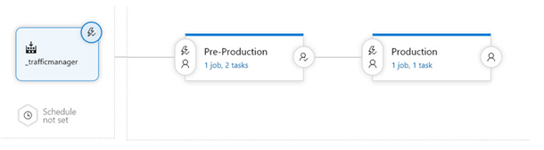

How many stages does the pipeline have?

* **1**
* **2**

**(Correct)**

* **3**
* **4**

**Explanation**

This is an example of a pipeline that has 2 stages. The example is given below

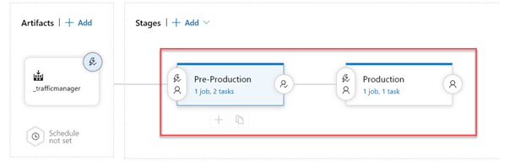

Bas du formulaire

Haut du formulaire

Question 44: **Correct**

Your team currently has the following Release pipeline in place



Is the Continuous deployment trigger set for the pipeline?

* **Yes**

**(Correct)**

* **No**

**Explanation**

If you click on the trigger, you will see that the Continuous deployment trigger is enabled

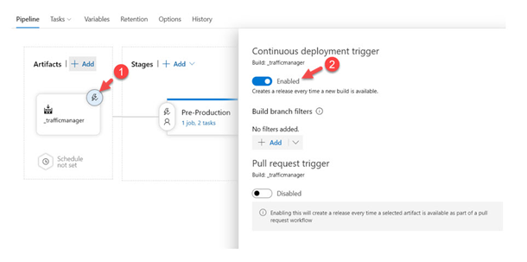

Bas du formulaire

Haut du formulaire

Question 45: **Correct**

Your team is working on application code within a git repository. You need to mark certain commits along the way as important application releases. You need to mark the first release for a particular commit. Which of the following statement would you issue for this requirement?

* **git commit -m “Release v1.0”**
* **git tag -a v1.0 -m “Release v1.0”**

**(Correct)**

* **git push -m “Release v1.0”**
* **git release -m “Release v1.0”**

**Explanation**

The correct way to mark a release is to tag the required commit.

For more information on tags, one can visit the below URL

<https://git-scm.com/book/en/v2/Git-Basics-Tagging>

Bas du formulaire

**Continuer**

Retake test