Haut du formulaire

Question 1: **Incorrect**

Your team has defined the below Azure pipeline

1. # ASP.NET Core (.NET Framework)
2. # Build and test ASP.NET Core projects targeting the full .NET Framework.
3. # Add steps that publish symbols, save build artifacts, and more:
4. # https://docs.microsoft.com/azure/devops/pipelines/languages/dotnet-core
6. trigger:
7. - main
9. pool:
10. name: Default
12. variables:
13. solution: '**/*.sln'
14. buildPlatform: 'Any CPU'
15. buildConfiguration: 'Release'
17. steps:
18. - task: UseDotNet@2
19. displayName: Install .NET 6
20. inputs:
21. packageType: 'sdk'
22. version: 6.x
24. - task: DotNetCoreCLI@2
25. displayName: Build
26. inputs:
27. command: build
28. projects: '**/*.csproj'
29. arguments: '--configuration $(buildConfiguration)'

Your team has discovered that it is taking time to download the NuGet packages for each pipeline run. You have to ensure that **the pipeline execution time is reduced**. Which of the following can be implemented for this requirement?

* **Add a cache task to the pipeline**

**(Correct)**

* **Add a package task to the pipeline**

**(Incorrect)**

* **Add a sonar task to the pipeline**
* **Add a publish task to the pipeline**

**Explanation**

You can use pipeline caching to download the normally used packages so that they can be re-used within pipeline runs.

For more information on using pipeline caching, one can visit the below URL

<https://docs.microsoft.com/en-us/azure/devops/pipelines/release/caching?view=azure-devops>

Bas du formulaire

Haut du formulaire

Question 2: **Correct**

Your team has defined the below Azure pipeline

1. # ASP.NET Core (.NET Framework)
2. # Build and test ASP.NET Core projects targeting the full .NET Framework.
3. # Add steps that publish symbols, save build artifacts, and more:
4. # https://docs.microsoft.com/azure/devops/pipelines/languages/dotnet-core
6. trigger:
7. - main
9. pool:
10. name: Default
12. variables:
13. solution: '**/*.sln'
14. buildPlatform: 'Any CPU'
15. buildConfiguration: 'Release'
17. steps:
18. - task: UseDotNet@2
19. displayName: Install .NET 6
20. inputs:
21. packageType: 'sdk'
22. version: 6.x
24. - task: DotNetCoreCLI@2
25. displayName: Build
26. inputs:
27. command: build
28. projects: '**/*.csproj'
29. arguments: '--configuration $(buildConfiguration)'

The application that is being built uses several open-source libraries**. You have to ensure that the open-source libraries comply with the company’s licensing policies**. Which of the following can be integrated into the pipeline for this requirement?

* **Gulp**
* **Mend Bolt**

**(Correct)**

* **Grunt**
* **Docker**

**Explanation**

You can use Mend Bolt for this requirement.

For more information on Mend Bolt, one can visit the below URL

<https://www.mend.io/free-developer-tools/bolt/>

Bas du formulaire

Haut du formulaire

Question 3: **Correct**

Your company has an Azure DevOps organization and an Azure subscription. They have created a Windows Server 2019 virtual machine as part of the Azure subscription. **This machine is going to be used as a self-hosted agent in Azure Pipelines.** Which of the following needs to be used to register the machine as a self-hosted agent?

* **OAuth**
* **Password**
* **Personal Access Token**

**(Correct)**

* **Service Connection**

**Explanation**

A personal access token needs to be used to register the machine as a self-hosted agent.

For more information on an example on using a self-hosted agent, one can visit the below URL

<https://docs.microsoft.com/en-us/azure/devops/pipelines/agents/v2-windows?view=azure-devops>

Bas du formulaire

Haut du formulaire

Question 4: **Correct**

Your company has an Azure DevOps organization and a project defined within the organization. They want to delegate permissions on working with agent pools within the organization and within the project**. Members assigned to a role should be able to view the agent pool and the agents at organization level**. Which role would be best suited for this requirement, ensuring that the least privilege is used when assigning the role?

* **Reader**

**(Correct)**

* **Service Account**
* **Administrator**

**Explanation**

The Reader role is sufficient for this requirement.

For more information on agent pools, one can visit the below URL

<https://docs.microsoft.com/en-us/azure/devops/pipelines/agents/pools-queues>

Bas du formulaire

Haut du formulaire

Question 5: **Correct**

Your company has an Azure DevOps organization and a project defined within the organization. They want to delegate permissions on working with agent pools within the organization and within the project. **Members assigned to a role should be able to use the agent pool within Azure pipelines**. Which role would be best suited for this requirement, ensuring that the least privilege is used when assigning the role?

* **Reader**
* **User**

**(Correct)**

* **Administrator**

**Explanation**

The User role is sufficient for this requirement.

For more information on agent pools, one can visit the below URL

<https://docs.microsoft.com/en-us/azure/devops/pipelines/agents/pools-queues>

Bas du formulaire

Haut du formulaire

Question 6: **Correct**

Your team needs to setup a build pipeline within an Azure DevOps project. The pipeline would be used to build an ASP.NET Core application. **You have to configure SonarCloud to perform a code quality check on the code as part of the build pipeline**.

You have to complete the below build pipeline for this requirement

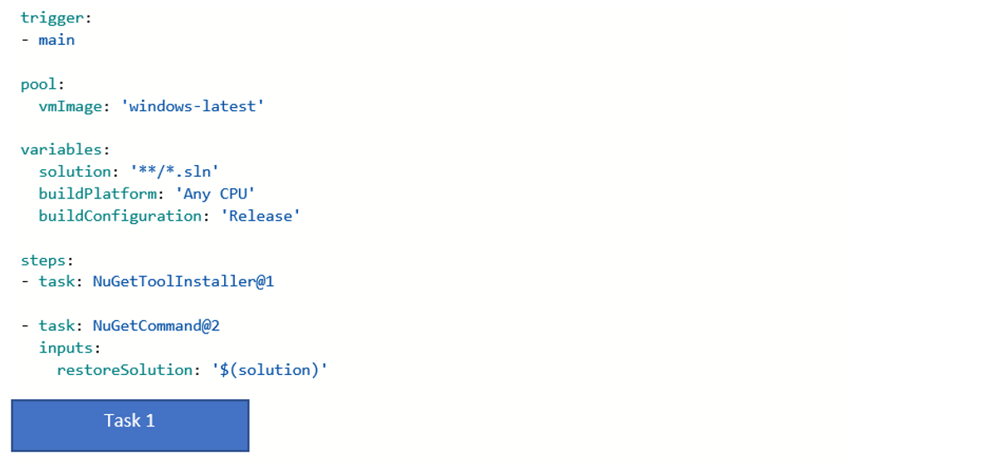

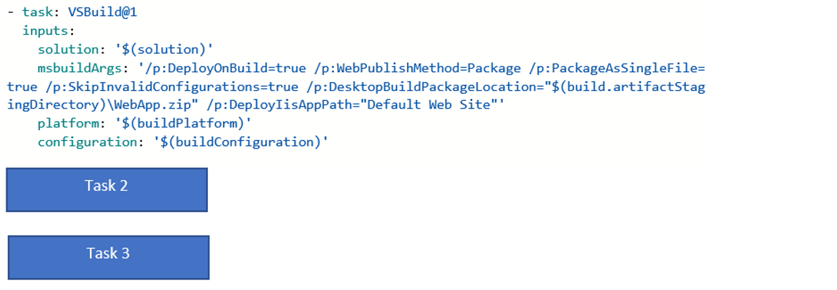

Which of the following task would come in Task 1 for this requirement?

* **Publish Build Artifacts**
* **Visual Studio Test**
* **Prepare Analysis Configuration**

**(Correct)**

* **Run Code Analysis**
* **Publish Quality Gate Result**

**Explanation**

Here we need to prepare the SonarCloud configuration.

Bas du formulaire

Haut du formulaire

Question 7: **Correct**

Your team needs to setup a build pipeline within an Azure DevOps project. The pipeline would be used to build an ASP.NET Core application. You have to configure **SonarCloud** to perform a code quality check on the code as part of the build pipeline.

You have to complete the below build pipeline for this requirement

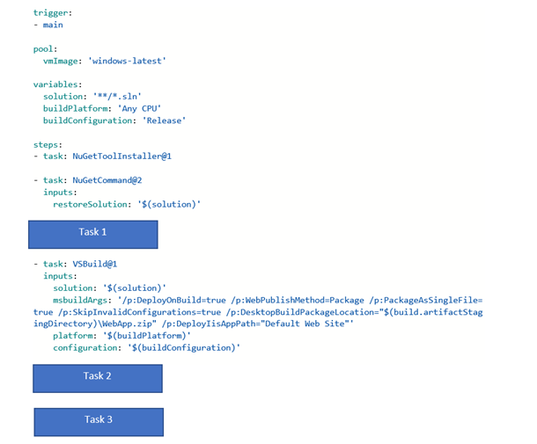

Which of the following task would come in Task 2 for this requirement?

* **Publish Build Artifacts**
* **Visual Studio Test**
* **Prepare Analysis Configuration**
* **Run Code Analysis**

**(Correct)**

* **Publish Quality Gate Result**

**Explanation**

Here we need to run the code analysis.

Bas du formulaire

Haut du formulaire

Question 8: **Correct**

Your team needs to setup a build pipeline within an Azure DevOps project. The pipeline would be used to build an ASP.NET Core application. You have to configure SonarCloud to perform a code quality check on the code as part of the build pipeline.

You have to complete the below build pipeline for this requirement

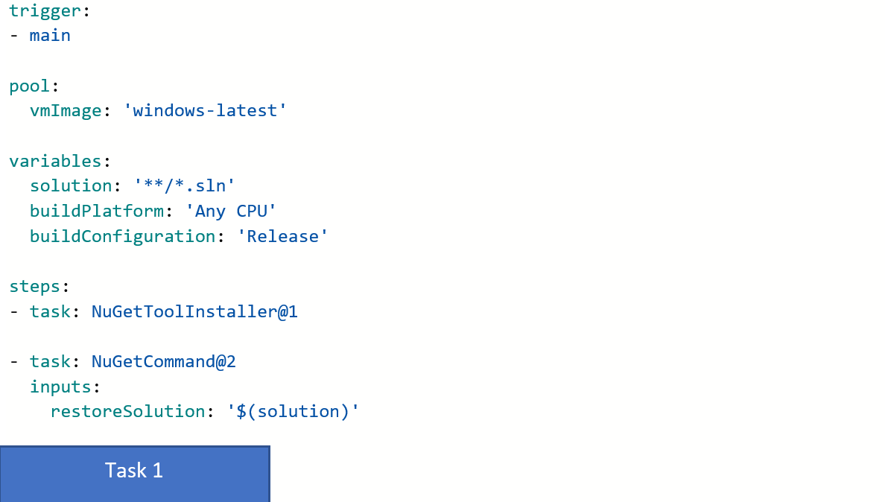

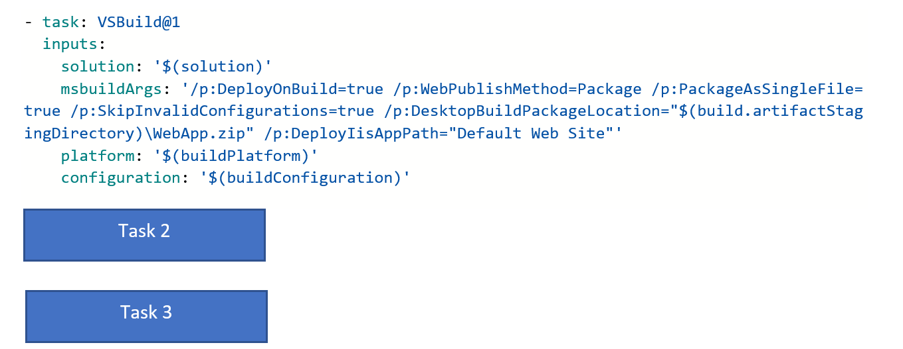

Which of the following task would come in Task 3 for this requirement?

* **Publish Build Artifacts**
* **Visual Studio Test**
* **Prepare Analysis Configuration**
* **Run Code Analysis**
* **Publish Quality Gate Result**

**(Correct)**

**Explanation**

Here we need to publish the code results.

Bas du formulaire

Haut du formulaire

Question 9: **Incorrect**

Your team needs to setup a build pipeline within an Azure DevOps project. **With each build, you also need to get an idea with regards to the technical debt of the codebase.** Which of the following tool can help in this regard?

* **SonarQube**

**(Correct)**

* **Jenkins**
* **Azure Artifacts**
* **Azure Boards**

**(Incorrect)**

**Explanation**

With the help of SonarQube , you can perform a code analysis of your code and get a good idea on the number of issues in the code and hence the technical debt.

Bas du formulaire

Haut du formulaire

Question 10: **Correct**

Your team currently has a release pipeline in place

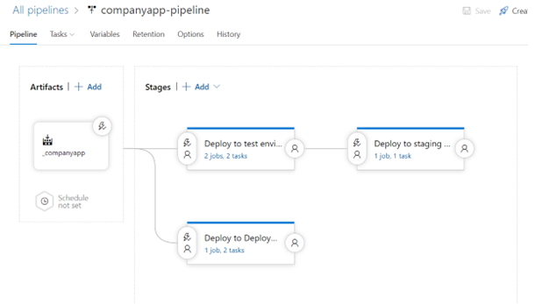

You have to ensure that that **the pipeline release information is attached to the work item related to the commit that triggered the build**. Which of the following must you configure for this requirement?

* **Create a service connection**
* **Create a service hook**
* **Configure the Integration options**

**(Correct)**

* **Configure a pipeline variable**

**Explanation**

You need to configure the Integration options to ensure the pipeline information is sent back to the work item.

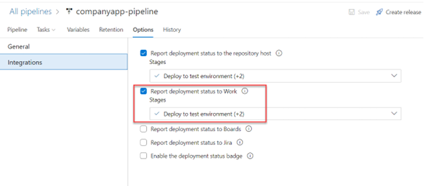

For more information on linking work items one can visit the below URL

<https://docs.microsoft.com/en-us/azure/devops/boards/work-items/work-item-deployments-control?view=azure-devops>

Bas du formulaire

Haut du formulaire

Question 11: **Correct**

Your team currently has a release pipeline in place



You have to ensure that **the build is not released to the staging environment if the deployment to the test environment does not comply with an Azure policy**. Which of the following can be configured in the pipeline for this?

* **A pipeline approval**
* **A deployment gate**

**(Correct)**

* **A pipeline trigger**

**Explanation**

You can configure a that ensures the deployment is not made unless it complies with the Azure policy service.

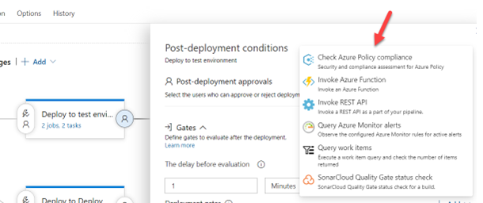

Bas du formulaire

Haut du formulaire

Question 12: **Correct**

Your team is building a build and release pipeline for an ASP.NET application. The application needs to be deployed to a **set of Azure virtual machines**. You need to devise an ideal strategy for releasing the application onto the set of Azure virtual machines. Which of the following could be considered for this requirement?

* **Place the virtual machines as part of a deployment group**

**(Correct)**

* **Place the virtual machines as part of the same DevOps project**
* **Place the virtual machines as part of the same DevOps organization**

**Explanation**

When you want to release an application to multiple machines, you should consider placing them into a deployment group.

For more information on deployment groups one can visit the below URL

<https://docs.microsoft.com/en-us/azure/devops/pipelines/release/deployment-groups/?view=azure-devops>

Bas du formulaire

Haut du formulaire

Question 13: **Incorrect**

Your team is building a Dockerfile for an ASP.NET application that needs to be published to an Azure Container registry as an image. You have to complete the below Dockerfile accordingly.

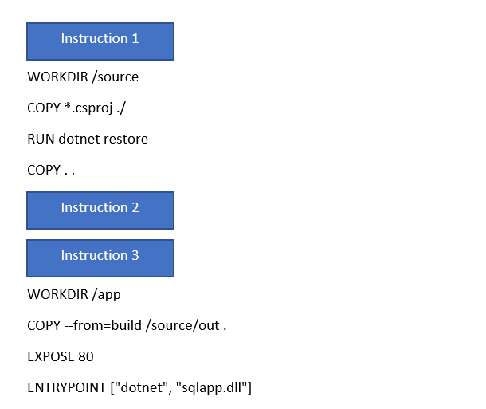

Which of the following would go as Instruction1?

* **FROM mcr.microsoft.com/dotnet/aspnet:6.0**

**(Incorrect)**

* **FROM mcr.microsoft.com/dotnet/sdk:6.0 AS build**

**(Correct)**

* **RUN dotnet publish -c Release -o out**

**Explanation**

Here we need to use the SDK to build the .NET application.

Bas du formulaire

Haut du formulaire

Question 14: **Incorrect**

Your team is building a Dockerfile for an ASP.NET application that needs to be published to an Azure Container registry as an image. You have to complete the below Dockerfile accordingly.



Which of the following would go as Instruction2?

* **FROM mcr.microsoft.com/dotnet/aspnet:6.0**

**(Incorrect)**

* **FROM mcr.microsoft.com/dotnet/sdk:6.0 AS build**
* **RUN dotnet publish -c Release -o out**

**(Correct)**

**Explanation**

Next, we need to publish the build.

Bas du formulaire

Haut du formulaire

Question 15: **Incorrect**

Your team is building a Dockerfile for an ASP.NET application that needs to be published to an Azure Container registry as an image. You have to complete the below Dockerfile accordingly.



Which of the following would go as Instruction3?

* **FROM mcr.microsoft.com/dotnet/aspnet:6.0**

**(Correct)**

* **FROM mcr.microsoft.com/dotnet/sdk:6.0 AS build**
* **RUN dotnet publish -c Release -o out**

**(Incorrect)**

**Explanation**

Finally, in this multi-stage build, we can create the final image using the aspnet runtime image.

Bas du formulaire

Haut du formulaire

Question 16: **Correct**

Which of the following tool can be used in your pipeline to automate **the UI testing of an application?**

* **Mend Bolt**
* **XUnit**
* **Selenium**

**(Correct)**

* **Grunt**

**Explanation**

You can the Selenium tool to create UI tests.

Bas du formulaire

Haut du formulaire

Question 17: **Correct**

Your team has the following pipeline in place

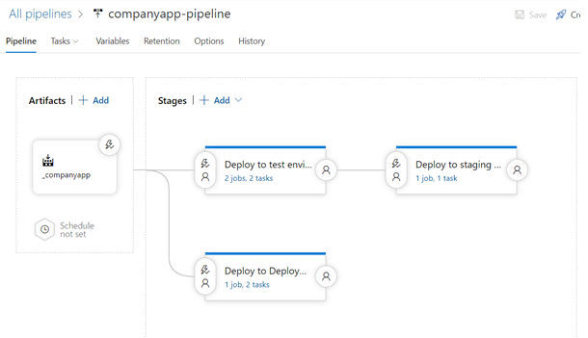

Is Continuous Delivery enable for this pipeline?

* **Yes**

**(Correct)**

* **No**

**Explanation**

Since the triggers are set for each stage, we do have a Continuous Delivery pipeline.

Bas du formulaire

Haut du formulaire

Question 18: **Incorrect**

Your team has setup an Azure Automation Account. They want to associate Windows-based Azure virtual machines as nodes in the Automation Account. All machines need to have the Web-Server role enabled on them.

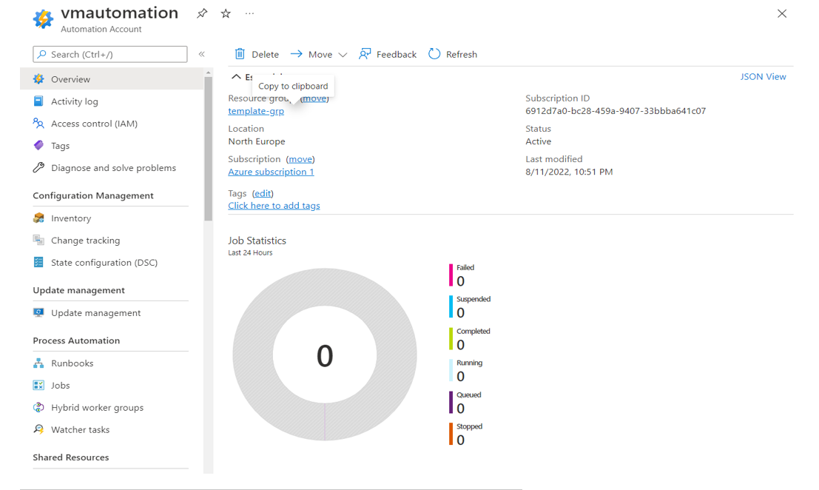

You need to complete the below Configuration for this requirement

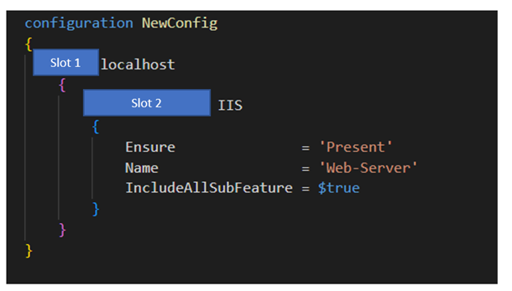

Which of the following would go into Slot 1?

* **Feature**
* **State**

**(Incorrect)**

* **WindowsFeature**
* **Node**

**(Correct)**

**Explanation**

Here the Node attribute would be used.

Bas du formulaire

Haut du formulaire

Question 19: **Incorrect**

Your team has setup an Azure Automation Account. They want to **associate** **Windows-based Azure virtual machines as nodes in the Automation Account**. All machines need to have the Web-Server role enabled on them.

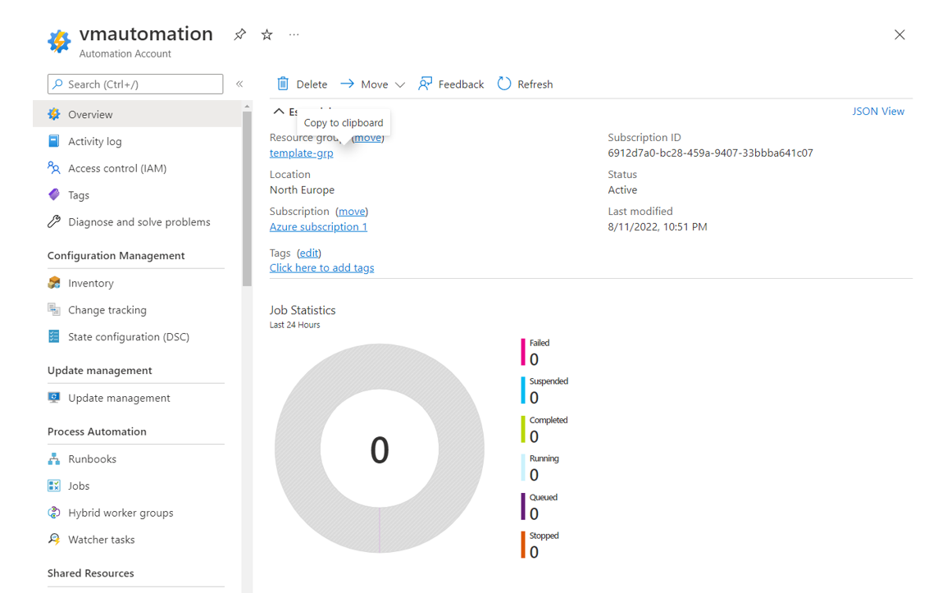

You need to complete the below Configuration for this requirement



Which of the following would go into Slot 2?

* **Feature**
* **State**
* **WindowsFeature**

**(Correct)**

* **Node**

**(Incorrect)**

**Explanation**

Here the WindowsFeature attribute would be used.

Bas du formulaire

Haut du formulaire

Question 20: **Correct**

Your company is currently using the following set of tools

1) Trello

2) Atlassian Bamboo

3) Atlassian Bitbucket

They now want to replace these tools with the use of the Azure DevOps set of tools.

Which of the following can be used in Azure **DevOps in replacement of Trello**?

* **Azure Boards**

**(Correct)**

* **Azure Repos**
* **Azure Pipelines**
* **Azure Test Plans**

**Explanation**

Trello is basically a task management tool which can be replace with Azure Boards

Bas du formulaire

Haut du formulaire

Question 21: **Correct**

Your company is currently using the following set of tools

1) Trello

2) Atlassian Bamboo

3) Atlassian Bitbucket

They now want to replace these tools with the use of the Azure DevOps set of tools.

Which of the following can be used in Azure DevOps in replacement of **Atlassian Bamboo?**

* **Azure Boards**
* **Azure Repos**
* **Azure Pipelines**

**(Correct)**

* **Azure Test Plans**

**Explanation**

Atlassian **Bamboo** is a **Continuous Integration tool, and you can use Azure Pipelines** in its place.

Bas du formulaire

Haut du formulaire

Question 22: **Correct**

Your company is currently using the following set of tools

1) Trello

2) Atlassian Bamboo

3) Atlassian Bitbucket

They now want to replace these tools with the use of the Azure DevOps set of tools.

Which of the following can be used in Azure DevOps in replacement of Atlassian **Bitbucket**?

* **Azure Boards**
* **Azure Repos**

**(Correct)**

* **Azure Pipelines**
* **Azure Test Plans**

**Explanation**

Atlassian **Bitbucket is used for hosting Git-based repositories** , so this can be replaced with the use of Azure Repos.

Bas du formulaire

Haut du formulaire

Question 23: **Correct**

Your team has a web application deployed to Azure via the use of Azure Web App. They also have an **Application Insights** resource linked to the Azure Web App. You need to use the different tools available in Application Insights to analyze user behavior.

Which of the following can be used to understand the following user behavior?

**“Analyze how load times and other factors influence conversion rates for the various parts of the application”**

* **User Flows**
* **Impact**

**(Correct)**

* **Retention**
* **Funnels**

**Explanation**

You can get this information from the Impact feature of Application Insights

For more information on the Application Insights – Impact feature , one can visit the below URL

<https://docs.microsoft.com/en-us/azure/azure-monitor/app/usage-impact>

Bas du formulaire

Haut du formulaire

Question 24: **Incorrect**

Your team has a web application deployed to Azure via the use of Azure Web App. They also have an Application Insights resource linked to the Azure Web App. You need to use the different tools available in Application Insights to analyze user behavior.

Which of the following can be used to understand the following user behavior?

**“Analyze how many users return to the application”**

* **User Flows**
* **Impact**
* **Retention**

**(Correct)**

* **Funnels**

**(Incorrect)**

**Explanation**

You can get this information from the Retention feature of Application Insights

For more information on the Application Insights – Impact feature , one can visit the below URL

<https://docs.microsoft.com/en-us/azure/azure-monitor/app/usage-impact>

Bas du formulaire

Haut du formulaire

Question 25: **Incorrect**

Your team has a web application deployed to Azure via the use of Azure Web App. They also have an Application Insights resource linked to the Azure Web App. You need to use the different tools available in Application Insights to analyze user behavior.

Which of the following can be used to understand the following user behavior?

**“Analyze how customers are flowing through the different stages of your application”**

* **User Flows**

**(Incorrect)**

* **Impact**
* **Retention**
* **Funnels**

**(Correct)**

**Explanation**

You can get this information from the Funnels feature of Application Insights

For more information on the Application Insights – Impact feature , one can visit the below URL

<https://docs.microsoft.com/en-us/azure/azure-monitor/app/usage-impact>

Bas du formulaire

Haut du formulaire

Question 26: **Correct**

Your DevOps team is currently using the Azure DevOps suite of services. They have defined a project in Azure DevOps and are currently using Azure Boards for work tracking purposes. They want to make use of chart widgets to track different project metrics.

Which of the following can be used to track the below metric?

**“Show the current status of each release pipeline”**

* **Build history**
* **Release pipeline overview**

**(Correct)**

* **Query tile**
* **Sprint capacity**

**Explanation**

You can get information on the releases via the Release pipeline overview

For more information on the entire widget catalog , one can visit the below URL

<https://docs.microsoft.com/en-us/azure/devops/report/dashboards/widget-catalog?view=azure-devops>

Bas du formulaire

Haut du formulaire

Question 27: **Correct**

Your DevOps team is currently using the Azure DevOps suite of services. They have defined a project in Azure DevOps and are currently using Azure Boards for work tracking purposes. They want to make use of chart widgets to track different project metrics.

Which of the following can be used to track the below metric?

**“Display the summary of shared query results”**

* **Build history**
* **Release pipeline overview**
* **Query tile**

**(Correct)**

* **Sprint capacity**

**Explanation**

You can display the summary of queries via the Query tile.

For more information on the entire widget catalog , one can visit the below URL

<https://docs.microsoft.com/en-us/azure/devops/report/dashboards/widget-catalog?view=azure-devops>

Bas du formulaire

Haut du formulaire

Question 28: **Correct**

Your DevOps team is currently using the Azure DevOps suite of services. They have defined a project in Azure DevOps and are currently using Azure Boards for work tracking purposes. They want to make use of chart widgets to track different project metrics.

Which of the following can be used to track the below metric?

**“Help to plan and monitor the resources assigned to a sprint”**

* **Build history**
* **Release pipeline overview**
* **Query tile**
* **Sprint capacity**

**(Correct)**

**Explanation**

You can get this information via sprint capacity.

For more information on the entire widget catalog , one can visit the below URL

<https://docs.microsoft.com/en-us/azure/devops/report/dashboards/widget-catalog?view=azure-devops>

Bas du formulaire

Haut du formulaire

Question 29: **Incorrect**

Your team is developing a pipeline which includes a task to deploy resources via an ARM template. The template needs to deploy an Azure Web app to a resource group named “template-grp”. **You have to ensure that no other resources in the resource group are impacted by this deployment.**

You have to complete the below task snippet in the pipeline for this requirement

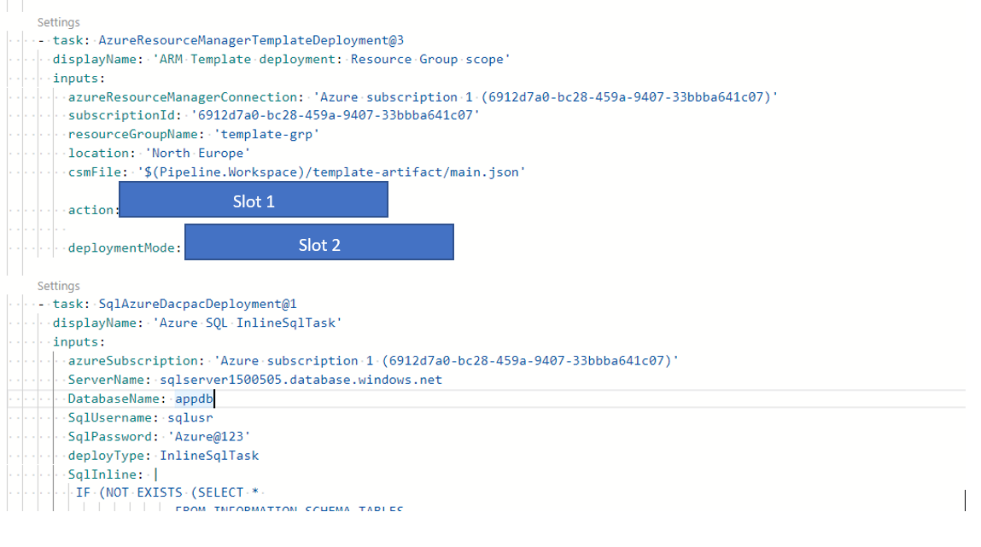

Which of the following would come in Slot 1 for this requirement?

* **‘Complete’**
* **‘Incremental’**
* **‘Delete Resource Group’**

**(Incorrect)**

* **‘Create or Update Resource Group’**

**(Correct)**

**Explanation**

Here we need to choose the option to ‘**Create or Update Resource Group’** because we need to update the resource group with the deployment of the new resource.

Bas du formulaire

Haut du formulaire

Question 30: **Incorrect**

Your team is developing a pipeline which includes a task to deploy resources via an ARM template. The template needs to deploy an Azure Web app to a resource group named “template-grp”. You have to ensure that no other resources in the resource group are impacted by this deployment.

You have to complete the below task snippet in the pipeline for this requirement

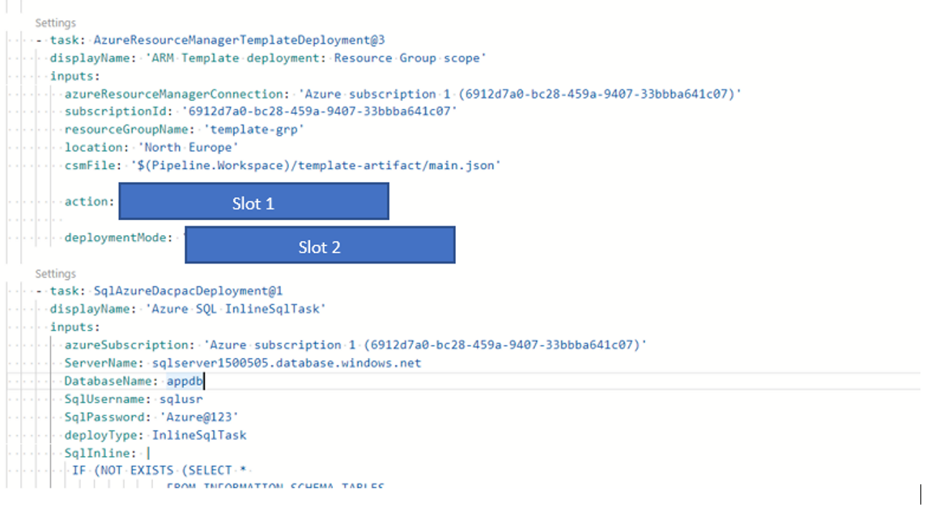

Which of the following would come in Slot 2 for this requirement?

* **‘Complete’**

**(Incorrect)**

* **‘Incremental’**

**(Correct)**

* **‘Delete Resource Group’**
* **‘Create or Update Resource Group’**

**Explanation**

**Since no other resources should be impacted , we need to choose the deployment mode of Incremental.**

Bas du formulaire

Haut du formulaire

Question 31: **Correct**

Your team has setup an Azure Web App that is connected to an Azure Application Insights instance. You have to ensure that **developers are warned about any potential performance problems or failures anomalies in the web application.** Which of the following can help in this regard?

* **Application Insights – Application Map**
* **Application Insights – Smart Detection**

**(Correct)**

* **Application Insights – User Flows**
* **Application Insights – Funnels**

**Explanation**

You can achieve this with the use of the Smart Detection feature in Application Insights

For more information on the Smart Detection feature , one can also visit the below URL

<https://docs.microsoft.com/en-us/azure/azure-monitor/alerts/proactive-diagnostics>

Bas du formulaire

Haut du formulaire

Question 32: **Incorrect**

Your team has setup an Azure Web App that is connected to an Azure Application Insights instance. Which of the following language is used to query for the data in the underlying workspace attached to Application Insights?

* **C# .Net**

**(Incorrect)**

* **KQL**

**(Correct)**

* **JavaScript**

**Explanation**

**When it comes to Application Insights, by default the data is stored in a Log Analytics workspace. You can query the data with the use of KQL which is Kusto Query Language.**

Bas du formulaire

Haut du formulaire

Question 33: **Correct**

Your company has a set of resources defined as part of their Azure subscription. A couple of Azure Web Apps are being used for hosting a production-based workload. The company wants to ensure that any **production-based alerts generated for the Azure Web Apps generate incidents in their external ServiceNow incident management system**. Which of the following can be used for this requirement?

* **Application Insights**
* **IT Service Management Integration**

**(Correct)**

* **Service connections**
* **Snapshot Debugger**

**Explanation**

The IT Service Management Connector can be used to send metric alerts from the Azure Monitor service onto the external Incident Management system.

For more information on the IT Service Management feature , one can also visit the below URL

<https://docs.microsoft.com/en-us/azure/azure-monitor/alerts/itsmc-overview>

Bas du formulaire

Haut du formulaire

Question 34: **Correct**

Your company has setup a couple of Azure Web Apps as part of their subscription. They want to provide DevOps professionals with the following capabilities

1) Be able to automatically detect performance issues within the web application hosted on the Azure Web App.

2) Get information on how users are using the application

Which of the following can be used for this requirement?

* **Application Insights**

**(Correct)**

* **Azure Advisor**
* **Microsoft Defender for Cloud**
* **Azure Active Directory**

**Explanation**

All of these features can be accomplished with the use of Application Insights.

For more information on Application Insights , one can also visit the below URL

<https://docs.microsoft.com/en-us/azure/azure-monitor/app/app-insights-overview>

Bas du formulaire

Haut du formulaire

Question 35: **Incorrect**

Your company has setup a couple of Azure Web Apps as part of their subscription. The Azure Web Apps are hosting a production-based workload. You are tasked with **creating an alert in Azure Monitor if the application becomes unresponsive for more than 5 minutes**. Which of the following could potentially be used for this requirement?

* **Azure Service Health Alert**

**(Incorrect)**

* **Availability test in Application Insights**

**(Correct)**

* **Test Plans in Azure DevOps**

**Explanation**

You can make use of Availability Tests in Application Insights to constantly test and monitor web sites.

For more information on Availability Tests in Application Insights , one can also visit the below URL

<https://docs.microsoft.com/en-us/azure/azure-monitor/app/availability-overview>

Bas du formulaire

Haut du formulaire

Question 36: **Incorrect**

Your company is currently developing a set of applications. These applications are going to be hosted on a set of Azure virtual machines. You have to decide on the right deployment strategy when it comes to application updates. Below are the requirements when it comes to Application deployments.

1) ApplicationA – **Ensure that a limited deployment of the newer application version is made. The functionality is then tested. Once testing is a success , then the rollout is carried out to all users.**

2) ApplicationB – Here the deployment would replace instances of the previous version of the application with instances of the newer version of the application on a fixed set of virtual machines.

Which of the following **deployment approach would you consider for ApplicationA**?

* **Rolling**

**(Incorrect)**

* **Blue-Green**
* **Canary**

**(Correct)**

**Explanation**

**Here the canary deployment can be used because we first want to rollout the newer version to a limited set of users.**

Bas du formulaire

Haut du formulaire

Question 37: **Correct**

Your company is currently developing a set of applications. These applications are going to be hosted on a set of Azure virtual machines. You have to decide on the right deployment strategy when it comes to application updates. Below are the requirements when it comes to Application deployments.

1) ApplicationA – Ensure that a limited deployment of the newer application version is made. The functionality is then tested. Once testing is a success , then the rollout is carried out to all users.

2) ApplicationB – Here the deployment would replace instances of the previous version of the application with instances of the newer version of the application on a fixed set of virtual machines.

Which of the following deployment approach would you consider for ApplicationB?

* **Rolling**

**(Correct)**

* **Blue-Green**
* **Canary**

**Explanation**

Here **we need to consider the Rolling update since a set of machines need to be replaced at a time here.**

Bas du formulaire

Haut du formulaire

Question 38: **Incorrect**

Your team has deployed an **Azure virtual machine scale set.**

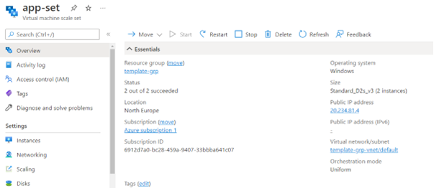

The virtual machine scale sets are being used to host a web application and they sit behind an Azure Load Balancer. You have to configure the scale set when it comes to upgrade of the individual instances. **The scale set must be able to determine which instances are eligible for an upgrade operation.** Which of the following can be considered for this requirement?

* **Application Health Extensions**

**(Correct)**

* **Installing a Custom Script Extension**
* **Configure a new backend in the Load Balancer**
* **Configure an autoscale condition for the scale set**

**(Incorrect)**

**Explanation**

With the use of Application Health Extensions, **the virtual machine scale set monitors each individual instance and see which ones are eligible for an upgrade operation.**

For more information on Virtual Machine extensions – Application Health Extension , one can also visit the below URL

<https://docs.microsoft.com/en-us/azure/virtual-machine-scale-sets/virtual-machine-scale-sets-health-extension>

Bas du formulaire

Haut du formulaire

Question 39: **Correct**

Your team has deployed an Azure virtual machine scale set.



An administrator needs to be notified whenever a scaling action occurs on the virtual machine scale set. Which of the following can be configured for this requirement?

* **Notification settings in the scaling section for the virtual machine scale set**

**(Correct)**

* **Maintenance control in Guest and host updates for the virtual machine scale set**
* **A custom script extension for the virtual machine scale set**
* **Continuous Delivery for the virtual machine scale set**

**Explanation**

You can configure this in the notification settings

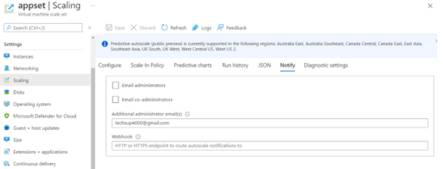

Bas du formulaire

Haut du formulaire

Question 40: **Incorrect**

Your team has an Azure virtual machine as shown below. A web application is being hosted on the virtual machine.

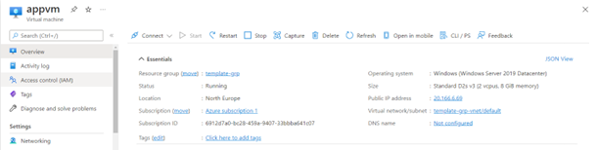

You have to enable the Service Map solution for the Azure virtual machine. Which of the following extensions need to be installed on the virtual machine for this requirement? Choose 2 answers from the options given below.

* **Microsoft Monitoring Agent**

**(Correct)**

* **Azure Pipelines Agent**
* **PowerShell DSC**

**(Incorrect)**

* **Microsoft Dependency Agent**

**(Correct)**

**Explanation**

You need to make use of the Microsoft Monitoring Agent and the Microsoft Dependency Agent for this requirement.

For more information on the Service Map solution , one can also visit the below URL

<https://docs.microsoft.com/en-us/azure/azure-monitor/vm/service-map>

Bas du formulaire

Haut du formulaire

Question 41: **Incorrect**

Your team is deploying a container group via a YAML definition. **They have to ensure to check the status of an external endpoint before the container starts**. **The container should also restart automatically if it stops.**

You need to complete the below YAML definition

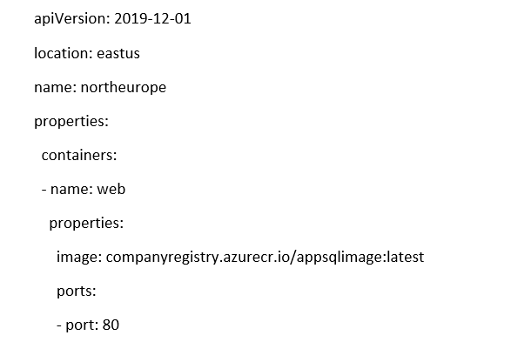

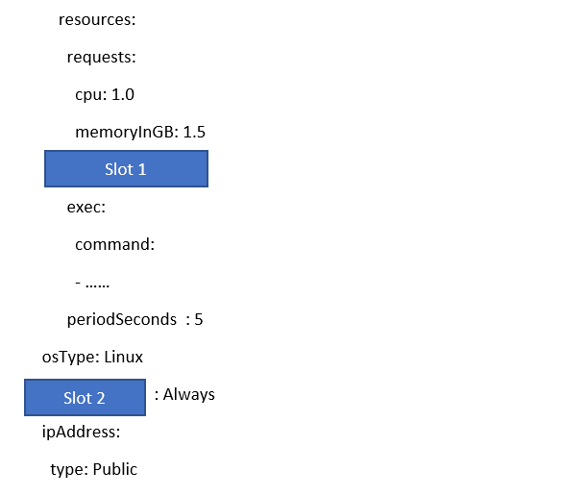

Which of the following can come in Slot 1?

* **livenessProbe**

**(Incorrect)**

* **readinessProbe**

**(Correct)**

* **Never**
* **Always**

**Explanation**

Here we need to add the **readinessProbe**, since this container has to start based on the availability of an external service.

For more information on the readiness probe , one can also visit the below URL

<https://docs.microsoft.com/en-us/azure/container-instances/container-instances-readiness-probe>

Bas du formulaire

Haut du formulaire

Question 42: **Correct**

Your team is deploying a container group via a YAML definition. They have to ensure to check the status of an external endpoint before the container starts. The container should also restart automatically if it stops.

You need to complete the below YAML definition





Which of the following can come in Slot 2?

* **livenessProbe**
* **readinessProbe**
* **Never**
* **restartPolicy**

**(Correct)**

**Explanation**

This is required based on the requirement that the container needs to restart automatically if it stops.

For more information on the readiness probe , one can also visit the below URL

<https://docs.microsoft.com/en-us/azure/container-instances/container-instances-readiness-probe>

Bas du formulaire

Haut du formulaire

Question 43: **Correct**

You have the following resources as part of your Azure subscription

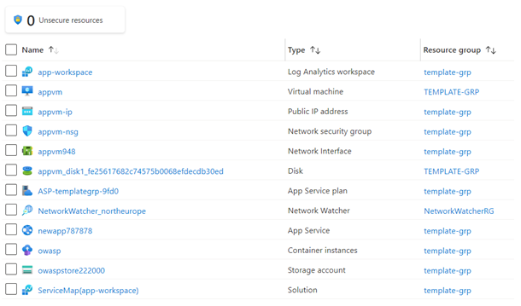

You want to be notified if there is any scheduled maintenance planned for the underlying services. Which of the following can be carried out for this requirement?

* **Create an Activity log alert in Azure Monitor**
* **Create an alert in Azure Monitor based on a Log Analytics workspace**
* **Create an Azure Service Health alert**

**(Correct)**

* **Create a metric alert in Azure Monitor**

**Explanation**

You can create an alert based on Azure Service Health for this requirement.

For more information on Azure Service Health alerts , one can also visit the below URL

<https://docs.microsoft.com/en-us/azure/service-health/alerts-activity-log-service-notifications-portal>

Bas du formulaire

Haut du formulaire

Question 44: **Incorrect**

Your team is planning on deploying several instances of the Azure Web App service. They will be used for hosting web applications**. You want to use a managed service that can used to store configuration values in the form of key/value pairs that can be used across the web applications**. The service must also have support for feature flags. Which of the following can be used for this requirement?

* **Azure Key Vault**

**(Incorrect)**

* **Azure Monitor**
* **Azure Advisor**
* **Azure App Configuration**

**(Correct)**

**Explanation**

You can store configuration data in the Azure App Configuration service. It also has the support for feature flags.

For more information on Azure App Configuration service, one can also visit the below URL

<https://docs.microsoft.com/en-us/azure/azure-app-configuration/overview>

Bas du formulaire

Haut du formulaire

Question 45: **Correct**

Your company has a set of Azure virtual machines. All virtual machines are based on Windows Server 2019. All machines currently have the Internet Information Services Role installed on them. **You have to ensure that this role remains installed always on the virtual machines.** Which of the following should you implement for this requirement? Choose 3 answers from the options given below

* **Create an Azure DevOps project**
* **Create an Azure Automation account**

**(Correct)**

* **Import and compile a DSC configuration onto the DevOps project**
* **Import and compile a DSC configuration onto the Azure Automation account**

**(Correct)**

* **Add the virtual machines as nodes onto the DevOps project**
* **Add the virtual machines as nodes onto the Azure Automation account**

**(Correct)**

**Explanation**

We need to create an Azure Automation account

Then we can add the DSC configuration onto the Azure Automation account. Then we compile the configuration.

We can then onboard or the machines as nodes onto the Azure Automation account.

Bas du formulaire