

City of Clearwater

EMSE 3.0 Deployment Checklist

V1.0

**TABLE OF CONTENTS**

[Document Control 2](#_Toc523227170)

[Overview 3](#_Toc523227171)

[Purpose 3](#_Toc523227172)

[Scope 3](#_Toc523227173)

[Accela Team 3](#_Toc523227174)

[Clearwater Team 3](#_Toc523227175)

[Go-Live Schedule/TASKS 4](#_Toc523227176)

[Dev to Test/Test to Prod 4](#_Toc523227177)

[Environment 6](#_Toc523227178)

[Development 6](#_Toc523227179)

[Test 6](#_Toc523227180)

[Production 7](#_Toc523227181)

[Configuration Items 8](#_Toc523227182)

[Rollback Plan 12](#_Toc523227183)

[Post-Deployment Clean-UP 12](#_Toc523227184)

[Maintenance process moving forward 12](#_Toc523227185)

[Using a SCCS (Source Code Control System) – Best Practice 12](#_Toc523227186)

# Document Control

|  |  |  |  |
| --- | --- | --- | --- |
| **Date** | **Name** | **Version** | **Change Reference** |
| 08/08/2017 | Jeanne E. Chalk | **1.0** | **First Draft** |
| 08/22/2018 | Jeremiah C. Johnson | 1.1 | Updates after turnover of project |
|  |  |  |  |
|  |  |  |  |
|  |  |  |  |

# Overview

## Purpose

This document describes the strategy and steps required for successful deployment of the 3.0 Master Script (EMSE) solution for the City of Clearwater, FL

## Scope

This Go-Live Checklist is limited in scope to migration from the self-hosted EMSE 1.x/2.0 to EMSE 3.0 environment.

# Accela Team

The Accela Deployment team consists of the following people:

Accela IT services for this upgrade will be performed under incidents:

|  |  |  |  |
| --- | --- | --- | --- |
| **Resource** | **Responsibility** | **Email** | **Phone** |
| Jeanne Chalk | * Solution Architect * Trainer * Issue Resolution and Support | [jchalk@accela.com](mailto:jchalk@accela.com) | 757-298-4507 |
| David Hedd | * Sr. Technical Consultant | [dhedd@accela.com](mailto:dhedd@accela.com) | 909-754-0498 |
| David Evans | * Project Manager | [daevans@accela.com](mailto:daevans@accela.com) | 828-200-5126 |
| Jeremiah Johnson | * Technical Consultant | [jjohnson@accela.com](mailto:jjohnson@accela.com) | 925-359-3659 |

# Clearwater Team

The City of Clearwater Deployment team consists of the following people: Update/Fill-in as needed.

|  |  |  |  |
| --- | --- | --- | --- |
| **Resource** | **Responsibility** | **Email** | **Phone** |
| Jeremy Williams | * Project Management | Jeremy.Williams@myClearwater.com |  |
| Lydia Moreda |  | Lydia.Moreda@myClearwater.com |  |
| Anelise Wilhelm |  | Anelise.Wilhelm@MyClearwater.com |  |
|  |  |  |  |
|  |  |  |  |
|  |  |  |  |

# Go-Live Schedule/TASKS

The following represent a high-level schedule of events and dates for the key tasks required for go-live. Update/Fill-in as needed.

Dev to Test/Test to Prod

|  |  |  |
| --- | --- | --- |
| **Task** | **Date (s)** | **Assigned To/Completed By** |
| Add the EMSE Tool page and portlet to the AdminConsole. | Jan 2018 | Done |
| Backup Events, Scripts, and Standard Choices in Test Using Data Manager. | Jan 2018 | Done in Repository |
| Import new 3.0 support standard choices exported from lower (tested) environment: EMSEConfigTool, EMSE\_EXECUTE\_OPTIONS, EMSE\_VARIABLE\_BRANCH\_PREFIX | Jan 2018 | Done 3.0 scripts in place and in use in production |
| Copy Contents of Dev Repository Folders to Test Repository Folders (Using local Integrated Development Environment Management Tools such as Eclipse or other IDE of choice) | Aug 20 2018 | Done |
| \*\*\*Special note for production deployment\*\*\*  Search repository for @emailTest tags There are 2 Custom Functions and 3 event branches that have emails changes that need to be made for the production deployment repository. Keep these in mind when modifying and promoting these specific .js files. |  | Clearwater staff will complete before prod update. File list: activeReviews.js, checkSubmittalDate.js, DUA;BUILDING!~!~!~.js, DUA;PLANNING!~!~!~.js, WTUB;BUILDING!CONSTRUCTION PERMIT!~!~.js |
| Update the EMSEToolConfigs Standard Choice with URL, Username/Password in test to match the access credentials of the Target Environment’s Repository | Aug 28 2018 | This has been completed each environment is at the desired EMSE Tool setup, code changes will be promoted through repos. |
| Deploy 3.0 version of all Custom Functions, Variable Branch Scripts, Pageflows, Batches, and Master Scripts to Test Environment using the EMSE Tool, Update DEBUG standard choice value desc to YES during the course of UAT. Do NOT enable this for Production. | Aug 28 2018 | Complete |
| Disable any Events with no master script associated | Aug 28 2018 | Complete |
| One event at a time, toggle the event association to the corresponding 3.0 scripts imported from the repository Miscellaneous folder: | Aug 16 2018 | Complete |
| Pageflow Enablement – Not required. Same scripts in use. |  | No changes were made to pageflow nothing should be needed here |
| User Acceptance Testing using Existing (Updated) test scripts |  |  |
| Disable converted standard choices once confirmed and change DEBUG standard choice value desc to NO |  |  |
| Delete converted standard choices at your leisure (maintain backup for reference) |  |  |
|  |  |  |

# Environment

To Be Completed by agency for reference

Development

Version:

V360/HTML: Agency =

Classic:

ACA:

AMO: User Group: ?

AGIS:

AGIS JS:

ADS:

EDMS\_VENDOR=

EDMS\_DOCUMENT\_SIZE\_MAX=

ADS\_SERVER\_URL=

ADS\_SERV\_PROV\_CODE=

ADS\_CLEARANCE\_KEY=

ADS\_SERVER\_SECURITY\_KEY=

ADS\_SECURITY\_KEY=

DEFAULT=

Pay Adapter:

EMSE Repo: URL: https://github.com

UserID:

UserPW:

Test

Version:

V360/HTML:

Classic:

ACA:

AMO:

AGIS:

AGIS JS:

ADS:

EDMS\_VENDOR=

EDMS\_DOCUMENT\_SIZE\_MAX=

ADS\_SERVER\_URL=

ADS\_SERV\_PROV\_CODE=

ADS\_CLEARANCE\_KEY=

ADS\_SERVER\_SECURITY\_KEY=

ADS\_SECURITY\_KEY=

DEFAULT=

Pay Adapter:

EMSE Repo: URL:

UserName:

Password/Token:

Production

Version:

V360/HTML:

Classic:

ACA:

AMO:

AGIS:

AGIS JS:

ADS:

EDMS\_VENDOR=

EDMS\_DOCUMENT\_SIZE\_MAX=

ADS\_SERVER\_URL=

ADS\_SERV\_PROV\_CODE=

ADS\_CLEARANCE\_KEY=

ADS\_SERVER\_SECURITY\_KEY=

ADS\_SECURITY\_KEY=

DEFAULT=

Pay Adapter:

EMSE Repo: URL:

UserID:

UserPW:

# Configuration Items

1. Installation of the following Standard Choices:
   1. EMSE\_EXECUTE\_OPTIONS

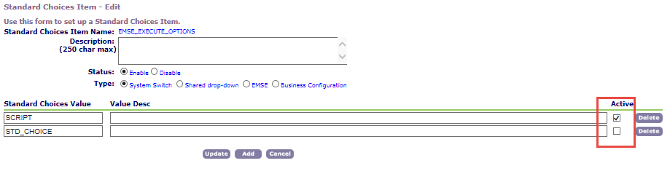

With 3.0 Event Master Scripts Enabled,

* Selecting SCRIPT will execute Business Rules (Variable Branches) from Events -> Scripts
* Selecting STD\_CHOICE will execute Business Rules (Variable Branches) from Agency Profile -> Standard Choices
* Selecting Both will cause duplicated execution with Standard Choices executing first
  1. EMSE\_VARIABLE\_BRANCH\_PREFIX

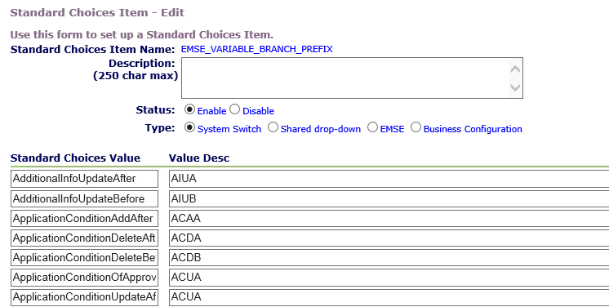

* 1. EMSEToolConfig – This will have unique values according to the environment as separate repositories may be created to manage multiple environments and support Change Management Policies.

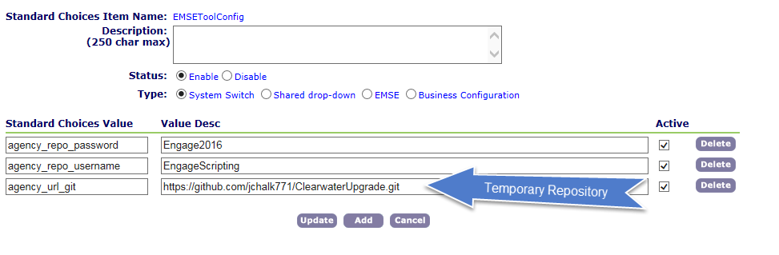

* 1. MASTER\_SCRIPT\_DEFAULT\_VERSION (Productized Master Script Usage Only)

In the future if the product is upgraded to version 8.0.1 or later the 3.0 scripts are productized. Meaning that the events may be associated with productized master scripts versions 8.0.1 and higher. At that time, this standard choice will also be required.

htt aa2.test. mydearwater. 
Act-Va Automation: Rbizdom.,. x 
City of Metropolis 
Standard Choices Item — Edit 
admi 
Menu Favorites Switch Agency Help Logout Civic matfc 
User ID: JJOHNSON 
Admin Tools 
Daily 
ACCELA 
use this form to set up a Standard Choices Item. 
standard choices Item Name: 
Description: 
(750 char max) 
Status: @ Enable C) Disable 
@System Switch O Shared drop-down C) EMSE C) Business Configuration 
Standard Choices Value 
9.3.o 
Value Desc 

* 1. MULTI\_SERVICE\_SETTINGS (Superagencies Only) – Not used in this jurisdiction
  2. DEBUG (Optional)

Set value to Yes for UAT and Troubleshooting, No/Disable for Production Environments and normal operations – Only leave on until execution is confirmed, reduces performance and creates HUGE logs.

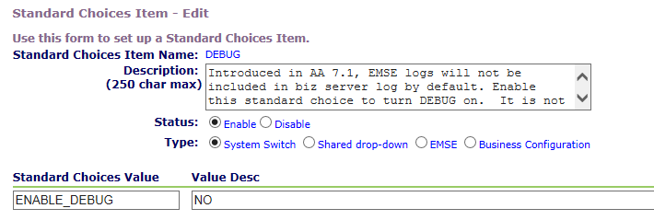

* 1. Event Enablement and Master Script Association Before

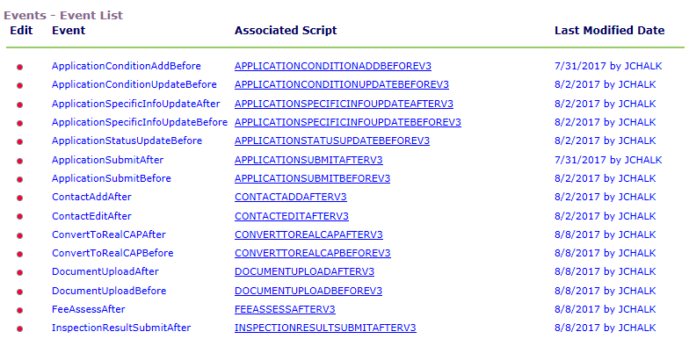

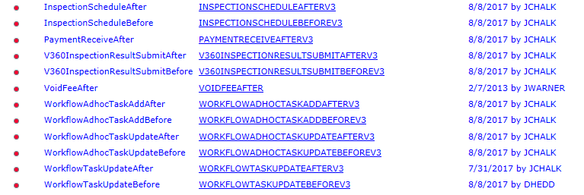

* 1. Event Enablement and Master Script Association After

https://aa2.testmydearwater.conVadmin/eventmmager/indeY_cfm?fuseactionzGetEventList&barselz6b&tags' 
Accela Automation: GetEvent„. 
Accela Automation S 
Accela Automation S 
Menu Favorites Switch Agency Help Logout Civic Platform 
City of Metropolis 
Events - Event List 
User 'JOHNSON 
Associated Script 
CONVERvr0REALCAPBEFOREV3 
WORKFI OWADHOCTASKADDAFTFRV3 
WORKH 
Admin Tools 
Edit 
Event 
convertToRealCAPBefore 
Voi d FeeAfter 
Wo kAd dAfter 
Wo rkflo wAdhocTas kAd dBefore 
wo r kfltMAd h ocTas kLJpdateAfter 
WorkflowAdhocTaskUpdateBefore WORKFLOWADHOCTASKUPDATEBEFOREV3 
App Ca ti o n S r 
Appl i cation StatusUpdatedefore 
ApplicationSubmitAfter 
convertToRealCAPAfter 
Docu mentUpIoadAfter 
p load Befo re 
I n spection 
AQQlicarianStatustJpdateBefore (Master Script 
AOOIirarianSuhmitAfter (Maeter - 
DocumentUoIoadAfter (Master Scriot - 9.3.0) 
(Master Script - 
FeeEstimateAfter4ACA Master ScriDt • 9.3. O) 
- q_mo) 
Scrint - q _3_m 
ACCELA AUTOMATION" 
Last Modified Date 
10/10/2017 by AWILHELM 
8/16/2018 
8/16/2018 by DOHNSON 
10/10/2017 by AWILHELM 
10/10/2017 by AwlLHELM 
10/10/2017 by AWILHELM 
8/16/2018 by Jj0HNSON 
8/16/2018 by 
8/16/2018 by JJ0HNsoN 
8/16/2018 by 
8/16/2018 by DOHNSON 
8/16/2018 by DOHNSON 
8/16/2018 by 
8/16/2018 by DOHNSON 
8/16/2018 by 

lnPrivate 
httpsWaa2.test.mydearwatercom/admin/eventmanager/index.cfm?fuseaction=GetEventList&barsel=6b&tags. • 
Accela Automation: GetEvent.„ x 
Accela Automations 
Accela Automations 
Favontes SWItChAgency Help Logout 
City of Metropolis 
Events - Event List 
Edit Event 
InspectionScheduIeAfter 
V 3601nspectionResuItSubmitAfter 
V 3601 n spectionResuItSubmitBefore 
Wo rkflo sku pdateAfter 
WorkflowTa skUpdate Befo re 
User ID: JJOHNSON 
Associated Script 
A d min 
InspectionScheduIeAfter (Master Script - 9.3.m 
InsoectionScheduIeBefore (Master Script - 9.30 
V3601nsoectionResulrSuhmitAfter (Master Script - 
WorkflowTaskUDdateAfter ( Master Script - 9.3. O) 
pages 
New Event 
Certificate error 
Liu 
ACCELA AUTOMATIONØ 
Last Modified Date 
8/16/2018 by 
8/16/2018 by JJOHNSON 
8/16/2018 by JJOHNSON 
8/16/2018 by DOHNSON 
8/16/2018 by JJOHNSON 
8/16/2018 by DOHNSON 
8/16/2018 by JJOHNSON 

The following events have not been productized, there is no master script available for them:

ConvertToRealCAPBefore

VoidFeeAfter

WorkflowAdhocTaskAddAfter

WorkflowAdhocTaskAddBefore

WorkflowAdhocTaskUpdateAfter

WorkflowAdhocTaskUpdateAfter

# Rollback Plan

1. No pre go-live rollback required but many agencies prefer to do a full DB backup prior to conversion efforts should the Data Manager Files fail to properly restore settings.
2. Once event/master script associations have been changed, the Data Manager File can facilitate a quick rollback if it is needed or the events can be manually rolled back to their pre-existing associations quickly.

# Post-Deployment Clean-UP

Once environment has been deemed stable, all old standard choices that have been converted should be disabled and subsequently removed after such time that the agency is confident of script performance. This will prevent other resources in the future from modifying those items in error.

# Maintenance process moving forward

The best practice for script development in any environment is to integrate with a Source Code Control. Using the integrated repository approach, the current state of scripts within the repository can be adjusted by rolling back a specific code commit within that product and re-deploying to Civic Platform. Alternatively, if there are configuration or security policy measures in place that prohibit repository integration with an Accela Environment, the Data Manager Approach may also be used to deploy code.

## Using a SCCS (Source Code Control System) – Best Practice

1. Administrative users (read and write access) of the SVN/GIT repository check out/clone the repository to a local Integrated Development Environment or code editor of choice. Some popular solutions include Eclipse Oxygen (free) or Notepad++ with Tortoise SVN (also free).
2. The Administrative User writes or adjusts the existing script as needed in accordance with Accela Best Practice Scripting Standards (leveraging script test feature to unit test and perform basic syntax and logical checks of the new or proposed code).
3. That code is committed to the SCCS upon successful completion of script testing.
4. Using the EMSE Tool built into the Civic Platform, select the newly changed script and visually compare with what is deployed in production to confirm overwrite.
5. Deploy change using EMSE Tool.
6. Perform UAT using updated Test Scripts revised to conform to the new workflow. Ensure all positive and negative test cases as well as any boundary values for <, >, <=, >= logic.
7. Once confirmed, using the repository manager of choice, whole script files (.js) can be copied and pasted from one repository to the other. Copying and pasting code directly is not recommended and may result in omitted ‘}’ or text that can cause errors at runtime.