

Cobb County

EMSE 3.0 Deployment Checklist

V1.1

**TABLE OF CONTENTS**

Document Control 2

Overview 3

Purpose 3

Scope 3

Accela Team 3

Cobb County Team 3

Go-Live Schedule/TASKS 4

Dev to Test/Test to Prod 4

Environment 5

Development 5

Test 5

Production 6

Configuration Items 7

GO-LIVE ISSUES 10

ROLLBACK PLAN 10

Post-Deployment Clean-UP 10

Maintenance process moving forward 10

Using a SCCS (Source Code Control System) – Best Practice 10

# Document Control

|  |  |  |  |
| --- | --- | --- | --- |
| **Date** | **Name** | **Version** | **Change Reference** |
| 05/10/2017 | Jeanne E. Chalk | **1.0** | **First Draft** |
| 06/16/2017 | Jeanne E. Chalk | 1.1 | Dev Deployment Milestone |
|  |  |  |  |
|  |  |  |  |
|  |  |  |  |

# Overview

## Purpose

This document describes the strategy and steps required for successful deployment of the 3.0 Master Script (EMSE) solution for Cobb County, GA.

## Scope

This Go-Live Checklist is limited in scope to migration from the self-hosted EMSE 1.x/2.0 to EMSE 3.0 environment.

# Accela Team

The Accela Deployment team consists of the following people:

Accela IT services for this upgrade will be performed under incidents:

|  |  |  |  |
| --- | --- | --- | --- |
| **Resource** | **Responsibility** | **Email** | **Phone** |
| Jeanne Chalk | * Solution Architect * Trainer * Issue Resolution and Support | [jchalk@accela.com](mailto:jchalk@accela.com) | 757-298-4507 |
| David Evans | * Project Manager | [daevans@accela.com](mailto:daevans@accela.com) | 828-200-5126 |

# Cobb County Team

The Cobb County Deployment team consists of the following people: Update/Fill-in as needed.

|  |  |  |  |
| --- | --- | --- | --- |
| **Resource** | **Responsibility** | **Email** | **Phone** |
|  |  |  |  |
|  |  |  |  |
|  |  |  |  |
|  |  |  |  |
|  |  |  |  |
|  |  |  |  |

# Go-Live Schedule/TASKS

The following represent a high-level schedule of events and dates for the key tasks required for go-live. Update/Fill-in as needed.

Dev to Test/Test to Prod

|  |  |  |
| --- | --- | --- |
| **Task** | **Date (s)** | **Assigned To/Completed By** |
| Backup Events, Scripts, and Standard Choices in Test Using Data Manager. |  |  |
| Import new 3.0 support standard choices: MASTER_SCRIPT_DEFAULT_VERSION, EMSEConfigTool, EMSE_EXECUTE_OPTIONS, EMSE_VARIABLE_BRANCH_PREFIX |  |  |
| Ensure that all users that deploy with the EMSE Tool have that portlet added to their console. |  |  |
| Add INCLUDES_CUSTOM_GLOBALS and set debug for SMEs and Admin |  |  |
| Copy Contents of Dev Repository Folders to Test Repository Folders (Using Tortoise SVN Repository Management Tools) |  |  |
| Update the EMSEToolConfigs Standard Choice with URL, Username/Password in test to match the access credentials of the Test Repository |  |  |
| Deploy 3.0 version of all Custom Functions, Variable Branch Scripts, Pageflows, Batches, and Miscellaneous to Test Environment using the EMSE Tool, Update DEBUG standard choice value desc to YES during the course of UAT. Do NOT enable this for Production. |  |  |
| One event at a time, toggle the event association to the corresponding productized 3.0 script (Master Script 8.0.1.0.0) with the exception of the following non-productized scripts/events imported from the repository Miscellaneous folder:  DOCUMENTUPLOADAFTERV3  INSPECTIONSCHEDULEAFTERV3  INSPECTIONSCHEDULEBEFOREV3  **NOTE: Access Classic from the new interface or “aa” cold fusion url to avoid a bug** |  |  |
| User Acceptance Testing using Existing (Updated) test scripts |  |  |
| Disable converted standard choices once confirmed and change DEBUG standard choice value desc to NO |  |  |
| Delete converted standard choices at your leisure (maintain backup for reference) |  |  |

# Environment

To Be Completed by agency

Development

Version:

V360/HTML: Agency =

Classic:

ACA:

AMO: User Group: ?

AGIS:

AGIS JS:

ADS:

EDMS_VENDOR=

EDMS_DOCUMENT_SIZE_MAX=

ADS_SERVER_URL=

ADS_SERV_PROV_CODE=

ADS_CLEARANCE_KEY=

ADS_SERVER_SECURITY_KEY=

ADS_SECURITY_KEY=

DEFAULT=

Pay Adapter:

EMSE Repo: URL: <https://DCP-ACLSVN1PRD.SS.COBBROOT.LOCAL/svn/Accela-Scripts-Dev>

UserID: AccelaDev (Read Only)

UserPW: AccelaDev

Test

Version:

V360/HTML:

Classic:

ACA:

AMO:

AGIS:

AGIS JS:

ADS:

EDMS_VENDOR=

EDMS_DOCUMENT_SIZE_MAX=

ADS_SERVER_URL=

ADS_SERV_PROV_CODE=

ADS_CLEARANCE_KEY=

ADS_SERVER_SECURITY_KEY=

ADS_SECURITY_KEY=

DEFAULT=

Pay Adapter:

EMSE Repo: URL:

UserName:

Password/Token:

Production

Version:

V360/HTML:

Classic:

ACA:

AMO:

AGIS:

AGIS JS:

ADS:

EDMS_VENDOR=

EDMS_DOCUMENT_SIZE_MAX=

ADS_SERVER_URL=

ADS_SERV_PROV_CODE=

ADS_CLEARANCE_KEY=

ADS_SERVER_SECURITY_KEY=

ADS_SECURITY_KEY=

DEFAULT=

Pay Adapter:

EMSE Repo: URL: <https://DCP-ACLSVN1PRD.SS.COBBROOT.LOCAL/svn/Accela-Scripts-Prod>

UserID: AccelaProd (Read Only)

UserPW: AccelaProd

# Configuration Items

1. Installation of the following Standard Choices:
   1. EMSE_EXECUTE_OPTIONS

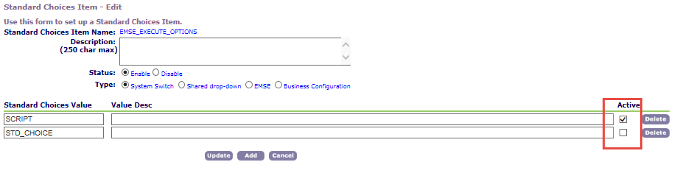

With 3.0 Event Master Scripts Enabled,

* Selecting SCRIPT will execute Business Rules (Variable Branches) from Events -> Scripts
* Selecting STD_CHOICE will execute Business Rules (Variable Branches) from Agency Profile -> Standard Choices
* Selecting Both will cause duplicated execution with Standard Choices executing first
  1. EMSE_VARIABLE_BRANCH_PREFIX

**Special note for Cobb** - The ConvertToRealCapAfter event prefix has been modified from CTRCA(BPT) to CRCA to match existing usage.

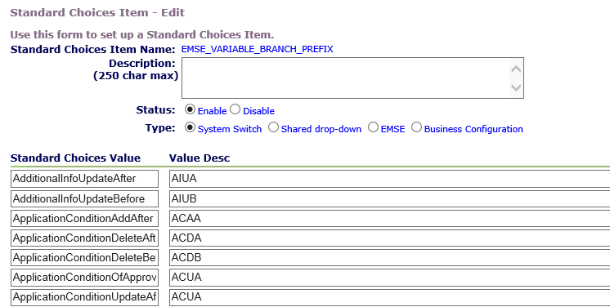

* 1. EMSEToolConfig – This will have unique values according to the environment as separate repositories may be created to manage multiple environments and support Change Management Policies.

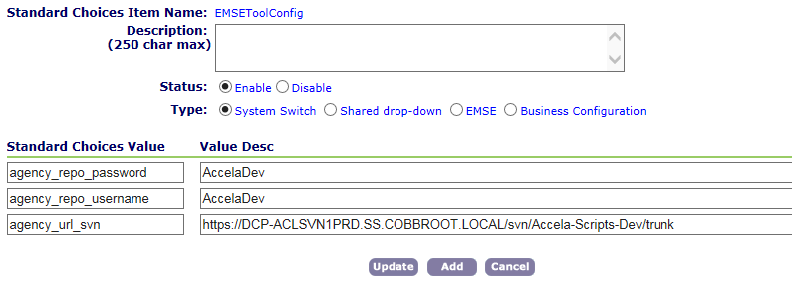

URL, username, and password may vary based on environment.

* 1. MASTER_SCRIPT_DEFAULT_VERSION (Productized Master Script Usage Only)

Note: You may wish to evaluate (compare) the INCLUDES_ACCELA_FUNCTIONS files each new product upgrade to see what new functions have been added and/or revised.

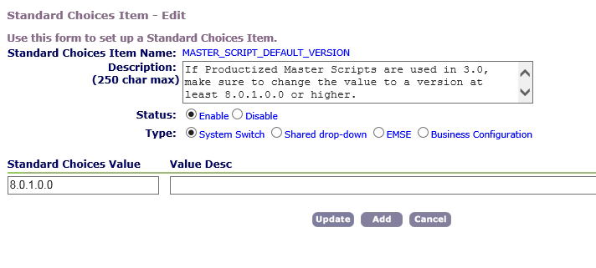

* 1. MULTI_SERVICE_SETTINGS (Superagencies Only) – Not used in this jurisdiction
  2. DEBUG (Optional)

Set value to Yes for UAT and Troubleshooting, No/Disable for Production Environments and normal operations – Only leave on until execution is confirmed, reduces performance and creates HUGE logs.

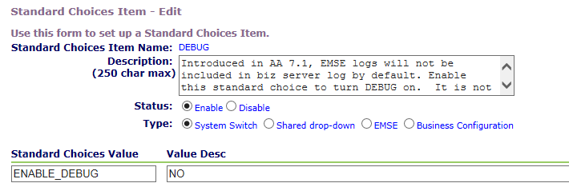

* 1. Event Enablement and Master Script Association

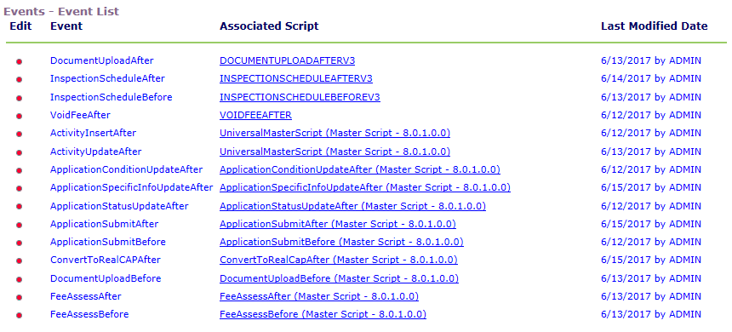

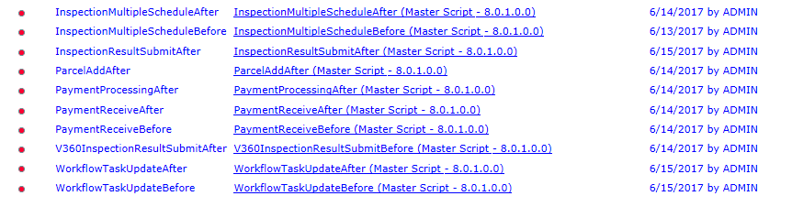

# GO-LIVE ISSUES

|  | ID | Go-Live Issues Task | Assigned To | Comments |
| --- | --- | --- | --- | --- |
|  | 200 |  |  |  |
|  | 201 |  |  |  |
|  | 202 |  |  |  |
|  | 203 |  |  |  |
|  |  |  |  |  |

# ROLLBACK PLAN

1. No pre go-live rollback required but many agencies prefer to do a full DB backup prior to conversion efforts should the Data Manager Files fail to properly restore settings.
2. Once event/master script associations have been changed, the Data Manager File can facilitate a quick rollback if it is needed or the events can be manually rolled back to their pre-existing associations quickly.

# Post-Deployment Clean-UP

Once environment has been deemed stable, all old standard choices that have been converted should be disabled and subsequently removed after such time that the agency is confident of script performance. This will prevent other resources in the future from modifying those items in error.

# Maintenance process moving forward

The best practice for script development in any environment is to integrate with a Source Code Control System (the preferred solution within this agency is SVN Server and Tortoise SVN tools). Using the integrated repository approach, the current state of scripts within the repository can be adjusted by rolling back a specific code commit within that product and re-deploying to Civic Platform. Alternatively, if there are configuration or security policy measures in place that prohibit repository integration with an Accela Environment, the Data Manager Approach may also be used to deploy code.

## Using a SCCS (Source Code Control System) – Best Practice

1. Administrative users (read and write access) of the SVN repository check out/clone the repository to a local Integrated Development Environment or code editor of choice. Some popular solutions include Eclipse Neon (free) or Notepad++ with Tortoise SVN (also free).
2. The Administrative User writes or adjusts the existing script as needed in accordance with Accela Best Practice Scripting Standards (leveraging script test feature to unit test and perform basic syntax and logical checks of the new or proposed code).
3. That code is committed to the SCCS upon successful completion of script testing.
4. Using the EMSE Tool built into the Civic Platform, select the newly changed script and visually compare with what is deployed in production to confirm overwrite.
5. Deploy change using EMSE Tool.
6. Perform UAT using updated Test Scripts revised to conform to the new workflow. Ensure all positive and negative test cases as well as any boundary values for <, >, <=, >= logic.
7. Once confirmed, using the repository manager of choice, whole script files (.js) can be copied and pasted from one repository to the other. Copying and pasting code directly is not recommended and may result in omitted ‘}’ or text that can cause errors at runtime.