**Cosc360 game Design Project Plan**

Team Murcurius: James Goodman, Dylan Pringle and James Chalmers

**Team Roles**

*Project Manager and Game Designer:* Shared

*Tech Roles:* Divided arbitrarily so may change especially if something is rate limiting

Player mechanics: Dylan Pringle

Enemies AI: James Goodman, this will probably need some iteration as things change.

Levels building: James Chalmers, Once systems are in place this can be shared.

*Art/Sound/StoryWriter*: Shared

*Testing:* Each person is responsible for designated jobs and final testing will be done by team.

*Marketing/Community Leader:* Shared, we will make a Facebook page to promote our game.

**Fundamentals**

***Game Name Ideas:***

Frank the Tank, Run Monster Run, Franken-Smasher

***Core concept / vision:***

A fast paced game set in a fictional era reminiscent of early 19th nineteenth century England (setting of Frankenstein) and potentially with aesthetic elements taken from the Middle Ages. This is centered on a large Frankensteinian monster that has just escaped from a lab that must outrun the violent mob chasing him down.

***Game overview:***

The player can only run forward as there is a relentless advancing mob of villagers chasing him form behind. There is a sense of urgency to keep running or be torn apart from the advancing mob. The player will also encounter enemies approaching him from the front and sides and immobile enemies throwing projectiles at him. The Player will have an attack to kill enemies if they get too close and burst through wooden walls and some small buildings. Enemies are armed with weaponry suited for medieval times such as pitchforks, sickles and torches.

***Game themes:***

The villagers represent mobmentality and intolerance. The monster will represent self-preservation and the idea that you have to fight for your rights.

***What is fun about it:***

Its fast paced, there is a sense of urgency, you can get to smash angry villagers (who are jerks) and you get to leave a trail of destruction in your wake.

***What is unique about this game:***

Levels will consist of interconnecting map blocks (prefabs) that are randomly chosen. Playing is a large character and enemies are small which is less common than the other way round.

***Goals:***

Our main goal is to successfully create a prefab map block interconnecting system, to successfully create an appropriate AI system for the enemies and to create an enjoyable movement and fighting system for the player. We want the basics mechanics of the game to work well.

***Non-goals:***

We are not trying to reinvent game mechanics more just try and implement them effectively and we are not going for complete randomness with the map design rather just a feeling of randomness. The same can be said for the UI and AI, which we want to be minimal.

***Characters and Story:***

There is only main character, the Frankenstein monster that needs to escape in order to gain his freedom. If time permits we will add a scientist boss at the end of the third level.

***Control scheme:***

Attack (punch): Ctrl

Movement (forward left, forward, forward right): Up, Left and Right arrow keys.

***Game Mechanics:***

The basic game logic will be to move the monster through a random village while being pursued forcing you to move as quickly as possible. The map blocks will appear randomly so you will not be able to completely predict what is coming when repeating levels. The monster must get to the end of the map without being caught by the mob, that are in close pursuit. If you lose all your health or are staggered long enough to be caught you lose and restart the level. If you make it to the end you move onto the next level.

***How will the game be balanced:***

As the game progresses the levels will be harder, but the powers up will also become more powerful and crucial for success.

***Risks:***

We are worried that we might not be able to create the random map block building system. We can build the level in place without the random generating if this does not work out. The AI for enemies and attacking system for player and enemies may be difficult to implement. Creating the enemies or the illusion of enemies following the monster could be challenging. The simple mechanics could limit the challenge and fun of the game so we are reliant on finishing prototypes early to give us more time to change/add mechanics if necessary.

**Tech overview**

***Sprites and Animation:***

Photoshop will be used to make sprites. There are minimal animation requirements in this project so most of the time will be spent on trying to make quality textures.

***Level/World rendering:***

The levels will be put together using pre-made blocks that will be selected pseudo randomly from an array of references. Many screens (say 15) will be pre-made per level to prevent repetition. These screens will be a component background with children that make up the objects in players way. These screens will need to be loaded at an arbitrary point before the player reaches the end of the current screen for a seamless transition. Maintaining momentum is important for immersion in this game.

***Sounds:***

We can make our own sounds effects using various items. Cabbage can be used for crunching, punching, poking and slashing noises and fire noises can be made with scrunching plastic wrappers. Grunts and villager noises can also be made using our own voices. Audacity makes this very easy and microphones can be rented. Some sounds can be found in the public domain.

***Path finding:***

The AI will track to the monsters position on screen and strike when in range. Some random elements will need to be added to make each AI act differently.

**Content Overview**

***Levels:***

There will be three Levels in this game with increasing difficult and rewards in terms of points and power ups. Level three may feature a final boss. We need to make ~15 blocks per level.

***Power Ups:***

There will be power ups to increase player speed, strength and defense that will be spawned randomly but at set locations in the pre-made blocks.

***Sprites and Animations:***

Time needs to be spent on the main character sprite as it will be constantly visible which will be Frankenstein’s monster viewed from the top down at a slight angle to show the back of the head and back. He needs to have a running animation and attacking animations. There will be animations for the villagers attacking. There also needs to be villagers attacking from behind, which will be constantly present and move with the character. Animations may be required for breaking walls.

***Sound:***

The monster will make grunts and will have stomping feat as he runs and punching sound effects when he attacks. Villagers need yelling sounds, swiping and poking attack noises and death cries.

***Music:***

There needs to be a sense of urgency in the game so music needs to have a reasonably fast tempo with a driving drum loop. Occasional suspenseful sound could cut in inspired by horror movies soundtracks such as a higher key melody or some string instruments. As a backup we could just use synth melodies.

***GUI:***

The GUI will be fairly simple with a start screen, which has an option to access high scores, new game, level select or quit. The game will have a HUD displaying player health as a red bar, time since start of level, points and any power ups that player is currently effected by.

**Aesthetics**

Drawings will be simple and from a top down view. Backgrounds will consist of brown and grey colors and foreground features that will be more colorful to bring them out. We will take some inspiration from cartoon depiction of medieval times for textures.

***Concept Art Ideas/asthetic/feeling – Houses and village***

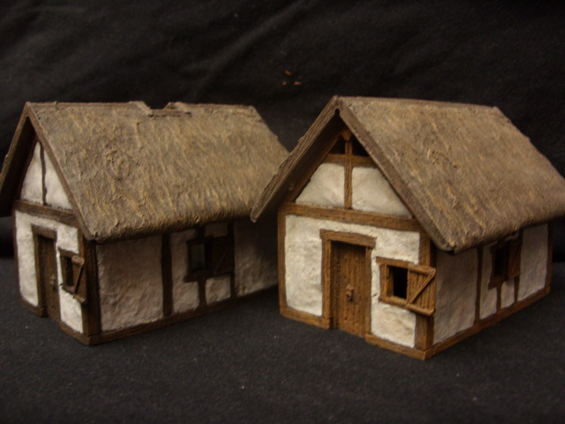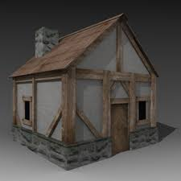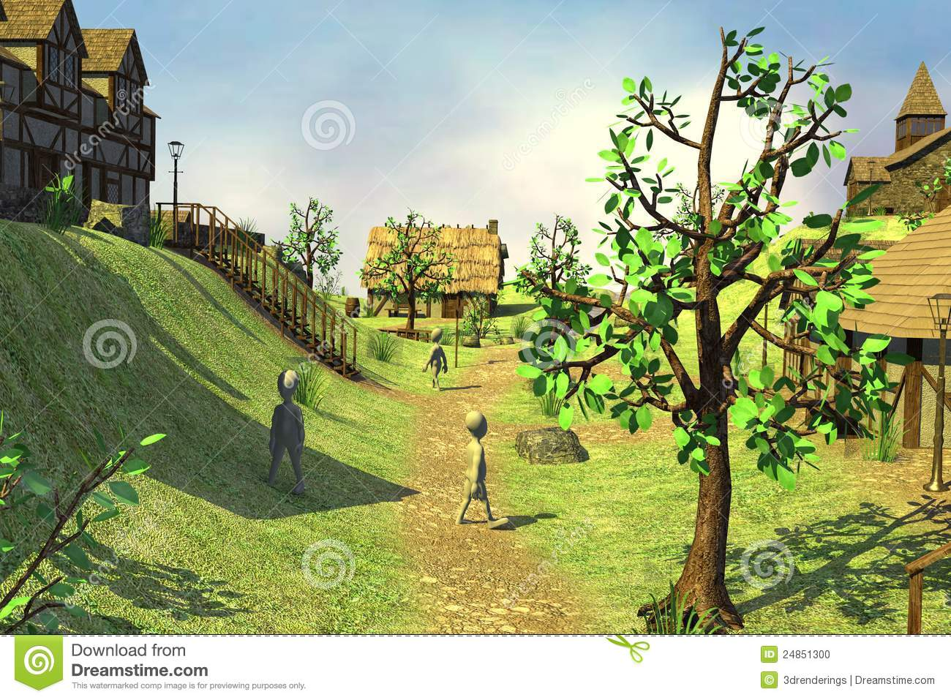

***Character Art Ideas/asthetic/feeling – Frankenstein Monster and Villagers***

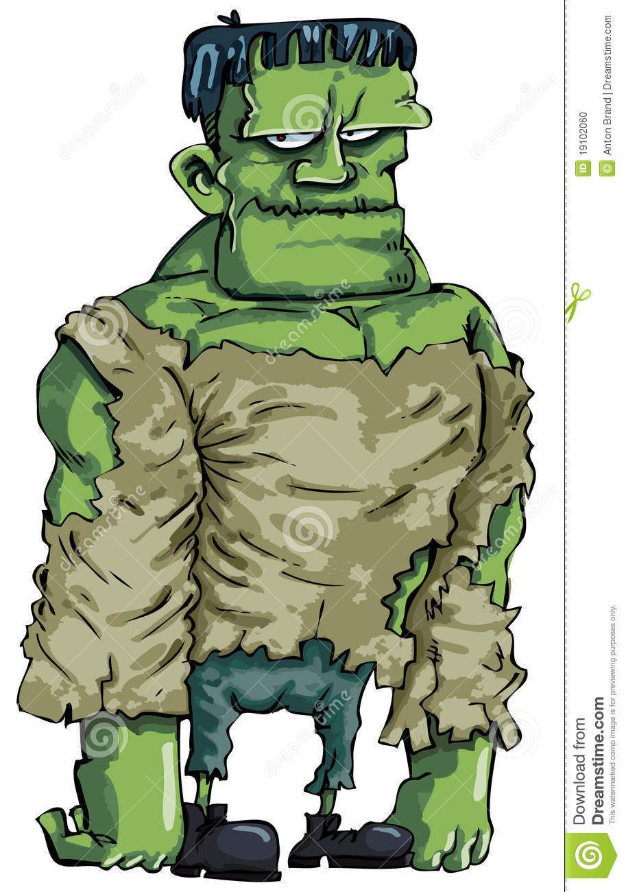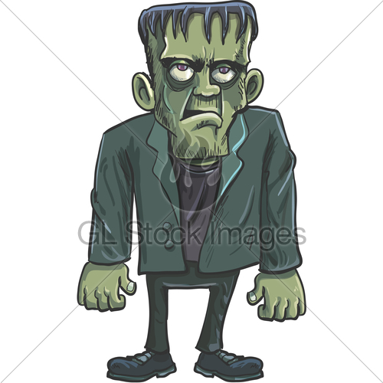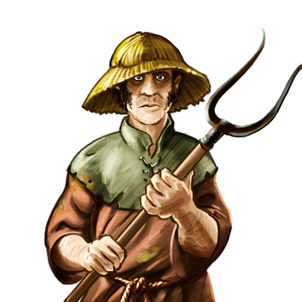

**Three-week production schedule:**

***Rapid Prototyping:***

*Divide our work into three pieces for the prototyping*

Map pieces and layout – James Chalmers

Character movements – Dylan Pringle

A.I creation – James Goodman

The most important questions that needs to be answered from the prototype is can we get the monster to move seamlessly from one block of map to another block. AI is also important but will likely need to be altered down the line.

***Alpha Build****:*

Once we establish the systems for mapping and movement we can start designing blocks for the levels. We can also get to work on enemy types and power ups. At the same time we can tweak the AI and difficulty of the levels. It would be good to have three levels completed at the end of the week. We will start working on music, sound, animation and art this week.

***Beta Build:***

This week will involve completing sound, animation and music as well using a priority list to fix the most important elements that weren’t working in the alpha build. Its likely we will still need to add major game elements this week due to time constraints but we have already discussed backup plans if things do not work.

